

**An**

**PROJECT REPORT ON**

“Health Give Rise to Non-Contact Biometric Attendance System”

IN THE PARTIAL FULFILMENT FOR THE

**Degree of** **Bachelor of Technology**

**in**

**Electronics and Communication Engineering**

**SUBMITTED By**

Mr.Huzefa Riyazahmed Arbhavi

**Under the Guidance of**

Prof.Dr.A.G.Bhosale

DEPARTMENT OF ELECTRONICS & COMMUNICATION ENGINEERING

of

SANJAY GHODAWAT UNIVERSITY

KOLHAPUR

2023-24

SANJAY GHODAWAT UNIVERSITY

KOLHAPUR

CERTIFICATE

This is to certify that the project report entitled,

## “Health Give Rise to Non-Contact Biometric Attendance System”

Submitted By,

|  |  |
| --- | --- |
| Student Name | Exam Seat No. |
| Mr. Huzefa Riyazahmed Arbhavi 21ST116332009 | |

Is a bonafide work carried out by them in the year 2023-24, under the supervision of Prof.Dr.A.G.Bhosale and it is approved for the partial fulfillment of the requirement of for the Bachelor of Technology in Electronics and communication Project

**Project Guide** **H.O.D**. Prof.Dr.A.G.Bhosale Prof.Dr.R.M.Linus

### ABSTRACT

Viruses such as COVID-19 are transferrable through touch and contact. There are WHO guidelines to clean or sanitize hands regularly to reduce the risk of infection. Attendance system is required in many different places such as offices, companies, schools, organizations and institutions, etc. There are many attendance systems to take attendance. But, every place need to have a good system. In this project we develop a Arduino based Automatic Sanitizer dispenser The controller processes the sensor data & actuates the pump and solenoid valve. The sanitizer liquid dispenses through nozzle. Biometric Attendance System with help the of ultrasonic sensor, RS305 fingerprint sensor and also check person health status by checking blood oxygen level & pulse heart rate of person before giving his biometric attendance with the help of multiple sensors. Parallax Data acquisition tool (PLX-DAQ) are the main components to display record in Excel.

### Keyword: Touchless Sanitizer Dispenser, Ultrasonic Sensor, Biometric Sensor, Oximeter, Arduino Microcontroller, Pump, Parallax Data.

**PRESENT ATTENDANCE SYSTEM**

In this system, the reference roll number and name for every student is provided by the institute with sheets. The teachers call out the roll number and mark ‘present’ or ‘absent’ on the sheet. For a particular class or each lecture, the call out process is also replaced by passing the sheet and signing. Many institute or university still use this type of paper-based attendance system. The disadvantages of this system are that roll calling and singing process is waste time and cannot take actual attendance.

**Index**

Contents

Chapter 1

INTRODUCTION ……………………………….…………………….……………………………....9

1.1: INTRODUCTION AND BACKGROUND……………………………………………………….9

Chapter 2

LITERATURE SURVEY…………………………………………………………………………….11

2.1: LITERATURE SURVEY FOR PROBLEM IDENTIFICATION AND SPECIFICATION…….11

Chapter 3

3.1: Methodology……………………………………………………………………………………12

3.2: System Flow Chart………………………………………………………………………………13

3.3 ARDUINO PROGRAMMING ………………………………………………………………….14

3.4 IDE……………………………………………………………………………………………….14

Chapter 4

Component Used……………………………………………………………………………….…….15

4.1 Arduino Mega 2560 Board…………………………………………………………………….…16

4.2 Ultrasonic Sensor……………………………………………………………………………........20

4.3 MAX30100 Pulse Oximeter…………………………….……………….……….………….……21

4.4 Finger Print Module…………………………………...………………………………………….22

4.5 RTC Module………………………………………….……….………………………………….24

4.6 LCD Display 16x2……………………………….………………………….……………………24

4.7 DC Motor……………………………………………….…………………………………………26

4.8Solenoid Valve……………….………………….…………………………………………………26

4.9Software Requirement……….…………………….……………………………………………….27

Chapter 5

5.1Block Diagram…………….………………………………………………………………………29

5.2Circuit Diagram……………………………………………...…………………………………….30

Chapter 6

6.1Sanitizer Dispenser working……………………………………………………………….……….31

6.2 Working of MAX30100 Pulse Oximeter and Heart-Rate Sensor………………………….……….31

6.3 Working of Finger Print attendance system………………………………………………………...33

Chapter 7

7.1Result……………………………………………………………….………………………………36

Chapter 8

8.1 Application…………………………………………………………………………………………37

Chapter 9

9.1 CONCLUSION AND FUTURE SCOPE………………….………….……………………………38

Chapter 10

10.1References………………………………………………………………………………………….39

# Chapter 1

## INTRODUCTION

## INTRODUCTION AND BACKGROUND:

Hygiene is an important aspect to remain healthy. There are various aspects of hygiene. A clean hand is one of them. Hands generally are touched at various surfaces and can be exposed to direct contamination. Cleaning hands at regular interval is recommended by various health organizations including WHO. Hand hygiene is now regarded as one of the most important element of infection control activities. In the wake of the growing burden of health care associated infections (HCAIs), the increasing severity of illness and complexity of treatment, superimposed by multi-drug resistant (MDR) pathogen infections, health care practitioners (HCPs) are reversing back to the basics of infection preventions by simple measures like hand hygiene. This is because enough scientific evidence supports the observation that if properly implemented, hand hygiene alone can significantly reduce the risk of cross-transmission of infection in healthcare facilities (HCFs)1–5.

Evidence suggests that hand sanitization significantly reduces the transmission of healthcare-associated pathogens and the incidence of HCAI (healthcare associated infections).[6]. According to the Center for Disease Control and Prevention (CDC), hand hygiene encompasses the cleansing of your hands using soap and water, antiseptic hand washes, alcohol-based hand sanitizers (ABHS), or surgical hand antiseptics. These days, alcohol-based hand sanitizers are increasingly being used instead of soap and water for hand hygiene in healthcare settings.

Poor or inadequate hand washing and/or hand hygiene is known to be problematic in hospital settings, and is a major source of infections contracted while patients are admitted to a hospital. While hand washing and hygiene policies and training are important and can be effective in reducing the spread of infections, the problem of infections due to unsatisfactory hygiene of staff, medical professionals, and even patients continues to be problematic. It is known to place hand washing stations and hand sanitizer dispensers throughout medical facilities including in examination rooms, hallways, lobbies, and even patient rooms. However, such systems are purely mechanical and incapable of providing an automated means of establishing accountability of good hygienic practices

# Chapter 2

LITERATURE SURVEY

## 2.1 LITERATURE SURVEY FOR PROBLEM IDENTIFICATION AND SPECIFICATION

## Many researchers have implemented Fingerprint based attendance system which makes use of a Fingerprint sensor/scanner along with other technologies. These systems are classified based on the tools and techniques used to implement the system.

The significance of hand washing with individual cleanliness. For ages, hand washing with cleanser and water has been viewed as a proportion of individual cleanliness. The idea of purging hands with a germicide specialist most likely rose in the mid nineteenth century.

The principles of pulse oximetry and assesses the accuracy of pulse oximeter measurements obtained during exercise, based on reports of 10 studies that evaluated 24 pulse oximeters. Nine of the studies used cycle exercise, and 1 study utilized treadmill running for mode of activity. Subject populations included patients with cardiovascular or pulmonary disorders, nondisabled individuals, and athletes. Studies were performed under normoxic and hypoxic conditions, and 5 of the 10 studies validated 18 pulse oximeters at arterial oxyhemoglobin saturation (%HbO2) levels of < or = 78%. Sixteen of the 24 pulse oximeters (67%), from 7 of the 10 studies, observed pulse oximeter estimates (%SpO2) during exercise to be accurate, at least when %HbO2 was > or = 85% in nonsmokers. However, the degree of accuracy of the pulse oximeters was variable, even among the same models.

Recent studies suggest the current generation of finger-probe-equipped pulse oximeters may be more accurate than ear-probe-equipped models. We recommend that clinicians carefully secure the probe; monitor signal strength; be wary of %SpO2 values of < or = 68% to 78% to avoid undetected severe hypoxemia; and be alert to whether a patient is a smoker.

**Chapter 3**

METHODOLOGY

## PROPOSED DETAILED METHODOLOGY OF SOLVING THE IDENTIFIED PROBLEM WITH ACTION PLAN:

**3.1****: Methodology:**

* + - Person Entry
    - Automatic Sanitizer dispenser to make his hand clean
    - Check Blood oxygen level & pulse heart rate
    - Biometric attendance if he is in well medical condition
    - Store this data in Excel from in computer.

### Proposed System:

In this system, there are three main parts: Sanitizing, Health check and final the Attendance. This simple device starts with touch-less sanitizer machine to reduce the risk due to contact. The system can sense the proximity with the help of ultrasonic sensor and sends signal to microcontroller. The controller processes the sensor data & actuates the pump and solenoid valve. The sanitizer liquid dispenses through mist nozzle. The solenoid valve has also been used to control the opening of nozzle and to facilitate to control the dispensing of liquid sanitizer.

In this we also add a device that can measure Blood Oxygen & Heart Rate using MAX30100 Pulse Oximeter & Arduino. The blood Oxygen Concentration termed as SpO2 is measured in Percentage and Heart Beat/Pulse Rate is measured in BPM. The MAX30100 is a Pulse Oximetry and heart rate monitor sensor solution.

The final connection of Arduino and fingerprint sensor to the computer for enrolling. In searching phase, as soon as the user presses the fingerprint sensor, it reads the user’s fingerprint and related user’s information are display on the computer depending on the instruction written in. For this system, scanning time, date, user name and ID number are displayed on the computer. Microsoft Excel is used in this system to show the information. PLX-DAQ is a useful tool to connect the Arduino with Exel.

**3.2** **System Flow Chart:**

Initialize System

Sanitize Hands

Check Blood Oxygen?

Alert Red Led ON

Not OK

Ok

Buzzer ON

Display Result

Not

Authorized

Buzzer ON

Check Biometrics?

Authorized

Display Results

Save Attendance

Stop

Above flow chart is the diagrammatical representation of the complete system working. Which also justify the flow of Arduino program. At initial system check presence of person using sensor & dispenser start working After that blood oxygen level & heart rate will check by using other sensor. If everything is in parameters, then person allowed for attendance using biometric system. The attendance will store with date & time to computer in excel format.

### 3.3 ARDUINO PROGRAMMING:

The Arduino programming language is based on a very simple programming language called processing, which is similar to the C language. After the sketch is written in the Arduino IDE, it should be uploaded on the Arduino board for execution. Arduino Programming is a low-cost computing platform. The goal is to make computing available to everyone globally to help them to learn programming. A program for Arduino hardware may be written in any programming language with compilers that produce binary machine code for the target processor. Atmel provides a development environment for their 8-bit AVR and 32-bit ARM Cortex-M based microcontrollers: AVR Studio (older) and Atmel Studio (newer)

### 3.4 IDE:

The Arduino integrated development environment (IDE) is a cross-platform application (for Windows, macOS, Linux) that is written in the programming language Java. It originated from the IDE for the languages Processing and Wiring. It includes a code editor with features such as text cutting and pasting, searching and replacing text, automatic indenting, brace matching, and syntax highlighting, and provides simple one-click mechanisms to compile and upload programs to an Arduino board. The Arduino IDE supplies a software library from the Wiring project, which provides many common input and output procedures. A program written with the Arduino IDE is called a sketch. Sketches are saved on the development computer as text files with the file extension .ino. Arduino Software (IDE) pre-1.0 saved sketches with the extension .pde. A minimal Arduino C/C++ program consist of only two funcsetup():

This function is called once when a sketch starts after power-up or reset. It is used to initialize variables, input and output pin modes, and other libraries needed in the sketch. loop(): After setup() has been called, function loop() is executed repeatedly in the main program. It controls the board until the board is powered off or is reset.

# Chapter 4

# COMPONENTS USED

## COMPONENTS USED:

* + - Arduino mega -01
    - Fingerprint module RS305 – 01
    - Max 30100 pulse oximeter – 01
    - Ultrasonic Sensor -01
    - Push Button – 04
    - LEDs - 01
    - 1K Resistor - 02
    - 2.2K resistor - 01
    - Power Supply
    - Connecting wires
    - Box - 01
    - Buzzer - 01
    - 16×2 LCD - 01
    - Bread Board - 01
    - RTC Module - 01
    - Solenoid valve - 01
    - Pump - 01

## Software Requirement:

### Arduino IDE:

Programs written using Arduino Software (IDE) are called sketches. These sketches are written in the text editor and are saved with the file extension .ino. The editor has features for cutting/pasting and for searching/replacing text. The message area gives feedback while saving and exporting and also displays errors. The console displays text output by the Arduino Software (IDE), including complete error messages and other information. The bottom right hand corner of the window displays the configured board and serial port. The toolbar buttons allow you to verify and upload programs, create, open, and save sketches, and open the serial monitor.

### PLX-DAQ Tool:

In this system, PLX-DAQ application software called parallax microcontroller data acquisition add-on tool is used to display the output of controller in Excel sheet. When PLX- DAQ software is opened, Excel sheet is automatically opened. After that, it is needed to connect PLX-DAQ with Arduino with the suitable baud rate of 9600bps and com port. Any of microcontrollers connected to any sensor can now send data directly into Excel using the serial port of a PC with PLX-DAQ. Data collection, analyzing of sensors values and real-time equipment monitoring are easily provided with PLX-DAQ. Plot or graph data can be constructed as it arrives in real-time using Microsoft Excel.

### 

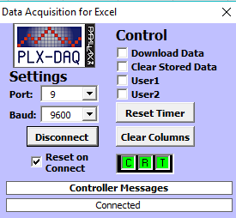

**Figure 10: PLX-DAQ Softwar**

**Chapter 5**

**DIAGRAM AND SETUP**

**Block Diagram:**



**Power Supply**



**Arduino Mega Microcontroller**



**Ultrasonic Sensor**



**Pulse oximeter Sensor**



**16x2 LCD**



**Solenoid Valve**

This system will help us to authenticate a personal identity through their fingerprint input. Our system has four push buttons for the functions ‘enroll’, ‘Delete/Okay’, and ‘Up/Down’The ‘enroll’ and ‘delete’ button has triple features. We will discuss these features first. When the user presses ‘enroll’, the LCD will ask for ID, and the user can then store their fingerprint image. In this way, they will be enrolled in the system. Enroll key also behaves as ‘BACK’ key and is also used to download attendance data using the LCD. ‘Delete/Okay’ also has dual functions. The user usually will select finger ID by the help of Up/Down buttons and use ‘Delete/OK’ to proceed with selected ID. (Here it is used as an Okay button. It behaves as a Delete button when used for resetting)



**Biometric Sensor**

### Circuit Diagram:

Now we will describe the circuit we will be using for this project. The circuit is actually quite simple. It consists of Arduino, pushes buttons (their functions have been discussed before), a buzzer for alerts, LEDs for indication and an LCD for showing instructions and messages.

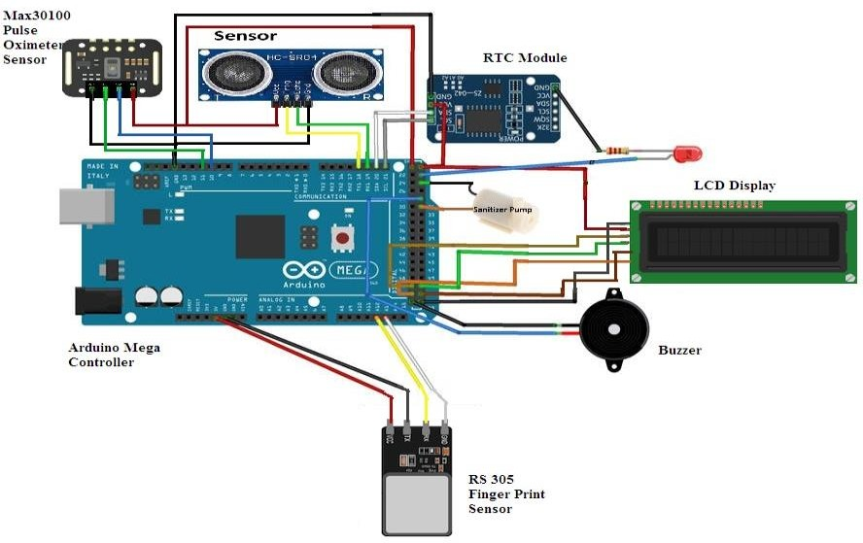

### Figure 11: Circuit Diagram

We have connected a push button to the pin A0 (Enroll), A1 (Delete), A2 (Up), and A3 (Down), of the Arduino. The Yellow LED is connected to the pin D7 of Arduino with a 1k resistor. The fingerprint modules Rx and Tx are directly connected to pins D2 and D3 of Arduino. A 5V power supply is provided to the fingerprint module through Arduino board. The buzzer is connected to pin A5. We use a 16×2 LCD by connecting its RS, EN, D4, D5, D6, and D7 to Arduino at digital pins D13, D12, D11, D10, D9, and

## Chapter 7

## RESULT

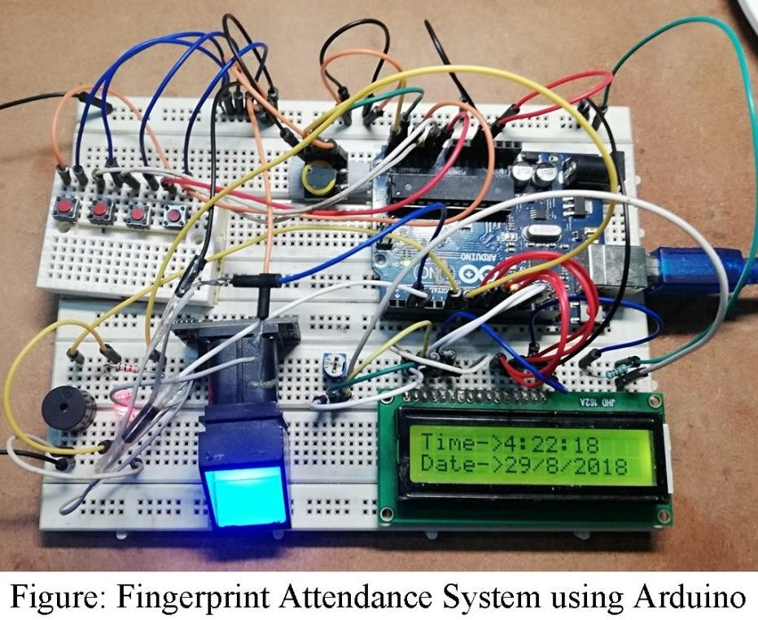

**Figure 13: Developed System**

Chapter 9

CONCLUSION AND FUTURE SCOPE

### Conclusion & Future Scope:

Biometric systems have replaced the manual and unreliable systems by presenting reliable, secured, fast and efficient system. This paper consists of one of those systems. Fingerprint based attendance system will help to detect the presence of student and employees in schools, colleges and offices etc. It is user friendly and reliable and most of all it displays the time and date to check whether the user is on time or late. It also displays ID numbers on excel sheet.

This Excel sheet can be saved and is used to calculate the attendance of the User. Hence, a system with expected results has been developed but there is still need for improvement. Further enhancing the system the designed system can be interfaced with camera and GSM module through which we will be able to send SMS to the parents/security persons/concerned staff so as to take care of the attendance if any false entry is made or when recognized by unauthorized user. This enables the added advantage to the person concerned/in-charge for monitoring attendance of students/employees. Through this the institute/organization is all time ready with the record of attendance of all the students/employees anytime.

**Chapter 10**

**References**

1. Guide to implementation of the WHO multimodal hand hygiene improvement strategy.Available from:http://www.who.int/patientsafety/en/ , accessed on August 24, 2010.

2. WHO Guidelines on Hand Hygiene in Health Care. First Global Patient Safety Challenge. Clean Care is Safer Care. Available from: http://www.who.int/patientsafety/en/ , accessed on August 24, 2010.

3. Boyce JM, Pittet D. Guideline for Hand Hygiene in Health-Care Settings. Recommendations of the Healthcare Infection Control Practices Advisory Committee and the HICPAC/SHEA/APIC/IDSA Hand Hygiene Task Force. PubMed, Google Scholar, Morb Mortal Wkly Rep. 2002;51:1–44.

4. Kampf G, Kramer A. Epidemiologic background of Hand Hygiene and evaluation of the most important agents for scrubs and rubs. Clin Microbiol Rev. 2004;17:863–93.

5. Mohamed Basheer K P, Raghu C V, “Fingerprint Attendance System for classroom needs”, NIT Calicut, Kerala, 2012.

6. D. Acharya and A. K. Mishra, “Wireless Fingerprint based Student Attendance system”, National Institute of Technology Rourkela, http://ethesis.nitrkl.ac.in/1765/

7. M. Kamaraju, P. A. Kumar, B. A. Krishna and B Rajasekhar, “Embedded Fingerprint Recognition System”, Recent Researches in Telecommunications, Informatics, Electronics and Signal Processing, 2013.

8. Mohamed Basheer K P, Raghu C V, “Fingerprint Attendance System for classroom needs”, NIT Calicut, Kerala, 2012.