**A REVIEW ON IMPLEMEMTATION OF 5S IN INDIAN CULTURE DURING DIWALI FESTIVAL**

**Prof. L.B.Diwakar**

***Faculty in Mech.Engg.Dept.S.E.S.Polytechic,Solapur,Maharashtra,India***

***Mail-lbdiwakar@gmail.com***

**ABSTRACT**

5S is a systematic technique used by organizations, and this comes from five Japanese words: seiri (sort), seiton (set in order), seiso (shine), seiketsu (standardize), and shitsuke (sustain). This system helps to organize a workplace for increasing efficiency and decrease wasting and optimize quality and productivity via monitoring an organized environment. There is a real need for the studies in field of new management systems and their impact on company’s performance. Aim of this paper is to identify the implementation of 5s in indian culture. The target festival considered for this review is selected Dipawali. The results obtained from this study shows that the 5s system was implemented in indian culture long way back.

**Key words** :- cleanliness, festivals, celebration, Efficiency

**1.INTRODUCTION**

5S is an approach that can be easily applied in all organizations. Its simplicity and easy recognition are the superior side of 5S. The 5S are prerequisites for any improvement program. As waste is potential gain, so eliminating waste is a gain. 5S Philosophy focuses on effective work place organization, simplifies work environment, reduces waste while improving quality and safety.

**Definition of 5S**

The 5S is the methodology of creation and maintaining well organized, clean, high effective and high quality workplace.

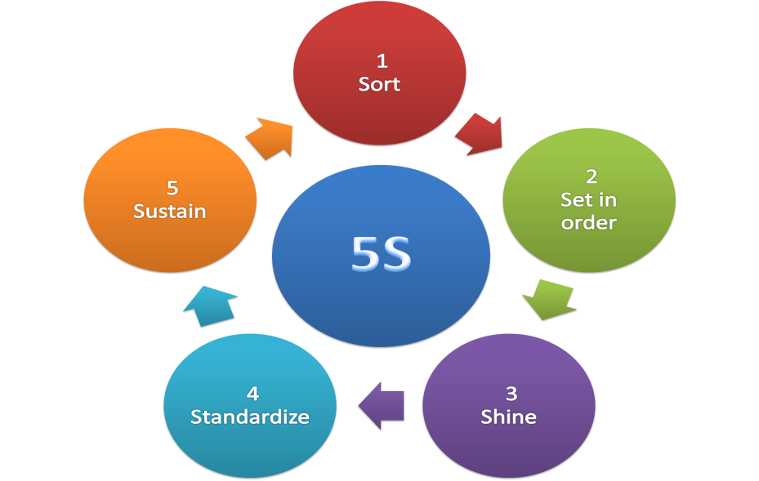

**2.Literature Review**

5S is the name of a workplace organization method that uses a list of five Japanese words:

1. **Sorting (Seiri)**

Eliminate all unnecessary tools, parts, and instructions. Go through all tools, materials, and so forth in the plant and work area. Keep only essential items and eliminate what is not required, prioritizing things per requirements and keeping them in easilyaccessible places. Everything else is stored or discarded.

**2. Set in Order (Seiton)**

There should be a place for everything and everything should be in its place. The place for each item should be clearly indicated.

Items should be arranged in a manner that promotes efficient work flow, with equipment used most often being the most easily accessible. Workers should not have to bend repetitively to access materials. Each tool, part, supply, or piece of equipment should be kept close to where it will be used – in other words, straightening the flow path. Seiton is one of the features that distinguish 5S from "standardized clean up". This phase can also be referred to as Simplifying.

**3. Shine (Seiso)**

Clean the workspace and all equipment, and keep it clean, tidy and organized. At the end of each shift, clean the work area and be sure everything is restored to its place. This makes it easy to know what goes where and ensures that everything is where it belongs. Spills, leaks, and other messes also then become a visual signal for equipment or process steps that need attention. A key point is that maintaining cleanliness should be part of the daily work – not an occasional activity initiated when things get too messy.

**4. Standardizing (Seiketsu)**

Work practices should be consistent and standardized. All work stations for a particular job should be identical. All employees doing the same job should be able to work in any station with the same tools that are in the same location in every station. Everyone should know exactly what his or her responsibilities are for adhering to the first 3 S's.

**5. Sustaining the Practice or Self Discipline (Shitsuke)**

Maintain and review standards. Once the previous 4 S's have been established, they become the new way to operate. Maintain focus on this new way and do not allow a gradual decline back to the old ways. While thinking about the new way, also be thinking about yet better ways. When an issue arises such as a suggested improvement, a new way of working, a new tool or a new output requirement, review the first 4 S's and make changes as appropriate

**Simplified approach for 5S**

|  |  |  |  |
| --- | --- | --- | --- |
| **5S PRINCIPLE** | **CONCEPT** | **PRACTICE** | **SIMPLIFIED APPROACH** |
| Sort | Clear out | Setting the Standards | Difference between necessary and  Unnecessary |
| Set in order | Configure | Place for everything and everything in its  place |
| Shine | Clean & Check | Cleaning with Meaning |
| Standardizing | Confirmity | Maintaining the Standard | Standardizing the practices of 1S, 2S and  3S |
| Sustain | Custom & Practice | Self-Discipline for sustaining the practices |

**3.Need for the Study**

The method of 5S is one way to engage people and contribute to culture change in the organization. 5S is a method used to build a strong cultural foundation and rapidly enhance product flow while improving quality and reducing total lead time of the product. The concept of 5s is already been implemented by our ancistors especially during the festival session. The study identifies a method to check the cultural change process as a way of living in the residential practices and integrate them with 5S principles for easy communication and implementation in the organization

**Objective of the Study**

1. To understand the 5S philosophy and rules
2. To identify the 5S philosophy in the Indian residential practice

**4.Methodology**

**Step-1**

|  |  |
| --- | --- |
| **First step in 5s** | **Previous day of Diwali Festival** |
| Sort the materials around your work place based on when you need  •If you don’t need and if you think it may be needed for someone send it to Red tag area  •Scrap the materials that’s not needed | Unwanted materials from home are moved out  •Display the unwanted materials to common place like road or open dustbins.  •If no one likes to have end of the day incinerate and dispose |

**Step-2**

|  |  |
| --- | --- |
| **Second Step of 5S** | **Previous day of Diwalil** |
| After completion of step 1 we will have only needed materials  •Arrange them neatly  •Retrievable based on the frequency of need | Wanted materials in home cleaned & painted  •There use to be different storage location like various clothes where occasionally needed will be stored at easily accessable place. |

**Step-3**

|  |  |
| --- | --- |
| **Third Step of 5S** | **Previous day of Diwali** |
| Cleaned the stored materials and inspect for defects  •If any fault or damage observed take necessary action | Arranging the good utensils or needed utensils are done after cleaning and careful inspection  •This avoids the muda |

**Step-4**

|  |  |
| --- | --- |
| **Fourth Step of 5S** | **Previous evening of Diwali** |
| Layouts and standards are developed , so that what ever done in 1s, 2s and 3s doesn't get spoiled by others like new recruits, labors etc. | This is what we do after cleaning of our home by painting foot prints by rangolli with rice paste paints of heavy items like furniture's, worship place and kitchen |

**Step-5**

|  |  |
| --- | --- |
| **Fifth Step of 5S** | **Weekly in Indian home** |
| Audit least weekly whether whatever done in the previous steps and standardized are maintained or practiced | This is done in Indian homes every week mostly on sunday a small thorough cleaning, floor washing, dusting etc., along with a prayer.. And parents trains their son or daughter on this practice |

**Obstacles in 5S implementation**

1**.** Lack of awareness

2. Lack of knowledge

3. Limited available space.

4. Limited work force available.

5. Availibility of Manpower.

**5.Benefits of 5S implementation**

5S technique is precious for every organisation since it facilitates realisation of motivating and safe working environment for all employees in the organisation. It requires top management commitment, promotional campaign, employee training, team working environment, evaluation of the results and maintaining the 5S records

When we compare it with cultural aspects & indian tradition it is observed that the atmosphere changes in the house which brings a hygienic touch to the house. This also improves the physical & mental health of each & every member in the house. This helps to celebrate our festivals with full of joy & pleasure.

**6.Concluding Remarks**

The purpose of this study is to examine the implementation of 5S in indian culture during festival season. This study clearly provides step-by-step 5S methodologies reported in systematic comparison of each and every step in 5s. The paper highlights the success factors and obstacles of 5S implementation during festival s in india. The implementation of 5s can definitely improve healthy atmosphere in the hose which helps in celebrating any festival.

**References**

Gupta, s. A. (2015). ‘an application of 5s concept to organize the workplace at a scientific instruments manufacturing company’. International journal of lean six sigma,, vol. 6, no. 1, pp.73–78.

Ho, s. C. (1995). ‘the japanese 5-s practice and tqm training’,. Training for quality,, vol. 3, no 4, pp.19–24.

Howell, v. (2009). ‘5s for success’,ceramic industry,. Vol. 159, no. 7, pp.17–20.

Hunglin, c. (2015). 5s implementation in wan cheng industry manufacturing factory in taiwan. Partial fulfillment of the requirements for the master of science degree in technology management., 45.

K.r. Dushyanth kumar1, d. S. (2006). ‘process efficiency improvement in small organization through lean supply chain approach’. Iosr journal of business and management (iosr-jbm), volume 18, issue 6.

K.ramesh1, v. N. (2014). ‘5s implementation studies in biomass processing unit’. International journal of innovative research in science, engineering and technology, volume 3, special issue 4.

Khanna, v. A. (2014). ‘comparative study of the impact of competency-based training on 5 s and tqm: a case study’. International journal of quality & reliability management,, vol. 31, no. 3, pp.238–260.

Lokunarangodage c.v.k. ®, w. 1. (2015). Effectiveness o f 5s application in tea industry and synchronization o f 5s into iso 22000:2005. Journal of tea science research., vol. 5, no. 6,1-14.

Mariano jiménez a, l. R. (2015). ‘5s methodology implementation in the laboratories of an industrial engineering university school’. Safety science, 163–172.

Pasale, r. A. (20132). ‘5s strategy for productivity improvement: a case study’,. Indian journal of research, vol. 2, no. 3, pp.151–153.

Patel, v. A. (2014). ‘review on implementation of 5s in various organization’,. International journal of engineering research and applications,, vol. 4, no. 3, pp.774–779.