**Anjuman College of engineering and Technology Sadar, Nagpur440001**

**TITLE:** Live Project on “Productivity Improvement at Accurate Engineering company PVT.LTD by Application of Lean Management Techniques – Poka- Yoke and Kaizen.”

**AUTHORS: 1*.*** *Prof. HUZAIFA. A. FIDVI* **2***.Omkar Rangari* **3*.*** *Shudanshu Kowache*

* **ABSTRACT:** Absolutely, the evolution of lean manufacturing has been driven by the need for organizations to adapt to changing business environments and remain competitive. Originally developed to maximize resource utilization by minimizing waste, lean principles have since been refined to address the challenges and complexities of today's rapidly changing landscape.
* In a world where businesses face constant fluctuations and fierce competition, the ability to systematically and continuously respond to these changes is crucial for survival. This is where the concept of adding value becomes paramount. By focusing on value-adding processes and eliminating non-value-adding activities, organizations can streamline their operations, enhance product value, and ultimately improve their competitiveness.
* Implementing a lean manufacturing system has indeed become a core competency for organizations across various industries, whether they are in manufacturing or service-oriented sectors. By embracing lean principles and practices, businesses can achieve greater efficiency, flexibility, and sustainability, thus positioning themselves for long-term success in an ever-evolving marketplace.
* **INTRODUCTION :** That's an impressive legacy for Accurate Engineering Company Pvt. Ltd. It's remarkable how the company has evolved and established itself as a prominent brand in dimensional metrology over the span of 58 years. Mr. Vilasrao Salunke's vision and pioneering efforts must have played a significant role in shaping the company's journey. With a focus on manufacturing measuring instruments and gauges, coupled with a commitment to quality and customer satisfaction, it's no wonder Accurate Engineering Company has become synonymous with dimensional quality control in the engineering industry in India. It's a testament to the dedication and expertise of everyone involved in the company's operations over the years.

**Lean management**

Lean management emphasizes the importance of respecting and empowering employees and encourages the development of a culture of problem-solving and continuous improvement. The two pivotal Lean pillars are indeed respect for people and a mindset of continuous improvement.

Lean management is based in five principal

1. Defining Value,
2. Mapping the Value Stream,

3) Creating Flow,

1. Using a Pull System,
2. Pursuing Perfection

What is Kaizen?

Kaizen is an approach to creating continuous improvement based on the idea that small, ongoing positive changes can reap significant improvements. Typically, it is based on cooperation and commitment and stands in contrast to approaches that use radical or top-down changes to achieve transformation. Kaizen is core to [lean manufacturing](https://www.techtarget.com/searcherp/definition/lean-production) and [the Toyota Way](https://www.techtarget.com/whatis/definition/Toyota-Way). It was developed in the manufacturing sector to lower defects, eliminate waste, boost productivity, encourage worker purpose and accountability and promote innovation.

JISHU HOZEN

Jishu Hozen is a Japanese word, when translated to English it means autonomous maintenance. “Jishu” loosely stands for independence or autonomy, while “Hozen” means preservation, integrity or conservation. Jishu Hozen is one of the eight pillars of Total Productive Maintenance.

Definition of Kobetsu Kaizen

Kobetsu Kaizen is a Japanese term that translates to “focused improvement.” It is a continuous improvement approach that involves making small, incremental changes to specific processes or machines in a manufacturing plant to achieve sustainable improvements in productivity, quality, and efficiency.

**MACHINE NO : 01**

**Power Source: Electric Motor 80 Ton C Frame Power Press Machine**

Capacity 80 Ton

Usage/Application Industrial

Power Source Electric Motor

Automation Grade Manual

Type Of Press C-Frame Press

C-Frame Power Press, capacity 80 Tons.Highly durable machine perfect for hich production.

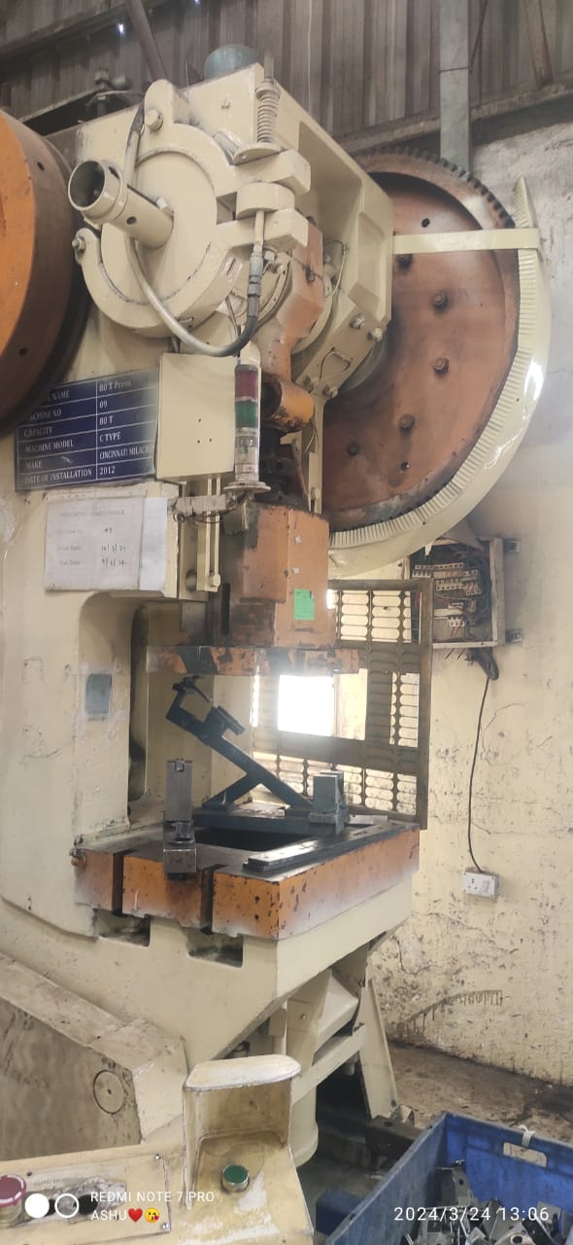

PROBLEMS :

1. main motor line broken:

Protecting against overvoltage and overload is critical for maintaining the integrity and functionality of equipment in a robotic weld cell:

1. Overvoltage Protection: Install surge protection devices to safeguard against damage caused by voltage surges. These devices are designed to divert excess voltage away from sensitive components, preventing electrical failures and potential downtime.

2. Overload Protection: Implement overload protection systems to safeguard motors and other components from excessive mechanical loads. These systems monitor voltage and current levels, automatically shutting down or adjusting operations if predefined thresholds are exceeded. Regularly check voltage and current levels for signs of electrical overload, and consider recent process changes that may contribute to mechanical overload.

1. pressure relay not work:

To ensure the optimal performance and longevity of the relay in a robotic weld cell, follow these best practices:

1. Secure Mounting: Install the relay securely and away from areas prone to shock or vibration to minimize mechanical stress.

2. Regular Maintenance: Adhere to the manufacturer's guidelines for cleaning, adjusting, and lubricating the relay to prevent degradation over time.

3. Lifecycle Considerations: Monitor the relay's lifespan and consider replacing it if it's approaching the end of its service life to prevent unexpected failures.

4. Prevent Contamination: Keep the relay free from contaminants, as they can cause premature failures. Regular cleaning and inspection can help mitigate this risk.

5. Proper Usage: Use the relay within its specified load capacity and avoid dropping or disassembling it, which can lead to damage.

6. Wiring Inspection: Regularly check the control circuit to ensure it provides the correct voltage, current, and proper wiring connections to the relay.

7. Relay Coil Verification: Verify that the relay coil receives the appropriate voltage to ensure proper functioning.

SOLUTION:

1. Main motor line maintenance shoud be done periodically.

2 .Adjusting air pressure.

* CONCLUSION:

Absolutely, you've highlighted some key benefits of applying Lean management principles within an organization. Let's break down some of these benefits:

Improved Flexibility and Quality of Operations: Lean management focuses on streamlining processes and eliminating waste, which enhances the organization's ability to adapt to changes in demand and market conditions while also improving the quality of products or services.

1. Reduction of Inventory: By implementing Lean practices such as Just-in-Time (JIT) inventory management, organizations can minimize excess inventory levels, reduce storage costs, and improve cash flow.
2. Enhanced Process Functionality: Lean methodologies help identify and eliminate inefficiencies in processes, leading to smoother operations and improved overall performance.
3. Elimination of Non-Value-Adding Activities: Lean management targets activities that do not contribute to value creation and aims to eliminate or reduce them, thereby optimizing resources and improving efficiency.
4. Better Utilization of Human Resources: Lean principles empower employees to contribute ideas for process improvement, leading to increased engagement, productivity, and job satisfaction.
5. Improved Organization of Work: By standardizing processes and creating visual management systems, Lean management helps organize work in a way that is more efficient and easier to understand, reducing errors and delays.
6. Increased Customer Satisfaction: Ultimately, by delivering higher quality products or services, with shorter lead times and greater responsiveness to customer needs, Lean management contributes to increased customer satisfaction and loyalty.

Regarding the Kaizen method, you've rightly pointed out its effectiveness in problem-solving and continuous improvement. Kaizen, with its focus on small, incremental changes driven by both qualitative and quantitative data, is a powerful tool for addressing various challenges across different industries. Its versatility and applicability make it a valuable asset for organizations striving for continuous improvement and excellence in their operations.