**Medical Report Management and Distribution System on Blockchain**

# Bibin M Jacob1 Devika Mohan2 Shefina Shereef3 Vaishnavi Nair S V4 Stefin Thomas Pallathu5

*1,2,3,4(B.Tech in Computer Science And Engineering, St. Thomas College of Engineering & Technology,Chengannur, India)*

*5(Assistant Professor, Department of Computer Science and Engineering, St. Thomas College of Engineering & Technology, Chengannur, India)*

|  |
| --- |
| ***Abstract:****The security and effective management of health records is a key issue for today's digitized healthcare environment. In terms of data security, integrity and accessibility, traditional centralized systems face challenges. We propose a novel system of medical report management and dissemination using the Block-chain technology, as well as SHA1 encryption for addressing these issues. In order to store hashed medical reports, our system uses a decentralized block-chain network to ensure tamper-proof and immutable records. SHA1 is used to hash every medical report, generating a unique identifier that's stored on the Block-chain. The integration of Flask, Python's lightweight web framework, facilitates the creation of an easy user interface to interact with a system easily. Secure storage, effective distribution and granular control of medical reports are among the key features of our system. In order to maintain the integrity and confidentiality of data, patients, physicians or authorized persons should be able to use secure means for accessing and updating their healthcare records. The use of SHA1 increases system security by providing a reliable cryptographic hash. Our system is aimed at simplifying the management and distribution of medical reports, thereby improving efficiency and patient outcomes in addition to enhanced data protection and integrity. By ensuring security, transparency and decentralized solutions, we are confident that the proposal for a medical records management system has the potential to revolutionize this area.*  ***Key Words****:*Blockchain *Algorithm,SHA1 Cryptographic hash function,Flask Framework.* |

1. **Introduction**

In recent years, the healthcare industry has seen a paradigm shift towards digitization, with electronic health records EHRs becoming the standard for the management of patient information. However, significant challenges related to data security, integrity and availability are presented by the centralized nature of traditional electronic health records systems. As patient information continues to grow in volume and complexity, innovative solutions are needed to address these challenges and guarantee the confidentiality and integrity of medical records. The use of Block-chain technology, which had its origins in cryptocurrencies like bitcoin, has proved to be a promising solution for enhancing the security and reliability of electronic transactions. By leveraging the decentralized and immutable nature of block-chain networks, healthcare organizations can revolutionize the way medical records are managed and distributed.n this context, we propose a Medical Report Management and Distribution System that utilizes block-chain technology, specifically integrating the SHA-1 cryptographic hash function, and implemented with Flask, a lightweight web framework for Python. The system is intended to ensure a secure, transparent and effective platform for the storage, access or update of medical records while safeguarding data integrity and patient privacy. The technical architecture, design principles and implementation details of the proposed system are examined in this paper. We will discuss the role played by technology to ensure tamper-proof and unaltered records, use of SHA Block-chains for cryptographic hashing in order to improve data security or integration of Flask into a user friendly interface1.In addition,we are highlighting the possible benefits of our system in terms of improved efficiency, increased safety and better health outcomes for patients. In this research, we shall aim at contributing to the continued effort to modernize healthcare information systems and address changing needs of patients, health care professionals and regulatory bodies in an ever more digitized world.

**II. System Design**

The proposed a system to manage and distribute medical reports in order to facilitate the secure and efficient management of health records, taking into account the needs of administrative staff, receptionists, doctors and patients. This system uses block-chain technology, SHA1 cryptographic hashing algorithms and the Flask framework to ensure the integrity, availability and confidentiality of data. The following overview of the system's functions is provided:

An authentication module for verifying the identity of users logging in is included in this system. Administrative staff shall have the privilege of recruiting and administering doctors and receptionists. A receptionist can register new patients in the system. For his or her patients, the doctor shall be authorized to submit a medical report. Each report is hashed using the SHA1 algorithm, which generates its own unique value.Storage of data on the Block-chain: On a distributed Block-chain network, hashes of healthcare reports are kept. Block-chain is designed to increase data security and integrity by providing a tamper-proof, indefinite storage of medical records. The Admin User Interface allows you to add and manage physicians and receptionists. It provides administrators with oversight of the system's activities and user administration. A list of the patients assigned to you can be viewed by your doctor through the Doctor Interface. They allows for the uploading of individual patient's medical reports. The Receptionist Interface enables staff to register new patients in the system. They provides a way for receptionists to update the patients' information if necessary. To access your medical records, patients can log in securely. Access to reports is granted by the specific hash values that are generated for each report. Based on the user role and permissions, access to medical records is strictly controlled. Only the corresponding hash values will allow patients to view their own medical reports. This ensures the protection of patients' privacy and compliance with data protection rules. In order to improve the usability and accessibility of this system, it has been developed with a user friendly interface.

1. **Diagram**

A number of key components, including the block chain network, user interface,and encryption mechanisms, are included in the proposed system architecture. In order to ensure data integrity and security, the block chain network is an essential infrastructure for storing and managing medical reports.In order to protect sensitive medical information and to comply with the privacy rules, encryption mechanisms have been put in place. The user interface provides stakeholders, including doctors, patients and hospital administrators, with a comfortable platform for interacting with the system. This enables seamless access to medical reports, scheduling of appointments and data sharing functionalities.

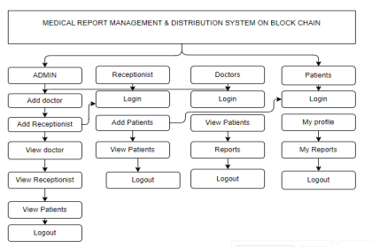

**Figure 1 :** Flowchart of the System

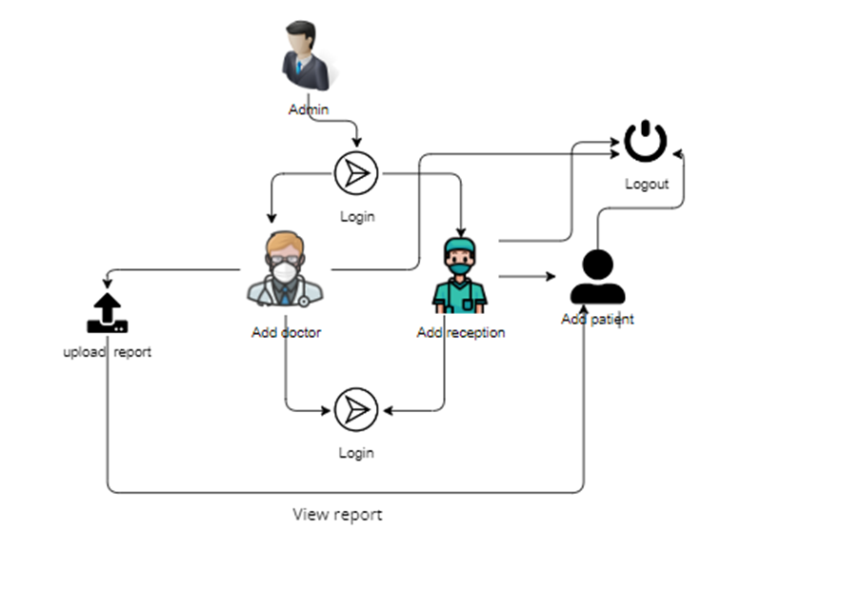

**Figure 2 :** Data-flow Diagram

**2.Working**

A comfortable platform for interaction with the system is provided by the user interface for interested parties, including doctors, patients and hospital administrators. This will allow users to access medical reports, schedule appointments and share data with one another. The administrator has specific privileges that allow him to use features such as the addition of doctors, added receptionists, view physicians' records and see their contact details.A dedicated administrative login portal is usually used to do this. Receptionists will be able to carry out tasks, such as the addition of new patients and view existing patient data when they log on. They're given access to the functions of care management. The physician has access to the patient's specific functionalities. Patients' details and medical reports can be viewed and uploaded by them to the patients they are assigned. Patients are given access to their own medical records. They will be able to read their reports securely when they log in. There is a database section in the system, which can be accessed by an administrator. The administrator can see login and logout times for all users, physicians, patients or receptionists, as well as other details in this section. An audit trail of user activities in the system is contained in this database. In order to guarantee that users can only use functionalities which are suitable for their roles, the system uses a role based Access Control mechanism. In addition, only authorized users are allowed to store and access sensitive data such as patient medical records. The system is based on the Flask web framework, which is a Python web framework. Web applications with features such as routing, template creation and handling of requests are supported by Flask. The description does not explicitly refer to the integration of the block-chain, although the system is mentioned to use SHA1 for hashing. However, more detailed information on the implementation of the block-chain would be needed if the system is to use the technology for additional security and transparency.In general, the system offers a comprehensive solution to manage medical reports and patient information for healthcare professionals as well as patients in an environment of safe access and effective management.

**IV.Result and Analysis**

**Enhanced Data Security:**The use of block-chain technology, coupled with the SHA-1 encryption algorithm, ensures that medical reports are securely stored and tamper-proof. The system uses block-chain's decentralized nature for the distribution of health records across several nodes in the network to encrypt patients' data prior to their storage on the block-chain, giving them an additional layer of protection from unauthorized access and breach.

**Decentralized Data Management:**This decentralized approach mitigates the risk of a failure at one point and increases data resilience, ensuring that health reports are available in case of network failures or attack. As a transparent and immutable transaction on the block-chain, any interaction with the system, such as uploading a medical report or accessing a patient's records, is recorded.

**Transparent and Auditable Transactions:**These transactions may be audited by healthcare professionals, patients and other authorized persons for the purpose of verifying the integrity and authenticity of health information. The use of the Block-chain technology makes it easier for healthcare providers and systems to share and interoperability data.

**Improved Data Sharing and Interoperability:**Patients are given greater control over their medical records, which will allow them to be shared with healthcare professionals in a secure manner and thus promote collaboration and continuity of care.

**Efficient Report Distribution:**This system provides a secure and efficient platform for sharing sensitive information in order to simplify the distribution of medical reports. In order to eliminate the need for physical copies and to reduce administrative costs, patients can access their reports remotely and securely share them with healthcare providers.

**Security and privacy issues have been addressed:** The system will address security and privacy concerns related to the management and dissemination of medical reports in an efficient way, thanks to the integration of cryptocurrencies and encryption techniques. In order to ensure confidentiality and compliance with data protection regulations, patients' personal information is encrypted, decentralized and kept in a tamper-proof way.

**Increased Patient Empowerment:** Patients are empowered to take control of their medical records and make more informed decisions on health care. Patients will be better able to understand their medical history, monitor their health status and work with healthcare professionals to develop personalized treatment plans with secure access to their reports.

In terms of data security, transparency and patient empowerment, the medical report management and distribution system based on the block-chain framework offers significant advantages. However, in order to realize the full potential of block-chain technology for healthcare, it is necessary to address scalability, interoperability and regulatory compliance issues.

**IV.Conclusion**

Finally, a significant advance in healthcare technology is the medical report management and distribution system based on the block-chain. The system offers many benefits to patients, healthcare providers and other stakeholders because of the inherent characteristics of block-chains such as security, transparency and decentralization. The system addresses longstanding concerns about data security and privacy by integrating encryption algorithms such as SHA1 to ensure the secure storage of medical reports, which is tamper proof and can be audited. This enhanced security framework does not only protect sensitive patient information, but also strengthens trust and confidence in the healthcare ecosystem. In addition, the decentralized nature of block-chain facilitates a seamless exchange of information and interoperability between different healthcare systems, improves cooperation and continuity of care. Patients are given more control over their health records, enabling them to take an active part in the healthcare process and make sound choices. Overall, it is a trans-formative shift in the healthcare ecosystem towards safer, more efficient and patient centered health systems that has taken place with the medical report management and distribution system under the block-chain framework. As the technology continues to evolve, it holds the promise of revolutionizing healthcare delivery and improving patient outcomes on a global scale.

**V.Acknowledgment**

We express our special gratitude to **Dr. SHYJITH M B ,** Head of the Department of Computer Science and Engineering for providing us constant guidance and encouragement throughout the Project preliminary work.

We express our sincere gratitude to the Project Supervisor **Mr. JAISON MATHEW JOHN,** Assistant Professor, Department of Computer Science and Engineering for the inspiration and timely suggestions.

We also express sincere gratitude to our guide **Ms. STEFIN THOMAS PALLATHU,** Assistant Professor , Department of Computer Science and Engineering for her guidance and support . We have to appreciate the guidance given by the panel members during the Project Preliminary presentations, thanks to their comments and advice. Last but not the least we place a deep sense of gratitude to our family members and friends who have been constant sources of inspiration during the preparation of the Project Preliminary works.

**References**

1. S. Tanwar, K. Paresh and R. Evans, "Block chain-based electronic healthcare record system for healthcare 4.0 applications", Journal of Information Security and Applications, vol. 50, no. 102407, February 2020.

2 .Y. Hassanzadeh-Nazarabadi, N. Nayal, S. S. Hamdan, O. Ozkasap and A. Küpçü, "A containerized proof-of-concept implementation of LightChain system", 2020 IEEE International Conference on Block-chain and Cryptocurrency (ICBC), pp. 1-2, 2020.

3. T. Jiang, H. Fang and H. Wang, "Block chain-Based Internet of Vehicles: Distributed Network Architecture and Performance Analysis", IEEE Internet of Things Journal, vol. 6, no. 3, pp. 4640-4649, June 2019.

4. B. Narendra, Kumar Rao, B. Bhaskar, Kumar Rao and Vellingiri J, "Block-chain Based Implementation of Electronic Medical Health Record", Journal International Journal of Innovative Technology and Exploring Engineering (IJITEE), vol. 8, no. 8, June 2019.

5. M. Kassab, J. DeFranco, T. Malas, V. V. Graciano Neto and G. Destefanis, "Block-chain: A Panacea for Electronic Health Records?", 2019 IEEE/ACM 1st International Workshop on Software Engineering for Healthcare (SEH), pp. 21-24, 2019.

6. M. Kassab, J. DeFranco, T. Malas, V. V. Graciano Neto and G. Destefanis, "Block-chain: A Panacea for Electronic Health Records?", 2019 IEEE/ACM 1st International Workshop on Software Engineering for Healthcare (SEH), pp. 21-24, 2019.

7. Patel Vishal, "A framework for secure and decentralized sharing of medical imaging data via block-chain consensus", Health Informatics Journal, vol. 25, no. 146045821876969, 2018.

8. J. Vora et al., "BHEEM: A Block chain-Based Framework for Securing Electronic Health Records", 2018 IEEE Globecom Workshops (GC Wkshps), pp. 1-6, 2018.

9. A. Azaria, A. Ekblaw, T. Vieira and A. Lippman, "MedRec: Using Block-chain for Medical Data Access and Permission Management", 2016 2nd International Conference on Op en and Big Data (OBD), pp. 25-30, 2016.

10. M. Mettler, "Blockchain technology in healthcare: The revolution starts here", 2016 IEEE 18th International Conference on e-Health Networking Applications and Services (Healthcom), pp. 1-3, 2016.

11. Health Information and the Law, “Who owns medial records: 50 state comparison,” 2015.

12. The Office of the Nat. Coordinator for Health Information Technology, “Report on health information blocking,” U.S. Department of HHS, Tech. Rep., 2015.

13. U.S. Department of HHS, “Individuals’ right under hipaa to access their health information,” 2015.

14. M. McGinnis et al., Clinical Data as the Basic Staple of Health Learning: Creating and Protecting a Public Good. National Academies Press, 2010.

15. K. D. Mandl et al., “Public standards and patients’ control: how to keep electronic medical records accessible but private,” BMJ, vol. 322, no. 7281, pp. 283–287, 2010.