**Report: Plant Disease Detection System Using Deep Learning**

### ****1. Introduction****

Plant diseases pose a significant threat to agricultural productivity and global food security. Traditional methods of disease identification rely heavily on expert knowledge and manual inspection, which are often time-consuming and inefficient. To address these challenges, this project leverages advanced deep learning techniques, specifically Convolutional Neural Networks (CNNs), to develop an automated system for accurate and efficient plant disease detection. The system provides a real-time, web-based interface to assist farmers and agricultural specialists in diagnosing plant health issues promptly, thereby enabling timely interventions.

### ****2. System Overview****

The system is designed to classify plant diseases using a pre-trained CNN model. Key features include:

* **User-Friendly Interface**: A web-based application built using Streamlit, allowing users to upload images of plant leaves for analysis.
* **Deep Learning Model**: A CNN model trained to classify diseases in plants such as tomatoes, potatoes, and corn.
* **Real-Time Prediction**: The system processes uploaded images and provides immediate diagnostic results.

### ****3. Implementation Details****

#### ****3.1 Libraries and Tools****

The system utilizes the following libraries:

* **Streamlit**: For creating the interactive web interface.
* **OpenCV (cv2)**: For image processing tasks such as resizing and conversion.
* **TensorFlow and Keras**: For loading and deploying the pre-trained CNN model.
* **NumPy**: For handling numerical operations and array manipulations.

#### ****3.2 Workflow****

1. **Image Upload**: Users upload an image of a plant leaf through the Streamlit interface.
2. **Image Preprocessing**: The uploaded image is converted into a format compatible with OpenCV. The image is resized to the dimensions required by the model (256x256 pixels).
3. **Model Prediction**: The preprocessed image is passed to the CNN model for classification.

The model outputs the predicted disease class.

1. **Result Display**: The system displays the predicted disease along with the uploaded image for visual confirmation.

#### ****3.3 Class Labels****

The system is trained to recognize the following diseases:

* **Tomato**: Bacterial spot
* **Potato**: Early blight
* **Corn**: Common rust

#### ****3.4 Example Output****

When a user uploads an image, the system processes it and generates a result in the format:  
"This is [Plant Name] leaf with [Disease Name]."  
For example: "This is Tomato leaf with Bacterial spot."

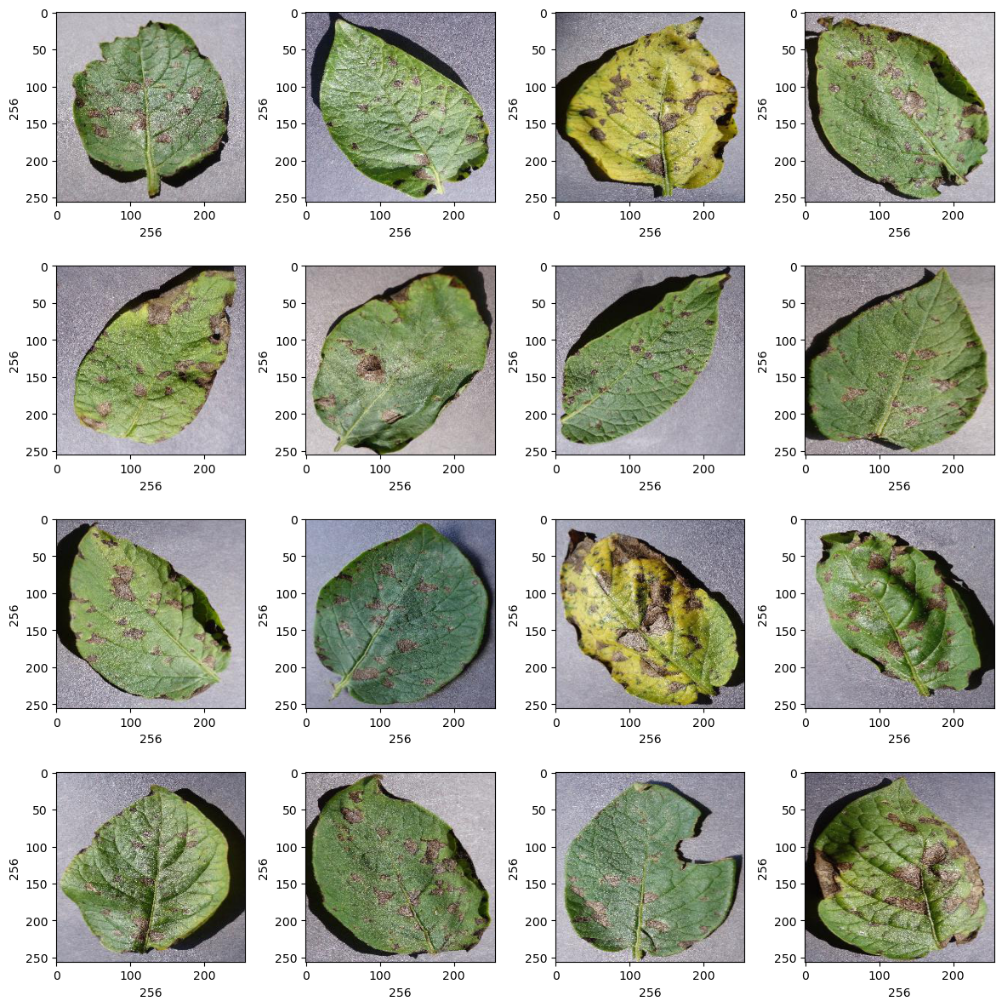

Base Coding :

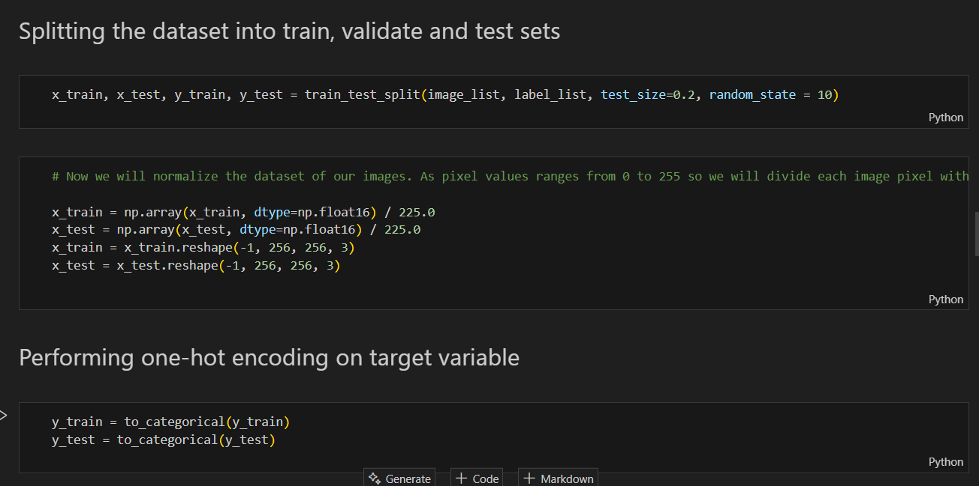

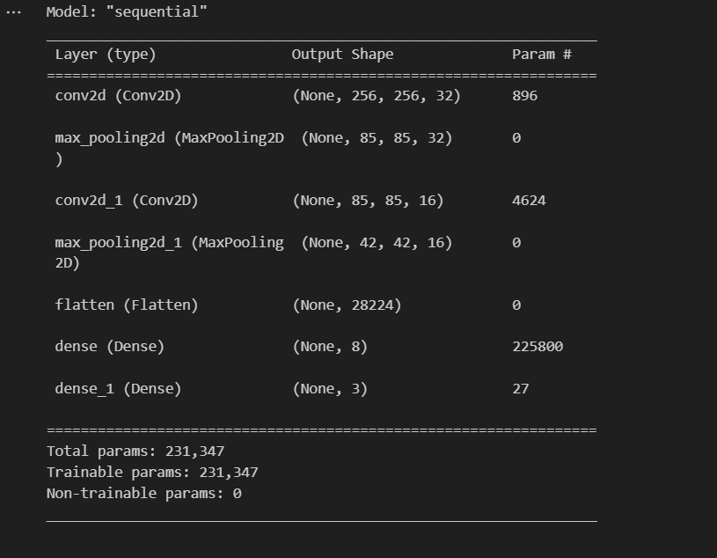

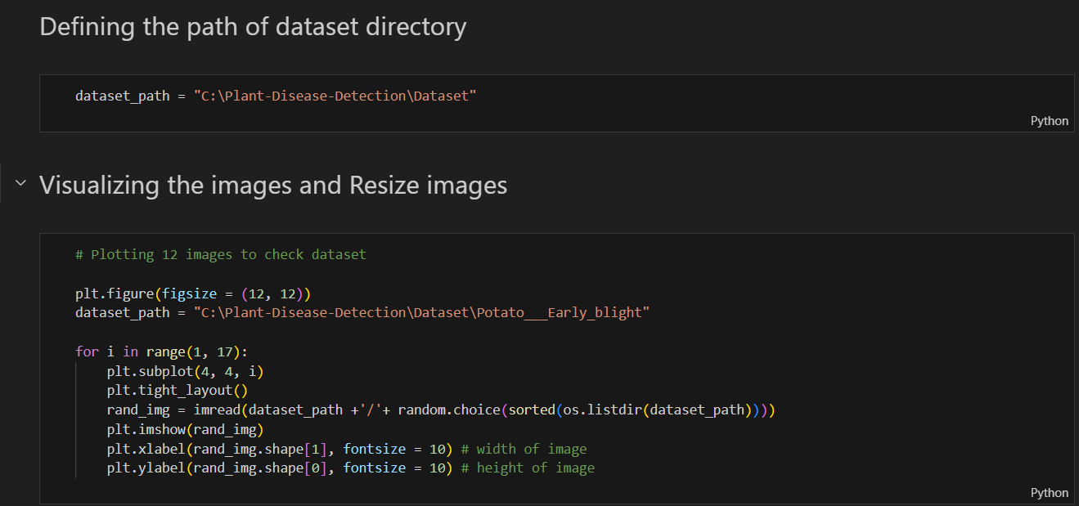

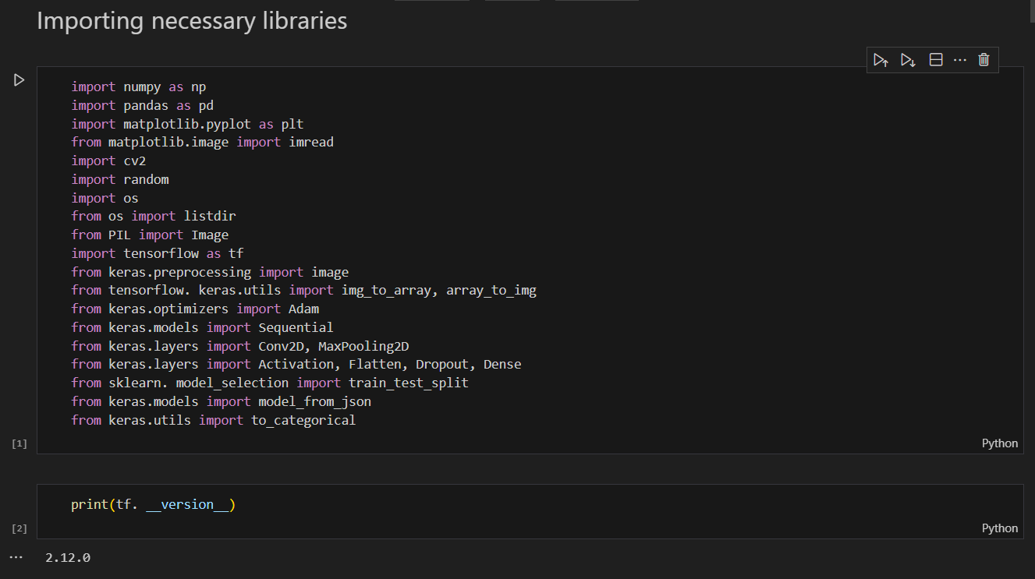

### ****4. Key Features****

* **Efficiency**: Automates the disease detection process, reducing reliance on manual inspection.
* **Accessibility**: Provides a simple, web-based interface accessible to farmers and non-experts.
* **Scalability**: The model can be expanded to include more plant species and diseases with additional training data.

### ****5. Conclusion****

The Plant Disease Detection System demonstrates the potential of deep learning in revolutionizing agricultural practices. By offering a fast, accurate, and user-friendly solution for disease identification, the system empowers farmers to take proactive measures to protect their crops. Future enhancements could include integrating multilingual support, expanding the dataset to cover more plant species, and improving the model's accuracy through advanced techniques like transfer learning.

**Note**: The images referenced in the document (e.g., media/image1.png) are likely screenshots or diagrams of the system's interface, workflow, or sample results. These visuals would further illustrate the application's functionality and user experience.