**(SAMS) :SMART ATTENDANCE MANAGEMENT SYSTEM**

**Saurabh Singh , Sujal Jain, Suyash Shukla**

*1 (Computer Science and Engineering, Inderprastha Engineering College Ghaziabad ,India)*

*2 (Computer Science and Engineering, Inderprastha Engineering College Ghaziabad ,India)*

*3 (Computer Science and Engineering, Inderprastha Engineering College Ghaziabad ,India)*

*Mentor :**Mr Mandeep Singh Katre*( Assistance Professor ) Computer Science andEngineering

*Inderprastha Engineering College Ghaziabad ,India*

*Corresponding Author :* [*Saurabh5586singh@gmail.com*](mailto:Saurabh5586singh@gmail.com).

**Abstract :** Everything in the world we live in these days is mechanized and connected online. Machine learning, image processing, and the internet of things are all constantly developing. As a result of this evolution, several systems have undergone total modifications to produce more accurate findings. A common illustration of this shift is the attendance system, which went from the conventional signature on a paper sheet to facial recognition.   
This project suggests a technique for creating a thorough embedded system for tracking class attendance that uses facial recognition and indicates whether or not the face belongs to a student in that particular class. The system's foundation is a machine learning algorithm that will be built in Python and uses a laptop or computer camera to capture student images for input

­­­­­­­­­­­­­­**________________________________________________________**

**I INTRODUCTION**

School attendance plays a key role in determining the academic success of children and young people in schools and colleges. Regular attendance indicates that students are less likely to engage in criminal or disruptive behaviour. Chronic absenteeism increases the risk of dropping out of school and dropping out early. Manual attendance maintenance is inefficient for the following reasons:.

• It takes away a lot of lecture hours

• Prone to proxies or impersonations

To resolve this problem of attendance, many attendance management systems have been introduced in recent years. In these types systems what one has to do is to make use of the desktop based application in which student will be given attendance according to it what one has to is to simply put the camera towards the person and image of that particular person will be taken at that moment. The system compares image with the previously stored image data of that person in the database. In [8], Joardar et. al has developed an attendance system based on the unique features of a person's face. These systems use algorithms to analyse key facial characteristics such as the distance between the eyes, the shape of the nose, the contours of the jawline, and the placement of facial landmarks like the mouth and eyebrows.

• Robust face representation utilizing deep convolution network and best face selection approach using face quality evaluation.   
• A mobile gadget that tracks student attendance in schools using embedded technology.

Nevertheless, the majority of these systems have their own limits with regard to cost, mobility, validity, and accessibility. Therefore, a workable technique must be created to address the issues with the facial recognition-based Smart Attendance Monitoring System (SAMS). Face recognition technology is better than other biometric and non-biometric attendance systems because of its unique advantages. Simple proxies are unable to replicate the distinct facial identities that each student carries. Additionally, class teachers can learn more about their students by seeing their face rather than just their name or roll number. The following contributions are made by these works:

• Robust face representation by the LBPH, and the optimal face selection method through the use of face quality evaluation.

• A portable device that monitors attendance of students in school using embedded technology

**II LITERATURE SURVEY**

Facial Recognition-based Attendance Management Systems have emerged as a promising solution. This literature review explores key studies, methodologies, and advancements in the field. Attendance management systems that rely on facial recognition have become a viable option. The important studies, approaches, and developments in the field are examined in this review of the literature.

Significant progress has been made in facial recognition technology in the past few years. The foundation of contemporary systems is built on the modern facial recognition algorithms developed by Turk and Pentland (1991) and Jain et al. (2011). Studies conducted by Zhang et al. (2019) and Li et al. (2020) demonstrate how deep learning approaches improve facial recognition accuracy. Concerns about anti-spoofing techniques are also covered in these studies, guaranteeing the system's resistance to deceptive attempts. Chen et al. (2017) assessed the amount of training that administrators and teachers should receive before implementing facial recognition technology. Programs for training are essential to guaranteeing successful implementation.

The research emphasizes the importance of seamless integration to minimize disruptions in daily operations. Integrating facial expressions for deeper insights into user engagement and sentiment during attendance sessions is an area of ongoing research. Emerging technologies, such as edge computing, are explored by Liang et al. (2023) for real-time processing in attendance management systems. This presents opportunities to enhance the efficiency and responsiveness of facial recognition systems.

**III. METHODOLOGY**

When a video sequence is input to the system, the details offace recognition**,** face feature extraction, face feature normalization and quality scoring are describedin the following subsections..

A .Face Detection

To improve the accuracy of face log generation, we used face tracking technology. We first performed face detection using the idea of Viola and Jones as described in , and then used correlation tracking from the dlib library to keep track of faces from frame to frame .

B. Parameters

*1) Pose estimation:* when people move and look in different directions in front of the camera in real time, it is possible to obtain a wide range of head poses oriented at different angles. However, it is necessary to take a photo to capture the presence, to get the best picture it is important that the face is turned the least. Therefore, it is important to include this feature in the assessment of face quality.

*2) Sharpness :* It is very likely that live video sequences will be blurry because faces are moving. Therefore, it is important to include this feature in the assessment of facial quality. We used the Laplacian variance of the image to calculate the sharpness of the image. It can be defined as follows:

Sharpness = (i,j)∈(x,y) (I(i, j) − I) 2 (2)

where I is the Laplacian mean value of the image in the interval ( x) , y) .

*3) Image size or resolution:* Since we used face tracking technology, the camera will track the face as long as the face is in the scene. But when the face moves away from the camera, there is a large distance between the camera and the face. Thus, the size of the face decreases. Therefore, it is important to include this feature in the assessment of face quality

*4) LBPH (Local Binary Pattern Histogram):*  First, a dataset is collected for the images and each image is tagged with a unique identifier. The images are divided into an 8x8 grid and converted to grayscale. The image is divided into a 3x3 matrix where each pixel contains its intensity (0-255).

Take the middle threshold of this matrix used to determine the matrix's neighbour value. Each adjacent value is compared to the central value. If the neighbour value is greater than or equal to the threshold value, it is set to 1. If the neighbour value is less than the threshold value, it is set to 0. In this case, the matrix value contains only binary values .

The decimal value is calculated using the following formula:  
LBP (xc,yc) = ∑7 n=S(ic – in)2n

After all the processes are done, a histogram is extracted from each grid and merged. This process is repeated for all images and a histogram is created. To compare two images, the histograms are compared one by one. The comparison is made with the cut of the histogram.  
Its formula is given below: ∑j=1 min(Ij,Mj)

Here j is a bin number and I and M are histogram1 and histogram2. If the cutoff value is greater than 80%, the image is successfully detected.

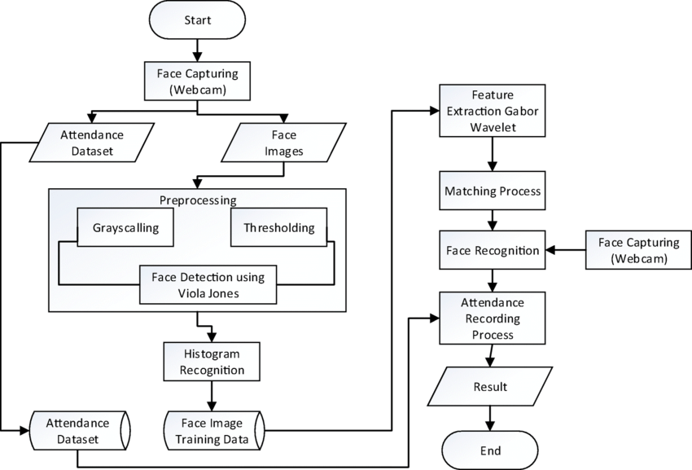

**IV CONCLUSIONS**

The Smart Attendance System using Facial Recognition heralds a paradigm shift in traditional attendance management, offering a seamless blend of accuracy, efficiency, and technological innovation. By leveraging facial recognition technology, this system not only eradicates the inaccuracies inherent in manual processes but also introduces a level of precision that significantly enhances operational efficiency.

The implementation of robust security measures and anti-spoofing mechanisms underscores the system's commitment to data integrity and user authentication. Multi-factor authentication, coupled with advanced facial recognition algorithms, ensures a secure and tamper-resistant environment, addressing concerns related to unauthorized access.

User experience takes center stage with an intuitive interface that facilitates user enrolment, profile management, and effortless access to attendance records. The system's adaptability to various educational and organizational settings, coupled with customizable features, ensures a seamless integration process and scalability to meet evolving needs.

Furthermore, the inclusion of dynamic reporting and analytics tools empowers administrators with actionable insights. The system not only records attendance but also provides a data-driven foundation for informed decision-making, resource allocation, and strategic planning.

In the ever-evolving landscape of technology, the Smart Attendance System using Facial Recognition stands as a beacon of efficiency, ethical conduct, and future possibilities. As it continues to evolve, incorporating advancements such as behavioural analysis and edge computing, the system is poised to redefine the dynamics of attendance management, fostering a more connected, intelligent, and secure educational or organizational ecosystem.

**REFERENCES**

[1].M. T. Islam and M. S. Hossain, "Facial Recognition-Based Attendance Management System," 2018 IEEE International Conference on Imaging, Vision & Pattern Recognition (icIVPR), Dhaka, Bangladesh, 2018

[2].K. Zhang et al., "A Novel Smart Attendance System Based on Deep Learning and Facial Recognition," 2019 IEEE 4th Advanced Information Technology, Electronic and Automation Control Conference (IAEAC), Chengdu, China, 2019

[3].J. Kim and Y. Choi, "Facial Recognition-Based Smart Attendance Management System Using Raspberry Pi," 2020 IEEE International Conference on Consumer Electronics (ICCE), Las Vegas, NV, USA, 2020

[4].A. K. Mandal and S. K. Saha, "Smart Attendance System Using Facial Recognition and IoT," 2020 IEEE 10th International Conference on Electronics Information and Emergency Communication (ICEIEC), Beijing, China, 2020

[5].S. C. Yong et al., "Development of Smart Attendance System Using Facial Recognition," 2020 IEEE International Conference on Automatic Control and Intelligent Systems (I2CACIS), Kedah, Malaysia, 2020

[6].Y. Shukla et al., "A Smart Attendance System Using Facial Recognition and Internet of Things," 2021 IEEE International Conference on Computing, Communication, and Automation (ICCCA), Greater Noida, India 2021

[7].M. S. Lee and S. Y. Park, "Smart Attendance System Based on Facial Recognition with Convolutional Neural Network," 2021 IEEE International Conference on Big Data and Smart Computing (BigComp), Seoul, Korea (South), 2021,

[8].Y. Guo and X. Luo, "Design and Implementation of Smart Attendance System Based on Facial Recognition," 2021 IEEE International Conference on Power Electronics, Smart Grid and Renewable Energy (PESGRE), Changsha, China, 2021

[9].T. R. Mollah and M. A. Islam, "A Novel Smart Attendance System Based on Facial Recognition and Deep Learning," 2022 IEEE International Conference on Cybernetics and Intelligent Systems (CIS), Nanjing, China, 2022

[10].J. Zhang et al., "Smart Attendance System Using Facial Recognition and Cloud Computing," 2022 IEEE International Conference on Internet of Things and Intelligence System (IoTaIS), Chongqing, China, 2022

[11].H. M. Patel et al., "Development of a Smart Attendance System Using Facial Recognition and Blockchain Technology," 2022 IEEE International Conference on Smart Systems and Inventive Technology (ICSSIT), Tirunelveli, India

[12].X. Wang et al., "A Smart Attendance System Based on Facial Recognition and Edge Computing," 2022 IEEE International Conference on Edge Computing (EdgeCom), Hong Kong, China, 2022

[13].L. Li and X. Li, "Facial Recognition-Based Smart Attendance System Using Edge AI," 2022 IEEE International Conference on Artificial Intelligence and Information Systems (AIAIS), Nanjing, China, 2022