**NUMERICAL MODELING OF MULTI-TIERED REINFORCED FLY ASH WALL**

**Pallavi N. Gharade1 ,Dr. A.P. Dange2**

*1,2 Civil Engineering, Government College of Engineering Amravati, Maharashtra, India*

*Pallavigharade1999@gmail.com*

|  |
| --- |
| ***Abstract:*** The multi-tiered wall functions as an earth-retaining structure akin to a reinforced wall. It's constructed with offsets between tiers, akin to a reinforced wall at certain heights. This study endeavours to utilize fly ash as a backfill for such a wall, focusing on analytical models. Both single and two-tiered models were analyzed to evaluate the impact of reinforcement length, spacing, and tier offset on vertical displacement, horizontal displacement, and normalized surcharge pressure. MIDAS GTS software is used to analyse the models.it is based on finite element analysis.  Numerical findings reveal that introducing reinforcement leads to increased critical offsets between tiers. For instance, without reinforcement, offsets were observed at 0.4L, whereas with reinforcement, they increased to 0.6L, where L represents the lower tier height. The introduction of geogrid reinforcement results in a significant increase in normalized surcharge pressure, reaching up to 68.90% at a reinforcement length of 0.7H, where H represents the total wall height. Furthermore, as the length of jute geotextile reinforcement increases, horizontal displacement of the wall facing decreases by up to 98% compared to the unreinforced model. Conversely, increasing spacing between reinforcing layers leads to a rise in horizontal displacement of the wall facing.  ***Key Word****:*Multi-tiered Wall, Geosynthetics Reinforced earth, offset, geogrid reinforcement length, displacement |

1. **Introduction**

Retaining walls serve as crucial geotechnical structures, designed to counteract lateral earth pressure during ground elevation changes. Historically, conventional methods like gravity or cantilever walls, predominantly constructed with reinforced concrete, have been employed for this purpose. However, escalating demands for taller retaining walls due to urban expansion and spatial limitations have led to rapidly increasing costs with height increments. Consequently, there's a pressing need for alternative construction approaches. Reinforced earth walls emerge as a viable solution, facilitating the construction of taller walls economically while enhancing tensile strength, thereby diverging from traditional retaining wall norms. A substantial body of research has focused on Mechanically Stabilized Earth (MSE) walls, with numerous studies conducted by various researchers such as Anubhav and Basudhar (2011), Chalermyanont and Benson (2004), and others. Hatami, Bathurst, and Pietro (2001) highlighted the influence of facing on reinforcement load, while Bathurst, Mitaya, and Allen (2010) conducted full-scale tests on reinforced soil walls, noting the impact of compaction efforts and global reinforcement stiffness on end-of-construction deformations. Multi-tiered walls, featuring offsets at specific heights, offer a promising approach to mitigate stress and construction challenges associated with increasing wall height. Previous investigations have demonstrated that such offsets enhance wall stability, with Wright (2005) providing guidelines for designing multi-tiered MSE walls. Notably, limited experimental and numerical studies have explored tiered MSE walls, including works by Leshchinsky and Han (2004), Kim and Yoo (2008), and Yoo, Jang, and Park (2011).

Yoo, Jang, and Park's (2011) study on the internal stability of tiered MSE walls revealed that FHWA's offset limits often exceed practical thresholds, indicating the potential for greater offset distances. Additionally, Mohamed, Yang, and Hung (2013) utilized limit equilibrium analyses to predict the performance of geosynthetic-reinforced soil wall models in a two-tiered configuration, with results aligning with centrifuge models in detecting failure planes. Further, Liu, Yang, and Ling (2014) employed finite element methods to assess the seismic performance of multi-tiered soil walls. These studies collectively contribute valuable insights into the behaviour and performance of tiered MSE walls, addressing stability, failure modes, and seismic considerations Jung (2004) conducted a study on a 5.6-meter-high two-tiered segmental retaining wall, observing increased horizontal deformation in both upper and lower tiers due to tier interaction. Field monitoring studies (Stuedlein et al., 2010; Qui et al., 2011; Stuedlein et al., 2012; Chiang, Kerrigan, and Bennetts, 2008) have primarily focused on behaviours within serviceability limits, limiting comprehensive understanding. While numerous studies have explored the impact of reinforcement strain on offset distance, research on the influence of reinforcement or backfill material on multi-tiered wall systems remains sparse. This highlights the need to investigate various factors affecting the performance of multi-tiered reinforced retaining walls for enhanced understanding.

Fly ash, a byproduct of coal combustion in thermal power plants poses significant disposal challenges due to its vast production volume. However, its engineering properties have prompted researchers to consider it as a substitute for traditional construction materials. Various studies have examined the engineering behaviour of fly ash, revealing drained material characteristics with an internal friction angle exceeding 30 degrees. Laboratory tests have shown similarities between class-F fly ash and natural sandy soils. Additionally, investigations into the triaxial behaviour of fly ash reinforced with cells made of used plastic bottles have demonstrated enhanced shear strength parameters with dual-layer reinforcement placement. Geotechnical engineering applications offer opportunities for mass utilization of fly ash, addressing disposal issues by employing it as a backfill for reinforced walls or embankment fill material. While studies have explored the potential of fly ash as a fill material, research specifically focusing on its utilization in multi-tiered retaining walls remains limited. Jute, a natural fibre derived from the jute plant, is primarily utilized for erosion control and separation purposes. Despite discussions on its potential as a reinforcing material, its use for ground improvement remains relatively unexplored. Few studies have investigated the application of jute geotextile reinforcement for enhancing bearing capacity in various contexts, including pond ash and flexible pavement subbases. However, research on employing jute geotextile as reinforcing material for retaining walls is scarce.

Research investigating the behaviour of multi-tiered walls, incorporating both fly ash and geogrid as fill material and reinforcement, respectively, remains limited. Existing studies inadequately address the impact of reinforcement inclusion on tier offsets, horizontal displacement, load settlement behaviour, and failure patterns of tiered walls. Moreover, investigations into the joint application of fly ash and geogrid for mass utilization in tiered walls are scarce. This study aims to address these gaps by examining the performance of two-tiered fly ash walls reinforced with geogrid. Numerical model tests were conducted, varying parameters such as reinforcement length, vertical spacing, and tier offsets, to assess their influence on the overall stability of the two-tiered fly ash wall model.

**II Backfill soil and reinforcement properties**

To conduct the analysis, a combination of fly ash backfills and geogrid reinforcement was employed. Table 1 and Table 2 shows the properties of fly ash and geogrid.

**Table 1** Details of properties selected for layers of fly ash

|  |  |
| --- | --- |
| **Parameters** | **Values** |
| Elastic modulus (E) | 0.3Kpa |
| Angle of internal friction (¢) | 30º |
| Unit weight (ℽ) | 12.3KN/m3 |
| Cohesion (C) | 1 |
| Poisson’s ratio (µ) | 0.3 |

**Table 2** Details of parameters selected for layers of geogrid

|  |  |
| --- | --- |
| **Parameters** | **Values** |
| Elastic modulus (E) | 40000 Mpa |
| Thickness (T) | 5mm |
| Poissons ratio (µ) | 0.3 |

**III Numerical Analysis**

A numerical model of a multi-tiered retaining wall is developed in the FEA software program in MIDAS GTS NX 3D. For the analysis, a 3D model of a multi-tiered retaining wall of fly ash is modelled. This research work aims to carry out an analysis of multi-tiered fly ash retaining walls for different parameters and to stability and suitability of fly ash multi-tiered walls. A wall model of 14m x 10 m is selected for the present study. The schematic sketch of the reinforced models indicating different offset distances has been shown in Figure 1 This study examines the impact of offsets between tiers on several factors affecting the design and stability of a reinforced wall system. Additionally, it focuses on understanding the role of reinforcement in a two-tiered reinforced wall. The numerical modelling program has been summarized in Table 3 The study determined the correlation between δ/H (horizontal displacement/total wall height) and y/H (height from the toe of the wall/total wall height) to understand the effects of reinforcement length (Lr), vertical spacing (Sv), and offset distance (D). The settlement of the backfill was measured for each load increment until either failure occurred or the settlement reached 50 mm. The relationship between normalized surcharge pressures (q/γH) and backfill settlement (ρ/b) was plotted to assess the impact of jute geotextile reinforcement length and vertical spacing on backfill settlement. where q= surcharge pressure, γ = unit weight of fly ash, ρ = settlement of loading plate and b= loading plate width.

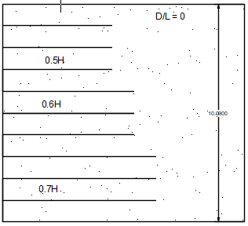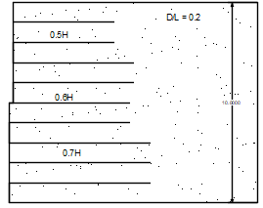

(a) (b)

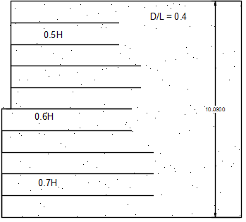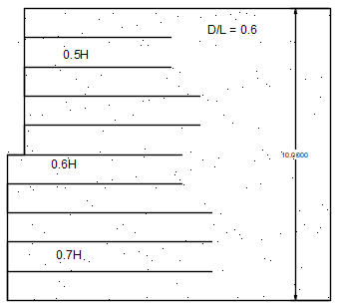

(c) (d)

**Figure 1:** Schematic view of reinforced fly ash wall with different offset

**Table 3.** Details of the Numerical program.

|  |  |  |  |  |
| --- | --- | --- | --- | --- |
| **Model type** |  | **Offset distance, D/L** | **Length of reinforcement, Lr/H** | **Vertical spacing, Sv/H** |
| Model1:Unreinforced | To study the effect of offset distance | 0, 0.2, 0.4, 0.6 | - | - |
| Model-2: Reinforced | To study the effect of the Length of reinforcement | 0, 0.2, 0.4, 0.6 | 0.4, 0.5, 0.6, 0.7 | 0.2 |
| Model-3: Reinforced | To study the effect of Vertical Spacing | 0, 0.2, 0.4, 0.6 | 0.4, 0.5, 0.6, 0.7 | 0.2, 0.3 |

Figure 2. shows the 3D model of a two-tiered retaining wall developed in MIDAS GTS NX with all features.

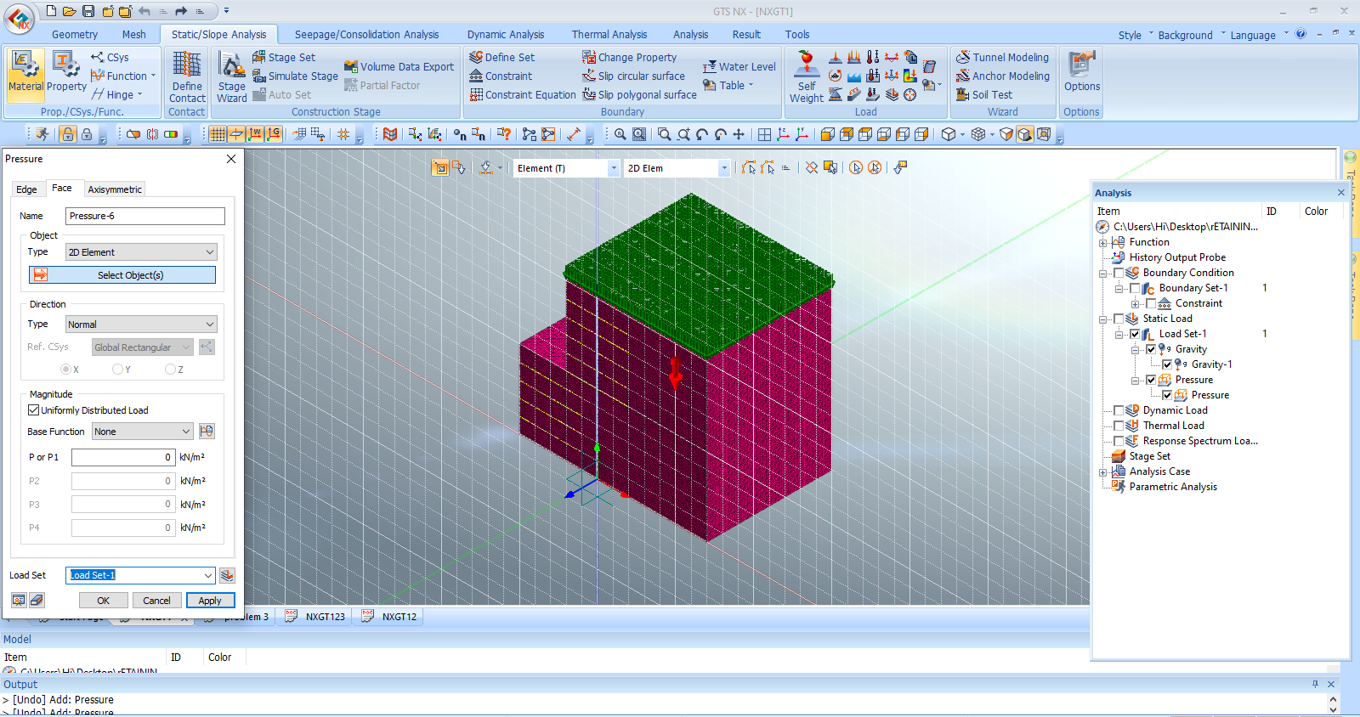

**Figure 2** Model development in MIDAS GTS NX 3D

**IV Result and discussion**

**1. Effect of the offsets between the tiers.**

The primary goal of varying offsets between the tiers was to identify the critical offset distance. This distance is defined as the point beyond which the tiers behave as separate walls with minimal direct interaction. To determine the critical offset distance and the impact of offsets on horizontal wall displacement. The offset between the tiers ranged from D/L = 0 (single wall) to D/L = 0.6. Figure 3 illustrates the variation of normalized horizontal displacement (δ/H) with offset distance at a surcharge of 100 kPa, as well as the relationship between maximum normalized horizontal displacement (δmax/H) and offset distance. As the offset increases, wall displacement initially decreases, reaching a minimum at D/L = 0.4, before increasing again at the critical offset between the two tiers. The minimum horizontal displacement was observed at an offset of D/L = 0.4. The reduction in horizontal displacement due to the offset varied, ranging from 30.10% for the unreinforced model to 89.60% for walls with a reinforcement length of 0.7H. The effect of the offsets between the tiers on horizontal wall displacement has been tabulated in Table 4.

1. (b)

**Figure 3** (a) Normalized wall displacement (δ/H) vs offset distance at a surcharge pressure of 100 kPa (b) Maximum normalized wall displacement (δmax/H) vs offset distance.

**Table 4** Percentage reduction in horizontal wall displacement due to offsets between the tiers.

|  |  |  |  |  |  |
| --- | --- | --- | --- | --- | --- |
| **Offset distance (D/L)** | **Length of Reinforcement in m** | | | | |
| **Lr=0H Lr=0.2H Lr=0.4H Lr=0.6H Lr=0.7H** | | | | |
| % Reduction in horizontal displacement | | | | | |
| 0.0 | 0.00 | 0.00 | 0.00 | 0.00 | 0.00 |
| 0.2 | 20.26 | 22.36 | 25.63 | 36.25 | 59.63 |
| 0.4 | 28.52 | 32.36 | 36.20 | 38.62 | 89.65 |
| 0.6 | 15.81 | 14.59 | 14.11 | 72.63 | 84.78 |

**2. Effect of geogrid reinforcement length.**

The geogrid reinforcement length was varied from 0.7H to 0.4H for reinforced wall models with different offset distances. This study aimed to determine the impact of the jute geotextile reinforcement length on horizontal wall displacement, offset distance between the tiers, and surcharge pressure on the wall. Figure 4 illustrates the horizontal displacement of the wall at different heights under various surcharge pressures for reinforcement lengths of 0.7H.

1. (b)

(c) (d)

**Figure 4**. Correlation of horizontal wall deformation of the wall with the height of the wall under different surcharge pressure (a) D/L= 0 (b) D/L= 0.2 (c) D/L= 0.4 and (d) D/L= 0.6.

Figure 5 shows the correlation between normalized wall displacement and varying reinforcement lengths. The test results reveal that increasing the length of reinforcement leads to a reduction in horizontal wall displacement. Specifically, a geogrid reinforcement length of 0.7H resulted in up to a 98% reduction in horizontal displacement. This effect is detailed in Table 5. Across all tests, the upper tier exhibited larger horizontal displacements compared to the lower tier. However, reducing the reinforcement length below 0.5H did not significantly decrease wall displacement. A correlation between q/γHq/\gamma Hq/γH and ρ/b\rho/bρ/b for varying reinforcement lengths is shown in Figure 6. A non-linear relationship was found between these variables, with higher ρ/b\rho/bρ/b values observed at the same q/γHq/\gamma Hq/γH when the reinforcement length decreased. In unreinforced models, increased q/γHq/\gamma Hq/γH led to rapid settlement due to the load plate punching through the fly ash. In contrast, reinforced models showed a more gradual settlement increase due to load mobilization by the reinforcement. Increasing the length of geogrid reinforcement also improved normalized surcharge pressure. For instance, a model wall with 0.7H reinforcement length showed a 68.75% increase in normalized surcharge pressure compared to an unreinforced model. Table 6 presents the improvement factor of wall models at normalized settlements of ρ/b=10%\rho/b = 10\%ρ/b=10% and 15%15\%15% due to reinforcement inclusion. The improvement factor is the ratio of the surcharge pressure of a reinforced wall model to that of an unreinforced model at a specific ρ/b\rho/bρ/b. The inclusion of reinforcement not only reduced horizontal wall displacement but also enhanced surcharge pressure. However, the influence of reinforcement diminished when the length was reduced below 0.5H, likely due to the fixed position of the loading strip. With shorter reinforcement lengths, the stress from the loading plate was only partially transferred to the reinforcement, resulting in behaviour similar to the unreinforced model.

**Figure 5**. Reinforcement length (Lr/H) vs normalized wall displacement (δ/H) (a) Sv/H= 0.2 (b) Sv/H = 0.3

**Table 5**. Percentage reduction in horizontal displacement due to reinforcement length

|  |  |  |  |  |  |
| --- | --- | --- | --- | --- | --- |
| % Reduction in horizontal displacement due to length of reinforcement measured at q = 100 kPa | | | | | |
| **Offset Distance (D/L)** | **Length Of Reinforcement in m** | | | | |
| Lr=0H Lr=0.2H Lr=0.4H Lr=0.6H Lr=0.7H | | | | |
| 0.0 | 0.0 | 14.23 | 22.56 | 61.65 | 93.62 |
| 0.2 | 0.0 | 18.96 | 28.59 | 69.63 | 95.09 |
| 0.4 | 0.0 | 22.56 | 31.56 | 78.25 | 97.85 |
| 0.6 | 0.0 | 12.85 | 23.12 | 85.96 | 98.96 |

(a)(b)

(c) (d)

**Figure 6** Correlation between q/γH and ρ/b with varying reinforcement length. (a) D/L= 0 (b) D/L= 0.2 (c) D/L= 0.4 and (d) D/L= 0.6

**Table 6** Improvement factors due to the inclusion of geogrid reinforcement

|  |  |  |  |  |  |  |  |  |
| --- | --- | --- | --- | --- | --- | --- | --- | --- |
| **Offsets between tiers (D/L)** | **0** | | **0.2** | | **0.4** | | **0.6** | |
| **Normalized settlement (ρ/b)** | 0.1 | 0.15 | 0.1 | 0.15 | 0.1 | 0.15 | 0.1 | 0.15 |
| **Length of reinforcement, Lr in m** | Improvement factor | | | | | | | |
| 0.0H | - | - | - | - | - | - | - | - |
| 0.4H | 1.31 | 1.25 | 1.95 | 1.82 | 1.95 | 1.81 | 1.29 | 1.91 |
| 0.5H | 1.58 | 1.95 | 1.78 | 2.15 | 2.81 | 2.84 | 2.0 | 1.89 |
| 0.6H | 2.65 | 1.98 | 3.26 | 3.41 | 2.95 | 3.12 | 2.95 | 1.91 |
| 0.7H | 3.81 | 3.45 | 3.30 | 2.96 | 2.75 | 3.15 | 2.84 | 2.12 |

**3. Effect of vertical spacing between the reinforcing layers**

The impact of the spacing between the reinforcing layers on horizontal wall displacement was investigated. Figure 7 illustrates the effect of vertical spacing on horizontal wall displacement at a surcharge pressure of 100 kPa. Across all models, an increase in vertical spacing resulted in greater horizontal wall displacement. The percentage reduction in horizontal displacement due to decreased vertical spacing varied, ranging from 14% for a reinforcement length of 0.4H to 94% for a reinforcement length of 0.7H. Figure 8 presents the relationship between the normalized surcharge pressure (q/γH) and the normalized spacing (ρ/b) with varying distances between the reinforcing layers. The normalized surcharge pressure decreases as the spacing between the reinforcing layers increases. The reduction in q/γH reached up to 61 % for the wall model with a D/L ratio of 0.6. Table 5 provides the values of normalized surcharge pressure at ρ/b = 10% for vertical spacings of 0.2H and 0.3H. The observed reduction in both horizontal wall displacement and normalized surcharge pressure is attributed to the decreased number of reinforcement layers as the vertical spacing increases. Consequently, the wall exhibits behaviour similar to that of an unreinforced model.

**Figure 7** Variation in horizontal wall displacement vs offset distance at 100 kPa surcharge.

1. (b)

**Figure 8** Correlation between q/γH and ρ/b with varying spacing between the reinforcing layers for offset distance (a) D/L= 0 (b) D/L= 0.2 (c) D/L= 0.4 and (d) D/L= 0.6

**Table 5.** Normalized surcharge pressure at ρ/b = 10% for different reinforcement spacing

|  |  |  |  |  |  |  |  |  |
| --- | --- | --- | --- | --- | --- | --- | --- | --- |
| **Offset Distance (D/L)** | 0 | | 0.2 | | 0.4 | | 0.6 | |
| **Vertical spacing Sv in m** | 0.20 | 0.30 | 0.20 | 0.30 | 0.20 | 0.30 | 0.20 | 0.30 |
| **Reinforcement length Lr in m** | ρ/b = 10% | | | | | | | |
| 0.0H | 12 | | 14 | | 21 | | 22 | |
| 0.4H | 14.50 | 16.30 | 11.0 | 21.9 | 12.0 | 22.3 | 12.2 | 18.1 |
| 0.5H | 16.3 | 20.3 | 14.1 | 25.0 | 13.0 | 28.1 | 14 | 22.1 |
| 0.6H | 17.0 | 32.0 | 21.0 | 31.0 | 16.1 | 33.2 | 18.0 | 20.1 |
| 0.7H | 34.1 | 25 | 34.2 | 26 | 36 | 28.1 | 39.6 | 24.9 |

**V Conclusions**

A series of numerical models were tested to understand the performance of multi-tiered fly ash walls. The variables adjusted in these models included offset distance, reinforcement length, and spacing between the reinforcing layers. The effects of these variations on horizontal wall displacement, normalized surcharge pressure, and failure patterns were observed. The conclusions that can be drawn based on the present numerical study are as follows:

1. The horizontal displacement of the wall was influenced by changes in both the length of reinforcement and the spacing between reinforcing layers. Increasing the length of reinforcement led to a significant reduction in horizontal displacement, reaching up to 98.96% compared to the reinforced model. However, diminishing returns were observed when the geogrid reinforcement length was decreased below 0.5 times the height of the wall, as the effect on horizontal displacement became negligible.
2. Changes in the spacing between reinforcing layers had a notable impact on horizontal wall displacement. Specifically, increasing the vertical spacing resulted in increased horizontal displacement across all wall models.
3. The observed horizontal wall displacement was influenced by changes in the offsets between the two tiers. Increasing the offsets between the tiers resulted in a reduction in horizontal wall displacement, reaching up to 89.63%.
4. A non-linear correlation was evident between the surcharge and the settlement of the backfill. Specifically, for a given normalized settlement of the footing, the normalized surcharge increased with longer geogrid reinforcement lengths and decreased with greater spacing between the reinforcing layers.
5. An increase in normalized surcharge pressure of up to 69.67% was observed when the geogrid reinforcement length reached 0.7 times the height of the fly ash wall, compared to the unreinforced wall model.

**References**

1. Bathurst, R. J., Y. Mitaya, and T. M. Allen 2010. “Facing Displacements in Geosynthetic Reinforced Soil Walls.” Proc. 2010 Earth Retention Conf. (ER 2010), ASCE Geo-Institute, Bellevue, Washington, 1-4 August. 442–459.
2. Berg, R. R., B. R. Christopher, and N. C. Samtani 2009. “Design of Mechanically Stabilized Earth Walls and Reinforced Soil Slopes — Volume I.” FHWA Report No. FHWA-NHI-10-024.
3. B.M.Das.2013 “Principles of foundation engineering”, 7 Edition.
4. Chalermyanont, T., and C. H. Benson. 2004. “Reliability-Based Design for Internal Stability of Mechanically Stabilized Earth Walls.” Journal of Geotechnical and Geoenvironmental Engineering. ASCE. 130: 163–173.
5. Dutta, S., and J. N. Mandal. 2015. “Model Studies on Geocell-Reinforced Fly Ash Bed Overlying Soft Clay.” Journal of Materials in Civil Engineering 28 (2): 04015091-1-04015091-13. doi:10.1061/(ASCE) MT.1943-5533.0001356.
6. Dutta, S., and J. N. Mandal. 2016. “Numerical Analyses on Cellular Mattress – Reinforced Fly Ash Beds Overlying Soft Clay.” International Journal of Geomechanics 17 (4): 4016095-1-4016095– 17. doi: 10.1061/(ASCE)GM.1943-5622.0000772
7. Ghosh, A., A. Ghosh, and A. K. Bera. 2005. “Bearing Capacity of Square Footing on Pond Ash Reinforced with Jute-Geotextile.” Geotextiles and Geomembranes 23 (2): 144–173. doi: 10.1016/j.geotexmem.2004.07.002.
8. Ghosh, A., A. Ghosh, and A. K. Bera. 2005. “Bearing Capacity of Square Footing on Pond Ash Reinforced with Jute-Geotextile.” Geotextiles and Geomembranes 23 (2): 144–173. doi: 10.1016/j.geotexmem.2004.07.002.
9. Hatami, K., R. J. Bathurst, and P. Pietro. 2001. “Static Response of Reinforced Soil Retaining Walls with Non-uniform Reinforcement.” International Journal of Geomechanics 1 (4): 477–506. doi:10.1061/ (ASCE)1532-3641(2001)1:4(477).
10. IS 3812-1 (2033): Specification for Pulverized Fuel Ash, Part 1:
11. Kim, S. B., and C. Yoo. 2008. “Performance of a Two-Tier Geosynthetic Reinforced Segmental Retaining Wall under a Surcharge Load: Full-Scale Load Test and 3D Finite Element Analysis.” Geotextiles and Geomembranes 26 (6): 460–472
12. Kim, B., M. Prezzi, and R. Salgado. 2008. “Geotechnical Properties of Fly and Bottom Ash Mixtures for Use in Highway Embankments.” Journal of Geotechnical and Geoenvironmental Engineering. ASCE 131 (7): 914–924
13. Krieger, J., and B. R. Thamm. 1991. “Studies of Failure Mechanisms and Design Methods for Geotextile-Reinforced Soil Walls.” Geotextiles and Geomembranes 10 (1): 53–63.
14. Kumar, A., and J. N. Mandal. 2017. “Effect of Reinforcement on Multi-tiered Fly Ash Wall.” Procedia Engineering 189: 446–453.
15. Lal, B. R. R., and J. N. Mandal. 2013. “Study Of Cellular Reinforced Fly Ash under Triaxial Loading Conditions.” International Journal Of Geotechnical Engineering 7 (1): 91-104. doi:10.1179/ 1938636212Z.0000000001.
16. Lal, B. R. R., and J. N. Mandal. 2014a. “Feasibility Study on Fly Ash as Backfill Material in Cellular Reinforced Walls.” Electronic Journal of Geotechnical Engineering 17: 1437–1458.
17. Leshchinsky, D., and E. B. Perry. 1989. “On the Design of Geosynthetic-Reinforced Walls.” Geotextiles and Geomembranes 8: 1–323.
18. Leshchinsky, D., and J. Han. 2004. “Geosynthetic Reinforced Multitiered Walls.” Journal of Geotechnical and Geoenvironmental Engineering. ASCE. 130: 1235–1255
19. Mohamed, S. B. A., K. H. Yang, and W. Y. Hung. 2014. “Finite Element Analyses of Two-Tier Geosynthetic-Reinforced Soil Walls: Comparison Involving Centrifuge Tests and Limit Equilibrium Results.” Computers and Geotechnics 61: 67–84
20. Mohammad Al-Barqawi 2021," Polymer Geogrids: A Review of Material, Design and Structure Relationships”, 14, 4745
21. MIDAS GTS user manual
22. NCMA. 1997, "Segmental retaining walls"
23. Prateek Malik, Sudipta K. Mishra Volume-10 Issue-3, January 2021Geosynthetics Stabilizers and Fly Ash for Soil Subgrade Improvement – A State of the Art Review ISSN: 2278-3075, International Journal of Innovative Technology and Exploring Engineering (IJITEE)
24. Sawicki, A., and D. Les̀ niewska. 1986. “Failure Modes and Bearing Capacity of Reinforced Soil Retaining Walls.” Geotextiles and Geomembranes 5: 29–44.
25. Wright, S. G. 2005. “Design Guidelines for Multi-Tiered MSE Walls.” FHWA Report No. FHWA/TX-05/0-4485-2
26. Yoo, C., and H. S. Jung. 2004. “Measured Behavior of a Geosynthetic-Reinforced Segmental Retaining Wall in a Tiered Configuration.” Geotextiles and Geomembranes 22: 359–376.
27. Yoo, C., Y. S. Jang, and I. J. Park. 2011. “Internal Stability of Geosynthetic- Reinforced Soil Walls in Tiered Configuration.” Geosynthetics International 18 (2): 74–83.
28. Leshchinsky, D., and E. B. Perry. 1989. “On the Design of Geosynthetic-Reinforced Walls.” Geotextiles and Geomembranes 8: 1–323.
29. Leshchinsky, D., and J. Han. 2004. “Geosynthetic Reinforced Multitiered Walls.” Journal of Geotechnical and Geoenvironmental Engineering. ASCE. 130: 1235–1255.