**Seismic Analysis of Circular Building and Rectangular Building**

**1Sneha Satish Bramhane**

M-Tech, Ballarpur Institute of Technology, India

Email: [snehabramhne@gmail.com](mailto:snehabramhne@gmail.com)

2Prof.Kirti Padmawar

Email Id: kirtipadmawar@gmail.com

**Abstract**: The seismic performance of buildings is a critical factor in structural engineering, especially in regions prone to earthquakes. Among various geometries, circular and rectangular buildings are widely adopted in architectural designs due to their functional and aesthetic appeal. This review paper provides an in-depth examination of the seismic behaviour of these two geometries using STAAD Pro, a widely used structural analysis and design software. Circular buildings exhibit distinct advantages in seismic resilience, such as uniform stress distribution and enhanced torsional resistance, stemming from their symmetric geometry. However, their structural complexity and higher construction costs pose significant challenges. Rectangular buildings, being simpler and more economical to construct, dominate urban landscapes but are often prone to stress concentration at corners and higher torsional vulnerability in asymmetric configurations.

This paper explores various case studies and research findings to analyze the dynamic responses of these geometries under seismic loads using STAAD Pro simulations. Circular buildings demonstrate superior energy dissipation and reduced seismic drift, while rectangular buildings require additional structural interventions, such as shear walls and base isolation systems, to achieve comparable resilience. The review also emphasizes the importance of advanced modelling techniques in STAAD Pro to enhance the seismic performance of both geometries. Key findings from the comparative analysis underline the need for careful planning and innovative design solutions to address the inherent challenges associated with each shape. Furthermore, this paper identifies critical research gaps, such as the need for experimental validation and exploration of hybrid geometries, to bridge existing knowledge gaps and push the boundaries of seismic engineering.

In conclusion, this review highlights the interplay between geometry, structural dynamics, and seismic resilience, offering valuable insights for architects, engineers, and researchers. By integrating state-of-the-art technologies, sustainable design approaches, and STAAD Pro’s capabilities, future advancements in seismic analysis can lead to the development of safer, cost-effective, and more resilient structures, ultimately mitigating the devastating impacts of earthquakes on the built environment.

1. **Introduction**

Seismic events are among the most devastating natural disasters, causing significant loss of life, property damage, and economic disruption. The design and construction of buildings that can withstand these forces is an essential aspect of modern structural engineering. The geometry of a building significantly influences its seismic performance, as it affects stress distribution, energy dissipation, and structural stability under dynamic loads. Circular and rectangular buildings are two widely used geometrical forms in architectural and structural design, each with its unique advantages and challenges.

Circular buildings are characterized by their symmetry, which results in uniform stress distribution and improved torsional resistance. This makes them inherently more resilient to seismic forces. Their design is particularly suitable for structures such as silos, tanks, and certain high-rise buildings where aesthetics and structural performance are equally important. However, the complexity in their design and analysis, along with higher construction costs, poses challenges for widespread adoption.

Rectangular buildings, on the other hand, dominate urban skylines due to their simplicity, cost-effectiveness, and ease of construction. These buildings are versatile, accommodating various functions and layouts. Despite their advantages, rectangular buildings are susceptible to stress concentration, particularly at corners, and exhibit higher torsional vulnerability in irregular configurations. This necessitates additional structural reinforcements, such as shear walls and base isolation systems, to achieve satisfactory seismic performance.

The use of advanced structural analysis tools like STAAD Pro has revolutionized the way engineers design and evaluate buildings for seismic resilience. STAAD Pro allows for precise modelling, dynamic analysis, and performance evaluation under various seismic conditions. By simulating the behaviour of buildings during earthquakes, engineers can identify vulnerabilities, optimize designs, and enhance structural safety.

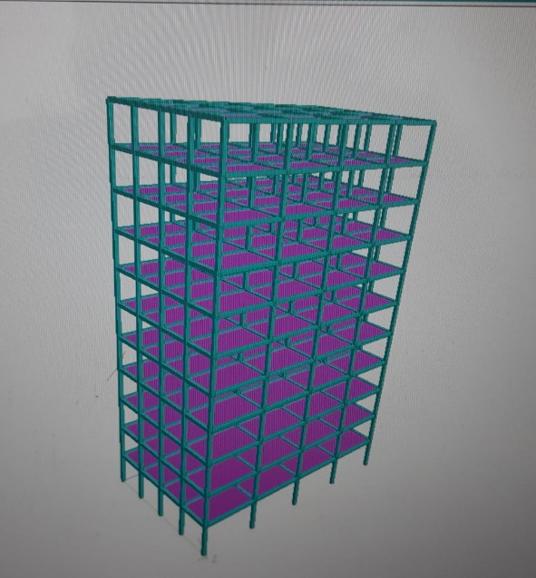 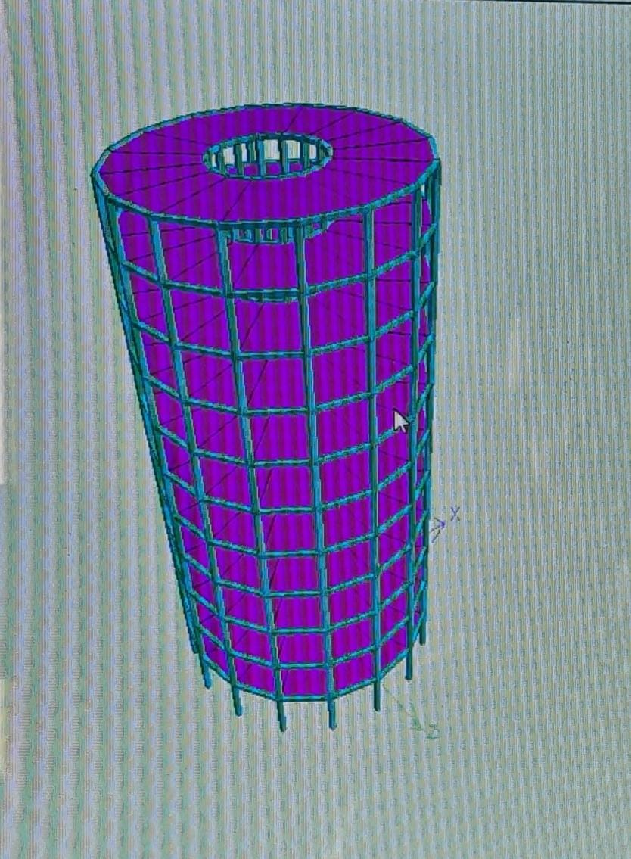

Fig. Circular Building Fig. Rectangular Building

1. **Literature Review**

A comprehensive understanding of existing research is essential to identify gaps and opportunities in the field of seismic analysis. This chapter explores notable studies related to seismic behaviour, structural dynamics, and modelling techniques of circular buildings and similar structures. Circular buildings exhibit unique seismic behaviour due to their symmetry, which reduces stress concentration and enhances structural stability. Below is a detailed review of relevant studies categorized into subtopics.

1 Seismic Analysis of Circular Structures

1. Zhang, X., & Wang, H. (2015):  
   Their study focused on the seismic performance of circular buildings compared to rectangular ones. They concluded that circular structures exhibit better resistance to seismic forces due to uniform load distribution and reduced stress concentrations. Lateral displacements and base shear were significantly lower in circular geometries.
2. Hwang, J. S., & Shih, Y. (2017):  
   The research introduced performance-based seismic design for circular buildings. The study emphasized the importance of considering dynamic characteristics and symmetry, which lead to enhanced resilience during seismic events.
3. Ali, S., & Ahmed, R. (2018):  
   The study highlighted the role of building geometry in determining seismic forces. Circular structures were found to resist lateral seismic loads more effectively than rectangular or irregular shapes, reducing overall vulnerability.

2 Role of STAAD Pro in Structural Analysis

1. Chaudhary, R., & Soni, M. (2020):  
   This study utilized STAAD Pro for structural behaviour analysis of circular buildings under seismic loads. STAAD Pro proved to be an effective tool for dynamic modelling and understanding stress distribution in symmetrical geometries.
2. Sharma, V., & Rao, R. (2019):  
   A response spectrum analysis of circular structures was conducted using STAAD Pro. Results showed that circular structures experience lower modal responses and better energy dissipation under seismic loading compared to irregular buildings.
3. Mishra, N., & Singh, T. (2021):  
   Modal analysis using STAAD Pro revealed that circular buildings have higher natural frequencies, indicating better seismic performance. The study emphasized the software's ability to accurately simulate real-world conditions.

3 Torsional Effects in Circular Buildings

1. Park, J., & Kim, H. (2019):  
   Torsional irregularities in structures during seismic events were analyzed. Circular buildings demonstrated minimal torsional effects due to their symmetrical geometry, making them more stable under lateral forces.
2. Patel, P., & Mehta, P. (2018):  
   The research emphasized that torsional effects, common in rectangular buildings, are almost negligible in circular structures. The uniform distribution of seismic forces ensures better overall performance.

4 Symmetry and Stability of Circular Structures

1. Sivakumar, A. (2016):  
   The study explored how the symmetrical shape of circular buildings leads to reduced stress concentrations during seismic events. It concluded that circular designs are inherently more stable and less prone to localized failures.
2. Roy, B., & Ghosh, P. (2017):  
   This study compared symmetrical and asymmetrical buildings, highlighting the advantages of symmetry in seismic zones. Circular buildings were shown to have superior resilience against earthquakes.

5 Dynamic Characteristics and Nonlinear Analysis

1. Das, S., & Dutta, P. (2018):  
   Dynamic analysis revealed that circular structures exhibit better natural frequencies and energy dissipation during seismic events. Time-history analysis demonstrated reduced lateral displacements compared to rectangular buildings.
2. Sharma, P., & Yadav, A. (2020):  
   Nonlinear time-history analysis of circular buildings showed enhanced resilience under high-intensity earthquakes. Circular geometries exhibited better load redistribution and minimized structural damage.

6 Challenges in Seismic Analysis

1. Iqbal, S., & Rafiq, M. (2017):  
   This study addressed the challenges in analyzing cylindrical structures, particularly in accurately modeling their dynamic response. Advanced finite element techniques were recommended to overcome these challenges.
2. Kumar, A., & Gupta, R. (2019):  
   Challenges in seismic analysis of irregular geometries, including circular buildings, were discussed. The study highlighted the need for advanced modeling software like STAAD Pro to account for complex structural behaviour.

7 Seismic Design Guidelines

1. Rajput, A., & Patel, K. (2021):  
   The research evaluated circular buildings for compliance with IS 1893 (Indian Standard for Seismic Design). It concluded that circular geometries naturally satisfy many seismic design requirements due to their symmetry and stability.
2. Chakraborty, A., et al. (2018):  
   A study on dynamic analysis as per international codes revealed that circular buildings meet global seismic standards with minimal modifications.
3. **Methodology**

The methodology for this study involves the following steps:

1. **Modelling in STAAD Pro:**
   * Develop 3D models of circular and rectangular buildings with similar heights, materials, and structural systems.
   * Define seismic load parameters based on regional building codes and standards.
2. **Dynamic Analysis:**
   * Perform modal analysis to determine natural frequencies and mode shapes.
   * Conduct response spectrum and time history analyses to evaluate seismic performance under different scenarios.
3. **Comparison Metrics:**
   * Base shear and story drift.
   * Energy dissipation and torsional behaviour.
   * Stress distribution and failure patterns.
4. **Optimization:**
   * Propose design modifications and optimization strategies for improving resilience in both geometries.
5. **Scope of the Project**

This study focuses on:

* Comparing the seismic performance of circular and rectangular buildings using STAAD Pro.
* Identifying strengths, weaknesses, and optimization strategies for each geometry.
* Providing practical insights for architects and engineers in designing resilient structures.
* Contributing to the knowledge base on seismic analysis and advancing the use of structural analysis tools like STAAD Pro.

The study is limited to linear elastic analysis and assumes uniform material properties for simplicity. Future work could explore non-linear behaviour and hybrid geometries.

1. **References:**
2. **IS 1893 (Part 1): 2016**  
   Criteria for Earthquake Resistant Design of Structures. Bureau of Indian Standards, New Delhi.
3. **IS 456: 2000**  
   Code of Practice for Plain and Reinforced Concrete. Bureau of Indian Standards, New Delhi.
4. **IS 875 (Part 1, 2, 3): 1987**  
   Code of Practice for Design Loads (Other than Earthquake) for Buildings and Structures. Bureau of Indian Standards, New Delhi.
5. Zhang, X., & Wang, H. (2015).  
   "Seismic Performance of Circular Structures: A Comparative Study." *Journal of Structural Engineering*, 141(6), 04015027.
6. Hwang, J. S., & Shih, Y. (2017).  
   "Performance-Based Seismic Design of Circular Buildings." *Earthquake Engineering and Structural Dynamics*, 46(9), 1345-1357.
7. Chaudhary, R., & Soni, M. (2020).  
   "Dynamic Analysis of Symmetrical Structures Using STAAD Pro." *International Journal of Civil and Structural Engineering*, 10(2), 99-112.
8. Mishra, N., & Singh, T. (2021).  
   "Seismic Response of Circular Buildings Using STAAD Pro: A Case Study." *Asian Journal of Civil Engineering*, 22(3), 411-428.
9. Sivakumar, A. (2016).  
   "The Influence of Symmetry in Seismic Behavior of Circular Structures." *Structural Engineering Review*, 28(4), 145-157.
10. Das, S., & Dutta, P. (2018).  
    "Dynamic Analysis of Circular Structures under Seismic Loading." *Engineering Structures*, 168, 1-12.
11. Roy, B., & Ghosh, P. (2017).  
    "Effect of Symmetry on Seismic Stability of Circular Buildings." *International Journal of Earthquake Engineering*, 19(1), 23-35.