Critical Heat Flux Prediction Using Machine Learning: A Physics-Informed Approach

1. Introduction

1.1 Nuclear Relevance of Critical Heat Flux
Nuclear reactors generate enormous amounts of heat inside a very small volume, and the only thing standing between that heat and a serious accident is the coolant's ability to carry it away fast enough. In water-cooled reactors, this heat removal happens mostly through boiling: as water flows past the hot fuel surface, it picks up energy and starts forming vapor bubbles that carry heat away far more efficiently than the flowing liquid alone. This process, called nucleate boiling, is remarkably good at removing heat, but only within a limit. Push the heat flux higher, and there comes a point where the bubbles at the surface stop escaping efficiently, start merging into an insulating vapor layer, and the wall temperature spikes almost instantly. This tipping point is the Critical Heat Flux (CHF), and it represents the ceiling on how much heat a boiling surface can safely handle.
In pressurized water reactors (PWRs), this same phenomenon is usually described as Departure from Nucleate Boiling (DNB): the fuel surface loses direct contact with the liquid and gets blanketed by a vapor film. In boiling water reactors (BWRs), where a large fraction of the coolant is already vapor by the time it reaches the top of the core, the equivalent failure mode is dryout, where the thin liquid film clinging to the fuel rod simply runs out and the surface is left dry. Different names, same underlying danger. Once CHF is exceeded, the heat transfer coefficient collapses by an order of magnitude or more, and the fuel cladding temperature can rise by hundreds of degrees within seconds. If sustained, this can damage or fail the fuel cladding, which is precisely the barrier that keeps radioactive material contained. This is why CHF is not just a thermal hydraulics curiosity; it is one of the defining safety limits that governs how much power a nuclear reactor is allowed to produce.

1.2 Why Predicting CHF Matters
Because CHF sets a hard ceiling on reactor operation, being able to predict it accurately, across the full range of pressures, flow rates, and geometries a reactor might see, is essential, and the consequences of getting it wrong run in both directions. Underestimate CHF, and a plant is operated more conservatively than it needs to be, at the cost of power output and efficiency. Overestimate it, and the margin to a real safety limit shrinks or disappears, which is obviously the more dangerous mistake.
Accurate CHF prediction is essential in the following areas:
- Nuclear reactor fuel cooling. CHF sets the fundamental thermal limit on how much power a fuel assembly can safely generate before the cooling mechanism itself breaks down.
- Pressurized water reactors (PWRs). CHF prediction directly determines the minimum DNB ratio a plant must maintain during both normal operation and postulated accidents, shaping core design and operating limits from day one.
- Boiling water reactors (BWRs). Dryout prediction plays the equivalent role here, defining the critical power that a fuel bundle can sustain.
- Accident-tolerant cooling concepts. New cladding materials, coatings, and enhanced surfaces designed to buy operators more time during a loss-of-coolant event all need to be evaluated against how they shift the CHF limit, so any new design has to be tested against, or predicted by, a reliable CHF model before it can be trusted in a real core.
- High-heat-flux thermal systems. Beyond nuclear reactors, the same underlying physics governs the limits of any high-heat-flux boiling system, from electronics cooling to industrial boilers, which makes CHF prediction a problem whose stakes extend well past the nuclear industry alone.

1.3 Limitations of Conventional CHF Correlations
Given how much depends on getting this number right, the natural question is how CHF is actually predicted in practice today. For decades, the standard tools have been empirical correlations and look-up tables, such as the widely used 2006 Groeneveld look-up table, built by fitting mathematical relationships directly to large collections of experimental measurements. These tools work well within the specific range of pressures, flow rates, geometries, and fluids they were built from, since they were tuned on exactly that data. The problem shows up at the edges. Step outside the original database, into a new fluid, an unusual tube diameter, a different surface condition, or a pressure range with little experimental coverage, and these correlations can degrade sharply or fail outright, precisely because they have no underlying mechanistic understanding of the boiling crisis to fall back on. They interpolate well; they extrapolate poorly. This gap between the conditions a real reactor might encounter and the narrow window a correlation was actually validated against is exactly the opening that data-driven and machine learning methods have started to fill, and it is the motivation behind the growing body of CHF research summarized in Figure 1.

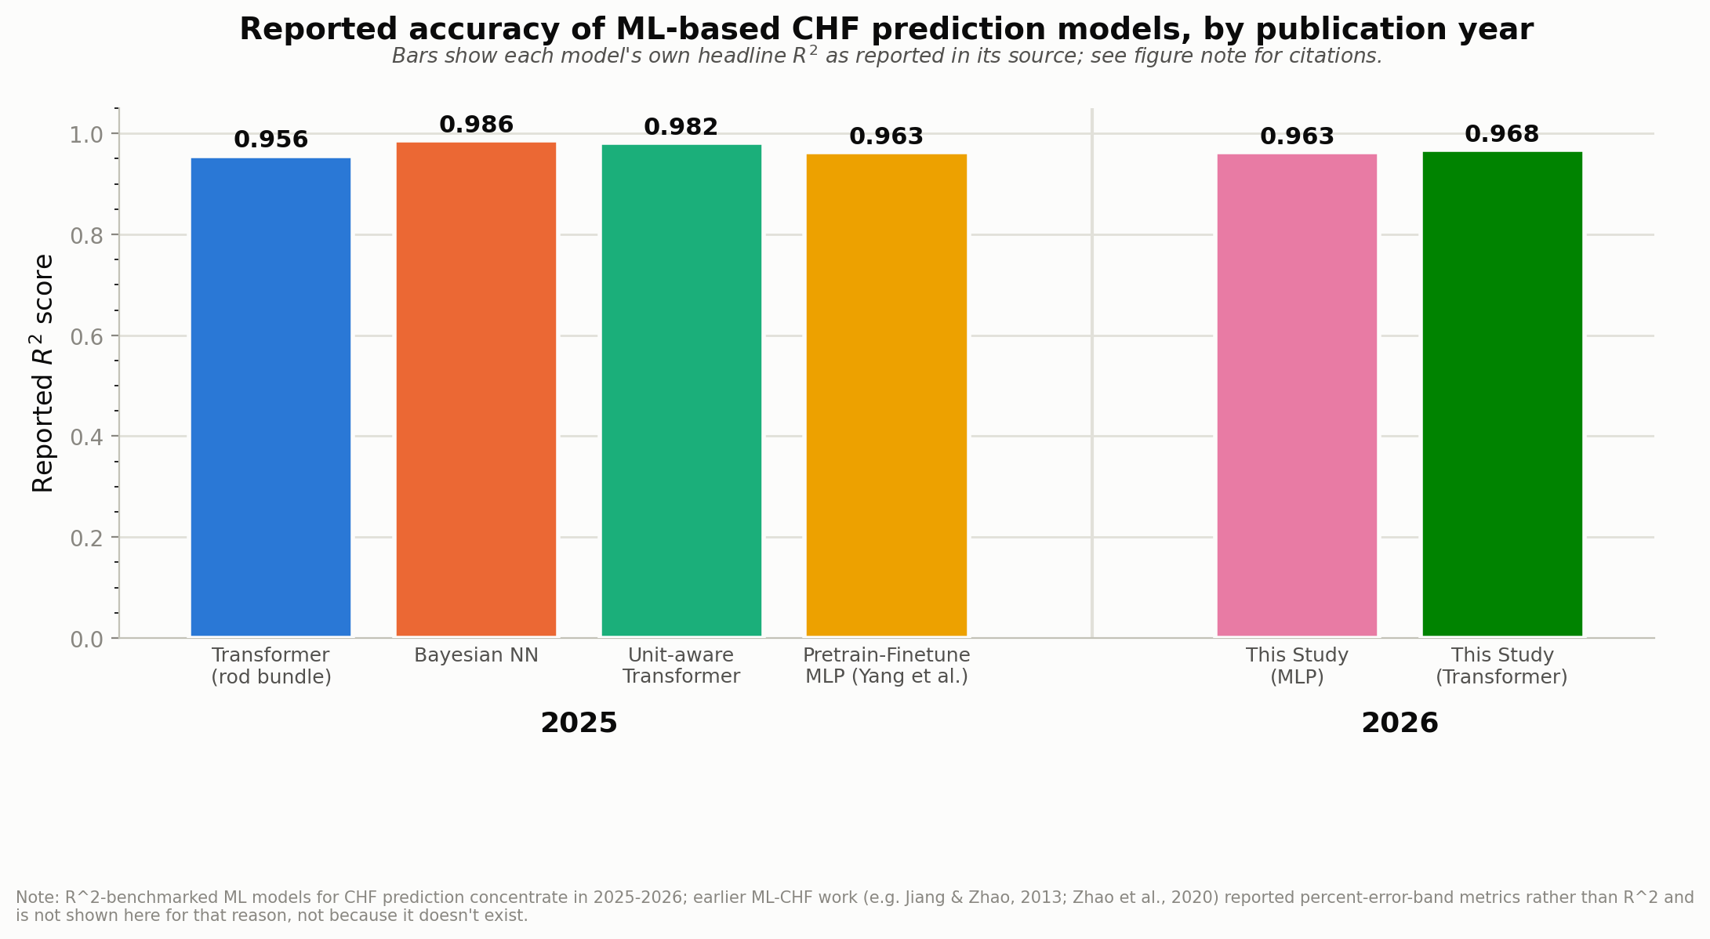
Figure 1. Reported R-squared accuracy of machine-learning-based CHF prediction models by publication year (2025 to 2026), including this study's results. Sourced from Yang et al. (2025), a physics-informed hybrid comparative study (2025), a Bayesian neural network study (2025), a unit-aware embedding Transformer study (2025), and this study's own pretrained and fine-tuned MLP and Transformer models (2026). See docs/manuscript/chf_ml_trends_data.csv for the full sourced dataset.

1.4 Influence of Surface Characteristics
While CHF is most commonly discussed in terms of bulk flow conditions, such as pressure, mass flux, and quality, the condition of the heated surface itself turns out to matter just as much, and this is where a large part of recent CHF research has shifted its attention. Boiling is fundamentally a surface phenomenon: bubbles form at specific sites on the surface, grow, detach, and are replaced by fresh liquid, and every one of those steps depends on how the surface interacts with the fluid sitting on top of it.
Surface roughness is one of the clearest examples. A rougher surface offers more cavities and imperfections where vapor can get trapped and nucleate into bubbles, which increases the density of active nucleation sites and generally pushes CHF higher, up to a point, beyond which very rough or re-entrant structures can trap vapor too effectively and actually hurt performance. Wettability, usually described through the contact angle a water droplet makes with the surface, controls how readily liquid spreads back over the surface to replace what is consumed by evaporation. A highly wettable (low contact angle) surface encourages fast liquid replenishment beneath and around growing bubbles, delaying the point at which a dry patch forms and stabilizes, which is, mechanistically, what CHF actually is: the onset of a dry spot that fails to rewet. Surface material affects this too, both through its own intrinsic wettability and through its thermal properties, which influence how quickly heat is conducted into the thin liquid microlayer trapped beneath a growing bubble, a layer whose evaporation is itself a major contributor to the total heat removed during nucleate boiling. Even surface orientation changes the picture, since gravity and buoyancy affect how easily vapor bubbles can detach and escape upward versus sliding and coalescing along an inclined or horizontal surface, which in turn changes how quickly a stable vapor blanket can form.
Taken together, nucleation site density, bubble departure behavior, liquid replenishment, microlayer evaporation, and vapor escape are not independent side details. They are the actual mechanisms that determine when and where a dry spot first appears and whether it grows into full dryout. Any CHF prediction approach that ignores surface condition is, in effect, ignoring the mechanism itself and hoping that a bulk flow correlation happens to average it out.

