Critical Heat Flux Prediction Using Machine Learning: A Physics-Informed Approach

1. Introduction

1.1 Nuclear Relevance of Critical Heat Flux
Nuclear reactors generate enormous amounts of heat inside a very small volume, and the only thing standing between that heat and a serious accident is the coolant's ability to carry it away fast enough. In water-cooled reactors, this heat removal happens mostly through boiling: as water flows past the hot fuel surface, it picks up energy and starts forming vapor bubbles that carry heat away far more efficiently than the flowing liquid alone. This process, called nucleate boiling, is remarkably good at removing heat, but only within a limit. Push the heat flux higher, and there comes a point where the bubbles at the surface stop escaping efficiently, start merging into an insulating vapor layer, and the wall temperature spikes almost instantly. This tipping point is the Critical Heat Flux (CHF), and it represents the ceiling on how much heat a boiling surface can safely handle.
In pressurized water reactors (PWRs), this same phenomenon is usually described as Departure from Nucleate Boiling (DNB): the fuel surface loses direct contact with the liquid and gets blanketed by a vapor film. In boiling water reactors (BWRs), where a large fraction of the coolant is already vapor by the time it reaches the top of the core, the equivalent failure mode is dryout, where the thin liquid film clinging to the fuel rod simply runs out and the surface is left dry. Different names, same underlying danger. Once CHF is exceeded, the heat transfer coefficient collapses by an order of magnitude or more, and the fuel cladding temperature can rise by hundreds of degrees within seconds. If sustained, this can damage or fail the fuel cladding, which is precisely the barrier that keeps radioactive material contained. This is why CHF is not just a thermal hydraulics curiosity; it is one of the defining safety limits that governs how much power a nuclear reactor is allowed to produce.

1.2 Why Predicting CHF Matters
Because CHF sets a hard ceiling on reactor operation, being able to predict it accurately, across the full range of pressures, flow rates, and geometries a reactor might see, is essential, and the consequences of getting it wrong run in both directions. Underestimate CHF, and a plant is operated more conservatively than it needs to be, at the cost of power output and efficiency. Overestimate it, and the margin to a real safety limit shrinks or disappears, which is obviously the more dangerous mistake.
Accurate CHF prediction is essential in the following areas:
- Nuclear reactor fuel cooling. CHF sets the fundamental thermal limit on how much power a fuel assembly can safely generate before the cooling mechanism itself breaks down.
- Pressurized water reactors (PWRs). CHF prediction directly determines the minimum DNB ratio a plant must maintain during both normal operation and postulated accidents, shaping core design and operating limits from day one.
- Boiling water reactors (BWRs). Dryout prediction plays the equivalent role here, defining the critical power that a fuel bundle can sustain.
- Accident-tolerant cooling concepts. New cladding materials, coatings, and enhanced surfaces designed to buy operators more time during a loss-of-coolant event all need to be evaluated against how they shift the CHF limit, so any new design has to be tested against, or predicted by, a reliable CHF model before it can be trusted in a real core.
- High-heat-flux thermal systems. Beyond nuclear reactors, the same underlying physics governs the limits of any high-heat-flux boiling system, from electronics cooling to industrial boilers, which makes CHF prediction a problem whose stakes extend well past the nuclear industry alone.

1.3 Limitations of Conventional CHF Correlations
Given how much depends on getting this number right, the natural question is how CHF is actually predicted in practice today. For decades, the standard tools have been empirical correlations and look-up tables, such as the widely used 2006 Groeneveld look-up table, built by fitting mathematical relationships directly to large collections of experimental measurements. These tools work well within the specific range of pressures, flow rates, geometries, and fluids they were built from, since they were tuned on exactly that data. The problem shows up at the edges. Step outside the original database, into a new fluid, an unusual tube diameter, a different surface condition, or a pressure range with little experimental coverage, and these correlations can degrade sharply or fail outright, precisely because they have no underlying mechanistic understanding of the boiling crisis to fall back on. They interpolate well; they extrapolate poorly. This gap between the conditions a real reactor might encounter and the narrow window a correlation was actually validated against is exactly the opening that data-driven and machine learning methods have started to fill, and it is the motivation behind the growing body of CHF research summarized in Figure 1.

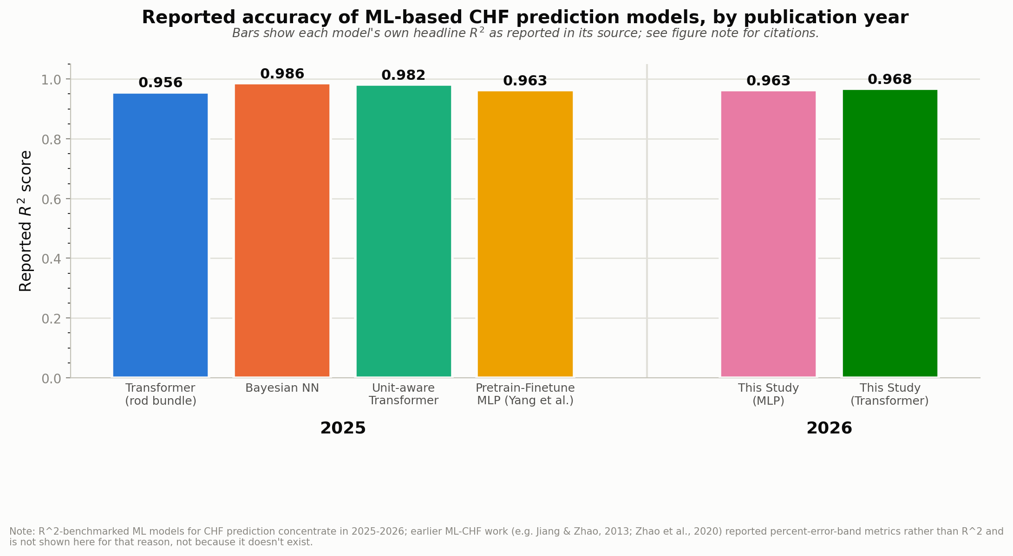
Figure 1. Reported R-squared accuracy of machine-learning-based CHF prediction models by publication year (2025 to 2026), including this study's results. Sourced from Yang et al. (2025), a physics-informed hybrid comparative study (2025), a Bayesian neural network study (2025), a unit-aware embedding Transformer study (2025), and this study's own pretrained and fine-tuned MLP and Transformer models (2026). See docs/manuscript/chf_ml_trends_data.csv for the full sourced dataset.

1.4 Influence of Surface Characteristics
The correlations described above are built almost entirely around bulk flow conditions: pressure, mass flux, and quality. But boiling does not happen in the bulk fluid. It happens at the surface, one nucleation site at a time, and the condition of that surface turns out to shape CHF just as strongly as the flow conditions do. This is why engineered surfaces (surfaces deliberately roughened, coated, or textured to control how boiling behaves on them) have become one of the most active areas of CHF research in recent years. Five surface properties in particular keep showing up across the literature: roughness, wettability, contact angle, surface material, and orientation. Each one acts through a distinct physical mechanism, and together they determine when and where a dry spot first forms.
- Surface roughness and nucleation site density. A rougher surface has more cavities where vapor can get trapped and grow into a bubble, so rougher surfaces generally support a higher density of active nucleation sites and, through that, a higher CHF. Roughness has been reported to raise the boiling heat transfer coefficient by close to 19 percent on typical roughened surfaces. But roughness alone is not the whole story: chromium coatings with very low roughness have still produced CHF increases of 32 to 79 percent through superhydrophilicity alone, and at the nanoscale, dense structuring can actually work against CHF, because very fine features can trap vapor so effectively that they interfere with rewetting right when it matters most, near the CHF point itself. In practice, the surfaces that perform best tend to combine micro-scale roughness (which drives nucleation and provides a wicking path for liquid) rather than relying on nanoscale texture alone.
- Wettability and contact angle. Wettability, measured through the contact angle a liquid makes with the surface, controls how aggressively liquid is drawn back toward a growing bubble. More wettable (lower contact angle) surfaces have been shown experimentally to reach higher CHF, and the mechanism is well characterized: CHF is triggered at a local dry spot where the liquid can no longer keep the surface wetted, and where it is instead violently scattered by strong evaporation right at the three-phase contact line. Interestingly, the specific way this failure happens depends on how wettable the surface is. On less wettable, non-wetting surfaces, a dry patch becomes unrecoverable once the rate of liquid supplied by capillary action falls below the rate of evaporation at its edge (an evaporation-limited failure, typically seen with water). On highly wettable surfaces, the dry patch can instead become unrecoverable once the surface temperature underneath it crosses the Leidenfrost point, so the liquid film simply cannot re-establish contact even where it is otherwise available (a levitation-limited failure, more typical of fluids like FC-72). These are two different physical routes to the same outcome, and which one applies depends directly on the wettability of the surface in question. As a further detail worth noting, experiments near the boiling crisis itself have found that the apparent contact angle tends to sit close to 90 degrees right at the point of triggering, regardless of the surface's static contact angle far from CHF.
- Microlayer evaporation, liquid replenishment, and dry spot formation. When a bubble nucleates, it leaves behind a thin liquid microlayer trapped between the growing bubble and the surface. Because this microlayer is so thin, heat conducts through it very efficiently, and its rapid evaporation supplies a large share of the energy needed for the bubble to keep growing. This is also where the dry spot begins: as the microlayer evaporates, the three-phase contact line advances outward, and the dry patch underneath the bubble spreads with it. Under normal nucleate boiling, the bubble eventually detaches and rises under buoyancy, the contact line retreats back toward the center, and liquid rewets the dry patch before it can do any damage. CHF is simply the point where this rewetting step fails to keep up. More wettable surfaces support a larger microlayer area to begin with, and surfaces with micro-scale roughness add a further advantage: their capillary wicking action pulls in extra liquid to the retreating contact line, which offsets the evaporation rate and buys the surface more time to rewet before a dry spot can lock in and spread out of control.
- Surface material. Beyond its influence on wettability, the material a surface is made of also affects CHF through its thermal properties. A material with higher thermal effusivity conducts heat into the thin liquid microlayer more readily, which changes how quickly that microlayer can evaporate and how the local wall temperature responds as a dry spot begins to form. This is part of why the same roughness or coating can produce different CHF outcomes on different base materials: the geometry of the surface and the thermal behavior of the material underneath it act together, not independently.
- Surface orientation, bubble departure, and vapor escape. Orientation determines how gravity and buoyancy act on a growing bubble. On a vertical, upward-facing surface, bubbles detach cleanly and rise away from the heated wall, clearing the way for liquid to return. On horizontal or inclined surfaces, bubbles are more likely to slide along the surface, coalesce with neighboring bubbles, and merge into a continuous vapor layer that is far harder for liquid to break through. This is the same underlying competition described in classical hydrodynamic instability models of CHF, where the boiling crisis is framed as a competition between the rate at which vapor can escape from the surface and the rate at which liquid can flow back in to replace it: orientation shifts that balance directly, by changing how easily bubbles depart and how quickly the vapor generated at the surface is able to escape rather than accumulate.
Taken together, nucleation site density, bubble departure behavior, liquid replenishment, microlayer evaporation, and vapor escape are not independent side details. They are the actual mechanisms that determine when and where a dry spot first appears and whether it grows into full dryout, and every one of the five surface properties discussed above acts by shifting one or more of these mechanisms. Any CHF prediction approach that ignores surface condition is, in effect, ignoring the mechanism itself and hoping that a bulk flow correlation happens to average it out.

