Camera View: Bobby’s Table 2 of 2 (Bobby, Amy-Lynn, Michelle I., Magdalena)
Date of filming: 05/16/1995
Harding public school, Kenilworth, NJ, Grade 7
Advanced Guess my Rule (AGMR): Inverse Function
Transcribed by: Morgan Sawin
Date of transcription: July 2010
Verified by: Andrea DePaolo
Date of verification: August 2010
Length of session: 00:36:45

Time Speaker Transcription

00:01 Michelle I. Bobby, work. (Takes away extra paper Bobby is writing on.) Don’t worry about m and c you know, and squared equals mc squared and stuff. Okay. So-
Magdalena I’m so messed up.
Michelle I. We’ll do something- We’ll do like the rule is s- box
Magdalena Squared.
Michelle I. Squared
Magdalena Plus.
Michelle I. Plus.
Magdalena Wait no. It’s the minus.
Michelle I. Minus… negative something. No.
Magdalena No if it was plus… Oh, how about plus negative something?
Michelle I. It’s the same as minus.
Bobby A hundred and thirty two times the speed a normal car’s going on the interstate highway.
Amy-Lynn (mumbles) Minus (unintelligible)
Magdalena But let’s make it… confusing! (Amy-Lynn and Michelle I. giggle)
00:46 Michelle I. Okay, plus negative uh, six. No-
Magdalena No it’s not six. Uh how ‘bout uh, eleven? No-
Amy-Lynn (With Michelle I.) Thirteen.
Michelle I. (With Amy-Lynn) Thirteen.
Magdalena Yeah.
Michelle I. Thirteen equals… triangle.
Magdalena? Triangle.
1:02 Michelle I. So the numbers would be- Let’s try- What would- If two was in the box- so the square root of two is four plus-
(Magdalena’s paper shows:)

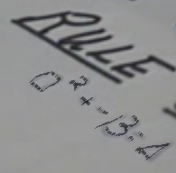

Bobby It’d be times two-
Magdalena Minus thirteen is negative-
Michelle I. Nine.
Magdalena Negative nine.
Michelle I. No wait hold on. Negative nine.
Bobby Wow.
1:24 Michelle I. So it’s two and negative nine. (sings chanting a cheer) Sorry. Okay now it- if it was-
Bobby What’s the (??) cheer?
Magdalena How ‘bout four-
Michelle I. Four. Oh (giggles). Okay.
Bobby (During Amy-Lynn below) Negative five.
Amy-Lynn So it’s sixteen. Sixteen! ‘Cause it’s four times four. Sixteen.
Magdalena Six and minus thirteen-
Michelle I. (During Magdalena above) Four times four is sixteen minus thirteen.
Amy-Lynn Oh. (giggles with Michelle I.)
Michelle I. Minus thirteen is-
Magdalena Negative…
Michelle I. Negative…
Magdalena Six- uh, four times four it’s eight and minus that is negative seven.
2:02 Michelle I. Negative seven yeah ‘cause it’s just (two more?) Now if we put zero the answer is negative thirteen.
Amy-Lynn But would that one be too easy for them? Then they would be able to figure it out.
Magdalena Don’t think of them like that.
Amy-Lynn Yeah.
Michelle I. But then they would just think- how could they figure it out like (snaps) that then?
Magdalena Yeah if it’s a zero like that they-
Amy-Lynn Yeah but then they won’t- but then they’ll figure out maybe the.. exponent.
02:24 Michelle I. But maybe they won’t realize that it’s zero t- times two.
Bobby Yeah but from my understanding ten feet away from-
Magdalena Zero times zero was zero. And zero times two is zero.
Michelle I. Yeah I know.
Magdalena So it’s- (pause) Okay let’s put that down.
Bobby If we manage to ???? (mumbles a lot to himself, unintelligible)
Michelle I. But would it give it away to them?
Magdalena Yeah it sort of does.
Michelle I. Well then let’s put
Magdalena Equals six and negative-
2:49 Michelle I. No that’s the same thing. It’s going down by two.
Magdalena Yeah. Let’s go-
Michelle I. So five,
Magdalena And then eight, three-.
Michelle I. Three, ten, negative one. Now let’s do like negative…two…that would be four.
Magdalena How did you get negative two here? Oh, negative two, okay. It’s supposed to be on the top.
3:14 Bobby Um, this is the same thing as negative eleven. It’s minus eleven from everything.
Magdalena (During Bobby above) And negative…
Michelle I. What if we did this…
Magdalena And negative thirteen.
Michelle I. …divided by something?
Bobby Wait.
Michelle I. and Magdalena
Whoooooaaa.
Michelle I. That’s intense.
Bobby This one’s kinda easy ‘cause look, just minus eleven from everything.
(Bobby’s paper shows:)

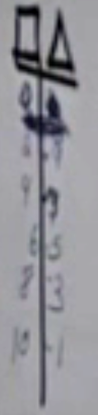 recreated for visibility 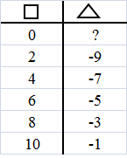

Michelle I. But that’s a different thing. What if we divided it by something? Whooooaaa.
Bobby Divided from the s- like a man stood thirty feet away from a brick wall. He turns on the flashlight. How long will it take for the light to get there?
(table giggles)
Michelle I. Bobby. You’re scaring me.
Bobby It’s true. (During Michelle below) I’m gonna work on that.
3:48 Michelle I. Okay. So we have that rule. Plus fifteen.
Magdalena And we gotta make something similar to that.
Michelle I. Divided by- five thousand. No.
Magdalena Five thousand go- So plus negative thirteen.
Michelle I. Divided by-
Magdalena Um.
Michelle I. Divided by, um,
Magdalena Wait um, how ‘bout two
Michelle I. Nine? No.
Magdalena Four.
4:20 Amy-Lynn We need something, uh, that’ll be easy to divide into the numbers.
Magdalena How ‘bout by three?
Michelle I. Okay.
Magdalena No but it won’t divide. Every number won’t divide by three. Doesn’t work.
Amy-Lynn What about- we need like an even or something.
Michelle I. So? We’ll put point something something something. We’ll put four and a third or something like that to get ‘em confused.
Amy-Lynn Yeah.
Michelle I. and Magdalena
Whooooaaa.
Amy-Lynn Whooooaaa. Cool.
Bobby Wait, I’m working on something.
Michelle I. So, if it was two over here that’d be negative nine divided by three.
Bobby Divided by thirty nanometers.
Amy-Lynn So that would be- negative nine divided by three. (To Bobby) Negative nine divided by three is negative three, right?
4:51 Michelle I. We could put divided by n- point three.
Amy-Lynn It’s negative- huh?
All girls Whooooaaa.
Michelle I. No.
Magdalena That’s too confusing, man.
Amy-Lynn So? These kids are supposed to be brainiacs. Kid prodigies. Especially Mike.
Bobby No I am. Remember I asked- told the guy that.
Michelle I. Okay. Bobby.
Michelle I. (During Amy-Lynn and Bobby above) Divided by point three. No. Let’s just put- Let’s just put three.
So it’s four plus negative three is negative nine.
Magdalena No hold on divided by one third.
Michelle I. Whoa.
Amy-Lynn Whoa.
5:18 Michelle I. So it’s negative nine divided by a third. Negative one third. Or no, divided by a third.
Magdalena Negative one third. Let’s make it even confusing. We can’t figure it out so they won’t.
Michelle I. (During Magdalena above) Negative one third. Oh, man.
(girls giggle)
Bobby (During girls giggles) Got it. Got it.
Amy-Lynn They got calculators? (Referring to another group?)
Bobby So it’s-
Michelle I. Can we use a calculator?
Amy-Lynn ‘Cause we’re gonna give a problem that’s really intense.
Michelle I. Can we have a calculator anyone?
Researcher 1 Well- I don’t know where they are.
Amy-Lynn Oh I know.
Researcher 1 Do you know where they’re kept?
Michelle I. Yes I do. (Gets up from seat)
5:48 Amy-Lynn This is really intense. I love math. Not that kinda way though.
Bobby I got it. I got the answer. A man’s standing thirty feet away, how long will it take- One billionth of a second. Repeating decimal.
Amy-Lynn Cool.
Researcher 2 Oh, what do you have here?
Bobby Um, we’re working on it… (Covering up his work)
Researcher 2 What do you have here?
Amy-Lynn (During Michelle I. below) This rule.
Michelle I. We’re making a rule and then we have to find the problems.
(Michelle I.’s paper shows:)

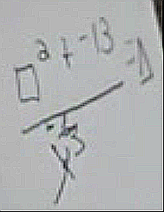

Researcher 2 Are you not gonna let me see? (Referring to Bobby’s work)
Amy-Lynn No that’s not it. This is it.
Michelle I. We messed up over there.
Amy-Lynn That’s (his?)
Researcher 2 That looks very complicated I think I’ll go to the next table.
(Students and Researcher 1 laugh)
Hmm.
Amy-Lynn We gotta figure it out ourselves.
6:22 Researcher 2 Oh my goodness. Is it-
Magdalena How about we go with the same um, numbers-
Michelle I. Uh, no it won’t turn on. (referring to calculator)
Magdalena Shelly, how ‘bout we go with the same numbers. Shelly?
Researcher 2 (To Amy-Lynn) This is supposed to give me this? Is that what you’re telling me?
Amy-Lynn Oh, no, this is- that was from this. But we’re making it even more intense so we have to figure out the numbers.
Magdalena No how about- no how about we keep the same numbers?
Michelle I. Of course I would take a broken calculator with my luck.
Amy-Lynn I’ll get it. I got one. (Gets up from seat)
Michelle I. Today is not gonna be a good day.
6:50 Bobby How fast is one billionth of a second?
Magdalena (Takes Bobby’s papers) Get the papers away from him.
Bobby No come on. I have the- I’ve been working on them. (Magdalena hands him back a paper). No that’s not mine. The one on the bottom (points to stack of papers).
Magdalena Bobby stop working on this stupid-
Michelle I. E equals M C squared-
Bobby It’s energy equals mass times speed of sunlight to the second power. (Magdalena and Michelle I. giggle) I’m so smart.
Michelle I. So wait, if it’s two-
Magdalena How about let’s keep all the numbers from the square and just figure out the answers.
Michelle I. Yeah, I was gonna say that.
7:18 Magdalena (To herself as she’s writing) Two, four, six, eight, ten, negative two. (Aloud) We sort of, like, skip around ‘cause it goes from ten to negative two.
Michelle I. That’s good. Makes them more confused.
Amy-Lynn (Arriving back to table) Wait, now what’d you get?
Michelle I. We’re using the same numbers on the side.
Magdalena I don’t think that’s what she asks us to do. Didn’t she ask us to it like (what are the things about them??)
Bobby Yeah.
Michelle I. To make a problem, right?
Bobby That’s what we’re doing. Can we use the man standing thirty feet away from a brick wall?
Michelle I. (Using calculator) So it’s two times two minus thirteen-
7:56 Magdalena It’s not times two, it’s times the number. Oh.
Amy-Lynn It is two.
Michelle I. (Gasps) We could do that! Box… (whispers to herself) box plus…
Magdalena and Amy-Lynn
Whoooooaaa. (giggle)
Bobby What about box to the triangle power?
Amy-Lynn Whoooooaaa.
Michelle I. No we can’t do that ‘cause then how could you find out the triangle?
Bobby Who knows?
Amy-Lynn It is a never-ending problem.
Magdalena No it’s not a-
Michelle I. So what if it’s two? So it’s two times two minus thirteen.
Amy-Lynn and Magdalena (with Michelle I. above)
…times two minus thirteen
(During Michelle I. below):
Bobby Let’s put the Pythagorean theorem in there.
Magdalena (giggles) How can you do that?
Amy-Lynn Sine, cosine, tan.
Bobby You square the sides of this, you get the triangle.
Magdalena Bobby.
Michelle I. No wait it sh- it should actually be-No wait- Okay. Two times two minus thirteen equals. A hundred nine. Oops
8:40 Amy-Lynn (Looking at calculator, to Michelle I.) A-N-S?
Magdalena No it- it’s two times two minus thirteen divided by negative one third.
Bobby Wait if you square the sides of this you can get the cube.
Magdalena Okay. Can I (two unintelligible words)?
Michelle I. Hold on where’s the dash sign?
Magdalena (Pointing to Michelle’s calculator) Dash sign? What are you talking about? Negative?
Michelle I. Ohhhh.
Bobby Wait. If you square the sides of the triangle you can get a cube.
Michelle I. Two times two (punches numbers into calculator)
Amy-Lynn ( To Michelle I.) You turned it off. (giggles)
Michelle I. (giggles) Two times two minus negative one third- oops.
Magdalena Come on Shelly.
Amy-Lynn (During Michelle I below, to herself or Bobby)
We need to get the sharps. Do you see any of the sharps? Do you see where the sharpies are?
Michelle I. I can do this.Two times two plus negative one third divided by- divided by-
Magdalena by negative three.
Michelle I. Negative-
9:27 Magdalena How do you get decimals on there?
Michelle I. One- it’s one of these buttons here. Um-
Magdalena How will you get, uh-
Bobby (To Amy-Lynn) I don’t know.
Magdalena (To Michelle I.) How do you get fractions there?
Amy-Lynn Get the book.
Magdalena It would be nice if we knew how to use it.
Michelle I. The sharpie (?) calculators are right back there somewhere.
Amy-Lynn Where are they? Sharpie calculators are weird.
Bobby We’re not that complex.
Magdalena Minus-
Amy-Lynn Wait would it be, wait-
Magdalena No defi- what- th-
Amy-Lynn We have to do, da da da da da- We have to do a fraction.
10:05 Researcher 1 You’re doing fancy things here.
Amy-Lynn Yeah, but-
Bobby I had like a more fancy thing but they wouldn’t listen to me. (others giggle as Researcher 1 reads Bobby’s work). What’s the problem? That’s a nice answer. See these- no look it’s easy. These two cross each other out. Except for the mass part. (To himself) Plus two, and that’s minus three. Minus mass equals triangle.
Magdalena (During Bobby above) I thought they were in the filing cabinet but they’re not. How did-?
10:41 Bobby See you can simplify it. So it like, makes it easier.
Amy-Lynn These ones may not able to fractions.
Michelle I. Bobby’s doing something weird. We’re doing something besides what he’s doing because-
Bobby And see since the mass is nothing, it’s just triangle minus three.
(Bobby’s paper shows the following:)

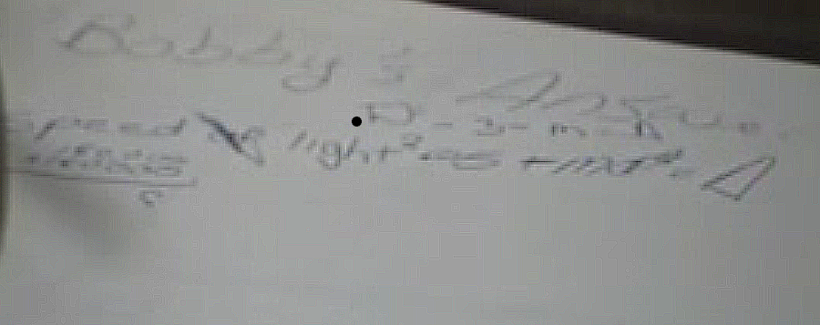

Magdalena Bobby. Go (unintelligible word- asks him to find calculators)
Amy-Lynn Maybe they’re in her closet.
Bobby No I wasn’t gonna use them. I was just gonna use this one.
Michelle I. (To Amy-Lynn) Wanna go check?
Magdalena It’s stuck (referring to Michelle I.’s calculator).
(To Michelle I.) Figure out how-
Bobby A man is standing thirty feet away from a brick wall. (Starts whispering) How long will it take the (??) to get to the wall?
11:13 Michelle I. It’s negative nine (using calculator).
Magdalena Hold on. (Looking up something in calculator handbook). Oh, here. Negative number. No, that’s not it. Um, the practice negatives.
Bobby You missed, uh, the appendix.
Magdalena I used it, it says one through eight.
Bobby Yeah, but still, ya know. What’s an index?
Michelle I. (To herself) Negative nine divided by-
Bobby It’s the appendix.
11:42 Michelle I. One. One of these buttons here? (Referring to calculator)
Bobby It might be on second function.
Magdalena You see that-?
Bobby We can’t find the negative sign.
Magdalena We found the negative, we can’t find the fraction.
Bobby Oh, don’t you push the A-B-? Here (leans toward Michelle)
Michelle I. Ohhh.
Bobby You push the, um, A-B-C button.
Michelle I. Where’s the A-B-C button?
Bobby I don’t know.
Magdalena It’s on the other calculators, the A-B-C?
Bobby No. It’ll be on this one, too.
12:14 Michelle I. There’s A-B-S.
Magdalena Look on her desk, maybe it’s there. (To Amy-Lynn)
Bobby We’re just gonna, like, destroy her desk.
Michelle I. It’s already destroyed.
Magdalena How ‘bout divided by thr- point three. ‘Cause it’s the same thing. Divided by three three three three three. Point one three three- no point three three three three three three.
Michelle I. Negative thirty.
Magdalena Whoa.
Michelle I. So, four times four, is four…
Magdalena (To Amy) Amy, never mind.
Michelle I. … plus negative thirteen, is three divided by point three, is ten.
13:00 Researcher 1 (During students above) As I’ve gone around to the tables, I see you doing some really interesting things. Um, Ankur you want to show us what you have? Would you come show everybody what you have…at your table?
(During Researcher 1 above)
Magdalena (To Michelle I.) Ten or negative ten?
Michelle I. Ten.
Amy-Lynn Is it negative point three?
Magdalena Yeah.
13:11 Michelle I. Oh wait. I didn’t put negative point three so it’s negative ten.
Magdalena That’s what I thought.
Amy-Lynn What is it? Point what? Two and negative thirty
Bobby (Singing) A never-ending story.
Michelle I. (Whispering) Magda, are you chewing gum?
Magdalena No. (giggles)
Michelle I. You know that’s not allowed.
Bobby Yea it’s like illegal in forty eight states including Hawaii and Alaska.
Magdalena Shut up, Bobby.
Bobby It’s legal in Montana and Arizona.
Michelle I. (giggles)
Bobby Well, it is.
Michelle I. You know that you look really weird to the people that are gonna be watching this.
Bobby (Shrugs)
Amy-Lynn They’ll edit it out. Hopefully. For Bobby’s sake.
Michelle I. But then how could you get anything in on us?
Amy-Lynn (Giggles)
14:09 Michelle I. What about the sixth one?
Amy-Lynn He’s doing a problem.
Michelle I. Six times six is thirty six.
Bobby Yeah but they edit these videos.
Michelle I. Minus thirteen.
Magdalena I got some weird answer.
Amy-Lynn Let me check.
14:20 Michelle I. Let me see. Let’s see. Oh, whoa. Let’s hope (microphone cuts out) it’s not right.
(NOT MIKED, so may be slightly inaccurate transcript)
Amy-Lynn? Thirteen… twenty three… divided by
Magdalena? Divided by…
14:41 Michelle I. It’s really weird, it must not be right.
Magdalena No, let’s look at- no that’s two
Michelle I.? Seventy (or thirty?) six… sixteen
14:55 Magdalena That’s sort of like..?
Amy-Lynn ??? …nightmare.
(Students may be talking during Researcher 1 below, but it is inaudible.)
15:02 Researcher 1 Well, uh, Ankur could you explain to them now why, he thinks all of those would give you the same set of ordered pairs. Does everybody agree with that? I know you’ve been working on similar things. Could you tell if they are right? I think your friends at this table agree. Could you go through them and tell us why you think they are alike?
(Ankur has written on the overhead.)

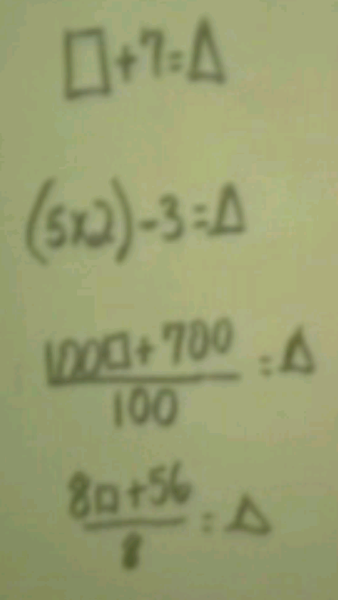

Ankur Well this is like the small- shortest way to say that’s like the way most people would think of the pattern.
Researcher 1 Okay, it’s just complicated people who would think of it the other way.
Ankur This just gets more complex and see the first, behind the equal sign this side equals seven this part equals seven, behind the equal sign.
Researcher 1 Okay
Ankur And so does this side.
Researcher 1 Do you know- I don’t see a box in that second one.
Student Yeah.
Ankur Oops.
16:06 Student You forgot to put it. You put a box after the three.
Ankur It’s minus three plus box. That’s behind the equal sign.
(Ankur corrects the equation as shown below.)

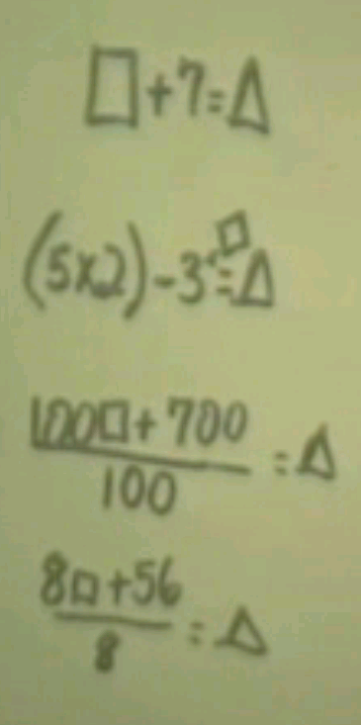

Researcher 1 Okay, could you explain why you think the next one works? I think there is some confusion about that.
Ankur This one?
Researcher 1 Uh- huh.
Ankur This one. It’s just, you can divide the hundred box by a hundred so that turns down to one box.
Researcher 1 We’re not quite clear is why one hundred times the number in the box, divided by a hundred would be the same as the number in the box. Could you explain that? And tell us why that works? Maybe write it over to the side or something. Just that part, a hundred times the number in the box divided by a hundred.
Ankur That equals one. A hundred divided by a hundred equals one. And fifty-six- no I mean seven hundred divided by one hundred equals seven. So that’s one box plus seven equals triangle.
Researcher 2 Can you write that down, those pieces that you just said?
Ankur Those pieces.
Researcher 2 That tells me a lot.
Ankur If I write the things…
Researcher 2 Just the two pieces you said were really nice.
Researcher 1 She wants you to say a hundred…
Ankur I know but if I write it on the overhead
Researcher Take another piece of paper.
Ankur Okay.
Researcher 1 Can you find another clean one under there?
Researcher 2 Rewrite that piece of it.
Researcher 1 I can help you find one, they’re under here, the clean ones.
(As Ankur works on the overhead, the microphone comes back. Bobby’s table was chatting and working during Ankur and Researcher 1 above, but it was inaudible until now)
(Ankur added to the slide as shown below.)

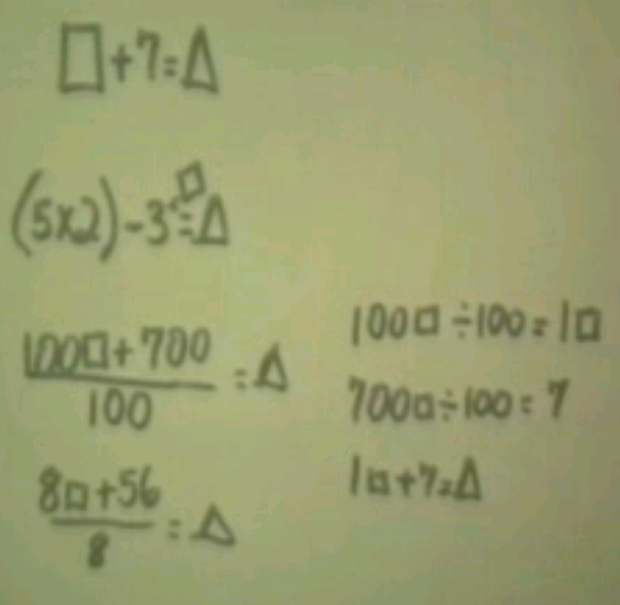

18:18 Bobby …two and negative thirty. (Inaudible) two equals negative three. Three equals ten. So four equals one.
Michelle I.? …six six(??)
Amy-Lynn (To Bobby) We took off the last number.
Bobby Yeah.
Amy-Lynn (To Michelle I.) We took off the last number, it compares. Bobby’s (inaudible) thing.
18:34 Bobby (inaudible during Amy-Lynn above) ‘Cause look. Two equals negative thirty, minus two equals number three. Four equals ten, minus four equals one. Six equals seventy six point six six- move the decimal, equals seven point six six.
Amy-Lynn (Writing to herself) Moving…
Bobby It moves the decimal place over one and like it cuts it one number.
Researcher 2 The people back there said to me…
Bobby I don’t know how I thought of that.
18:54 Researcher 2 You see this piece here, are you all looking? Right, which Ankur wrote like that. What they said to me was that they could write that top part like this.
(Researcher 2 rewrites one of Ankur’s equation on the overhead as shown below.)

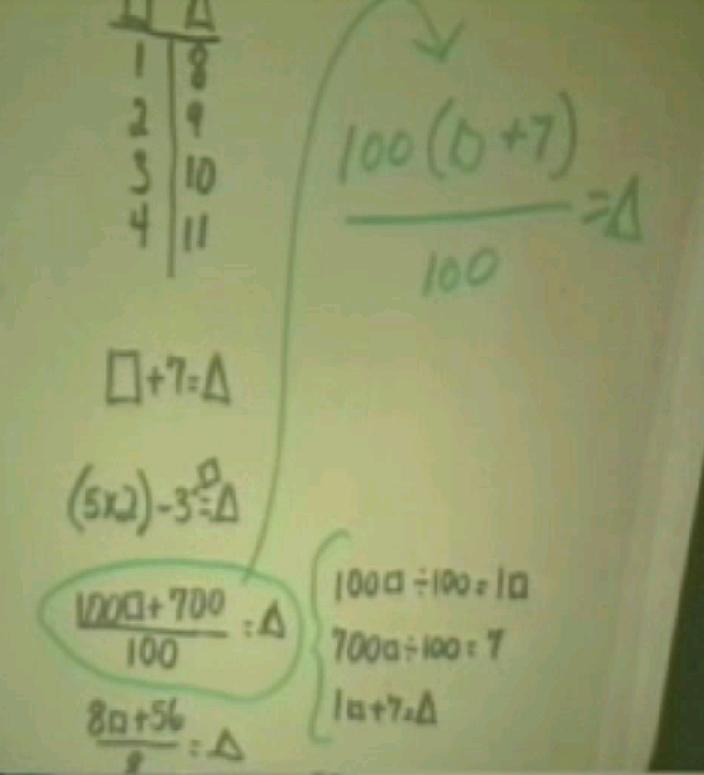

Bobby (During Researcher above) Isn’t that weird?
Amy-Lynn It’s cool.
Bobby No, it’s scary. It’s like dividing by zero. Whoa.
Researcher 2 You can. Could you explain that to me I don’t understand that?
Bobby (During Ankur explaining to the class) It’s divide by zero, so it messes the whole thing up.
Ankur Because one hundred is outside the parenthesis and one hundred times box equals one hundred box and one hundred times seven equals seven hundred so that’s one hundred box plus seven hundred.
Researcher 2 How do you get, how do you end up getting what you finally got? How do you go from there to get this result here.
Ankur You simplify.
Researcher 2 I’m sorry I didn’t want to mess that one up. Can you put the one back in? Thanks. Can you show me how we go from here to here and why that works?
Ankur From here you can go
Researcher 2 To yours, yeah, how do you simplify that?
Ankur From here you go to here
Researcher 2 No, the one under.
Ankur This one? How do you simplify?
Researcher 2 How do you go from here to here? Can you show us?
(Bobby’s table is talking during Researcher 2 and Ankur, but microphone is off so it is inaudible, except for Magdalena below)
Magdalena How about we square root number two?
Ankur Okay, one hundred is outside the parenthesis so that equals one hundred box that’s right here.
(Microphone turns back on)
20:09 Magdalena (During Ankur above, pointing to Michelle I.’s work) And- and that minus root thirteen equals- will never give this, uh, you know- no- divided by two.
Bobby Last time were you dividing by one third or point three?
Michelle I. Shhh.
Bobby (Whispering) Last time you divided by one third or point three?
Amy-Lynn (Whispering to Bobby) Point three.
Bobby (Whispering) That’s why.
Amy-Lynn (Whispering) Whoa.
Bobby It’s the same.
Michelle I. It’s negative four.
Magdalena (Crosses out her previous work)
Researcher 2 You’ve all seen what Ankur’s doing here. What do you think Angela?
Angela That’s like what we were doing like crossing out the zeros and you asked us why and we want to know if Ankur knows why.
Researcher 2 Now, can you tell me why it works? I was confused.
Angela We don’t know why. We want to know if Ankur knows why.
Researcher 2 You want to know if Ankur knows why, well
20:51 Michelle I. (Whispering) Magda. Magda we have to pay attention to Ankur.
Magdalena We’re supposed to- we’re supposed to (inaudible)
Researcher 1 Ankur your explanation didn’t convince her that anybody knows why. Can you try, can you think of any other way to say it?
(Ankur explains the work on the overhead as shown below.)

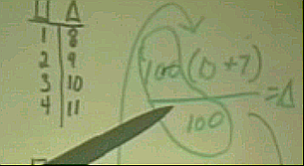

Ankur The one hundred cancels out the one hundred.
Reasearcher 2 What do you mean by cancels out?
Ankur Because it’s on both sides so you can eliminate it.
Researcher 2 That’s where you lost me.
Ankur Then all you have left is box plus seven. That’s one box plus seven equals triangle.
Researcher 2 I don’t understand when you say cancels out. I see one hundred divided by one hundred here.
21:34 Ankur That equals one.
Researcher 2 I can see that that’s one. I’ll buy that that is another name for one.
Ankur So that equals one box and seven. It’s still seven. So one box equals
Researcher 1 Ankur do you know what worries me about cancelling? Is that
sometimes people see things you know and they just mark them out because they look alike. Could you show us an example with
numbers where you have a hundred times something divided by a
hundred and to be sure that it makes sense in numbers or something.
Ankur How should I do that?
Researcher 1 What if you have a hundred times five.
Ankur Five hundred.
Researcher 1 …divided by a hundred. Let’s say will you write that down and see? You have a hundred multiplied times five and then that divided by a hundred. Let’s see if you can tell us what happens.
Ankur So this is on both sides of the equation.
(Ankur added 100 x 5 divided by 100 on the overhead as shown below.)

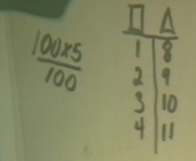

Researcher 2 That’s not an equation, Ankur. There is no equation there. There is no equation. Look at that that’s just a fraction.
22:43 Ankur Then the fraction.
Researcher 2 Do you all see that? That’s where you confuse me. I see a hundred times five divided by a hundred. That looks like a fraction to me.
Ankur Okay, then you can put-
Researcher 2 You guys were talking about equations even at the other table and I don’t see an equation.
Ankur Then this equals five hundred and you can cancel out the two zeros.
Researcher 2 I don’t understand what you do when you cancel out zeros.
(Ankur has crossed out zeros as shown on the overhead below.)

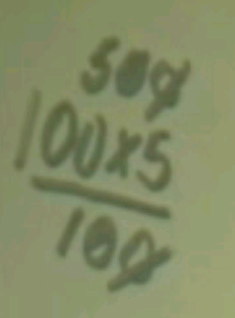

Ankur Because they’re on both sides. You can do anything on one side. whatever you do to one side you can do on the other side.
Researcher 2 Um, Angela and Stephanie (both have raised their arms)
Angela I finally figured out why you, uhm, cancel each other out cause they’re inverse operations. Like if you had one and you plus one and you subtracted one they cancel each other out. If you, had I don’t know it just cancels each other out. And you don’t even need the one up there because one box is just box so it would be box plus seven.
Ankur Or you could do it like this. Five hundred over one hundred that simplifies to five over one. That’s five.
Researcher 1 But why? (Yet why?)
23:47 Ankur What does why mean?
Researcher 2 Stephanie you were going to say something?
Stephanie Oh no I was just going to say kinda what she said. It’s just what it is you have to whatever if you take away a zero from one side because you can do that. Because it’s I can’t it’s like whatever you do to the one side you have to be able to do to the other side otherwise you can’t do it.
24:09 Researcher 2 Okay, I think you guys are going to get into a lot of trouble when you study algebra unless we really work this out. Because first of all you are saying things about side and this is a fraction. There’s a number on the top and a number on the bottom, that’s a fraction. You are giving me examples that have to do with equations and balances and that’s something else. So I really think we are going to have to work this out otherwise you may fall into some trouble. We have all the algebra teachers in this room, in horror, worrying about what’s going to happen to you guys down the line. So we are gonna maybe take a time out here. The question I want to leave you with- Bobby you want to make a comment before I leave you with a question? Go ahead Bobby.
24:43 Bobby Oh, ‘cause like five hundred divided by one hundred is five.
Researcher 2 Very nice.
Bobby Even if you cross the hundreds out it is still going to be five no matter what.
Researcher 1 But she’s looking at it now as division with everything.
Researcher 2 Okay I’ll- that I’ll buy Bobby. I’ll buy that. Five hundred divided by hundred is five. I am going to ask you something else here.
(Michael has raised his hand) Yes Michael?
(Researcher 2 places the slide shown below on the overhead.)

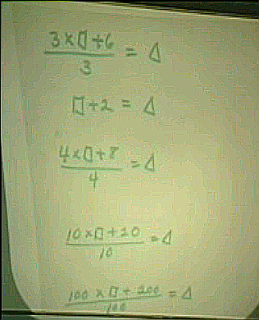

Michael Well the time before you could not only write it as a fraction, you can also write it as an equation, as an equation. So when you write an equation then you can cross out things.
Researcher 2 Well that’s where I get a little confused because this is an equation. We’ve written this as an equation. But you see when you talk about crossing out things this is one side of an equation and this is another. This is the numerator of a fraction and this is a denominator and I get very confused when you’re crossing things from the- from the fraction and then you are talking about an equation.
Michael Then change it into an equation and then you can understand it more.
25:34 Bobby (Whispering to table) Wait I have an idea. On the bottom of it put (five equals six…five?)
Researcher 2 Okay, but we need to work on that. I think our time is out. But we have a visitor here for just one minute. Tell me your name?
Lindsey Lindsey.
25:45 Researcher 2 Lindsey? Lindsey, um, Lindsey sent me a wonderful problem. Lindsey’s a third grader and you know how I am about why. Don’t you all know how I am about why? And Lindsey, um, come say hi to this- this class, Lindsey. Lindsey- Lindsey discovered a- a- an interesting rule. And my question to all of you is to help, uh, Lindsey tell me why. If I can find a blank overhead.
Student (Justice?) (Class laughs)
26:23 Researcher 2 Lindsey’s- now these- You guys used to do this to me when you were third graders. Are we out of paper? Overheads? (Class laughs)
Researcher 1 There should be some under there.
Researcher 2 I don’t see any more.
Researcher Here you go.
Researcher 2 One piece is all I need. Okay what Lindsey said is the following. Lindsey do you want to say it or do you want me to? Do you want to say it? This is what you wrote me. Remember?
Lindsey Yeah.
Researcher 2 Go ahead. Why don’t you tell me and I’ll write- write what you want me to write. Tell the class.
26:51 Lindsey Five times an even number you, um, split the even number in half and you add a zero and you get your answer.
Researcher 2 So five times an even number- and you said, for example, six, right?
Lindsey Mm hmm (nods)
Reseacher 2 She says you split the even number in half. Spitting six in half gives you…
Students Three
Researcher 2 Three. She says then you add-
Lindsey A zero.
(Researcher 2 writes down the example using Lindsey’s rule.)

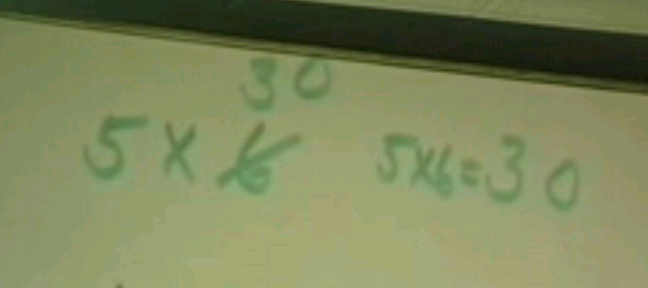

Reseacher 2 Zero. And that’s how you get five times six equals thirty. Right? Now let’s try it with another even number. Five times- give me another even number.
27:22 Student Forty-six.
Researcher 2 Forty-six. You split the even number in half, right? Split forty-six Jeff and what do you get?
Students Twenty-three.
Researcher 2 Twenty-three, right? So five times forty-six is going to be- adding a zero-
Students Two thirty.
Researcher 2 Which will be two thirty. Does that work?
(Researcher 2 has added the second example to the overhead.)

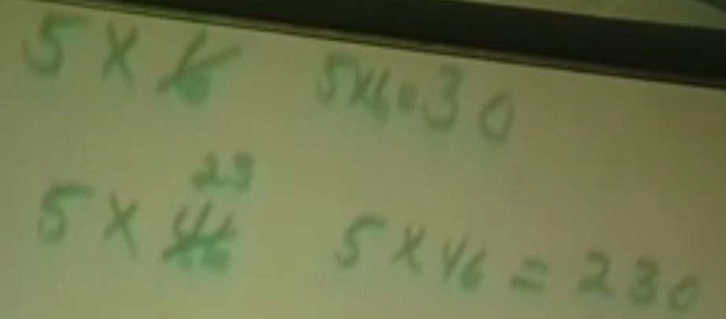

Michelle I. Cool.
Bobby Whoa.
27:39 Reseacher 2 Right? So you can- you can try some oth- now Lindsey has another one for you. (Class laughs) ‘Cause Lindsey does not want to limit her theories to just even numbers. She also wants odd numbers, right? So what’s your rule Lindsey about odd? This is for the even, right?
Jeff I wish I learned this. (Class laughs)
Researcher 2 Jeff, Lindsey invented this. Okay, let’s go on.
28:02 Lindsey Five times an odd number you, um, make the odd number, um, the next smallest number. Then you split that in half again and then you add a five.
Jeff Yeah so five times three would be fifteen.
Researcher 2 Obviously. (Class laughs) You got that? I had to think. What is it- when you took, you- you took the odd number again, Lindsey. You reduced it by…
(Researcher 2 has written this example on the overhead.)

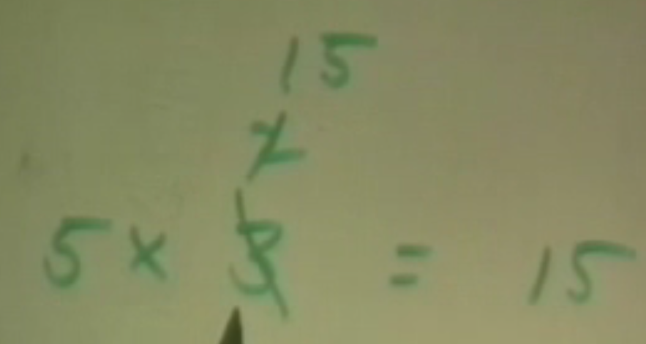

Lindsey Um, the next even number.
Researcher 2 And then you-
Lindsey Add a five.
Researcher 2 And you- when she said add a five, you append a five, right? A five at the end. Let’s try another one. Yes?
Jeff (To Lindsey) What were you doing when you thought this up?
28:44 Lindsey I was just doing some problems and I just figured it out.
Student Wow.
Bobbby Geez.
Researcher 2 Angela you have a question?
Angela It’s the same thing, how could you figure this out?
Researcher 2 Oh no, that’s your problem. (Class laughs) Lindsey has the (inaudible) up here, Angela. This is the problem. The theory is, let’s write this down, five- let’s write the first one down, Lindsey. Five times an even number, right?
Lindsey Mm hmm. You split it-
Researcher 2 How you obtain it- you split it- you split the even number in half, right? And what do you do?
29:27 Lindsey You add- you um, put a zero at the end.
Researcher 2 And, um, append, alright? Append a zero. Right? You’re not adding, like an addition operation, okay? And the next one is five times an odd number, right?
Lindsey Yeah.
Researcher 2 You-reduced it by
Lindsey You, um, make it the next even number-
Researcher 2 Okay, so you make the next even- smaller or larger?
Lindsey The even smaller.
Researcher 2 Okay. You subtract by one is that okay?
30:04 Michelle I. Yeah that’s that’s like what you’re doing.
Lindsey Yeah.
Michelle I. That’s- that’s exactly what you’re doing- subtracting by one.
Researcher 2 So you go to the next smallest even- next smallest number. Even, right?
Lindsey Yes.
Michelle I. (Whispering) You subtract one.
Reseacher 2 And then what do you do?
Lindsey You add- you put, um, a five at the end.
Researcher 2 And? Subtract a one, don’t you? (Pauses)
30:28 Michelle I. (During Researcher 2) Whoa. We leave in five minutes those two periods went by fast.
Amy-Lynn Thank god.
Michelle I. Thank god (inaudible)
Amy-Lynn Yeah.
Bobby Do we still have one more period?
Michelle I. Yeah. But then we’ll be in science, and we’re not allowed to stay. I want to stay, though.
Amy-Lynn So stay (?)
Researcher 2 (To Lindsey) What’s the divide number? And split it, and split it, right? And append what? A five. Okay.
Researcher 2 writes Lindsey’s rule in words on the overhead as shown below.)

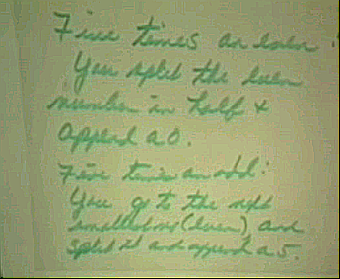

Researcher 2 So your job is, why does this work? Because you know you could- you could make- I’m gonna tea- all the math you’re telling me oh, you just cross out zeros or you just- or you just add this. You have to know why things work because if- and does it always work? I want you to write up why it works. Lindsey, would you like to know why this works? Do you know why it works? No. So she’s discovered it, so now she needs some help. And maybe she can come back tomorrow when you all can tell her. I mean she looks to the wisdom of the seventh grade- almost eighth grade class to guide her in her future. Let’s give her a round of applause. Let’s give her a round of applause. (Class claps). Thank you very much Lindsey. This was lovely. Any theories? Okay, thank you, Lindsey.
31:38 Bobby I know, I know why.
Researcher 2 Bobby knows why?
Bobby Yeah.
Researcher 2 Why?
Bobby Because, like, with an even number, it has to have a zero at the end. (Researcher 2 begins to speak during Bobby’s table’s conversation below) Five times any number has zero. Five times an odd, had a five.
Michelle I. It’s true.
Amy-Lynn It is true.
Bobby (partially inaudible)… always pick me.
Michelle I. (laughs and looks at camera)
Amy-Lynn Way to go, Bobby,
Bobby Thank you, Amy.
Michelle I. Convincing me that you’re smart.
Bobby I know it.
(During Bobby, Michelle I, Amy-Lynn above)
31:47 Researcher 2 My final- my final question to you before you all disappear- if you could just look at this for a moment. Yes, Michael.
(Researcher 2 presents the slide shown below on the overhead.)

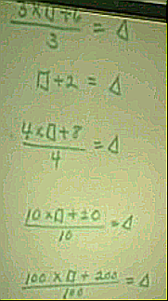

32:00 Michael Well you said we’re crossing zeros without an explanation.Well we are - we do have an explanation.We are taking off a number- a certain number off each side and- to balance it out. Like, if we take off a number from each side and it’s the same thing as crossing it out- if you take off a zero off each side- you take off a- you divide by- (writes on paper) you divide a hundred by ten on top and that equals ten. And you do it each number, you’re not just crossing it out, you’re dividing it. When you take out a zero you’re dividing a hundred by ten equals ten, it’s like crossing a zero out at the end… a shortcut…
32:48 Researcher 2 So what you’re say- what I’m hearing you say, then, partially is that, um, it’s okay to divide- not saying each side- divide the top of a fraction- the numerator by a number- as long as you divide the denominator by the same number. So in other words if I had a fraction four eights, right?
Michael That’d be saying four over eight (?)
Researcher 2 So that’s the same- I could divide both the numerator and denominator by the same number.
Michael It would be a half.
Researcher 2 So I could say, for instance, I could divide them both by four, right? And why does that work? Why does that give you one half? What does it mean to divide the numerator by four and the denominator by four?
Student (inaudible)
Amy-Lynn (Inaudible)
Researcher 2 Right but what am I really doing?
Student You just-
Researcher 2 Why does that work?
(Researcher 2 writes the fraction work as shown below.)

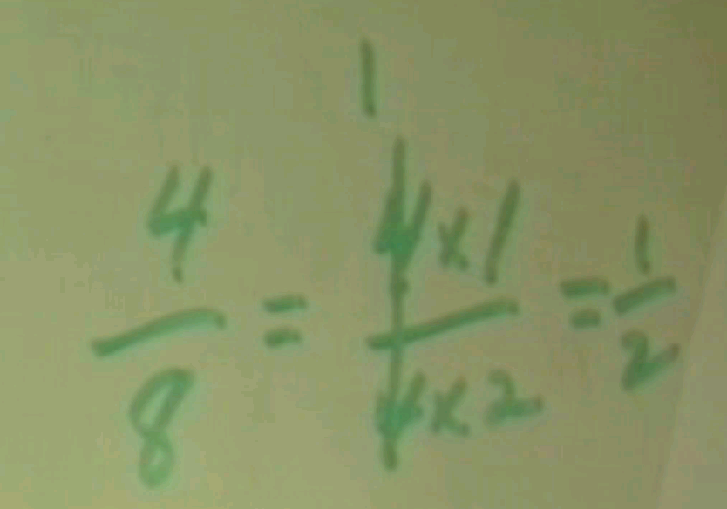

33:44 Michael Because it’s the same thing as a half except that it- it’s in smaller pieces. So all you gotta do is add the four eighths, like four eighths they equal two eighths. One half because it’s just like one half cut into little pieces.
Researcher 2 Anybody else have any ideas? Michael had a- an explanation. Angela?
34:10 Angela You’re just making four eighths, which is one half, more complicated.
Researcher 2 When you write it as four eighths it’s a more complicated version of one half?
Angela ‘Cause like four times one and four- over four times two is just the same as four eighths, it’s just more complicated.
Researcher 2 What made it more complicated?
Angela Like adding times one and times two.
Researcher 2 Okay, anybody else have any thoughts on that? Anybody else have any thoughts? That’s it? I think our time is out. Okay well it’s something to think about for tomorrow. Don’t forget Lindsey’s problem. Isn’t that neat for a third grader? Were you all impressed?
Bobby (To Amy-Lynn) Do we have to write up something about that?
Amy-Lynn No. I don’t think so. We just have to think about it.
(Students exit)

