Camera View: Bobby’s Table 1 of 2 (Bobby, Amy-Lynn, Magdalena, Michelle I.)
Date of filming: 05/16/1995
Harding public school, Kenilworth NJ, Grade 7
Advanced Guess my Rule (AGMR): Inverse: problem
Transcribed by: Andrea DePaolo
Date of transcription: June 2008
Verified by: Eman Aboelnaga
Date of verification: September 2008
Length of session: 00:55:41

Time Speaker Transcription

00:00 (Videographers and facilitators set-up.)
05:52 (Students enter classroom and sit at tables)
(Bobby, Amy-Lynn, Michelle I, and Magdalena test speaker and prepare for the session by getting paper and pens)
11:48 Researcher 1 Are you ready to start? I’m Dr. Dann and I work with these people at Rutgers. Dr. Maher who comes in a lot of times and you probably, some of you, have already guessed what we are going to do today by those sheets that are on the table. No, no. Do you remember doing something called Guess My Rule about two years ago with Dr. Davis? Do you remember something about that? Let’s look at an example.
Michelle I. I remember the sheets but not …
Researcher 1 Suppose that, can you see it, that I am thinking of a rule like this, and what I am going to do is add three to some numbers, and suppose that I put a zero in the box, what would I have to put in the triangle?
(Researcher 1 writes on the overhead as shown below.)

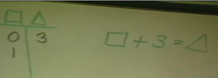

Michelle I. A three.
Researcher 1 A three, okay. Suppose I put a one in the box, what would I have to put in the triangle?
Student from another table: Four
Researcher 1 A four, all right, okay, so this is pretty easy, right.
(Researcher 1 has entered three entries for this rule on the overhead as shown below.)

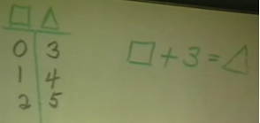

Researcher 1 So far we have limited ourselves to what kind of numbers? What kind of numbers are we using there? We are using positive numbers, does anybody know another name we could call these ever? What other kinds of numbers do you think we could use?
Student? Negative numbers
Researcher 1 We could use negative numbers. What about if we put in negative one what would we have to put in the triangle?
Bobby two
Researcher 1 And if we put negative two we would have to put one in the triangle.
(Researcher 1 fills in two more entries in the table as shown below.)

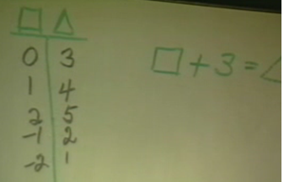

Researcher 1 Okay so what, let me ask you a little bit harder question. This is probably a very easy rule for you but what if I put a ten in the triangle. What would I have to put in the box? Brian?
Brian Seven
(Researcher 1 writes ‘10’ in the triangle column and then enters ‘7’, from Brian’s response, in the box column as shown below.)

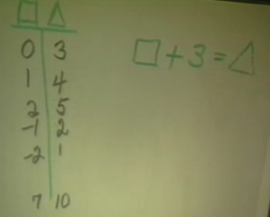

Researcher 1 A seven, and how did you get the seven?
Brian Ten minus three.
Researcher 1 Okay, so the rule that we started off with said that we were adding three but when you were doing it backwards you subtracted three. So addition and subtraction are inverse operations, one undoes the other. Do you know any other operations that work like that? Bobby?
Bobby Multiplication and division.
Researcher 1 Multiplication and division work like that, one undoes the other. They could be called inverses. Do you know of any other kind of operations that work like that? That may be all you’ve had so far. What if you square a number? What if I start with the number five and square it? What do you get?
Student? Twenty-five.
Researcher 1 What does five squared mean?
Amy-Lynn Five times five.
Researcher 1 It means five times five and so you get twenty-five. Does anybody know what you would call it if you went back the other direction?
Ankur The square root.
Researcher 1 The square root. Have you talked about that some, the square root, and does anybody know how to write it? The square root, could you come up and write that for us and do the square root of twenty-five?
(Angela, from Jeff’s table, comes to the overhead and writes
5
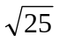 as shown below.)
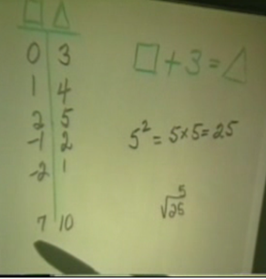

Researcher 1 Okay, would be five, okay, so do you think squaring and square root are also inverse operations right? What I want to do is I’m gonna think of a rule and I am going to put down some numbers that work in the rule and see if you can guess the rule. Do you remember doing that now with Dr. Davis? One day maybe? What do you think? My rule says that if I put a one in the box, that in the triangle I’d have to put one-third and if I put a two I would get two-thirds and… Would you talk to some of your friends there and see if you can think of a rule that would work?
(Researcher 1 writes on the overhead as shown below.)

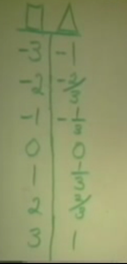

16:31 Michelle I. The first one would be plus two and the last one would be minus two.
Researcher 1 We want a rule that will work on every line.
Amy-Lynn And then they just go, you see how it’s minus two, plus two.
Magdalena It goes by two then one and one-third, then two-thirds, going down.
Bobby Up by two-thirds…
Magdalena Down.
Bobby Going down… minus two-thirds, minus one-third, minus two.
Michelle I./Amy-Lynn/Bobby/Magdalena (together respond while Michelle I. writes the numbers on her paper) Plus two, plus one and one-third, plus two-thirds, plus zero.
(Michelle I. writes: ‘+2, +1¹/_{3,} +²/₃ ’, see below)
Amy-Lynn And then you are just starting with negatives.
Michelle I./Amy-Lynn/Bobby/Magdalena (continue while Michelle I. writes the numbers on her paper) minus two-thirds, minus one and one-third, minus two.
(Michelle I. writes: ‘-²/₃, -1¹/₃, -2’ as shown below.)

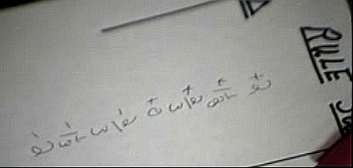

Michelle I. Wow, that was quick.
Magdalena You are going down by two-thirds then you are going up by two-thirds. Are we supposed to write that down?
Michelle I. No
(Conversation turns to a Spanish Test)
I wonder if we are going to get a test in Spanish today, vocab test..
Bobby When it’s negative…
Amy-Lynn With the department and everything, patio el la planto…
I think of sardines.
Researcher 1 Oh you did do something. Okay, all right.
Student We found out the pattern. We are done.
Researcher 1 But what about a rule, is there something you can do that would work on every line?
Magdalena When it’s positive, it goes down by two-thirds; it goes down by two-thirds, and here it goes up by two-thirds, and then, here, it goes up by two-thirds, yes. From the zero it goes down by two-thirds…
Michelle I. …
Researcher 1 I started with a really hard one didn’t I. I’d like to come back to that one. Could we come back to that one later? Let’s try another one. I think that one may not be a rule.
Michelle I. It is not a rule. You have to have a rule for every single one. What if you put minus twenty?
Researcher 1 Suppose that when I put in say negative three in the box, then what I get is negative twelve and when I put negative two I get negative eight.
Bobby/Amy-Lynn
Times four.
Researcher 1 and so forth like this. What do you think of that rule?
(Researcher 1 writes on the overhead as shown below.)

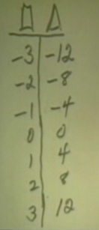

(Bobby, Amy-Lynn, and Michelle I. have raised their hands ready to answer.)
Researcher 1 Angela you think you know that one already?
Angela It’s box times four equals triangle.
Researcher 1 She thinks it is box times four is equal triangle. Anyone else agree with it? Could you come up and write that for us?
(Angela goes to overhead and writes X 4 = as shown below.)

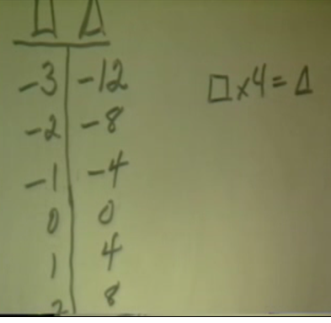

Researcher 1 Could you show us how some of the ordered pairs work there. Like how it is that one and four. Could you show us some of that?
Angela One times four equals four.
Researcher 1 Okay, two times four equal eight. Is everybody seeing that? All right, thank you Angela.
Researcher 1 Um, what about if I put something here like sixty in the triangle. Could you tell me what would have to be in the box? Bobby?
(Researcher 1 adds ‘60’ to the triangle column as shown below.)

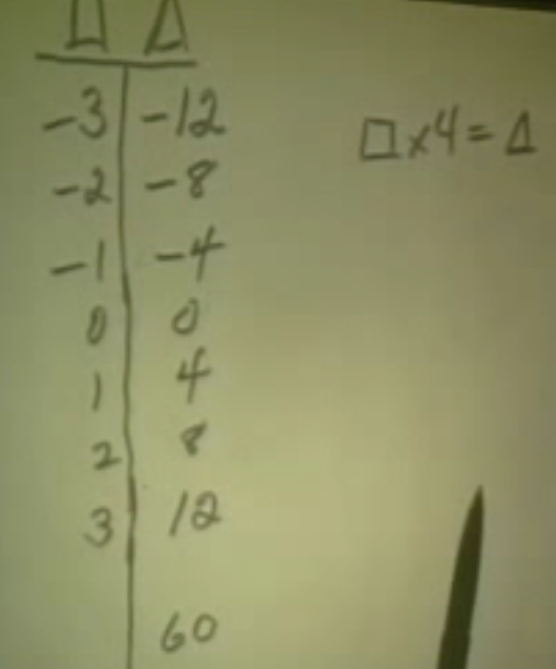

Bobby Fifteen.
Researcher 1 Fifteen, do you think so? And how did you do that Bobby?
Bobby Sixty divided by four.
(Researcher 1 adds ‘15’ to the box column as shown below.)

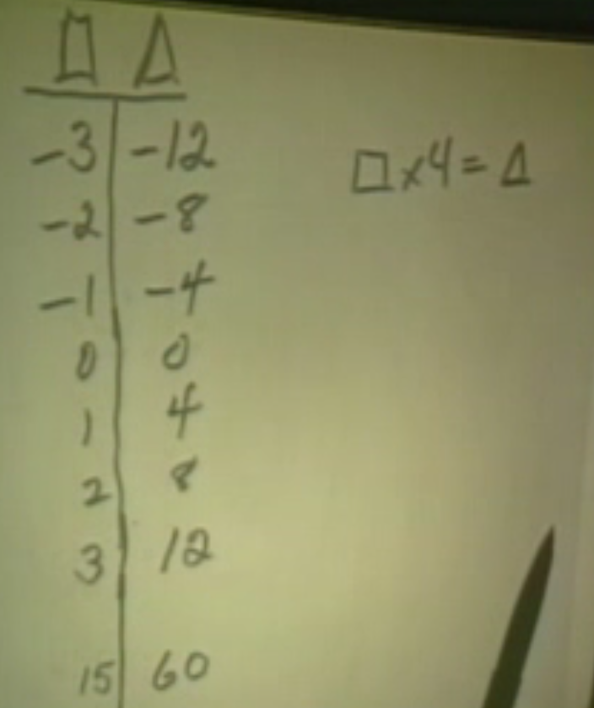

Researcher 1 Sixty divided by four so he’s using the idea of the inverses. Somehow I think you ought to be able to do this one. (R1 goes back to the previous slide at the overhead.) Want to try again? Did you notice, you know that one that fast already.
(Overhead slide is shown below.)

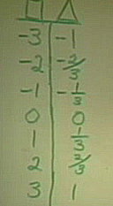

Students? We already knew it.
Researcher 1 Oh you knew it. All right, Michael come up and see if, what other people think about yours.
Michael (comes to the overhead) Uh, write that rule? Just write it down.
Researcher 1 Yeah and see if some other people agree with you.
(Michael writes on the overhead: x ¹/₃ = as shown below .)

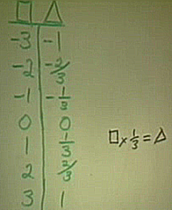

21:22 Researcher 1 What do you think? Did some other people get that rule or if you didn’t get that rule would you see if you think it works? Michael would you mind coming back and convincing some of them, show why you think it works.
Michael Two times one-third.
Researcher 1 Can you write some of those out?
Michael Two times one-third equals two-thirds and two times one-third is one-third plus one-third and that equals two-thirds..
(Michael writes
‘2 x ¹/₃ = ²/₃
¹/₃ + ¹/₃ = ²/₃’ on the overhead, as shown below.)

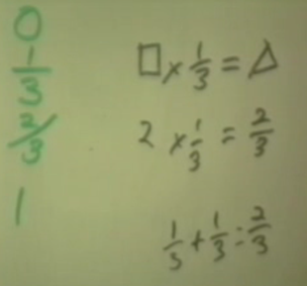

Researcher 1 All right. Are you convinced or you want to see him do some of the other pieces. I think they‘d like to see you do some of the other pairs. They may be convinced that two and two-thirds work, that this row works, what about some of the others?
(At 22:02 Michelle I. has written on her paper as shown below.)
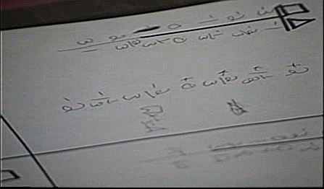

Michael Three times one-third equals one, because there’s three of the one-thirds and that means that three of the one-thirds equal three thirds, which three-thirds equal one.
(Michael writes
‘3 x ¹/₃ = 1
³/₃ = 1’ on the overhead, as shown below.)

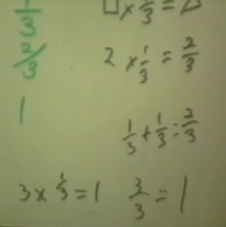

Researcher 1 Who is convinced that his rule works? All right Michael, thank you. Do you know what though it is a little strange to me because I had another rule in mind and I think it works too. Um, here’s what I was thinking about. I was thinking about the box divided by three. The number in the box divided by three is equal to the number in the triangle. Do you think that would work too? Do you think that would work?
(Researcher 1 writes on the overhead

— = as shown below.)
3

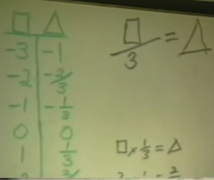

Students? Yes.
(Michelle I. added to her paper as shown below.)
— =
3

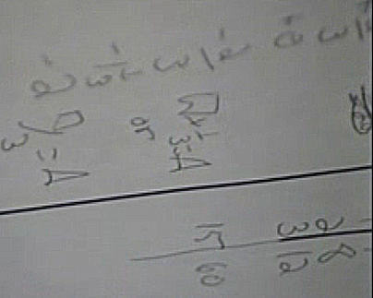

Researcher 1 So you think that there could be two rules for some, some tables? So are you telling me that if you divide a number by three that you get the same answer as if you say one-third times that number? Would that always work? Do you think that works for every number? I’m not sure whether you agree with that or not.
Student? inverse operations …
Researcher 1 So you think you could talk about inverse two different ways in this case. You could say a third, all right. What if I gave you in the triangle the number two, what number would have to be in the box? Okay, Amy-Lynn.
Amy-Lynn Six.
Researcher 1 Does everybody think six will work? All right, all right. Very good you’re off to a good start. What about, maybe this one is a little harder for you.
(Researcher 1 writes on the overhead as shown below.)

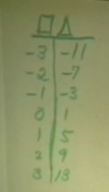

(Bobby’s table works on the rule. Each student copies the table onto their own paper.)
26:17 Bobby This side goes down by four. This goes down by one.
Michelle I. What’s the rule? We have a pattern but now we need the rule.
(Students continue to work on the problem)
Amy-Lynn Wait I got something. Look. This times four plus one, times four plus one, times four plus one, times four plus one.
27:02 (Amy-Lynn writes ‘x 4 + 1’ on her paper.)
Magdalena It won’t work. No, it won’t work. No. It doesn’t work on the first one.
Bobby It should be times four minus one.
Amy-Lynn Minus one.
Michelle I. When it’s negative, it’s times four minus one. When it’s positive, it’s times four plus one.
(Amy-Lynn and Michelle I. hi five)
Bobby It should be negative. It should be like negative one, negative five.
Michelle I. When it’s negative, it’s times four minus one, when it’s positive it’s…
Magdalena It can’t be plus, or minus one, it has to be plus negative one.
Michelle I. Plus negative one, it is the same thing, plus negative one and minus one.
Magdalena No, cause if you plus one you like minus-ing from it, cause if you go negative three times four plus one, so it’s a negative. Oh that’s it. That’s it.
(Amy-Lynn speaks to Researcher 1 about her rule.)
27:50 Amy-Lynn Yeah, like when it’s negative like these, it’s times four minus one, cause and then when it’s positive you do times four plus one.
Researcher 1 Amy-Lynn thinks she has a rule. Does anybody else? We will give them another minute or two? Then we can let you put that up and see what they think?
Michelle I. So, it’s always times four plus one.
Amy-Lynn Always times four plus one?
Bobby Yeah, cause when you add it to a negative number it’s.
Michelle I. Okay.
Amy-Lynn Times four plus one.
Michelle I. It’s always times four plus one.
Magdalena Yeah that’s it.
(They all write that down on their paper.)
(At 29:32 Michelle I.’s paper is shown below.)

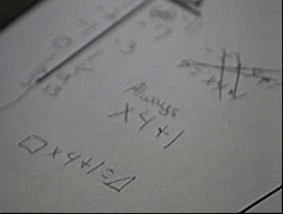

Bobby It is box times four plus one equals triangle. Cause the box times four.
Amy-Lynn Then what would this be negative three times four…
Magdalena Equals negative eleven plus one like minus-ing so it’s negative eleven. Get me.
Amy-Lynn No.
Magdalena Cause if you plus the positive number to a negative number it goes down.
Bobby Say you owe someone twelve dollars and you gave him a dollar then you only owe him eleven.
(All laugh)
Researcher 1 Does anybody else think they have it yet? The rule? How are you doing over there?
Student from
another table We got one.
Researcher 1 You got one? Let’s let Amy-Lynn put hers up and see if you agree with that one. Amywould you do that for us.
Amy-Lynn Should I just do it in the thing, cause this is what we came up with, like times four plus one, that was like our rule, to do with everything in the box.
(Amy-Lynn writes
x 4 + 1
x 4 + 1 = on the overhead, as shown below. )

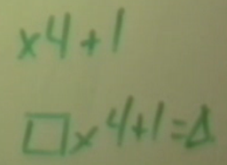

Researcher 1 What do you think of Amy-Lynn’s rule? That same rule you got? Or you couldn’t? What about over there at the far table? Do you agree with it?
Students (whisper) Yes.
Researcher 1 Do you want her to convince you or do you agree with her? Do you agree? You Agree? Thank you Amy-Lynn that’s really nice. What if I put forty-nine in the triangle? Could you tell me what would have to be in the box? Already? Michelle.
Michelle I. Twenty-four.
Researcher 1 Michelle thinks twenty-four.
Bobby Twelve.
31:07 Researcher 1 And you think twelve.
Magdalena It’s twelve now.
Researcher 1 Lots of people are thinking twelve.
Michelle I. I did it wrong. I calculated wrong.
Researcher 1 Do you agree with that twelve? What did you do? Does everybody agree that twelve works? You had twelve times four. Angela?
Angela Forty-nine minus one divided by four. Forty-nine minus one is forty-eight and you divide by four.
Researcher 1 So Angela is saying that she took the forty-nine and subtracted one and then divided by
Angela Four.
Researcher 1 Four. Do you think you could write that for us where we had triangle equal to something with the box?
(Researcher 1 writes on the overhead
= as shown below.)

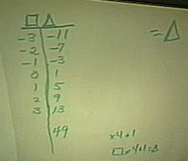

(Angela goes to overhead)
Angela I can do it like backwards?
(Angela writes on the overhead
– 1 ÷ 4 = as shown below. )

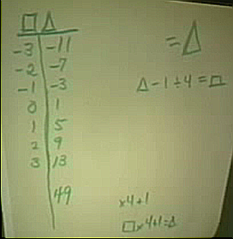

Researcher 1 Can you do that? Do it either way you want to. All right. Now I heard you say something different from that before, you took forty-nine minus one and you got forty-eight and then what did you do?
Angela You divided forty-eight by four.
Researcher 1 Oh and you have division there. Okay, I see what you did. Okay, all right that’s good. I read that as a plus sign. Does everybody know that you could also write this, this way if you want to.
(Researcher 1 writes on the overhead:

– 1 = as shown below.)
4

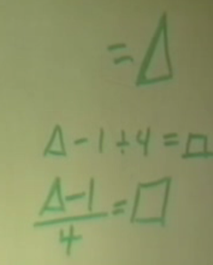

Researcher 1 It is just a different way of writing. That’s really nice. Do you want to try another one, see if we can stump you?
Michelle I. We are child prodigies. That guy at Wendy’s believed Mike too.
Researcher 1 Let’s say that when we do this we get zero and when we put in negative two that we get two.
(Researcher 1 writes a new table at the overhead as shown below.)

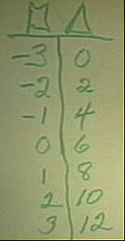

(Students at Bobby’s table copy the table to their paper.)
33:26 Michelle I. Plus three. It worked for the first two didn’t it?
Magdalena For the first one
Michelle I. The first one negative three plus three is zero.
Magdalena For the next one is plus four.
Michelle I. Oh, sorry.
Bobby Plus three, plus four, plus five, plus six, plus seven, plus nine
Michelle I. Shut up Bobby.
Bobby No, look really, plus three, plus four, plus five, plus six, plus seven, plus nine.
Michelle I. But you have to find the rule.
Bobby Messed up. No, really. It goes from seven to nine.
Michelle I. But we have to find a rule.
Magdalena I know.
Michelle I. So do I.
Bobby Times two plus six,
Amy-Lynn What about for this?
Bobby …two times two, negative two times two is negative four plus 6 equals two, negative one times one is negative two plus six is four.
Amy-Lynn Cool Bobby. Way to go Bobby
Michelle I. It has to be the same rule every time
Magdalena Yeah, it is.
Michelle I. I thought he said like negative.
Magdalena No look, it’s times two plus six.
Michelle I. So two times two plus six equals triangle, ten.
Researcher 1 Who thinks they have the rule?
Student? I do.
Researcher 1 Oh, Okay. Magdalena you want to put the rule that you have up and see if they agree with you?
Amy-Lynn Bobby
(Magdalena goes to overhead and writes:
x 2 + 6 = as shown below.)

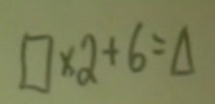

Bobby This is not fair, I never get any credit.
Michelle I. It is on camera Bobby, don’t worry.
Amy-Lynn Hopefully she could hear you.
(Laughter)
Researcher 1 Is that what the rest of you got or somebody have a different rule? Everybody had that same rule?
35:59 Researcher 1 Magdalena, can you give them a number to put in the triangle and see if they can find the number in the box. Can you think of a good number to put in the triangle?
Michelle I. Box divided by two minus six equals.
Bobby What about the second one?
Amy-Lynn Let Bobby go up.
Bobby No.
Amy-Lynn Let Bobby go up.
Michelle I. I have a different one.
Amy-Lynn What?
Michelle I. It’s triangle divided by two minus six equals box.
Amy-Lynn Does it work?
Michelle I. It’s the same thing but backwards.
Magdalena I’ll put fifty-six.
(Magdalena writes ‘56’ in the triangle column.)
Bobby Just put this on everybody’s paper so they know it’s mine.
Researcher 1 Magdalena put fifty-six in the triangle. Could you tell her what you had in the box? Okay, Michael.
Michael Twenty-five.
Researcher 1 Twenty-five and everybody agrees with that. And how did you get it Michael?
Michael Minus six, fifty-six minus six and I divided by two.
Michelle I. Isn’t it..
Researcher 1 Could you write that as a rule?
(Michael goes to the overhead and writes:
– 6 = as shown below.)
2

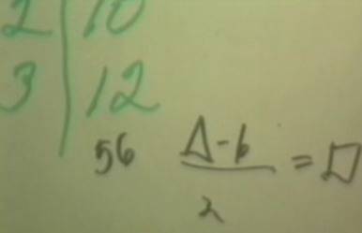

Michelle I. Divided by two minus six.
Magdalena It is times two plus six.
Michelle I. Don’t mind me. I came from gym and I am still a little sloppy.
Researcher 1 All right that’s nice. But you know what I had another, a different rule that I think works. I had this. Tell me if you think that this would have to work too. I had two times box plus three is equal to triangle.
(Researcher 1 writes on the overhead
2 x ( + 3 ) = as shown below.)

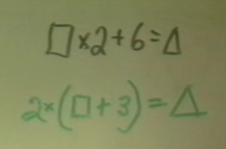

Michelle I. Wow, that’s heavy stuff. No.
Researcher 1 Do you think that works?
Michelle I. Yes, it definitely does.
Researcher 1 Well do you think there are just two rules that work? Do you think that one works, that both of those work? Do you think there are any other rules that work?
Amy-Lynn There might be but I don’t feel like working on them.
Researcher 1 Can anybody tell me why that works? It seems a little strange to me. Bobby?
Bobby You have to do the work in the parenthesis first and like, then, if you add three to negative three, it’s zero, and, if you times two by it, it like stays the same cause it’s zero, and it like works on every one.
Researcher 1 Did you understand what Bobby said? Does anybody think it’s odd that you have a three down there you have a box plus three but when you have the rule the other way you have a six and that you get the same number? What do you think Ankur?
Ankur Two outside the parenthesis so it becomes sort of like a six.
Researcher 1 Would you go up and explain what you are saying?
Ankur The two outside of the parenthesis doubles what ever's inside.
Researcher 1 You mean it doubles everything that’s inside.
Ankur Yes.
Researcher 1 All right, what do the rest of you think?
Bobby? Two squared?
Researcher 1 Think that will always be true, Jeff?
Jeff Yes
Researcher 1 Jeff thinks yes.
Student? I do too.
Researcher 1 You think yes too. All right, all right. Let’s try another one.
Amy-Lynn She’s getting mad at us. We are knowing, we are getting these too fast for her.
Michelle I. ??
Researcher 1 Maybe this is too easy.
Michelle I. ???
Amy-Lynn What?
Michelle I. (Laughter) ?
Michelle I. I am still slow from gym and you people.
Magdalena or Amy-Lynn
I should be slow I had Health.
39:57 Researcher 1 This one is probably too easy for you.
(Researcher 1 writes a new table at the overhead as shown below.)

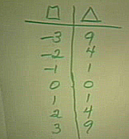

(Students at Bobby’s table copy the table to their paper.)
Magdalena It um times um.
Amy-Lynn It’s times its number.
Michelle I. Times its number.
Bobby No, cause you times three by negative three, it is negative nine.
Amy-Lynn No it ain’t.
Bobby Yes it is.
Researcher 1 Jeff thinks he has a rule. Anybody else? Jeff do you want to come put up the rule and see if they agree with you?
Bobby Box times the square root of fifty-two adding negative nine plus two you get it.
Michelle I. Yeah, Bobby. whatever.
Amy-Lynn Yeah, that is what we had.
(Jeff comes to the overhead and writes x = as shown below.)

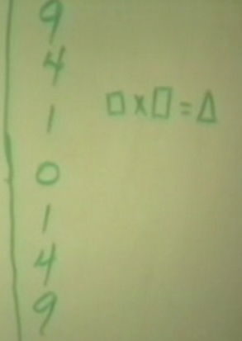

Jeff Box times box is triangle.
Bobby (raises his hand). Ur that’s wrong.
Michelle I. That does not work cause if it’s negative three times negative three it’s negative nine.
Amy-Lynn/Magdalena
It’s positive nine.
Amy-Lynn It’s positive nine.
Michelle I. No, you people, you people told me that.
Amy-Lynn Yeah .. I said it wasn’t right.
Michelle I. I was just repeating what they said, and I disagreed with it, and then they tell me that I am wrong. So it is their fault that I was wrong.
Michelle I. It’s on the camera. I’m telling you.
Amy-Lynn I said it before. Shelly (Michelle I.) and I said it and you (meaning Magdalena) said we were wrong.
Magdalena No I didn’t. Bobby said it.
Amy-Lynn Bobby said you were wrong.
Michelle I. Bobby the supposedly child prodigy over there.
Researcher 1 So they are having a discussion at this table. They feel that some people were led astray about negative three times negative three being negative nine or positive nine?
Amy-Lynn/Michelle I.
It’s nine.
Bobby You times the whole number …?
Researcher 1 Do you want to write that for us Michael? Michael has another way of writing it.
Student Sarah wants to.
Researcher 1 Sarah.
(Laughter at Bobby’s table)
(Michael comes to the overhead and writes
² = as shown below. )

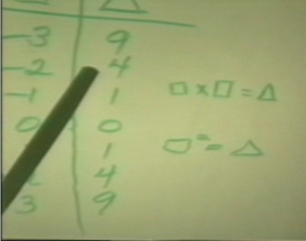

Researcher 1 All right. Thank you. That’s great. Now, did I hear someone talking about square roots? Were you talking about square root?
Michelle I.? Fortunately.
Amy-Lynn Poor Shelly.
Researcher 1 Were you talking about the square root?
Bobby I said the square root of fifty-two.
Amy-Lynn Plus six or something
Angela (explains her answer to Researcher 1)
Researcher 1 Angela is saying that if I gave you a number over here like twenty-five, that you would ‘ve to find the square root. (Researcher 1 adds ‘25’ to the triangle column.) There is a little confusion about that. Look, when we had nine on this side, and we went backwards we could get a three. We also worked that nine would give us a negative three. So that’s a little different isn’t it. What if I put a negative thirty-six here.
(Researcher 1 adds ‘-36’ to the triangle column as shown below.)

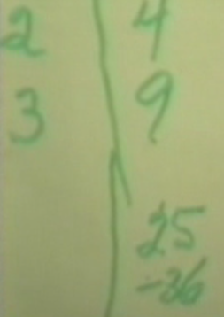

Researcher 1 What would you get on the other side? Brian?
Brian It is either a positive or a negative six. I’m not sure.
Researcher 1 Hey, Brian thinks it’s either a positive six or a negative six. What did you think Joe? (talking to Jeff)
Joe (Jeff) Nothing.
Magdalena It’s a negative,
Michelle I. I am not saying anything cause you people always make me look wrong.
Researcher 1 Bobby?
Bobby You can’t put a negative there. Cause to get a negative number you have to times like a positive and a negative. So you get a negative.
Michelle I. So that’s a negative times a negative and that’s a positive. Which Bobby got wrong before and made me look dumb.
Researcher 1 They’re saying over here that they don’t think I should put a negative over here that you wouldn’t be able to get an answer.
Michelle I. No.
Bobby Yes, that’s what I’m saying.
Researcher 1 Do you think that’s right?
Amy-Lynn Bobby’s saying it, not us.
Researcher 1 We shouldn’t use this negative thirty-six over here. Okay.
Amy-Lynn/Michelle I.
We are saying it because it is right.
Researcher 1 All right. You’re doing great. You told me you would.
Amy-Lynn Bobby’s on a roll.
Michelle I. I am going to solve this next one. My brain is in full gear.
Amy-Lynn Don’t get emotional.
Researcher 1 Maybe this one will be a little bit harder.
Michelle I. Don’t make me look dumb.
Magdalena …
Michelle I. And you agreed with him too.
Amy-Lynn No you didn’t.
Magdalena …
Amy-Lynn No you didn’t. You told me. Then I said something then Shelly said something. Then you made poor Shelly look like an idiot.
(Researcher 1 writes on the overhead as shown below.)

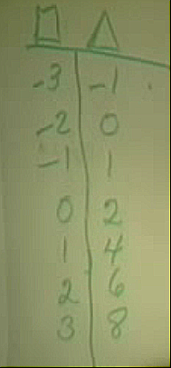

(Students at Bobby’s table copy the data to their paper.)
44:37 Magdalena …You made yourself look like an idiot.
Michelle I. I just wanted to point out that it’s wasn’t me it was you.
Bobby Plus two, plus two
Michelle I. Plus two.
Magdalena Plus two.
Michelle I. I don’t think it is plus two anymore.
Researcher 1 No, I did that wrong. I did that wrong.
Michelle I. No, we just messed up the whole box.
Researcher 1 This should be three. This should be four. This should be five.
(Researcher 1 corrects the table on the overhead as shown below.)
-3 | -1
-2 | 0
-1 | 1
0 | 2
1 | 3
2 | 4
3 | 5

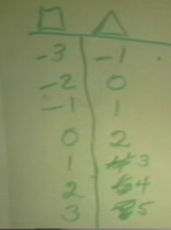

(Students at Bobby’s table correct their paper.)
Bobby For some reason, I was right.
Michelle I. We all said that Bobby, don’t try to take the credit.
Researcher 1 Michelle has a rule already.
Michelle I. Plus two.
Researcher 1 Want to come and write the rule for us?
Amy-Lynn Yeah, Shelly. She got one, her brain is in gear. It’s on camera.
Gonna play the tape back for Shelly.
(Michelle I. goes to the overhead and writes as shown below.)

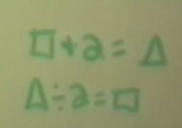

Researcher 1 That turned out pretty easy didn’t it. And here I thought I’d made a harder rule. Do you know what my rule was?
Amy-Lynn Plus two.
Bobby Times four minus two.
Researcher 1 I had three times the number in the box plus six divided by three is equal to the number in the triangle. Do you think that would work? Do you think that would work?
(Researcher 1 writes on the overhead
3 x + 6 = as shown below. )
3

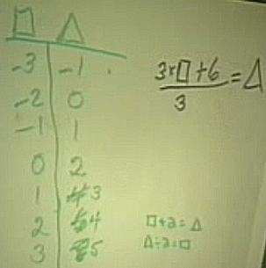

Magdalena/Amy-Lynn
…complicated, why can’t you do it the easy way?
Student? I guess so.
Researcher 1 Would you tell me if it works?
Student? It does.
Researcher 1 So what do you think Stephanie why does it, that work out to be the same? Think that might work out to be the same?
46:45 Bobby? Divide by three’s and zero.
Researcher 1 Think why that might work out to be the same.
Bobby No, cause like negative two times three is negative six plus six is twelve, and, if you divide it by three, it will be four not zero.
Researcher 1 So are you, I wasn’t sure what you are saying Bobby, do you get the same answer or a different answer?
Bobby A different answer.
Magdalena Three times negative two….
Researcher 1 Bobby is getting a different answer. Are some other people getting a different answer too? Angela?
Magdalena ….It is negative three and when you divide by three it is zero….
Angela Shelly made a mistake up there. She put box plus two then she put triangle divided by two.
Michelle I. It’s the same thing, Angela. Oh, sorry, it’s supposed to be minus not divide. Sorry about that.
Researcher 1 All right. Thank you Angela, I hadn’t noticed it. That’s good.
Magdalena So if you times three times negative three.
Researcher 1 Do you want to change that who put it up?
(Michelle I. goes to the overhead and changes the division sign to a minus sign,
– 2 = as shown below. )

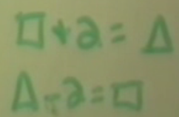

Magdalena Cause it you go three times negative three it’s negative nine plus six is negative three.
Researcher 1 What I want to know if three times the number in the box plus six divided by three does that work for all of them?
Magdalena It doesn’t.
Bobby Negative three times two is six.
Amy-Lynn Negative six.
Booby Plus six is..
(Bell rings)
Amy-Lynn It doesn’t, cause look at the next one.
Magdalena/Bobby
Look at the first one
Amy-Lynn/Michelle I./Magdalena
Negative three times three is negative nine plus six is negative three divided by three is zero.
Michelle I. We know the answer.
Bobby Three divided by three is one.
Michelle I./Amy-Lynn/Magdalena
Oh, it works. Oops.
Researcher 1 It doesn’t work?
Michelle I./Amy-Lynn/Magdalena
It works. It works. We just kinda miscalculated again.
Michelle I. I can’t agree with you people any more you always make me look dumb.
48:45 Researcher 1 Some people think it works and some people think it doesn’t work.
Magdalena I think it works.
Michelle I./Amy-Lynn
It works.
Bobby I messed up.
Amy-Lynn We miscalculated
Michelle I. Bobby you messed up again.
Researcher 1 What do you think Michael. It works?
Magdalena/Michelle I./Amy-Lynn
It works
Bobby Three divided by three is really zero.
Michelle I./Amy-Lynn
It works.
Researcher 1 Now, it would be a whole lot easier for me to write it as box plus two equals triangle if I knew that was the same. Is there any way I could know that it was the same?
Student? Test it?
Researcher 1 To do?
(Bobby’s table is working)
Magdalena What are we doing?
Amy-Lynn I don’t know.
Researcher 1 Does anybody have an idea why that could be the same?
(Bell rings)
Michelle I. Maybe there’s two rules for every one.
Magdalena Look six divided by three is two so it might work. I don’t know I just thought of it.
Michelle I. Six divided by two. Whoa.
Magdalena Is it two?
Bobby What?
Magdalena Six divided by three.
Bobby/Amy-Lynn
Yea. (laughter)
Amy-Lynn Like I was just making sure.
Michelle I. I was just making sure.
Amy-Lynn Then because if you say something… I can blame Bobby.
Michelle I. Do you know what one plus one is?
Magdalena Is it two?
Amy-Lynn No that’s one divided by one.
Researcher 1 Want to come try? Michael just wants to stay at his desk. He doesn’t want to come up.
Michael Six on the top divided by the three at the top equal two. Then the two threes, on the bottom and the top, cross each other out, so it’s box plus two.
Magdalena That’s what I got.
Amy-Lynn Way to go Magda.
Researcher 1 What do you think, did you hear what Michael said?
Michelle I. Yes I did.
Researcher 1 What do you think about that?
Michelle I. I think it’s true.
Researcher 1 I don’t know that’s sounds a little dangerous this crossing things out. I wonder if it’s anything like trying to find the one you did before?
Michelle I. Multiplication. I just said that for the heck of saying.
Amy-Lynn Scooby Dooby Doo.
Researcher 1 We were looking at something else where you had two times the number in the box plus six, I think it was, and you told me that that would be the same as this. And I wonder if there is anything about this one that’s like that one?
(Researcher 1 writes on the overhead:
2 + 6 =
2 ( + 3 ) = as shown below.)

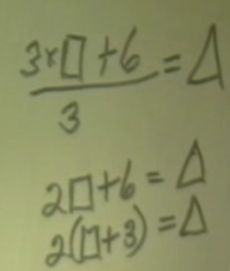

Michael Because if you have a variable in the parenthesis, you can divide, I mean times each number by itself. Like two times the box is two box, and two times three is six, so it’s the two times the .. I’ll write it down.
(Michael goes to the overhead and explains how two times box plus three is equal to two times box plus two times three using distribution)
Researcher 1 If you need anymore here…
Michael Okay, well, here if you don’t know how, box plus three, there is the variable here, you can times two times the box which is two box, plus two times three is six which is the same thing as this.
Amy-Lynn We had the same thing…
Researcher 1 Okay, what does that have to do, don’t go away. Is there any thing about this one that’s like that? …Okay.
Michelle I. cold
Amy-Lynn I keep my chin up.
Michelle I. I don’t wanna..
Bobby I got the answer. (shows paper to ..
Michael Three times the box can be written as three box plus six. They are similar to each other, three box plus six and two box plus six.
(Michael writes on the overhead:
3 + 6 = as shown below.)
3

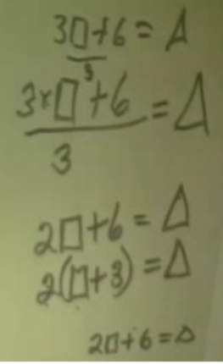

Researcher 1 Instead of multiplying by two
Michael the top and then dividing it, multiplying….
53:48 Researcher 1 Would it hurt anything if I put, don’t go away, would it hurt anything if I put parenthesis right here?
(Researcher 1 adds parenthesis to the overhead:
( 3 x + 6 ) = as shown below.)
3

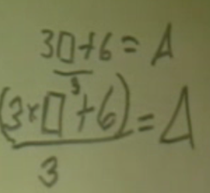

Michelle I. No
Michael No, it wouldn’t hurt.
Researcher 1 Would it help any?
Amy-Lynn If would be three box plus nine using the distributive. It would be three box plus nine.
Michelle I. ..
Bobby What did I do
Michelle I. You have the answer (shows Bobby’s paper to the camera)
Researcher 1 So you’re saying this one looks like this one.
Michael That is except for the division…..
Researcher 1 That instead of multiplying you are dividing it.
Bobby Who cares, it is the right answer.
Researcher 1 So what do you think about what Michael is saying? Do you think that might be the reason that?
Researcher 1 Could somebody make up another one that you think would work two ways? See if you can make up one that would work two ways.
Amy-Lynn/Bobby
Okay.
Michelle I. Zero, two
Magdalena What are you making up?
Michelle I. I don’t know.
Amy-Lynn She’s making up numbers.
Michelle I. Let’s do it so it’s...
Bobby Let’s use this equation (Bobby points to the equation on his paper)
Michelle I. Let’s use this one, negative three times two plus one. Let’s use square root to make it really hard. That would be fun.
Magdalena And you get lost again
Michelle I. Get lost in your own problem. Wait a second what did I do here?
Bobby I am going to figure this out.
55:41 Michelle I. Okay, so…

