Camera View: Jeff’s Table 1 of 2(Jeff, Michael, Angela, Sarah)
Date of filming: 05/16/1995
Harding public school, Kenilworth NJ, Grade 7
Advanced Guess my Rule (AGMR): Inverse: problem
Transcribed by: Vanessa I. Bell
Date of transcription: 6/2009
Verified by: Andrea DePaolo
Date of verification: August 2010
Length of session: 00:46:11

Time Speaker Transcription

00:00 (Videographers and facilitators set-up.)
08:09 (Students enter classroom and sit at tables)
Jeff, Michael, Angela and Sarah test speaker and prepare for the session by getting paper and pens)
14:03 Researcher 1 Are you ready to start? I’m Dr. Dann and I work with these people at Rutgers. Dr. Maher who comes in a lot of times and you probably, some of you, have already guessed what we are going to do today by those sheets that are on the table. No, no? Do you remember doing something called Guess My Rule about two years ago with Dr. Davis? Do you remember something about that? Let’s look at an example. Suppose that, can you see it, that I am thinking of a rule like this, and what I am going to do is add three to some numbers, and suppose, that umm, I put a zero in the box, then what will I have to put in the triangle?
(Researcher 1 writes on the overhead:)

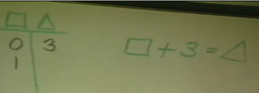

Michelle I. A three.
Researcher 1 A three, okay, suppose I put a one in the box, what would I have to
put in the triangle?
Student from another table: Four
Researcher 1 A four, all right, okay, so this is pretty easy, right.
(Researcher 1 has entered three entries for this rule on the overhead.)

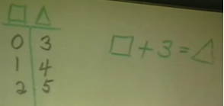

Researcher 1 So far we’ve limited ourselves to what kind of numbers? What kind of numbers are we using there? We are using positive numbers, does anybody know another name we could call those ever? What other kinds of numbers do you think we could use?
Student Negative numbers.
Researcher 1 We could use negative numbers. Okay. What about if we put in negative one what would we have to put in the triangle?
Student from
another table Two
Researcher 1 Two. And if we put negative two we would have to put one in the triangle.
(Researcher 1 continues and fills in two more entries in the table.)

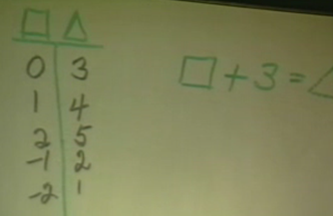

Researcher 1 Okay, so what, let me ask you a little bit harder question. This is probably a very easy rule for you but what if I put a ten in the triangle. What would I have to put in the box? Brian?
Brian Seven
(Researcher 1 writes ‘10’ in the triangle column and then enters ‘7’, from Brian’s response, in the box column.)
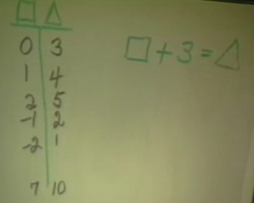

Researcher 1 A seven, and how did you get the seven?
Brian Because ten minus three is seven.
Researcher 1 Okay, so the rule that we started off with said that we were adding three but when you were doing it backwards you subtracted three. So addition and subtraction are inverse operations, one undoes the other. Do you know any other operations that work like that? Bobby?
Bobby Multiplication and division.
Researcher 1 Multiplication and division work like that, one undoes the other. They could be called inverses. Do you know of any other kind of operations that work like that? That may be all you’ve had so far. What if you square a number? What if I start with the number five and square it? What do you get?
Angela Twenty-five.
Researcher 1 What does five squared mean?
Amy-Lynn Five times five.
Researcher 1 It means five times five and so you get twenty-five. Does anybody know what you would call it if you went back the other direction?
Ankur The square root.
Researcher 1 The square root. Have you talked about that some, the square root, and does anybody know how to write it? The square root, could you come and write that for us and do the square root of twenty-five?
(Angela, from Jeff’s table, comes to the overhead and writes:)
5
√25

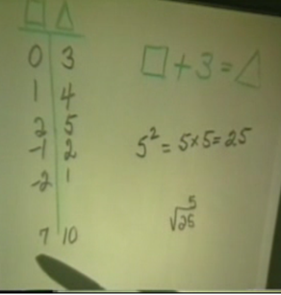

Researcher 1 Okay, would be five, okay, so do you think squaring and square root are also inverse operations right? What I want to do is I’m gonna think of a rule and I am going to put down some numbers that work in the rule and see if you can guess the rule. Do you remember doing that now with Dr. Davis? One day maybe? What do you think? My rule says that if I put a one in the box, that in the triangle I’d have to put one-third and if I put a two I would get two-thirds and… Would you talk to some of your friends there and see if you can think of a rule that would work?
(Overhead shows:)

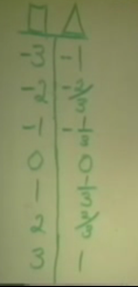

18:34 Angela Okay.
Michael The box means one-third.
Angela It looks like whatever the number is divided by three, like over three.
Michael The box times one-third.
Researcher 1 We want a rule that will work on every line.
Angela Let’s check it again. The box times one-third equals the triangle, right?
Sarah (Asks something inaudible to Angela.)
Angela What? What the rule is Sarah.
Sarah What?
Angela We’re trying to figure out what the rule is.
Sarah What Rule?
Angela That.
Sarah Oh. The box times… (looks puzzled.)
Angela Times one-third equals the triangle.
Sarah One-third?
Angela Yes.
Jeff Just look, zero and zero and one and one-third equals zero and one-third.
Angela (Laughs) Three times one-third equals one Sarah because it’s three-thirds. (spoken in a condescending tone)
Sarah I know that.
Angela (laughs) God. (mutters to herself while fixing her name tag and shaking her head.)
Angela Michael, what are you doing?
Michael (no response given)
Michael Are we done?
Angela I don’t know, I guess.
Sarah Angela, you know what my name is spelled backwards?
Angela Haras, haras, harass.
Sarah (Laughing) I didn’t know that.
Researcher 1 Okay, alright. But what about a rule, is there something you can do that would work on every line?
Angela That’s not good. Sarah, go and sing into the microphone this time.
Angela Mike, do you know what her name spelled backwards is? Harass.
Researcher 1 I started with a really hard one didn’t I?
Angela That was easy. That was easy, we got it.
Researcher 1 I’d like to come back to that one. Could we come back to that one later?
Angela Yeah.
Researcher 1 Let’s try another one. I think that one may not be a rule. Suppose that when I put in say negative three in the box, then what I get is negative twelve and when I put negative two I get negative eight.
Angela Times four. Because a negative times a negative equals a positive.
Researcher 1 and so forth like this. What do you think of that rule?
(Researcher 1 writes the table below on the overhead)

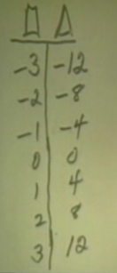

Angela Oh that’s easy. (Raises hand.)
Researcher 1 Angela you think you know that one already?
Angela It’s box times four equals triangle.
Researcher 1 She thinks it is box times four is equal triangle. Anyone else agree with it? Could you come up and write that for us?
(Angela goes to the overhead and writes x 4 = .)

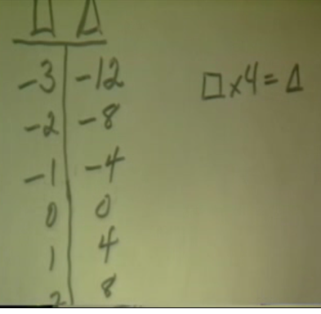

Researcher 1 Could you show us how some of the ordered pairs work there? Like how it is that one and four. Could you show us some of that?
Angela One times four equals four.
Researcher 1 Okay, two times four equal eight. Is everybody seeing that? All right, thank you Angela.
Dr.Dann Um, what about if I put something here like sixty in the triangle. Could you tell me what would have to be in the box? Bobby?
(Researcher 1 writes ‘60’ in the triangle column.)

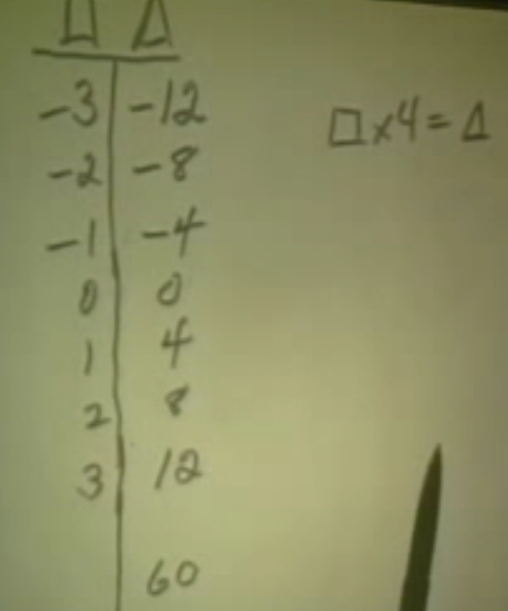

Bobby Fifteen.
Researcher 1 Fifteen, do you think so? And how did you do that Bobby?
Bobby Sixty divided by four.
(Researcher 1 writes ‘15’ in the box column.)

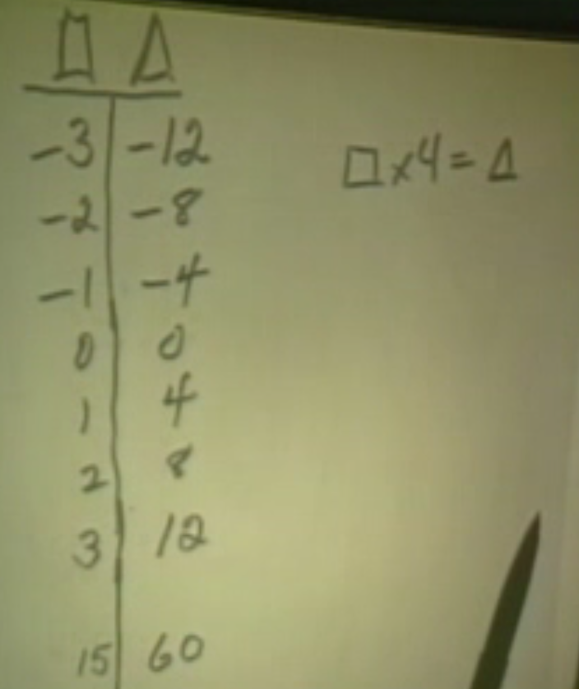

Researcher 1 Sixty divided by four so he’s using the idea of the inverses. Somehow I think you ought to be able to do this one. (she goes back to the previous sheet at the overhead) Want to try again? Did you notice, you know that one that fast already.
(Overhead shows:)

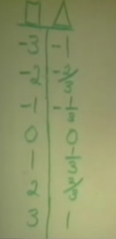

Michael We already knew it.
Angela We knew it.
Researcher 1 Oh you knew it. All right, Michael come up and see if, what other people think about yours.
Michael (comes to the overhead) Uh, write that rule? Just write it down.
Researcher 1 Yeah and see if some other people agree with you.
(Michael writes on the overhead: X ¹/₃ = as shown below:)

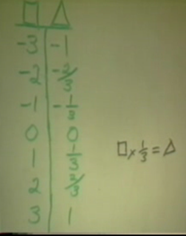

23:39 Researcher 1 What do you think? Did some other people get that rule or if you didn’t get that rule would you see if you think it works? Michael would you mind coming back and convincing some of them, show why you think it works.
Michael Two times one-third.
Researcher 1 Can you write some of those out?
Michael Two times one-third equals two-thirds and two times one-third is one-third plus one-third and that equals two-thirds..
(Michael writes on the overhead
2 x ¹/₃ = ²/₃ and ¹/₃ + ¹/₃ = ²/_{3.})

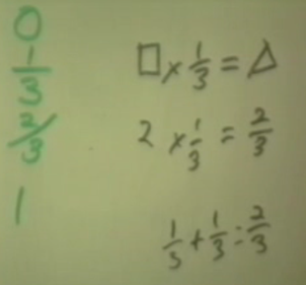

Researcher 1 All right. Are you convinced or you want to see him do some of the other pieces. I think they‘d like to see you do some of the other pairs. They may be convinced that two and two-thirds work, that this row works, what about some of the others?
Michael Three times one-third equals one, because there’s three of the one-thirds and that means that three of the one-thirds equal three thirds, which three-thirds equal one.
(Michael writes on the overhead 3 x ¹/₃ = 1 and ³/₃ = 1.)

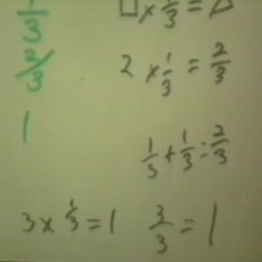

Researcher 1 Who is convinced that his rule works? All right Michael, thank you. Do you know what though it is a little strange to me because I had another rule in mind and I think it works too. Um, here’s what I was thinking about. I was thinking about the box divided by three. The number in the box divided by three is equal to the number in the triangle. Do you think that would work too? Do you think that would work?
(Researcher 1 writes on the overhead:

— = . )
3

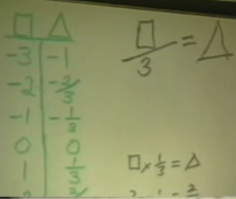

Students? Yes.
Jeff Possibly. Because they’re inverse op…(cut off)
Researcher 1 So you think that there could be two rules for some, some tables? So are you telling me that if you divide a number by three that you get the same answer as if you say one-third times that number? Would that always work? Do you think that works for every number? I’m not sure whether you agree with that or not.
Jeff Inverse operations, wouldn’t that work?
Researcher 1 So you think you could talk about inverse two different ways in this case. You could say a third?
Jeff Yeah.
Researcher 1 All right. What if I gave you in the triangle the number two, what number would have to be in the box? Okay, Amy-Lynn.
Amy-Lynn Six.
Researcher 1 Does everybody think six will work? All right, all right. Very good you’re off to a good start. What about, maybe this one is a little harder for you.
(Researcher 1 writes on the overhead:)

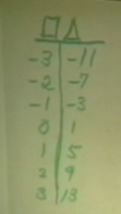

(Jeff’s table looks at the new table on the overhead, trying to figure out the rule. Then, Michael, Jeff, Angela, and Sarah copy the table on their own paper.)
28:47 Angela Hey Mike, this side keeps adding four.
Michael This side.
Angela It’s like consecutive numbers. (Pointing to Jeff’s paper.) Look, it looks like on this side, the triangle side, it keeps adding four.
Jeff Three and one, that sounds like a four.
Angela Negative three.
Jeff Positive four.
Angela No you can’t add four Sarah because it’s just on this side. It doesn’t work for this side. So what’s our new rule?
Sarah This is too difficult. (Hits hand on head.)
Angela Negative three plus four is not negative eleven.
Jeff It’s close.
Angela It’s negative seven, which is down here.
Sarah Negative three plus four is one.
Angela This is plus eight here.
30:16 Researcher 1 Amy-Lynn thinks she has a rule. Does anybody else?
Angela No.
Researcher 1 We will give them another minute or two? Then we can let you put that up and see what they think?
Jeff They did exactly what we thought.
Angela (To Jeff) Are you by any chance tired?
Jeff Me? Very. I didn’t sleep last night.
Angela This is plus, minus five triangle. Three doesn’t go into eleven.
Jeff I was so looking forward to a nice easy math today.
Angela Yeah, things are never easy.
Jeff If we worked on our paper, it would have been all good. Did you finish your paper?
Angela Sarah did. We were working together to figure some of it and then she wrote the letter.
Jeff Sarah you’re good.
Angela Do you know what Sarah’s name spelled backwards is? Haras.
Jeff Haras? You have too much time on your hands.
Angela No, no, she thought…
Researcher 1 Does anybody else think they have it yet? The rule? How are you doing over there?
Student from
another table We got one.
Researcher 1 You got one? Let’s let Amy-Lynn put hers up and see if you agree with that one. Amy would you do that for us.
Amy-Lynn Should I just do it in the thing, cause this is what we came up with, like times four plus one, that was like our rule, to do with everything in the box.
(Amy-Lynn writes on the overhead:
x 4 + 1
x 4 + 1 = .)

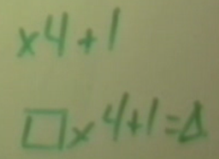

Researcher 1 What do you think of Amy-Lynn’s rule? That same rule you got? Or you couldn’t? What about over there at the far table? Do you agree with it?
Students (whisper) Yes.
Researcher 1 Do you want her to convince you or do you agree with her?
Michael I agree.
Researcher 1 Do you agree? You Agree?
Michael Yes, I do.
Researcher 1 Thank you Amy-Lynn that’s really nice. What if I put forty-nine in the triangle? Could you tell me what would have to be in the box?
(Michael and Sarah have raised their hand with the answer.)
Researcher 1 Already? Michelle.
Michelle I. Twenty-four.
Researcher 1 Michelle thinks twenty-four.
Bobby Twelve.
Researcher 1 And you think twelve.
Magdalena It’s twelve now.
Researcher 1 Lots of people are thinking twelve.
Michelle I. I did it wrong. I calculated wrong.
Researcher 1 Do you agree with that twelve? What did you do? Does everybody agree that twelve works? You had twelve times four. Angela?
Angela Forty-nine minus one divided by four. Forty-nine minus one is forty-eight and you divide by four.
Researcher 1 So Angela is saying that she took the forty-nine and subtracted one and then divided by
Angela Four.
Researcher 1 Four. Do you think you could write that for us where we had triangle equal to something with the box?
(Researcher 1 writes on the overhead:
=
(Angela goes to overhead)
Angela I would have to do it backwards?
Researcher 1 Can you do that? Do it either way you want to.
(Angela writes on the overhead
– 1 ÷ 4 = . )

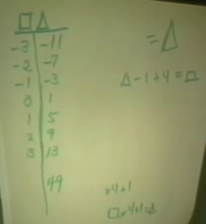

Researcher 1 All right. Now I heard you say something different from that before, you took forty-nine minus one and you got forty-eight and then what did you do?
Angela Then I divided forty-eight by four.
Researcher 1 Oh and you have division there. I see what you did. Okay, all right that’s good. I read that as a plus sign.
Angela Sorry.
Researcher 1 Does everybody know that you could also write this, this way if you want to.
(Researcher 1 writes on the overhead:
– 1 = . .)
4
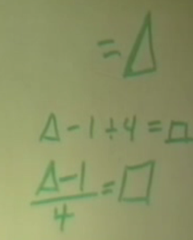

Researcher 1 It is just a different way of writing. That’s really nice.
Angela Sure.
Researcher 1 Do you want to try another one, see if we can stump you?
Angela I went up twice.
Michael I went up once.
Researcher 1 Let’s say that when we do this we get zero and when we put in negative two that we get two.
(Overhead shows:)

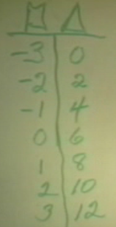

36:32 Jeff (Whispers to Ankur at Stephanie’s table.)
(Angela copies the table to her paper.)
Angela It’s zero, two, four, six, eight
Jeff If three, twelve equals goes up by nine, two ten, goes up by eight.
Angela Times two plus six.
Jeff What?
Michael Three times two.
Angela Times two plus six?
Jeff Why can’t you just say that you add the number it goes up by?
Michael Two times three is six.
Angela (While working on her paper.) Times two plus six. (Speaking to the group) Let’s just use our paper.
Jeff Nah, listen to me!
Angela Go ahead.
Jeff From zero, there’s six then add one: seven.
Michael (Excited) No, I got it, got it, got it!
Jeff Add two: eight. I’m adding one.
Angela Uh-huh.
Jeff Look.
Angela I’m not understanding what you are trying to say.
Jeff Zero.
Angela No, do it on the paper.
Jeff (Pointing to Angela’s paper.) Zero plus six is six. One plus seven is eight. Two plus eight is ten. Three, it’s going up by one.
(Angela’s paper shown below:)
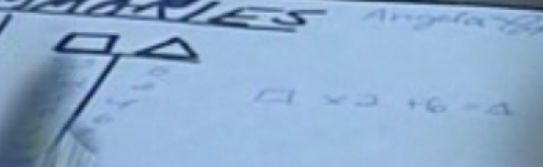

Angela Yeah, but you have to have the same exact rule for each one.
Jeff Well it’s gonna come up eventually. I’ll figure out something for there, but right now, this looks nice.
Michael I figured it out.
Angela Yeah, but Mike has a rule.
Researcher 1 Who thinks they have the rule?
Michael I do.
Researcher 1 Oh, Okay.
Jeff What is it?
Researcher 1 Magdalena you want to put the rule that you have up and see if they agree with you?
Michael Box times two plus six. It works, just believe me.
Sarah I agree with you.
Jeff But how?
Sarah But it works.
Jeff Where’d you get that from?
Michael I don’t know. (Looking at the board)
Angela It works.
Michael I was right.
(Magdalena goes to overhead and writes:
x 2 + 6 = .)

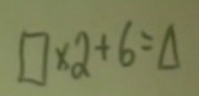

Researcher 1 Is that what the rest of you got or somebody have a different rule?
Michael Yes, I got it.
Researcher 1 Everybody had that same rule?
Jeff I came up with one for half of it.
Angela Except for Jeff.
Michael (Speaking to Jeff). The next one get right or Sarah is going up.
Sarah We don’t want him to get jealous. Not so easy to write them. I’m not comfortable writing them.
Jeff (Turns and talks to Stephanie at another table.)
Jeff’s table (Talks inaudibly among themselves.)
Researcher 1 Magdalena, can you give them a number to put in the triangle and see if they can find the number in the box. Can you think of a good number to put in the triangle?
Magdalena I’ll put fifty-six.
(Magdalena writes 56 in the triangle column.)
Researcher 1 Magdalena put fifty-six in the triangle. Could you tell her what you had in the box? Okay, Michael.
Michael Twenty-five.
Researcher 1 Twenty-five and everybody agrees with that. And how did you get it Michael?
Michael Minus fifty-six, I mean fifty-six minus six and I divided by two.
Researcher 1 Could you write that as a rule?
(Michael goes to the overhead and writes:
– 6 = .)
2

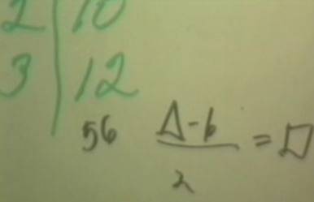

Researcher 1 All right that’s nice. But you know what I had another, a different rule that I think works. I had this. Tell me if you think that this would have to work too. I had two times box plus three is equal to triangle.
(Researcher 1 writes on the overhead:
2 x ( + 3 ) = .)

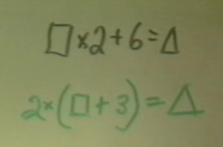

Michelle I. Wow, that’s heavy stuff. No.
Researcher 1 Do you think that works?
Michelle I. Yes, it definitely does.
Researcher 1 Well do you think there are just two rules that work? Do you think that one works, that both of those work? Do you think there are any other rules that work?
Researcher 1 Can anybody tell me why that works? It seems a little strange to me. Bobby?
Bobby You have to do the work in the parenthesis first and like, then if you add three to negative three it’s zero and if you times two by it, it like stays the same cause it’s zero and it like works on every one.
Researcher 1 Did you understand what Bobby said?
Jeff (Whispering) Sarah, could you get your paper for me.
Sarah Hands Jeff her paper.
Jeff Thanks.
Researcher 1 Does anybody think it’s odd that you have a three down there you have a box plus three but when you have the rule the other way you have a six and that you get the same number? What do you think Ankur?
Ankur Two outside the parenthesis so it becomes sort of like a six.
Researcher 1 Would you go up and explain what you are saying?
Ankur The two outside of the parenthesis doubles what ever's inside.
Researcher 1 You mean it doubles everything that’s inside.
Ankur Yes.
Researcher 1 All right, what do the rest of you think?
Researcher 1 Think that will always be true, Jeff?
Jeff Yes
Researcher 1 Jeff thinks yes.
Michael I do too.
Researcher 1 You think yes too.
Jeff That’s my partner.
Michael/Jeff (Shake hands)
Researcher 1 All right, all right. Let’s try another one.
Angela Genius.
Angela I can’t believe the people at Wendy’s believe you.
Jeff Hey, that’s because they’re working at Wendy’s.
Michael Don’t talk because…
Jeff Yeah, but that’s why they’re working at Wendy’s.
Researcher 1 Maybe this is too easy.
(Researcher 1 is writing on the overhead)
Researcher 1 This one is probably too easy for you.
(Overhead shows:)

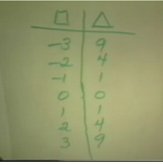

42:38 Michael Three squared, no.
Jeff Why isn’t it box times box equals triangle?
Michael Box times box.
Researcher 1 Jeff thinks he has a rule.
Jeff Yeah, I do.
Angela Yeah, it is.
Researcher 1 Anybody else? Jeff do you want to come put up the rule and see if they agree with you?
Jeff Oh, Okay.
Angela Box, squared squared.
Michael No, box times box.
Angela (Slams pen to table.) Yeah.
(Jeff comes to the overhead and writes:
x = .)

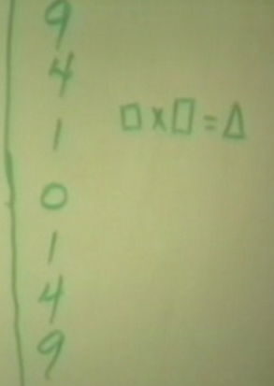

Jeff Box times box equals triangle.
Bobby (raises his hand). Ur that’s wrong.
Michelle I. That does not work
Jeff Yes it does, it has to work.
Michelle I. Because if it’s negative three times negative three it’s negative nine.
Jeff Yes!
Michelle I. No, you people, you people told me that.
Student? He’s right.
Jeff It’s a positive times a positive is another positive.
Student? A negative times a negative equals a positive.
Michelle I. I was just repeating what they said and I disagreed with it and then they tell me that I am wrong. So it is their fault that I was wrong.
Jeff We know Michelle.
Michelle I. It’s on camera, I’m telling you.
Michael (Raising and waiving hand.) I know another way.
Angela Sarah is next time.
Michael (Talking to Sarah) So go box is squared equals triangle. Hey, you want to go? (Talking about going up to the overhead.)
Sarah (Shakes head to indicate ‘no’.)
Researcher 1 So they are having a discussion at this table. They feel that some people were led astray about negative three times negative three being negative nine or positive nine?
Michael (raises his hand) There is another way to write it. It’s box squared equals triangle.
Researcher 1 Do you want to write that for us Michael? Michael has another way of writing it.
Angela Sarah wants to.
Researcher 1 Sarah.
Sarah (Giggles and turns away from the front of the classroom, then starts to get up.)
Michael (Gets up, but doesn’t see Sarah rising.)
Angela Mike, she was going up.
Michael I’ll just write it fast.
(Laughter at Jeff’s table)
(Michael comes to the overhead and writes the rule another way
² = .)

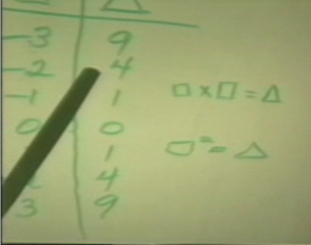

Researcher 1 All right. Thank you. That’s great. Now, did I hear someone talking about square roots? Were you talking about square root?
Researcher 1 Were you talking about the square root?
Angela No, but if the number is triangle, then to find what box is, you have to find the square root of the triangle.
Researcher 1 Angela is saying that if I gave you a number over here like twenty-five, that you would‘ve to find the square root. (Researcher 1 adds ‘25’ to the triangle column.) There is a little confusion about that. Look, when we had nine on this side, and we went backwards we could get a three. We also worked that nine would give us a negative three. So that’s a little different isn’t it? What if I put a negative thirty-six here, (Researcher 1 adds ‘-36’ to the triangle column). What would you get on the other side? Brian?
(Overhead shows:)

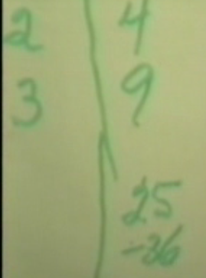

Brian It is either a positive or a negative six. I’m not sure.
Researcher 1 Hey, Brian thinks it’s either a positive six or a negative six. What did you think Jeff?
Jeff Nothing.
Researcher 1 Bobby?
Bobby You can’t put a negative there. Cause to get a negative number you have to times like a positive and a negative. So you get a negative.
Michelle I. So that’s a negative times a negative and that’s a positive. Which Bobby got wrong before and made me look dumb.
46:05 Researcher 1 They’re saying over here that they don’t think I should put a
negative over here that you wouldn’t be able to get an answer.

