S.NO | TITLE | PAGE NO
1. | INTRODUCTION  - SYNOPSIS  - PROJECT DESCRIPTION  - ORGANIZATION PROFILE
2. | SYSTEM ANALYSIS  2.1 INTRODUCTION TO SYSTEM ANALYSIS  2.2 FEASIBILITY STUDY  2.3 EXISTING SYSTEM  2.4 PROPOSED SYSTEM
3. | SYSTEM DESIGN  3.1 DATAFLOW DIAGRAM  3.2 USE CASE DIAGRAM  3.4 ER DIAGRAM
4. | SYSTEM REQUIREMENTS  4.1 SOFTWARE REQUIREMENTS  4.2 HARDWARE REQUIREMENTS
5. | SOFTWARE DESCRIPTION  5.1 FRONT END TOOL  5.2 BACK END TOOL
6. | IMPLEMENTATION  6.1 SOURCE CODE  6.2 TESTING
7. | OUTPUT  7.1 FORM
8. | CONCLUSION
9. | FUTURE ENHANCEMENTS
10. | REFERENCES
CONTENT

- INTRODUCTION
  - SYNOPSIS
Public complaint management plays a crucial role in maintaining urban infrastructure and ensuring timely delivery of essential civic services. However, manually analyzing and categorizing large volumes of complaints often leads to delays, human errors, and inefficient prioritization. To address these challenges, this project proposes “A Secure ML-Based Public Complaint Monitoring System”, which automates complaint understanding using Machine Learning and Natural Language Processing (NLP).
The primary objective of this system is to automatically classify complaint text into predefined categories such as road issues, water supply problems, waste management, electricity failures, and public safety concerns. A second Machine Learning model predicts the priority level (High, Medium, Low) based on urgency and severity. These two models enable government departments or service agencies to respond faster and allocate resources effectively.
The system uses text preprocessing techniques, TF-IDF vectorization, Logistic Regression/SVM for complaint categorization, and Random Forest/XGBoost for priority prediction. Secure storage and model inference are implemented using Python, and the final interface is deployed through Streamlit for easy user interaction. The application also ensures data confidentiality and integrity through secure handling and controlled access.
By automating complaint analysis, this ML-based system significantly reduces response time, minimizes manual workload, and improves overall efficiency in grievance handling. The proposed solution can be extended to smart-city platforms, municipal dashboards, and government service portals for real-time complaint monitoring and decision support.

1.2 PROJECT DESCRIPTION
The proposed system titled “A Secure ML-Based Public Complaint Monitoring System” focuses on developing an intelligent, automated, and real-time framework for classifying and prioritizing public complaints using Machine Learning (ML) and Natural Language Processing (NLP). The system helps government departments, municipal corporations, and service agencies analyze large volumes of citizen complaints efficiently and respond with higher accuracy and reduced delays.
1. Data Collection
The dataset required for this project is collected from multiple complaint sources:
1. Text-Based Public Complaints
These include complaint descriptions from:
- Municipal service portals
- Civic issue reporting apps
- Public grievance websites
- Datasets containing descriptions of issues like road damage, drainage problems, garbage accumulation, water leakage, electricity faults, street light failure, safety issues, and noise disturbances.
Each complaint contains:
- Complaint description (text)
- Type/category
- Severity (if available)
- Location details
- Date/time of the report

2. Manually Labeled Severity Levels
For training the priority prediction model, labels are prepared:
- High Priority (accidents, electricity failure, water contamination, safety threats)
- Medium Priority (road repair, drainage block, waste management issues)
- Low Priority (minor disturbances, non-urgent civic requests)
This multi-source dataset supports both ML category prediction and severity classification.
2. Data Preprocessing
After dataset collection, the complaint data undergoes several preprocessing operations to ensure consistency and optimal ML performance:
- Text Cleaning: removing stopwords, special characters, noise, and repetitive phrases
- Tokenization & Lemmatization: converting complaint sentences into meaningful tokens
- TF-IDF Vectorization: transforming cleaned text into feature vectors suitable for ML training
- Encoding Labels: mapping category names (Road/Water/Electricity/Garbage/Safety) into numeric labels
- Handling Missing Data: removing incomplete complaints
- Balancing Dataset: resolving category imbalance using oversampling (if required)
- Train–Test Split: dividing data into training, validation, and testing sets
This ensures a high-quality input pipeline for the Machine Learning models.

3. Model Training
Two different ML pipelines are developed:
1. Complaint Category Prediction (ML Model 1)
This model categorizes complaints into predefined civic issue categories.
Algorithms used:
- Logistic Regression
- Support Vector Machine (SVM)
- Random Forest Classifier
- Multinomial Naïve Bayes
These models learn patterns from complaint text such as “pothole in road”, “street light not working”, “water pipe leakage”, etc.
Each model is evaluated using:
- Accuracy
- Precision
- Recall
- F1-Score
The best-performing classifier is selected and exported as category_model.pkl.
2. Complaint Priority Prediction (ML Model 2)
This model predicts the urgency of a complaint:
- High
- Medium
- Low

ML algorithms used:
- Random Forest
- XGBoost
- Gradient Boosting
The model uses text features plus additional indicators (keywords like “urgent”, “dangerous”, “leakage”, etc.) to decide real-world severity.
The final trained model is converted into priority_model.pkl.
4. System Integration
Both ML models are integrated into a secure Streamlit-based web interface with:
- A complaint input box
- Real-time category and priority prediction
- Secure API request handling
- Optional database storage for complaint history
- Admin dashboard for viewing categorized complaints
The ML models run in the backend and automatically classify and prioritize user complaints instantly.
5. Outcome & Impact
The proposed system automates the entire complaint analysis pipeline.
It enables:
- Faster grievance response
- Improved municipal planning
- Reduced human workload
- Accurate categorization and urgency estimation
- Smart city-level complaint management
1.3 ORGANIZATION PROFILE
Year of Establishment
Our organization “Infosystems” was started during the year 2000.
Inspiration
Due the inspiration given by the golden line “Computer - a word which rules the world with humans as workers”, which bloomed like a banyan tree which still provide its service to the Thanjavur folks.
Certification
We have been awarded ISO9001 certificate, which is a great achievement and immense recognition of our team work still day.
Milestones
Beginning itself our organization interested in servicing the students society with recent technologies. As an example we were the first to introduce Web technologies and the various networking concepts like LAN to the student’s society. We got ISO90001 certification for our project “Text to Speech Conversion” during the year 2001 and developed websites for the various institutions and companies and we done various projects during the period of 11 years for various institutions and others. Our organization usually did awareness programs for the recent technologies in various institutions and in this year we did a special training and seminar on .NET in PM University, at PRC, and on JAVA in KunthavaiNaachiaayar Government Arts College, Thanjavur.
Real Time Project
Real Time Projects like “Resume parsing”, “Water purifier”, and “SQL Diamond”, “Residence Messenger” for the other countries like Singapore, Australia, and Dubai earned a great name for our organization during the year 2005. We did such projects in this year also but in different color. We started a separate division for software development, namely “Infosoft” and did overseas projects for a Singaporian stationary shop for maintaining their inventory every day and every year, we also did project for the TNPL which automates the tendering process.
Placement
Our training made numerous students to get placed in various companies; during 2008, 40 students placed in the Wipro technologies. In this academic year about 50 students were placed in various companies and especially 3 students got placement in the CTS.
Student Projects
The numbers of projects in various domains such as Arts and Science (UG & PG), Engineering (UG & PG), PhD based on IEEE papers, do increase every year like our growth rate.
Research Activities
Our organisation also encourages the students and the staff members to publish the research papers in various National, International conference and journals. About 8 papers of such were published during the last academic year.
Community Services
With this our organisation also being concentrated on various social service activities from the beginning itself. Our organisation,
- Trained 2500 students about the basics of computer operations of various Middle and Higher secondary schools of PapanasamTaluk, during 2004-2005.

- SYSTEM ANALYSIS

2.1 INTRODUCTION TO SYSTEM ANALYSIS
Systems are created to solve problems. One can think of the systems approach as an organized way of dealing with a problem. In this dynamic world, the subject System Analysis and Design (SAD), mainly deals with the software development activities.
A collection of components that work together to realize some objectives forms a system. Basically there are three major components in every system, namely input, processing and output.
A collection of components that work together to realize some objectives forms a system. Basically there are three major components in every system, namely input, processing and output.
Input output
Processing

In a system the different components are connected with each other and they are interdependent. For example, human body represents a complete natural system. We are also bound by many national systems such as political system, economic system, educational system and so forth.
The objective of the system demands that some output is produced as a result of processing the suitable inputs. A well-designed system also includes an additional element referred to as ‘control’ that provides a feedback to achieve desired objectives of the system

2.2 FEASIBILITY STUDY
In case the system proposal is acceptable to the management, the next phase is to examine the feasibility of the system. The feasibility study is basically the test of the proposed system in the light of its workability, meeting user’s requirements, effective use of resources and of course, the cost effectiveness. These are categorized as technical, operational, economic and schedule feasibility.
The main goal of feasibility study is not to solve the problem but to achieve the scope. In the process of feasibility study, the cost and benefits are estimated with greater accuracy to find the Return on Investment (ROI). This also defines the resources needed to complete the detailed investigation. The result is a feasibility report submitted to the management. This may be accepted or accepted with modifications or rejected. The system cycle proceeds only if the management accepts it.
There are number of steps in the feasibility study, some of them are
1) Forming a team for the specific project and appointing a suitable leader.
2) Preparing layouts and flowcharts of the system.
3) Enumerate the candidate systems.
4) Identify and describe the characters of the candidate systems.
5) Determining the performance of each candidate system with the standards set.
6) Reviewing the performance of the system and performing the cost analysis.
7) Selecting the best candidate for the system and preparing the final report for the management.

2.3 EXISTING SYSTEM
Traditional public complaint management systems mainly rely on manual grievance handling, physical complaint registers, call-center–based complaint logging, and basic web forms without any intelligent processing. In most municipal corporations and government service portals, complaints are manually categorized by staff based on their understanding of the issue. These systems depend heavily on operators to read, interpret, and route complaints to the appropriate department such as water supply, electricity, sanitation, or road maintenance.
Some digital grievance portals allow users to submit complaints online, but they still lack automated classification or prioritization. The categorization is performed by human staff who manually examine each complaint description. This results in delays, inconsistency, and misrouting of issues. In many cases, complaints are assigned priorities based only on simple rules (e.g., electricity failure = urgent, garbage = medium), which is neither scalable nor accurate.
DRAWBACKS OF EXISTING SYSTEM
- Manual Categorization & Misclassification
Complaints are assigned to departments manually, causing delays, inconsistency, and frequent routing errors.
- Dependence on Human Operators
Complaint descriptions must be read and analyzed by staff, making the process slower and increasing the chance of human interpretation errors.
- No Automated Priority Prediction
Existing systems cannot understand urgency (High/Medium/Low). Even critical issues like water leakage or street light failure at night may not be automatically recognized as high priority.
- Lack of AI/ML Integration
Most systems do not use machine learning, NLP, or deep learning methods for:

- Text classification
  - Severity analysis
  - Pattern recognition
  - Trend forecasting
This reduces accuracy and limits scalability.
- Poor Real-Time Processing
Current portals do not support instant classification, real-time data processing, or automated decision-making.
- Limited Data Utilization
Large amounts of historical complaint data are underutilized—they are not used for training predictive models or improving service quality.
- High Response Time & Inefficiency
Manual workload delays responses, leading to backlog, low satisfaction, and poor municipal service performance.
- Insufficient real-time integration
Existing systems do not seamlessly integrate live weather APIs, forecast data, or satellite imagery in one place.

2.4 PROPOSED MODEL
The proposed system introduces an intelligent, automated, and machine-learning–driven framework for classifying and prioritizing public complaints in real time. Unlike traditional manual grievance systems that depend heavily on human operators, the developed solution leverages advanced ML and NLP techniques to automatically understand complaint text, identify the nature of the issue, and determine its urgency level. This ensures faster resolution, reduced human workload, and improved governance efficiency.

ADVANTAGES OF THE PROPOSED MODEL
- Higher accuracy using advanced NLP + ML models
- Fully automated categorization and priority detection
- Real-time processing for instant decision-making
- User-friendly interface through Streamlit
- Improved response time & resource optimization
- Reduced manual workload for municipal staff
- Better governance via data-driven complaint handling

- SYSTEM DESIGN

3.1 DATAFLOW DIAGRAM

LEVEL 0

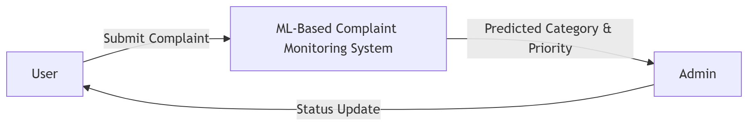

LEVEL 1
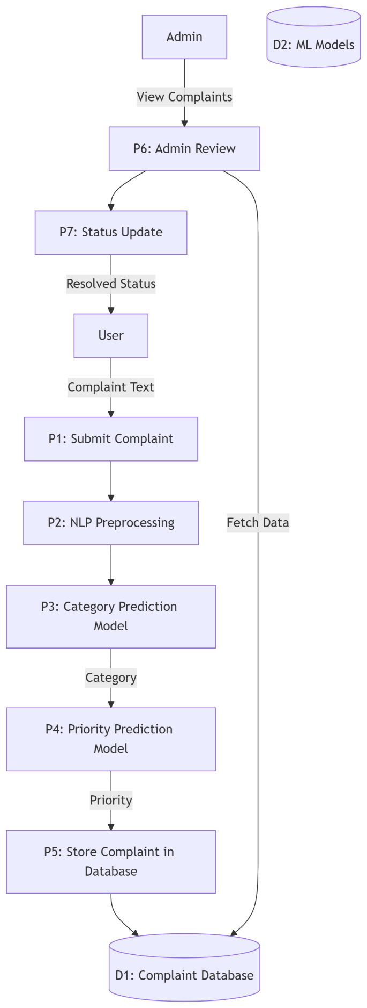

LEVEL 2
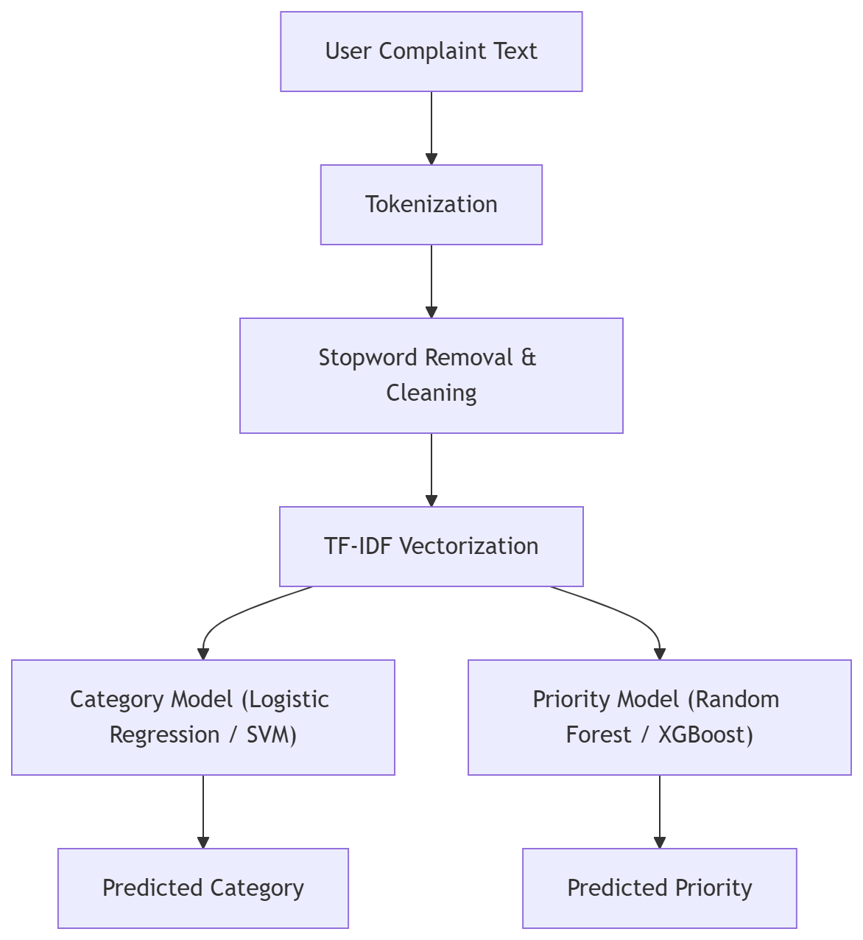
3.2 USE CASE DIAGRAM

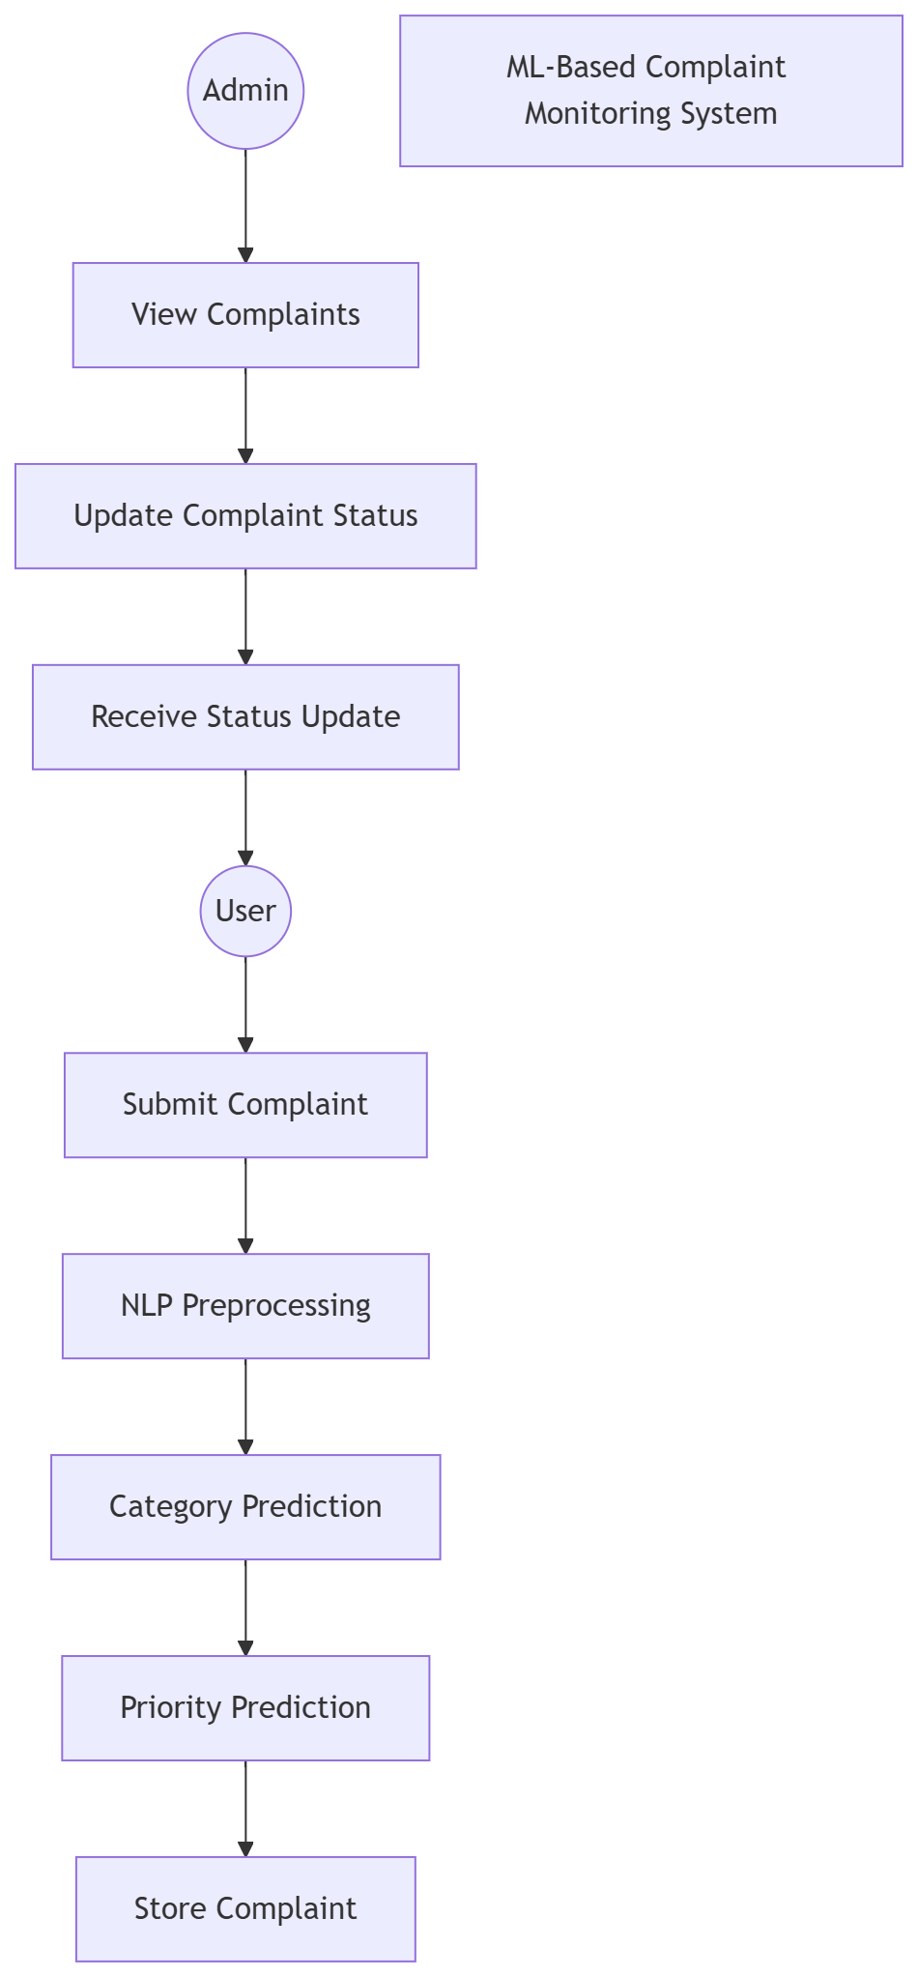

3.3 ER DIAGRAM
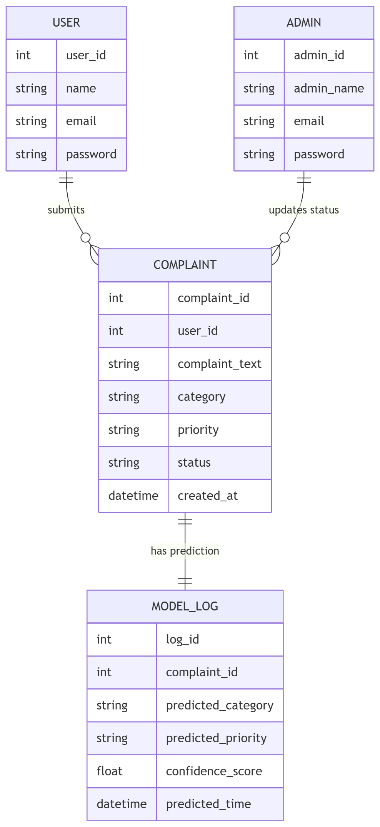

4. SYSTEM REQUIRMENTS
4.1 SOFTWARE REQUIREMENTS
Operating System : Microsoft windows11
Front End : Streamlit
Back End : Python
Database : MySQL
Documentation : Microsoft Word
4.2 HARDWARE REQUIREMENTS
Processor : Intel i5 core
Speed : 3.10 GHz
RAM : 16 GB
Hard Disk : 512 GB
Monitor : 15 SVGA color
Mouse : Wired mouse
Keyboard : wired keyboard
Printer : Laser Printer

- SOFTWARE DESCRIPTION
5.1 FRONT END TOOL
Introduction to Streamlit
For the development of the user interface (UI) and the interactive dashboards of the "Secure Web Application for Public Complaint Monitoring," Streamlit was utilized as the primary front-end framework. Streamlit is a modern, open-source Python library designed explicitly for creating and sharing custom web applications for machine learning and data science projects. Unlike traditional web development frameworks that require a deep understanding of HTML, CSS, and JavaScript, Streamlit allows developers to build highly interactive, responsive, and aesthetically pleasing web interfaces entirely in Python.
By treating the UI components as simple Python function calls, Streamlit bridges the gap between complex backend machine learning algorithms and front-end user interaction, making it the ideal choice for this AI-driven civic issue tracker.
Why Streamlit was Chosen for this Project The selection of Streamlit over traditional frameworks (like React or Angular) was driven by several project-specific requirements:
- Seamless Machine Learning Integration: Since the core of this project involves a Natural Language Processing (NLP) model to categorize complaints, Streamlit allows the machine learning model (joblib and scikit-learn) to be directly loaded and executed within the same script that renders the web page.
- Rapid Prototyping and Development: It drastically reduces the development time by eliminating the need to write separate REST APIs to connect the frontend to the backend. The frontend UI and backend logic coexist efficiently.
- Built-in Data Visualization: The administrative dashboard requires complex data representations (such as pie charts and bar graphs) to monitor complaint trends. Streamlit seamlessly integrates with data visualization libraries like Plotly and Pandas to render these charts dynamically.
- Responsive Design: Applications built with Streamlit are natively responsive, meaning the complaint portal adapts perfectly to both desktop monitors and mobile device screens without writing extra CSS media queries.
Implementation of Front-End Features In this project, Streamlit handles the entire client-side experience through various interactive widgets and layout structures. The key implementations include:
A. User Authentication & Session Management: The application utilizes Streamlit’s st.session_state feature to manage secure user logins. It tracks whether a user is an 'Admin' or a 'Citizen' and dynamically renders the appropriate dashboard based on their role. This ensures secure role-based access control directly from the front end.
B. Citizen Dashboard (User Interface):
- Data Input Widgets: The system uses st.text_area for citizens to securely type their detailed complaint descriptions.
- Location Tracking: Widgets like st.text_input are used to capture the exact street address and Pincode for geo-tagging the issue.
- Multimedia Uploads: The st.file_uploader component provides a drag-and-drop interface for users to upload photographic evidence of the civic issue (e.g., broken pipes, uncollected garbage).
- Real-time Feedback: Upon submitting a complaint, st.progress is used to display the Artificial Intelligence Confidence Score, providing transparency to the user about the AI's categorization accuracy.
C. Administrative Dashboard (Official Interface):
- Data Presentation: The st.dataframe component is used to display the entire MySQL database of complaints in a clean, scrollable, and sortable grid format.
- Visual Analytics: Using st.plotly_chart, the front end renders interactive Pie Charts (showing Pending vs. Resolved statuses) and Bar Charts (showing complaint categories), allowing administrators to gauge the city's civic health at a glance.
- Action Panels: st.selectbox and st.button components allow administrators to easily update the status of a complaint, which immediately triggers a backend MySQL update and refreshes the UI.
D. Dynamic Layout and Theming: To organize the vast amount of information, Streamlit’s layout features such as st.sidebar (for navigation and emergency contacts), st.columns (to place forms and maps side-by-side), and st.tabs (to separate "Register Complaint," "My Complaints," and "Notifications") were extensively utilized. The application is also configured with a "wide" layout and a dark-mode theme to reduce eye strain for administrators monitoring the system continuously.
Advantages of Using Streamlit in the Proposed System
- Interactive Data Flow: Whenever a user interacts with a widget (e.g., filtering complaints by "Pending" status), Streamlit automatically reruns the necessary parts of the script to fetch fresh data from the MySQL database and update the screen instantly.
- Security: Because Streamlit executes on the server side, sensitive API keys, database credentials, and Machine Learning model weights are never exposed to the client's browser, ensuring a high level of security for the public complaint portal.
- Extensibility: The tool allows for easy expansion. For instance, rendering HTML iframes to embed Google Maps for tracking complaint locations was achieved effortlessly using Streamlit's component integration.
Conclusion on Front End In summary, Streamlit proved to be an exceptionally powerful front-end tool for this project. It provided the necessary agility to design a secure, role-based, and AI-integrated web portal, ensuring that citizens have a smooth experience while reporting issues, and authorities have a robust, data-rich dashboard for efficient public administration.

5.2 BACK END TOOL
PYTHON
Python is an open source programming language that was made to be easy-to-read and powerful. Python is an interpreted language. Interpreted languages do not need to be compiled to run. A program called an interpreter runs Python code on almost any kind of computer. This means that a programmer can change the code and quickly see the results. This also means Python is slower than a compiled language like C, because it is not running machine code directly.
Python is a good programming language for beginners. It is a high-level language, which means a programmer can focus on what to do instead of how to do it. Writing programs in Python takes less time than in some other languages. Python is a computer programming language designed for readability and functionality. One of Python’s design goals is that the meaning of the code is easily understood because of the very clear syntax of the language. Python programming language has a specific syntax (form) and semantics (meaning) which enables it to express computations and data manipulations which can be performed by a computer. Python’s implementation was started in 1989 by Guido van Rossum at CWI (a national research institute in the Netherlands) as a successor to the ABC programming language (an obscure language made more popular by the fact that it motivated Python!). Van Rossum is Python’s principal author, and his continuing central role in deciding the direction of Python is reflected in the title given to him by the Python community, Benevolent Dictator for Life (BDFL). Python is an interpreted language, i.e., a programming language whose programs are not directly executed by the host cpu but rather executed (or “interpreted”) by a program known as an interpreter. The source code of a Python program is translated or (partially) compiled to a “byte code” form of a Python “process virtual machine” language.
This is in distinction to C code which is compiled to cpu-machine code before runtime. Python is a “dynamically typed” programming language. A programming language is said to be dynamically typed, when the majority of its type checking is performed at run-time as opposed to at compile-time. Dynamically typed languages include JavaScript, Lisp, Lua, Objective-C, Python, Ruby, and Tcl. Python is an object-oriented language. Object-oriented programming (OOP) uses “objects” - data structures consisting of data fields and methods - to design computer programs. For example, a matrix could be the “object” you want to write programs to deal with. It could define a class of matrices and, for example, a method for that class might be addition (representing ordinary addition of matrices). It will return to this example in more detail later in the course.
PYTHON LIBRARY
Python is used by hundreds of thousands of programmers and is used in many places. Sometimes only Python code is used for a program, but most of the time it is used to do simple jobs while another programming language is used to do more complicated tasks. Its standard library is made up of many functions that come with Python when it is installed. On the Internet there are many other libraries available that make it possible for the Python language to do more things. These libraries make it a powerful language; it can do many different things.
Some things that Python is often used for are:
- Web development
- Game programming
- Desktop GUIs
- Scientific programming
- Network programming.
Python also does something called "dynamic variable assignment". This means that when a number or word is made in a program, the user does not have to say what type it is. This makes it easier to reuse variable names, making fast changes simpler. An example of this is shown below.
INPUT/OUTPUT
Sage is built on Python, so includes Python, but is designed for general purpose mathematical computation (the lead developer of Sage is a numbertheorist). The interface to Sage is IPython, though it has been configured in a customized way to that the prompt says sage: as opposed to In or >>>. Other than this change in prompt, the command line interface to Sage is similar to that if Python and SymPy. Sage sage: a = 3.1415 sage: print a 3.14150000000000 sage: type(a) Sage also include SymPy and a nice graphical interface called the Sage notebook.
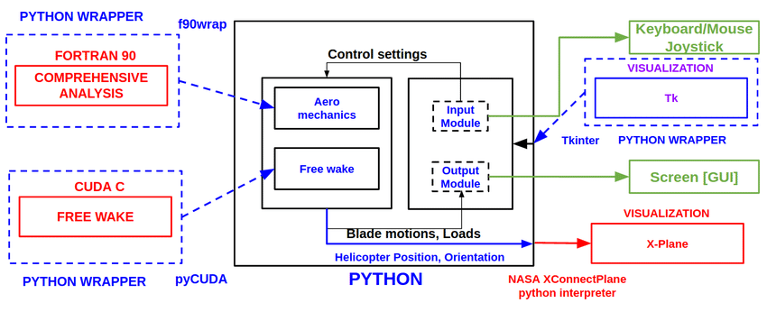
FRAMEWORK

DATA TYPES
The data which a Python program deals with must be described precisely. This description is referred to as the data type. In the case of Python, the fact that Python is dynamically typed basically means that the interpreter or compiler will figure out for you what type a variable is at run-time, so you don’t have to declare variable types yourself. Besides numerical data types, such as int (for integers) and float (for reals), there are other types such as tuple and list. A more complete list, with examples, is given below.
Type Description
- An immutable sequence "string", """\python of Unicode characters is great""", ’2012’ bytes An immutable sequence of bytes b’Some ASCII’.
- List Mutable, can contain mixed types [1.0, ’list’, True].
- Tuple Immutable, can contain mixed types (-1.0, ’tuple’, False) set, Unordered, contains no duplicates set([1.2, ’xyz’, True]), frozensetfrozenset([4.0, ’abc’, True]).
- Dict A mutable group of key {’key1’: 1.0, ’key2’: False} and value pairs int An immutable fixed precision 42 number of unlimited magnitude float An immutable floating point 2.71828 number (system-defined precision).
- Complex An immutable complex number -3 + 1.4j with real and imaginary parts Boolean. An immutable Boolean value True, False.
STRUCTURE OF PYTHON
- Command-Line Application Layouts
  - One-Off Script
  - Installable Single Package
  - Application with Internal Packages
- Web Application Layouts
  - Django
  - Flask
Python, though opinionated on syntax and style, is surprisingly flexible when it comes to structuring your applications. On the one hand, this flexibility is great: it allows different use cases to use structures that are necessary for those use cases. On the other hand, though, it can be very confusing to the new developer. The Internet isn’t a lot of help either—there are as many opinions as there are Python blogs. Examples of common Python application structures, including command-line applications (CLI apps), one-off scripts, installable packages, and web application layouts with popular frameworks like Flask and Django.

COMMAND-LINE APPLICATION LAYOUTS
A lot of us work primarily with Python applications that are run via command-line interfaces (CLIs). This is where you often start with a blank canvas, and the flexibility of Python application layouts can be a real headache. Starting with an empty project folder can be intimidating and lead to no shortage of coder’s block.

One-Off Script
The following layout will work for all of these cases and can easily be modified to reflect whatever installation or other tools you use in your workflow. This layout will cover you whether you’re creating a pure Python script (that is, one with no dependencies) or using a tool like pip or Pipenv. That the exact location of the files in the layout matters less than the reason they are placed where they are. All of these files should be in a project directory named after your project. For this example, we will use (what else?) helloworld as the project name and root directory.
Here’s the Python project structure I typically use for a CLI app:
This is pretty straightforward: everything is in the same directory. The files shown here are not necessarily exhaustive, but I recommend keeping the number of files to a minimum if you plan on using a basic layout like this. Some of these files will be new to you, so let’s take a quick look at what each of them does.
- .gitignore: This is a file that tells Git which kinds of files to ignore, like IDE clutter or local configuration files. Our Git tutorial has all the details, and you can find sample .gitignore files for Python projects here.
- helloworld.py: This is the script that you’re distributing. As far as naming the main script file goes, I recommend that you go with the name of your project (which is the same as the name of the top-level directory).
- LICENSE: This plaintext file describes the license you’re using for a project. It’s always a good idea to have one if you’re distributing code. The filename is in all caps by convention.
- README.md: This is a Markdown (or reStructuredText) file documenting the purpose and usage of your application. Crafting a good README is an art, but you can find a shortcut to mastery here.
- requirements.txt: This file defines outside Python dependencies and their versions for your application.
- setup.py: This file can also be used to define dependencies, but it really shines for other work that needs to be done during installation. You can read more about both setup.py and requirements.txt in our guide to Pipenv.
- tests.py: This script houses your tests, if you have any. You should have some.

Introduction to MySQL
MySQL is a very popular open-source relational database management system (RDBMS).MySQL is a relational database management system A relational database stores data in separate tables rather than putting all the data in one big storeroom. The database structure is organized into physical files optimized for speed. MySQL is a relational database management system (RDBMS) developed by Oracle that is based on structured query language (SQL). A database is a structured collection of data.Its name is a combination of "My", the name of co-founder Michael Widenius's daughter My, and "SQL", the acronym for Structured Query Language.MySQL is developed, distributed, and supported by Oracle Corporation

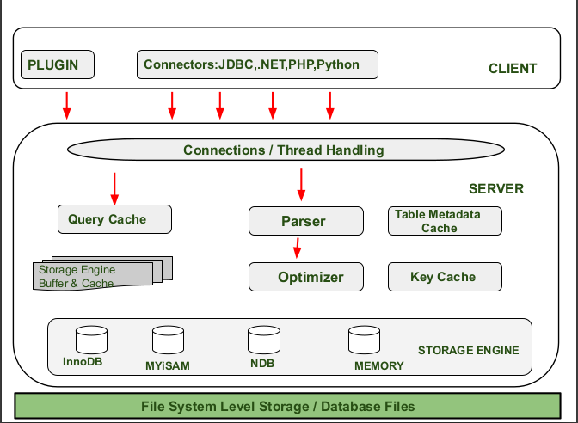

Features:
- MySQL is a relational database management system
- MySQL is open-source
- MySQL is free
- MySQL is ideal for both small and large applications
- MySQL is very fast, reliable, scalable, and easy to use
- MySQL is compliant with the ANSI SQL standard
- MySQL was first released in 1995
To build a web site that shows data from a database, you will need:
- An RDBMS database program (like MySQL)
- A server-side scripting language, like PHP
- To use SQL to get the data you want
- To use HTML / CSS to style the page

Some of the Most Important SQL Commands
- SELECT - extracts data from a database
- UPDATE - updates data in a database
- DELETE - deletes data from a database
- INSERT INTO - inserts new data into a database
- CREATE DATABASE - creates a new database
- ALTER DATABASE - modifies a database
- CREATE TABLE - creates a new table
- ALTER TABLE - modifies a table
- DROP TABLE - deletes a table
- CREATE INDEX - creates an index (search key)
- DROP INDEX - deletes an index
Limitations
When using some storage engines other than the default of InnoDB, MySQL does not comply with the full SQL standard for some of the implemented functionality, including foreign key references. Check constraints are parsed but ignored by all storage engines before MySQL version 8.0.15.
Up until MySQL triggers are limited to one per action / timing, meaning that at most one trigger can be defined to be executed after an INSERT operation, and one before INSERT on the same table.No triggers can be defined on views.
MySQL database's inbuilt functions like UNIX_TIMESTAMP() will return 0 after 03:14:07 UTC on 19 January 2038. Recently, there had been an attempt to solve the problem which had been assigned to the internal queue.
Deployment
MySQL can be built and installed manually from source code, but it is more commonly installed from a binary package unless special customizations are required. On most Linux distributions, the package management system can download and install MySQL with minimal effort, though further configuration is often required to adjust security and optimization settings.
Though MySQL began as a low-end alternative to more powerful proprietary databases, it has gradually evolved to support higher-scale needs as well. It is still most commonly used in small to medium scale single-server deployments, either as a component in a LAMP-based web application or as a standalone database server. Much of MySQL's appeal originates in its relative simplicity and ease of use, which is enabled by an ecosystem of open source tools such as phpMyAdmin. In the medium range, MySQL can be scaled by deploying it on more powerful hardware, such as a multi-processor server with gigabytes of memory.
There are, however, limits to how far performance can scale on a single server ('scaling up'), so on larger scales, multi-server MySQL ('scaling out') deployments are required to provide improved performance and reliability. A typical high-end configuration can include a powerful master database which handles data write operations and is replicated to multiple slaves that handle all read operations. The master server continually pushes binlog events to connected slaves so in the event of failure a slave can be promoted to become the new master, minimizing downtime. Further improvements in performance can be achieved by caching the results from database queries in memory using memcached, or breaking down a database into smaller chunks called shards which can be spread across a number of distributed server clusters.

High availability software
Oracle MySQL offers a high availability solution with a mix of tools including the MySQL router and the MySQL shell. They are based on Group Replication, open source tools.
MariaDB offers a similar offer in terms of products.

Cloud deployment
MySQL can also be run on cloud computing platforms such as Microsoft Azure, Amazon Elastic Compute Cloud, Oracle Cloud Infrastructure. Some common deployment models for MySQL on the cloud are:
Virtual machine image
In this implementation, cloud users can upload a machine image of their own with MySQL installed, or use a ready-made machine image with an optimized installation of MySQL on it, such as the one provided by Amazon EC2.
MySQL as a service
Some cloud platforms offer MySQL "as a service". In this configuration, application owners do not have to install and maintain the MySQL database on their own. Instead, the database service provider takes responsibility for installing and maintaining the database, and application owners pay according to their usage.Notable cloud-based MySQL services are the Amazon Relational Database Service; Oracle MySQL Cloud Service, Azure DatabaseforMySQL, Rackspace; HPConverged Cloud; Heroku and Jelastic. In this model the database service provider takes responsibility for maintaining the host and database.

Graphical user interfaces

A graphical user interface (GUI) is a type of interface that allows users to interact with electronic devices or programs through graphical icons and visual indicators such as secondary notation, as opposed to text-based interfaces, typed command labels or text navigation.
Third-party proprietary and free graphical administration applications (or "front ends") are available that integrate with MySQL and enable users to work with database structure and data visually.

MySQL Workbench
MySQL Workbench is the integrated environment for MySQL. It was developed by MySQL AB, and enables users to graphically administer MySQL databases and visually design database structures.
MySQL Workbench is available in three editions, the regular free and open source which may be downloaded from the MySQL website, and the proprietary which extends and improves the feature set of the Community Edition, and the MySQL Cluster CGE.

Command-line interfaces
A command-line interface is a means of interacting with a computer program where the user issues commands to the program by typing in successive lines of text (command lines). MySQL ships with many command line tools, from which the main interface is the mysql client.
MySQL Utilities is a set of utilities designed to perform common maintenance and administrative tasks. Originally included as part of the MySQL Workbench, the utilities are a stand-alone download available from Oracle.
Percona Toolkit is a cross-platform toolkit for MySQL, developed in Perl. Percona Toolkit can be used to prove replication is working correctly, fix corrupted data, automate repetitive tasks, and speed up servers. PerconaToolkit is included with several Linux distributions such as CentOS and Debian, and packages are available for Fedora and Ubuntu as well. Percona Toolkit was originally developed as Maatkit, but as of late 2011, Maatkit is no longer developed.
MySQL shell is a tool for interactive use and administration of the MySQL database. It supports JavaScript, Python or SQL modes and it can be used for administration and access purposes.

Application programming interfaces
Many programming languages with language-specific APIs include libraries for accessing MySQL databases. These include MySQL Connector/Net for .NET/CLI Languages, and the JDBC driver for Java.

- IMPLEMENTATION
6.1 SOURCE CODE
app.py
import streamlit as st
import mysql.connector
import joblib
import pandas as pd
from datetime import datetime
import hashlib
import os
import plotly.express as px
import urllib.parse
import streamlit.components.v1 as components
# Create 'uploads' directory for saving images if it doesn't exist
if not os.path.exists("uploads"):
os.makedirs("uploads")

# --- 1. PAGE CONFIGURATION ---
st.set_page_config(page_title="Smart Complaint Portal", page_icon="🏛️", layout="wide")

# --- 2. MYSQL DATABASE CONNECTION SETTINGS ---
DB_CONFIG = {
'host': 'localhost',
'user': 'root', # Update your MySQL username
'password': 'root', # Update your MySQL password
'database': 'complaint_system_db'
}

def get_db_connection():
temp_conn = mysql.connector.connect(
host=DB_CONFIG['host'],
user=DB_CONFIG['user'],
password=DB_CONFIG['password']
)
cursor = temp_conn.cursor()
cursor.execute(f"CREATE DATABASE IF NOT EXISTS {DB_CONFIG['database']}")
temp_conn.commit()
temp_conn.close()

conn = mysql.connector.connect(**DB_CONFIG)
c = conn.cursor()
c.execute('''CREATE TABLE IF NOT EXISTS users (
username VARCHAR(50) PRIMARY KEY,
password VARCHAR(255) NOT NULL,
role VARCHAR(20) NOT NULL)''')

# Updated Complaints Table with New Features
c.execute('''CREATE TABLE IF NOT EXISTS complaints (
id INT AUTO_INCREMENT PRIMARY KEY,
username VARCHAR(50),
description TEXT NOT NULL,
category VARCHAR(100),
confidence FLOAT,
location VARCHAR(255),
pincode VARCHAR(10),
image_path VARCHAR(255),
status VARCHAR(50) DEFAULT 'Pending',
date DATETIME,
FOREIGN KEY (username) REFERENCES users(username))''')
conn.commit()
return conn

# Initialize Database
try:
get_db_connection().close()
except Exception as e:
st.error(f"⚠️ MySQL Connection Error. Details: {e}")
st.stop()

# --- 3. HELPER FUNCTIONS ---
def make_hashes(password):
return hashlib.sha256(str.encode(password)).hexdigest()

def add_user(username, password, role):
conn = get_db_connection()
c = conn.cursor()
try:
c.execute('INSERT INTO users (username, password, role) VALUES (%s, %s, %s)', (username, password, role))
conn.commit()
return True
except mysql.connector.IntegrityError:
return False
finally:
conn.close()

def login_user(username, password):
conn = get_db_connection()
c = conn.cursor(dictionary=True)
c.execute('SELECT * FROM users WHERE username = %s AND password = %s', (username, password))
data = c.fetchall()
conn.close()
return data

# --- 4. ML MODEL LOADING ---
@st.cache_resource
def load_model():
return joblib.load('complaint_model.pkl')

try:
model = load_model()
except Exception as e:
st.error("⚠️ Model not found! Please run 'train_model.py' first.")
st.stop()

# --- 5. SESSION STATE ---
if 'logged_in' not in st.session_state:
st.session_state['logged_in'] = False
if 'username' not in st.session_state:
st.session_state['username'] = ''
if 'role' not in st.session_state:
st.session_state['role'] = ''

# --- 6. MAIN APPLICATION LOGIC ---
def main():
st.sidebar.title("Navigation 🧭")

if not st.session_state['logged_in']:
menu = ["Home", "Login", "Sign Up"]
choice = st.sidebar.selectbox("Menu", menu)
# ... (Home, Signup, Login logic remains exactly the same as previous code) ...
# (Included here briefly for completeness)
if choice == "Home":
# --- INDEX PAGE (Project Description) ---
st.title("🏛️ Smart Public Complaint Portal")
col1, col2, col3 = st.columns([1, 2, 1])
with col2:
st.image("https://images.unsplash.com/photo-1517245386807-bb43f82c33c4?ixlib=rb-4.0.3&auto=format&fit=crop&w=800&q=80", use_container_width=True)
st.markdown("### Welcome to the AI-Powered Civic Issue Tracker")
st.info("👈 Please use the Sidebar menu to Login or Sign Up to get started.")

st.divider()

# Detailed Project Description
st.markdown("""
#### 📖 About the Project
The rapid growth of digital governance has increased the need for transparent, secure, and efficient platforms for handling public grievances. Traditional complaint registration systems are often manual, time-consuming, and lack proper tracking mechanisms.

To address these challenges, we have developed this **Smart Public Complaint Portal**. It is designed to streamline the process of complaint submission, tracking, and resolution through a centralized, AI-driven web platform.

#### 🚀 How Our AI System Works
Our system completely automates the grievance routing process:
1. **Citizen Submission:** Users log in and describe their civic issue (e.g., broken streetlights, water leaks, uncollected garbage) in simple, natural language.
2. **AI Processing:** Instead of users manually guessing and selecting departments, our integrated **Machine Learning Model** reads the complaint text and instantly predicts the exact government department responsible for the issue.
3. **Secure Storage & Tracking:** The complaint, along with location data and photo evidence, is saved securely in our database. Citizens can track the status (Pending, In Progress, Resolved) in real-time.
4. **Admin Resolution:** Government officials have a dedicated, role-based dashboard to view, manage, and resolve registered complaints efficiently.

#### ⭐ Key Features
* **Automated Categorization:** Powered by Natural Language Processing (NLP) to avoid manual misrouting.
* **Multimedia Support:** Citizens can upload photo evidence and provide precise location details (Pincode/Street).
* **Role-Based Access Control:** Distinct and secure portals for standard Users (Citizens) and Administrators (Officials).
* **Local Community Feed:** Users can search their Pincode to view other registered issues in their locality.
* **Smart Notifications:** Real-time alerts to the user when an official updates the status of their complaint.

#### 🛠️ Technology Stack
* **Frontend & UI:** Streamlit (Python) for a highly responsive, modern interface.
* **Backend Logic:** Core Python programming.
* **Machine Learning Engine:** Scikit-Learn (TF-IDF Vectorization & Logistic Regression) trained on real-world civic issue datasets.
* **Database Management:** MySQL for secure, relational, and scalable data storage.
""")

st.divider()
st.caption("Designed and Developed as a Secure Web Application for Public Grievance Management.")
elif choice == "Sign Up":
st.subheader("Create New Account 📝")
new_user = st.text_input("Username")
new_password = st.text_input("Password", type='password')
role = st.selectbox("Role", ["User", "Admin"])
if st.button("Sign Up"):
if new_user and new_password:
if add_user(new_user, make_hashes(new_password), role):
st.success("Account created successfully! Please go to Login.")
else:
st.error("Username exists.")
elif choice == "Login":
st.subheader("Login 🔐")
username = st.text_input("Username")
password = st.text_input("Password", type='password')
if st.button("Login"):
result = login_user(username, make_hashes(password))
if result:
st.session_state['logged_in'] = True
st.session_state['username'] = username
st.session_state['role'] = result[0]['role']
st.rerun()
else:
st.warning("Incorrect Credentials")

else:
# --- SIDEBAR REDESIGN ---
# 1. User Profile Avatar
st.sidebar.image("https://cdn-icons-png.flaticon.com/512/3135/3135715.png", width=80)
st.sidebar.success(f"Welcome back, **{st.session_state['username']}**!")
st.sidebar.caption(f"Account Type: {st.session_state['role']}")

st.sidebar.divider()

# 2. Quick Guidelines for Users
st.sidebar.markdown("### 💡 Quick Tips")
st.sidebar.info(
"• Provide exact landmarks.\n"
"• Upload clear photos.\n"
"• Track status in Notifications."
)

st.sidebar.divider()

# 3. Emergency Contacts
st.sidebar.markdown("### 📞 Emergency Contacts")
st.sidebar.error(
"👮 Police: 100\n"
"🚑 Ambulance: 108\n"
"🚒 Fire Rescue: 101"
)

st.sidebar.divider()

# 4. Logout Button
if st.sidebar.button("🚪 Logout", use_container_width=True):
st.session_state.clear()
st.rerun()

st.sidebar.caption("v1.0.0 | Smart City Portal")

# ----------------------------------------
# USER DASHBOARD (Citizen View)
# ----------------------------------------
if st.session_state['role'] == "User":
st.title(f"👋 Welcome, {st.session_state['username']}!")
tab1, tab2, tab3, tab4 = st.tabs(["📢 Register Complaint", "📋 My Complaints", "🌍 Local Issues", "🔔 Notifications"])

with tab1:
st.markdown("### Report a new issue")
# ONLY this text goes to the ML Model
complaint_text = st.text_area("📝 Describe your problem in detail:", height=150)

# Extra Features (Goes only to Database)
col1, col2 = st.columns(2)
with col1:
location = st.text_input("📍 Exact Location (Street/Area)")
with col2:
pincode = st.text_input("📌 Pincode")

uploaded_file = st.file_uploader("📸 Upload Photo Evidence (Optional)", type=['jpg', 'jpeg', 'png'])

if st.button("🚀 Submit Complaint", type="primary"):
if complaint_text.strip() != "":

# 1. ML Prediction & Confidence Calculation
predicted_category = model.predict([complaint_text])[0]
# Extract probabilities to calculate confidence score
probabilities = model.predict_proba([complaint_text])[0]
confidence_score = max(probabilities) * 100

# 2. Handle Image Upload
image_path = "No Image"
if uploaded_file is not None:
image_path = os.path.join("uploads", uploaded_file.name)
with open(image_path, "wb") as f:
f.write(uploaded_file.getbuffer())

current_date = datetime.now().strftime("%Y-%m-%d %H:%M:%S")

# 3. Save everything to MySQL
conn = get_db_connection()
c = conn.cursor()
c.execute('''INSERT INTO complaints
(username, description, category, confidence, location, pincode, image_path, status, date)
VALUES (%s, %s, %s, %s, %s, %s, %s, %s, %s)''',
(st.session_state['username'], complaint_text, predicted_category, confidence_score,
location, pincode, image_path, "Pending", current_date))
conn.commit()
conn.close()

# 4. Success UI & Progress Bar
st.success("✅ Complaint Registered Successfully!")
st.info(f"🤖 AI routed this to Department: **{predicted_category}**")

st.write("📊 **AI Confidence Score:**")
st.progress(int(confidence_score))
st.caption(f"Our AI is {confidence_score:.2f}% sure about this category.")

# 5. Download Receipt Feature
receipt_text = f"""
-----------------------------------------
COMPLAINT RECEIPT
-----------------------------------------
Date & Time : {current_date}
Citizen Name: {st.session_state['username']}

Description : {complaint_text}
Location : {location}, {pincode}

AI Category : {predicted_category} (Confidence: {confidence_score:.2f}%)
Status : Pending
-----------------------------------------
Thank you for your civic responsibility!
"""
st.download_button(
label="📄 Download Complaint Receipt",
data=receipt_text,
file_name=f"Complaint_{current_date.replace(':', '-')}.txt",
mime="text/plain"
)
else:
st.warning("⚠️ Please enter a complaint description.")

with tab2:
st.markdown("### 🔍 Track your complaints")

# 6. Filter "My Complaints" Feature
filter_status = st.selectbox("Filter by Status", ["All", "Pending", "In Progress", "Resolved", "Rejected"])

conn = get_db_connection()
c = conn.cursor(dictionary=True)

if filter_status == "All":
c.execute("SELECT id, description, category, location, pincode, status, date FROM complaints WHERE username=%s", (st.session_state['username'],))
else:
c.execute("SELECT id, description, category, location, pincode, status, date FROM complaints WHERE username=%s AND status=%s", (st.session_state['username'], filter_status))

data = c.fetchall()
conn.close()

df = pd.DataFrame(data)
if not df.empty:
st.dataframe(df, use_container_width=True, hide_index=True)
else:
st.info(f"No complaints found for status: {filter_status}")
# --- TAB 3: LOCAL COMMUNITY FEED ---
with tab3:
st.markdown("### 🌍 Local Area Issues")
st.write("Enter your area pincode to see what other issues people have registered nearby.")

search_pin = st.text_input("🔍 Enter Pincode to search:", placeholder="e.g., 613009")

if search_pin:
conn = get_db_connection()
c = conn.cursor(dictionary=True)
# Fetching complaints for this pincode, ordered by latest
c.execute("SELECT category, description, location, status, date FROM complaints WHERE pincode=%s ORDER BY date DESC", (search_pin,))
local_data = c.fetchall()
conn.close()

if local_data:
st.success(f"📍 Found {len(local_data)} complaints in Pincode {search_pin}")
for item in local_data:
# Using expander to make it look like a neat feed
with st.expander(f"{item['category']} at {item['location']} - Status: {item['status']}"):
st.write(f"**Issue:** {item['description']}")
st.caption(f"Reported on: {item['date']}")
else:
st.info("No complaints have been registered in this pincode yet. The area is all clear!")

# --- TAB 4: NOTIFICATIONS / ALERTS ---
with tab4:
st.markdown("### 🔔 Recent Notifications")
st.write("You will receive alerts here when the Admin updates your complaint status.")

conn = get_db_connection()
c = conn.cursor(dictionary=True)
# Fetch only complaints that are NOT pending (meaning admin has taken some action)
c.execute("SELECT id, category, status, date FROM complaints WHERE username=%s AND status != 'Pending' ORDER BY date DESC", (st.session_state['username'],))
alerts = c.fetchall()
conn.close()

if alerts:
for alert in alerts:
if alert['status'] == 'Resolved':
st.success(f"🎉 **Good News!** Your complaint #{alert['id']} ({alert['category']}) has been successfully **Resolved**.")
elif alert['status'] == 'In Progress':
st.info(f"🚧 **Update:** Your complaint #{alert['id']} ({alert['category']}) is currently **In Progress**. It will be fixed soon.")
elif alert['status'] == 'Rejected':
st.error(f"❌ **Alert:** Your complaint #{alert['id']} ({alert['category']}) has been **Rejected**.")
else:
st.write("No new notifications. Once the Admin updates your complaints, they will appear here like a timeline!")
# ----------------------------------------
# ADMIN DASHBOARD
# ----------------------------------------
elif st.session_state['role'] == "Admin":
st.title("🛡️ Admin Control Panel & Analytics")

# Fetch all data once
conn = get_db_connection()
c = conn.cursor(dictionary=True)
c.execute("SELECT * FROM complaints ORDER BY date DESC")
data = c.fetchall()
conn.close()

df_all = pd.DataFrame(data)

if not df_all.empty:
# --- FEATURE 3: ADVANCED FILTERING ---
st.markdown("### 🔍 Filter Complaints")
col_f1, col_f2 = st.columns(2)
with col_f1:
status_options = ["All"] + list(df_all['status'].unique())
filter_status = st.selectbox("Filter by Status:", status_options)
with col_f2:
cat_options = ["All"] + list(df_all['category'].unique())
filter_cat = st.selectbox("Filter by Category:", cat_options)

# Apply Filters
df_filtered = df_all.copy()
if filter_status != "All":
df_filtered = df_filtered[df_filtered['status'] == filter_status]
if filter_cat != "All":
df_filtered = df_filtered[df_filtered['category'] == filter_cat]

# Top Metrics
col1, col2, col3 = st.columns(3)
col1.metric("Total Filtered", len(df_filtered))
col2.metric("Pending", len(df_filtered[df_filtered['status'] == 'Pending']))
col3.metric("Resolved", len(df_filtered[df_filtered['status'] == 'Resolved']))

st.divider()

# --- FEATURE 1: VISUAL ANALYTICS (GRAPHS) ---
st.markdown("### 📊 Complaint Analytics")
if not df_filtered.empty:
chart_col1, chart_col2 = st.columns(2)
with chart_col1:
# Pie Chart for Status
status_counts = df_filtered['status'].value_counts().reset_index()
status_counts.columns = ['Status', 'Count']
fig_pie = px.pie(status_counts, names='Status', values='Count', hole=0.4, title="Status Distribution")
st.plotly_chart(fig_pie, use_container_width=True)

with chart_col2:
# Bar Chart for Category
cat_counts = df_filtered['category'].value_counts().reset_index()
cat_counts.columns = ['Category', 'Count']
fig_bar = px.bar(cat_counts, x='Category', y='Count', title="Complaints by Category", color='Category')
st.plotly_chart(fig_bar, use_container_width=True)
else:
st.info("No data available for the selected filters to show charts.")

st.divider()

# --- DISPLAY TABLE & FEATURE 4: EXPORT TO CSV ---
col_t1, col_t2 = st.columns([3, 1])
with col_t1:
st.markdown("### 📋 Complaint Records")
with col_t2:
# CSV Download Button
if not df_filtered.empty:
csv_data = df_filtered.to_csv(index=False).encode('utf-8')
st.download_button(
label="📥 Download CSV Report",
data=csv_data,
file_name=f"Admin_Report_{datetime.now().strftime('%Y%m%d')}.csv",
mime="text/csv",
use_container_width=True
)

st.dataframe(df_filtered[['id', 'username', 'category', 'location', 'pincode', 'status', 'date']], use_container_width=True, hide_index=True)

st.divider()

# --- FEATURE 2: COMPLAINT INSPECTOR & PHOTO VIEWER ---
st.markdown("### 📸 Complaint Inspector & Action Panel")
if not df_filtered.empty:
insp_col1, insp_col2 = st.columns([1, 1])

with insp_col1:
selected_id = st.selectbox("Select Complaint ID to Inspect/Update:", df_filtered['id'].tolist())

# Get details of selected complaint
selected_row = df_filtered[df_filtered['id'] == selected_id].iloc[0]

st.info(f"**Full Description:**\n\n{selected_row['description']}")
st.write(f"**🤖 AI Confidence:** {selected_row['confidence']:.2f}%")
st.write(f"**📌 Current Status:** {selected_row['status']}")

# Action Panel
status_list = ["Pending", "In Progress", "Resolved", "Rejected"]
current_index = status_list.index(selected_row['status']) if selected_row['status'] in status_list else 0
new_status = st.selectbox("Update Status To:", status_list, index=current_index)

if st.button("Save New Status", type="primary"):
conn = get_db_connection()
c = conn.cursor()
c.execute("UPDATE complaints SET status = %s WHERE id = %s", (new_status, selected_id))
conn.commit()
conn.close()
st.success(f"✅ Complaint #{selected_id} updated to {new_status}!")
st.rerun()

with insp_col2:
st.markdown("**📍 Location Map:**")
st.write(f"{selected_row['location']} - {selected_row['pincode']}")

# --- GOOGLE MAPS INTEGRATION ---
address_query = f"{selected_row['location']} {selected_row['pincode']}"
url_encoded_address = urllib.parse.quote(address_query)
map_url = f"https://maps.google.com/maps?q={url_encoded_address}&output=embed"

components.html(
f'<iframe width="100%" height="250" frameborder="0" scrolling="no" marginheight="0" marginwidth="0" src="{map_url}"></iframe>',
height=250
)

st.markdown("**📸 Uploaded Evidence (Photo):**")
img_path = selected_row['image_path']

if pd.notna(img_path) and img_path != "No Image" and os.path.exists(img_path):
try:
# Try to load the image
st.image(img_path, use_container_width=True)
except Exception as e:
# If image is corrupted, show this error instead of crashing
st.error("⚠️ The uploaded image file is corrupted or not a valid image format.")
else:
st.warning("No photo was uploaded for this complaint.")
else:
st.info("🎉 No complaints registered yet in the system. Everything is clear!")

if __name__ == '__main__':
main()

6.2 TESTING
Testing is a process of running software in an intention to find errors the software, which has been developed, has to be tested to prove its validity. Testing is considered to be the least creative phase of the whole cycle of system design. In the real sense it is the phase, which helps to bring out the creativity of the phases.
Testing program is the first step in the debugging process. Some people idea of the testing a program consists of running the program a few times to see what happens, each time using slightly different input. This process can succeed when we have a short program, but it is not effective for a long program. In any case, even for the simplest program the choice of test data is all-important.
A good testing suite is vital because the user must test all possible Execution paths inside the code in order to have any hope it will be bug free. Testing program is an art, not a science. Testing of the system is done to ensure the integrity of the system. Testing is vita for the success of the project, which is the last stage of development. The aim of testing is to prove that the development system addresses the predefined processing requirements and will perform reliably and efficiently during time.
Testing is the process of creating a program with the explicit information of finding error that makes a program fail. Successful test finds the error yet undiscovered. As an additional benefit, testing demonstrates that a software function appear to be working according to the specifications.
PURPOSES OF TESTING
- To affirm the quality of the project.
- To find and eliminate any errors from previous stages.
- To validate the software and to eliminate the operation.
- Reliability of the system.
TYPES OF TESTING
The software, which has been developed, has to be tested to prove its validity. Testing is considered to be the least creative phase of the whole cycle of system design. In the real sense it is the phase, which helps to bring out the creativity of the phases.
The “Time Assessment for molding of casting” was tested along the following guidelines to prove its validity. It was tested using two techniques of software testing.
UNIT TESTING
In the lines of this strategy all the individual functions and modules were put to the test independently. By following this strategy all the error in coding were identified and corrected. This method was applied in combination with the white and Black box testing techniques to find the errors in each module.
SYSTEM TESTING
The idea of applying this strategy was to put the system to a series of different test whose primary purpose is to fully exercise the computer-based system. Although each test has a different purpose, all work to verify that all system elements have been properly integrated and perform allocated functions, security testing was conducted.
VALIDATION TESTING
The main aim of this testing is to verify that the software system does what it was designed for Alpha testing and Beta testing were conducted to ensure the validity of the system. A customer conducted the Alpha test at the developer’s site. The end user of the software conducted the Beta test at one or more of the customer site.

7.OUTPUT
7.1FORM
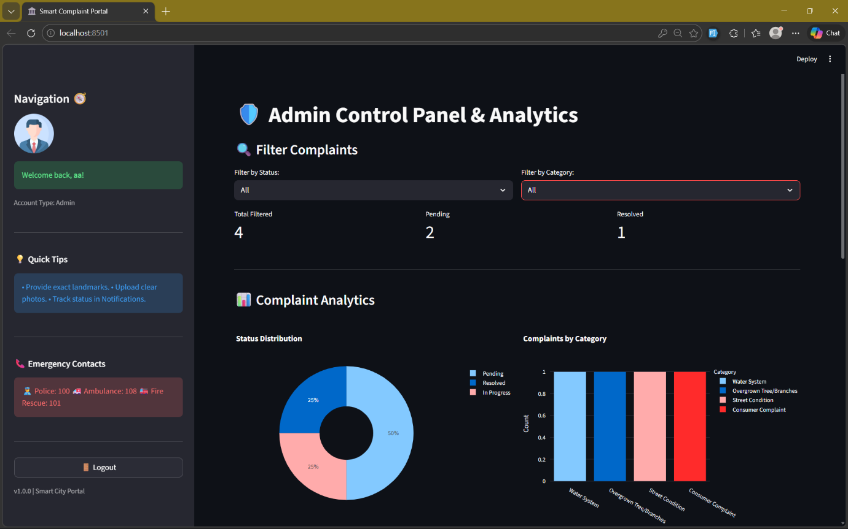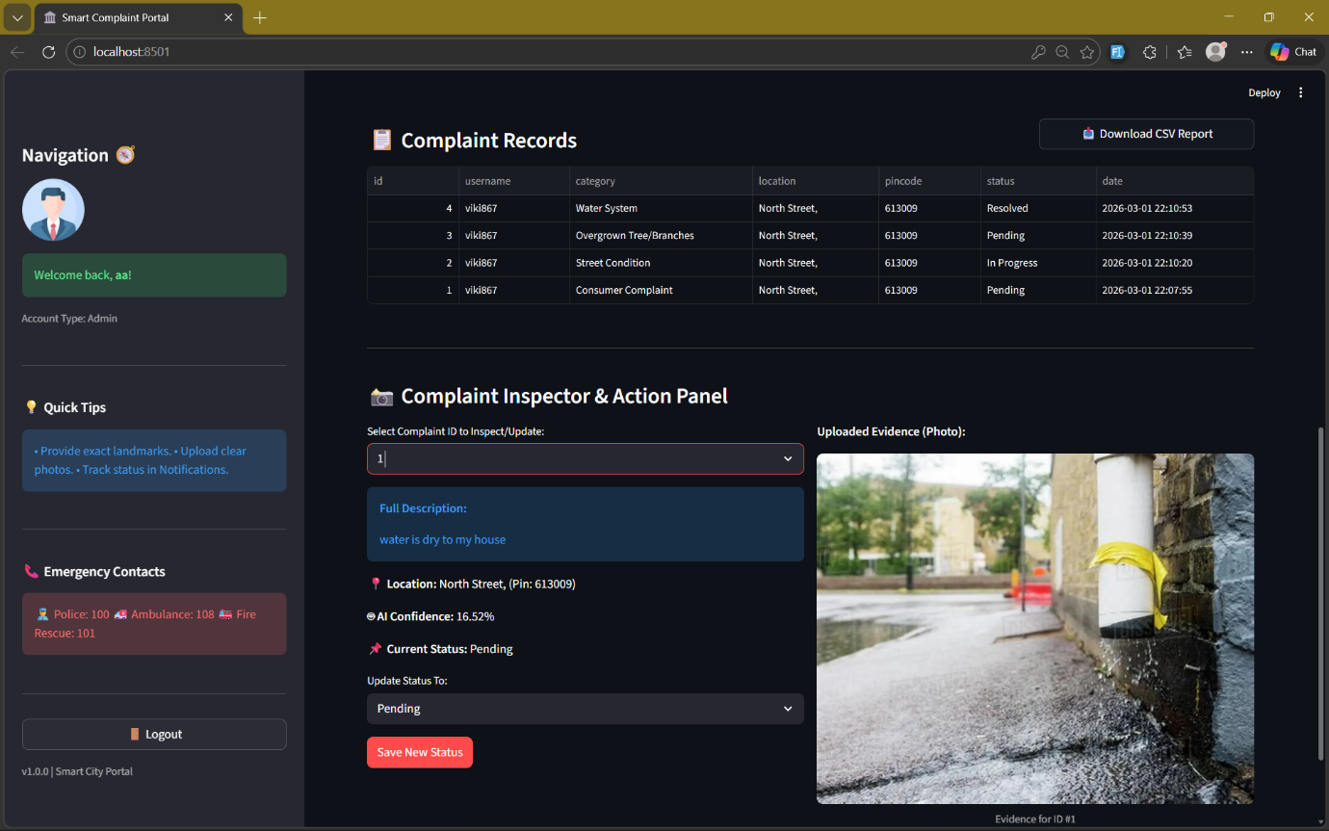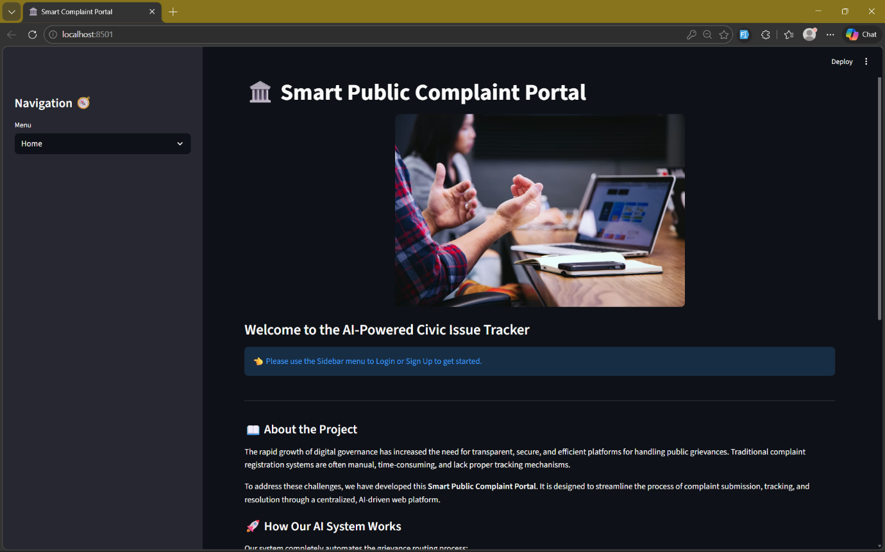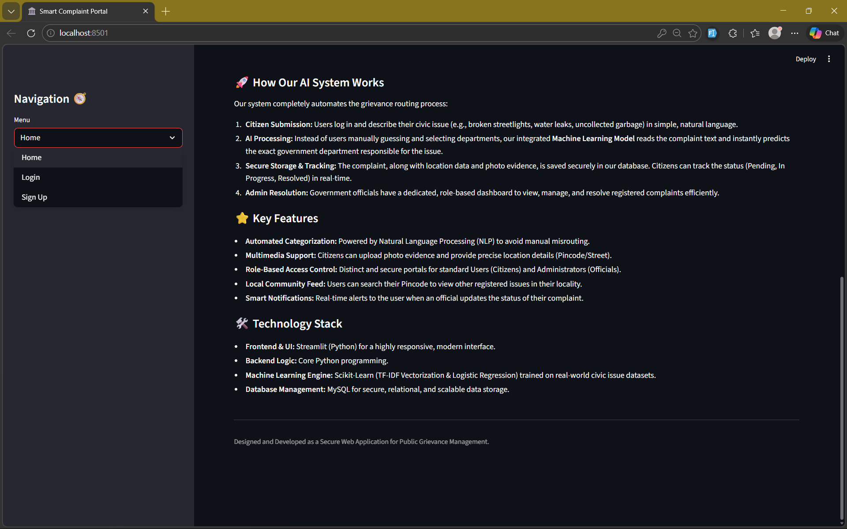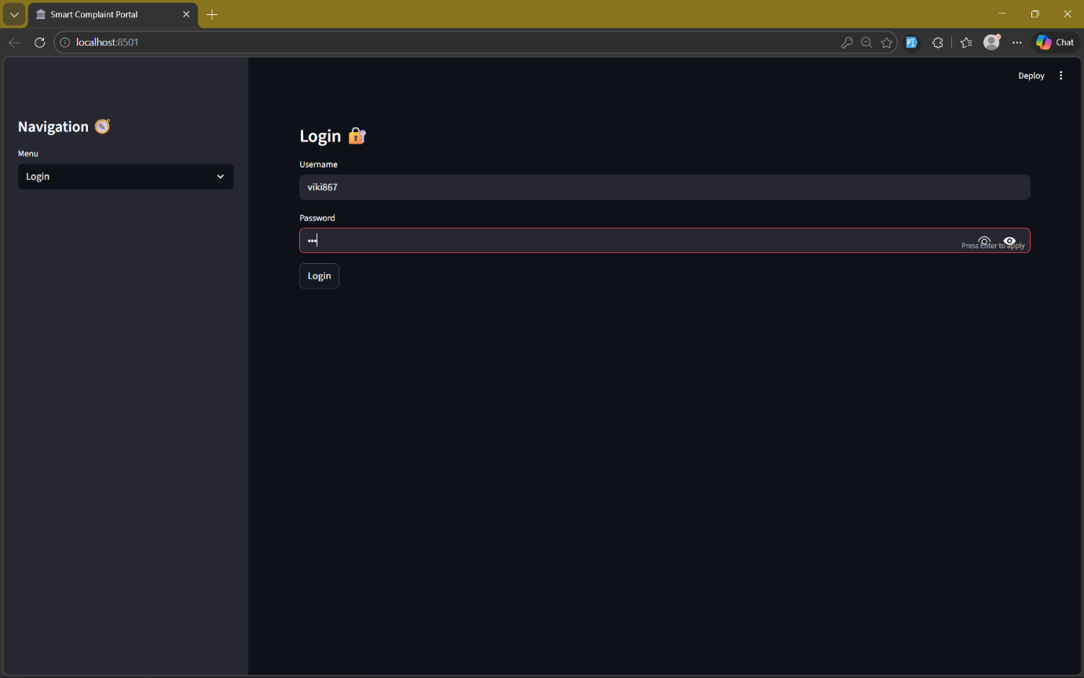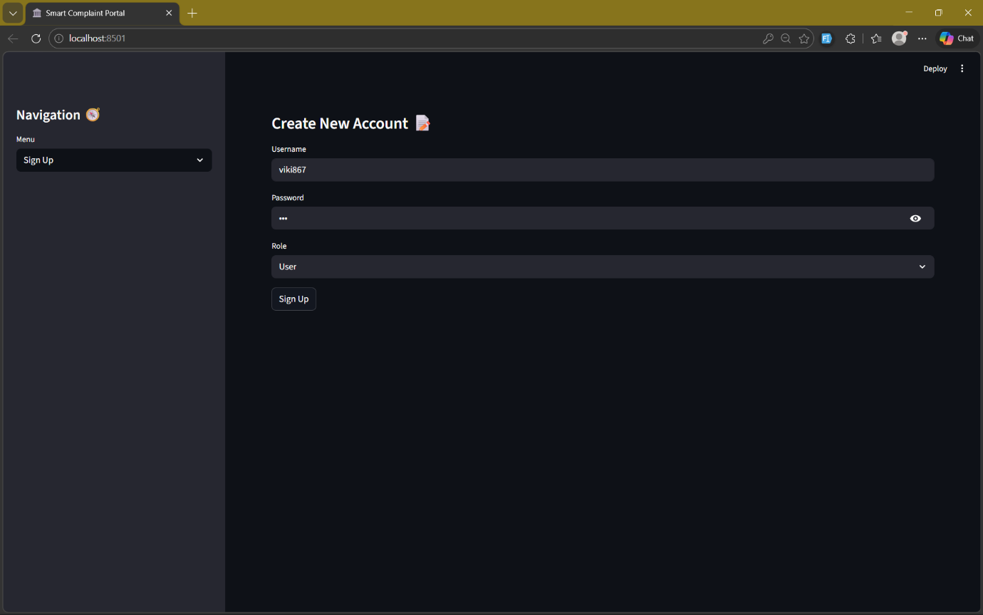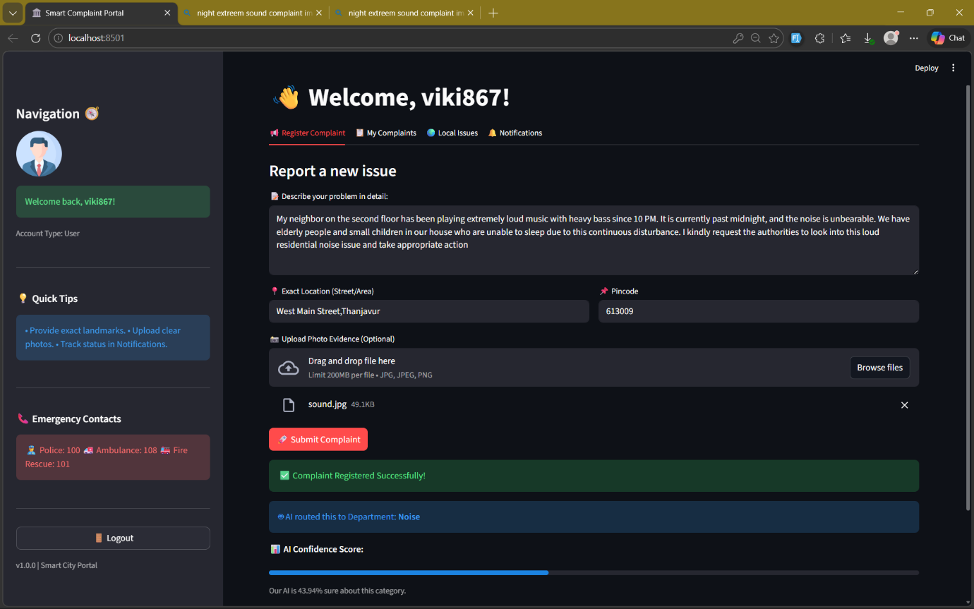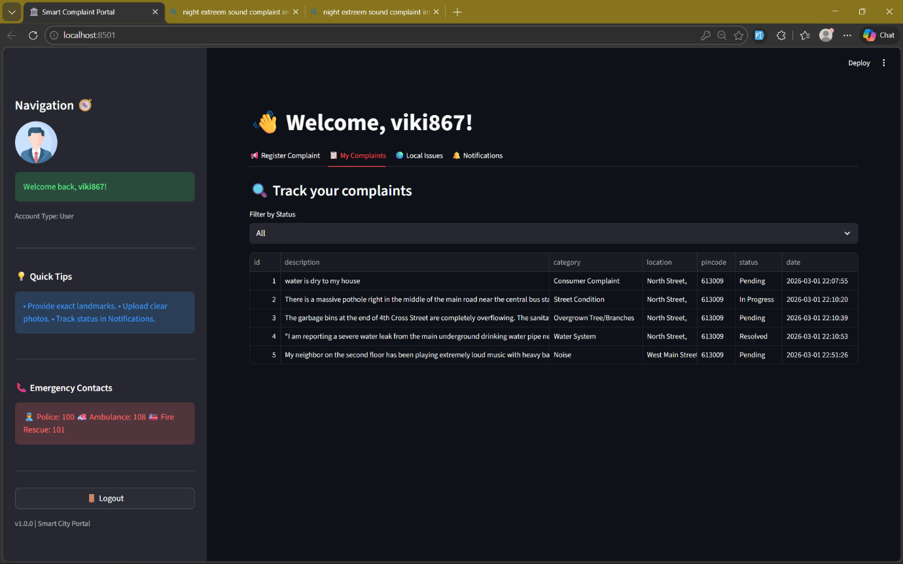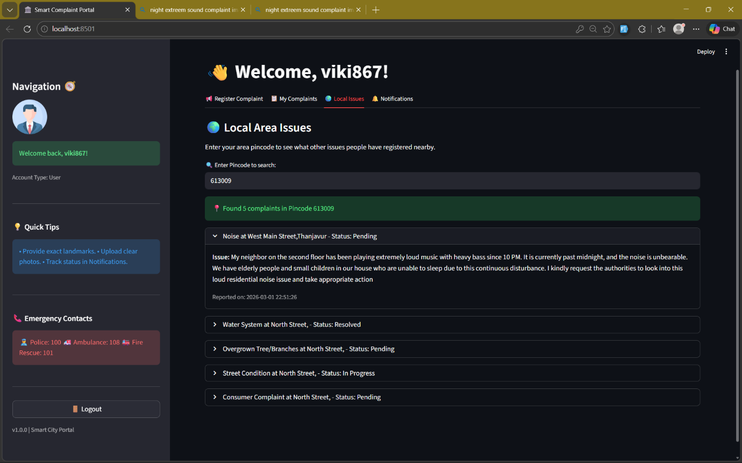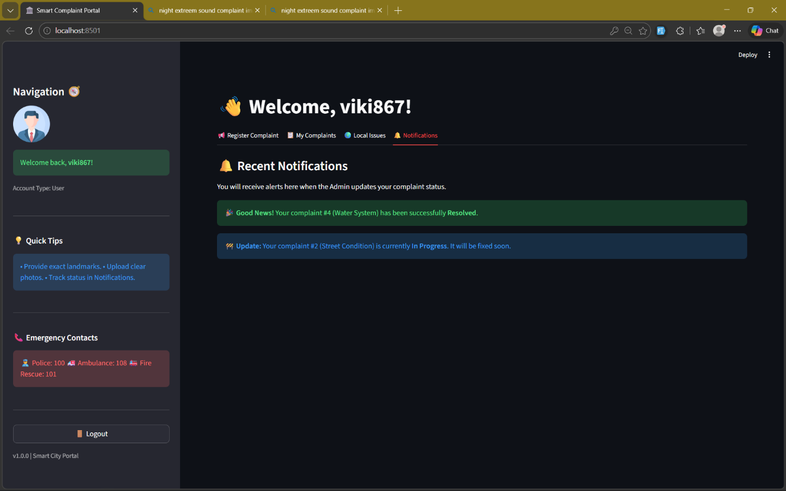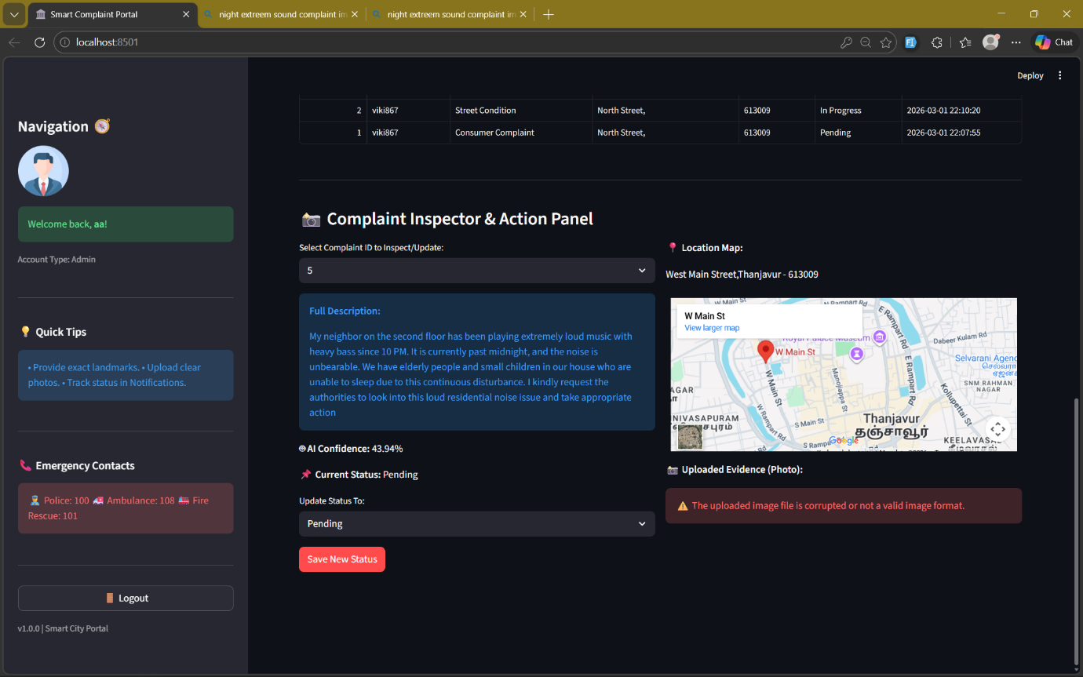

8.CONCLUSION
The proposed ML-based public complaint monitoring system successfully automates the process of understanding, categorizing, and prioritizing citizen complaints. By applying advanced Natural Language Processing (NLP) and Machine Learning (ML) techniques, the system eliminates the need for manual interpretation and significantly improves the accuracy, consistency, and speed of complaint handling.
The category prediction model efficiently classifies complaints into civic issue types such as road problems, garbage management, water leakage, electricity faults, and public safety concerns. Similarly, the priority prediction model assigns appropriate urgency levels—High, Medium, or Low—based on the severity indicators present in the complaint text. Together, these models enable faster routing of issues to the correct departments and ensure that critical complaints receive immediate attention.
The Streamlit-based interface integrates real-time prediction, visual dashboards, and complaint history management, making the system user-friendly and suitable for practical deployment. It reduces human workload, minimizes delays, and brings transparency to the grievance redressal workflow. The automated mechanism benefits municipal corporations, smart city systems, and public service platforms by supporting data-driven decision-making.
Overall, the system demonstrates that artificial intelligence can play a transformative role in public service management. With further enhancements—such as larger datasets, multilingual support, deep learning integration, and real-time civic issue mapping—the system can evolve into a powerful smart-governance solution capable of improving citizen satisfaction and operational efficiency.

9.FUTURE ENHANCEMENTS
The proposed ML-based public complaint monitoring system can be significantly improved in future stages by integrating more advanced technologies, expanding datasets, and enhancing automation capabilities. One major enhancement is the inclusion of multilingual NLP models that can process complaints in multiple regional languages, allowing citizens to submit grievances in Tamil, Hindi, Telugu, or other Indian languages without losing accuracy. This will make the system accessible to a wider audience and reduce communication barriers.
The ML classification pipeline can be upgraded using state-of-the-art transformer models such as BERT, RoBERTa, DistilBERT, and GPT-based text encoders to better understand the semantic meaning of complaint descriptions. Deep learning architectures like Bi-LSTM and attention mechanisms can also be integrated to improve the accuracy of category detection and priority prediction, especially for complex or ambiguous complaints. Expanding the dataset with large volumes of real municipal complaint data will further enhance model generalization.
From a system perspective, the platform can be evolved into a full-fledged smart governance application, featuring automated department routing, live issue tracking, map-based visualization of complaint hotspots, and integration with municipal management systems. Features like push notifications, SMS/email updates, and public dashboards can strengthen transparency and citizen engagement.
Operational deployment can be improved by adopting Docker containers, cloud hosting (AWS/GCP/Azure), and GPU-accelerated inference to handle large-scale usage. Real-time streaming pipelines can be implemented to process complaints continuously without manual refresh. Integration with IoT-enabled sensors—such as smart bins, street-light monitors, and water-level sensors—can provide automated alerts and combine sensor data with complaint analytics for more accurate issue detection.
These enhancements will make the complaint monitoring system more robust, intelligent, scalable, and suitable for deployment at municipal, state, or national levels, ultimately supporting smart city initiatives and improving public service delivery.

10. REFERENCES

    - Municipal Administration and Urban Development, “Urban Civic Issue Reports and Public Grievance Data,” Govt. Open Data Portal, accessed: Feb 2026.
    - Open Government Data (OGD) Platform India, “Public Service Complaint Records,” https://data.gov.in/, accessed: Feb 2026.
    - Kaggle, “Urban Issues & Civic Complaints Dataset,” https://www.kaggle.com/, accessed: Feb 2026.
    - S. Poria, E. Cambria, and A. Gelbukh, “Aspect-Based Sentiment Analysis: A Survey,” ACM Computing Surveys, vol. 52, no. 3, 2019.
    - C. Manning, H. Schütze, “Foundations of Statistical Natural Language Processing,” MIT Press, 1999.
    - J. Pennington, R. Socher, C. Manning, “GloVe: Global Vectors for Word Representation,” EMNLP Conference, 2014.
    - T. Joachims, “Text Categorization with Support Vector Machines,” Machine Learning: ECML, Springer, 1998.
    - Scikit-Learn Documentation, “Text Classification, TF-IDF, and Machine Learning Models,” https://scikit-learn.org/, accessed: Feb 2026.
    - Streamlit Documentation, “Building Data Apps with Streamlit,” https://streamlit.io/, accessed: Feb 2026.
    - A. Vaswani et al., “Attention Is All You Need,” Advances in Neural Information Processing Systems (NIPS), 2017.
    - World Bank Open Data, “Urban Infrastructure and Public Service Statistics,” accessed: Feb 2026.
    - M. K. Dalal and M. A. Zaveri, “Automatic Classification of User Complaints Using NLP Techniques,” International Journal of Computer Applications, 2020.
    - International Association of Public Participation (IAP2), “Best Practices for Public Grievance Redressal Systems,” accessed: Feb 2026.
    - R. Sebastiani, “Machine Learning in Automated Text Categorization,” ACM Computing Surveys, 2002.

