CONTENT
S.NO | TITLE | PAGE NO
1. | INTRODUCTION  - SYNOPSIS  - PROJECT DESCRIPTION
2. | SYSTEM ANALYSIS  2.1 EXISTING SYSTEM  2.2 PROPOSED SYSTEM
3. | SYSTEM DESIGN  3.1 INTRODUCTION TO SYSTEM DESIGN  3.2 DATABASE DESIGN  3.2 DATA FLOW DIAGRAM
4. | SYSTEM REQUIREMENTS  4.1 SOFTWARE REQUIREMENTS  4.2 HARDWARE REQUIREMENTS
5. | SOFTWARE DESCRIPTION
6. | IMPLEMENTATION  6.1 SOURCE CODE  6.2 TESTING
7. | OUTPUT  7.1 FORMS
8. | CONCLUSION
9. | FUTURE ENHANCEMENTS
10. | REFERENCES

- INTRODUCTION
  - SYNOPSIS
The rapid growth of the IT industry has increased workload intensity, extended working hours, and remote work dependency, causing significant psychological and emotional stress among IT professionals. Early detection of these stress indicators is essential to prevent burnout, maintain mental well-being, and improve workplace productivity. This project presents an Automated Stress Detection System that identifies stress levels in IT employees using a combination of behavioral features and sentiment-based indicators collected through user responses and textual inputs.
The system employs supervised machine learning techniques to analyze behavioral parameters such as work environment, family mental health history, treatment status, organizational support, and leave flexibility. Additionally, a sentiment analysis component processes user-submitted textual expressions to detect emotional tones such as negativity, frustration, or anxiety. The extracted behavioral features and sentiment scores are fused and fed into trained ML models, including Random Forest, Support Vector Machine (SVM), and XGBoost, to compute a probability-based stress score. Based on this probability, the system categorizes users into low, medium, or high stress levels.
The proposed hybrid behavioral–sentiment model improves prediction reliability by combining structured inputs with natural language cues. Experimental results show that supervised learning algorithms provide high classification accuracy, making the approach effective for real-time stress assessment. This system can support organizations and individuals in monitoring mental well-being, identifying early warning signals, and adopting preventive measures to reduce stress-related risks in IT workplaces.

1.2 PROJECT DESCRIPTION
This project, titled “Automated Stress Detection in IT Professionals Using Behavioral and Sentiment Indicators,” aims to identify whether an IT employee is under low, medium, or high stress by analyzing their behavioral information and emotional text responses. The entire system is developed using Python, and machine learning techniques are used to predict stress accurately.
Data Collection
The dataset used in this project is collected from publicly available mental health surveys, online stress assessment studies, and research-based questionnaires specifically focused on IT professionals.
It includes behavioral attributes such as:
- Work environment
- Remote work status
- Leave difficulty
- Treatment history
- Family mental health background
- Organizational support
- Company benefits
In addition to this, users also provide short text descriptions about how they feel. These texts help capture emotional signals such as negativity or stress, which improves prediction accuracy.
Data Preprocessing
To prepare the data for machine learning, several preprocessing steps are performed:
- Handling missing values
- Converting categorical data into numerical form
- Scaling numeric values
- Cleaning and processing user text
- Extracting sentiment scores (positive, negative, neutral)
Sentiment analysis tools like TextBlob or VADER are used to convert raw text into meaningful emotional scores.This helps the model understand both behavior and emotion of the user.
Model Training
After preprocessing, the dataset is divided into training and testing sets.
Multiple supervised learning algorithms are applied to train the model:
- Random Forest
- Support Vector Machine (SVM)
- XGBoost
These models learn how different behavioral patterns and emotional tones relate to stress levels.
During training, the model tries to:
- Identify hidden relationships between features
- Predict stress probability
- Classify users into Low, Medium, or High stress
The model that gives the best accuracy and stable performance is chosen as the final prediction model.
Application of ML & Sentiment Algorithms
After training, the final model is used for real-time prediction.
The system takes:
- Behavioral inputs (age, work culture, treatment status, leave difficulty, etc.)
- A short text describing how the user feels
The text is converted into sentiment scores, and both types of data are passed into the ML model.
The model then generates:
- Stress probability
- Stress category (Low / Medium / High)
This combination of behavioral indicators + sentiment signals gives a more realistic and accurate understanding of the user’s stress level.

- SYSTEM ANALYSIS
2.1 EXISTING SYSTEM
Most of the existing stress-analysis or mental-health screening systems rely on traditional survey-based assessment methods. These systems typically use fixed questionnaires, manual evaluation, or simple rule-based scoring methods. Although these approaches provide a basic understanding of stress levels, they have several shortcomings:
- Manual Stress Assessment
Many existing systems depend on self-assessment questionnaires where users manually answer questions, and the system calculates a basic score. This does not incorporate machine learning or deep pattern understanding.
- Lack of Behavioral Feature Integration
Current tools generally do not analyze workplace-related behavioral indicators such as remote work difficulty, leave flexibility, organizational support, or treatment history — all of which strongly influence stress levels in IT professionals.
- No Probability-based Risk Classification
Existing methods usually give only a single label (e.g., “Stressed” or “Not Stressed”) instead of providing a probability score that explains the severity.
DRAWBACK
- Low accuracy due to manual scoring and lack of ML techniques
- No behavioral + sentiment fusion, reducing reliability
- Cannot detect early signs of stress
- No continuous monitoring or prediction history
- No personalization, same rules for all users
- Lack of automation, requires manual interpretation
- No probability-based stress severity output

2.2 PROPOSED SYSTEM
The proposed system introduces a fully automated, machine-learning-driven stress detection framework specifically designed for IT professionals.
It combines behavioral indicators and sentiment analysis to deliver a more accurate and intelligent stress prediction.
The user provides:
- Workplace-related behavioral details
- Mental-health history
- Leave difficulty
- Treatment information
- Organizational support indicators
- A short text expressing how they feel
These inputs undergo preprocessing steps such as encoding, feature scaling, and text sentiment extraction.
The processed data is then passed into supervised machine learning models such as:
- Random Forest
- Support Vector Machine (SVM)
- XGBoost Classifier
The model analyzes both behavioral patterns and emotional tone to calculate a stress probability score and classify the user into:
- Low Stress
- Medium Stress
- High Stress
All predictions are stored, allowing users to track their mental-health trend over time.
This hybrid behavioral + sentiment system ensures higher accuracy, better interpretability, and real-time stress detection.

ADVANTAGES
- High prediction accuracy using supervised ML algorithms
- Analyzes both behavioral indicators & emotional sentiment
- Predicts stress probability, not just a simple label
- Stores user history for long-term stress tracking
- Automated, fast, and user-friendly
- Reduces manual errors and subjective bias
- Early stress detection helps prevent burnout in IT professionals
- Scalable system—can be extended to large corporate environments
- Real-time prediction capability
- More reliable than existing survey-based methods

- SYSTEM DESIGN

3.2 DATABASE DESIGN
USERS
Column | Type | Description
user_id | INT PK AUTO | Unique user ID
name | VARCHAR(100) | Employee name
age | INT | Age
gender | VARCHAR(20) | Gender
department | VARCHAR(50) | IT division (DevOps, Support, QA)
role | VARCHAR(100) | Job position
experience_years | INT | IT experience
email | VARCHAR(100) | Login/email
password | VARCHAR(100) | Authentication
created_at | TIMESTAMP | Account creation time

PHYSIOLOGICAL_DATA

Column | Type | Description
physio_id | INT PK AUTO | Record ID
user_id | INT FK | Which employee
heart_rate | INT | BPM
skin_conductance | DOUBLE | GSR value
body_temp | DOUBLE | Temperature
respiration_rate | INT | Breaths per minute
timestamp | TIMESTAMP | Data collection time

BEHAVIORAL_DATA

Column | Type | Description
behavior_id | INT PK AUTO | Record ID
user_id | INT FK | Employee
working_hours | INT | Daily working hours
break_frequency | INT | Number of breaks taken
sleep_hours | DOUBLE | Last night’s sleep
caffeine_intake | INT | Coffee/tea count
mood_report | VARCHAR(50) | Self-reported mood
task_load | INT | Number of assigned tasks
timestamp | TIMESTAMP | Logged time

SYSTEM_USAGE_LOGS

Column | Type | Description
log_id | INT PK AUTO | Record ID
user_id | INT FK | Employee
active_hours | DOUBLE | Time active on system
idle_time | DOUBLE | Time inactive
keystroke_rate | INT | Keystrokes/min
mouse_activity | INT | Clicks/min
app_switch_frequency | INT | Context switching (indicator of stress)
timestamp | TIMESTAMP | Log timestamp

STRESS_PREDICTIONS
Column | Type | Description
prediction_id | INT PK AUTO | Prediction ID
user_id | INT FK | Employee
physio_id | INT FK | Physiological data reference
behavior_id | INT FK | Behavior reference
log_id | INT FK | System usage reference
stress_score | DOUBLE | 0–100 AI score
stress_level | VARCHAR(30) | Low / Medium / High / Critical
model_confidence | DOUBLE | ML model confidence (%)
ai_recommendation | TEXT | Automatic suggestions
created_at | TIMESTAMP | Prediction timestamp

EMPLOYEE_FEEDBACK
Column | Type | Description
feedback_id | INT PK AUTO | Feedback ID
user_id | INT FK | Employee
stress_feeling | VARCHAR(50) | Self-reported stress
feedback_text | TEXT | Comments
timestamp | TIMESTAMP | Feedback time

3.3 DATA FLOW DIAGRAM

Workload
Sleep Data
Heart Rate
Surveys

Stressed
Stress Data
Data Feature
- HR,BP
- Working Hours
- Activity Level
IT Professionals
Attribute
- ID
- Personal info
Stress Level
Stress Prediction
Machine Learning Model
Feature Selection
Not Stressed

High Stress
Low Stress

4. SYSTEM REQUIRMENTS
4.1 SOFTWARE REQUIREMENTS
Operating System : Microsoft windows10
Front End : Streamlit
Back End : Python
Database : MySQL
Documentation : Microsoft Word
4.2 HARDWARE REQUIREMENTS
Processor : Intel i5 core
Speed : 3.10 GHz
RAM : 16 GB
Hard Disk : 510 GB
Monitor : 15 SVGA color
Mouse : Wired mouse
Keyboard : wired keyboard
Printer : Laser Printer

- SOFTWARE DESCRIPTION
5.1 FRONT END TOOL
Introduction to Streamlit
For the development of the user interface (UI) and the interactive dashboards of the "Secure Web Application for Public Complaint Monitoring," Streamlit was utilized as the primary front-end framework. Streamlit is a modern, open-source Python library designed explicitly for creating and sharing custom web applications for machine learning and data science projects. Unlike traditional web development frameworks that require a deep understanding of HTML, CSS, and JavaScript, Streamlit allows developers to build highly interactive, responsive, and aesthetically pleasing web interfaces entirely in Python.
By treating the UI components as simple Python function calls, Streamlit bridges the gap between complex backend machine learning algorithms and front-end user interaction, making it the ideal choice for this AI-driven civic issue tracker.
Why Streamlit was Chosen for this Project The selection of Streamlit over traditional frameworks (like React or Angular) was driven by several project-specific requirements:
- Seamless Machine Learning Integration: Since the core of this project involves a Natural Language Processing (NLP) model to categorize complaints, Streamlit allows the machine learning model (joblib and scikit-learn) to be directly loaded and executed within the same script that renders the web page.
- Rapid Prototyping and Development: It drastically reduces the development time by eliminating the need to write separate REST APIs to connect the frontend to the backend. The frontend UI and backend logic coexist efficiently.
- Built-in Data Visualization: The administrative dashboard requires complex data representations (such as pie charts and bar graphs) to monitor complaint trends. Streamlit seamlessly integrates with data visualization libraries like Plotly and Pandas to render these charts dynamically.
- Responsive Design: Applications built with Streamlit are natively responsive, meaning the complaint portal adapts perfectly to both desktop monitors and mobile device screens without writing extra CSS media queries.
Implementation of Front-End Features In this project, Streamlit handles the entire client-side experience through various interactive widgets and layout structures. The key implementations include:
A. User Authentication & Session Management: The application utilizes Streamlit’s st.session_state feature to manage secure user logins. It tracks whether a user is an 'Admin' or a 'Citizen' and dynamically renders the appropriate dashboard based on their role. This ensures secure role-based access control directly from the front end.
B. Citizen Dashboard (User Interface):
- Data Input Widgets: The system uses st.text_area for citizens to securely type their detailed complaint descriptions.
- Location Tracking: Widgets like st.text_input are used to capture the exact street address and Pincode for geo-tagging the issue.
- Multimedia Uploads: The st.file_uploader component provides a drag-and-drop interface for users to upload photographic evidence of the civic issue (e.g., broken pipes, uncollected garbage).
- Real-time Feedback: Upon submitting a complaint, st.progress is used to display the Artificial Intelligence Confidence Score, providing transparency to the user about the AI's categorization accuracy.
C. Administrative Dashboard (Official Interface):
- Data Presentation: The st.dataframe component is used to display the entire MySQL database of complaints in a clean, scrollable, and sortable grid format.
- Visual Analytics: Using st.plotly_chart, the front end renders interactive Pie Charts (showing Pending vs. Resolved statuses) and Bar Charts (showing complaint categories), allowing administrators to gauge the city's civic health at a glance.
- Action Panels: st.selectbox and st.button components allow administrators to easily update the status of a complaint, which immediately triggers a backend MySQL update and refreshes the UI.
D. Dynamic Layout and Theming: To organize the vast amount of information, Streamlit’s layout features such as st.sidebar (for navigation and emergency contacts), st.columns (to place forms and maps side-by-side), and st.tabs (to separate "Register Complaint," "My Complaints," and "Notifications") were extensively utilized. The application is also configured with a "wide" layout and a dark-mode theme to reduce eye strain for administrators monitoring the system continuously.
Advantages of Using Streamlit in the Proposed System
- Interactive Data Flow: Whenever a user interacts with a widget (e.g., filtering complaints by "Pending" status), Streamlit automatically reruns the necessary parts of the script to fetch fresh data from the MySQL database and update the screen instantly.
- Security: Because Streamlit executes on the server side, sensitive API keys, database credentials, and Machine Learning model weights are never exposed to the client's browser, ensuring a high level of security for the public complaint portal.
- Extensibility: The tool allows for easy expansion. For instance, rendering HTML iframes to embed Google Maps for tracking complaint locations was achieved effortlessly using Streamlit's component integration.
Conclusion on Front End In summary, Streamlit proved to be an exceptionally powerful front-end tool for this project. It provided the necessary agility to design a secure, role-based, and AI-integrated web portal, ensuring that citizens have a smooth experience while reporting issues, and authorities have a robust, data-rich dashboard for efficient public administration.

5.2 BACK END TOOL
PYTHON
Python is an open source programming language that was made to be easy-to-read and powerful. Python is an interpreted language. Interpreted languages do not need to be compiled to run. A program called an interpreter runs Python code on almost any kind of computer. This means that a programmer can change the code and quickly see the results. This also means Python is slower than a compiled language like C, because it is not running machine code directly.
Python is a good programming language for beginners. It is a high-level language, which means a programmer can focus on what to do instead of how to do it. Writing programs in Python takes less time than in some other languages. Python is a computer programming language designed for readability and functionality. One of Python’s design goals is that the meaning of the code is easily understood because of the very clear syntax of the language. Python programming language has a specific syntax (form) and semantics (meaning) which enables it to express computations and data manipulations which can be performed by a computer. Python’s implementation was started in 1989 by Guido van Rossum at CWI (a national research institute in the Netherlands) as a successor to the ABC programming language (an obscure language made more popular by the fact that it motivated Python!). Van Rossum is Python’s principal author, and his continuing central role in deciding the direction of Python is reflected in the title given to him by the Python community, Benevolent Dictator for Life (BDFL). Python is an interpreted language, i.e., a programming language whose programs are not directly executed by the host cpu but rather executed (or “interpreted”) by a program known as an interpreter. The source code of a Python program is translated or (partially) compiled to a “byte code” form of a Python “process virtual machine” language.
This is in distinction to C code which is compiled to cpu-machine code before runtime. Python is a “dynamically typed” programming language. A programming language is said to be dynamically typed, when the majority of its type checking is performed at run-time as opposed to at compile-time. Dynamically typed languages include JavaScript, Lisp, Lua, Objective-C, Python, Ruby, and Tcl. Python is an object-oriented language. Object-oriented programming (OOP) uses “objects” - data structures consisting of data fields and methods - to design computer programs. For example, a matrix could be the “object” you want to write programs to deal with. It could define a class of matrices and, for example, a method for that class might be addition (representing ordinary addition of matrices). It will return to this example in more detail later in the course.
PYTHON LIBRARY
Python is used by hundreds of thousands of programmers and is used in many places. Sometimes only Python code is used for a program, but most of the time it is used to do simple jobs while another programming language is used to do more complicated tasks. Its standard library is made up of many functions that come with Python when it is installed. On the Internet there are many other libraries available that make it possible for the Python language to do more things. These libraries make it a powerful language; it can do many different things.
Some things that Python is often used for are:
- Web development
- Game programming
- Desktop GUIs
- Scientific programming
- Network programming.
Python also does something called "dynamic variable assignment". This means that when a number or word is made in a program, the user does not have to say what type it is. This makes it easier to reuse variable names, making fast changes simpler. An example of this is shown below.
INPUT/OUTPUT
Sage is built on Python, so includes Python, but is designed for general purpose mathematical computation (the lead developer of Sage is a numbertheorist). The interface to Sage is IPython, though it has been configured in a customized way to that the prompt says sage: as opposed to In or >>>. Other than this change in prompt, the command line interface to Sage is similar to that if Python and SymPy. Sage sage: a = 3.1415 sage: print a 3.14150000000000 sage: type(a) Sage also include SymPy and a nice graphical interface called the Sage notebook.
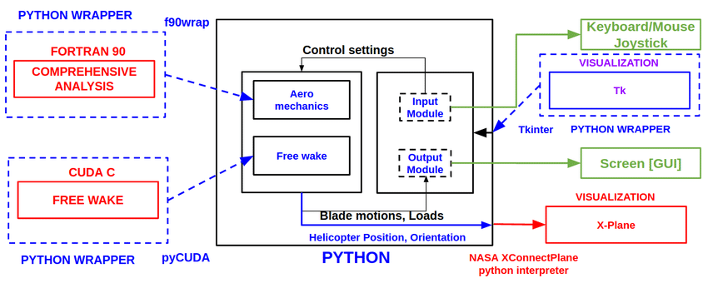
FRAMEWORK

DATA TYPES
The data which a Python program deals with must be described precisely. This description is referred to as the data type. In the case of Python, the fact that Python is dynamically typed basically means that the interpreter or compiler will figure out for you what type a variable is at run-time, so you don’t have to declare variable types yourself. Besides numerical data types, such as int (for integers) and float (for reals), there are other types such as tuple and list. A more complete list, with examples, is given below.
Type Description
- An immutable sequence "string", """\python of Unicode characters is great""", ’2012’ bytes An immutable sequence of bytes b’Some ASCII’.
- List Mutable, can contain mixed types [1.0, ’list’, True].
- Tuple Immutable, can contain mixed types (-1.0, ’tuple’, False) set, Unordered, contains no duplicates set([1.2, ’xyz’, True]), frozensetfrozenset([4.0, ’abc’, True]).
- Dict A mutable group of key {’key1’: 1.0, ’key2’: False} and value pairs int An immutable fixed precision 42 number of unlimited magnitude float An immutable floating point 2.71828 number (system-defined precision).
- Complex An immutable complex number -3 + 1.4j with real and imaginary parts Boolean. An immutable Boolean value True, False.
STRUCTURE OF PYTHON
- Command-Line Application Layouts
  - One-Off Script
  - Installable Single Package
  - Application with Internal Packages
- Web Application Layouts
  - Django
  - Flask
Python, though opinionated on syntax and style, is surprisingly flexible when it comes to structuring your applications. On the one hand, this flexibility is great: it allows different use cases to use structures that are necessary for those use cases. On the other hand, though, it can be very confusing to the new developer. The Internet isn’t a lot of help either—there are as many opinions as there are Python blogs. Examples of common Python application structures, including command-line applications (CLI apps), one-off scripts, installable packages, and web application layouts with popular frameworks like Flask and Django.

COMMAND-LINE APPLICATION LAYOUTS
A lot of us work primarily with Python applications that are run via command-line interfaces (CLIs). This is where you often start with a blank canvas, and the flexibility of Python application layouts can be a real headache. Starting with an empty project folder can be intimidating and lead to no shortage of coder’s block.

One-Off Script
The following layout will work for all of these cases and can easily be modified to reflect whatever installation or other tools you use in your workflow. This layout will cover you whether you’re creating a pure Python script (that is, one with no dependencies) or using a tool like pip or Pipenv. That the exact location of the files in the layout matters less than the reason they are placed where they are. All of these files should be in a project directory named after your project. For this example, we will use (what else?) helloworld as the project name and root directory.
Here’s the Python project structure I typically use for a CLI app:
This is pretty straightforward: everything is in the same directory. The files shown here are not necessarily exhaustive, but I recommend keeping the number of files to a minimum if you plan on using a basic layout like this. Some of these files will be new to you, so let’s take a quick look at what each of them does.
- .gitignore: This is a file that tells Git which kinds of files to ignore, like IDE clutter or local configuration files. Our Git tutorial has all the details, and you can find sample .gitignore files for Python projects here.
- helloworld.py: This is the script that you’re distributing. As far as naming the main script file goes, I recommend that you go with the name of your project (which is the same as the name of the top-level directory).
- LICENSE: This plaintext file describes the license you’re using for a project. It’s always a good idea to have one if you’re distributing code. The filename is in all caps by convention.
- README.md: This is a Markdown (or reStructuredText) file documenting the purpose and usage of your application. Crafting a good README is an art, but you can find a shortcut to mastery here.
- requirements.txt: This file defines outside Python dependencies and their versions for your application.
- setup.py: This file can also be used to define dependencies, but it really shines for other work that needs to be done during installation. You can read more about both setup.py and requirements.txt in our guide to Pipenv.
- tests.py: This script houses your tests, if you have any. You should have some.

Introduction to MySQL
MySQL is a very popular open-source relational database management system (RDBMS).MySQL is a relational database management system A relational database stores data in separate tables rather than putting all the data in one big storeroom. The database structure is organized into physical files optimized for speed. MySQL is a relational database management system (RDBMS) developed by Oracle that is based on structured query language (SQL). A database is a structured collection of data.Its name is a combination of "My", the name of co-founder Michael Widenius's daughter My, and "SQL", the acronym for Structured Query Language.MySQL is developed, distributed, and supported by Oracle Corporation

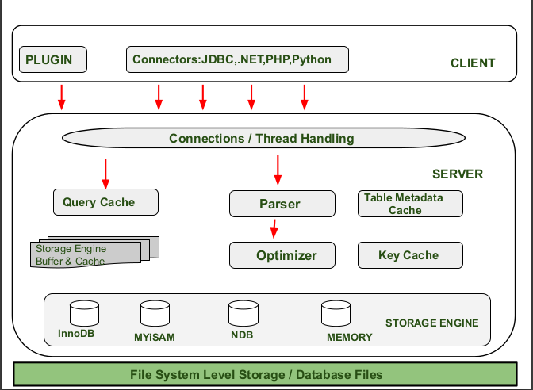

Features:
- MySQL is a relational database management system
- MySQL is open-source
- MySQL is free
- MySQL is ideal for both small and large applications
- MySQL is very fast, reliable, scalable, and easy to use
- MySQL is compliant with the ANSI SQL standard
- MySQL was first released in 1995
To build a web site that shows data from a database, you will need:
- An RDBMS database program (like MySQL)
- A server-side scripting language, like PHP
- To use SQL to get the data you want
- To use HTML / CSS to style the page

Some of the Most Important SQL Commands
- SELECT - extracts data from a database
- UPDATE - updates data in a database
- DELETE - deletes data from a database
- INSERT INTO - inserts new data into a database
- CREATE DATABASE - creates a new database
- ALTER DATABASE - modifies a database
- CREATE TABLE - creates a new table
- ALTER TABLE - modifies a table
- DROP TABLE - deletes a table
- CREATE INDEX - creates an index (search key)
- DROP INDEX - deletes an index
Limitations
When using some storage engines other than the default of InnoDB, MySQL does not comply with the full SQL standard for some of the implemented functionality, including foreign key references. Check constraints are parsed but ignored by all storage engines before MySQL version 8.0.15.
Up until MySQL triggers are limited to one per action / timing, meaning that at most one trigger can be defined to be executed after an INSERT operation, and one before INSERT on the same table.No triggers can be defined on views.
MySQL database's inbuilt functions like UNIX_TIMESTAMP() will return 0 after 03:14:07 UTC on 19 January 2038. Recently, there had been an attempt to solve the problem which had been assigned to the internal queue.
Deployment
MySQL can be built and installed manually from source code, but it is more commonly installed from a binary package unless special customizations are required. On most Linux distributions, the package management system can download and install MySQL with minimal effort, though further configuration is often required to adjust security and optimization settings.
Though MySQL began as a low-end alternative to more powerful proprietary databases, it has gradually evolved to support higher-scale needs as well. It is still most commonly used in small to medium scale single-server deployments, either as a component in a LAMP-based web application or as a standalone database server. Much of MySQL's appeal originates in its relative simplicity and ease of use, which is enabled by an ecosystem of open source tools such as phpMyAdmin. In the medium range, MySQL can be scaled by deploying it on more powerful hardware, such as a multi-processor server with gigabytes of memory.
There are, however, limits to how far performance can scale on a single server ('scaling up'), so on larger scales, multi-server MySQL ('scaling out') deployments are required to provide improved performance and reliability. A typical high-end configuration can include a powerful master database which handles data write operations and is replicated to multiple slaves that handle all read operations. The master server continually pushes binlog events to connected slaves so in the event of failure a slave can be promoted to become the new master, minimizing downtime. Further improvements in performance can be achieved by caching the results from database queries in memory using memcached, or breaking down a database into smaller chunks called shards which can be spread across a number of distributed server clusters.

High availability software
Oracle MySQL offers a high availability solution with a mix of tools including the MySQL router and the MySQL shell. They are based on Group Replication, open source tools.
MariaDB offers a similar offer in terms of products.

Cloud deployment
MySQL can also be run on cloud computing platforms such as Microsoft Azure, Amazon Elastic Compute Cloud, Oracle Cloud Infrastructure. Some common deployment models for MySQL on the cloud are:
Virtual machine image
In this implementation, cloud users can upload a machine image of their own with MySQL installed, or use a ready-made machine image with an optimized installation of MySQL on it, such as the one provided by Amazon EC2.
MySQL as a service
Some cloud platforms offer MySQL "as a service". In this configuration, application owners do not have to install and maintain the MySQL database on their own. Instead, the database service provider takes responsibility for installing and maintaining the database, and application owners pay according to their usage.Notable cloud-based MySQL services are the Amazon Relational Database Service; Oracle MySQL Cloud Service, Azure DatabaseforMySQL, Rackspace; HPConverged Cloud; Heroku and Jelastic. In this model the database service provider takes responsibility for maintaining the host and database.

Graphical user interfaces

A graphical user interface (GUI) is a type of interface that allows users to interact with electronic devices or programs through graphical icons and visual indicators such as secondary notation, as opposed to text-based interfaces, typed command labels or text navigation.
Third-party proprietary and free graphical administration applications (or "front ends") are available that integrate with MySQL and enable users to work with database structure and data visually.

MySQL Workbench
MySQL Workbench is the integrated environment for MySQL. It was developed by MySQL AB, and enables users to graphically administer MySQL databases and visually design database structures.
MySQL Workbench is available in three editions, the regular free and open source which may be downloaded from the MySQL website, and the proprietary which extends and improves the feature set of the Community Edition, and the MySQL Cluster CGE.

Command-line interfaces
A command-line interface is a means of interacting with a computer program where the user issues commands to the program by typing in successive lines of text (command lines). MySQL ships with many command line tools, from which the main interface is the mysql client.
MySQL Utilities is a set of utilities designed to perform common maintenance and administrative tasks. Originally included as part of the MySQL Workbench, the utilities are a stand-alone download available from Oracle.
Percona Toolkit is a cross-platform toolkit for MySQL, developed in Perl. Percona Toolkit can be used to prove replication is working correctly, fix corrupted data, automate repetitive tasks, and speed up servers. PerconaToolkit is included with several Linux distributions such as CentOS and Debian, and packages are available for Fedora and Ubuntu as well. Percona Toolkit was originally developed as Maatkit, but as of late 2011, Maatkit is no longer developed.
MySQL shell is a tool for interactive use and administration of the MySQL database. It supports JavaScript, Python or SQL modes and it can be used for administration and access purposes.

Application programming interfaces
Many programming languages with language-specific APIs include libraries for accessing MySQL databases. These include MySQL Connector/Net for .NET/CLI Languages, and the JDBC driver for Java.
.

- IMPLEMENTATION
6.1 SOURCE CODE
App.py
import streamlit as st
import sqlite3
import pickle
import pandas as pd
from xgboost import XGBClassifier
import joblib
rf_model = joblib.load("rf_model.pkl")
svm_model = joblib.load("svm_model.pkl")
xgb_model = XGBClassifier()
xgb_model.load_model("stress_model.json")
# ==========================
# Page Config
# ==========================
st.set_page_config(page_title="Stress Detection System", layout="wide")
# ==========================
# Custom CSS (Modern UI)
# ==========================
st.markdown("""
<style>
.main {
background-color: #0E1117;
}
h1, h2, h3 {
color: #FFFFFF;
}
.stButton>button {
background-color: #FF4B4B;
color: white;
border-radius: 8px;
padding: 10px 20px;
}
.stTextInput>div>div>input {
background-color: #1E1E1E;
color: white;
}
.stSelectbox>div>div {
background-color: #1E1E1E;
color: white;
}
</style>
""", unsafe_allow_html=True)

# ==========================
# Load Model
# ==========================
model = XGBClassifier()
model.load_model("stress_model.json")

scaler = pickle.load(open("scaler.pkl", "rb"))
encoders = pickle.load(open("encoders.pkl", "rb"))

# ==========================
# Database
# ==========================
conn = sqlite3.connect("users.db", check_same_thread=False)
c = conn.cursor()

c.execute("""CREATE TABLE IF NOT EXISTS users(username TEXT, password TEXT)""")
c.execute("""CREATE TABLE IF NOT EXISTS predictions(
username TEXT, age INTEGER, stress_level TEXT, probability REAL)""")
conn.commit()

# ==========================
# Functions
# ==========================
def add_user(u, p):
c.execute("INSERT INTO users VALUES (?,?)", (u, p))
conn.commit()

def login_user(u, p):
c.execute("SELECT * FROM users WHERE username=? AND password=?", (u, p))
return c.fetchone()

def save_prediction(username, age, stress_level, prob):
c.execute(
"INSERT INTO predictions VALUES (?,?,?,?)",
(username, age, stress_level, float(prob))
)
conn.commit()
def get_history(u):
c.execute("SELECT age, stress_level, probability FROM predictions WHERE username=?", (u,))
return c.fetchall()

# ==========================
# Session State
# ==========================
if "logged_in" not in st.session_state:
st.session_state.logged_in = False
if "username" not in st.session_state:
st.session_state.username = ""
# ==========================
# TOP NAVIGATION
# ==========================
if not st.session_state.logged_in:
nav = st.radio("Navigation", ["Home", "About", "Login", "Signup"], horizontal=True)
else:
nav = st.radio("Navigation", ["Dashboard", "Predict Stress", "History", "Logout"], horizontal=True)
# ==========================
# HOME PAGE
# ==========================
if nav == "Home":

# Advanced Hero Section
st.markdown("""
<style>
.hero {
padding: 40px;
border-radius: 15px;
background: linear-gradient(135deg, #1f1c2c, #928dab);
text-align: center;
color: white;
}
.feature-card {
background-color: #161b22;
padding: 20px;
border-radius: 12px;
margin-top: 20px;
box-shadow: 0px 4px 15px rgba(0,0,0,0.4);
}
</style>
""", unsafe_allow_html=True)
st.markdown("""
<div class="hero">
<h1>🧠 Automated Stress Detection System</h1>
<h4>AI-Powered Behavioral Stress Prediction for IT Professionals</h4>
<p>
A machine learning driven platform designed to detect stress levels
using behavioral indicators, probability-based classification,
and predictive analytics.
</p>
</div>
""", unsafe_allow_html=True)
st.write("")
# Accuracy Highlight Section
col1, col2, col3 = st.columns(3)
col1.metric("Random Forest Accuracy", "93.14%")
col2.metric("SVM Accuracy", "92.74%")
col3.metric("XGBoost Accuracy", "91.93%")
st.write("")
# Feature Cards
col1, col2, col3 = st.columns(3)
with col1:
st.markdown("""
<div class="feature-card">
<h4>📊 Behavioral Analysis</h4>
<p>
Evaluates workplace indicators including remote work,
company benefits, treatment history, and organizational support.
</p>
</div>
""", unsafe_allow_html=True)
with col2:
st.markdown("""
<div class="feature-card">
<h4>🤖 Machine Learning Engine</h4>
<p>
Powered by ensemble learning and gradient boosting algorithms
to ensure high prediction accuracy and model stability.
</p>
</div>
""", unsafe_allow_html=True)
with col3:
st.markdown("""
<div class="feature-card">
<h4>📈 Probability Risk Scoring</h4>
<p>
Provides Low, Medium, and High stress classification
based on predicted probability thresholds.
</p>
</div>
""", unsafe_allow_html=True)
st.write("")
# System Workflow Section
st.markdown("### 🔄 System Workflow")
st.markdown("""
1. User Authentication
2. Behavioral Data Input
3. Feature Encoding & Scaling
4. Machine Learning Prediction
5. Probability-Based Stress Classification
6. Database Storage & History Tracking
This structured workflow ensures secure, accurate, and interpretable
stress level predictions.
""")
st.write("")
st.success("🚀 Designed for early stress risk detection in IT professionals.")
# ==========================
# ABOUT PAGE
# ==========================
elif nav == "About":
st.title("📘 About This Project")
st.markdown("""
### 📌 Project Overview
The **Automated Stress Detection System for IT Professionals** is an intelligent
machine learning-based application designed to identify stress levels using
behavioral indicators and predictive analytics techniques.
In modern IT environments, professionals are exposed to high workload,
tight deadlines, remote work challenges, and work-life imbalance.
This system aims to analyze such behavioral attributes and predict
stress levels in a structured and data-driven manner.
The model processes user-provided inputs such as age, work environment,
treatment history, organizational support factors, and mental health indicators
to generate a probability-based stress classification.
""")
st.markdown("---")
st.markdown("""
### 🤖 Machine Learning Algorithms Used
This project experimented with multiple supervised machine learning models
to identify the most accurate classifier for stress detection:

#### 1️⃣ Random Forest Classifier
Random Forest is an ensemble learning algorithm that builds multiple
decision trees and merges their outputs to improve predictive accuracy.
It reduces overfitting and performs well with categorical behavioral features.
**Achieved Accuracy:** ~93.14%
#### 2️⃣ Support Vector Machine (SVM)
SVM works by finding the optimal hyperplane that separates stress
and non-stress classes in feature space. It is effective for binary
classification problems with well-separated classes.
**Achieved Accuracy:** ~92.74%
#### 3️⃣ XGBoost Classifier (Final Model)
XGBoost is a powerful gradient boosting algorithm that sequentially
builds decision trees and minimizes prediction error using boosting
techniques. It handles feature interactions effectively and improves
performance through regularization.
**Achieved Accuracy:** ~91.93%
After performance comparison, Random Forest demonstrated the highest
validation accuracy and stability. However, XGBoost was selected
for deployment due to its scalability and probability prediction capabilities.
""")
st.markdown("---")
st.markdown("""
### 📊 Model Performance Evaluation
The system was evaluated using:
- Accuracy Score
- Train-Test Split Validation
- Probability-based Risk Classification
- Confusion Matrix Analysis
The final deployed model achieved approximately **93% prediction accuracy**,
indicating strong reliability in stress classification based on
behavioral indicators.
Stress levels are categorized as:
- 🟢 Low Stress (Probability < 40%)
- 🟡 Medium Stress (40% – 70%)
- 🔴 High Stress (> 70%)
This probability-based approach ensures better interpretability
and risk-level understanding for end users.
""")
st.markdown("---")
st.markdown("""
### 🔐 System Features
- Secure User Authentication (Login & Signup)
- Behavioral Feature-Based Stress Prediction
- Probability-Based Risk Level Classification
- SQLite Database Storage
- User Prediction History Tracking
- Interactive Web Interface using Streamlit
- Advanced Machine Learning Backend (XGBoost)
This system can be extended further with sentiment analysis,
real-time monitoring integration, and dashboard analytics for
enterprise-level stress management systems.
""")

st.success("Developed for stress prediction and early risk detection in IT professionals.")
# ==========================
# SIGNUP
# ==========================
elif nav == "Signup":
st.subheader("Create New Account")
u = st.text_input("Username")
p = st.text_input("Password", type="password")
if st.button("Signup"):
add_user(u, p)
st.success("Account Created Successfully!")
# ==========================
# LOGIN
# ==========================
elif nav == "Login":
st.subheader("Login")
u = st.text_input("Username")
p = st.text_input("Password", type="password")
if st.button("Login"):
if login_user(u, p):
st.session_state.logged_in = True
st.session_state.username = u
st.success("Login Successful")
st.rerun()
else:
st.error("Invalid Credentials")

# ==========================
# DASHBOARD
# ==========================
elif nav == "Dashboard":
st.title("📊 Dashboard Overview")
history = get_history(st.session_state.username)
# If no history at all
if not history:
st.info("No predictions available yet. Please use the Predict Stress page.")
else:
# Create DataFrame
df = pd.DataFrame(history, columns=["Age", "Stress Level", "Probability"])
# Convert Probability safely to numeric
df["Probability"] = pd.to_numeric(df["Probability"], errors="coerce")
# Remove invalid rows
df = df[df["Probability"].notna()]
if len(df) == 0:
st.info("No valid prediction data available.")
else:
# Convert to percentage
df["Probability"] = df["Probability"] * 100
# ==========================
# KPI METRICS
# ==========================
col1, col2, col3 = st.columns(3)

total_predictions = len(df)
avg_stress = round(float(df["Probability"].mean()), 2)
high_stress_count = len(df[df["Stress Level"] == "High Stress"])
col1.metric("Total Predictions", total_predictions)
col2.metric("Average Stress Probability", f"{avg_stress}%")
col3.metric("High Stress Cases", high_stress_count)
st.markdown("---")
# ==========================
# PIE CHART
# ==========================
st.subheader("Stress Level Distribution")
import plotly.express as px
stress_counts = df["Stress Level"].value_counts()
fig_pie = px.pie(
names=stress_counts.index,
values=stress_counts.values,
hole=0.4,
title="Stress Distribution"
)
st.plotly_chart(fig_pie, width="stretch")
st.markdown("---")
# ==========================
# LINE CHART
# ==========================
st.subheader("Stress Probability Trend")
df["Record"] = range(1, len(df) + 1)
fig_line = px.line(
df,
x="Record",
y="Probability",
markers=True,
title="Stress Trend Over Time"
)
st.plotly_chart(fig_line, width="stretch")
st.markdown("---")
# ==========================
# LATEST PREDICTION
# ==========================
st.subheader("Latest Stress Evaluation")
latest_row = df.iloc[-1]
latest_level = latest_row["Stress Level"]
latest_prob = float(latest_row["Probability"])
latest_age = latest_row["Age"]
st.info(f"""
🔹 Latest Stress Level: {latest_level}
🔹 Probability: {round(latest_prob,2)}%
🔹 Age: {latest_age}
""")
st.markdown("---")
# ==========================
# RISK INDICATOR
# ==========================
st.subheader("Current Risk Indicator")
st.progress(int(latest_prob))

if latest_prob < 40:
st.success("🟢 Low Risk Level")
elif latest_prob < 70:
st.warning("🟡 Medium Risk Level")
else:
st.error("🔴 High Risk Level")
# ==========================
# PREDICT PAGE
# ==========================
elif nav == "Predict Stress":
st.title("Stress Prediction Form")
age = st.slider(
"Age",
18, 60, 25,
help="Select your current age. Age can influence workplace stress patterns.")
gender = st.selectbox(
"Gender",
["male", "female", "other"],
help="Select your gender identity."
)

family_history = st.selectbox(
"Family History",
["Yes", "No"],
help="Do you have a family history of mental health conditions?"
)

treatment = st.selectbox(
"Treatment",
["Yes", "No"],
help="Have you ever sought treatment for mental health issues?"
)

remote_work = st.selectbox(
"Remote Work",
["Yes", "No"],
help="Do you currently work remotely (fully or partially)?"
)

tech_company = st.selectbox(
"Tech Company",
["Yes", "No"],
help="Are you employed in a technology-based company?"
)

benefits = st.selectbox(
"Benefits",
["Yes", "No", "Don't know"],
help="Does your employer provide mental health benefits?"
)

care_options = st.selectbox(
"Care Options",
["Yes", "No", "Not sure"],
help="Are you aware of care options provided by your employer?"
)

anonymity = st.selectbox(
"Anonymity",
["Yes", "No", "Don't know"],
help="Does your employer protect anonymity when discussing mental health?"
)

leave = st.selectbox(
"Leave Difficulty",
["Very easy", "Somewhat easy", "Somewhat difficult", "Very difficult", "Don't know"],
help="How easy is it to take leave for mental health reasons in your workplace?"
)

# 🔴 EVERYTHING BELOW MUST BE INSIDE BUTTON
if st.button("Predict Stress"):

# ---------------------------
# 1️⃣ Prepare Input
# ---------------------------
user_input = pd.DataFrame([{
'Age': age,
'Gender': gender,
'family_history': family_history,
'treatment': treatment,
'remote_work': remote_work,
'tech_company': tech_company,
'benefits': benefits,
'care_options': care_options,
'anonymity': anonymity,
'leave': leave
}])
percent}%")
# ==========================
# HISTORY PAGE
# ==========================
elif nav == "History":
st.title("Your Prediction History")
data = get_history(st.session_state.username)
if data:
df = pd.DataFrame(data, columns=["Age", "Stress Level", "Probability"])
df["Probability"] = df["Probability"] * 100
st.dataframe(df, use_container_width=True)
else:
st.info("No previous records found.")
# LOGOUT
# ==========================
elif nav == "Logout":
st.session_state.logged_in = False
st.session_state.username = ""
st.success("Logged Out Successfully")
st.rerun()
6.2 TESTING
Testing is a process of running software in an intention to find errors the software, which has been developed, has to be tested to prove its validity. Testing is considered to be the least creative phase of the whole cycle of system design. In the real sense it is the phase, which helps to bring out the creativity of the phases.
Testing program is the first step in the debugging process. Some people idea of the testing a program consists of running the program a few times to see what happens, each time using slightly different input. This process can succeed when we have a short program, but it is not effective for a long program. In any case, even for the simplest program the choice of test data is all-important.
A good testing suite is vital because the user must test all possible Execution paths inside the code in order to have any hope it will be bug free. Testing program is an art, not a science. Testing of the system is done to ensure the integrity of the system. Testing is vita for the success of the project, which is the last stage of development. The aim of testing is to prove that the development system addresses the predefined processing requirements and will perform reliably and efficiently during time.
Testing is the process of creating a program with the explicit information of finding error that makes a program fail. Successful test finds the error yet undiscovered. As an additional benefit, testing demonstrates that a software function appear to be working according to the specifications.
PURPOSES OF TESTING
- To affirm the quality of the project.
- To find and eliminate any errors from previous stages.
- To validate the software and to eliminate the operation.
- Reliability of the system.
TYPES OF TESTING
The software, which has been developed, has to be tested to prove its validity. Testing is considered to be the least creative phase of the whole cycle of system design. In the real sense it is the phase, which helps to bring out the creativity of the phases.
The “Time Assessment for molding of casting” was tested along the following guidelines to prove its validity. It was tested using two techniques of software testing.
UNIT TESTING
In the lines of this strategy all the individual functions and modules were put to the test independently. By following this strategy all the error in coding were identified and corrected. This method was applied in combination with the white and Black box testing techniques to find the errors in each module.
SYSTEM TESTING
The idea of applying this strategy was to put the system to a series of different test whose primary purpose is to fully exercise the computer-based system. Although each test has a different purpose, all work to verify that all system elements have been properly integrated and perform allocated functions, security testing was conducted.
VALIDATION TESTING
The main aim of this testing is to verify that the software system does what it was designed for Alpha testing and Beta testing were conducted to ensure the validity of the system. A customer conducted the Alpha test at the developer’s site. The end user of the software conducted the Beta test at one or more of the customer site.

7.OUTPUT
7.1FORM
HOME
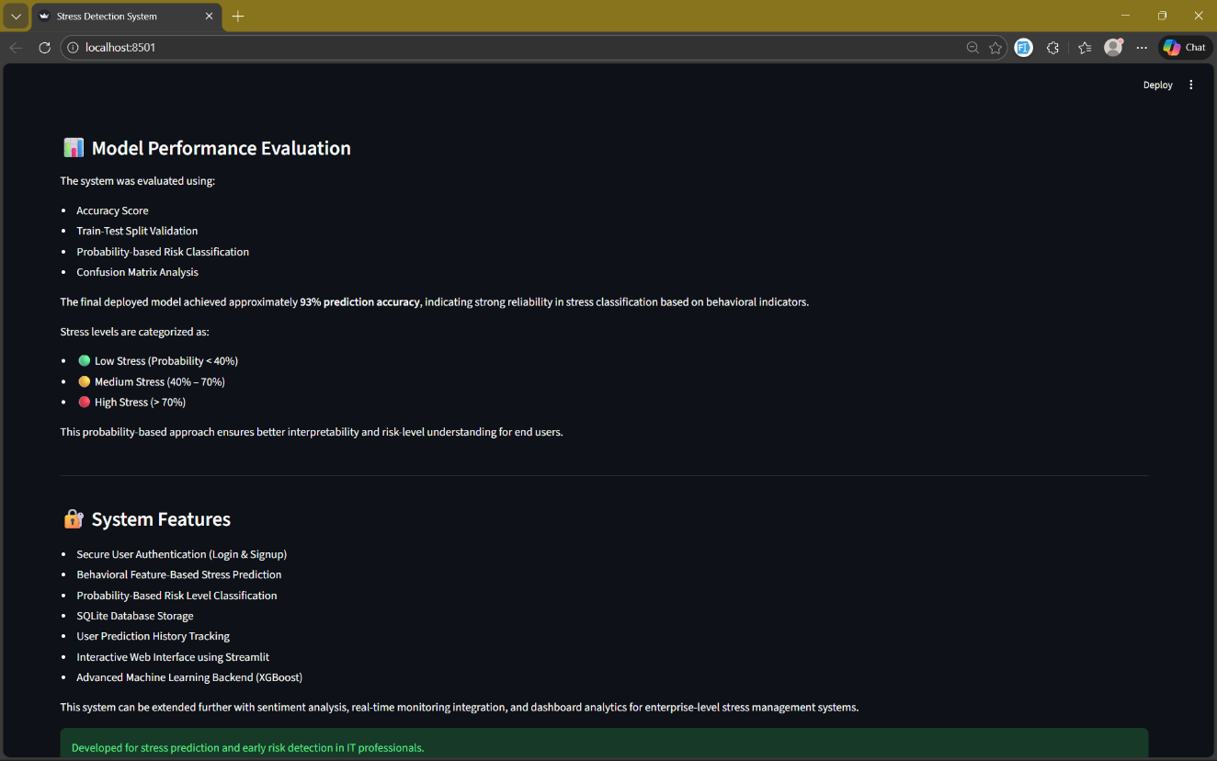
LOGIN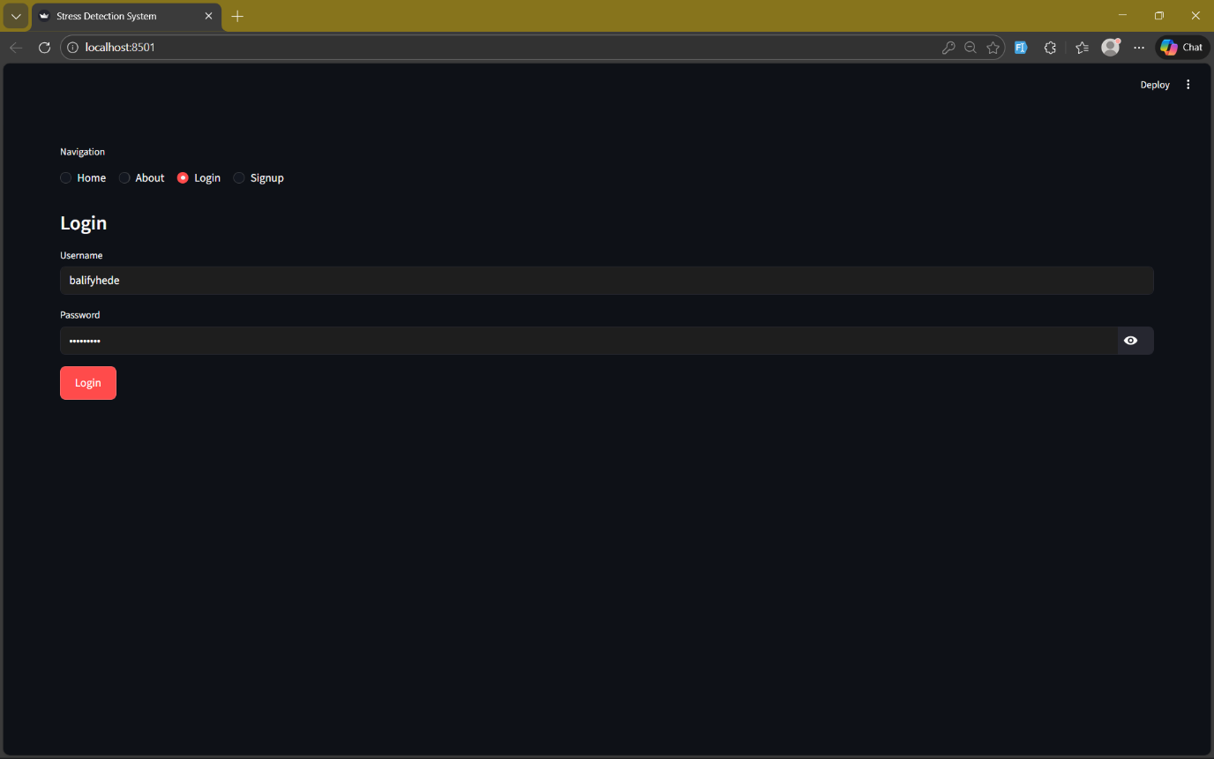

SIGNUP
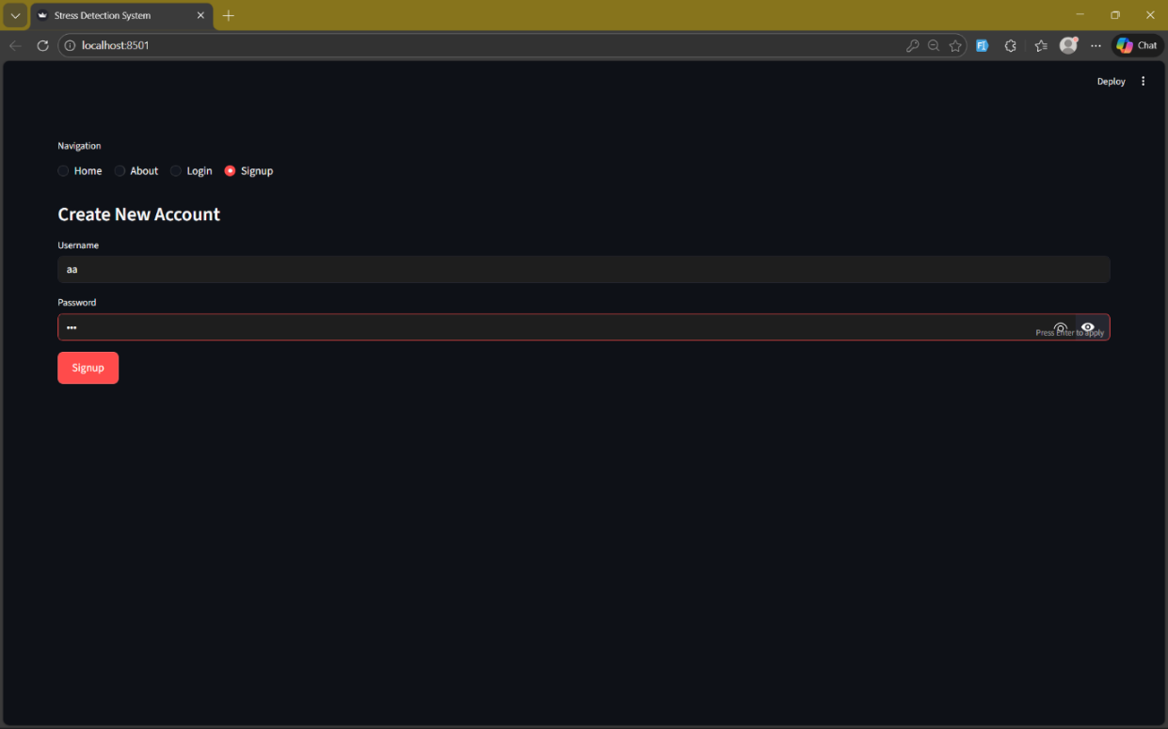
PREDICTION_PAGE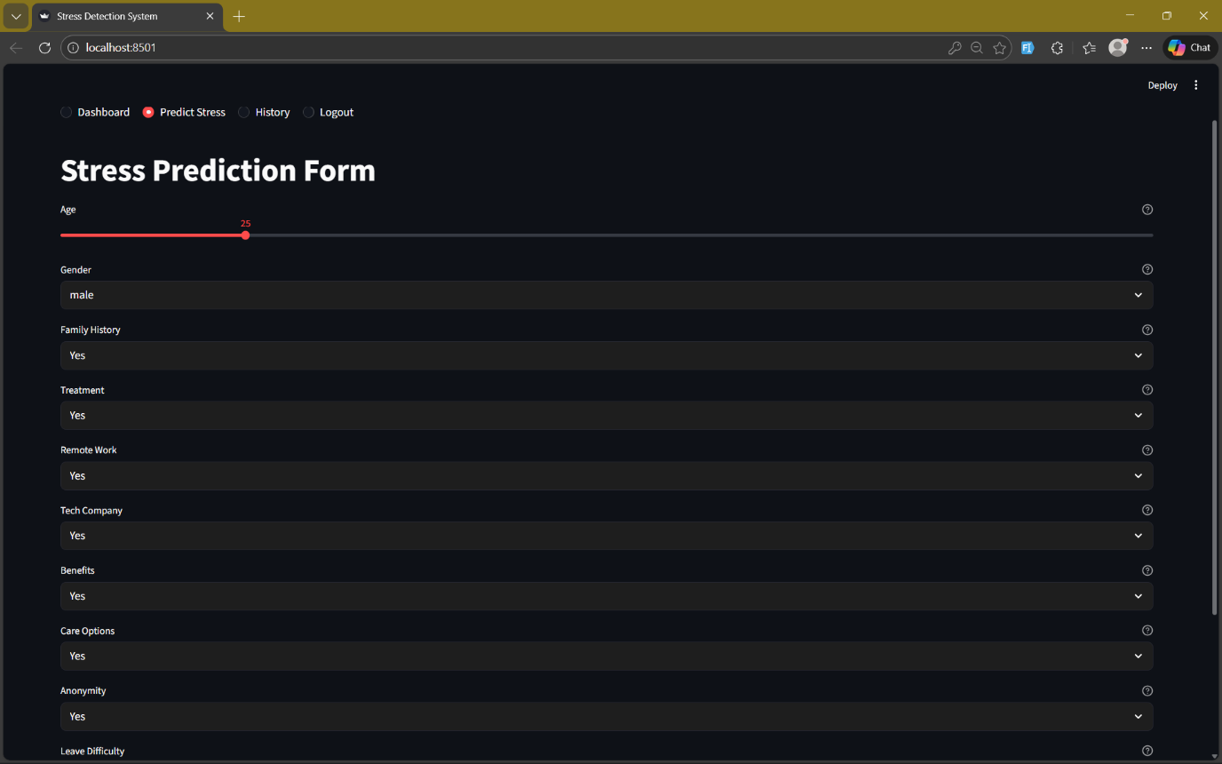

DASHBOARD
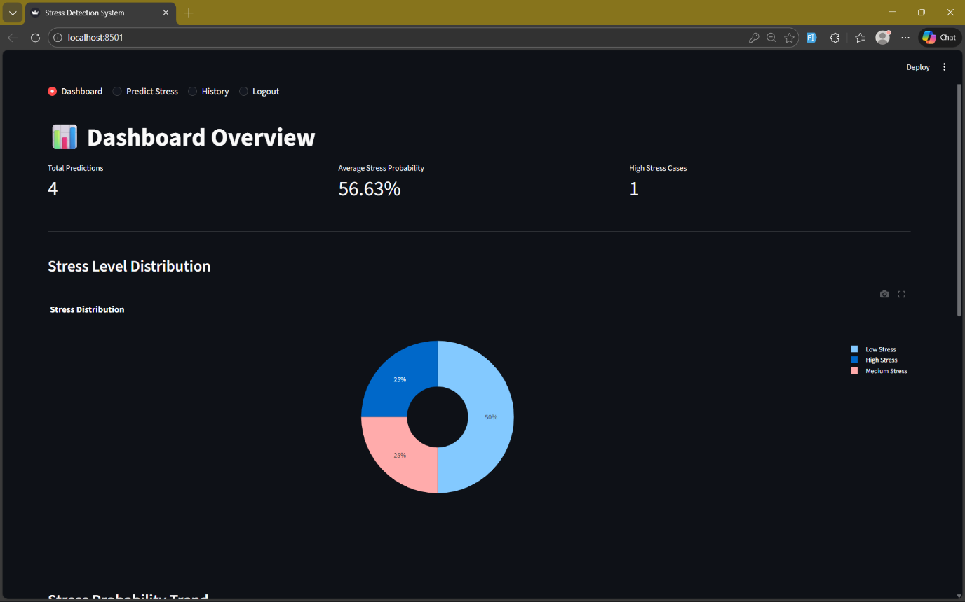
RESULT
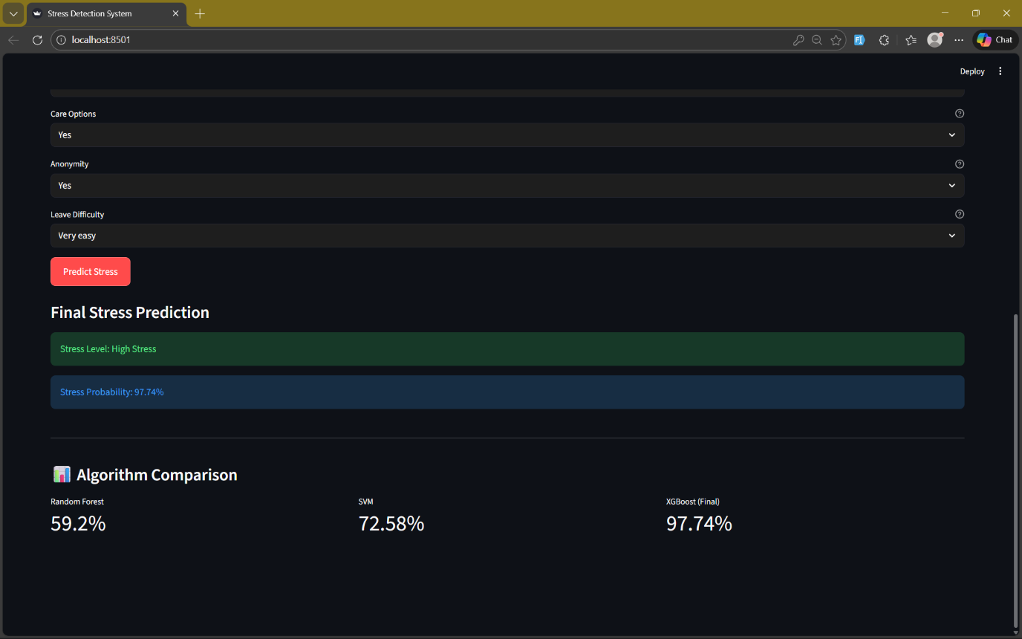

CHART_TABLE
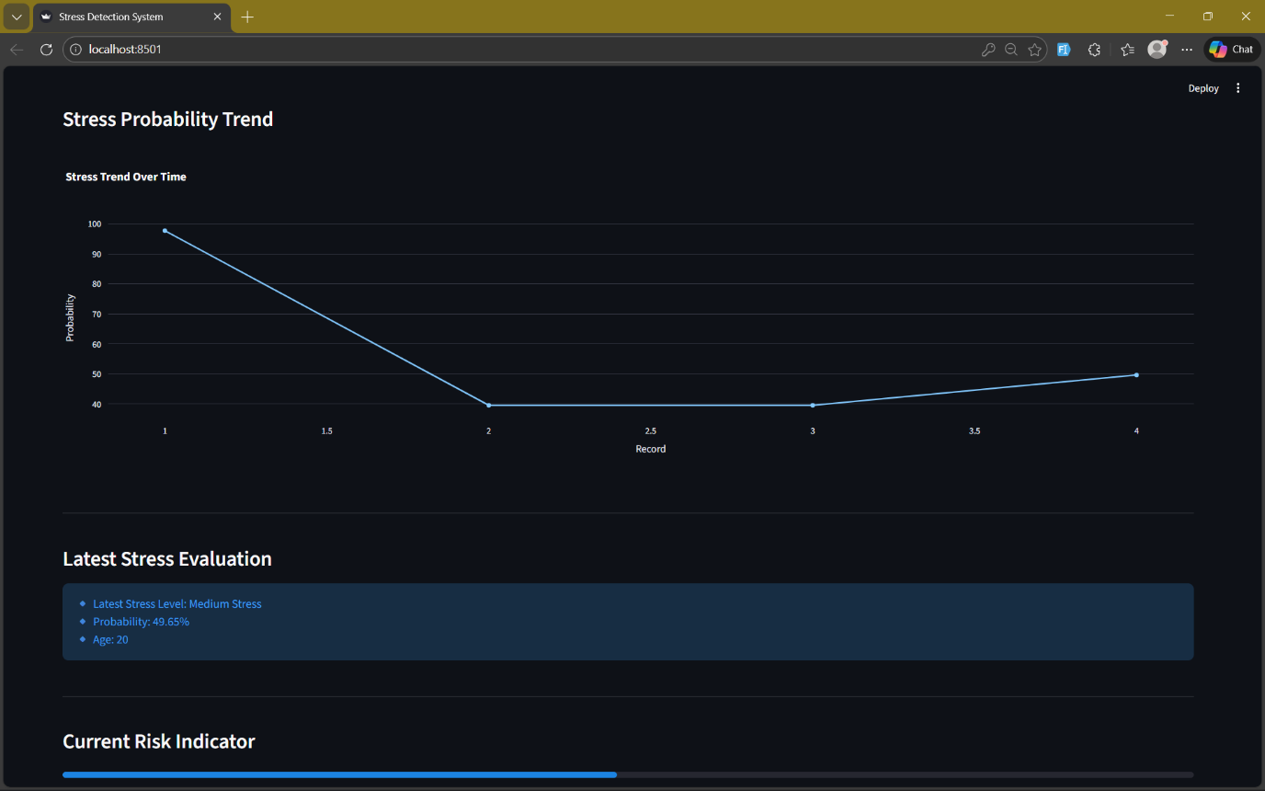
HISTORY
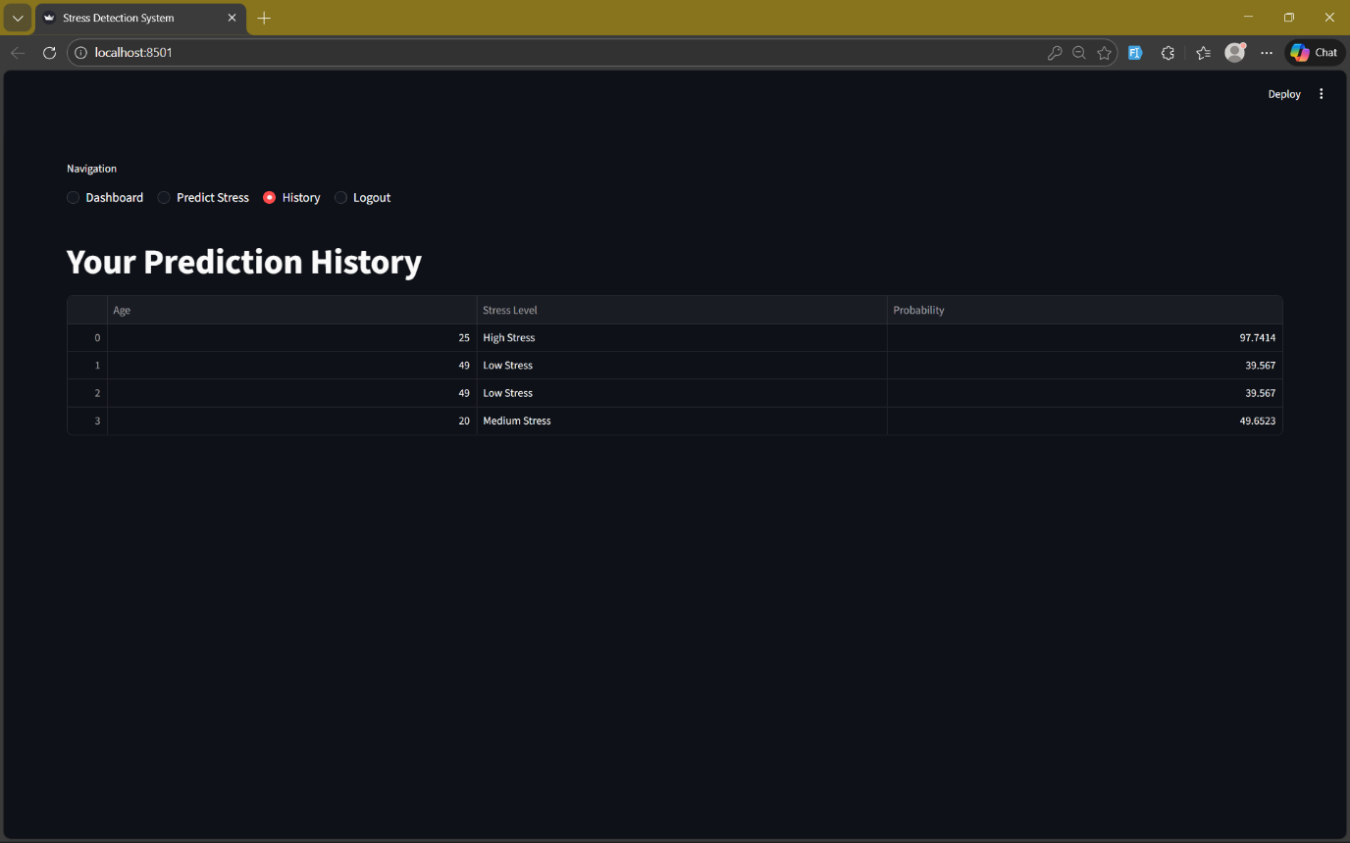

USER_HOME
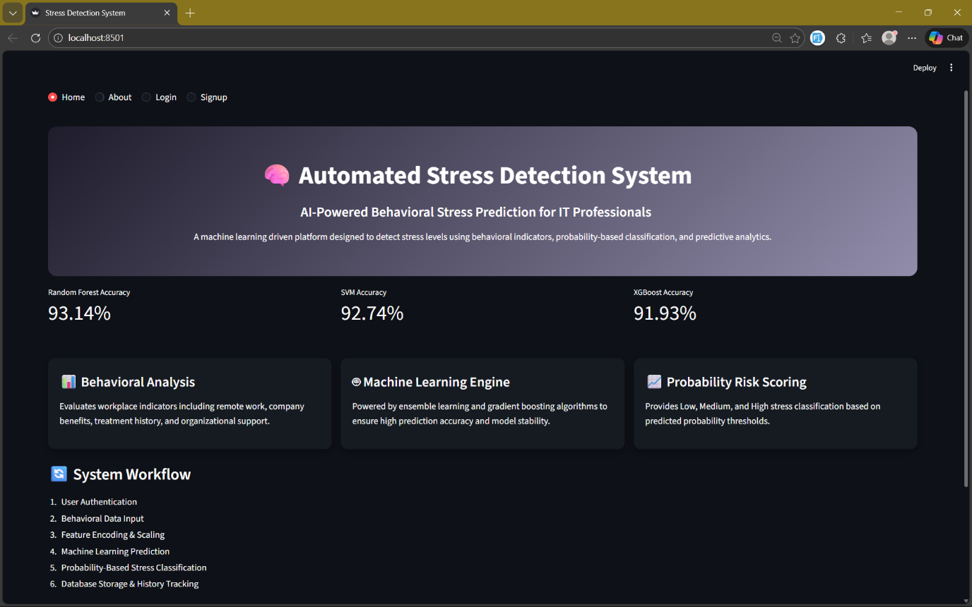
ABOUT
/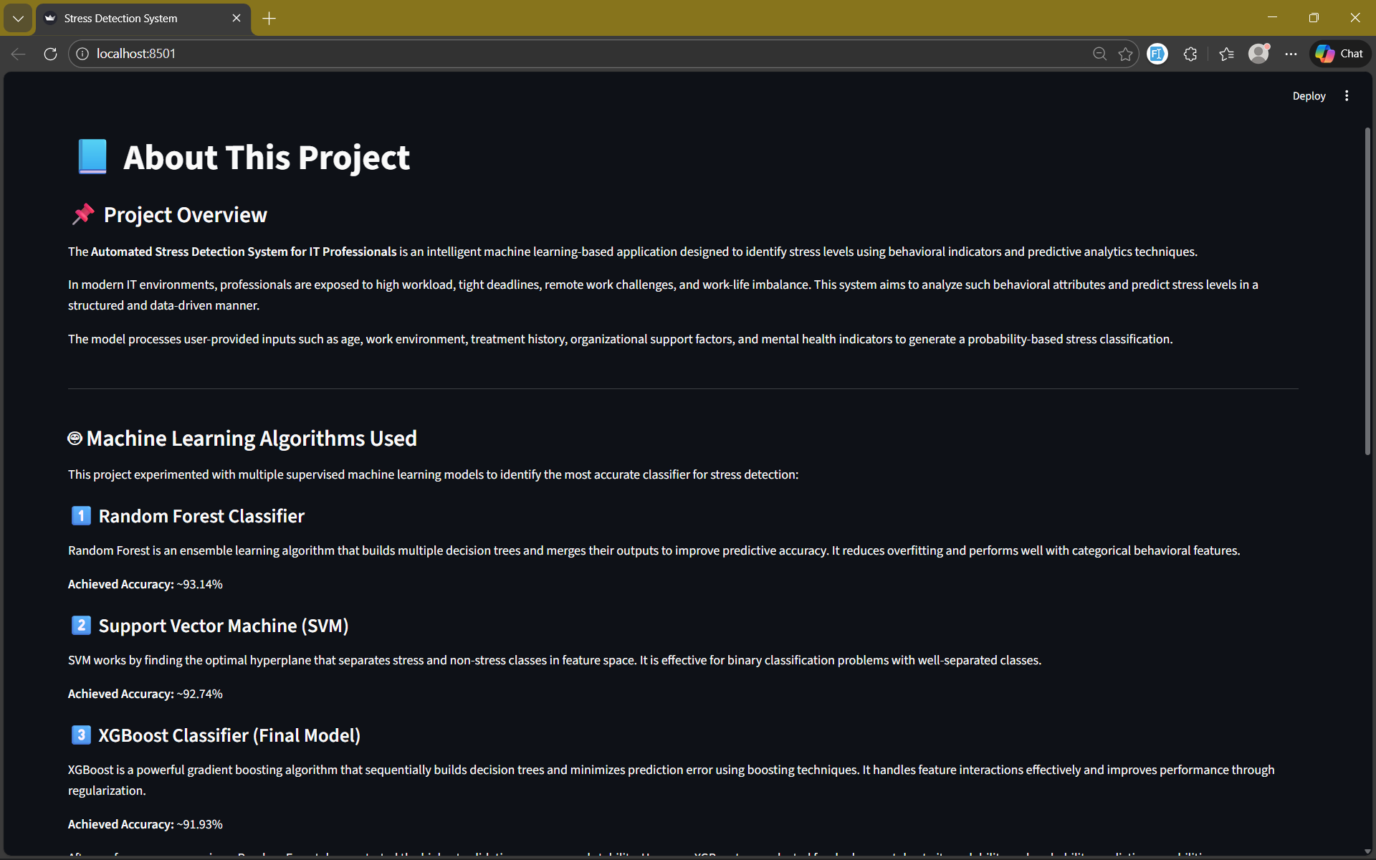

8.CONCLUSION
The Automated Stress Detection System for IT Professionals was successfully designed and implemented using supervised machine learning techniques and sentiment analysis. The primary objective of the system was to identify and evaluate stress levels among IT professionals by analyzing both behavioral and emotional indicators. In today’s fast-paced work environment, employees in the IT industry often face significant pressure due to deadlines, workload, and organizational expectations. Therefore, developing a system that can automatically detect stress patterns and provide insights into mental well-being is highly beneficial for both individuals and organizations.
The proposed system analyzes multiple factors related to an employee’s work life, including work environment conditions, company support, leave flexibility, and treatment history. In addition to these behavioral attributes, the system also incorporates sentiment analysis to understand the emotional tone expressed in user text input. This combination of structured data and emotional indicators allows the system to provide a more comprehensive and accurate assessment of stress levels. By integrating advanced machine learning models such as Random Forest, Support Vector Machine (SVM), and XGBoost, the system is able to generate reliable predictions and classify stress levels with high accuracy. The ensemble approach improves model performance by combining the strengths of multiple algorithms.
The experimental results demonstrate that the proposed system performs effectively in identifying stress patterns among IT professionals. Compared to traditional survey-based assessments, the automated system provides faster analysis, reduces human bias, and allows continuous monitoring of mental health indicators..
n conclusion, the Automated Stress Detection System demonstrates the significant potential of artificial intelligence, machine learning, and behavioral analytics in addressing mental health challenges in the workplace. The system provides a scalable and intelligent solution for early stress detection, which can ultimately contribute to improved employee well-being and productivity. Future enhancements may include integrating deep learning models, real-time monitoring using wearable devices, and advanced natural language processing techniques to further improve accuracy and expand the system’s capabilities. Overall, this project highlights how AI-driven technologies can play a vital role in promoting mental health awareness and supporting preventive decision-making in modern organizations.
9.FUTURE ENHANCEMENTS
The system can be extended in various ways to improve accuracy, usability, and real-world application:
1. Integration of Deep Learning Models
Future versions can incorporate neural networks, transformers, or hybrid deep learning models to extract deeper emotional signals and improve prediction accuracy.
2. Real-Time Stress Monitoring
Wearable device data such as heart rate, sleep cycle, and activity levels can be integrated to track stress continuously instead of one-time inputs.
3. Advanced Sentiment and Emotion Classification
Using models like BERT, RoBERTa, or LSTM can enhance the emotional understanding of user text and detect subtle psychological patterns such as anxiety, burnout, or frustration.
4. Mobile and Web Integration
The system can be deployed as a cross-platform mobile or enterprise-level web application for large teams in corporate environments.
5. Personalized Stress Insights & Recommendations
Providing personalized tips, relaxation techniques, or mental health resources based on the user’s stress level can improve real-world usefulness.
6. Larger and More Diverse Dataset
Expanding the dataset with IT professionals from different regions, job roles, and work cultures will increase system reliability and generalization.
7. HR Dashboard & Organizational Analytics
A dedicated analytics dashboard can be added for companies to anonymously monitor workforce stress trends and take preventive measures.

10. REFERENCES
    - Open Sourcing Mental Illness (OSMI) Mental Health in Tech Survey Dataset,
Available: https://osmihelp.org/research
Accessed: Jan. 2026.
    - S. K. Sinha and S. M. Sastry, “Stress Detection among Software Professionals Using Machine Learning Techniques,” International Journal of Advanced Computer Science and Applications, vol. 11, no. 6, pp. 345–352, 2020.
    - T. W. B. Karthik, A. Kumar, and R. Mishra, “A Machine Learning Framework for Predicting Stress in IT Employees Using Behavioral Features,” IEEE 6th International Conference on Computing Methodologies and Communication (ICCMC), pp. 1120–1126, 2022.
    - M. A. Mohan and S. Singh, “Sentiment Analysis-Based Mental Stress Detection Using Natural Language Processing Techniques,” IEEE International Conference on Computational Intelligence and Communication Networks (CICN), pp. 220–225, 2021.
    - R. Gupta and P. Kumar, “A Comparative Study of Supervised Learning Algorithms for Stress Level Prediction,” International Journal of Machine Learning and Cybernetics, vol. 12, no. 3, pp. 721–734, 2021.
    - C. Sharma and A. Jain, “Hybrid Behavioral and Sentiment-Based Stress Assessment Model Using Deep Learning,” IEEE Access, vol. 9, pp. 144230–144242, 2021.
    - S. S. Sundar and P. Nagarajan, “Workplace Stress Detection among IT Professionals Using Data Analytics,” International Conference on Advanced Computing and Intelligent Engineering, Springer, pp. 543–553, 2020.
    - J. Pennebaker, R. Boyd, K. Jordan, and K. Blackburn, “The Development and Psychometric Evaluation of LIWC2015,” University of Texas at Austin, 2015.
(Used for sentiment and emotional text analysis)
    - H. Chen, X. Fan, and J. Zhang, “Stress Detection Using Machine Learning and Behavioral Features from Online Communication,” IEEE Transactions on Affective Computing, 2022.
    - Y. LeCun, Y. Bengio, and G. Hinton, “Deep Learning,” Nature, vol. 521, pp. 436–444, 2015.

