CONTENT
S.NO | TITLE | PAGE NO
1. | INTRODUCTION  - SYNOPSIS  - PROJECT DESCRIPTION
2. | SYSTEM ANALYSIS  2.1 EXISTING SYSTEM  2.2 PROPOSED SYSTEM
3. | SYSTEM DESIGN  3.1 INTRODUCTION TO SYSTEM DESIGN  3.2 DATABASE DESIGN  3.2 DATA FLOW DIAGRAM
4. | SYSTEM REQUIREMENTS  4.1 SOFTWARE REQUIREMENTS  4.2 HARDWARE REQUIREMENTS
5. | SOFTWARE DESCRIPTION
6. | IMPLEMENTATION  6.1 SOURCE CODE  6.2 TESTING
7. | OUTPUT  7.1 FORMS
8. | CONCLUSION
9. | FUTURE ENHANCEMENTS
10. | REFERENCES

- INTRODUCTION
  - SYNOPSIS
Cyclones are among the most destructive natural disasters, often causing widespread damage, loss of life, and significant socio-economic impact. Accurate and early prediction of cyclone formation and severity is essential for disaster preparedness and mitigation. Traditional cyclone prediction models rely heavily on numerical weather prediction systems and manual meteorological analysis, which can be time-consuming and may lack precision during rapidly changing atmospheric conditions. With advancements in artificial intelligence, Machine Learning (ML) and Deep Learning (DL) techniques have emerged as powerful tools capable of analyzing complex weather patterns and satellite imagery for more accurate cyclone forecasting.
This project proposes a hybrid cyclone prediction framework that compares the effectiveness of various Machine Learning algorithms such as Random Forest, Support Vector Machine (SVM), Logistic Regression, and XGBoost with Deep Learning models such as Convolutional Neural Networks (CNN). The ML models predict cyclone severity using meteorological parameters including atmospheric pressure, wind speed, latitude, and longitude collected through real-time weather APIs. Meanwhile, the CNN model analyzes infrared and raw satellite images to detect cyclone structure and intensity visually.
The system additionally integrates live weather data, 24-hour forecasts, geolocation-based mapping, and historical cyclone records to enhance prediction reliability. A user-friendly Streamlit dashboard displays severity predictions, visual analytics, and real-time risk scores. High-severity alerts are automatically sent to users via email, improving preparedness during critical weather conditions.
By conducting a comparative analysis of ML and DL approaches, the project identifies which model performs best for cyclone prediction under varied environmental and data conditions. The final outcome is an intelligent, automated, and scalable prediction system capable of assisting disaster management authorities, researchers, and local communities in making informed decisions.

1.2 PROJECT DESCRIPTION
The proposed system titled “Comparative Analysis of Machine Learning and Deep Learning Techniques for Cyclone Prediction” focuses on developing an intelligent, automated, and real-time cyclone severity forecasting platform. The project integrates Machine Learning (ML), Deep Learning (DL), meteorological parameters, satellite imagery, and live weather APIs to accurately predict cyclone intensity and assist in effective disaster management.
• Data Collection
The data required for cyclone prediction is collected from multiple sources:
- Meteorological Parameters:
  - Atmospheric pressure
  - Wind speed (low, moderate, high)
  - Latitude & longitude
  - Temperature and humidity (via API)
These values are obtained from OpenWeather API, real-time weather stations, and historical cyclone datasets released by IMD/NOAA.
- Satellite Imagery:
Infrared and raw images from INSAT-3D satellite cyclone datasets are used for the Deep Learning (CNN-based) model to visually detect cyclone formation and intensity patterns.
- Historical Cyclone Records:
A consolidated dataset containing cyclone name, path, landfall region, wind speed, and severity levels is used to train and validate the ML models.
• Data Preprocessing
After collection, the dataset undergoes preprocessing to ensure its suitability for ML/DL training. The preprocessing steps include:
- Cleaning missing or inconsistent meteorological values
- Handling outliers (abnormal pressure or wind readings)
- Normalizing wind and pressure features
- Label encoding cyclone severity (Low / Moderate / High)
- Converting satellite images to uniform size, grayscale normalization, and noise removal
- Splitting the dataset into training, validation, and test sets
This stage ensures the models receive high-quality and consistent data.
• Data Training
Two different training pipelines are developed:
1. Machine Learning Training
Models used include:
- Random Forest
- XGBoost
- Support Vector Machine (SVM)
- Logistic Regression
These algorithms are trained using meteorological parameters (pressure, wind, coordinates, etc.).
The models are evaluated using metrics such as accuracy, precision, recall, and f1-score, and the best-performing model is identified.

- SYSTEM ANALYSIS
2.1 EXISTING SYSTEM
Traditional cyclone prediction systems mainly depend on numerical weather prediction (NWP) models, manual meteorological analysis, and conventional satellite interpretation. Existing models such as statistical cyclone intensity prediction, pressure–wind relationship models, and rule-based forecasting techniques are widely used by meteorological departments, including IMD and NOAA. These systems rely heavily on manual observation of atmospheric parameters such as wind speed, humidity, temperature gradients, sea surface temperature, and cloud formation patterns captured by satellite images.
Some modern research works apply basic machine learning models for cyclone track prediction or simple classification (cyclone / no cyclone). However, they lack a combined framework that utilizes both numerical weather parameters and deep learning-based satellite image analysis. These systems often struggle with real-time prediction and are dependent on limited datasets.
DRAWBACKS OF EXISTING SYSTEM
- Low accuracy during sudden cyclone intensification
Traditional models cannot capture rapid changes in pressure and wind patterns, leading to inaccurate predictions.
- Heavy dependence on expert meteorologists
Manual interpretation of satellite images and weather charts results in delays and potential human errors.
- Lack of automated systems
Most existing approaches are not fully automated and require continuous monitoring and manual updates.
- Limited use of AI techniques
Most models do not utilize advanced ML/DL algorithms such as Random Forest, XGBoost, or CNNs, reducing prediction reliability.
- Insufficient real-time integration
Existing systems do not seamlessly integrate live weather APIs, forecast data, or satellite imagery in one place.
2.2 PROPOSED SYSTEM
The proposed system introduces an intelligent and automated Cyclone Prediction Model that integrates both Machine Learning (ML) and Deep Learning (DL) techniques to enhance the accuracy and reliability of cyclone severity forecasting. Unlike traditional meteorological systems that depend on manual interpretation and numerical models, the developed system leverages real-time atmospheric data and satellite imagery to deliver faster and more precise predictions.
1. Machine Learning–Based Numerical Prediction
This module uses key meteorological parameters such as:
- Atmospheric pressure
- Wind speed (low, moderate, and high)
- Latitude and longitude
- Temperature and humidity
These parameters are processed and fed into ML algorithms such as:
- Random Forest
- XGBoost
- Support Vector Machine (SVM)
- Logistic Regression
Each model predicts cyclone severity as Low, Moderate, or High.
The performance of each ML model is recorded and compared to identify the best-performing algorithm for real-time forecasting.
Integrated Hybrid Prediction System
The ML and DL outputs are combined within a unified Streamlit dashboard.
Key features include:
- Live weather data fetching using OpenWeather API
- 24-hour forecast analysis
- Satellite-image-based CNN classification
- Geolocation mapping using Folium
- Confidence score and risk analysis
- Automatic email alerts for high-severity predictions
- Historical cyclone data visualization for pattern comparison
This hybrid model provides a comprehensive, multi-perspective cyclone prediction framework that greatly improves accuracy and real-time usability.

ADVANTAGES OF THE PROPOSED MODEL
- Higher accuracy using both ML and DL compared to traditional systems
- Real-time cyclone prediction using live weather API and satellite imagery
- Automated and fast decision-making, reducing manual interpretation
- User-friendly dashboard for visualization, maps, and forecasts
- Early warning capability via automated email alerts
- Effective for disaster preparedness and risk reduction
- Comparative analysis helps identify the most reliable prediction model

- SYSTEM DESIGN
3.1 INTRODUCTION TO SYSTEM DESIGN
The Cyclone Prediction System is designed to provide an intelligent and automated platform for forecasting cyclone intensity using advanced computational techniques. In recent years, cyclones have caused significant damage to life and property, especially in coastal regions. Traditional forecasting methods rely heavily on manual observation and limited statistical models, which may not always provide highly accurate or timely predictions. Therefore, the proposed system integrates modern technologies such as Machine Learning (ML), Deep Learning (DL), meteorological data analysis, and satellite image processing to develop a more reliable and efficient cyclone prediction framework.
The system design focuses on collecting and analyzing multiple sources of environmental data to improve prediction accuracy. Meteorological parameters such as atmospheric pressure, wind speed, temperature, humidity, and geographical coordinates are gathered from real-time weather APIs and historical cyclone datasets. In addition, satellite imagery from sources such as INSAT-3D provides visual information about cloud structures and cyclone formations. By combining these different types of data, the system can capture both numerical and visual patterns associated with cyclone development and severity.
The architecture of the system follows a modular design consisting of data collection, preprocessing, model training, prediction, and result visualization modules. The collected meteorological data and satellite images undergo preprocessing steps to remove noise, handle missing values, normalize features, and convert raw data into a format suitable for machine learning models. This preprocessing stage ensures that the models receive consistent and high-quality data, which is essential for accurate prediction.
The core component of the system is the prediction engine, which utilizes both machine learning and deep learning techniques. Machine learning models such as Random Forest, Support Vector Machine (SVM), Logistic Regression, and XGBoost analyze meteorological parameters to identify patterns related to cyclone severity. At the same time, a Convolutional Neural Network (CNN) processes satellite images to detect structural features such as cloud spirals, eye wall formation, and thermal intensity associated with cyclones. By combining these approaches, the system creates a hybrid prediction model that leverages the strengths of both ML and DL techniques.
3.2. DATABASE DESIGN
USERS
Column Name | Data Type | Description
user_id (PK) | INT | Unique ID for each user
name | VARCHAR(100) | User full name
email | VARCHAR(150) | User email address (login)
password | VARCHAR(200) | Encrypted password

WEATHER_DATA
Column Name | Data Type | Description
weather_id (PK) | INT | Unique weather record ID
city | VARCHAR(100) | City name
latitude | FLOAT | Latitude value
longitude | FLOAT | Longitude value
pressure | INT | Atmospheric pressure (hPa)
wind_low | INT | Low wind speed (km/h)
wind_moderate | INT | Moderate wind speed (km/h)
wind_high | INT | High wind speed (km/h)
datetime_recorded | DATETIME | When weather data was captured

MODEL_INFO
Column Name | Data Type | Description
model_id (PK) | INT | Unique model ID
model_name | VARCHAR(100) | Model name (RF, XGBoost, SVM, CNN)
model_type | VARCHAR(50) | ML or DL
accuracy | FLOAT | Model accuracy %

prediction
Column Name | Data Type | Description
prediction_id (PK) | INT | Unique prediction ID
user_id (FK) | INT | User who made the prediction
model_id (FK) | INT | ML/DL model used
severity | VARCHAR(20) | Low / Moderate / High
pressure_used | INT | Pressure value used for prediction
wind_used | INT | Wind speed used
city | VARCHAR(100) | Prediction location
prediction_time | DATETIME | Date & time of prediction

CNN_IMAGE_DATA
Column Name | Data Type | Description
image_id (PK) | INT | Unique satellite image ID
file_path | VARCHAR(255) | Path to stored image file
predicted_intensity | VARCHAR(50) | CNN output category
timestamp | DATETIME | Upload time of image

HISTORICAL_CYCLONES
Column Name | Data Type | Description
hist_id (PK) | INT | Unique historical record ID
city | VARCHAR(100) | Cyclone affected city
year | INT | Cyclone year
cyclone_name | VARCHAR(150) | Cyclone name
severity | VARCHAR(50) | Severity level
wind_speed | INT | Max wind speed recorded

3.3 DATAFLOW DIAGRAM

LEVEL 0
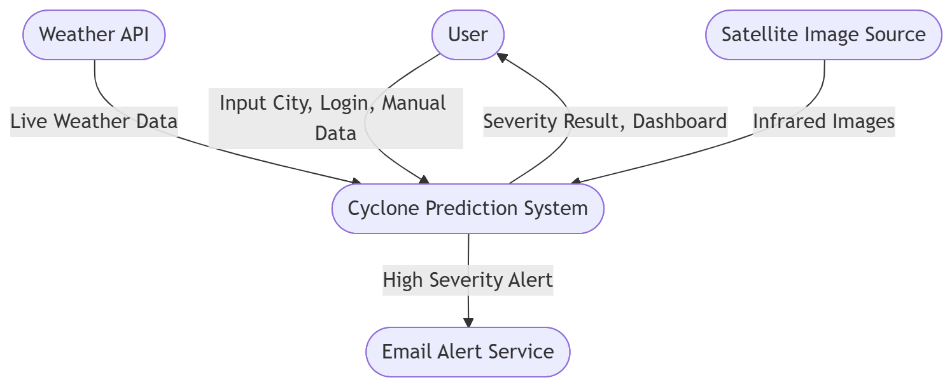

LEVEL 1
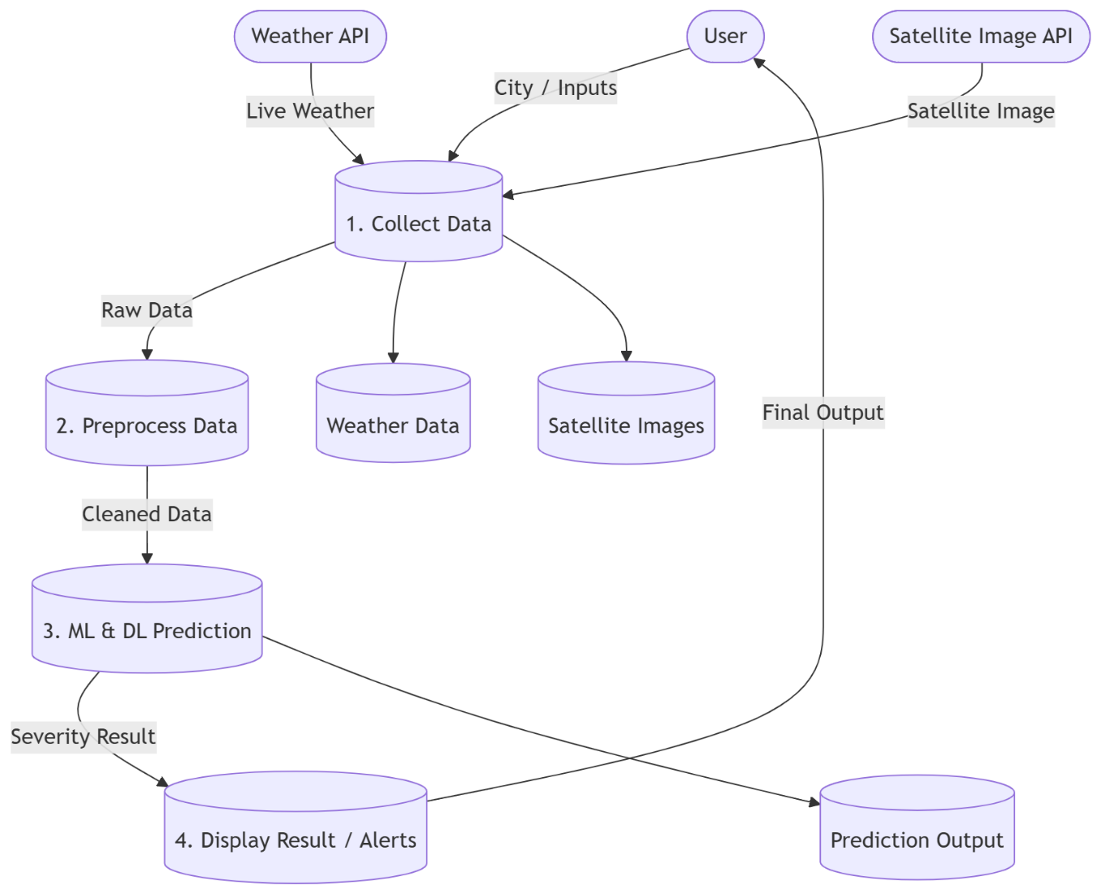

4. SYSTEM REQUIRMENTS
4.1 SOFTWARE REQUIREMENTS
Operating System : Microsoft windows11
Front End : Streamlit
Back End : Python
Database : MySQL
Documentation : Microsoft Word
4.2 HARDWARE REQUIREMENTS
Processor : Intel i5 core
Speed : 3.10 GHz
RAM : 16 GB
Hard Disk : 512 GB
Monitor : 15 SVGA color
Mouse : Wired mouse
Keyboard : wired keyboard
Printer : Laser Printer

- SOFTWARE DESCRIPTION
5.1 FRONT END TOOL
Introduction to Streamlit
For the development of the user interface (UI) and the interactive dashboards of the "Secure Web Application for Public Complaint Monitoring," Streamlit was utilized as the primary front-end framework. Streamlit is a modern, open-source Python library designed explicitly for creating and sharing custom web applications for machine learning and data science projects. Unlike traditional web development frameworks that require a deep understanding of HTML, CSS, and JavaScript, Streamlit allows developers to build highly interactive, responsive, and aesthetically pleasing web interfaces entirely in Python.
By treating the UI components as simple Python function calls, Streamlit bridges the gap between complex backend machine learning algorithms and front-end user interaction, making it the ideal choice for this AI-driven civic issue tracker.
Why Streamlit was Chosen for this Project The selection of Streamlit over traditional frameworks (like React or Angular) was driven by several project-specific requirements:
- Seamless Machine Learning Integration: Since the core of this project involves a Natural Language Processing (NLP) model to categorize complaints, Streamlit allows the machine learning model (joblib and scikit-learn) to be directly loaded and executed within the same script that renders the web page.
- Rapid Prototyping and Development: It drastically reduces the development time by eliminating the need to write separate REST APIs to connect the frontend to the backend. The frontend UI and backend logic coexist efficiently.
- Built-in Data Visualization: The administrative dashboard requires complex data representations (such as pie charts and bar graphs) to monitor complaint trends. Streamlit seamlessly integrates with data visualization libraries like Plotly and Pandas to render these charts dynamically.
- Responsive Design: Applications built with Streamlit are natively responsive, meaning the complaint portal adapts perfectly to both desktop monitors and mobile device screens without writing extra CSS media queries.
Implementation of Front-End Features In this project, Streamlit handles the entire client-side experience through various interactive widgets and layout structures. The key implementations include:
A. User Authentication & Session Management: The application utilizes Streamlit’s st.session_state feature to manage secure user logins. It tracks whether a user is an 'Admin' or a 'Citizen' and dynamically renders the appropriate dashboard based on their role. This ensures secure role-based access control directly from the front end.
B. Citizen Dashboard (User Interface):
- Data Input Widgets: The system uses st.text_area for citizens to securely type their detailed complaint descriptions.
- Location Tracking: Widgets like st.text_input are used to capture the exact street address and Pincode for geo-tagging the issue.
- Multimedia Uploads: The st.file_uploader component provides a drag-and-drop interface for users to upload photographic evidence of the civic issue (e.g., broken pipes, uncollected garbage).
- Real-time Feedback: Upon submitting a complaint, st.progress is used to display the Artificial Intelligence Confidence Score, providing transparency to the user about the AI's categorization accuracy.
C. Administrative Dashboard (Official Interface):
- Data Presentation: The st.dataframe component is used to display the entire MySQL database of complaints in a clean, scrollable, and sortable grid format.
- Visual Analytics: Using st.plotly_chart, the front end renders interactive Pie Charts (showing Pending vs. Resolved statuses) and Bar Charts (showing complaint categories), allowing administrators to gauge the city's civic health at a glance.
- Action Panels: st.selectbox and st.button components allow administrators to easily update the status of a complaint, which immediately triggers a backend MySQL update and refreshes the UI.
D. Dynamic Layout and Theming: To organize the vast amount of information, Streamlit’s layout features such as st.sidebar (for navigation and emergency contacts), st.columns (to place forms and maps side-by-side), and st.tabs (to separate "Register Complaint," "My Complaints," and "Notifications") were extensively utilized. The application is also configured with a "wide" layout and a dark-mode theme to reduce eye strain for administrators monitoring the system continuously.
Advantages of Using Streamlit in the Proposed System
- Interactive Data Flow: Whenever a user interacts with a widget (e.g., filtering complaints by "Pending" status), Streamlit automatically reruns the necessary parts of the script to fetch fresh data from the MySQL database and update the screen instantly.
- Security: Because Streamlit executes on the server side, sensitive API keys, database credentials, and Machine Learning model weights are never exposed to the client's browser, ensuring a high level of security for the public complaint portal.
- Extensibility: The tool allows for easy expansion. For instance, rendering HTML iframes to embed Google Maps for tracking complaint locations was achieved effortlessly using Streamlit's component integration.
Conclusion on Front End In summary, Streamlit proved to be an exceptionally powerful front-end tool for this project. It provided the necessary agility to design a secure, role-based, and AI-integrated web portal, ensuring that citizens have a smooth experience while reporting issues, and authorities have a robust, data-rich dashboard for efficient public administration.

5.2 BACK END TOOL
PYTHON
Python is an open source programming language that was made to be easy-to-read and powerful. Python is an interpreted language. Interpreted languages do not need to be compiled to run. A program called an interpreter runs Python code on almost any kind of computer. This means that a programmer can change the code and quickly see the results. This also means Python is slower than a compiled language like C, because it is not running machine code directly.
Python is a good programming language for beginners. It is a high-level language, which means a programmer can focus on what to do instead of how to do it. Writing programs in Python takes less time than in some other languages. Python is a computer programming language designed for readability and functionality. One of Python’s design goals is that the meaning of the code is easily understood because of the very clear syntax of the language. Python programming language has a specific syntax (form) and semantics (meaning) which enables it to express computations and data manipulations which can be performed by a computer. Python’s implementation was started in 1989 by Guido van Rossum at CWI (a national research institute in the Netherlands) as a successor to the ABC programming language (an obscure language made more popular by the fact that it motivated Python!). Van Rossum is Python’s principal author, and his continuing central role in deciding the direction of Python is reflected in the title given to him by the Python community, Benevolent Dictator for Life (BDFL). Python is an interpreted language, i.e., a programming language whose programs are not directly executed by the host cpu but rather executed (or “interpreted”) by a program known as an interpreter. The source code of a Python program is translated or (partially) compiled to a “byte code” form of a Python “process virtual machine” language.
This is in distinction to C code which is compiled to cpu-machine code before runtime. Python is a “dynamically typed” programming language. A programming language is said to be dynamically typed, when the majority of its type checking is performed at run-time as opposed to at compile-time. Dynamically typed languages include JavaScript, Lisp, Lua, Objective-C, Python, Ruby, and Tcl. Python is an object-oriented language. Object-oriented programming (OOP) uses “objects” - data structures consisting of data fields and methods - to design computer programs. For example, a matrix could be the “object” you want to write programs to deal with. It could define a class of matrices and, for example, a method for that class might be addition (representing ordinary addition of matrices). It will return to this example in more detail later in the course.
PYTHON LIBRARY
Python is used by hundreds of thousands of programmers and is used in many places. Sometimes only Python code is used for a program, but most of the time it is used to do simple jobs while another programming language is used to do more complicated tasks. Its standard library is made up of many functions that come with Python when it is installed. On the Internet there are many other libraries available that make it possible for the Python language to do more things. These libraries make it a powerful language; it can do many different things.
Some things that Python is often used for are:
- Web development
- Game programming
- Desktop GUIs
- Scientific programming
- Network programming.
Python also does something called "dynamic variable assignment". This means that when a number or word is made in a program, the user does not have to say what type it is. This makes it easier to reuse variable names, making fast changes simpler. An example of this is shown below.

INPUT/OUTPUT
Sage is built on Python, so includes Python, but is designed for general purpose mathematical computation (the lead developer of Sage is a numbertheorist). The interface to Sage is IPython, though it has been configured in a customized way to that the prompt says sage: as opposed to In or >>>. Other than this change in prompt, the command line interface to Sage is similar to that if Python and SymPy. Sage sage: a = 3.1415 sage: print a 3.14150000000000 sage: type(a) Sage also include SymPy and a nice graphical interface called the Sage notebook.
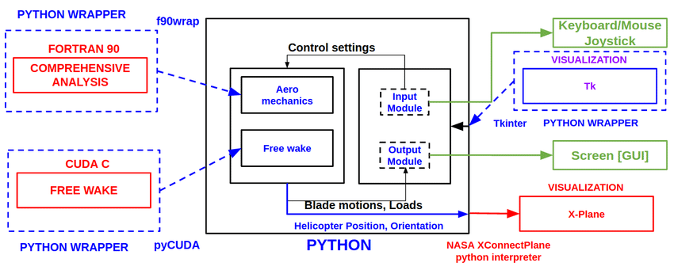
FRAMEWORK

DATA TYPES
The data which a Python program deals with must be described precisely. This description is referred to as the data type. In the case of Python, the fact that Python is dynamically typed basically means that the interpreter or compiler will figure out for you what type a variable is at run-time, so you don’t have to declare variable types yourself. Besides numerical data types, such as int (for integers) and float (for reals), there are other types such as tuple and list. A more complete list, with examples, is given below.
Type Description
- An immutable sequence "string", """\python of Unicode characters is great""", ’2012’ bytes An immutable sequence of bytes b’Some ASCII’.
- List Mutable, can contain mixed types [1.0, ’list’, True].
- Tuple Immutable, can contain mixed types (-1.0, ’tuple’, False) set, Unordered, contains no duplicates set([1.2, ’xyz’, True]), frozensetfrozenset([4.0, ’abc’, True]).
- Dict A mutable group of key {’key1’: 1.0, ’key2’: False} and value pairs int An immutable fixed precision 42 number of unlimited magnitude float An immutable floating point 2.71828 number (system-defined precision).
- Complex An immutable complex number -3 + 1.4j with real and imaginary parts Boolean. An immutable Boolean value True, False.
STRUCTURE OF PYTHON
- Command-Line Application Layouts
  - One-Off Script
  - Installable Single Package
  - Application with Internal Packages
- Web Application Layouts
  - Django
  - Flask
Python, though opinionated on syntax and style, is surprisingly flexible when it comes to structuring your applications. On the one hand, this flexibility is great: it allows different use cases to use structures that are necessary for those use cases. On the other hand, though, it can be very confusing to the new developer. The Internet isn’t a lot of help either—there are as many opinions as there are Python blogs. Examples of common Python application structures, including command-line applications (CLI apps), one-off scripts, installable packages, and web application layouts with popular frameworks like Flask and Django.

COMMAND-LINE APPLICATION LAYOUTS
A lot of us work primarily with Python applications that are run via command-line interfaces (CLIs). This is where you often start with a blank canvas, and the flexibility of Python application layouts can be a real headache. Starting with an empty project folder can be intimidating and lead to no shortage of coder’s block.

One-Off Script
The following layout will work for all of these cases and can easily be modified to reflect whatever installation or other tools you use in your workflow. This layout will cover you whether you’re creating a pure Python script (that is, one with no dependencies) or using a tool like pip or Pipenv. That the exact location of the files in the layout matters less than the reason they are placed where they are. All of these files should be in a project directory named after your project. For this example, we will use (what else?) helloworld as the project name and root directory.
Here’s the Python project structure I typically use for a CLI app:
This is pretty straightforward: everything is in the same directory. The files shown here are not necessarily exhaustive, but I recommend keeping the number of files to a minimum if you plan on using a basic layout like this. Some of these files will be new to you, so let’s take a quick look at what each of them does.
- .gitignore: This is a file that tells Git which kinds of files to ignore, like IDE clutter or local configuration files. Our Git tutorial has all the details, and you can find sample .gitignore files for Python projects here.
- helloworld.py: This is the script that you’re distributing. As far as naming the main script file goes, I recommend that you go with the name of your project (which is the same as the name of the top-level directory).
- LICENSE: This plaintext file describes the license you’re using for a project. It’s always a good idea to have one if you’re distributing code. The filename is in all caps by convention.
- README.md: This is a Markdown (or reStructuredText) file documenting the purpose and usage of your application. Crafting a good README is an art, but you can find a shortcut to mastery here.
- requirements.txt: This file defines outside Python dependencies and their versions for your application.
- setup.py: This file can also be used to define dependencies, but it really shines for other work that needs to be done during installation. You can read more about both setup.py and requirements.txt in our guide to Pipenv.
- tests.py: This script houses your tests, if you have any. You should have some.

Introduction to MySQL
MySQL is a very popular open-source relational database management system (RDBMS).MySQL is a relational database management system A relational database stores data in separate tables rather than putting all the data in one big storeroom. The database structure is organized into physical files optimized for speed. MySQL is a relational database management system (RDBMS) developed by Oracle that is based on structured query language (SQL). A database is a structured collection of data.Its name is a combination of "My", the name of co-founder Michael Widenius's daughter My, and "SQL", the acronym for Structured Query Language.MySQL is developed, distributed, and supported by Oracle Corporation

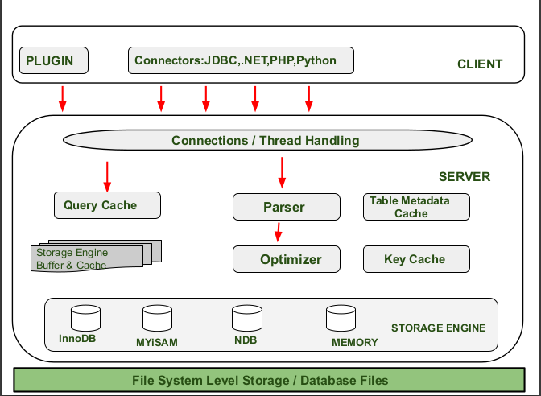

Features:
- MySQL is a relational database management system
- MySQL is open-source
- MySQL is free
- MySQL is ideal for both small and large applications
- MySQL is very fast, reliable, scalable, and easy to use
- MySQL is compliant with the ANSI SQL standard
- MySQL was first released in 1995
To build a web site that shows data from a database, you will need:
- An RDBMS database program (like MySQL)
- A server-side scripting language, like PHP
- To use SQL to get the data you want
- To use HTML / CSS to style the page

Some of the Most Important SQL Commands
- SELECT - extracts data from a database
- UPDATE - updates data in a database
- DELETE - deletes data from a database
- INSERT INTO - inserts new data into a database
- CREATE DATABASE - creates a new database
- ALTER DATABASE - modifies a database
- CREATE TABLE - creates a new table
- ALTER TABLE - modifies a table
- DROP TABLE - deletes a table
- CREATE INDEX - creates an index (search key)
- DROP INDEX - deletes an index
Limitations
When using some storage engines other than the default of InnoDB, MySQL does not comply with the full SQL standard for some of the implemented functionality, including foreign key references. Check constraints are parsed but ignored by all storage engines before MySQL version 8.0.15.
Up until MySQL triggers are limited to one per action / timing, meaning that at most one trigger can be defined to be executed after an INSERT operation, and one before INSERT on the same table.No triggers can be defined on views.
MySQL database's inbuilt functions like UNIX_TIMESTAMP() will return 0 after 03:14:07 UTC on 19 January 2038. Recently, there had been an attempt to solve the problem which had been assigned to the internal queue.
Deployment
MySQL can be built and installed manually from source code, but it is more commonly installed from a binary package unless special customizations are required. On most Linux distributions, the package management system can download and install MySQL with minimal effort, though further configuration is often required to adjust security and optimization settings.
Though MySQL began as a low-end alternative to more powerful proprietary databases, it has gradually evolved to support higher-scale needs as well. It is still most commonly used in small to medium scale single-server deployments, either as a component in a LAMP-based web application or as a standalone database server. Much of MySQL's appeal originates in its relative simplicity and ease of use, which is enabled by an ecosystem of open source tools such as phpMyAdmin. In the medium range, MySQL can be scaled by deploying it on more powerful hardware, such as a multi-processor server with gigabytes of memory.
There are, however, limits to how far performance can scale on a single server ('scaling up'), so on larger scales, multi-server MySQL ('scaling out') deployments are required to provide improved performance and reliability. A typical high-end configuration can include a powerful master database which handles data write operations and is replicated to multiple slaves that handle all read operations. The master server continually pushes binlog events to connected slaves so in the event of failure a slave can be promoted to become the new master, minimizing downtime. Further improvements in performance can be achieved by caching the results from database queries in memory using memcached, or breaking down a database into smaller chunks called shards which can be spread across a number of distributed server clusters.

High availability software
Oracle MySQL offers a high availability solution with a mix of tools including the MySQL router and the MySQL shell. They are based on Group Replication, open source tools.
MariaDB offers a similar offer in terms of products.

Cloud deployment
MySQL can also be run on cloud computing platforms such as Microsoft Azure, Amazon Elastic Compute Cloud, Oracle Cloud Infrastructure. Some common deployment models for MySQL on the cloud are:
Virtual machine image
In this implementation, cloud users can upload a machine image of their own with MySQL installed, or use a ready-made machine image with an optimized installation of MySQL on it, such as the one provided by Amazon EC2.
MySQL as a service
Some cloud platforms offer MySQL "as a service". In this configuration, application owners do not have to install and maintain the MySQL database on their own. Instead, the database service provider takes responsibility for installing and maintaining the database, and application owners pay according to their usage.Notable cloud-based MySQL services are the Amazon Relational Database Service; Oracle MySQL Cloud Service, Azure DatabaseforMySQL, Rackspace; HPConverged Cloud; Heroku and Jelastic. In this model the database service provider takes responsibility for maintaining the host and database.

Graphical user interfaces

A graphical user interface (GUI) is a type of interface that allows users to interact with electronic devices or programs through graphical icons and visual indicators such as secondary notation, as opposed to text-based interfaces, typed command labels or text navigation.
Third-party proprietary and free graphical administration applications (or "front ends") are available that integrate with MySQL and enable users to work with database structure and data visually.

MySQL Workbench
MySQL Workbench is the integrated environment for MySQL. It was developed by MySQL AB, and enables users to graphically administer MySQL databases and visually design database structures.
MySQL Workbench is available in three editions, the regular free and open source which may be downloaded from the MySQL website, and the proprietary which extends and improves the feature set of the Community Edition, and the MySQL Cluster CGE.

Command-line interfaces
A command-line interface is a means of interacting with a computer program where the user issues commands to the program by typing in successive lines of text (command lines). MySQL ships with many command line tools, from which the main interface is the mysql client.
MySQL Utilities is a set of utilities designed to perform common maintenance and administrative tasks. Originally included as part of the MySQL Workbench, the utilities are a stand-alone download available from Oracle.
Percona Toolkit is a cross-platform toolkit for MySQL, developed in Perl. Percona Toolkit can be used to prove replication is working correctly, fix corrupted data, automate repetitive tasks, and speed up servers. PerconaToolkit is included with several Linux distributions such as CentOS and Debian, and packages are available for Fedora and Ubuntu as well. Percona Toolkit was originally developed as Maatkit, but as of late 2011, Maatkit is no longer developed.
MySQL shell is a tool for interactive use and administration of the MySQL database. It supports JavaScript, Python or SQL modes and it can be used for administration and access purposes.

Application programming interfaces
Many programming languages with language-specific APIs include libraries for accessing MySQL databases. These include MySQL Connector/Net for .NET/CLI Languages, and the JDBC driver for Java.
In addition, an ODBC interface called MySQL Connector/ODBC allows additional programming languages that support the ODBC interface to communicate with a MySQL database, such as ASP or ColdFusion. The HTSQL – URL-based query method also ships with a MySQL adapter, allowing direct interaction between a MySQL database and any web client via structured URLs. Other drivers exists for languages like Python or Node.js.

- IMPLEMENTATION
6.1 SOURCE CODE
Home.py
import streamlit as st
st.set_page_config(layout="wide", page_title="Cyclone Prediction Home", page_icon="🏠")
st.title("🌪️ Comparative Analysis of ML & DL Techniques for Cyclone Prediction")
st.image("https://images.unsplash.com/photo-1594225095383-73516848072d?w=800", use_column_width=True)
st.markdown("---")
st.header("About This Project")
st.write("""
This application provides a comprehensive platform for weather prediction.
It uses advanced machine learning algorithms to analyze atmospheric data
and accurately forecast weather conditions such as temperature, rainfall,
humidity, and wind patterns.
""")
st.info("Please **Login** or **Sign Up** using the navigation sidebar on the left to access the prediction dashboard.")
Dashboard.py
import streamlit as st

import streamlit as st
import pandas as pd
import joblib
import requests
import numpy as np
import folium
import json
from streamlit_folium import st_folium
import plotly.graph_objects as go
import smtplib
from email.mime.multipart import MIMEMultipart
from email.mime.text import MIMEText

# ===================================================================
# SECURITY CHECK: This is the most important part!
# ===================================================================
if 'logged_in' not in st.session_state or not st.session_state['logged_in']:
st.warning("🔒 Please log in to access this page.")
st.stop() # Stop the rest of the script from running

# If the script continues, the user is logged in.
st.success(f"Logged in as **{st.session_state['username']}**")
st.markdown("---")

# -------------------------------------------------------------------

# -------------------------------------------------------------------
# 2. INITIAL SETUP (Functions, Data Loading etc.)
# -------------------------------------------------------------------
@st.cache_resource
def load_all_models():
models = {}
model_names = ["Random Forest", "XGBoost", "SVM", "Logistic Regression"]
for name in model_names:
try:
filename = f"{name.lower().replace(' ', '_')}_model.joblib"
models[name] = joblib.load(filename)
except FileNotFoundError:
st.error(f"Model file not found: {filename}")
models[name] = None
return models

@st.cache_data
def load_performance_data():
try:
with open("model_performance.json", "r") as f:
return pd.DataFrame.from_dict(json.load(f), orient='index')
except FileNotFoundError:
return None

try:
LABEL_ENCODER = joblib.load("label_encoder.joblib")
except FileNotFoundError:
st.error("`label_encoder.joblib` not found. Predictions will be numeric.")
LABEL_ENCODER = None

@st.cache_data
def load_historical_data():
"""Loads historical cyclone data from a CSV file."""
try:
df = pd.read_csv("historical_cyclones.csv")
df.columns = df.columns.str.strip() # Clean column names
return df
except FileNotFoundError:
# Using st.error for better visibility in the main app area if the file is critical
st.error("`historical_cyclones.csv` not found. Historical data feature is disabled.")
return None

MODELS = load_all_models()
PERFORMANCE_DF = load_performance_data()
def send_email_alert(recipient_email, city, model_name, prediction, pressure, wind_speed):
"""Sends an email alert using credentials from st.secrets."""
try:
# Get credentials from secrets
sender_email = st.secrets["SENDER_EMAIL"]
sender_password = st.secrets["SENDER_PASSWORD"]

# --- Create the email content ---
msg = MIMEMultipart()
msg['From'] = sender_email
msg['To'] = recipient_email
msg['Subject'] = f"Cyclone Alert for {city}!"

body = f"""
<html>
<body>
<h2 style="color: #c0392b;">High Severity Cyclone Alert</h2>
<p>This is an automated alert from the Cyclone Prediction System.</p>
<p>A prediction using the <b>{model_name}</b> model indicates a potential <b>'{prediction}'</b> severity cyclone for the <b>{city}</b> area.</p>

<h4>Prediction Details:</h4>
<ul>
<li><b>Minimum Pressure:</b> {pressure} hPa</li>
<li><b>Moderate Wind Speed:</b> {wind_speed} km/h</li>
</ul>

<p>Please take necessary safety precautions and stay tuned to official announcements.</p>
<p>Stay Safe!</p>
</body>
</html>
"""
msg.attach(MIMEText(body, 'html'))

# --- Send the email ---
server = smtplib.SMTP('smtp.gmail.com', 587)
server.starttls()
server.login(sender_email, sender_password)
server.sendmail(sender_email, recipient_email, msg.as_string())
server.quit()

return True # Success
except Exception as e:
st.error(f"Failed to send email: {e}")
return False # Failure
@st.cache_data
def load_historical_data():
"""Loads historical cyclone data from a CSV file."""
try:
df = pd.read_csv("historical_cyclones.csv")
df.columns = df.columns.str.strip() # Clean column names
return df
except FileNotFoundError:
st.sidebar.error("`historical_cyclones.csv` not found. Historical data feature is disabled.")
return None

# --- Application Data ---
MODELS = load_all_models()
PERFORMANCE_DF = load_performance_data()
HISTORICAL_DF = load_historical_data()
CITY_DATA = {
"Chennai": (13.0674, 80.2376), "Mumbai": (19.0761, 72.8774), "Kolkata": (22.5726, 88.3639),
"Visakhapatnam": (17.7041, 83.2977), "Kakinada": (16.93, 82.23), "Karaikal": (10.9254, 79.8380),
"Tuticorin": (8.7642, 78.1348), "Nagapattinam": (10.7668, 79.8436), "Puducherry": (11.9139, 79.8145),
"Surat":(21.1702,72.8311), "Porbandar":(21.6417,69.6293), "Veraval":(20.9077,70.3679),
"Ratnagiri":(16.9944,73.3007), "Karwar":(14.8136,74.1297), "Panaji":(15.4909,73.8278),
"Alappuzha":(9.4981,76.3388), "Kollam":(8.8932,76.6141), "Cuddalore":(11.7447,79.7680),
"Diu":(20.7144,70.9870), "Jamnagar":(22.4707,70.0577), "Mandapam":(9.2795,79.1213)
}
API_KEY = "a93a426093ba976321864b03434d075d"

# -------------------------------------------------------------------
# 3. UI LAYOUT
# -------------------------------------------------------------------
st.title("🌪️ Comparative Analysis of ML & DL Techniques for Cyclone Prediction")
# --- Create the Tabs ---
tab1, tab2, tab3,tab4 = st.tabs(["🌪️ Prediction Dashboard", "📊 Analysis Charts","🔬 Model Comparison", "📜 Historical Data"])

# --- Tab 1: Prediction Dashboard (The main page) ---
with tab1:
col_main_1, col_main_2 = st.columns([1, 1]) # Main columns for the dashboard

with col_main_1:
st.subheader("🤖 Select Prediction Model")
selected_model_name = st.selectbox("Choose an algorithm:", list(MODELS.keys()))

st.subheader("📍 City Selection")
city = st.selectbox("Select Coastal City", list(CITY_DATA.keys()), label_visibility="collapsed")
latitude, longitude = CITY_DATA[city]
st.write(f"Displaying map for **{city}** (Lat: {latitude}, Lon: {longitude})")
m = folium.Map(location=[latitude, longitude], zoom_start=8)
folium.Marker([latitude, longitude], popup=city, tooltip=city).add_to(m)
st_folium(m, height=450)

with col_main_2:
st.subheader("🌦️ Weather Data Source")
data_source = st.radio("Choose an option:", ('Manual Input', 'Fetch Current', 'Fetch 24-Hour Forecast'), horizontal=True)

pressure, wind_speed = 1000, 50 # Default values

# --- API Data Fetching Logic ---
if data_source == 'Fetch Current':
try:
url = f"https://api.openweathermap.org/data/2.5/weather?q={city}&appid={API_KEY}&units=metric"
res = requests.get(url).json()
if res["cod"] == 200:
pressure = res["main"]["pressure"]
wind_speed = res["wind"]["speed"] * 3.6
st.success("✅ Current weather data loaded!")
else: st.error(f"⚠️ Error: {res['message']}")
except Exception as e: st.error(f"⚠️ Network error: {e}")

elif data_source == 'Fetch 24-Hour Forecast':
try:
url = f"https://api.openweathermap.org/data/2.5/forecast?q={city}&appid={API_KEY}&units=metric"
res = requests.get(url).json()
if res["cod"] == "200":

with st.expander("📈 Click to view 24-Hour Forecast Details", expanded=True):
forecast_data = [{"Time": pd.to_datetime(i['dt_txt']), "Pressure (hPa)": i['main']['pressure'], "Wind Speed (km/h)": i['wind']['speed'] * 3.6} for i in res['list'][:8]]
forecast_df = pd.DataFrame(forecast_data).set_index("Time")
st.line_chart(forecast_df)

time_options = {f"{t.strftime('%b %d, %H:%M')} (P: {p:.0f}, W: {w:.0f})": t for t, p, w in zip(forecast_df.index, forecast_df['Pressure (hPa)'], forecast_df['Wind Speed (km/h)'])}
selected_time_str = st.selectbox("Select a forecast time to use for prediction:", list(time_options.keys()))
if selected_time_str:
selected_time = time_options[selected_time_str]
pressure = forecast_df.loc[selected_time]['Pressure (hPa)']
wind_speed = forecast_df.loc[selected_time]['Wind Speed (km/h)']

else: st.error(f"⚠️ Error: {res['message']}")
except Exception as e: st.error(f"⚠️ Network error: {e}")

# --- Sliders for all parameters ---
st.subheader("🌬️ Adjust Parameters")
min_pressure = st.slider("Minimum Pressure (hPa)", 900, 1100, int(pressure))
low_wind = st.slider("Low Wind Speed (km/h)", 0, 100, int(wind_speed * 0.6))
moderate_wind = st.slider("Moderate Wind Speed (km/h)", 0, 200, int(wind_speed))
high_wind = st.slider("High Wind Speed (km/h)", 0, 300, int(wind_speed * 1.5))
# --- Email Alert Input ---
st.markdown("---")
st.subheader("📧 Get an Email Alert")
recipient_email = st.text_input("Enter your email for a high severity alert:", placeholder="example@email.com")

# --- Prediction Button and Logic ---
if st.button("🔍 Predict Cyclone Severity", use_container_width=True, type="primary"):
model_to_use = MODELS[selected_model_name]
if model_to_use:
input_df = pd.DataFrame([{"Latitude": latitude, "Longitude": longitude, "Minimum Pressure": min_pressure, "Total_Low_Wind": low_wind, "Total_Moderate_Wind": moderate_wind, "Total_High_Wind": high_wind}])
required_cols = ['Latitude', 'Longitude', 'Minimum Pressure', 'Total_Low_Wind', 'Total_Moderate_Wind', 'Total_High_Wind']
prediction_encoded = model_to_use.predict(input_df[required_cols])[0]
prediction_label = LABEL_ENCODER.inverse_transform([prediction_encoded])[0]

st.success(f"Predicted Severity (using {selected_model_name}): **{prediction_label}**")

if prediction_label == "High" and recipient_email:
with st.spinner("Sending high severity alert via email..."):
if send_email_alert(recipient_email, city, selected_model_name, prediction_label, min_pressure, moderate_wind):
st.info(f"✅ High severity alert successfully sent to {recipient_email}")
elif prediction_label == "High" and not recipient_email:
st.warning("Prediction is 'High' severity. Enter an email address to receive an alert.")
st.markdown("---")
st.subheader("Live Gauges")
col_gauge_1, col_gauge_2 = st.columns(2)
with col_gauge_1:
fig_wind = go.Figure(go.Indicator(mode="gauge+number", value=moderate_wind, title={'text': "Moderate Wind (km/h)"}, gauge={'axis': {'range': [None, 250]}, 'bar': {'color': "royalblue"}, 'steps': [{'range': [0, 80], 'color': "lightgreen"}, {'range': [80, 150], 'color': "yellow"}, {'range': [150, 250], 'color': "red"}]}))
st.plotly_chart(fig_wind, use_container_width=True)
with col_gauge_2:
fig_pressure = go.Figure(go.Indicator(mode="gauge+number", value=min_pressure, title={'text': "Pressure (hPa)"}, gauge={'axis': {'range': [900, 1050]}, 'bar': {'color': "darkblue"}, 'steps': [{'range': [900, 960], 'color': "red"}, {'range': [960, 1000], 'color': "yellow"}, {'range': [1000, 1050], 'color': "lightgreen"}]}))
st.plotly_chart(fig_pressure, use_container_width=True)

# --- Tab 2: Analysis Charts ---
with tab2:
st.header("📊 Meteorological Analysis for Selected Parameters")
st.info(f"Charts below are based on the parameters set in the 'Prediction Dashboard' tab: **{min_pressure} hPa** and **{moderate_wind} km/h**.")
col_chart_1, col_chart_2 = st.columns(2)
with col_chart_1:
st.subheader("Pressure vs Severity")
pressure_data = pd.DataFrame({'General Trend': [1, 2, 3, 4, 5, 6]}, index=[1010, 1000, 990, 970, 950, 920])
pressure_data['Your Selection'] = 0
closest_pressure_index = (pressure_data.index.to_series() - min_pressure).abs().idxmin()
pressure_data.loc[closest_pressure_index, 'Your Selection'] = pressure_data.loc[closest_pressure_index, 'General Trend']
st.bar_chart(pressure_data)
st.caption("Lower pressure correlates with higher severity.")
with col_chart_2:
st.subheader("Wind Speed vs Severity")
wind_data = pd.DataFrame({'General Trend': [1, 2, 3, 4, 5]}, index=[50, 100, 150, 200, 250])
wind_data['Your Selection'] = 0
closest_wind_index = (wind_data.index.to_series() - moderate_wind).abs().idxmin()
wind_data.loc[closest_wind_index, 'Your Selection'] = wind_data.loc[closest_wind_index, 'General Trend']
st.bar_chart(wind_data)
st.caption("Higher wind speed correlates with higher severity.")

with tab3:
st.header("🔬 Comparative Performance of Models")
if PERFORMANCE_DF is not None:
st.dataframe(PERFORMANCE_DF.style.highlight_max(axis=0, color='lightgreen'))
else:
st.warning("Performance data file (`model_performance.json`) not found.")

# --- Tab 4: Historical Data ---
with tab4:
st.header(f"📜 Past Cyclone History for {city}")
if HISTORICAL_DF is not None:
city_history_df = HISTORICAL_DF[HISTORICAL_DF['City'].str.strip() == city]
if not city_history_df.empty:
st.dataframe(city_history_df[['Year', 'CycloneName', 'Severity', 'WindSpeed_kmh']], use_container_width=True, hide_index=True)
else:
st.info(f"No historical data available for **{city}** in our records.")
else:
st.warning("Historical data file could not be loaded.")
# --- Footer ---
st.markdown("---")
st.caption("Developed by Viki • Infosystem Thanjavur")

6.2 TESTING
Testing is a process of running software in an intention to find errors the software, which has been developed, has to be tested to prove its validity. Testing is considered to be the least creative phase of the whole cycle of system design. In the real sense it is the phase, which helps to bring out the creativity of the phases.
Testing program is the first step in the debugging process. Some people idea of the testing a program consists of running the program a few times to see what happens, each time using slightly different input. This process can succeed when we have a short program, but it is not effective for a long program. In any case, even for the simplest program the choice of test data is all-important.
A good testing suite is vital because the user must test all possible Execution paths inside the code in order to have any hope it will be bug free. Testing program is an art, not a science. Testing of the system is done to ensure the integrity of the system. Testing is vita for the success of the project, which is the last stage of development. The aim of testing is to prove that the development system addresses the predefined processing requirements and will perform reliably and efficiently during time.
Testing is the process of creating a program with the explicit information of finding error that makes a program fail. Successful test finds the error yet undiscovered. As an additional benefit, testing demonstrates that a software function appear to be working according to the specifications.
PURPOSES OF TESTING
- To affirm the quality of the project.
- To find and eliminate any errors from previous stages.
- To validate the software and to eliminate the operation.
- Reliability of the system.
TYPES OF TESTING
The software, which has been developed, has to be tested to prove its validity. Testing is considered to be the least creative phase of the whole cycle of system design. In the real sense it is the phase, which helps to bring out the creativity of the phases.
The “Time Assessment for molding of casting” was tested along the following guidelines to prove its validity. It was tested using two techniques of software testing.
UNIT TESTING
In the lines of this strategy all the individual functions and modules were put to the test independently. By following this strategy all the error in coding were identified and corrected. This method was applied in combination with the white and Black box testing techniques to find the errors in each module.
SYSTEM TESTING
The idea of applying this strategy was to put the system to a series of different test whose primary purpose is to fully exercise the computer-based system. Although each test has a different purpose, all work to verify that all system elements have been properly integrated and perform allocated functions, security testing was conducted.
VALIDATION TESTING
The main aim of this testing is to verify that the software system does what it was designed for Alpha testing and Beta testing were conducted to ensure the validity of the system. A customer conducted the Alpha test at the developer’s site. The end user of the software conducted the Beta test at one or more of the customer site.

7.OUTPUT
7.1FORM
HOME
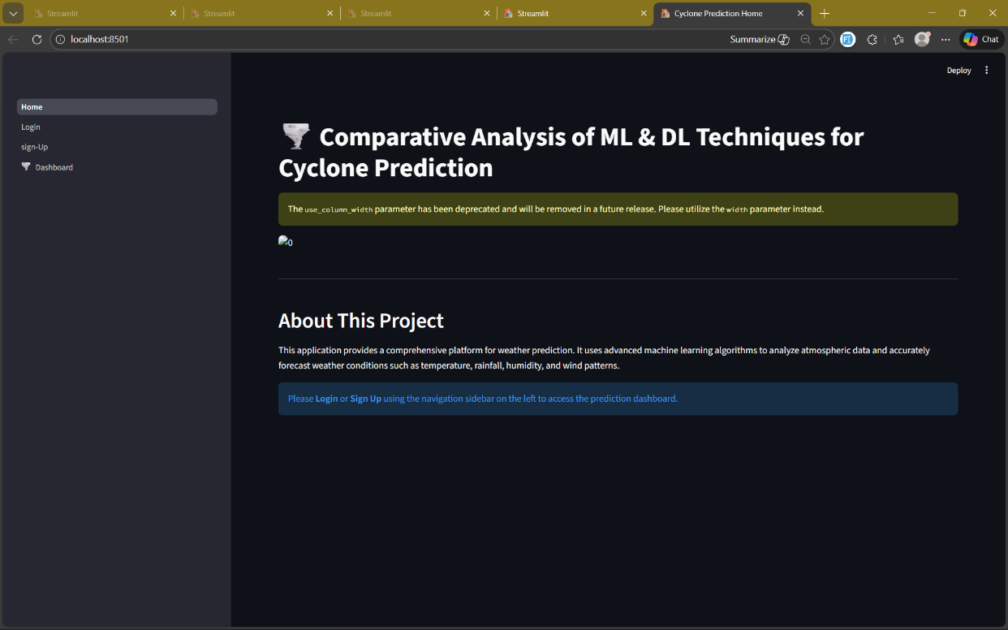
LOGIN
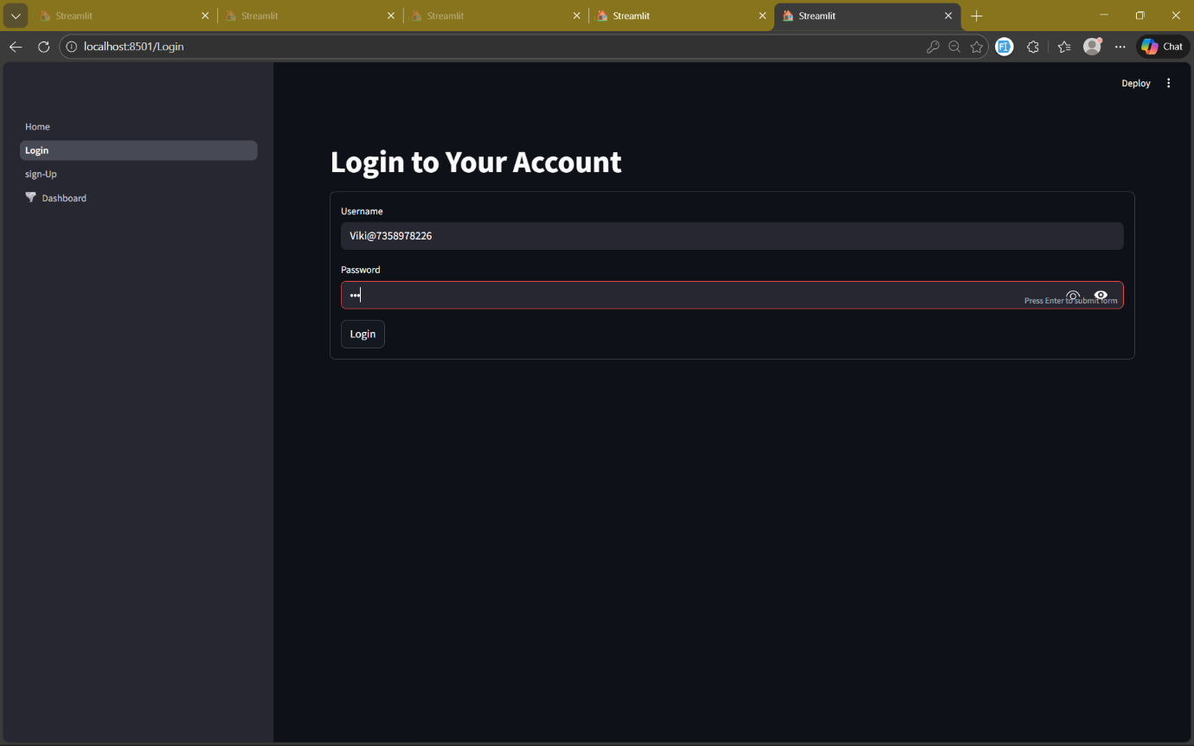

SIGNUP
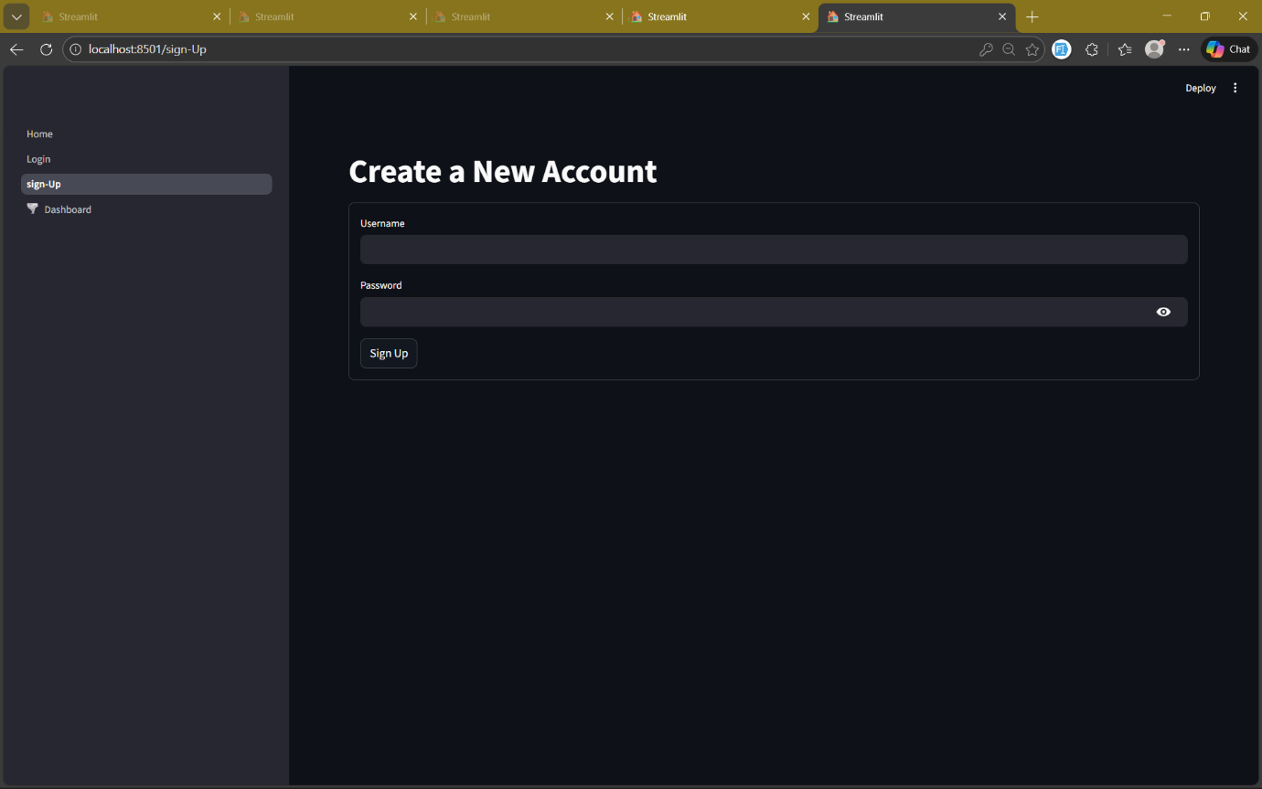
USER_HOME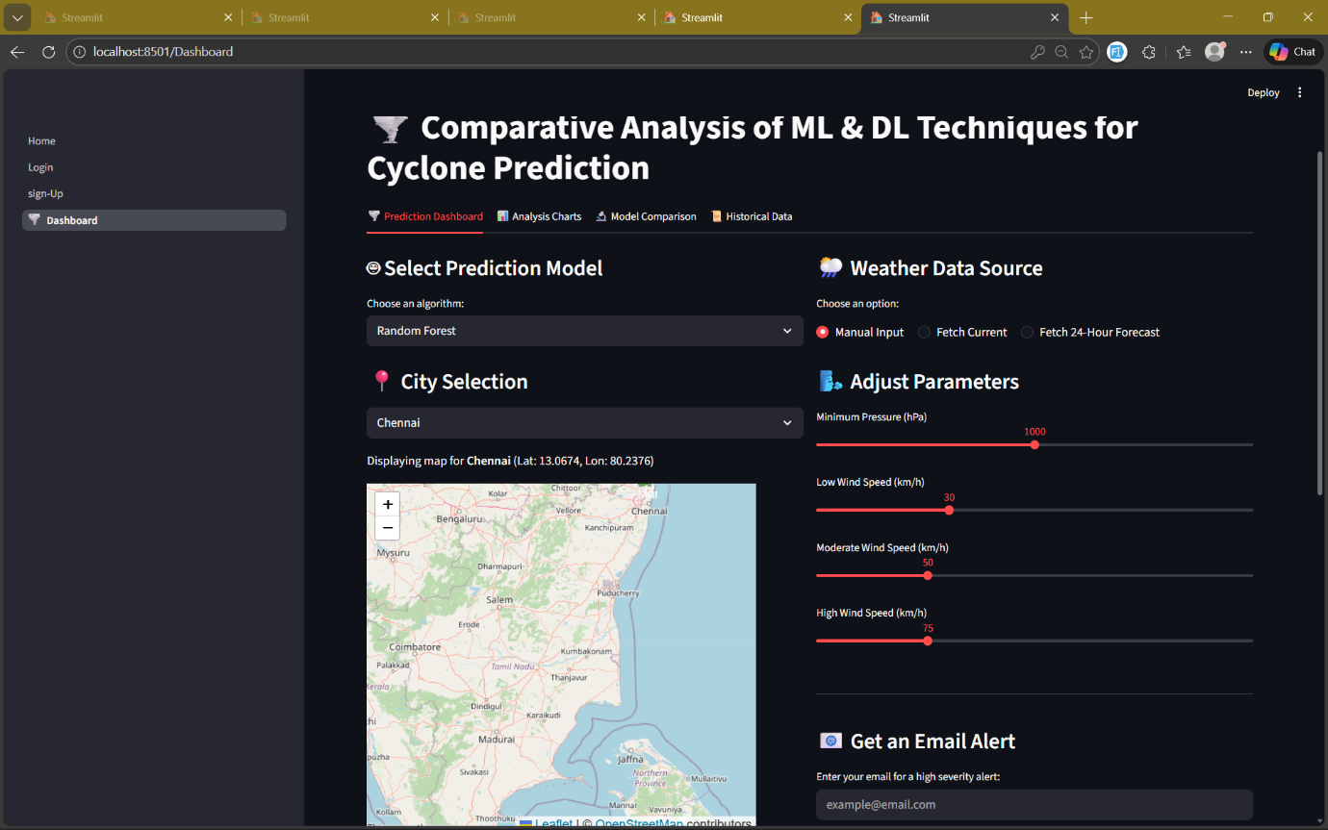

RESULT
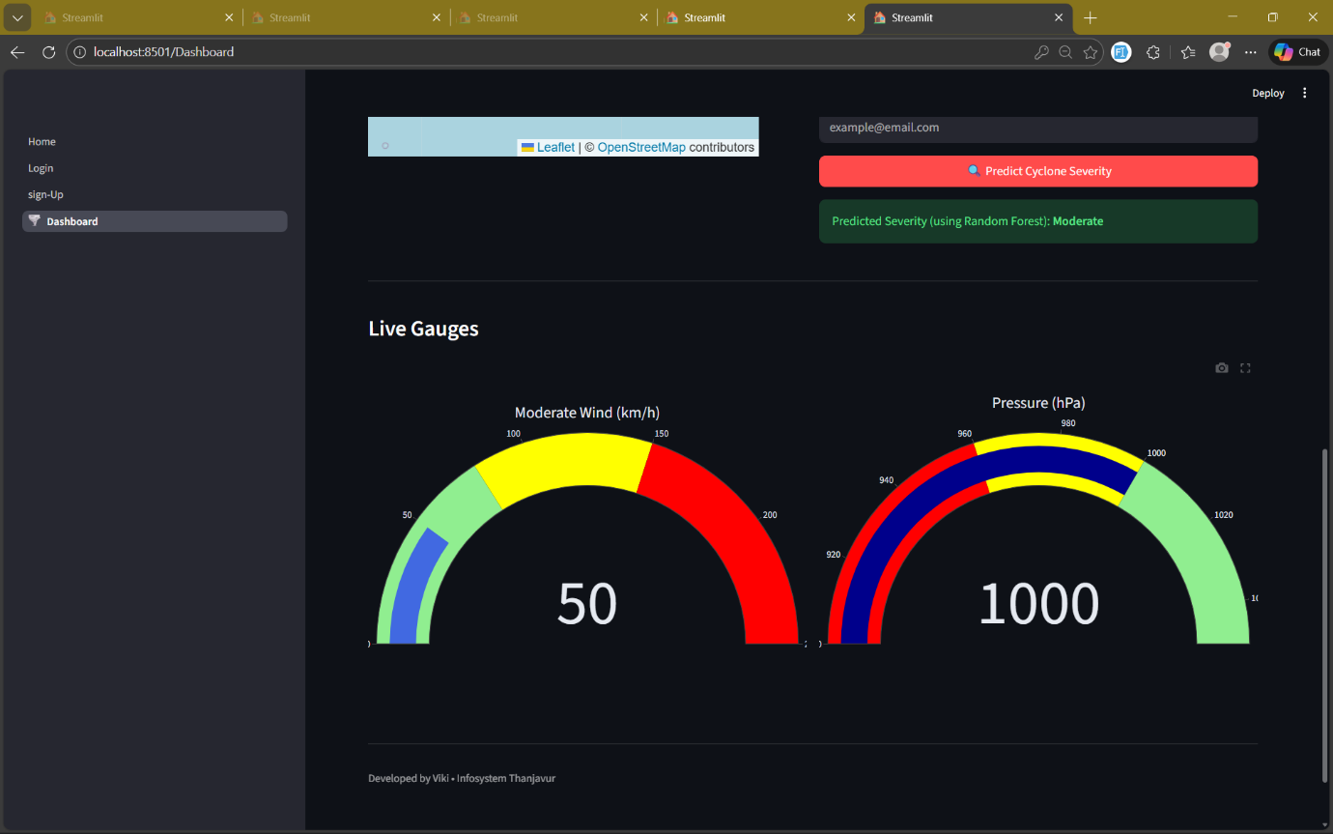
ANALYSIS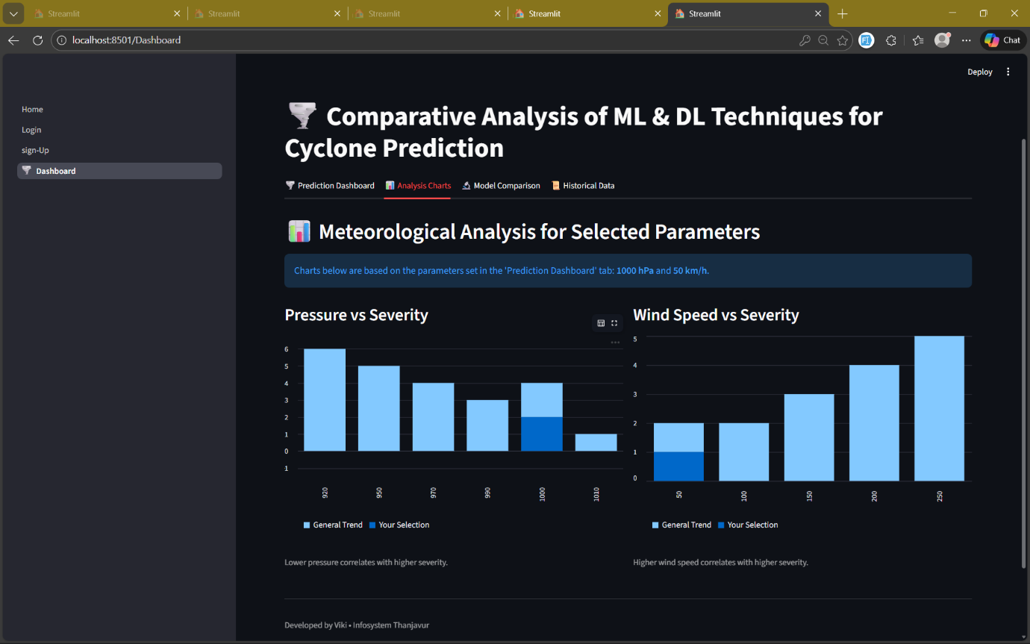

COMPARATIVE_ANALYSIS & HISTORY
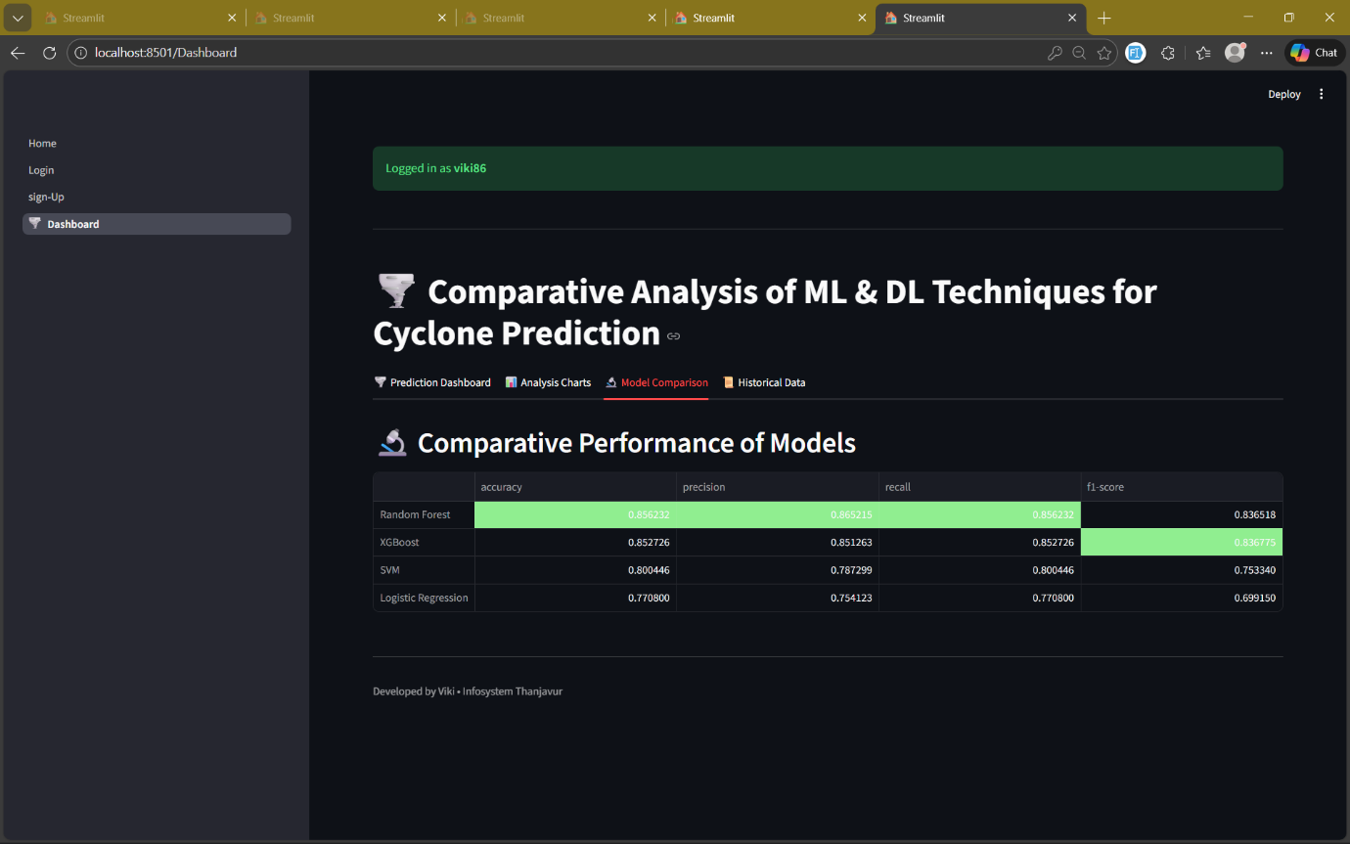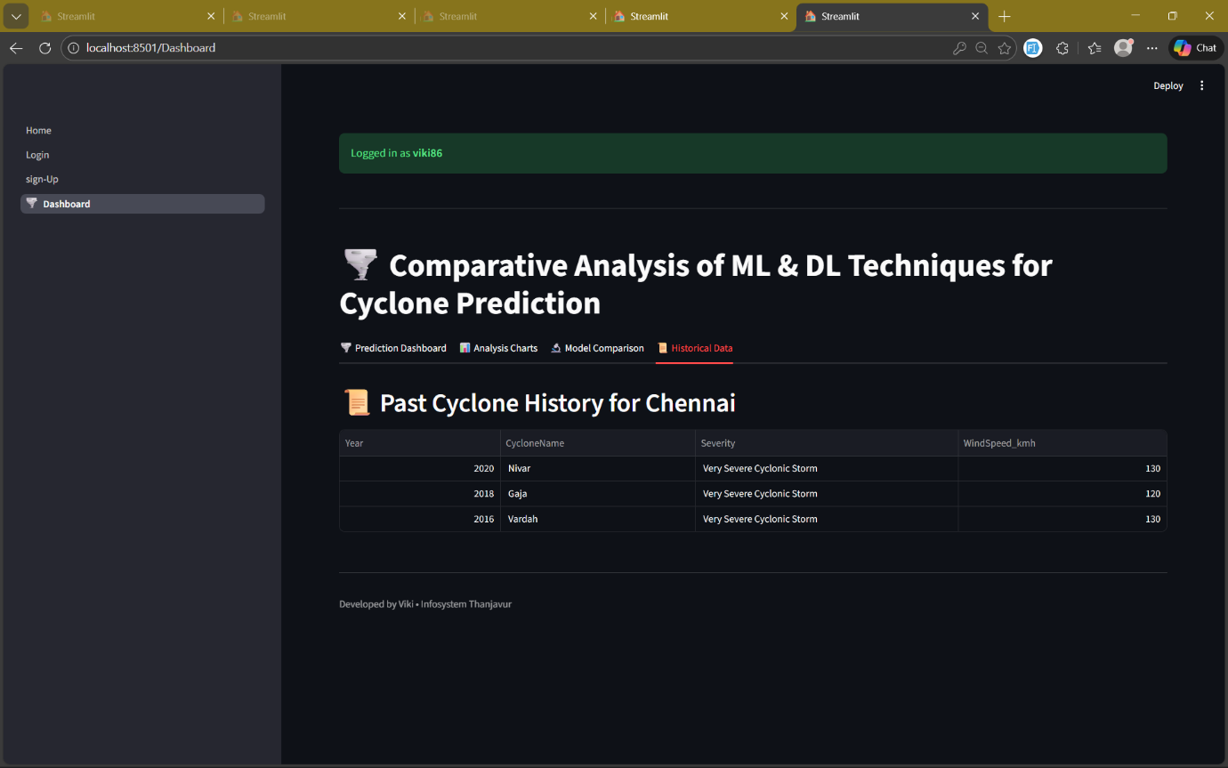

8.CONCLUSION
The Comparative Analysis of Machine Learning and Deep Learning Techniques for Cyclone Prediction has been successfully developed to enhance the accuracy, reliability, and speed of cyclone severity forecasting. By integrating meteorological parameters with satellite imagery, the system provides a hybrid approach that significantly improves prediction quality compared to traditional weather prediction methods.
The Machine Learning models—such as Random Forest, XGBoost, SVM, and Logistic Regression—proved effective in predicting severity levels based on real-time atmospheric data such as pressure, wind speed, and geographical coordinates. Meanwhile, the Deep Learning (CNN) model demonstrated strong capability in analyzing infrared satellite images to identify cyclone structure, eye formation, and intensity patterns.
The Streamlit-based dashboard integrates these models along with live weather APIs, historical cyclone records, forecast analysis, geolocation mapping, and automated high-severity email alerts, making the system practical for real-world usage.
The comparative evaluation revealed that the hybrid ML–DL framework enhances accuracy, reduces dependency on manual analysis, and enables early warning capabilities essential for disaster preparedness. This system can support meteorological departments, researchers, emergency responders, and communities by providing timely and data-driven insights.
Future improvements may include expanding the training dataset, incorporating more advanced deep learning architectures, integrating additional atmospheric parameters, and deploying the system for real-time operational use during cyclone seasons. Overall, the system demonstrates the impactful role of artificial intelligence in environmental monitoring and natural disaster prediction.

9.FUTURE ENHANCEMENTS
In the future, the proposed cyclone prediction system can be further enhanced by integrating more advanced technologies and expanding the data sources. One major improvement would be the incorporation of high-resolution satellite imagery, multi-spectral data, and real-time oceanographic parameters obtained from global meteorological agencies, which can significantly improve the accuracy of both ML and DL models.
The deep learning component can be strengthened by using advanced architectures such as ResNet, EfficientNet, LSTM-CNN hybrids, and Vision Transformers, which are capable of capturing complex spatial and temporal cyclone patterns more effectively. Additionally, training the system with larger historical datasets from IMD, NOAA, and NASA will improve generalization and reduce prediction errors during extreme weather events.
The system can also be extended into a full-fledged web and mobile application, enabling disaster management authorities and the public to access cyclone forecasts from anywhere. Features such as push notifications, real-time alert systems, and region-based risk maps can be integrated to improve early warning and emergency response.
For operational deployment, the model can be optimized using adaptive learning rates, distributed training techniques, and cloud-based GPU/TPU acceleration, ensuring faster processing during cyclone seasons. Integration with IoT-enabled weather sensors and automated satellite data pipelines would allow the system to function as a completely real-time, self-updating cyclone monitoring platform.
These enhancements will make the prediction system more robust, scalable, and suitable for national-level disaster preparedness and climate monitoring applications.

10. REFERENCES

    - Indian Meteorological Department (IMD), “Cyclone Data and Reports,” https://mausam.imd.gov.in/, accessed: Feb 2026.
    - NOAA National Center for Environmental Information (NCEI), “Historical Tropical Cyclone Tracks,” https://www.ncdc.noaa.gov/, accessed: Feb 2026.
    - Joint Typhoon Warning Center (JTWC), “Best Track Cyclone Dataset,” https://www.metoc.navy.mil/jtwc/, accessed: Feb 2026.
    - OpenWeatherMap API Documentation, “Weather & Forecast API,” https://openweathermap.org/api, accessed: Feb 2026.
    - Krizhevsky, A., Sutskever, I., & Hinton, G. E., “ImageNet Classification with Deep Convolutional Neural Networks,” Advances in Neural Information Processing Systems, 2012.
    - Y. LeCun, Y. Bengio, and G. Hinton, “Deep Learning,” Nature, vol. 521, pp. 436–444, 2015.
    - S. Bhalekar, S. Deshmukh, “Cyclone Intensity Prediction Using Machine Learning Techniques,” IEEE Conference on Big Data, 2020.
    - Mirzaei, S., & Fathian, M., “Tropical Cyclone Track and Intensity Prediction Using Random Forest and SVM,” International Journal of Climatology, 2021.
    - R. Kumar, P. K. Singh, “Deep CNN-Based Cyclone Detection Using Satellite Images,” IEEE Geoscience and Remote Sensing Letters, 2022.
    - NASA Earth Observatory, “Cyclone Infrared Satellite Imagery,” https://earthobservatory.nasa.gov/, accessed: Feb 2026.
    - Kaggle Dataset, “Tropical Cyclone Wind & Pressure Dataset,” https://www.kaggle.com/, accessed: Feb 2026.
    - V. Chandrasekar et al., “Machine Learning for Weather Prediction: A Survey,” IEEE Transactions on Geoscience and Remote Sensing, 2020.
    - World Meteorological Organization (WMO), “Cyclone Warning and Monitoring Systems,” https://public.wmo.int/, accessed: Feb 2026.

