Task 1 – Pointer Basics

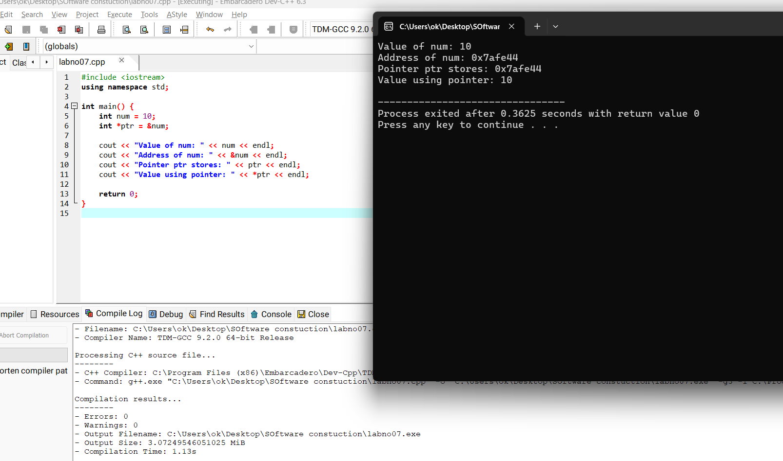

Task 2 – Swap Numbers Using Pointers

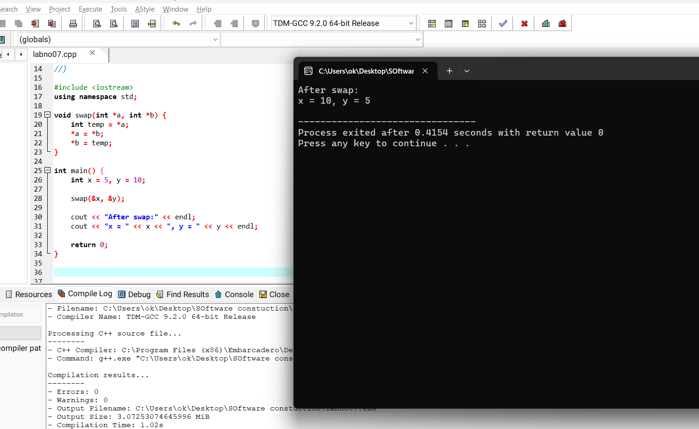

Task 3 – Dynamic Memory Allocation

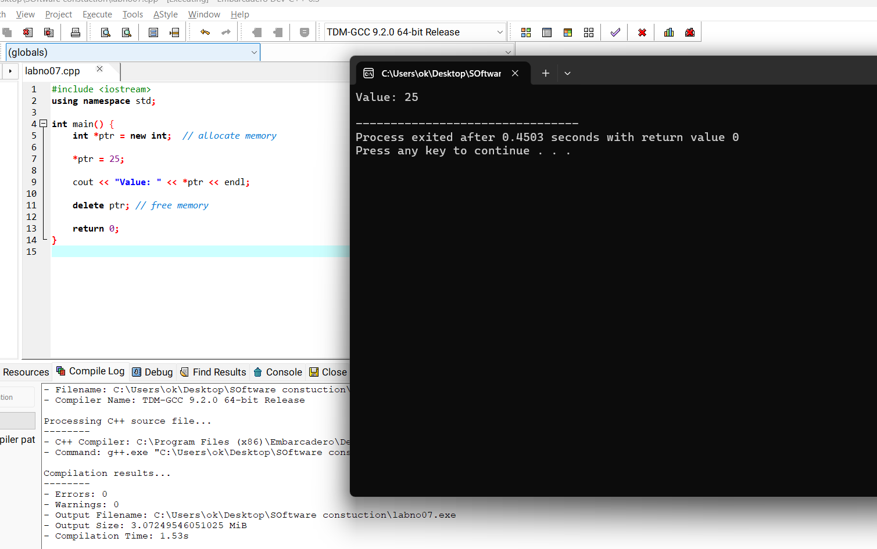

Task 4 – Dynamic Array
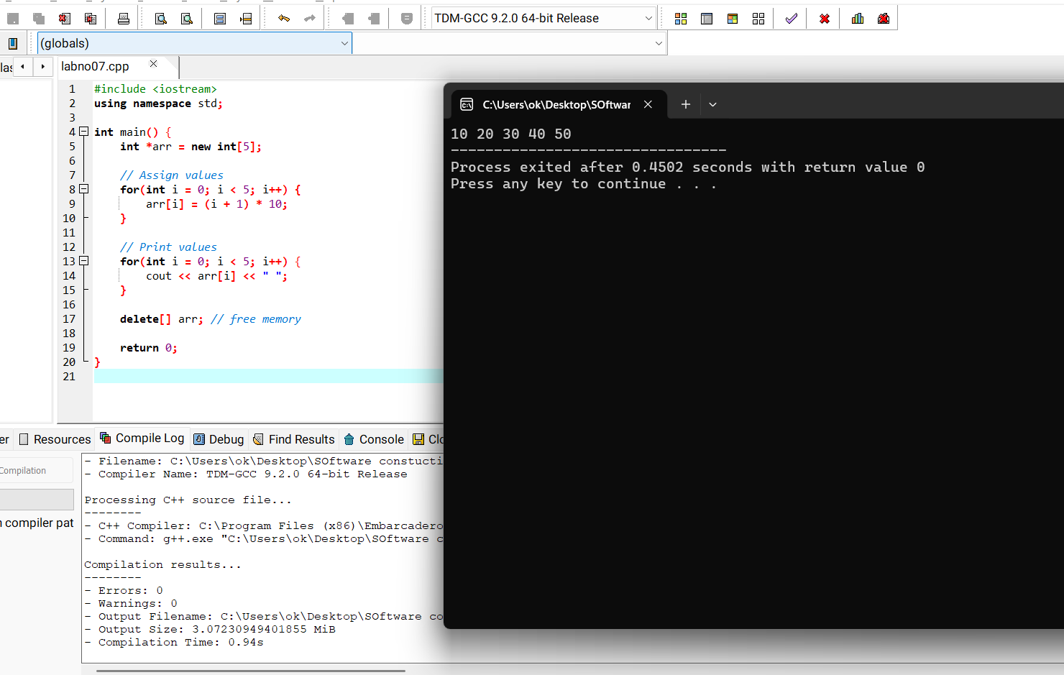

Task 5 – Pointer Arithmetic

