Authentication Strategy
Hybrid Session Cookie + JWT Token Exchange

Document Type | Architecture Decision Record (ADR)
Date | March 2026
Project | Stellantis — Next.js + FastAPI Application
Status | ✅ Active

1. Overview
This document explains the authentication and authorization strategy used in this application and justifies why the Hybrid Session Cookie + JWT Token Exchange approach was chosen over storing a JWT directly in a browser cookie.
Our stack consists of a Next.js frontend served by a Node.js server and a separate FastAPI (Python) backend gateway. These two services live on different logical layers, which demands a modern, decoupled authentication strategy.

2. Architecture Diagrams

2.1 Approach Comparison
The diagram below compares storing a JWT directly in a browser cookie (left, insecure) versus our current hybrid approach (right, secure).
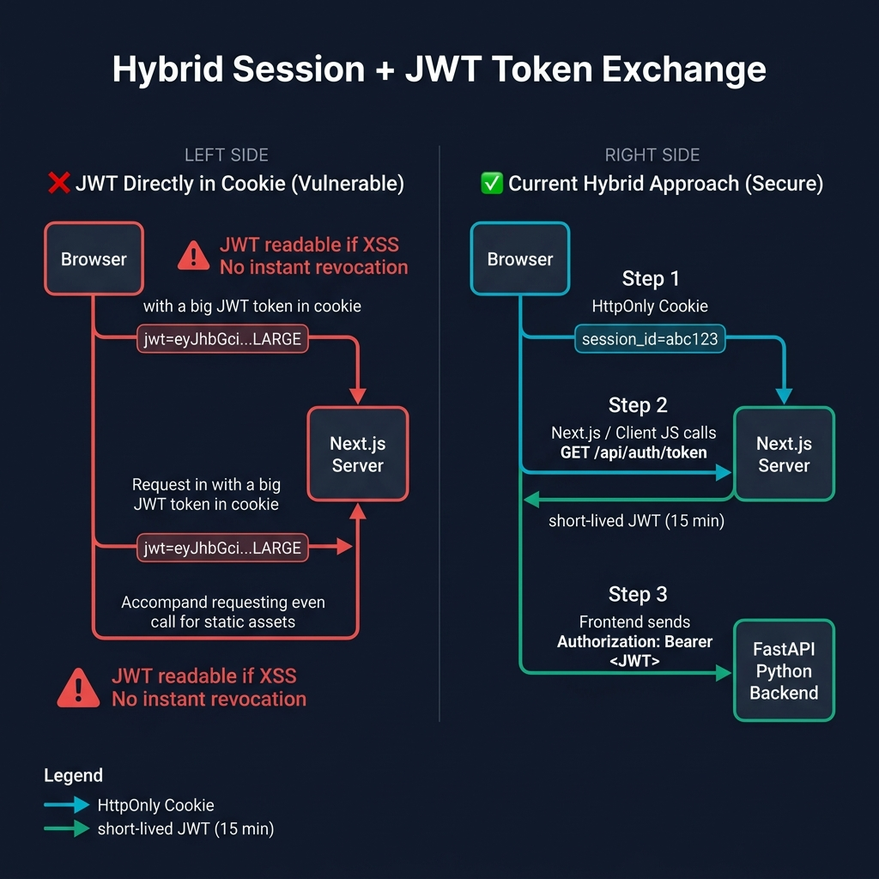

2.2 Authentication & Authorization Sequence Flow
The sequence diagram below shows the exact steps from user login through to an authenticated API call.
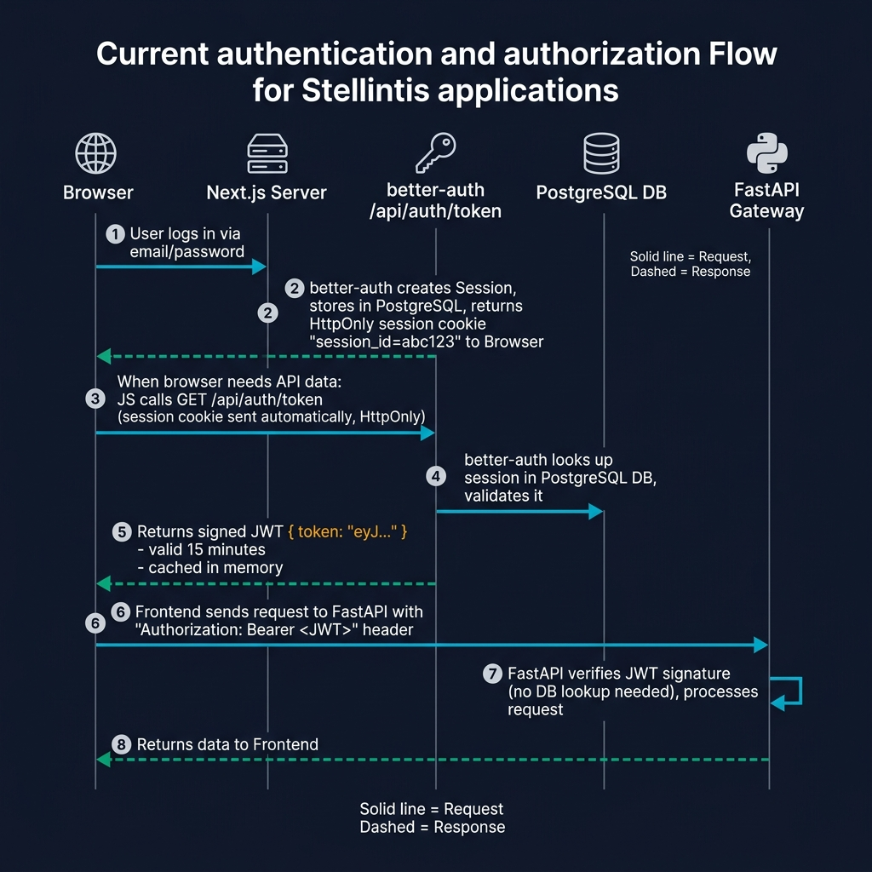

Step-by-step: (1) User logs in → (2) better-auth creates session in PostgreSQL, returns HttpOnly cookie → (3) JS calls GET /api/auth/token → (4) Session validated against DB → (5) Short-lived JWT returned & cached (15 min) → (6) Frontend sends Authorization: Bearer <JWT> to FastAPI → (7) FastAPI verifies signature (no DB call) → (8) Data returned.

3. Approach 1: JWT Directly in Browser Cookie
In this simpler approach, after login the server signs a JWT and sets it directly in a browser cookie. That cookie is then sent on every request, making it immediately usable by both the server and client.

Pros
- ✅ Simple to implement — single token serves all purposes.
- ✅ No extra round-trip to exchange the session for a JWT.
- ✅ Works well for monolithic apps with a single backend server.

Cons
Issue | Description
XSS Vulnerability | JavaScript must read the JWT to use it in an Authorization header — the cookie cannot be HttpOnly. Any XSS attack can steal the token.
No Instant Revocation | JWTs are stateless. A stolen long-lived JWT remains valid until its exp claim is reached (potentially hours or days).
Cookie Bloat | JWTs carrying roles and permissions can reach several KB and are sent with every single request — including static assets.
Cross-Domain Friction | Sharing auth across Next.js and a separate Python API requires complex CORS and cookie-domain configuration.
CSRF Exposure | Cookies are sent automatically by the browser, requiring careful SameSite and CSRF-token configuration.

4. Approach 2: Hybrid Session + JWT Token Exchange (Current)
Our approach separates concerns: the browser holds a secure session reference, and the JavaScript application exchanges it for a short-lived JWT only when it needs to call the backend. This is implemented using the jwt() plugin from better-auth.

Implementation Snippets
// frontend/src/server/better-auth/config.ts
export const auth = betterAuth({
database: new Pool({ connectionString: env.DATABASE_URL }),
emailAndPassword: { enabled: true },
plugins: [
jwt() // Enables GET /api/auth/token endpoint
]
});

// frontend/src/core/api/auth-fetch.ts
async function fetchJwtToken(): Promise<string | null> {
const res = await fetch('/api/auth/token', {
method: 'GET',
credentials: 'include', // Sends HttpOnly session cookie
});
const data = await res.json();
return data?.token ?? null; // Returns short-lived JWT for backend
}

Pros
Benefit | Description
XSS Protection | The session cookie is HttpOnly — JavaScript can never read it. Token theft via script injection is blocked at the browser level.
Instant Revocation | Deleting the session from PostgreSQL immediately invalidates access. The next token exchange call will fail even if the 15-min JWT hasn't expired.
Minimal Cookie Footprint | The session_id cookie is ~32 characters. No payload bloat on every request, including static assets.
Stateless Backend | FastAPI validates JWTs using only a cryptographic signature — no database call per request. Enables horizontal scaling and high throughput.
Clean Decoupling | Next.js handles identity (sessions). FastAPI handles resources (data). Standard Bearer token auth means any future service can be added with zero auth changes.
Smart Caching | The JWT is cached in memory for 14 minutes, minimizing /api/auth/token round-trips while rotating tokens regularly.

Cons
Trade-off | Description
Extra Complexity | Requires understanding of two token types (session + JWT) and a token refresh/caching mechanism.
Additional Latency (cold) | On cache miss, an extra HTTP call to /api/auth/token adds a small round-trip before the main API call.
In-Memory Cache Ephemerality | A page refresh clears the cached token, triggering a fresh exchange on the next API call.

5. Security Comparison Summary
Security Property | JWT in Cookie | Hybrid Approach (Current)
XSS Token Theft | 🔴 Vulnerable (requires readable cookie) | 🟢 Protected (HttpOnly session)
Instant Revocation | 🔴 Not possible (stateless) | 🟢 Supported (delete DB session)
CSRF Protection | 🟡 Requires explicit mitigation | 🟢 Built-in via SameSite cookie
Cookie Size / Performance | 🔴 Large cookie on every request | 🟢 Tiny session ID only
Backend Scalability | 🟡 Requires shared session store | 🟢 Stateless JWT verification
Cross-Service Auth | 🔴 Domain-tied cookie friction | 🟢 Standard Bearer token
Implementation Complexity | 🟢 Simple | 🟡 Moderate (one-time cost)

Overall Assessment: The one-time complexity cost of the hybrid approach is justified by significant gains in security, scalability, and architectural cleanliness — especially given our decoupled Next.js + FastAPI stack.

6. Industry Alignment
- OWASP recommends HttpOnly, Secure, and SameSite cookie attributes as the first line of defense against session hijacking.
- OAuth 2.0 Token Exchange (RFC 8693) formalizes the concept of exchanging a primary token for a scoped downstream token — exactly what /api/auth/token implements.
- better-auth's own documentation states the JWT plugin is purpose-built for obtaining JWTs for microservices and external API calls from a secure session-based identity layer.
- OWASP and Snyk security guides consistently recommend against storing JWTs in localStorage or readable cookies, which this approach enforces by design.

7. Files Reference
File | Purpose
frontend/src/server/better-auth/config.ts | Configures better-auth with jwt() plugin
frontend/src/server/better-auth/server.ts | Server-side session helper (getSession)
frontend/src/core/api/auth-fetch.ts | Token exchange logic, 14-min cache, fetchWithAuth helper
backend/packages/auth/jwt_auth/__init__.py | FastAPI JWT verification dependency
backend/app/gateway/dependencies.py | Injects get_current_user into gateway routes

Stellantis · Architecture Decision Record · March 2026

