**///** /Thematic Workshop 3 – OSLO TRAPEZE/

**////////////////////////////////////////////////////////////////////////////////////////////////////////**

**Date**: 18/11/2021

**Time:** 13:00 – 15:30

**Location**: Online – Microsoft Teams Meeting

# Attendees

* Digitaal Vlaanderen
  + Frédéric Hennequin
  + Lora Van Looveren
  + Michael Geamanu
  + Arne Van Der Stuyft
* Datanutsbedrijf: Filip Borloo
* Inrupt: Nick Mondada
* Konsolidate: Christophe Cop
* Fluvius: Koen Putteman

# Agenda of the working group

| **Part 1** | Welcome: Who is who |
| --- | --- |
| **Part 2** | Summary of the previous workshop |
| **Part 3** | New iteration of the data model |
| **Part 4** | Use cases |
| **Part 5** | Q&A and next steps |

## Part 1: Welcome

All attendees presented themselves. The input was used to put together the list of attendees.

## Part 2: Summary of the previous workshop

A short summary of the previous workshop was given in the presentation. The previous workshop was the second thematic workshop of the consent trajectory, and the meeting minutes of that workshop have been shared via the invitation mail for the 3rd thematic workshop sent by Digitaal Vlaanderen.

The list of [GitHub](https://github.com/Informatievlaanderen/OSLOthema-consent/issues) issues identified in the 2nd thematic workshop were addressed during the workshop through use cases and a short brainstorming session was held. One issue on the expression of expiry conditions within the model has remained unresolved for the time being.

## Part 3: New iteration of the data model TBU

A short summary was given of the updates made to the new iteration of the data model in line with the discussion on issues from the previous workshop.

**Different Agents within Consent:** Different agents (DataSubject, DataRequester, Data Controller) were added to the model and the class Agent became a superclass. Identifiers were added to the model and were kept open for all types of identifiers, following the voting session during the 2nd thematic workshop.

It was stressed that multiple agents should be able to be involved (e.g. a family). This can be done through:

1. delegation
2. adding multiplicity in the model

**Agent as super class with the attribute identifier:** Agent was changed to an implicit class as the superclass of DataSubject, DataController and DataRequester.

**CCCEV classes have been added:** The CCCEV data model is used to define contextual and conceptual consents.

**Higher granularity for PersonalData:** Within previous workshops we highlighted that we would like the granularity of the PersonalData to be as high as possible (ideally up until field level). Hence, we added attributes that should help to define the data that is asked for.

**Extra options for the status of Consent:** Within consent a few attributes have been changed or added. For the expiryCondidtion attribute, Solid has two ways (both in draft) to express expiryCondition: WAC & ECP. Those could serve as inspiration.

**Purpose and relationship within the model:** A relationship could be broader than a purpose and help to fulfil a specific transaction. The purpose is added as an attribute of the class PersonalDataHandling and is left open to fill in as detailed as necessary. The relationship between the DataSubject and DataRequester is indicated in a more general way.

**Adding the class Document for DataSubject in a human-readable way:** The class Document was added to the datamodel to give an agent the possibility to check what (s)he has given consent to. It was proposed to link the entity document directly to PersonalData because of the relationship between both classes.

Finally, the audience was asked for input on the unresolved GitHub issue on the legal validity of the model.

* The legal validity is being discussed by the legal team at the Datanutsbedrijf and Inrupt as there are different ways to (being allowed to) share data such as public interest for governments and contracts. Also Digitaal Vlaanderen is discussing this. This should be followed-up in the next thematic workshop.
* A reflection was made on whether consent is the right name because it can have different meanings in different countries and regions. It was agreed to move away from the term ‘consent’ to keep legal validity in every single context it could be used. The definition of consent should be addressed in the next thematic workshop. Instead, access request, access grant and access receipt

## 

## Part 4: Use cases

### Use case 1: Give consent to salary data for a mortgage loan

### 

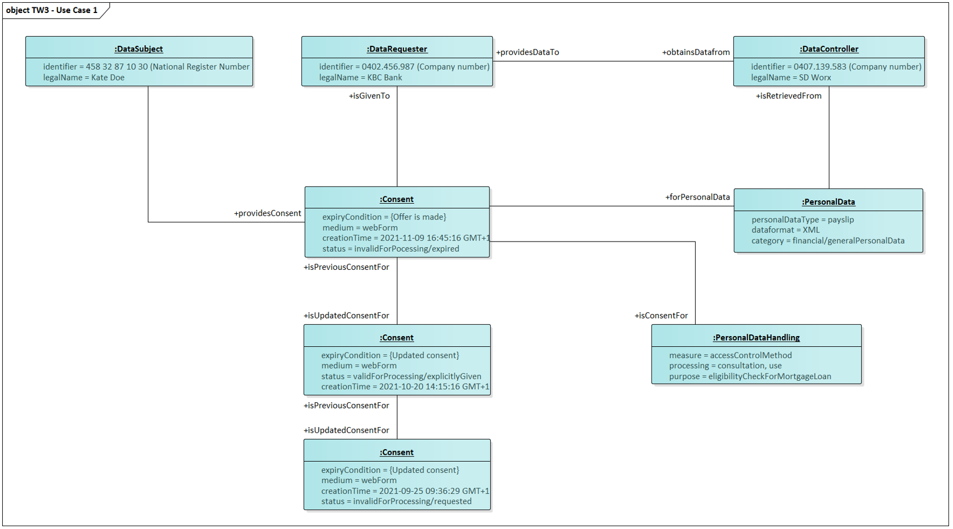

The above context model was shown to the attendees and was demonstrated on the basis of a use case. The use case revolved around giving a bank consent to salary data for a mortgage loan. A fictitious character Kate is a customer of KBC bank. She has both a current and a savings account. Recently, she has set her eyes on a house, and thus applies for a mortgage loan at KBC. KBC requests her payslips to verify her eligibility and to calculate an appropriate interest rate. Kate gives consent for this via a web form and specifies that the requested data can be retrieved from SD Worx. She also specifies that her consent will be withdrawn once the offer is made. KBC gives Kate an offer for her mortgage loan.

### The following topics were discussed

**Chain of consent:** Machine readable ways to define the expiryCondition were discussed. For the time being, there is not much progress in this regard; WAC does not have one and ECP is looking into it (event based vs. time based).

**PersonalData:** The participants highlighted that the DataSubject should be able to identify which datafield (s)he would like to share with the DataRequester. As a result, granular control of the data is needed and there should be no more than “need to know” access. In personalDataHandling we can make sure that only the necessary data is being used.It is currently unclear how to describe/implement it in the model:

* 1. attribute
  2. model e.g. OSLO loongegevens

### Use case 2: Give consent to blood group info in case of a medical emergency

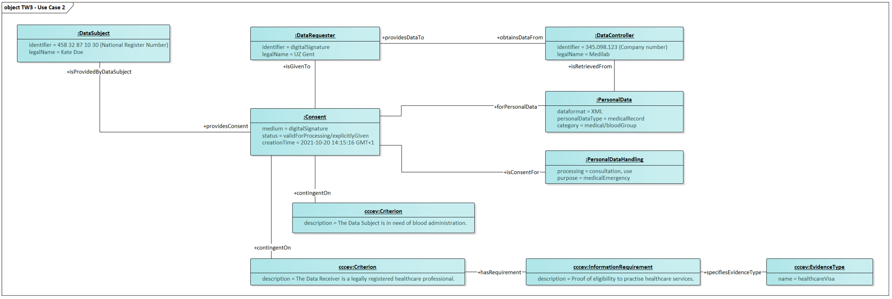

The above context model was shown to the attendees and was demonstrated on the basis of a use case. The use case revolved around giving consent to blood group information in case of a medical emergency. In this use case, Kate got involved in a car accident while on her way back from the bank. She was rushed to the hospital and is in urgent need of a blood administration. Kate is unconscious, but luckily, she has already given consent to access her blood group in the past in case of medical emergencies with regards to healthcare professionals.

### The following topics were discussed

The use case was clear. No comments were provided.

### Use case exercise: Additional use cases to test with the data model

The attendees were asked about other use cases that could be used to test the data model to find any remaining gaps. The following use cases were brought up:

**Machine learning (ML)**: A use case where an application does data processing without any human agent involved; e.g. data cleaning. Points that need to be looked into are a.o., if

* this should be part of purpose;
* the scope of this model is only human readable processing;
* a computer is also considered an agent; and
* This use case is already covered in the first use case, since machine learning/software will calculate your interest rate.

**Multi-person consent:** A use case in which the data subject can be multiple people and thus multiple people need to give consent, e.g.: banks may need the family income instead of that of only one person or approval from the entire board of an organisation.

**Different frequencies for consent**: A use case in which consent is given for different frequencies, e.g.: verification of the monthly salary of the first year or once per month. It needs to be checked

* if this can be covered by adding attributes such as time, frequency, and cadence; and
* if contracts (contractual requirements) can be put in the attributes.

**Consent delegation**: A use case that allows to delegate consent to another party, e.g. I have a deteriorating health condition and I want to delegate consent over my data to my lawyer or a family member or I went through a divorce or lost custody rights. It needs to be verified

* whether it needs an expiryCondition on the delegation (e.g; divorce or lost custody right) or on consent.
* how to indicate in the model that one or more agents must versus can agree on the consent.

## Part 5: Q&A and next steps TBU

**Q: How do we ensure the publication of standards in a consistent way, e.g. to avoid that a page goes 505.**

* This should be looked into.

To close the workshop, an overview was given of the next steps for the coming months:

* Process the input from the workshop
* Circulate the main findings of this workshop
* Further research and prepare the fourth thematic workshop
* Capture further input through GitHub

If you would like to participate in one of the following thematic workshops, you can find an overview of the workshops and register via the link below. The next thematic workshop will take place on 16/12/’21 at 13h via Microsoft Teams. The link will be sent to the participants after registration.

<https://overheid.vlaanderen.be/opleiding/oslo-trapeze>

In the meantime, if you have any questions or notice a problem, you can always open an issue on GitHub or send an e-mail to the e-mail addresses below:

* [laurens.vercauteren@vlaanderen.be](mailto:laurens.vercauteren@vlaanderen.be)
* [lora.van.looveren@pwc.com](mailto:lora.van.looveren@pwc.com)
* [michael.geamanu@pwc.com](mailto:michael.geamanu@pwc.com)