**///** /Thematic Workshop 4 – OSLO TRAPEZE/

**////////////////////////////////////////////////////////////////////////////////////////////////////////**

**Date**: 16/12/2021

**Time:** 13:00 – 15:30

**Location**: Online – Microsoft Teams Meeting

# Attendees

* Datanutsbedrijf
  + Filip Borloo
* Datavillage
  + Frederic Lebeau
  + Philippe Duchesne
* Digitaal Vlaanderen
  + Frédéric Hennequin
  + Frédéric Hannes
  + Geert Thijs
  + Lauro Vanderborght
  + Lora Van Looveren
  + Michael Geamanu
  + Michael Mampaey
* Inrupt
  + Esther De Loof
  + Nicolas Mondada
* Konsolidate
  + Christophe Cop

# Agenda of the working group

|  |  |
| --- | --- |
| **Part 1** | Welcome: Who is who |
| **Part 2** | Summary of the previous workshop |
| **Part 3** | New iteration of the data model |
| **Part 4** | Use cases |
| **Part 5** | Definitions |
| **Part 6** | Q&A and next steps |

## Part 1: Welcome

All attendees presented themselves. The input was used to put together the list of attendees.

## Part 2: Summary of the previous workshop

A short summary of the previous workshop was given in the presentation. The previous workshop was the third thematic workshop of the OSLO Consent trajectory, and the meeting minutes of that workshop have been shared via the invitation mail of the 4rd thematic workshop sent by Digitaal Vlaanderen.

The list of [GitHub](https://github.com/Informatievlaanderen/OSLOthema-consent/issues) issues was addressed during the workshop through use cases and a short brainstorming session was held. A question arose on how to ensure persistent publication of standards. This was clarified with Digital Flanders. They confirmed that Application profiles and definitions from Digital Flanders will not disappear. However, when we reuse definitions from other sources, we refer to vocabularies outside of the governance of Digital Flanders. That is why reuse should be tied to data standards that we expect to have good governance.

## Part 3: New iteration of the data model

A short summary was given of the updates made to the new iteration of the data model in line with the discussion on issues from the previous workshop.

**Granularity of the personal data**To maintain a maximal granularity when referring to the personal data, the PersonalData class is changed to a metaclass. This means that the metaclass PersonalData can be any class that is personal data. The update was clear; there were no comments.

**Link with existing data models**The data model maximises the reuse of existing vocabularies and data models. The data models that were used within our model are: GConsent, Data Protection Vocabulary (DPV), Core Criterion and Core Evidence Vocabulary (CCCEV), and OSLO-Generiek.

It was highlighted that a few other models and ontologies which were not mentioned are also being used, e.g., OSLO-Persoon and OSLO-Organisatie.

**Use of the involved agents**Data subject, data controller and data processor are three terms that are widely used and clearly defined in GDPR. The model is adapted to correctly use those terms; DataRequester was removed and DataProcessor was added.

It was brought up that the use and composition of the agents (DataController and Dataprocessor) in the proposed model differ from the DPV model, which works with ThirdParties instead. It was agreed to adapt the current model by adding ThirdParty as an abstract class so that the PersonalDataHandling can never be instantiated unless you are able to specify if it is a data processor or data controller and to avoid the third party from being substantiated.

**Legal bases of GDPR in the data model**

GDPR defines six lawful bases for the processing of personal data, with consent only being one of those. To visualise this, the class LegalBasis was added as a superclass of Consent. Additionally, LegalBasis was added as an attribute to the classes PersonalDataHandling and DataRetention, defining the legal basis on which the data handling or retention is based.

The added value of the class LegalBasis was discussed, which is to show that consent is a subclass of the superclass LegalBasis, because consent is only one of the legal bases for processing personal data.

Additionally, the different meanings of ‘consent’ were discussed: ‘granting permission’ and ‘GDPR consent’. To avoid any confusion, other names were proposed such as ‘GDRP_Consent’, ‘permission’ and ‘assent’.

Finally, it was clarified that this model should cover the legal basis of ‘consent’ only. It would however be possible to extend the model to the other legal bases in another trajectory, where definitions and usage notes get updated to fit the other legal bases, because right now the definitions are reused from ontologies that focus on the legal basis of consent only. During the public review the team of Datanutsbedrijf will do a mapping exercise on the data model to see if it is possible to use the data model for all their use cases - which are broader than only about GDPR’s consent.

**Class DataRetention**The class DataRetention is added to the model to indicate in the model if data needs to be kept longer than the purpose of the consent and to introduce the data processing which is based on the other legal bases. The update was clear; there were no comments.

**Expiry conditions**Expiry conditions canbe addressed by making the expiry conditions solely quantifiable or by adding event-based expiry conditions to the model by using the CCCEV. The use cases show both options. The update was clear; there were no comments.

**Enumerations**The enumerations within the data model have been elaborated and aligned with the GDPR. DPV has also identified lists for several of these enumerations, which are reused. It was recommended to refer to existing codelists with URIs, otherwise they can only be added to the diagram for illustrative purposes. Additionally, it was shared that codelists should be defined separately and that enumerations with hierarchies should be made by creating an entire taxonomy in SKOS concept schemes. In the concept scheme you can then refer to a definition of the term ‘elsewhere’, a corresponding class in DPV.

**Class PersonalDataHandling**The PersonalDataHandling class name was aligned with the DPV naming. The attribute legalBasis is also part of the class and thus was added. On top of that, personalDataType and personalDataCategory were moved to this class as the PersonalData class is now a metaclass and finally the liveData attribute was added to indicate if the recipient of the data requires access to the live data (yes) or only needs a static version of the data (no). The update was clear; there were no comments.

**Superclass Agent**

The superclass Agent was deleted because it was considered an opening for misinterpretation rather than a clarification. However, it was noticed that as a result, it is no longer possible for the data controller to be a person. It was agreed to reintroduce the superclass Agent to allow a natural person as well as an organisation to be a data controller.

## Part 4: Use cases

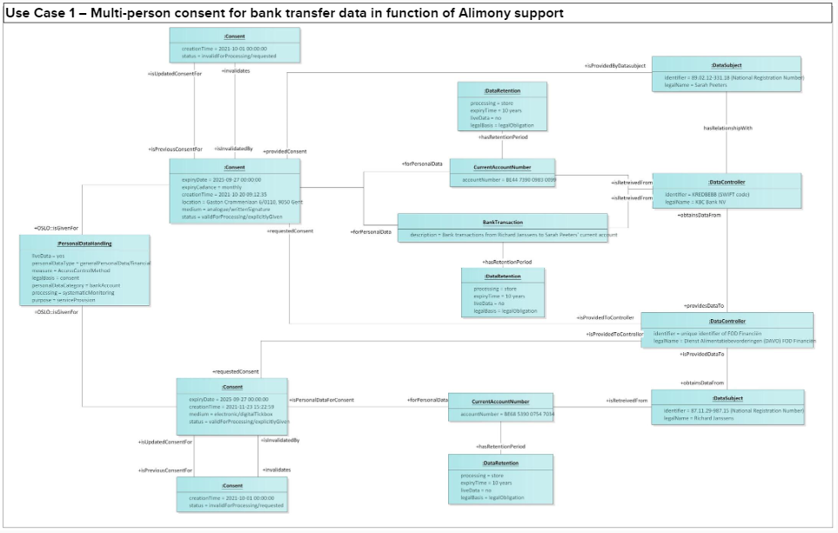

The above context model was shown to the attendees and was demonstrated on the basis of a use case. The use case revolved around multiple persons giving consent to sharing bank transfer data. DAVO (Dienst Alimentatiebevorderingen i.e., Alimony Claims Service of Belgium) wants to automate the advances they give to parents not receiving their alimony (in time). Sarah Peeters is a mother with full custody over her children. The father of her children, Richard, is not able to pay the alimony of the children according to the requirements put in place by the judge. To be able to automate the processes DAVO requested consent from Sarah Peeters and Richard to access the money transfers from Richard's bank account to Sarah's bank account. As the youngest child just became 14 years old DAVO asked for the consent to last for the next 4 years, so that they are able to provide their services until the youngest one is 18 year old and no longer required to receive alimony. Richard is expected to pay Sarah on a monthly basis, meaning DAVO should have access to the data in the same cadence.

The following topics were discussed:

**PersonalData ‘CurrentAccountNumber’ presented as if it is a class**It was highlighted that ‘CurrentAccountNumber’ is presented as if it is a class, while this is just an object with no datatype. This can be resolved by adding a double point in the front.

**Options for expressing the expiry conditions**The attendees were asked to vote on how to address the expiry conditions as explained in ‘Part 3: New iteration of the data model’, either by making the expiry conditions solely quantifiable (option 1) or by adding event-based expiry conditions to the model by using the CCCEV (option 2). The majority of the attendees remained indifferent, while two attendees voted for the second option as option 1 is only time specific. Additionally, it was added that if the conditions are legally right, then option 1 should be considered, while if there are more subtle conditions, then the second option needs to be considered. Finally, making Expiry a subclass of Criterion was brought up as the best option for the use case.

**Multi-person consent**It was mentioned that the cardinalities in the associations of PersonalDataHandling and DataSubject should be added in the data model to make the application profile more useful. Additionally, it was highlighted that the use case will not always work in case data needs to be shared from a family income so owned by multiple persons where consent from each person needs to be collected. It was discussed that this could be resolved with a cardinality (one to more) going from Consent to DataSubject. In the usage notes it needs to be specified that the consent involves shared data. Revoking the consent could be handled with a CCCEV criterion.

**DataRetention**It was noticed that LegalBasis is twice in the data model (as association and attribute) and the cardinality is not specified.

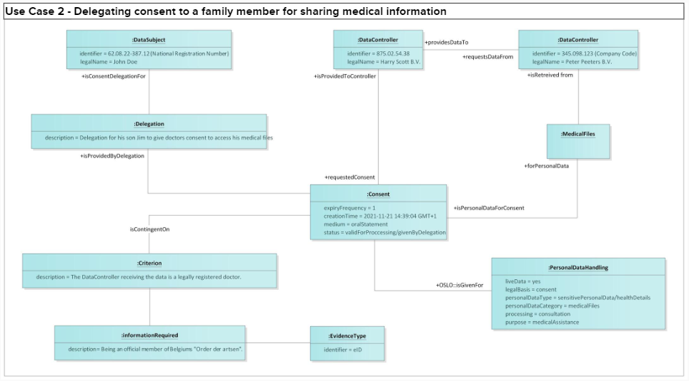

The above context model was shown to the attendees and was demonstrated on the basis of a use case. The use case revolved around delegating consent to a family member for sharing medical information. In this use case, John Doe suffers from a neurological disease in which a malfunction of his nerves can make him enter into a situation in which he becomes unresponsive until he gets the needed emergency healthcare. On the 21 November 2021, Joe was on a get-a-way and encountered such a neurological attack. A hospital that did not have any knowledge of his medical files thus needed to give him the required emergency healthcare. To anticipate this kind of situation John gave his wife (Jane Doe) power of attorney to act on his behalf in this kind of emergency. After the doctors confirmed the fact that he was having a neurological attack the hospital asked Jane consent for the doctors to access his medical files to be able to help him to the best of their abilities. The hospital asked for constant access to his files for as long as he is staying in the hospital.

The use case was clear. No comments were provided.

## Part 5: Definitions

The approach for the definition of the classes, attributes and relationships was explained. Reuse is encouraged as much as possible.

It was highlighted that a definition from an existing vocabulary cannot be changed, however in an application profile you can further elaborate, deviate, be more specific in the usage notes.

Since DPV definitions are used in this data model and the status of its publication is unclear, it would be advisable to contact DPV about their next releases.

## Part 6: Q&A and next steps

To close the workshop, an overview was given of the next steps for the coming months:

* Process the input from the workshop
* Circulate the main findings of this workshop and the presentation
* Run the model through the toolchain
* Initiate the public review and capture feedback from Github

If you would like to contribute to the public reviews, you can provide feedback to the draft application profile , which will be made available in January (as draft) on [test.data.vlaanderen.be](https://test.data.vlaanderen.be/standaarden/standaard-in-ontwikkeling/vocabularium-en-applicatieprofiel-oslo-consent.html). The link will also be sent to the participants of this workshop.

In the meantime, if you have any questions or notice a problem, you can always open an issue on GitHub or send an e-mail to the e-mail addresses below:

* [laurens.vercauteren@vlaanderen.be](mailto:laurens.vercauteren@vlaanderen.be)
* [lora.van.looveren@pwc.com](mailto:lora.van.looveren@pwc.com)
* [michael.geamanu@vlaanderen.be](mailto:michael.geamanu@vlaanderen.be)