DNN

================================================

================== train info ==================

================================================

Top frequency words range : 10000

Embedding Vectors dimension : 100

Epoch Size : 20

Batch Size : 500

Learning Rate : 0.001

train x shape : (145791, 80)

train y shape : (145791,)

test x shape : (48995, 80)

test y shape : (48995,)

================================================

================= train start ==================

================================================

[Epoch 001/020] - time taken: 1.770 | Loss: 0.560 | Acc: 70.143 | validation Loss: 0.483 | validation Acc : 76.678

[Epoch 002/020] - time taken: 1.646 | Loss: 0.424 | Acc: 79.995 | validation Loss: 0.641 | validation Acc : 72.622

[Epoch 003/020] - time taken: 1.945 | Loss: 0.361 | Acc: 83.720 | validation Loss: 0.466 | validation Acc : 77.183

[Epoch 004/020] - time taken: 1.875 | Loss: 0.320 | Acc: 85.763 | validation Loss: 0.449 | validation Acc : 80.352

[Epoch 005/020] - time taken: 1.670 | Loss: 0.283 | Acc: 87.699 | validation Loss: 1.792 | validation Acc : 53.479

[Epoch 006/020] - time taken: 1.642 | Loss: 0.250 | Acc: 89.320 | validation Loss: 0.594 | validation Acc : 79.009

[Epoch 007/020] - time taken: 1.684 | Loss: 0.219 | Acc: 90.818 | validation Loss: 3.016 | validation Acc : 56.437

[Epoch 008/020] - time taken: 1.973 | Loss: 0.190 | Acc: 92.101 | validation Loss: 0.890 | validation Acc : 73.494

[Epoch 009/020] - time taken: 1.780 | Loss: 0.164 | Acc: 93.448 | validation Loss: 0.604 | validation Acc : 80.920

[Epoch 010/020] - time taken: 1.798 | Loss: 0.141 | Acc: 94.386 | validation Loss: 1.279 | validation Acc : 70.500

[Epoch 011/020] - time taken: 1.734 | Loss: 0.125 | Acc: 95.067 | validation Loss: 0.889 | validation Acc : 75.141

[Epoch 012/020] - time taken: 1.667 | Loss: 0.107 | Acc: 95.862 | validation Loss: 1.811 | validation Acc : 71.506

[Epoch 013/020] - time taken: 1.628 | Loss: 0.096 | Acc: 96.234 | validation Loss: 1.660 | validation Acc : 72.997

[Epoch 014/020] - time taken: 2.009 | Loss: 0.081 | Acc: 96.911 | validation Loss: 1.204 | validation Acc : 73.071

[Epoch 015/020] - time taken: 1.869 | Loss: 0.071 | Acc: 97.292 | validation Loss: 1.022 | validation Acc : 74.148

[Epoch 016/020] - time taken: 1.783 | Loss: 0.065 | Acc: 97.545 | validation Loss: 1.574 | validation Acc : 66.103

[Epoch 017/020] - time taken: 1.860 | Loss: 0.061 | Acc: 97.725 | validation Loss: 3.315 | validation Acc : 65.262

[Epoch 018/020] - time taken: 1.733 | Loss: 0.057 | Acc: 97.880 | validation Loss: 1.255 | validation Acc : 79.256

[Epoch 019/020] - time taken: 1.626 | Loss: 0.050 | Acc: 98.128 | validation Loss: 1.599 | validation Acc : 79.975

[Epoch 020/020] - time taken: 1.729 | Loss: 0.044 | Acc: 98.355 | validation Loss: 2.044 | validation Acc : 78.597

[ model test ] - time taken: 0.483 | Loss: 1.950 | Acc: 78.855

================================================

========= model training is all done ===========

================================================

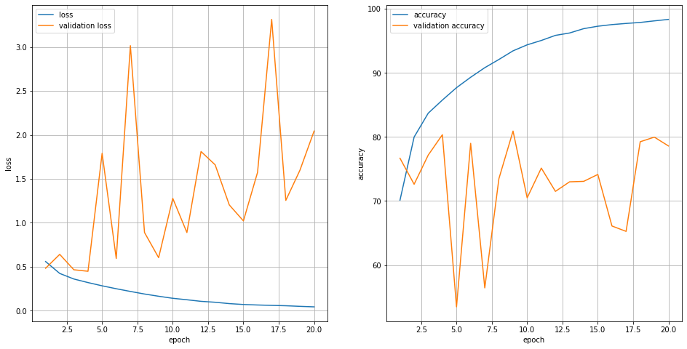

LSTM

================================================

================== train info ==================

================================================

Top frequency words range : 10000

Embedding Vectors dimension : 100

Epoch Size : 20

Batch Size : 500

Learning Rate : 0.001

train x shape : (145791, 80)

train y shape : (145791,)

test x shape : (48995, 80)

test y shape : (48995,)

================================================

================= train start ==================

================================================

[Epoch 001/020] - time taken: 8.884 | Loss: 0.486 | Acc: 75.620 | validation Loss: 0.409 | validation Acc : 80.874

[Epoch 002/020] - time taken: 8.588 | Loss: 0.364 | Acc: 83.509 | validation Loss: 0.364 | validation Acc : 83.885

[Epoch 003/020] - time taken: 8.665 | Loss: 0.324 | Acc: 85.714 | validation Loss: 0.354 | validation Acc : 84.190

[Epoch 004/020] - time taken: 8.732 | Loss: 0.294 | Acc: 87.346 | validation Loss: 0.351 | validation Acc : 84.713

[Epoch 005/020] - time taken: 8.708 | Loss: 0.266 | Acc: 88.677 | validation Loss: 0.356 | validation Acc : 84.701

[Epoch 006/020] - time taken: 8.717 | Loss: 0.239 | Acc: 89.999 | validation Loss: 0.371 | validation Acc : 84.871

[Epoch 007/020] - time taken: 8.583 | Loss: 0.212 | Acc: 91.307 | validation Loss: 0.389 | validation Acc : 84.589

[Epoch 008/020] - time taken: 8.906 | Loss: 0.183 | Acc: 92.586 | validation Loss: 0.418 | validation Acc : 84.197

[Epoch 009/020] - time taken: 8.709 | Loss: 0.157 | Acc: 93.827 | validation Loss: 0.460 | validation Acc : 84.273

[Epoch 010/020] - time taken: 8.889 | Loss: 0.131 | Acc: 95.004 | validation Loss: 0.506 | validation Acc : 83.809

[Epoch 011/020] - time taken: 8.883 | Loss: 0.106 | Acc: 95.977 | validation Loss: 0.573 | validation Acc : 83.670

[Epoch 012/020] - time taken: 8.884 | Loss: 0.088 | Acc: 96.729 | validation Loss: 0.643 | validation Acc : 83.445

[Epoch 013/020] - time taken: 8.892 | Loss: 0.074 | Acc: 97.257 | validation Loss: 0.685 | validation Acc : 83.348

[Epoch 014/020] - time taken: 8.863 | Loss: 0.060 | Acc: 97.785 | validation Loss: 0.768 | validation Acc : 83.697

[Epoch 015/020] - time taken: 9.032 | Loss: 0.048 | Acc: 98.238 | validation Loss: 0.866 | validation Acc : 83.276

[Epoch 016/020] - time taken: 8.707 | Loss: 0.044 | Acc: 98.406 | validation Loss: 0.904 | validation Acc : 83.155

[Epoch 017/020] - time taken: 8.928 | Loss: 0.036 | Acc: 98.676 | validation Loss: 0.959 | validation Acc : 83.017

[Epoch 018/020] - time taken: 8.993 | Loss: 0.033 | Acc: 98.762 | validation Loss: 1.007 | validation Acc : 83.561

[Epoch 019/020] - time taken: 8.873 | Loss: 0.029 | Acc: 98.883 | validation Loss: 1.057 | validation Acc : 83.148

[Epoch 020/020] - time taken: 8.815 | Loss: 0.027 | Acc: 98.979 | validation Loss: 1.190 | validation Acc : 82.912

[ model test ] - time taken: 1.408 | Loss: 1.178 | Acc: 83.170

================================================

========= model training is all done ===========

================================================

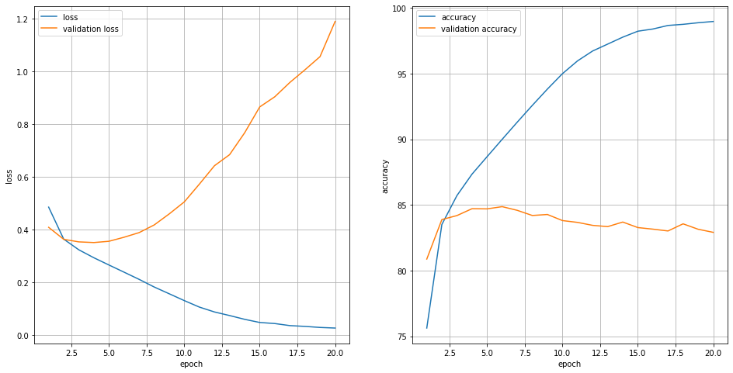

CNN with Resnet(skip layer)

================================================

================== train info ==================

================================================

Top frequency words range : 10000

Embedding Vectors dimension : 100

Epoch Size : 20

Batch Size : 500

Learning Rate : 0.001

train x shape : (145791, 80)

train y shape : (145791,)

test x shape : (48995, 80)

test y shape : (48995,)

================================================

================= train start ==================

================================================

[Epoch 001/020] - time taken: 23.471 | Loss: 1.022 | Acc: 61.075 | validation Loss: 0.597 | validation Acc : 68.685

[Epoch 002/020] - time taken: 22.821 | Loss: 0.479 | Acc: 76.752 | validation Loss: 0.647 | validation Acc : 69.034

[Epoch 003/020] - time taken: 22.976 | Loss: 0.394 | Acc: 81.973 | validation Loss: 0.431 | validation Acc : 80.713

[Epoch 004/020] - time taken: 23.242 | Loss: 0.350 | Acc: 84.559 | validation Loss: 0.407 | validation Acc : 82.264

[Epoch 005/020] - time taken: 23.276 | Loss: 0.319 | Acc: 86.156 | validation Loss: 0.535 | validation Acc : 77.968

[Epoch 006/020] - time taken: 23.270 | Loss: 0.300 | Acc: 87.120 | validation Loss: 0.438 | validation Acc : 81.517

[Epoch 007/020] - time taken: 23.119 | Loss: 0.267 | Acc: 88.814 | validation Loss: 0.432 | validation Acc : 81.999

[Epoch 008/020] - time taken: 23.256 | Loss: 0.245 | Acc: 89.884 | validation Loss: 0.455 | validation Acc : 82.002

[Epoch 009/020] - time taken: 23.244 | Loss: 0.227 | Acc: 90.678 | validation Loss: 0.594 | validation Acc : 78.760

[Epoch 010/020] - time taken: 23.276 | Loss: 0.209 | Acc: 91.636 | validation Loss: 0.493 | validation Acc : 81.589

[Epoch 011/020] - time taken: 23.149 | Loss: 0.190 | Acc: 92.491 | validation Loss: 0.536 | validation Acc : 81.418

[Epoch 012/020] - time taken: 22.938 | Loss: 0.175 | Acc: 93.157 | validation Loss: 0.563 | validation Acc : 81.089

[Epoch 013/020] - time taken: 22.898 | Loss: 0.153 | Acc: 94.198 | validation Loss: 0.607 | validation Acc : 81.326

[Epoch 014/020] - time taken: 22.928 | Loss: 0.142 | Acc: 94.668 | validation Loss: 0.675 | validation Acc : 80.425

[Epoch 015/020] - time taken: 22.993 | Loss: 0.131 | Acc: 95.089 | validation Loss: 0.703 | validation Acc : 80.493

[Epoch 016/020] - time taken: 22.871 | Loss: 0.113 | Acc: 95.944 | validation Loss: 0.751 | validation Acc : 80.293

[Epoch 017/020] - time taken: 23.054 | Loss: 0.100 | Acc: 96.468 | validation Loss: 0.801 | validation Acc : 80.177

[Epoch 018/020] - time taken: 23.074 | Loss: 0.090 | Acc: 96.841 | validation Loss: 0.913 | validation Acc : 79.548

[Epoch 019/020] - time taken: 22.874 | Loss: 0.084 | Acc: 97.085 | validation Loss: 0.929 | validation Acc : 79.863

[Epoch 020/020] - time taken: 22.903 | Loss: 0.075 | Acc: 97.410 | validation Loss: 1.100 | validation Acc : 79.906

[ model test ] - time taken: 4.564 | Loss: 1.088 | Acc: 80.137

================================================

========= model training is all done ===========

================================================

