**Affiliation marketing courses**

Graphic design

Content marketing

Copywrting

Email marketing

Dm Automation

Whatapp marketing

Affiliate marketing

**What Is Content Marketing?**

**Useful content should be at the core of your marketing**

Traditional marketing is becoming less and less effective by the minute; as a forward-thinking marketer, you know there has to be a better way.

Enter content marketing.

*Content marketing is a strategic marketing approach focused on creating and distributing valuable, relevant, and consistent content to attract and retain a clearly defined audience — and, ultimately, to drive profitable customer action.*

## What Is Copywriting?

**Copywriting is the process of writing persuasive marketing and promotional materials** that motivate people to take some form of action, such as make a purchase, click on a link, donate to a cause, or schedule a consultation.

These materials can include written promotions that are published in print or online. They can also include materials that are spoken, such as scripts used for videos or commercials.

The text in these materials is known as “copy,” hence the name “copywriting.”

You may not realize it, but copywriting is everywhere.

In fact, if you just start by looking in your mailbox, you’ll find some obvious examples of copywriting. Promotions for local restaurants, catalogs, fundraising letters from charitable organizations, or sales letters for various products and services are all forms of copywriting.

## ****What is Email Marketing?****

Email marketing is the act of sending promotional messages to people in mass quantities. It typically is to generate sales or leads and it may contain advertising.

## ****How Does Email Marketing Work?****

Email marketing is one of the top-performing strategies, in no small part because it’s fairly intuitive and often automated.

In its basic form, an effective email marketing campaign requires three essential elements:

### ****1. An Email List****

For you to pull off successful email campaigns, you need an active email list. This is a database of email contacts who have expressed interest in receiving marketing communications from your brand.

There are many ways to build an email list. One of the easiest is to create a lead magnet (also called an offer) your target audience is interested in, like a coupon, in exchange for their email addresses.

### ****2. An Email Service Provider****

An [email service provider](https://neilpatel.com/blog/best-email-marketing-services/) (ESP), also known as an email marketing platform, is software that [helps manage your email](https://neilpatel.com/blog/email-inbox-management/) list. It also helps design and execute automated email marketing campaigns.

Using an ESP allows you to automate actions triggered by your target audience’s behaviors. These enable you to personalize each interaction with them, meaning engagement and conversion rates generally improve.

### ****3. Clearly Defined Goals****

You can use email marketing to achieve many business goals. For example, you can use email marketing to:

* [drive sales](https://neilpatel.com/blog/how-to-maximize-ecommerce-store-sales-using-email-marketing/)
* boost brand awareness
* generate and nurture leads
* keep customers engaged
* increase customer loyalty and lifetime value

To execute an effective email marketing campaign, your email list, ESP, and goals must align. Then, you can get to work.

The first step is to segment your email list according to subscriber demographics or actions.

Next, create an email or series of emails designed to get consumers to do something (your goal).

Finally, use your ESP to send emails and monitor the campaign automatically.

## ****Email Marketing Examples****

Let’s briefly look at a couple of email marketing examples for a bit of inspiration.

### ****Teaonic****

Teaonic is an e-commerce brand specializing in organic, healthy teas.

**Subject line**: Getting Low On Wellness?

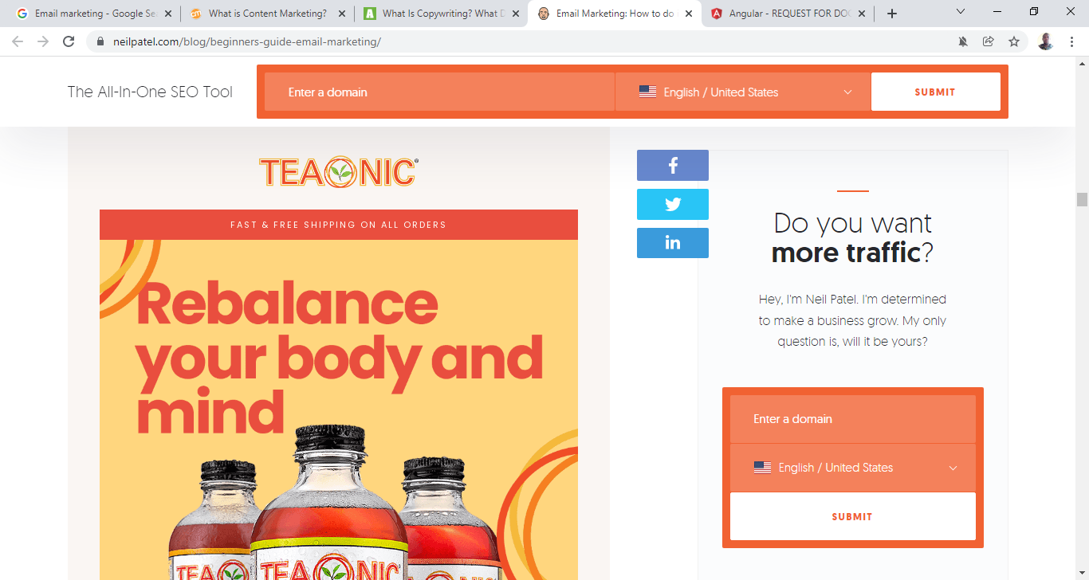

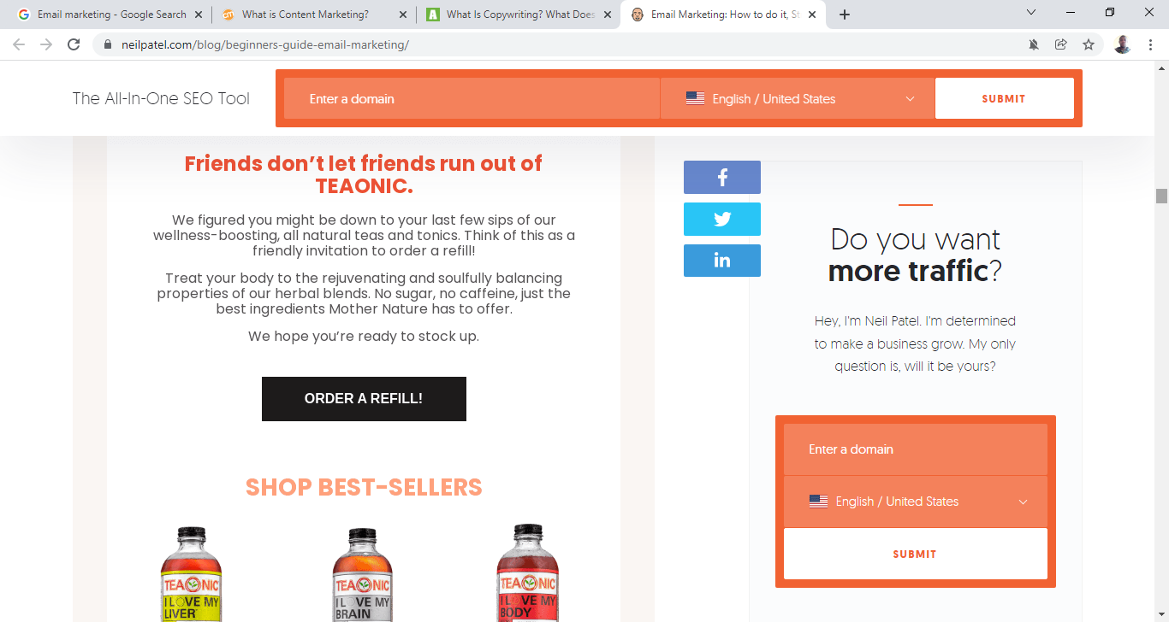

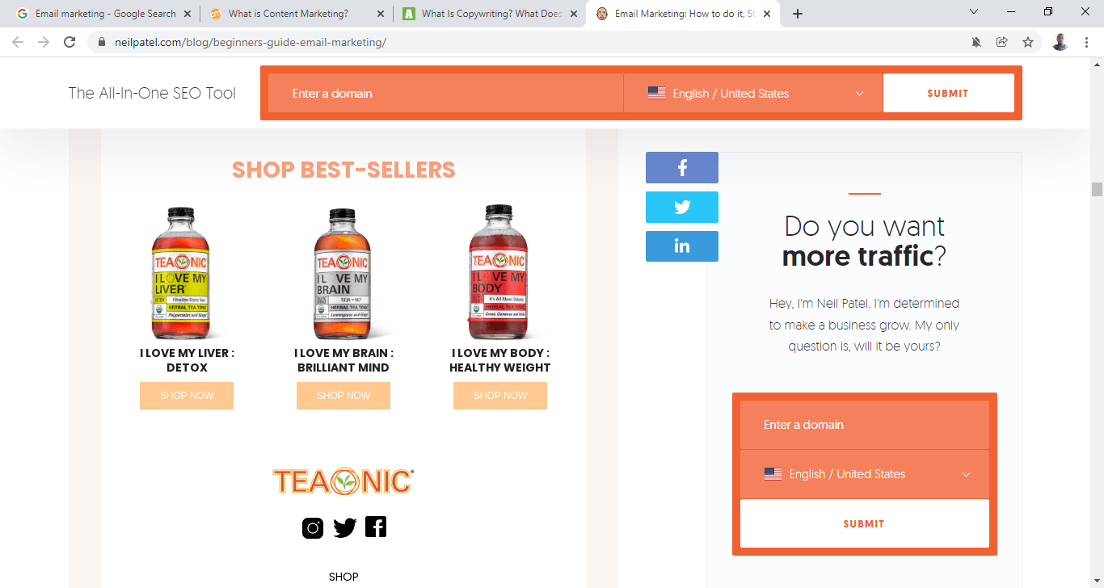

What does [this email](https://reallygoodemails.com/emails/getting-low-on-wellness) get right?

* Great subject line: The subject line focuses on the target audience’s main pain point, i.e., improving their health.
* Leverages color psychology: The bright, warm colors trigger feelings of health and happiness.
* Well-timed: The email is targeted at people who have purchased the product and is sent when the customer’s supply is about to run out

### ****Bluehost****

Well-known for its hosting services, Bluehost decided to try its hand at creating a website builder.

**Subject line**: Bluehost’s new Website Builder makes building simple.

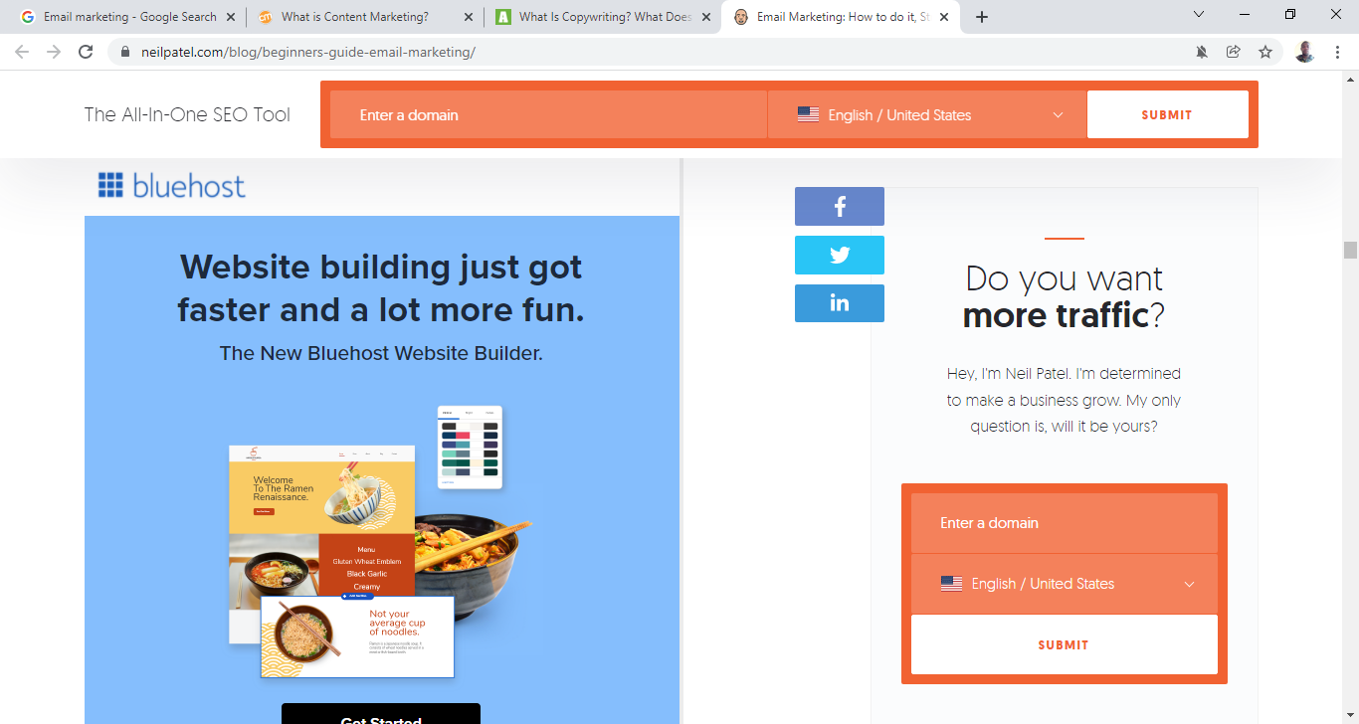

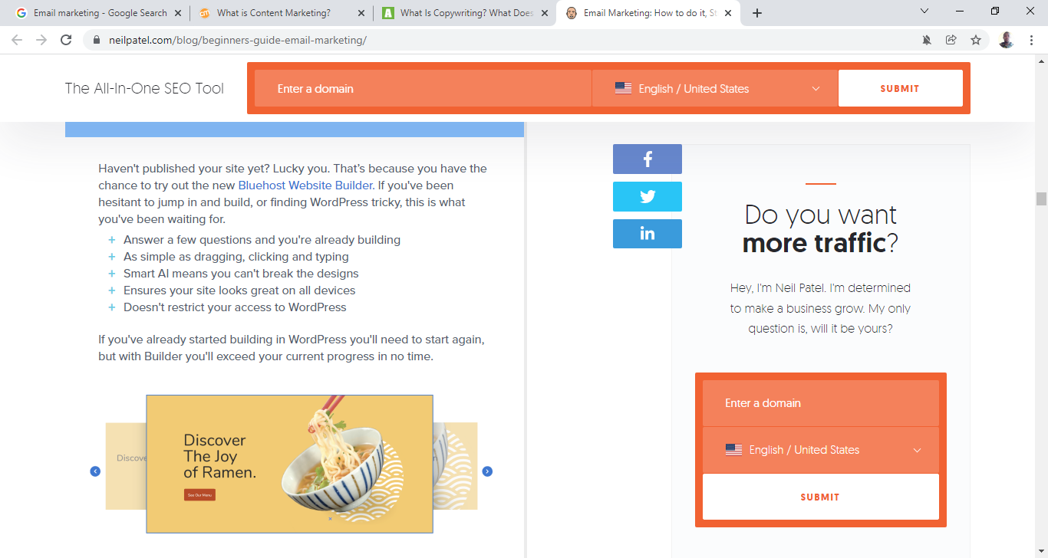

* Sells the benefits, not features: Focusing on the benefits makes the copy more compelling.
* Clean design: The simple design makes the email aesthetically pleasing and easy to read.
* Excellent targeting: Bluehost knows their audience is mainly made up of small business owners without technical expertise. The email uses language targeted at this demographic.

### ****Email Service Providers (ESP)****

One of the most critical email marketing tools you need is an ESP. Some top ESPs are:

* [**Constant Contact**](https://www.constantcontact.com/global/home-page?clickid=UfDTMxWhoxyLWOVwUx0Mo3EOUkBUr9zXMWFkRU0&AID=211042&PID=2402550&cc=CLK_DCLKAFF_IR_2402550_211042&pn=iraffiliate): This is best for e-commerce email marketing campaigns, thanks to features like automated product recommendations and shoppable emails. Plans start at $20/month.
* [**Sendinblue**](https://www.sendinblue.com/?tap_a=30591-fb13f0&tap_s=1521114-2f6319&tm_subid1=np0370): Sendinblue is best for small businesses running simple email campaigns. It has a rich feature set with a CRM, live chat, and SMS, among others. Plans start at $25/month.
* [**Pardot**](https://www.pardot.com/?lang_geo=us): B2B email campaigns require a platform specifically designed for the B2B buyer journey. Pardot fits the bill perfectly. However, to build high-growth email campaigns with Pardot, be prepared to part with at least $1,250/month.

### ****Deliverability Tools****

Email deliverability refers to the ability of an ESP to place emails in your receivers’ inboxes successfully. The wise email marketer will have an email deliverability tester in their toolbox. Here are some of the top ones:

* [**MailGenius**](https://www.mailgenius.com/): MailGenius inspects your emails for possible spam triggers. You can use it to run deliverability tests to ensure your emails reach their intended recipients’ inboxes. MailGenius is a free tool.
* [**GlockApps**](https://glockapps.com/): GlockApps shows your delivery results in real-time, including whether your email landed in the Inbox, Spam folder, Gmail’s Promotional or Social tabs, or if it was never delivered at all. Personal accounts are free, and prices go up from there.

**WhatsApp marketing**

***WhatsApp marketing is a type of***[***messenger marketing***](https://sendpulse.ng/support/glossary/messenger-marketing)***, which implies promoting a brand through WhatsApp. This channel helps brands reach an enormous audience, build strong relationships with customers, and increase sales.***

## What is Affiliate Marketing?

Affiliate marketing is the practice of promoting the products or services of another person or company in exchange for a commission on the resulting sale. Affiliate marketers join affiliate programs, find reputable affiliate products to promote, and then share those products with their audiences.

Basically, it’s a modern interpretation of a very old idea — getting a commission on a sale.

If you’ve been listening to us for long, you’ve learned that [bloggers make money](https://smartblogger.com/make-money-blogging/) by building an audience who trusts them, and then by offering products or services that will genuinely help that audience.

Affiliate marketing is really just a quick way to offer products and services without having to create your own products and services.

For bloggers, that means you find a product or service that you like, promote it to your readers, and earn part of the profit on each sale that you make.

### How Does Affiliate Marketing Work?

Affiliate marketing can get pretty technical, even for those well-versed in digital marketing. Fortunately, you don’t need to know all the details to get started.

**Free Bonus:** [Click here](https://app.monstercampaigns.com/c/vv0zfdcoadykssam5d0g/) to get our “cheat sheet” for affiliate marketers delivered straight to your inbox (for free).

The actual mechanics run in the background, thanks to the merchant’s affiliate software.

But here’s a quick look behind the scenes:

The actual mechanics run in the background, thanks to the merchant’s affiliate software.

But here’s a quick look behind the scenes:

1. When an affiliate joins the merchant’s program, he or she is given a unique ID and a specific URL to use when promoting the company’s product.
2. The affiliate includes the link in their blog post and/or via their email marketing efforts and invites readers to click it to find out more.
3. When a potential buyer clicks on the link to visit the affiliate partner’s site, a cookie identifying the affiliate is placed on the website visitor’s computer. The cookie ensures that the publisher is credited with the referral sale even if it occurs days or even weeks later.
4. Whenever a buyer completes the sale process, the merchant checks the sales record for a cookie identifying the source of the referral.
5. If the merchant finds a cookie with an affiliate ID, the affiliate is credited with the sale.
6. The merchant makes reports available so that the affiliate can see their referrals (clicks) and sales.
7. The merchant pays the affiliate commission at the end of each payment period (i.e. revenue sharing).

Here’s a graphical overview to help you visualize the process:

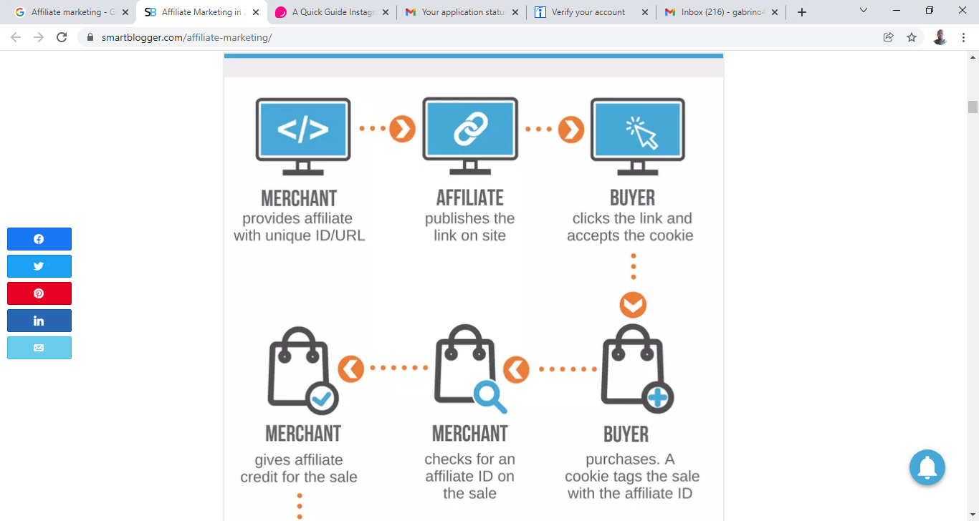

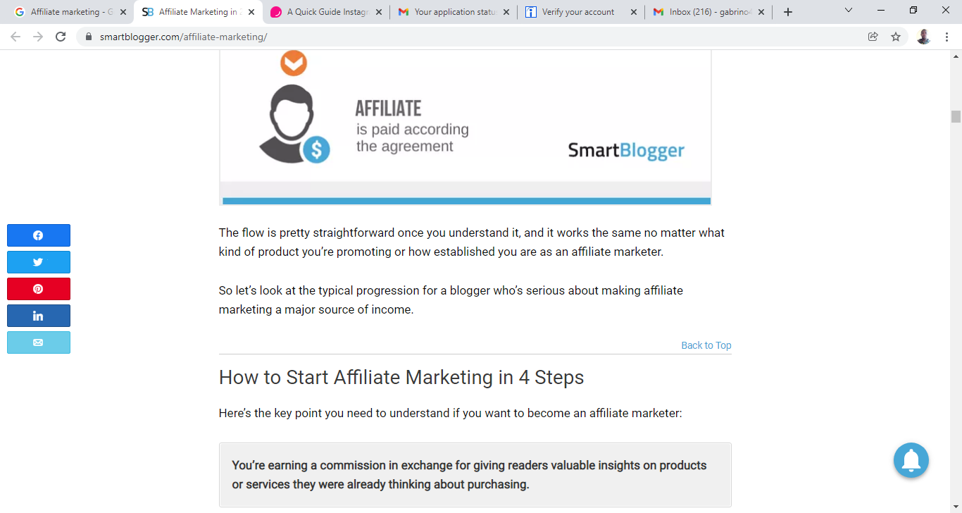

The flow is pretty straightforward once you understand it, and it works the same no matter what kind of product you’re promoting or how established you are as an affiliate marketer.

So let’s look at the typical progression for a blogger who’s serious about making affiliate marketing a major source of income.

## How to Start Affiliate Marketing in 4 Steps

Here’s the key point you need to understand if you want to become an affiliate marketer:

The question is, could you help them make a smarter decision than they could alone?

Because that’s where you add value. You earn a commission in exchange for being an influencer and helping people make smarter decisions, and you use your blog and the Internet to systemize that process, providing valuable advice to thousands of people.

Here’s a step-by-step process for doing exactly that:

### Step 1: Choose a Product to Promote as an Affiliate

As ethical content creators, we’re constrained in the products we choose to represent in one of two ways:

* Either we’re limited by our experience to products that we’ve used and liked, that have affiliate programs and that are a good fit for our audience, or
* We’re constrained by the products we can get access to in order to evaluate them, either by buying them outright or getting a free sample or trial.

No matter which approach you take, expect to have to invest time and money into researching the best products for your audience.

Here are your two main options (with your best option listed first).

#### OPTION #1: PROMOTE PRODUCTS YOU ALREADY KNOW AND LOVE

This is the most common way to get started with affiliate offers.

You become an affiliate for something that you’ve used yourself, had a good experience with, thoroughly tested and feel good recommending. You should be fairly confident that others will get the same results you did (or better), as long as they do the work.

If you’ve found great success from a course, mastermind, or ebook that your readers could also benefit from, it only makes sense for you to spread the word and share your results.

Do an inventory of the products, services, and courses you already have experience with. You might have a list of a dozen or more.

Which of these would you be thrilled to promote? Cross out any that don’t fit the bill.

Now simply check to see if the merchant has an affiliate program (some won’t but you’ll probably be surprised at how many do).

Using a search engine like Google, search for “affiliate program” + [product name], or simply email the merchant and ask.

Then run your remaining options through this Good Affiliate Product checklist:

* You’ve previewed the product so you know its quality (given, in this case).
* They have a solid refund policy that you trust they’ll honor.
* They provide good customer support (and you’ve tested it).
* You have a good story to share about your experience with the product.
* The offer fits your audience’s needs and won’t abuse the trust you’ve built with them.

The products that tick all the checkboxes are your best opportunities for affiliate revenue. As time goes on, add as many of these products to your mix as you like.

You’ve found your first product! Apply using the merchant’s process and start promoting.

If you’re just dipping your toe in the affiliate marketing industry, this first option may be enough to get you started.

However, most bloggers will want to try the next one, too.

(And you’ll have to explore the second option if you don’t have an existing product you love that is also a great match for your audience and offers an affiliate program.)

#### Option #2: Find Products Via an Affiliate Network

If you don’t have any direct experience with or knowledge of products in your niche that could help your readers, you can often find good affiliate products on [affiliate networks](https://smartblogger.com/affiliate-networks/) (← our detailed guide).

But be careful — this approach requires that you invest time into research and money into purchasing products to try out, more so than the first option.

That’s because there’s less trust and prior knowledge involved from the outset. You have to do your due diligence to protect your reputation and the credibility you’ve built with your readers.

When you work through a network, you typically won’t know the merchant ahead of time and usually won’t build a relationship with them (your business relationship is with the network).

The list of popular and reliable affiliate networks includes [ClickBank](https://smartblogger.com/clickbank/), [CJ Affiliate](https://smartblogger.com/cj-affiliate-commission-junction/), the [eBay Partner Network](https://smartblogger.com/ebay-partner-network/), [ShareASale](https://smartblogger.com/shareasale-review/), CJ Affiliate (aka Commission Junction), and the [Amazon Associates program](https://smartblogger.com/amazon-associates-program/). Some networks will even assign you an affiliate manager to lend a hand and show you the ropes.

Amazon products, in particular, are an easy way to get started. Many newbies begin by becoming an Amazon affiliate and then scaling to other types of more profitable affiliate offers

**You’re earning a commission in exchange for giving readers valuable insights on products or services they were already thinking about purchasing.**