**CSEAN**

**What worked (WEB)**

**Sign up successfully**:

Email verification was successfully done – Passed

**Multichannel Registration Workflow Handshake: Mobile and Web Channel**

**Membership** **Onboarding**

The onboarding process was successfully done- **Passed**

**User dashboard :**

*All requirements were met successfully –*Passed

**Payment Integration :**

All the requirement were met successfully-Passed

**Communication center (member):**

**WHAT DID NOT WORK (WEB)**

**1. SEED**

* Record Spend (Expenditure) - unless you have more than one sub-category. the available balance & available after spent, Payee name won't be shown and user will be unable to submit, see image - Failed

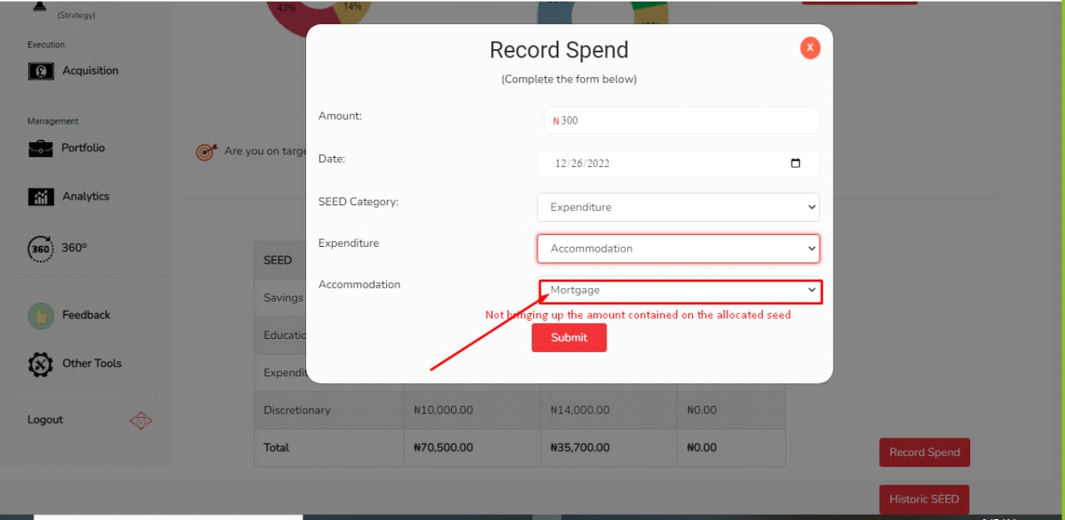

2. Historical Seed - The date on the average seed is a fixed date, the user is unable to pick a preferred date. This issue was only recorded on a new account. please see image - Failed

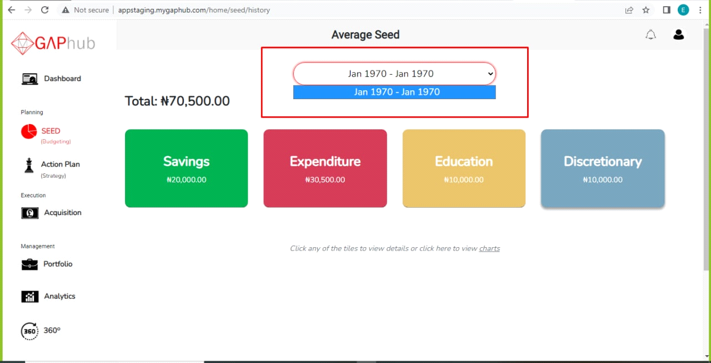

2. Some images on REAP are broken, see image - Failed

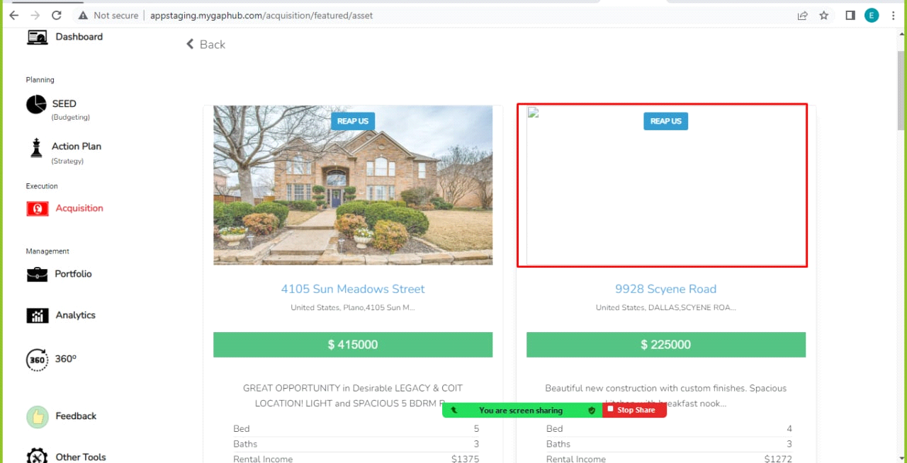

3. Some images on GANP are broken, see images - Failed

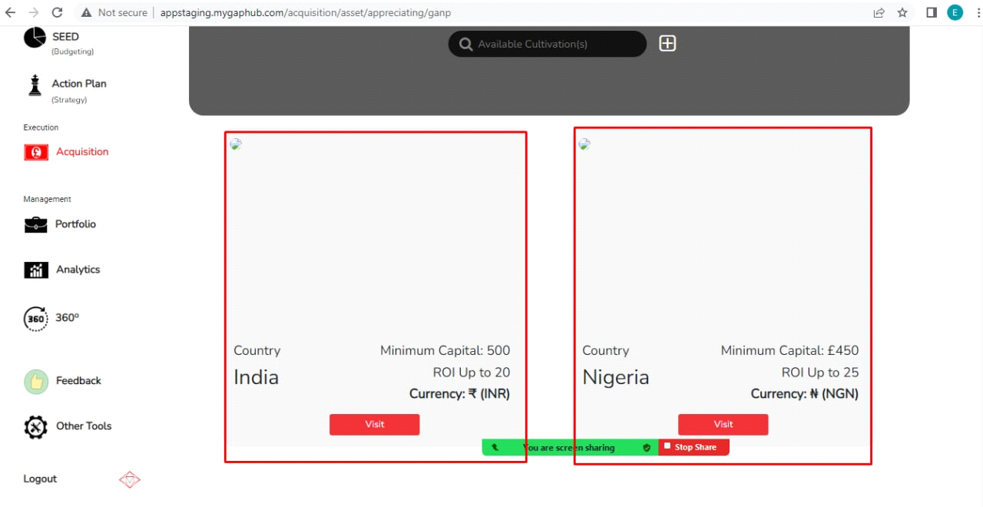

**What worked (MOBILE)** **Existing CSEAN Website Integration**

**1. Sign up successfully**. - Passed

2. Email confirmation was successfully done - Passed

3. Financial calculator workflow after Sign up - Passed

4. Onboarding workflow was done successfully - Passed

5. I was able to validate my 7G assumptions - Passed

6. I was able to create my Bespoke KPI - Passed

7. **360 WHEEL**

* *Net Worth - All requirements were met successfully -* Passed
* *Cash - All requirements were met successfully -*Passed
* *Mortgage - All requirements were met successfully -* Passed
* *Action Plan - All requirements were met successfully -*Passed
* Philanthropy - *All requirements were met successfully -*Passed
* Retirement - *All requirements were met successfully -*Passed
* Asset - *All requirements were met successfully -*Passed
* iLab - *All requirements were met successfully -*Passed

8. **SEED :** - *All requirements were met successfully -*Passed

9. Passcode - user is able to verify with a passcode after leaving the application - Passed

10. Forgot password -

**WHAT DID NOT WORK (MOBILE)**

1.Frequent timeout of the pin code when using the application(that is the request to enter pin is comes up while you are operating the app.

2. After verifying the user's email, the user was directed to the web view for the Financial calculator workflow, which is not meant to be. User is supposed to be redirected to the mobile for their financial calculator workflow. see image - Failed

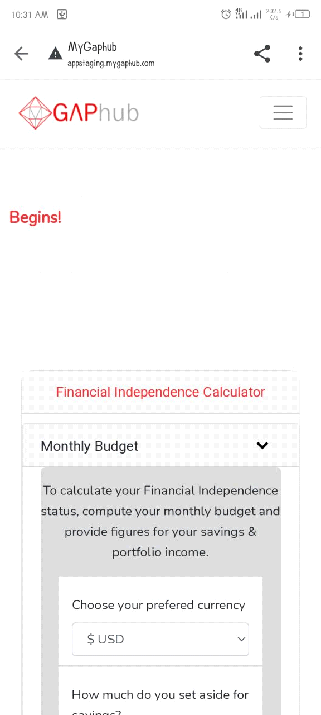

3. **360 WHEEL**

* Income (add asset in portfolio) - unable to add asset in the portfolio from Income, a blank page is displayed. see images - Failed

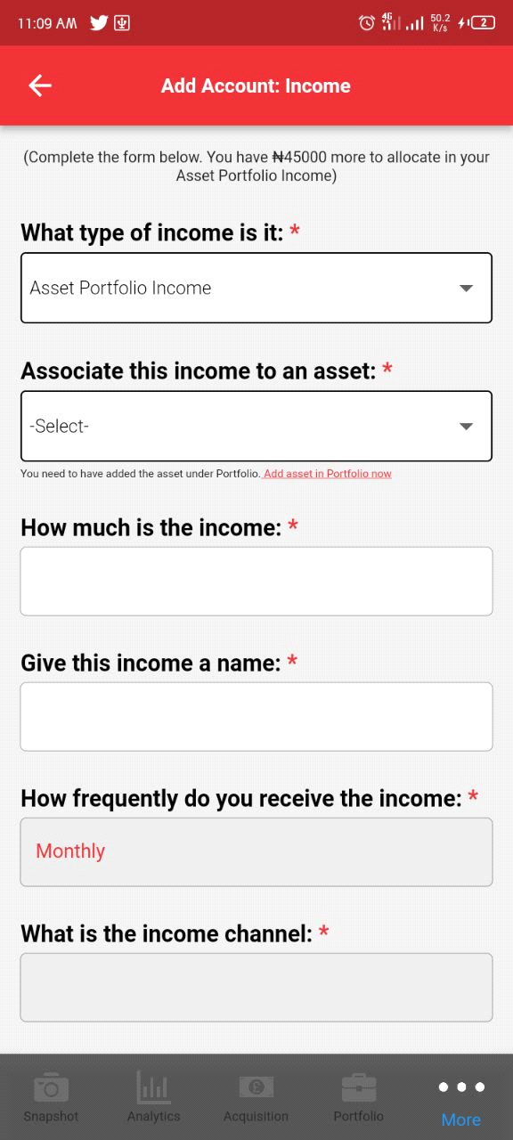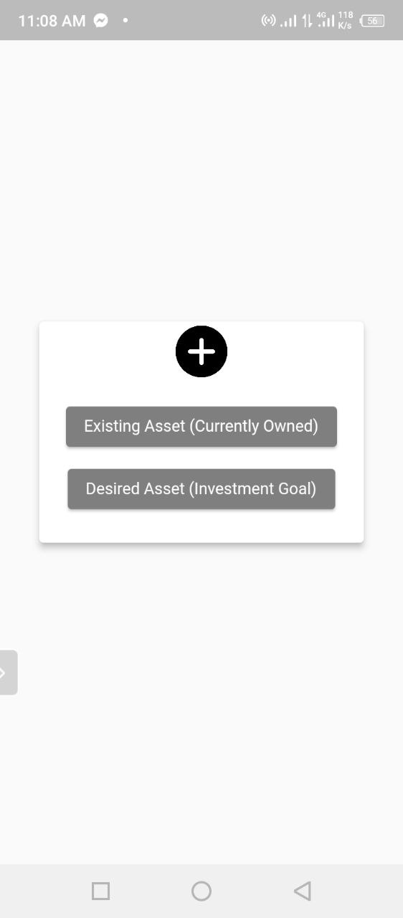

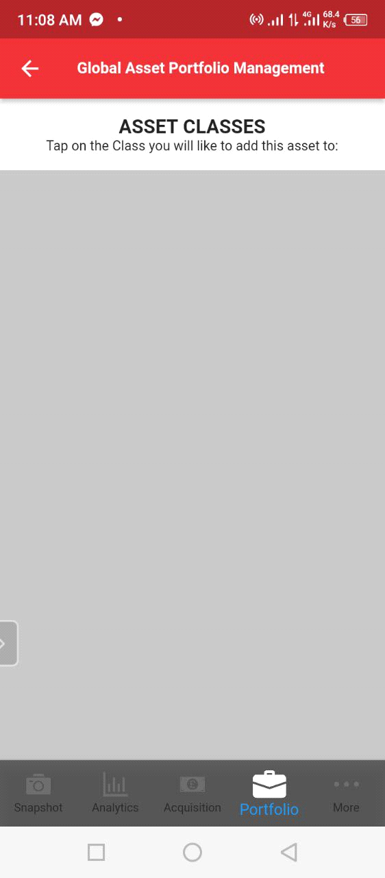

* *Liability: A service timeout is displayed. see images -* Failed

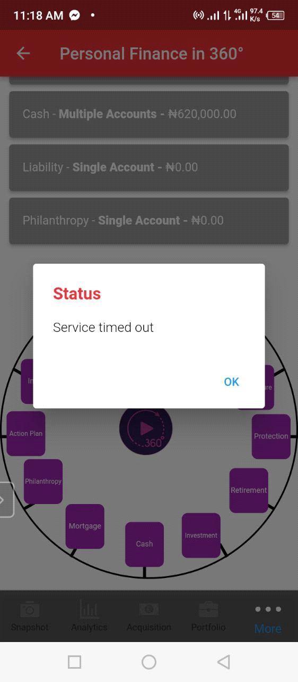

4. Investment - A blank page is displayed. see image - Failed



5. Protection - Unable to save a form under protection add account. A service timeout and error note. see image - Failed

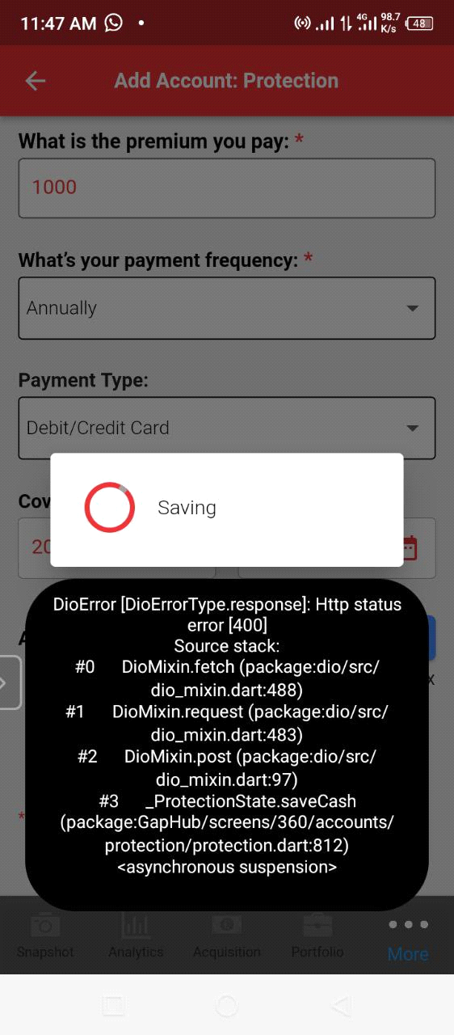

6. Historic Seed - A blank page is displayed - Failed



7. Portfolio - Unable to update portfolio - Failed

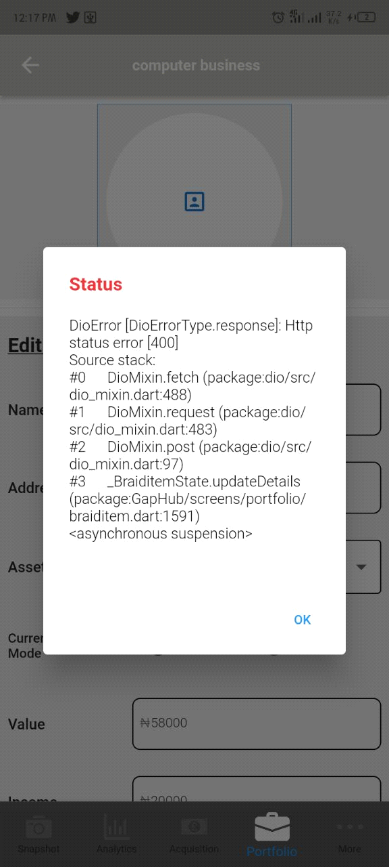

8. GANP - an error occurred message displayed - Failed

9. REAP - unable to go to the next page - Failed

10. Forgot Password - unable to verify email address for different accounts. see images - Failed

