**Test Scenerio 1: Registration**

**FeedBack1: Data registers and directs to both public and private mails but save at the spam.**

Test Verdict: Not fully ready: The requirement is fully met—not fully done

**Test Scenerio 2: Calculator Work-Flow**

**FeedBack1: Calculator workflow is work perfectly, tested in all forms to validate the authenticity**

Test Verdict: fully ready: The requirement is fully met—fully done

**Test Scenerio 3: Create a budget-000**

**FeedBack1: Budget button navigates to the current month page**

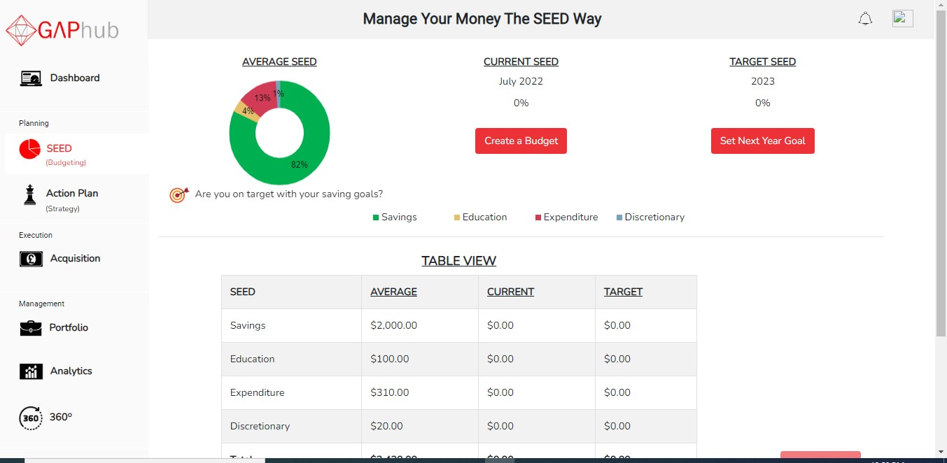

Test Verdict: fully ready: The requirement was fully met— fully done

**Test Scenerio 4: Set Budget Amount-001**

**FeedBack1: Initial Budget was set on $0.00 amount**

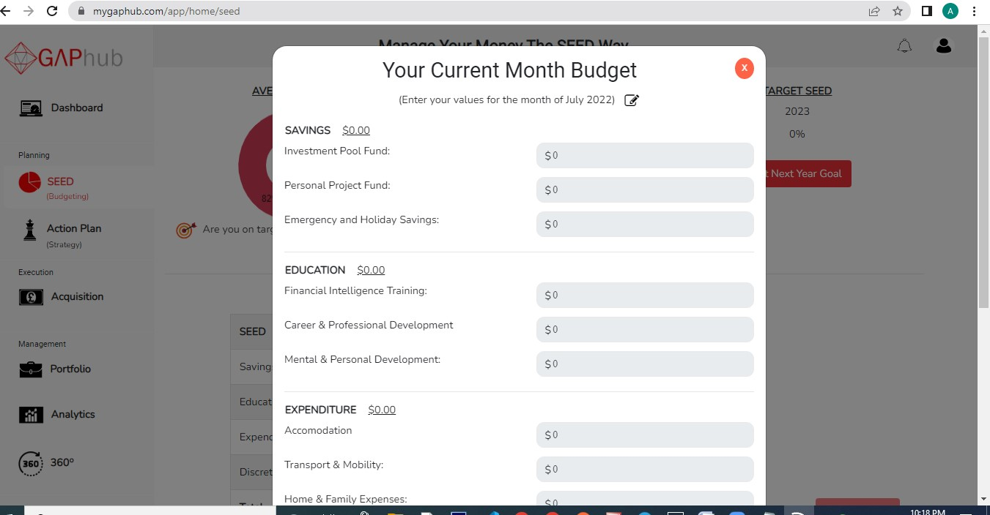

Test Verdict: fully ready: The requirement was fully met— fully done

**Test Scenerio 5: Tool Tips-003**

**FeedBack1: A form to complete the allocation process**



Test Verdict: fully ready: The requirement was fully met— fully done

**Test Scenerio 6: SEED Allocation Tiles-005**

**FeedBack1: A drop down form from the saving allocation to allocate fund but no ‘other’ option provided to allocate fund**



Test Verdict: fully ready: The requirement was not fully met— fully done

**Test Scenerio 7: SEED Categories dropdown selection-006**

**FeedBack1: Only the Discretionary Tiles has ‘other’ category option in the dropdown options while the rest tiles have no ‘other’ option.**

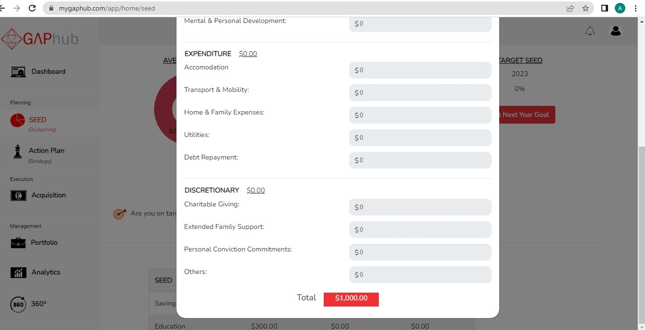

Test Verdict: not fully ready: The requirement was not met— not fully done

**Test Scenerio 8: Summary Page Display**

**FeedBack1: I could update the available categories, but could not delete any of the already added categories from the drop down list.**



Test Verdict: fully ready: The requirement was not met— not fully done

**Test Scenerio 9: My Budget-013**

**FeedBack1: the current is leading to the amount Budgeted, amount available for allocation but no option for total amount spent and remaining balance.**

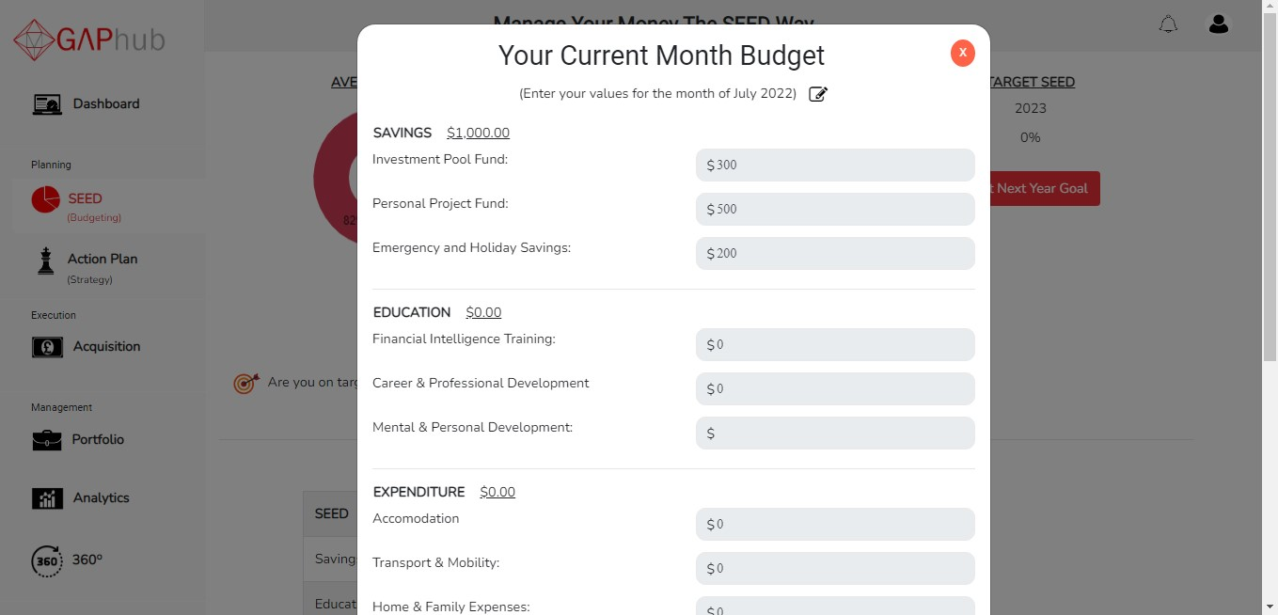

Test Verdict: fully ready: The requirement was not met—not fully done

**Test Scenerio 10: SEED Tile Allocation Amount**

**FeedBack1: the seed tile allocation for each seed is shown and the total balance allocated to each category.**



Test Verdict: fully ready: The requirement was met— fully done

**Test Scenerio 11: Acquisition (REAP and GANP)**

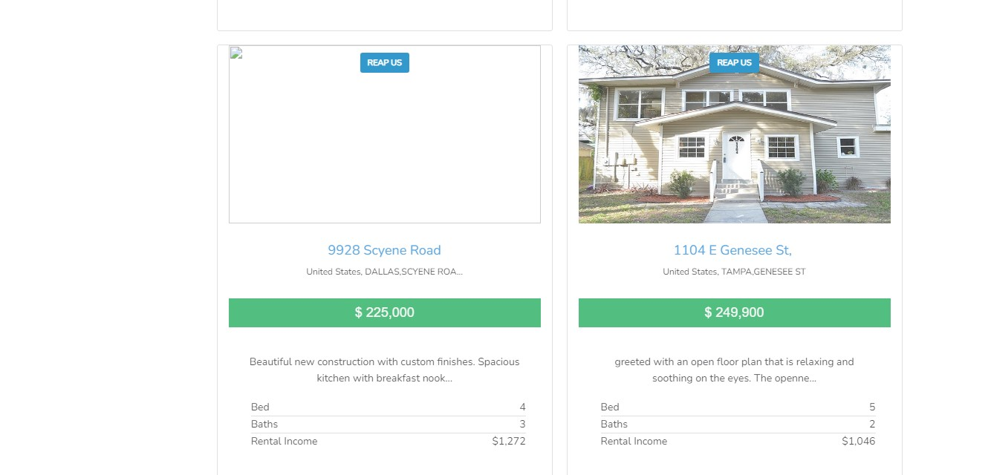**FeedBack1: When click on REAP it showed that some images were not showing**

[**http://appstaging.mygaphub.com/acquisition/asset/reap/16**](http://appstaging.mygaphub.com/acquisition/asset/reap/16)

Test Verdict: not fully ready: The requirement was not met— not fully done

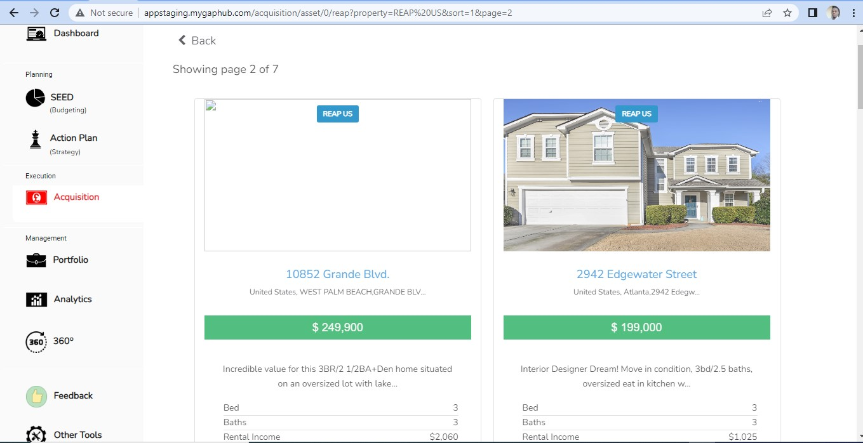

http://appstaging.mygaphub.com/acquisition/asset/reap/22

Test Verdict: not fully ready: The requirement was not met— not fully done

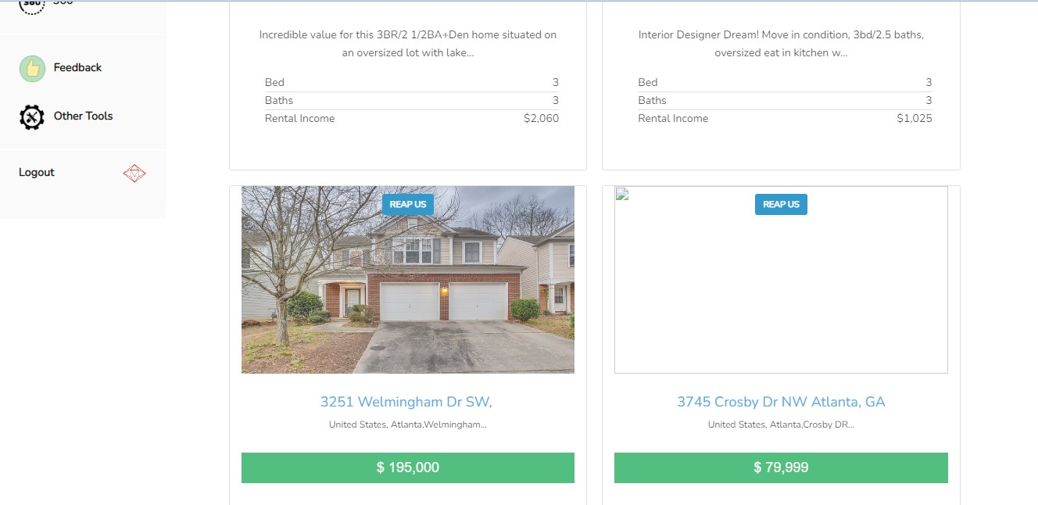

http://appstaging.mygaphub.com/acquisition/asset/reap/25

Test Verdict: not fully ready: The requirement was not met— not fully done

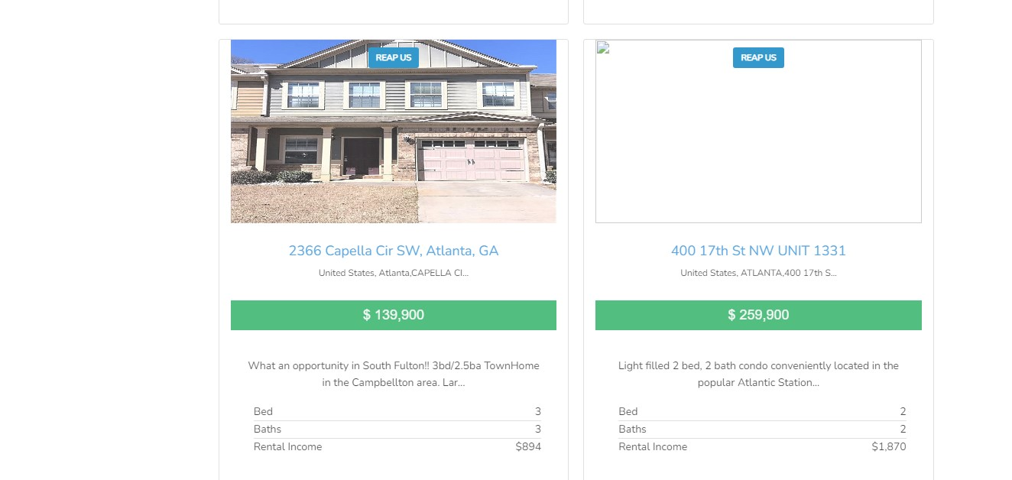

http://appstaging.mygaphub.com/acquisition/asset/reap/25

Test Verdict: not fully ready: The requirement was not met— not fully done

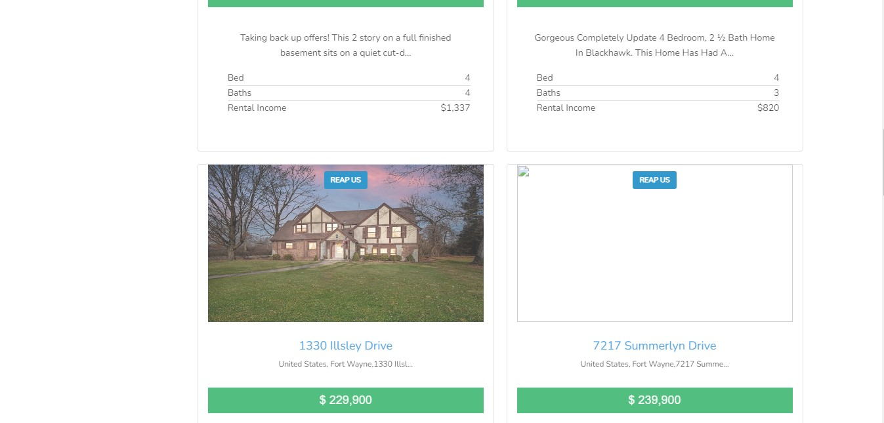

[**http://appstaging.mygaphub.com/acquisition/asset/reap/51**](http://appstaging.mygaphub.com/acquisition/asset/reap/51)

Test Verdict: not fully ready: The requirement was not met— not fully done

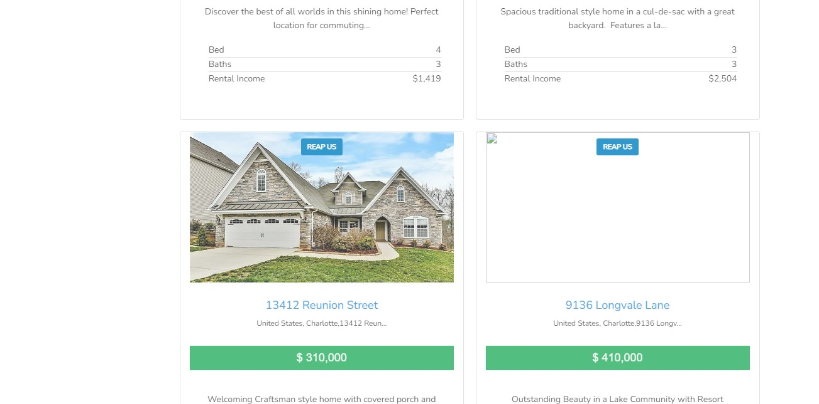

[**http://appstaging.mygaphub.com/acquisition/asset/reap/57**](http://appstaging.mygaphub.com/acquisition/asset/reap/57)

Test Verdict: not fully ready: The requirement was not met— not fully done

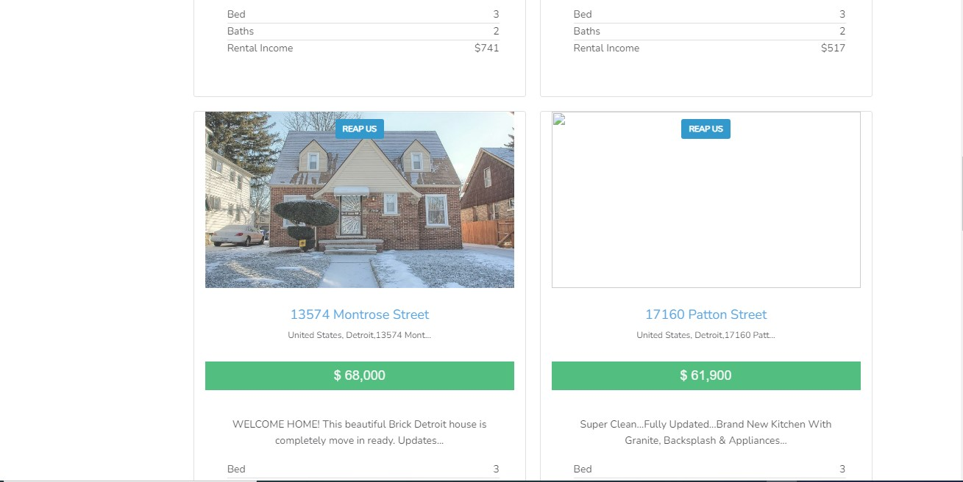

[**http://appstaging.mygaphub.com/acquisition/asset/reap/63**](http://appstaging.mygaphub.com/acquisition/asset/reap/63)

Test Verdict: not fully ready: The requirement was not met— not fully done

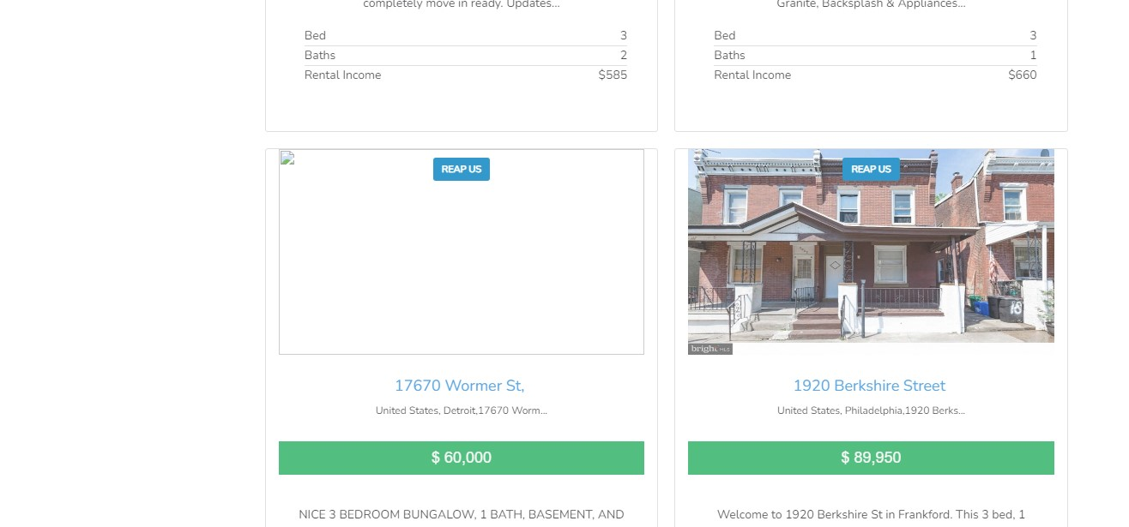

[**http://appstaging.mygaphub.com/acquisition/asset/reap/64**](http://appstaging.mygaphub.com/acquisition/asset/reap/64)

Test Verdict: not fully ready: The requirement was not met— not fully done

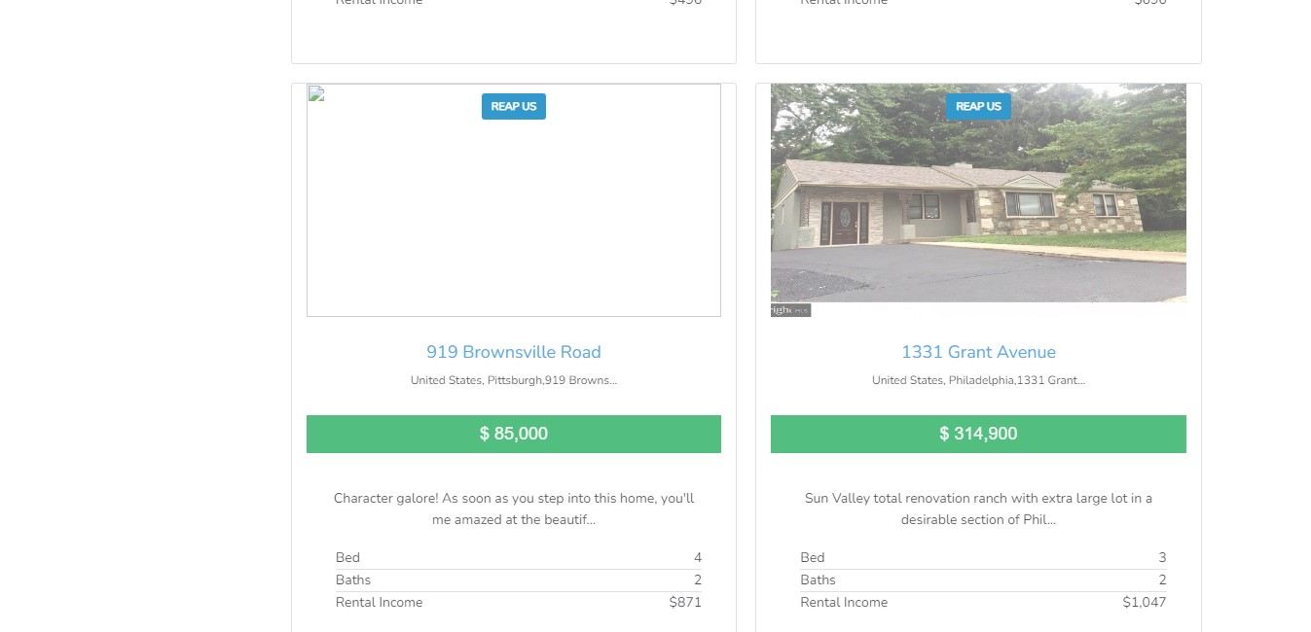

[**http://appstaging.mygaphub.com/acquisition/asset/reap/72**](http://appstaging.mygaphub.com/acquisition/asset/reap/72)

Test Verdict: not fully ready: The requirement was not met— not fully done

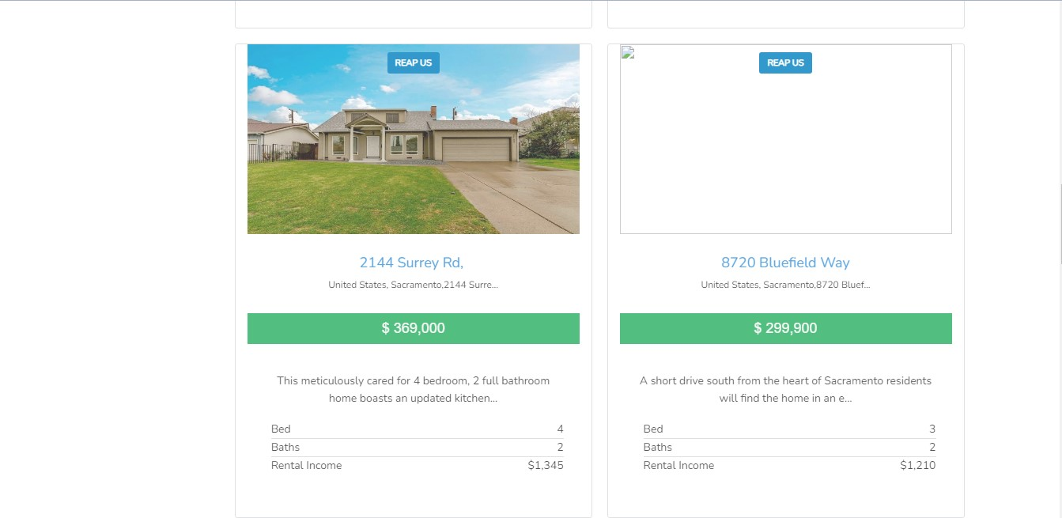

**http://appstaging.mygaphub.com/acquisition/asset/reap/81**

Test Verdict: not fully ready: The requirement was not met— not fully done

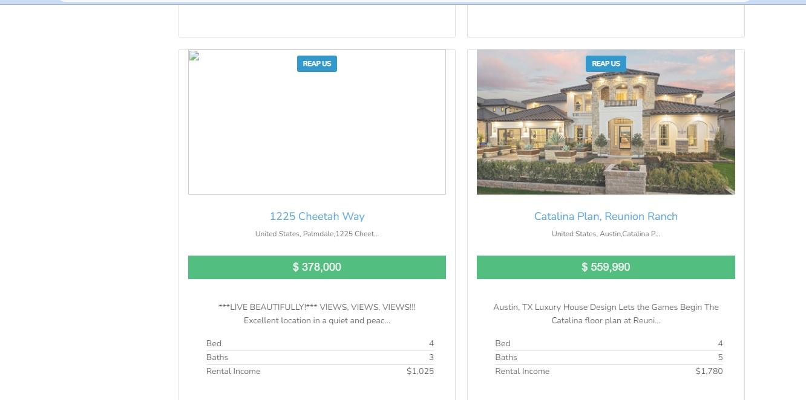

[**http://appstaging.mygaphub.com/acquisition/asset/reap/82**](http://appstaging.mygaphub.com/acquisition/asset/reap/82)

Test Verdict: not fully ready: The requirement was not met— not fully done

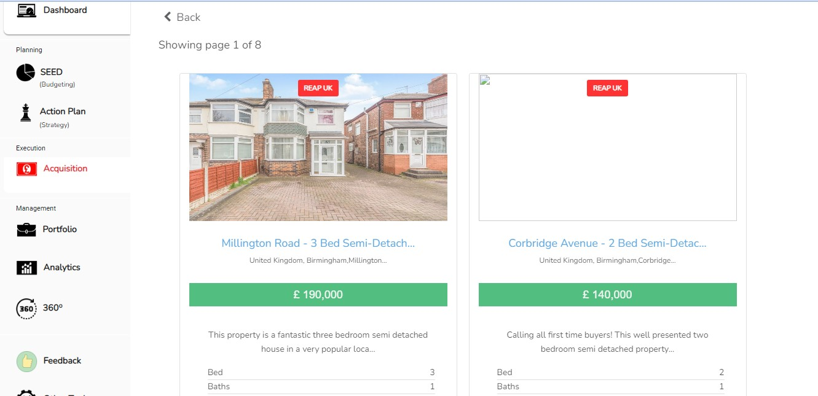

[**http://appstaging.mygaphub.com/acquisition/asset/reap/91**](http://appstaging.mygaphub.com/acquisition/asset/reap/91)

Test Verdict: not fully ready: The requirement was not met— not fully done

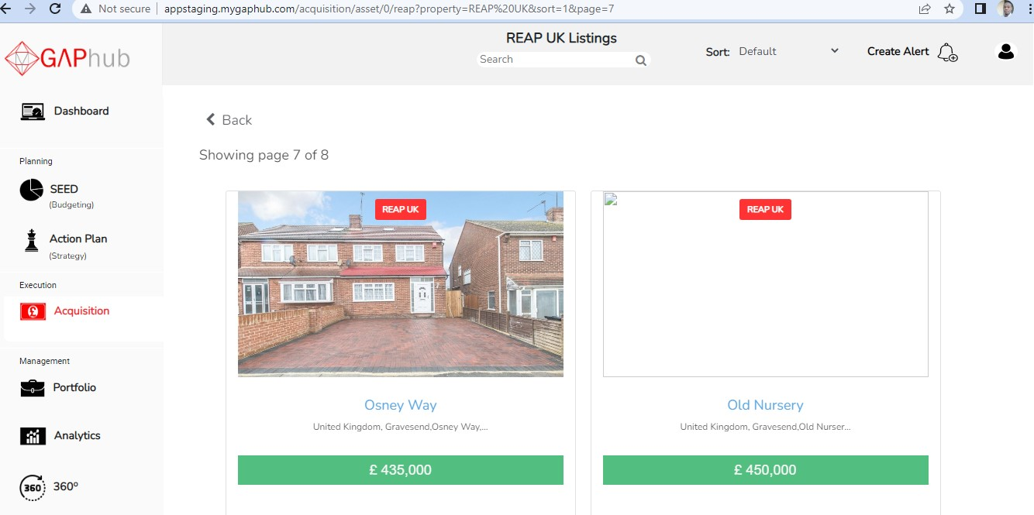

[**http://appstaging.mygaphub.com/acquisition/asset/reap/197**](http://appstaging.mygaphub.com/acquisition/asset/reap/197)

Test Verdict: not fully ready: The requirement was not met— not fully done

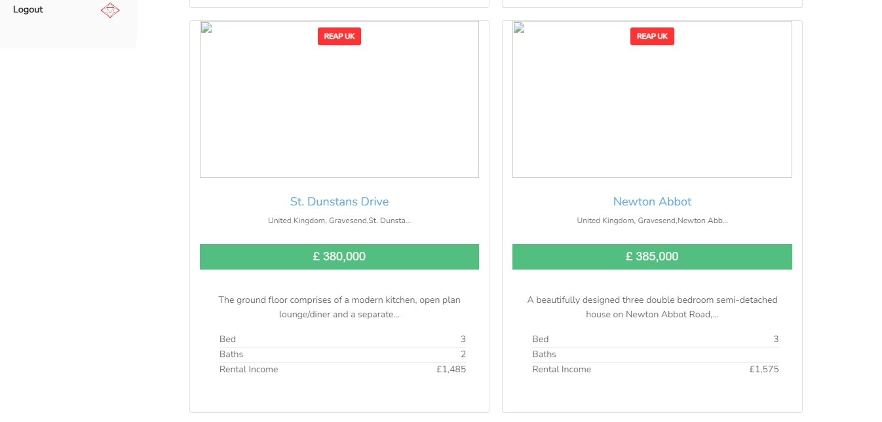

[**http://appstaging.mygaphub.com/acquisition/asset/reap/198**](http://appstaging.mygaphub.com/acquisition/asset/reap/198)

**http://appstaging.mygaphub.com/acquisition/asset/reap/199**

Test Verdict: not fully ready: The requirement was not met— not fully done

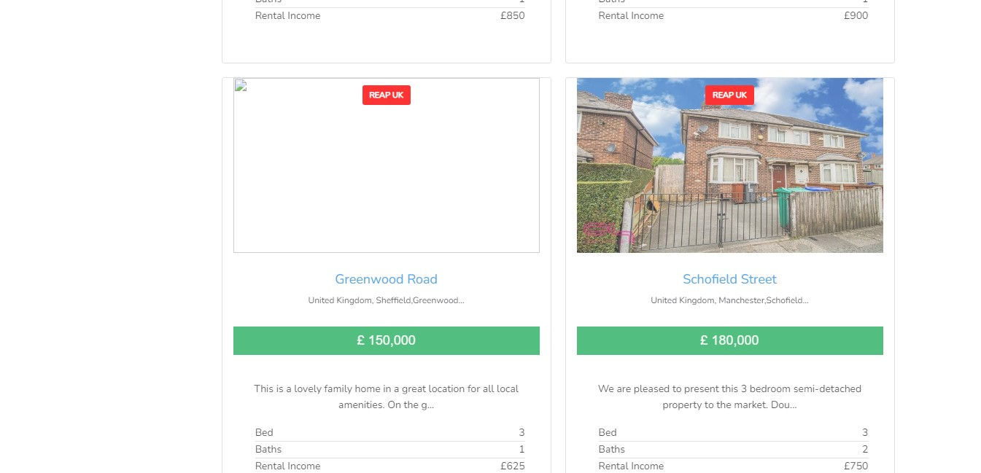

[**http://appstaging.mygaphub.com/acquisition/asset/reap/210**](http://appstaging.mygaphub.com/acquisition/asset/reap/210)

Test Verdict: not fully ready: The requirement was not met— not fully done 09079587368

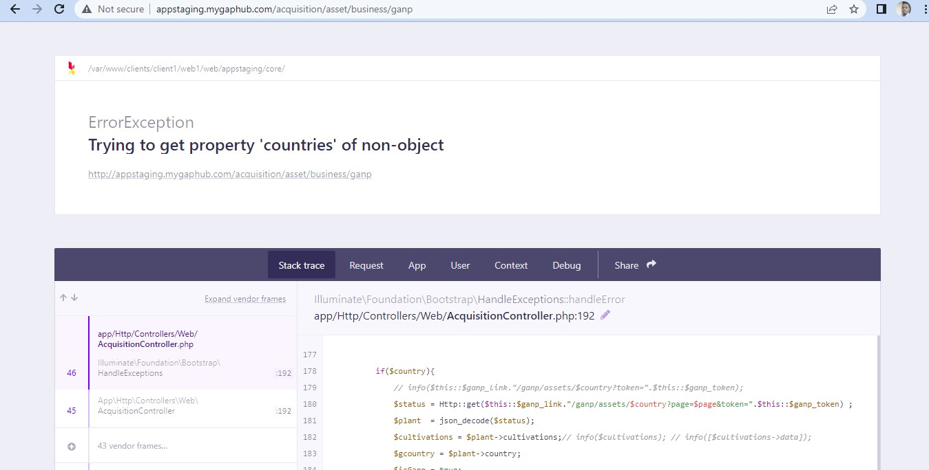

**FeedBack1: When click on GANP it showed an error message shown below**

Test Verdict: not fully ready: The requirement was not met— not fully done