**MYGAPHUB (WEB)**

**WHAT WORKED**

1. **Calculator Workflow**

*Feedback:* unable to test this process– NOT TESTED

1. **7G Analytics Behavior Web**

*Feedback:* The 7G analytic and bespoke all met the requirement – PASSED

1. **Assets**

*Feedback:* This process worked fine. – PASSED

1. **Income**

*Feedback:* This process worked fine. – PASSED

*Comment: Income added is not displaying after closing modal, exit from the income page.*

1. **Mortgage**

*Feedback:* This process worked fine. – PASSED

1. **Cash**

*Feedback:* This process worked fine. – PASSED

1. **Investment:**

*Feedback:* This process worked fine. – PASSED

1. **Liability**

*Feedback:* This process worked fine. – PASSED

1. **NetWorth:**

*Feedback:* This process worked fine. – PASSED

1. **iLab**

*Feedback:* This process worked fine. – PASSED

1. **SEED**

*Feedback:* All the requirements were met – PASSED

**WHAT DID NOT WORKED**

1. **User Registration on Web**

*Feedback:* This process did not work perfectly – FAILED

*Comment: User was able to sign up, because of recaptcha was missing*

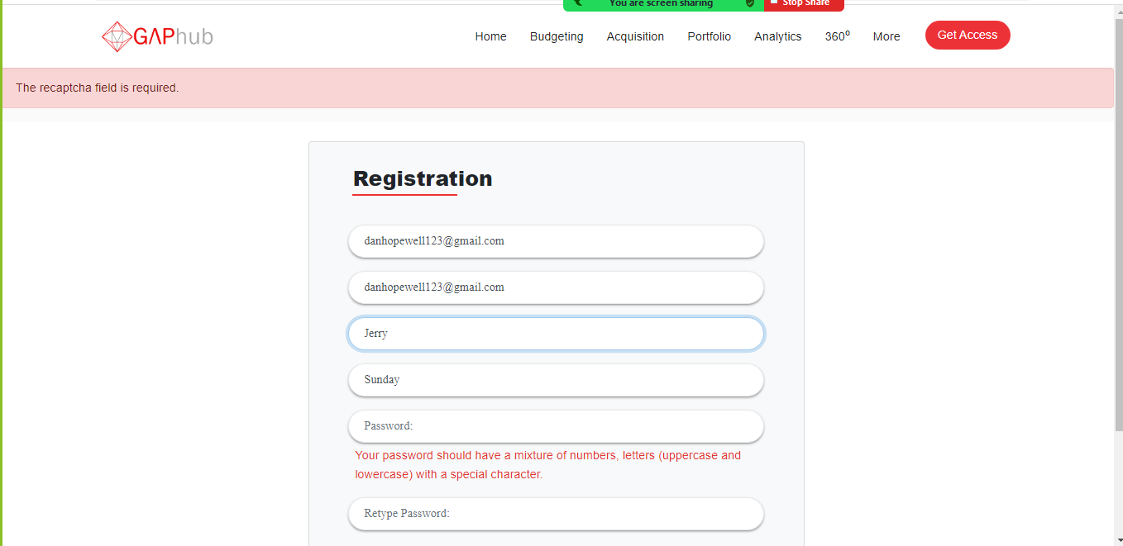

1. **Action plan**

*Feedback:* There is a broken image – FAILED

*Comment:* *broken image*

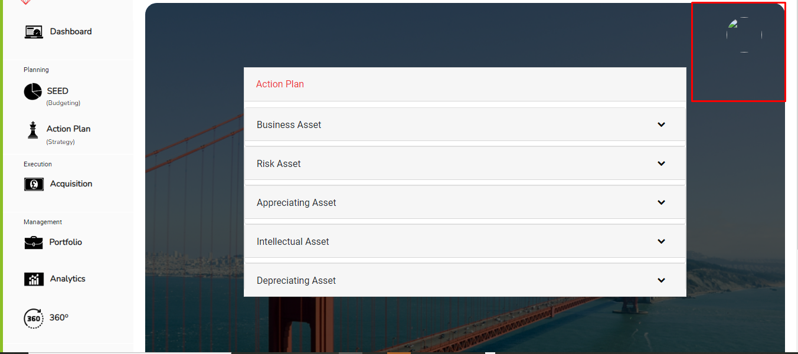

1. **Philanthropy**

*Feedback: This process did not work properly*– FAILED

*Comment:* The data saved are not reflecting on the chart and also on philanthropy profile.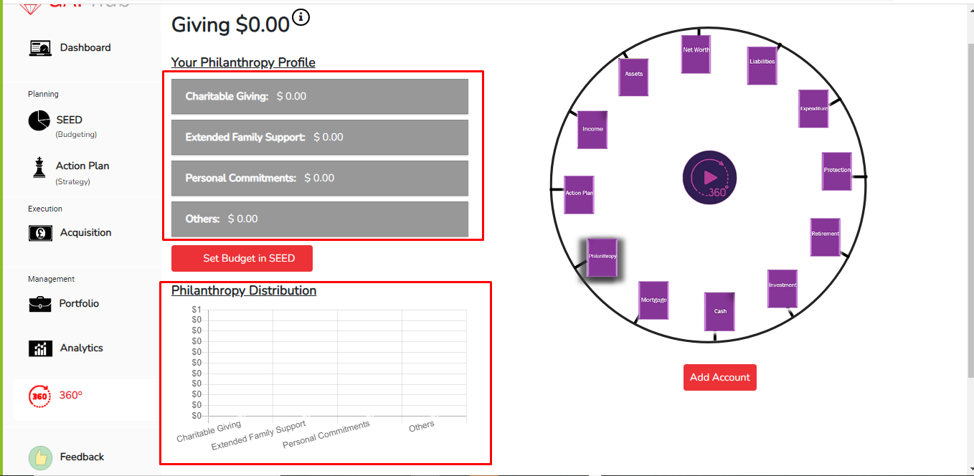

1. **Portfolio**

*Feedback: This process did not work properly*– FAILED

*Comment:* Unable to upload image and unable to download the uploaded document 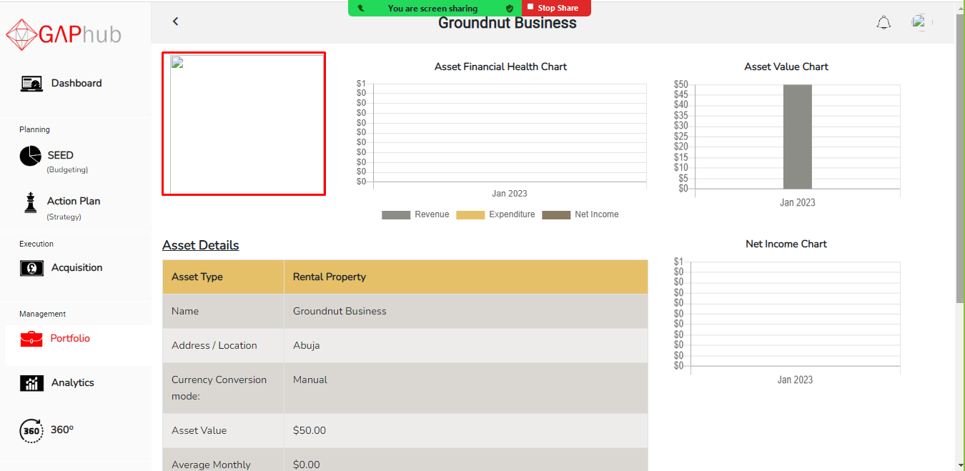

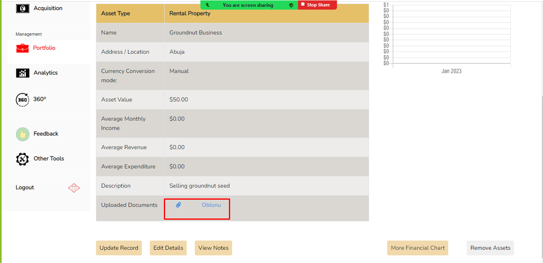

1. **Retirement**

*Feedback: This process did not work properly*– FAILED

*Comment:* When submit button is clicked an error page is displayed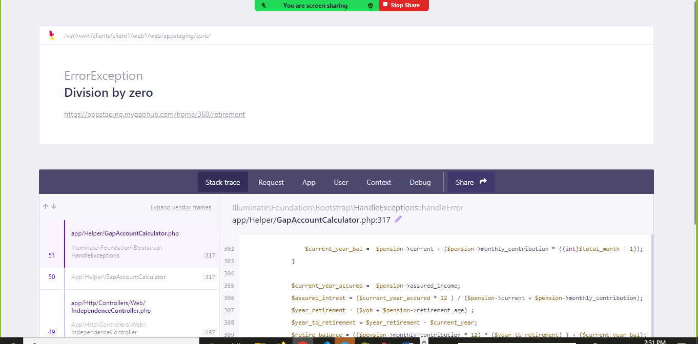

1. **Protection**

*Feedback: This process did not work properly*– FAILED

*Comment:* Unable to view document after creation of account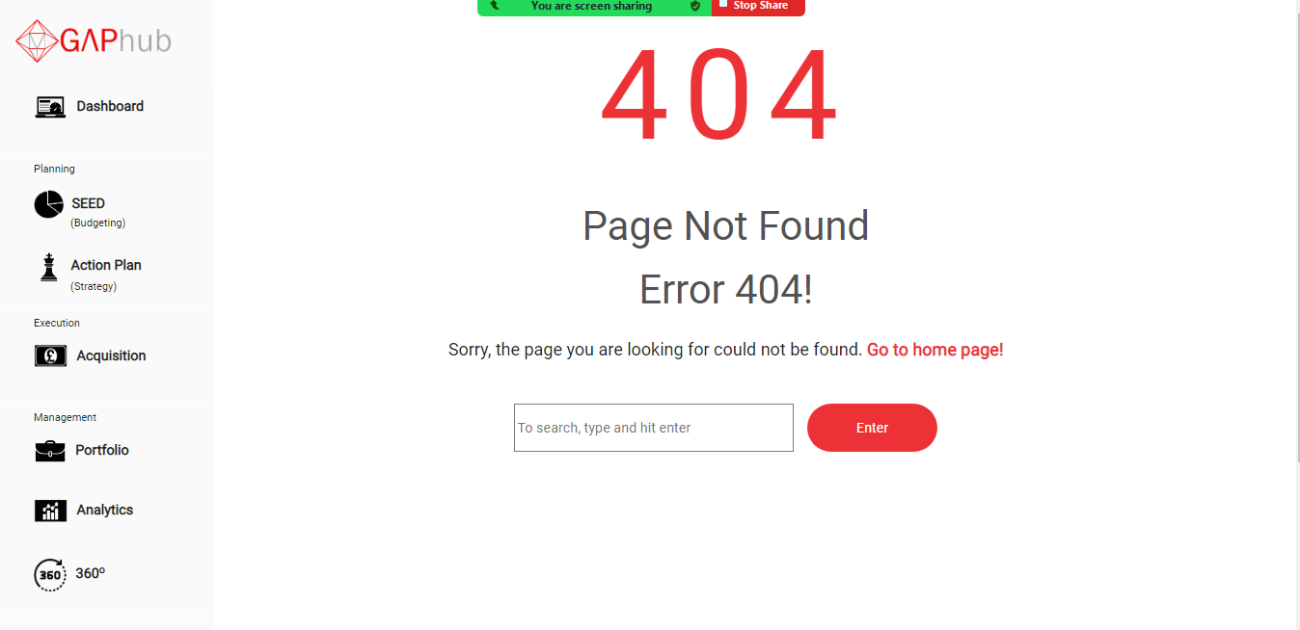

1. **Expenditure**

*Feedback: This process did not work properly*– FAILED

*Comment:* Allocated data were not showing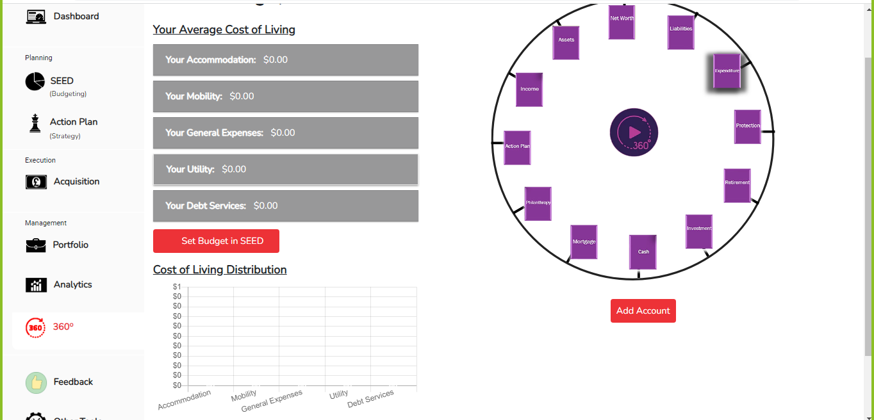

1. **Retirement**

*Feedback: This process did not work properly*– FAILED

*Comment:* When submit button is clicked an error page is displayed

1. **Reap**

*Feedback: Broken Image*– FAILED

*Comment:* Some Images are broken

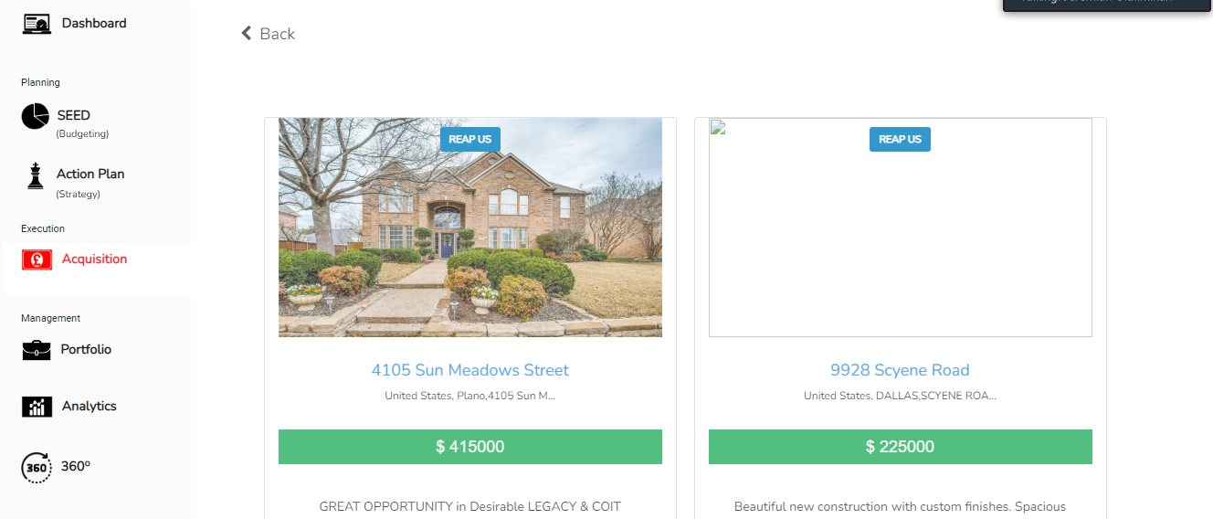

1. **Ganp**

*Feedback: Broken Image*– FAILED

*Comment:* Some Images are broken

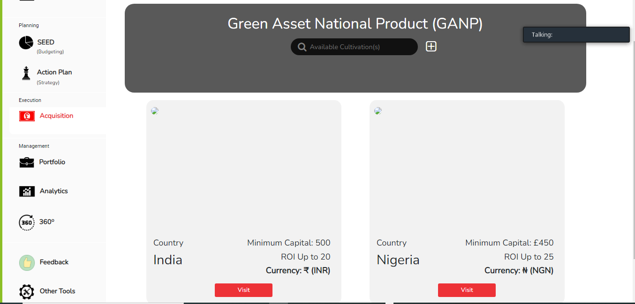

1. **Dashboard**

*Feedback: Broken Image*– FAILED

*Comment:* The profile is broken on the dashboard

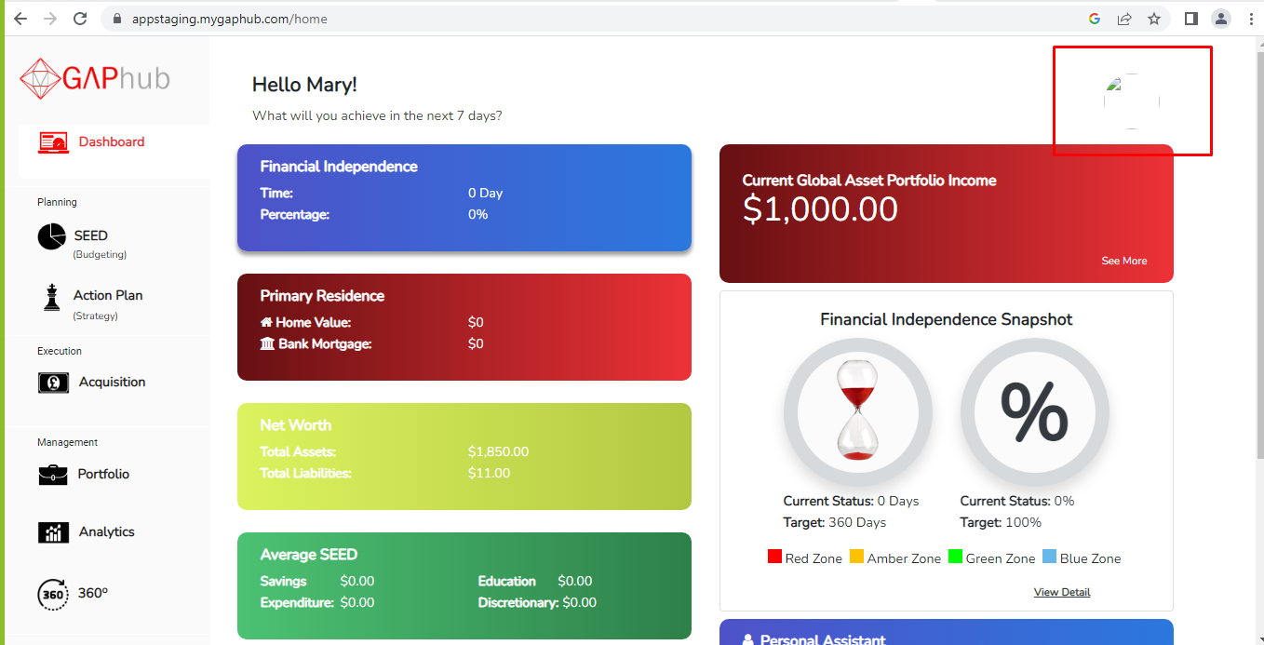

1. **Average seed**

*Feedback: The process is not working fine*– FAILED

*Comment:* The average seed under dashboard is not fetching up data from the Average Seed under SEED

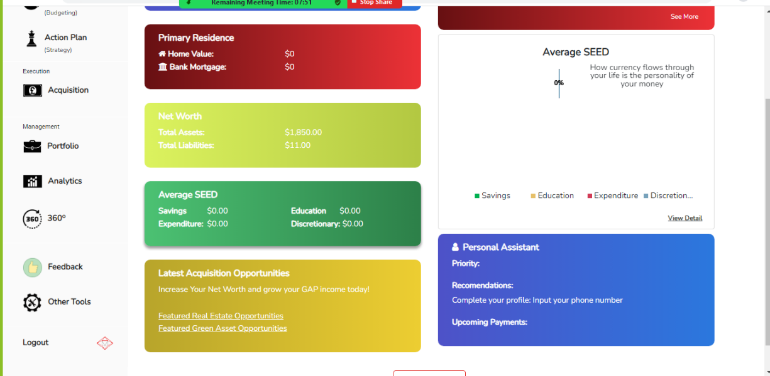

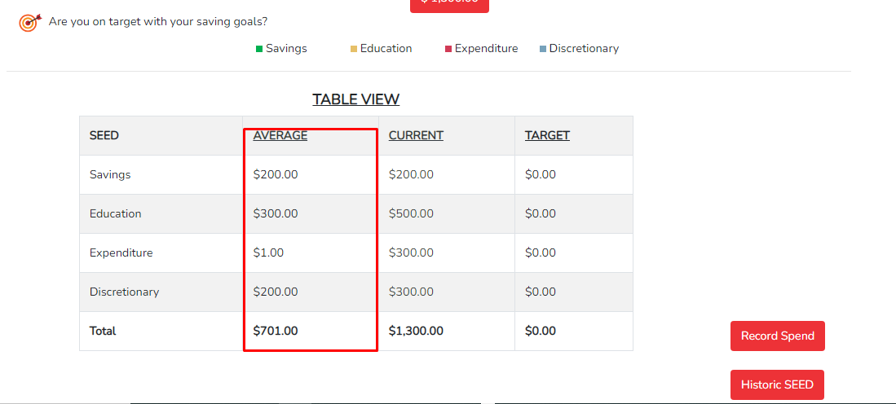

1. **Historic seed**

*Feedback: The process is not working fine*– FAILED

*Comment:* The seed tiles under historic are not clickable

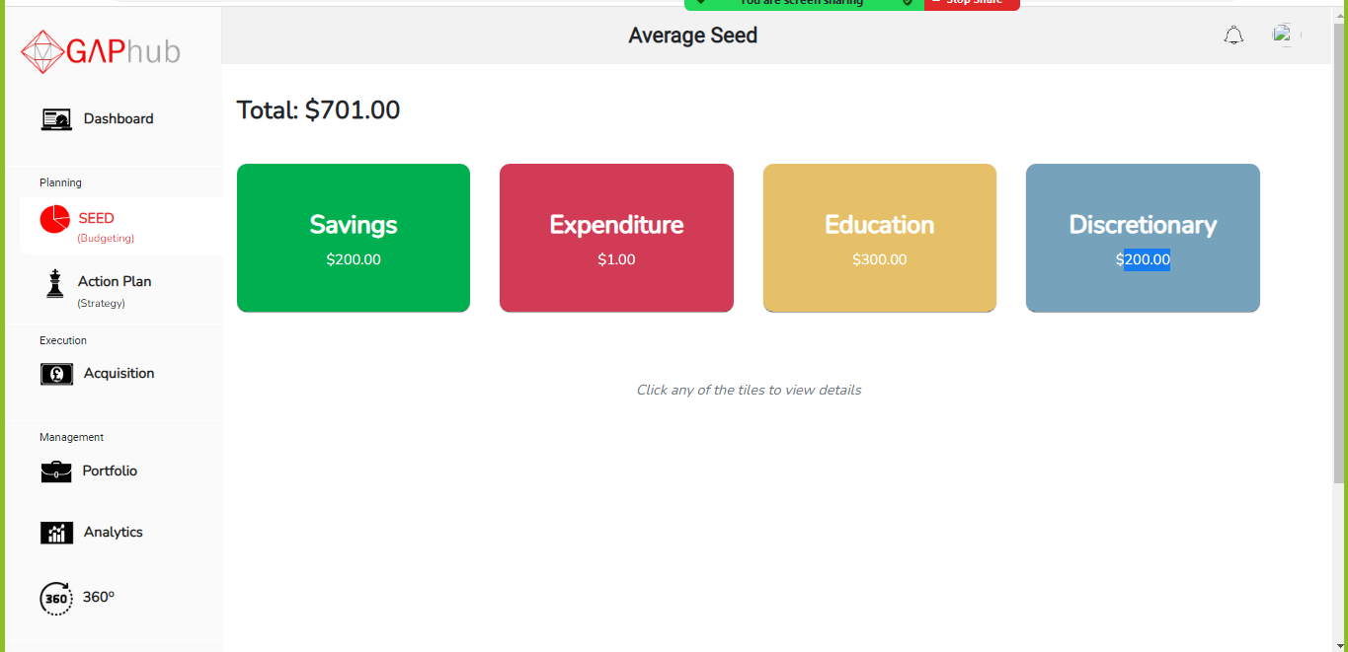

1. **Forgot**

*Feedback: The process is not working fine*– FAILED

*Comment:* the forgot password link is not leading to anywhere

