**GAPHUB APPSTAGING TEST (WEB)**

**WHAT WORKED**

1. Registration Sign Up: This process worked fine. – PASSED
2. 7G KPI Assumption: Could not test due to email not being received – PASSED
3. BESPOKE KPI Assumption: Could not test due to email not being received – PASSED
4. **360:**
5. Assets: All requirement were met successfully - PASSED
6. Income: All requirement were met successfully - PASSED
7. Action Plan: All requirement were met successfully – PASSED
8. Mortgage: All requirement were met successfully – PASSED
9. Cash: All requirement were met successfully - PASSED
10. Investment: All requirement were met successfully - PASSED
11. Protection: All requirement were met successfully - PASSED
12. Net worth: All requirement were met successfully - PASSED
13. iLab: All requirement were met successfully – PASSED
14. Liabilities**:** All requirement were met successfully – PASSED
15. **Acquisition:** All requirement were met successfully - PASSED
16. **Analytics:** All requirement were met successfully – PASSED
17. **SEED**: All requirement were met successfully – PASSED
18. **Forgot Password:** All requirement were met successfully – PASSED

**WHAT DID NOT WORKED**

1. Email Verification: User did not receive email. – FAILED
2. Calculator Workflow: Could not test due to email not being received – Not Tested
3. 7G Onboarding Workflow: Could not test due to email not being received – Not Tested
4. Bespoke: Could not test due to email not being received – Not Tested
5. Philanthropy: Values distributed did not appear both on the chart and the tiles – FAILED

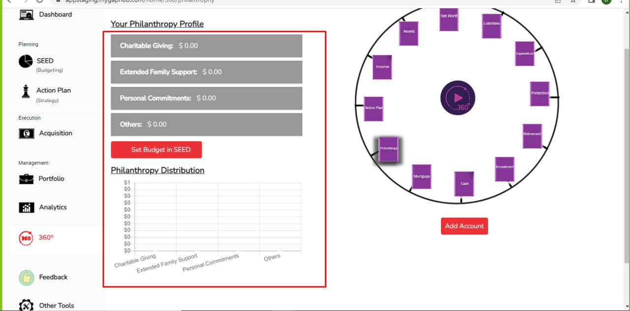

1. Expenditure: No value was captured, no chart displayed after allocation – FAILED

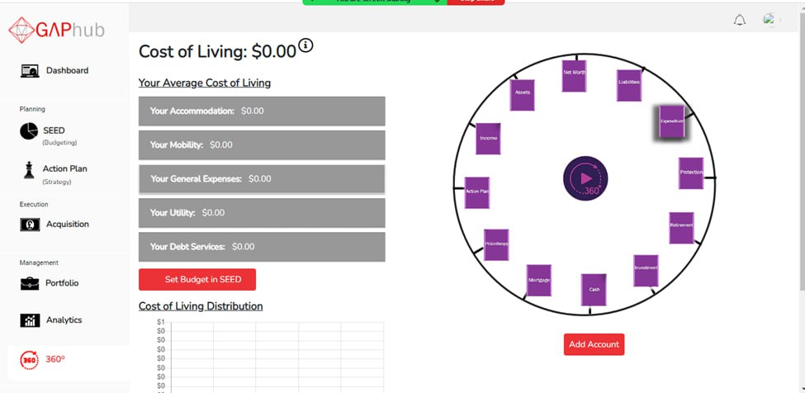

1. **Portfolio:**  Uploaded image saved was broken – FAILED
2. **REAP:**  Some images are broken - FAILED
3. **GANP:** Some images are broken – FAILED

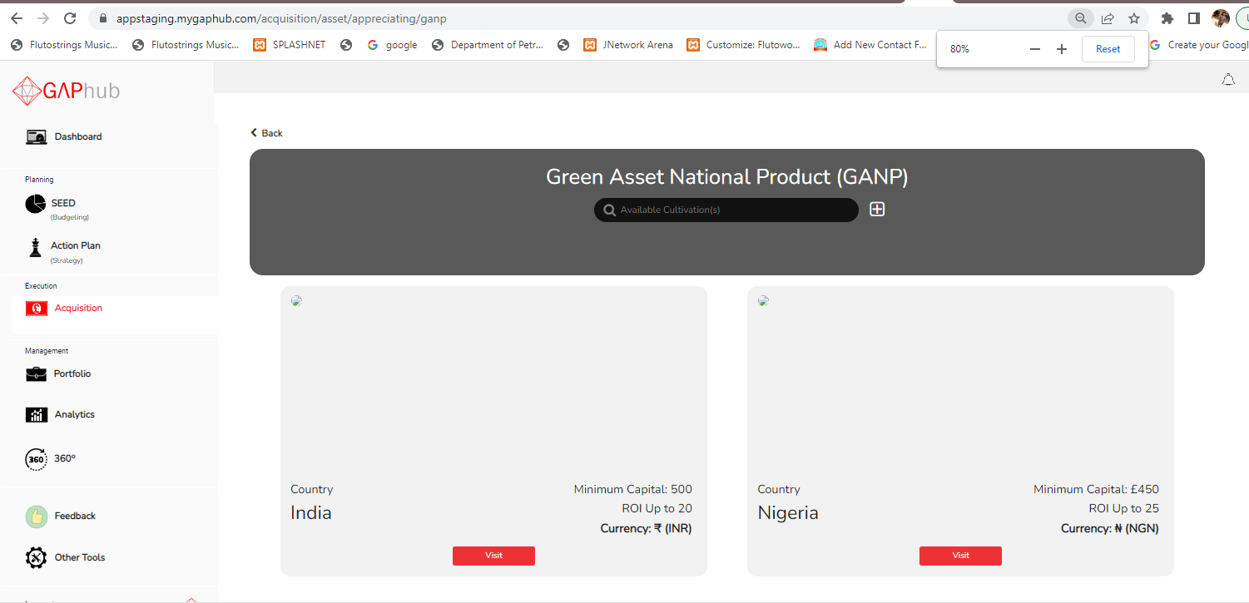

1. Retirement: An error occurred page was displayed - FAILED

