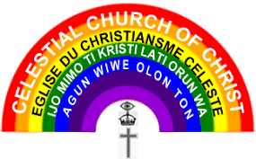

**ASEGUN-L’OLUWA PARISH**

**4/5 Aba-ida Olokuta, olunde olomi Academy,**

**Ibadan, Oyo State.**

**(Tel: 07012713412, 08057316619)**

**The Choir Master/Coordinator,**

Hallelujah Sir/Ma,

**SPECIAL INVITATION FOR SONG MINISTRATION**

Calvary greetings to in the name of our Lord Jesus Christ.

The above-named church humbly invites your choir to her forth coming night Praise concert **for a song ministration.** This is set as one of the activities to mark the **10th Annual Anniversary** and **Thanksgiving Service.**

Theme**: HARVEST OF NEW CHAPTER**

Date**: Friday, 25th November, 2022.**

Venue**: Church Auditorium.**

Please note we are imploring you to be available on time, and you surely don’t want to miss this. Thanks in anticipation; We pray the good Lord strengthens your ministry.

Yours in Christ,

Choir Secretary Choir Master

Choir Coordinator