**My Gaphub(mobile)**

**What worked**

**1. Sign up successfully**. - Passed

2. Email confirmation did not pass - Failed

3. Financial calculator workflow after Sign up – Not tested

4. Onboarding workflow was not done - Tested

5. I was able to validate my 7G assumptions - Passed

6. I was able to create my Bespoke KPI - Passed

**360 WHEEL**

* *Cash - All requirements were met successfully -*Passed
* Asset - *All requirements were met successfully –*Passed
* Mortgage- *All requirements were met successfully –*Passed
* Liabilities- *All requirements were met successfully –*Passed
* Net worth- *All requirements were met successfully –*Passed
* Retirement- *All requirements were met successfully –*Passed
* Investment- *All requirements were met successfully –*Passed
* iLab- *All requirements were met successfully –*Passed
* Action Plan: *All requirements were met successfully –*Passed

**REAP**: *All requirements were met successfully –* Passed

**GANP**: *All requirements were met successfully –* Passed

**WHAT DID NOT WORK (WEB)**

**1.** *Portfolio – Under Edit*

Comment: Edit details is unable to submit, also not able upload document

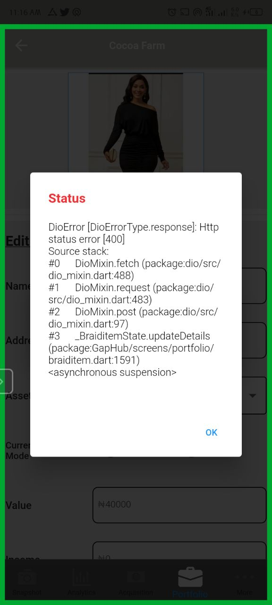

**2.** *Protection – under 360* Comment: After choosing a date before yesterday for the cover start date, its’ still showing user should choose a date before yesterday.

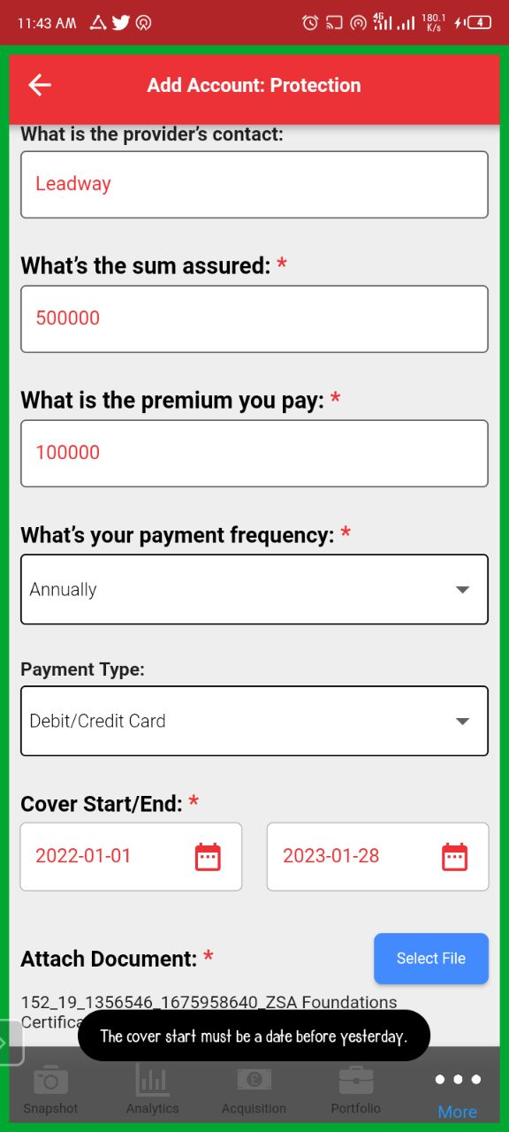

**3.** Income*– under 360*

Comment: No option to add Business asset. The web view is below

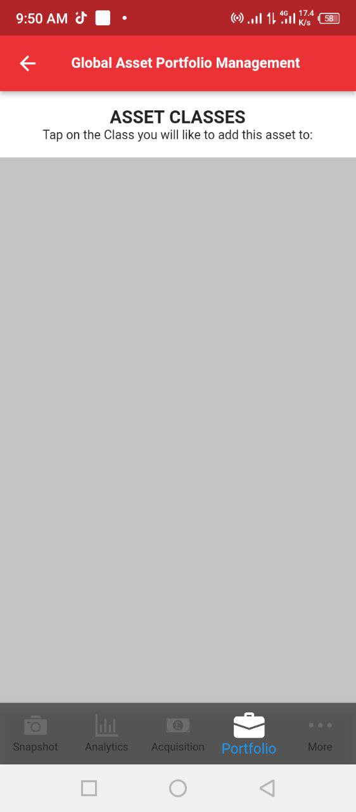

4.Net Worth *– under 360*

Comment: Under Net Worth when a user clicks on current liability value, it just keeps loading endlessly.

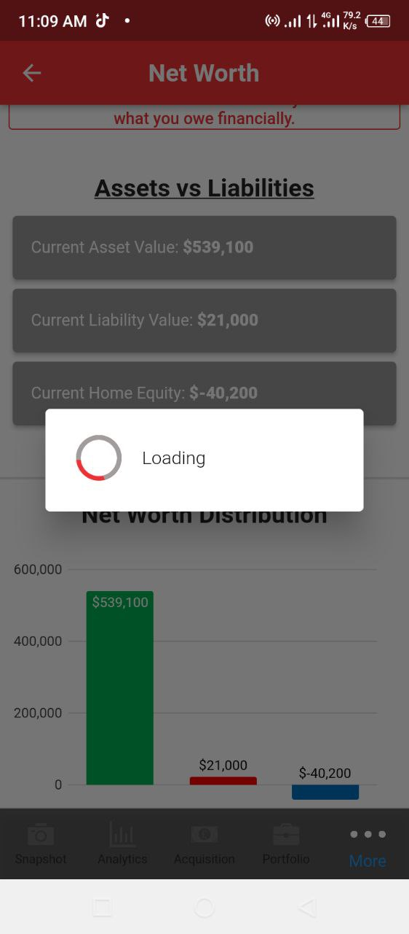

5. Forgot Password: This process did not pass

Comment: link is bringing up error message when click on

**6. SEED**: *Did not pass*

Comment: A Blank page is display when click on seed

**General Remarks**

* Email verification need to be checked to enable test of a new account
* Also after submitting a new income account, the modal should not pop up again in order for users to see what they just added.
* Remove button should be available on the liabilities of the 360 for user to be able to archive account.