**Infosys Super Bot – Installation Document**

**Super Bot/Version: 1.0**

**July-2021**

COPYRIGHT NOTICE

© 2021 Infosys Limited, Bangalore, India. All Rights Reserved. Infosys believes the information in this document is accurate as of its publication date; such information is subject to change without notice. Infosys acknowledges the proprietary rights of other companies to the trademarks, product names and such other intellectual property rights mentioned in this document. Except as expressly permitted, neither this documentation nor any part of it may be reproduced, stored in a retrieval system, or transmitted in any form or by any means, electronic, mechanical, printing, photocopying, recording or otherwise, without the prior permission of Infosys Limited and/or any named intellectual property rights holders under this document.

Infosys Limited

Electronic City,

Hosur Road,

Bangalore 560 100

India.

Telephone: 91 80 2852 0261

Fax: 91 80 2852 0362

Website: http://www.infosys.com

**Table of Contents**

1. Prerequisites 4

2. Installation package 5

3. Database server: 6

3.1 Prerequisites 6

3.2 Add SQL Server Port to Windows firewall 6

3.3 Database Creation 9

3.4 Create Local User 11

4. Superbot API Setup: 16

4.1 Prerequisites 16

4.2 Web Site Creation 19

5. Configuration Management API Setup 25

5.1 Prerequisites 25

5.2 Setting up Configuration Management API 25

6. Update Application Configuration 29

7. Superbot Health Check 32

7.1 Prerequisites 32

7.2 Add user to “logon as batch job” policy 32

7.3 Setting up SuperBot HealthCheck Task 35

8. Message Queuing Installation 42

8.1 Prerequisites 42

8.2 Create Queues 43

9. Process Loader Service Setup 47

9.1 Prerequisites 47

9.2 Creating ProcessLoader Windows Service 47

10. Superbot Environment Scan Setup 50

10.1 Prerequisites 50

10.2 Setting Environment Scan Task 50

11. Configuration Management View setup 56

11.1 Prerequisites 56

11.2 Configuration Steps 56

12. DashBoards 57

12.1 Environment Operations Dashborad Setup 57

12.1.1 Prerequisites 57

12.1.2 Setup 57

13. TroubleShooting 59

13.1 SuperBot and ConfigurationManangement api 59

13.2 Task Scheduler failed to start 59

13.3 Cannot connect to SQL Server 60

13.4 Cannot run the Task 61

14. FAQ 61

# Prerequisites

1. Following software/components need to be installed on the target server:

SQL Server Standard Edition 2012,2014 or 2016

SQL Server Management studio v18

Windows Task Scheduler

* Operating System: Windows Server 2012 R2 - 64-bit, 2016 R2 - 64-bit.
* .NET Framework 4.6.1
* MSMQ
* MS Internet Information Services (IIS) v8.5,v10
* Power BI Desktop 2.71 (Optional)

Install Script Control Center by following the setup document:

Script_Control_Center Server Installation_v1.docx

1. Minimum Hardware/System Specification:

* Dual core CPU
* 4 GB RAM
* HDD 500 GB

1. Windows Service Account

# Installation package

Installation package contains following:

* Database creation script
* Superbot creation related files
* Configuration Management creation related files
* Dashboard creation related files

Installation Package is available at location –

**Release 1.0\Infosys\**

Extract all the zip files present under above location and save it at proper location on target server. It has following folders –

|  |  |
| --- | --- |
| **Server Folder** | **Extract location** |
| Superbot\db.zip | <Drive>:\Infosys\Superbot\1.0\db (Ex: C:\Infosys\Superbot\1.0\db) |
| Superbot\api.zip | <Drive>:\Infosys\Superbot\1.0\api |
| Superbot\healthcheck.zip | <Drive>:\Infosys\Superbot\1.0\healthcheck |
| Superbot\processloader.zip | <Drive>:\Infosys\Superbot\1.0\processloader |
| Superbot\environmentscan.zip | <Drive>:\Infosys\Superbot\1.0\environmentscan |
| ResourceConfigurationManagement\  configutationmanagementapi.zip | <Drive>:\Infosys\Superbot\1.0\configurationmanagementapi |
| ResourceConfigurationManagement\  configutationmanagementview.zip | <Drive>:\Infosys\Superbot\1.0\configurationmanagementview |
| Dashboards\EnvironmentOperationsDashboard.pbix | <Drive>:\Infosys\Superbot\1.0\Dashboards\EnvironmentOperationsDashboard.pbix |
| scripts.zip | <Drive>:\Infosys\Superbot\1.0\scripts |
| references.zip | <Drive>:\Infosys\Superbot\1.0\references  Copy “**Infosys.Lif.MSMQ.dll**” from target location to C:\Infosys.IntegrationLib\References\ |

# Database server:

## Prerequisites

* + SQL server Standard Edition 2012,2014 or 2016 has been installed
  + SQL Server Management studio v18 has been installed
  + Windows Service account is required for windows integrated security.

## Add SQL Server Port to Windows firewall

* + Click Start, type “Firewall” into the search box, and then click on “Windows Firewall with Advanced Security.”

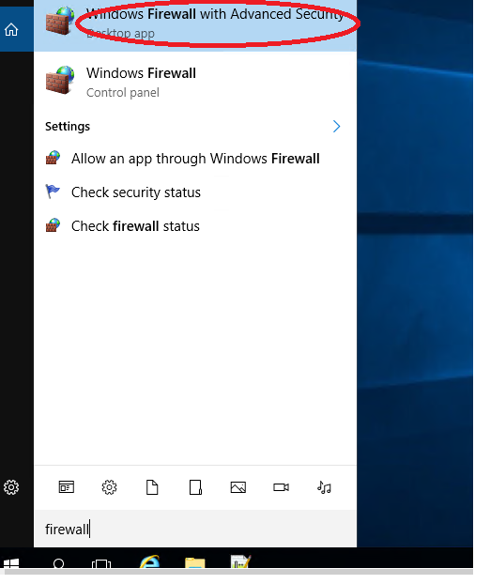

* + Click the “Inbound Rules” category on the left. In the far right pane, click the “New Rule” command.

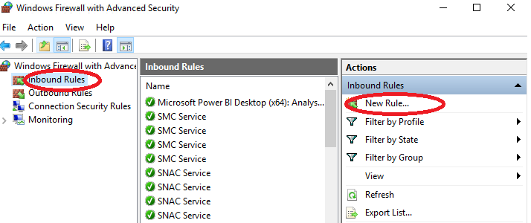

* + On the Rule Type page, select the “Port” option and then click “Next.”

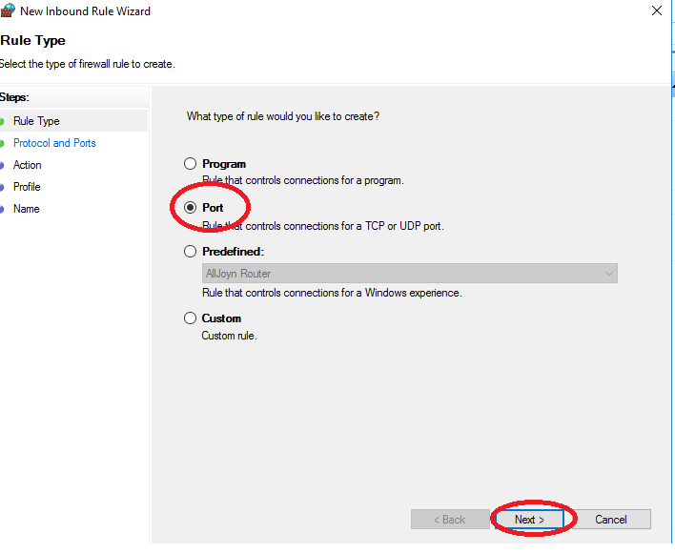

* + Enter the Port Number 1433 and click “Next”

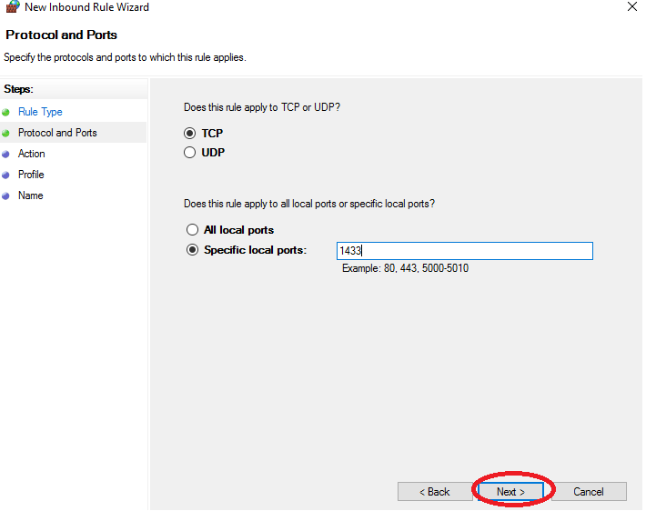

* + On the next page, click “Allow the Connection” and then click “Next.”

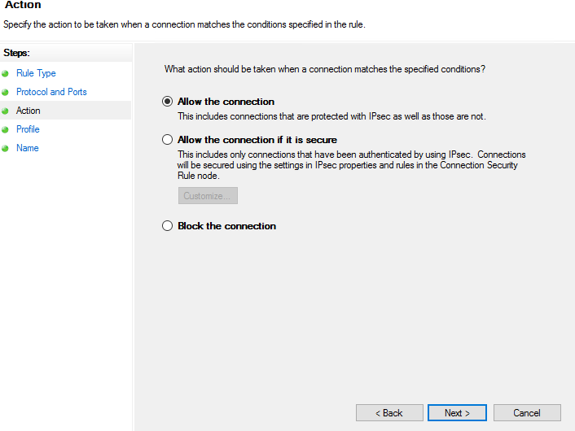

* + choose All the rules and click “Next.”

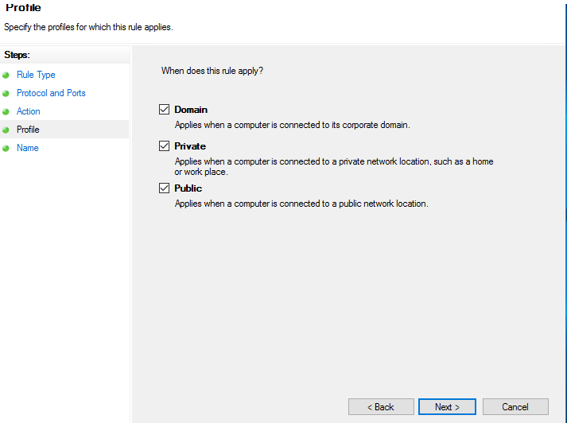

* + Give your new rule a name and an optional, more detailed description. Click “Finish” when you’re done

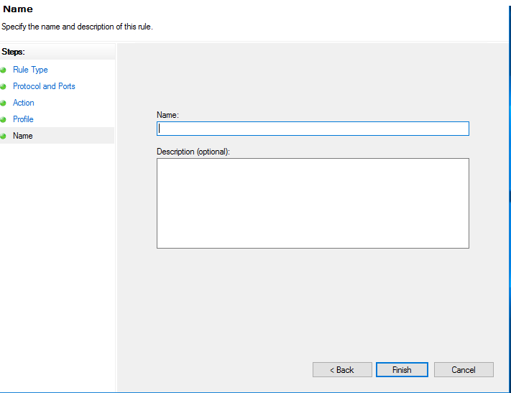

## Database Creation

1. Login to SQL server using admin account

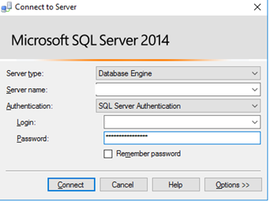

1. Right click on database and select new database

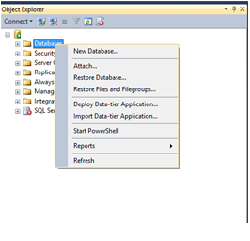

1. Following screen appears. Provide “Superbot” in database name and click OK.

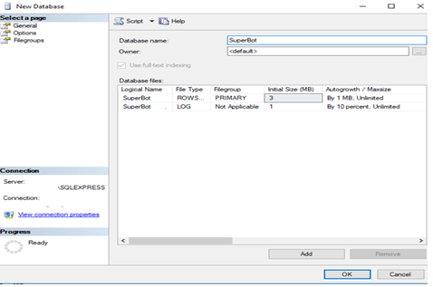

1. Ensure that Database folder ‘db’ copied to target location from deployment package on server and execute script in given sequence by following below steps

|  |  |
| --- | --- |
| **Script** | **Remarks** |
| Create_Objects.sql | Execute the script to create tables |
| LoggingDatabase.sql | Execute the script for creating logging db and tables |

* + Go to File > Open > File > Choose Create_Objects.sql file (the one that contains your script) > Press Open > the file will be opened within SQL Server Management Studio, press Execute button.

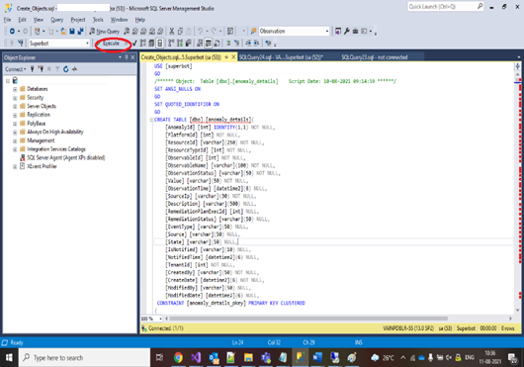

* + Goto File > Open > File > Choose LoggingDatabase.sql file (the one that contains your script) > Press Open > the file will be opened within SQL Server Management Studio, press Execute button.

## Create Local User

1. Login to SQL server using admin account

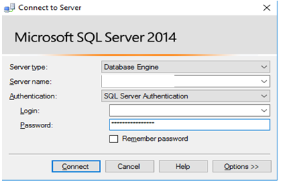

1. Expand “Security” and Right click on “Login” and select “New Login”

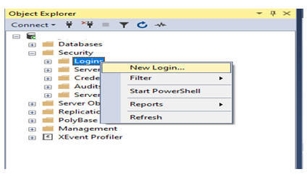

1. Do the following steps
   * Enter the “Login name” value “superbotapp”
   * Select “SQL server authentication”
   * Enter password and confirm password values
   * Select Default database “superbot”

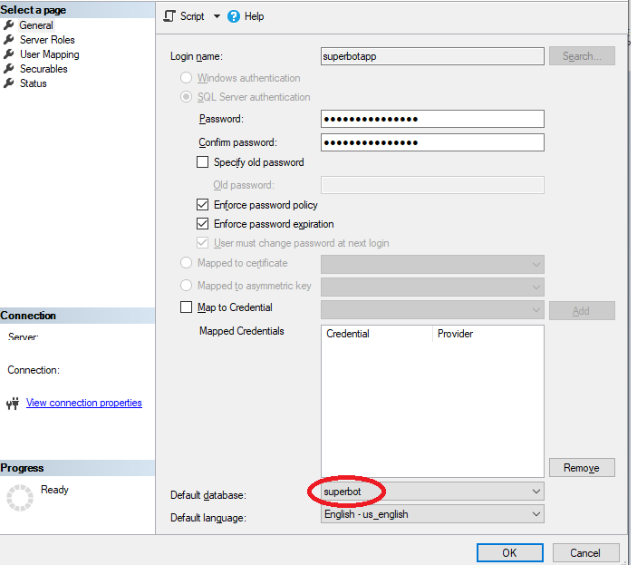

1. Select “User Mapping” in Left hind side window

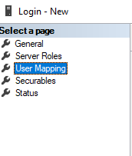

1. Check “superbot” db and set default schema value to “dbo”

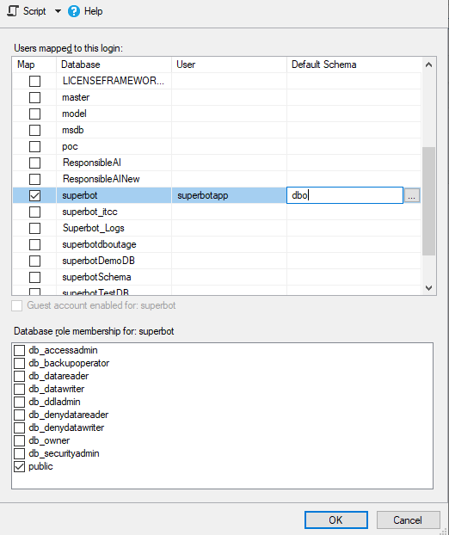

1. Click “Ok” to add user
2. Expand databases and do the following steps

* Right Click on the “superbot” db
* Select Properties

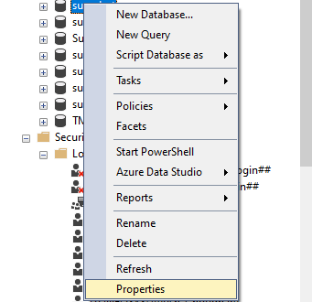

1. Go to “Permissions” in left hand side window

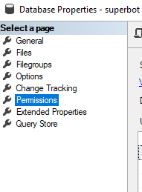

1. Select the user “superbot” and grant below permissions and Click Ok

* Select

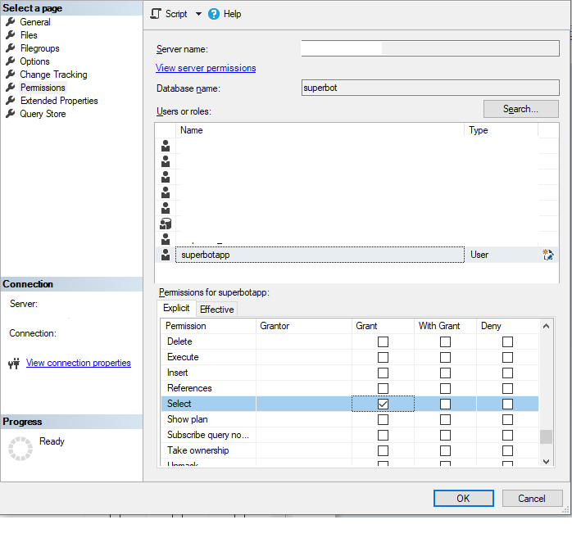

# Superbot API Setup:

## Prerequisites

1. IIS v8.5 or v10 is installed
2. Admin access is required to enable windows features
3. Windows Service account is available for authentication and authorization.
4. Make sure following features are installed while installing IIS –
5. Go to Turn Windows Features On or Off
   1. Web Server (IIS)
      1. Common Http features

Check in the below features as shown in the figure below

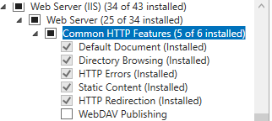

* + 1. Health and Diagnostics

Check in the below features as shown in the figure below

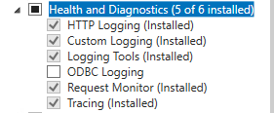

* + 1. Performance

Check in the below features as shown in the figure below



* + 1. Security

Check in the below features as shown in the figure below

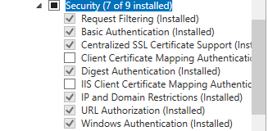

* + 1. Application Development Features

Check in the below features and install as shown in the figure below

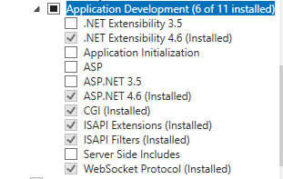

* 1. FTP Server

Check in the below features and install as shown in the figure below



* 1. Management Features

Check in the below features and install as shown in the figure below

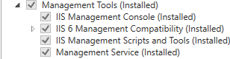

* 1. Click on Next
  2. .NET Framework 4.6 Features

Check in the below features and install as shown in the figure below

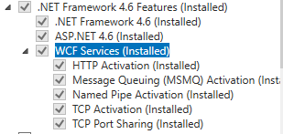

* 1. Click on Install

## Web Site Creation

1. Open IIS. Go to run and type inetmgr

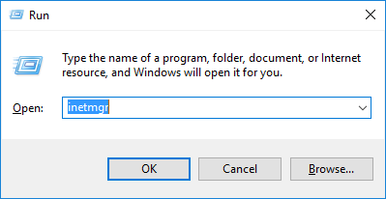

Click Yes

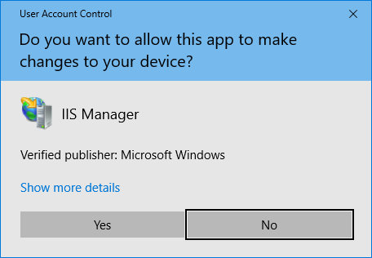

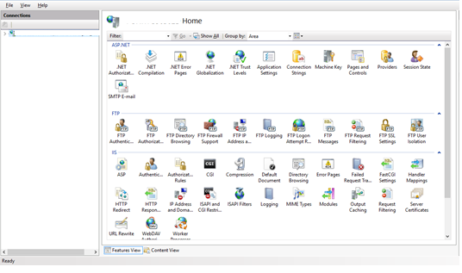

1. Once IIS is opened, expand the machine name listed on left hand side.
2. Right Click on Application Pool and select Add Application Pool to create an application pool required for the application.

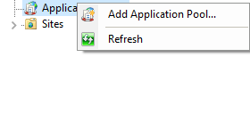

1. Provide application pool name as Superbot

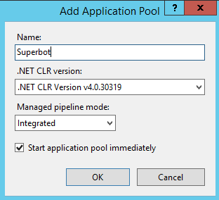

1. Change app pool account to service account
2. Select application pool and right click and select advanced settings

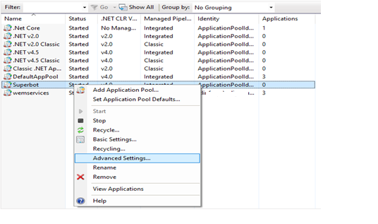

1. Select “ApplicationPoolIdentity”

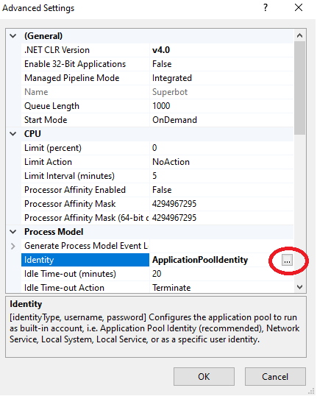

1. Select custom account and click on set

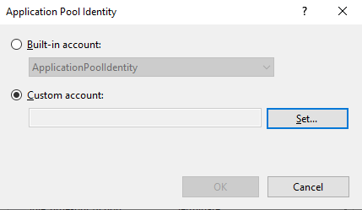

1. Set the username and password of the windows service account.

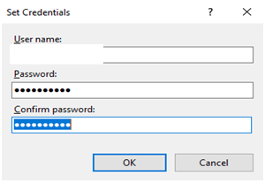

1. After that expand sites.

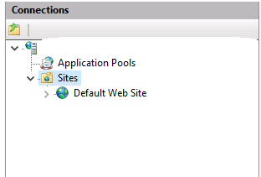

1. Right click on default website and add a new application ( it should be added only under default website)

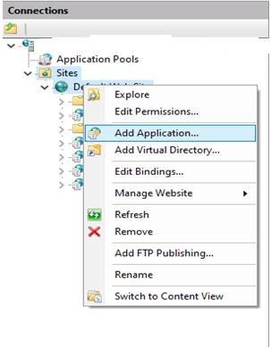

1. Provide application name, application path and application pool name

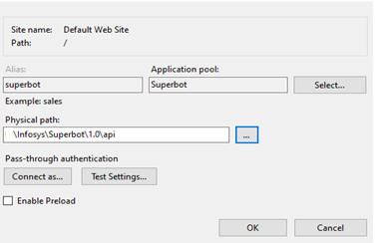

1. Click on “Connect as”

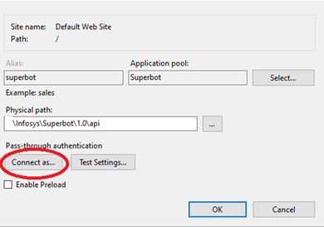

1. Select “Specific user” and click “Set”

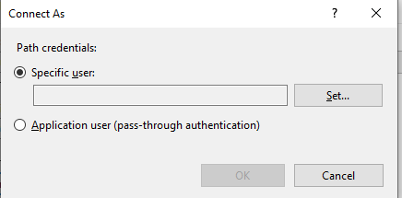

1. Enter “windows service account” username and password and click Ok



1. Once the application is created, then browse the following URL.

<http://localhost/superbot/Test.html>

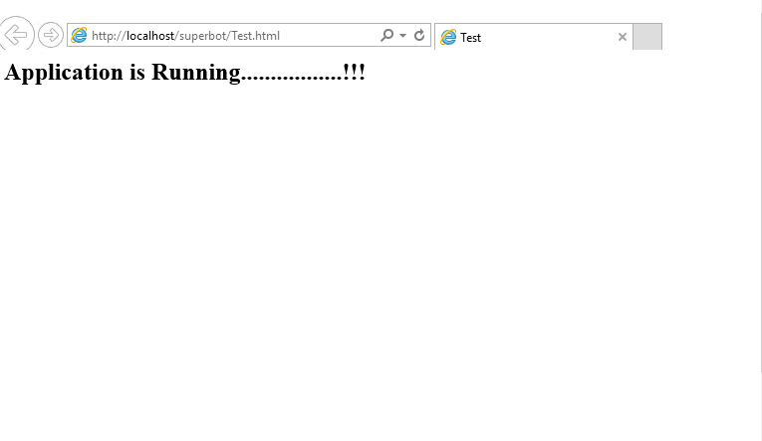

1. Browse the URL –http://localhost/Superbot/swagger/

Following page should be displayed:

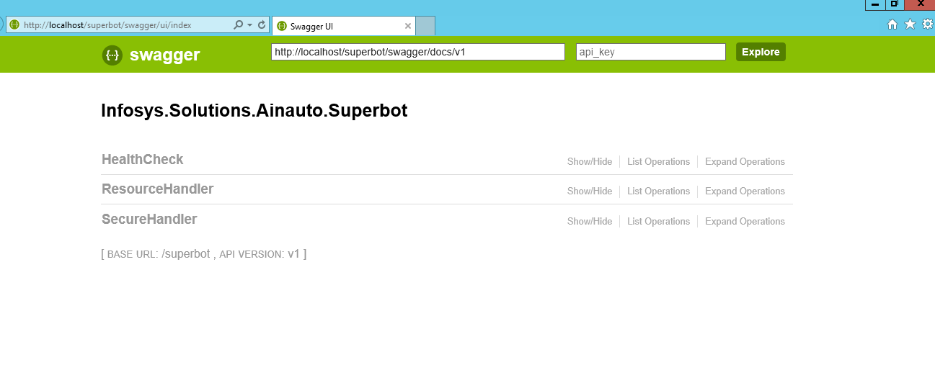

# Configuration Management API Setup

## Prerequisites

* Windows Service account required for authentication and authorization
* Admin access requires for IIS
* Ensure that the libraries have been extracted to folder m“<Drive>:\Infosys\Superbot\1.0\configurationmanagementapi” as mentioned in section 2

## Setting up Configuration Management API

1. Open IIS. Go to run and type inetmgr.



Click Yes.



1. Expand sites column present on left hand side an expand it.

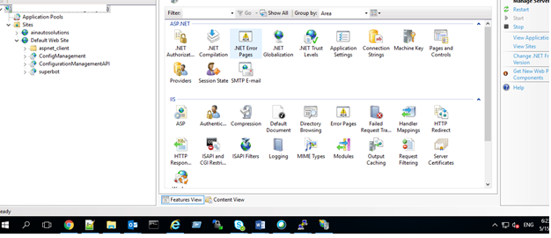

1. Right click on default website and add a new application

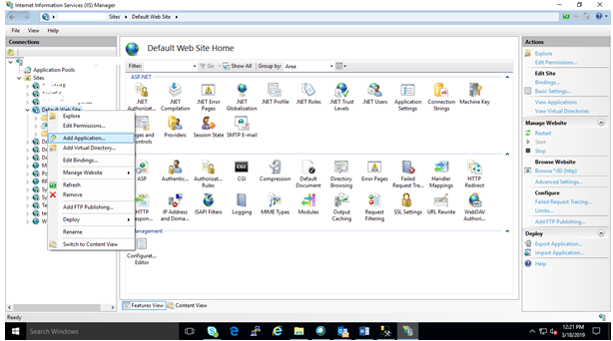

1. Provide application name, application path and application pool name. Click Ok.

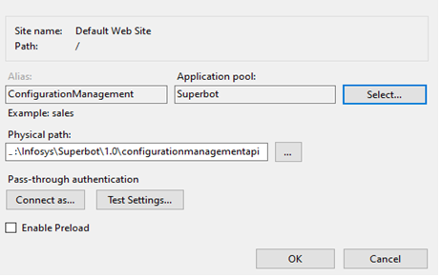

1. In the physical path provide the path till configurationmanagementapi folder location copied in the server.
2. Click on ok.
3. Open command prompt in admin mode and type iisreset for resetting iis settings.
4. Open IIS and right click on newly created Config Management site and click on browse.
5. Try browsing <http://localhost/ConfigurationManagement/Test.html>

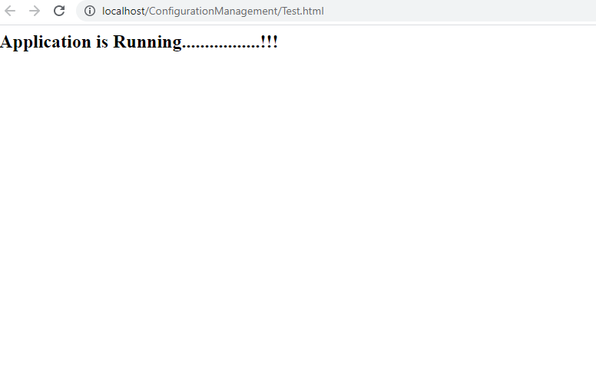

# Update Application Configuration

* Update below fields in “<Drive>:\Infosys\Superbot\1.0\scripts\configuration.json”

|  |  |  |
| --- | --- | --- |
| **Property** | **Value** | **Description** |
| RootPath | <Drive>:\\Infosys\Superbot\\1.0\\ | Update <Drive> name in root path |
| superbot_servername | machine123 | Provide hostname or ipaddress on which superbot api has been deployed |
| scc_servername | machine123 | Provide hostname or ipaddress on which Script Control Center has been deployed |
| superbot_dbserver | machine123 | Provide hostname or ipaddress on which Superbot db has been configured |
| Dbusername | user_123 | superbot db local userid |
| Dbpassword | Xxxxxxxx | superbot db Password |
| ServiceAccount | xyz_123 | Provide windows service account id e.g. xyz_123, etc. |
| configurationmanagement_servername | machine123 | Provide hostname or ipaddress on which ConfigurationManagement api will deploy |
| Domainname | DomainName | Specify the LDAP domain name in which the module is getting deployed |

Below is the sample Json format

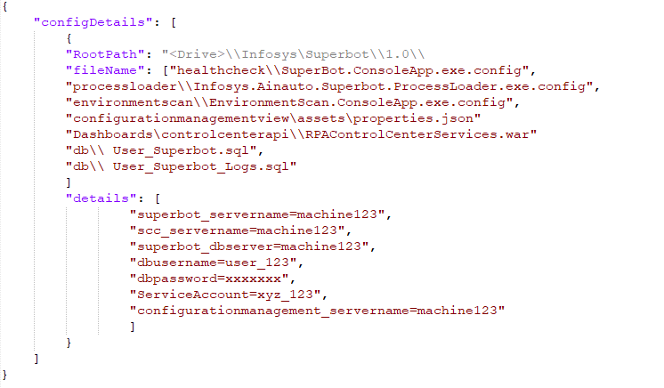

* Execute Below Command on windows PowerShell to update the properties

**<Drive>:\Infosys\Superbot\1.0\scripts\updateConfigurationFiles.ps1** **-jsonPath** **<Drive>:\Infosys\Superbot\1.0\scripts\configuration.json**

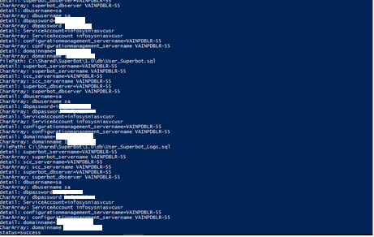

* Ensure that Database folder ‘db’ copied to target location from deployment package on server and execute script in following sequence

|  |  |
| --- | --- |
| **Script** | **Remarks** |
| MetaData_Insert_Scripts.sql | Execute the script to insert master data |
| User_Superbot.sql | Execute the script to add service account user for windows integrated security |
| User_Superbot_Logs.sql | Execute the script to add service account user for windows integrated security |

* 1. Go to File > Open > File > Choose MetaData_Insert_Scripts.sql file (the one that contains your script) > Press Open > the file will be opened within SQL Server Management Studio, press Execute button.

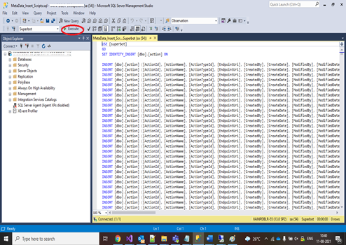

* 1. Go to File > Open > File > Choose “User_Superbot.sql” file (the one that contains your script) > Press Open > the file will be opened within SQL Server Management Studio, press Execute button.
  2. Go to File > Open > File > Choose “User_Superbot_Logs.sql” file (the one that contains your script) > Press Open > the file will be opened within SQL Server Management Studio, press Execute button.
* Execute Below Command on windows PowerShell to update the cluster and portfolios

**<Drive>:\Infosys\Superbot\1.0\scripts\updateTenantandCluster.ps1** -jsonPath **<Drive>:\Infosys\Superbot\1.0\scripts\tenantinput.json**

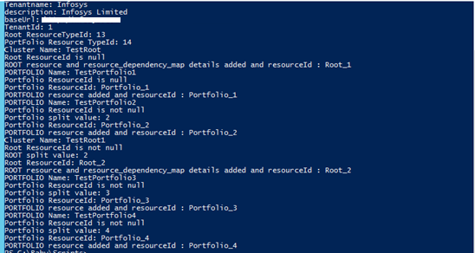

# Superbot Health Check

## Prerequisites

* + Windows Service account is required for authentication and authorization
  + Admin access required to setup task
  + Ensure that the libraries have been extracted to folder “<Drive>\Infosys\Superbot\1.0\healthcheck” as mentioned in section 2
  + “Infosys.Lif.MSMQ.dll” needs to be available in C:\Infosys.IntegrationLib\References\ as mentioned in section 2

## Add user to “logon as batch job” policy

* + Open “Run” prompt and type “secpol.msc”

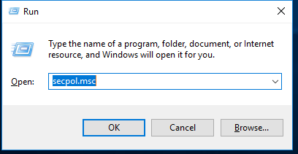

* + Click on “Ok” and below screen displays

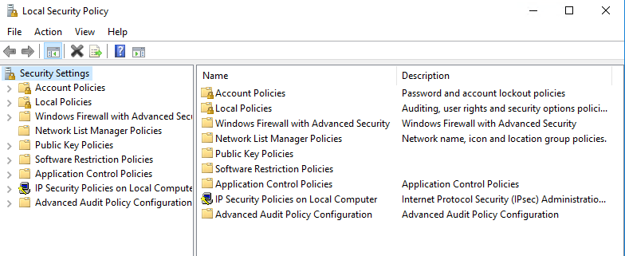

* + Go to “Local Policies” and select “User Rights Assignment”

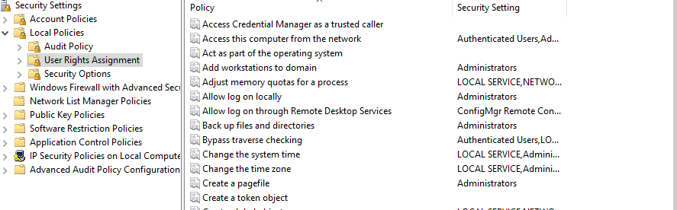

* + Go to “Logon on as a batch job” and select Properties

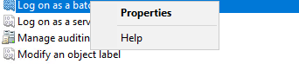

* + Select “Add User or Group”

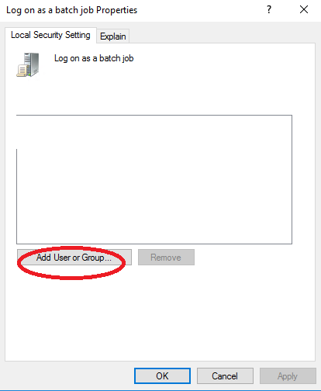

* + Enter windows service account user and click Ok

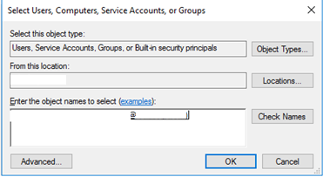

* + Click on “Apply” and “Ok”

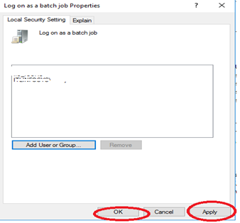

## Setting up SuperBot HealthCheck Task

Thisallows superbot HealthCheck App to be automatically executed whenever a certain set of conditions is met.

1. Open Task Scheduler from windows search tab .

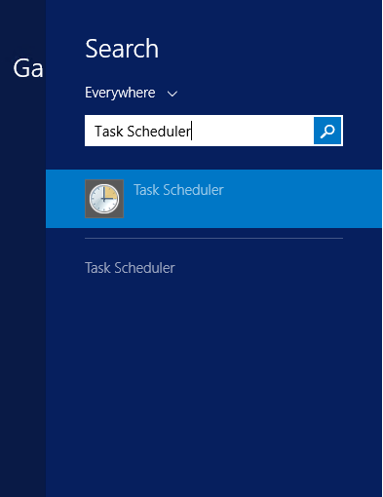

1. Click on Create Basic Task tab on the left

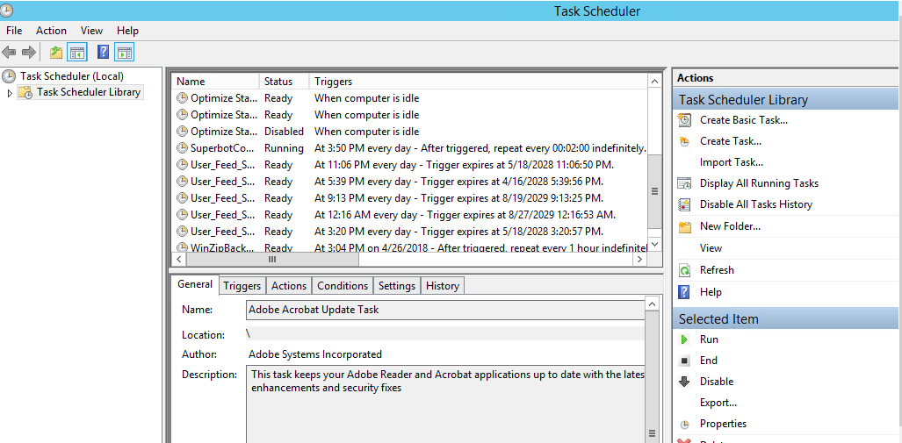

1. Give the task name as **Infosys.Superbot.HealthCheck** and click on next

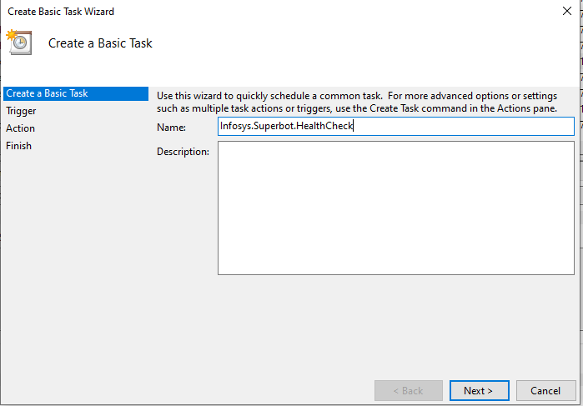

1. Set the task trigger according to business requirement and click on next. (For example, schedule the task to execute daily basis for every 30 mins. This will trigger the task for every 30 mins)

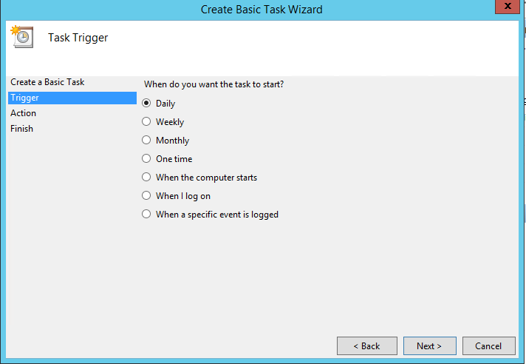

1. Select the start date and time for the task and click on next.

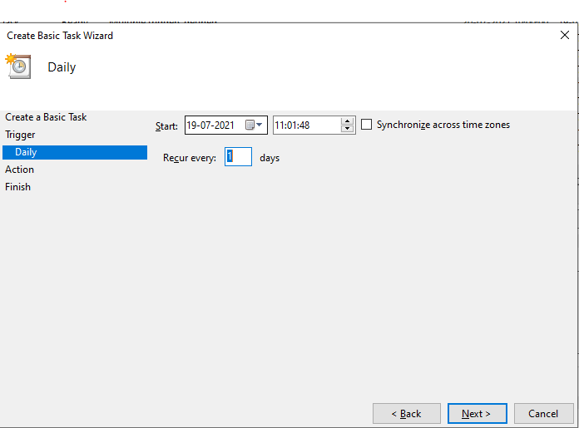

1. Select Start a program option in Action window and click on next.

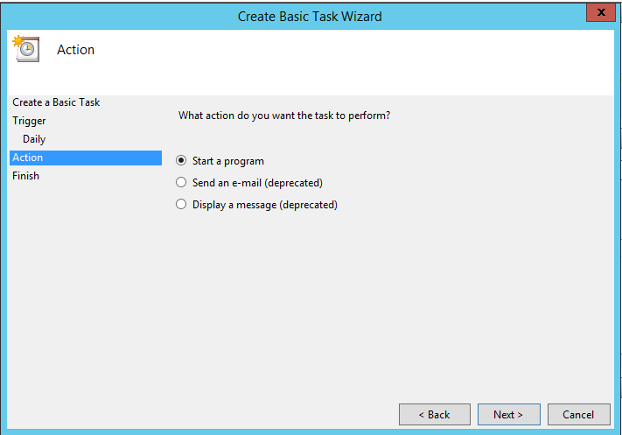

1. Provide path for the “**SuperBot.ConsoleApp.exe**” present in **“HealthCheck”** folder and provide arguments separated with spaces as shown in image-
2. Steps Execute the script **“<Drive>:\Infosys\Superbot\1.0\scripts\fetchResourceId.ps1**” to fetch arguments

* Open “Windows Powershell”

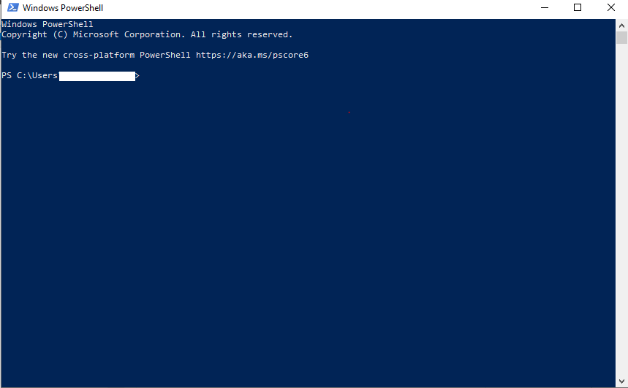

* Send the below arguments for script to execute
  + - jsonPath
    - TenantName
    - PlaftformName
    - ResourceTypeName
* Execute the following command by replacing with the configured TenantName, PlatformName and ResourceTypeName

<Drive>:\Infosys\Superbot\1.0\scripts\fetchResourceId.ps1 -jsonPath <Drive>:\Infosys\Superbot\1.0\scripts\dbResourceId.json -TenantName Infosys -platformName AutomationAnywhereEnterprise -ResourceTypeName 'Bot Runner'

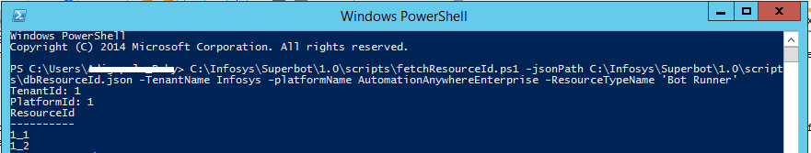

* Pass the arguments in this format <type> <platformid> <tenantid> <dependencyResourceid>

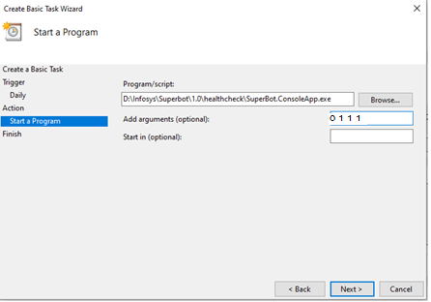

Click on next and click on finish .

1. The created task will be now shown in task scheduler library .

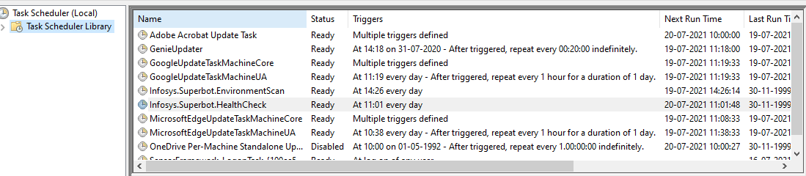

Double click on task and following window will open –

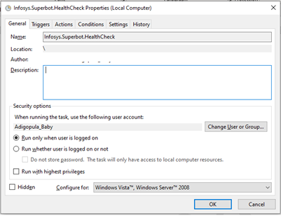

1. Click on Change User or Group in order to run the task with service account. Make sure to select Run whether user is logged on or not option below.
2. Click on Triggers option on top following window will appear –

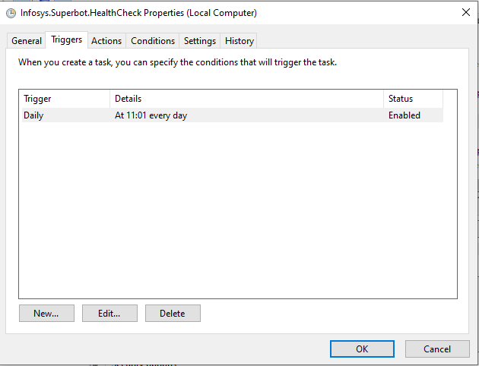

1. Click on Edit option in order to set the repetition time for the task .

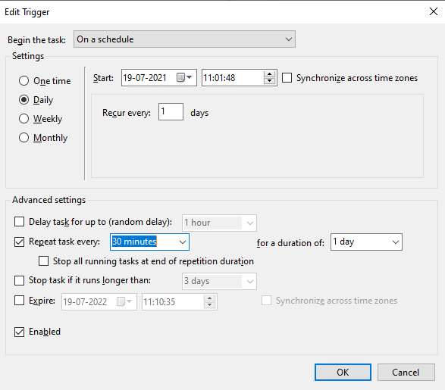

* In the Advanced settings section you can provide the Task run frequency according to your monitoring (How frequently you need to do health check monitoring) requirement for the task to repeat after specified time For eg.30,60 minutes.
* After setting click on ok.

1. In the Task Scheduler Library click right click on the created **Infosys.SuperBot.HealthCheck** task and select run. The task will start running in the background.

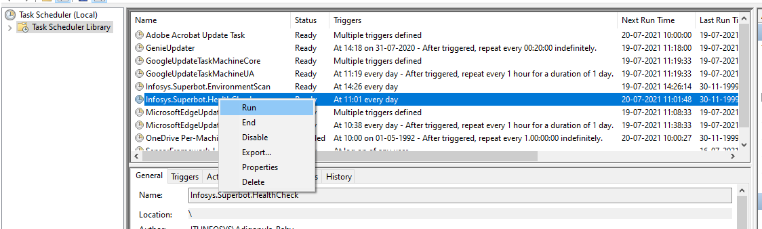

# Message Queuing Installation

## Prerequisites

* Admin access required for MSMQ installation
* Go to Turn Windows Features On Or Off in the start menu of Windows.(One needs to have admin access to use this functionality. )

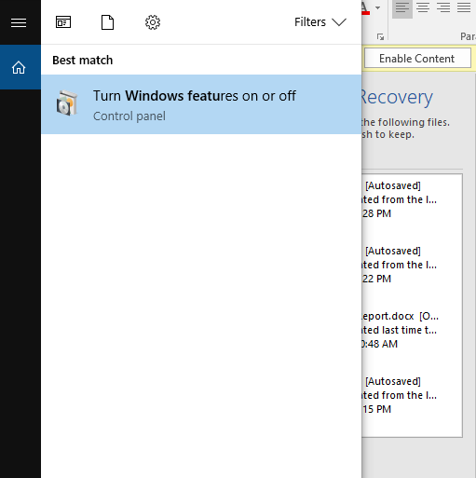

* Find ‘Microsoft Message Queue (MSMQ) Server Core’ in the features list. And check in the Microsoft Message Queue (MSMQ) Server Core under MSMQ .

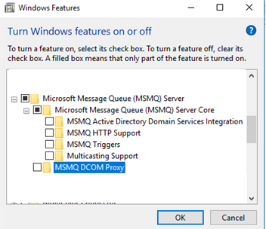

## Create Queues

1. After the feature is completely installed Open the Computer Management from Windows start menu.

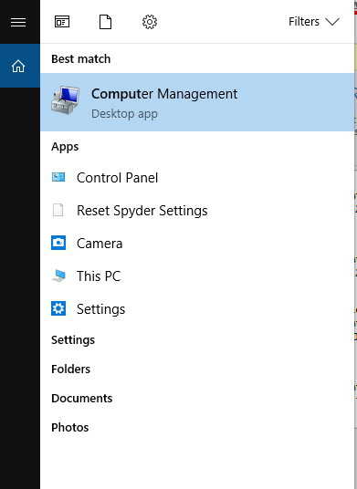

Following window will appear –

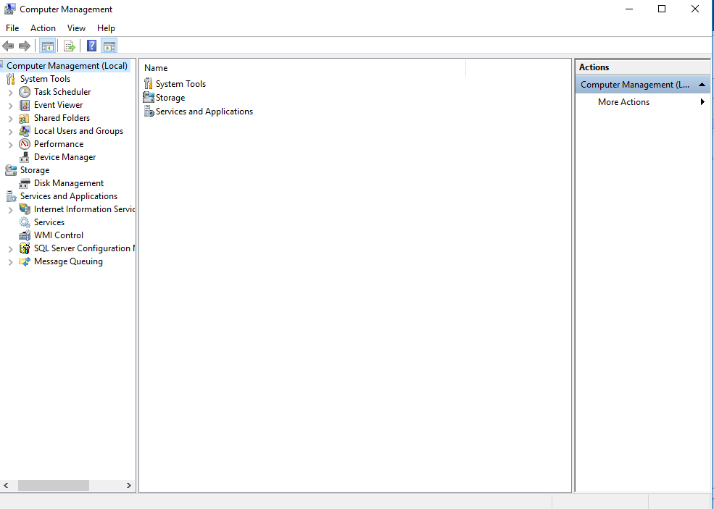

1. Expand the Message Queuing option and right click on Private Queues to Create a New queue.

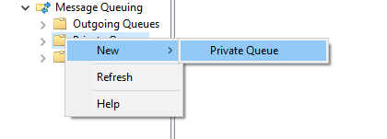

1. Create a queue with name ‘healthcheckmetrics’ and click on Ok.

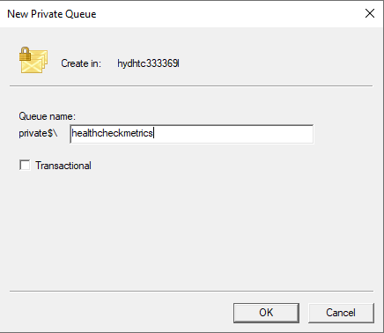

1. After creating a queue you can see the queue in Private Queues option.

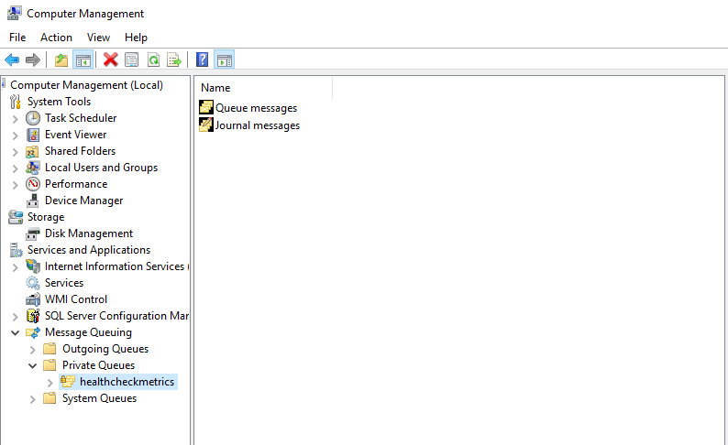

1. Right click on the queue and go to Properties.

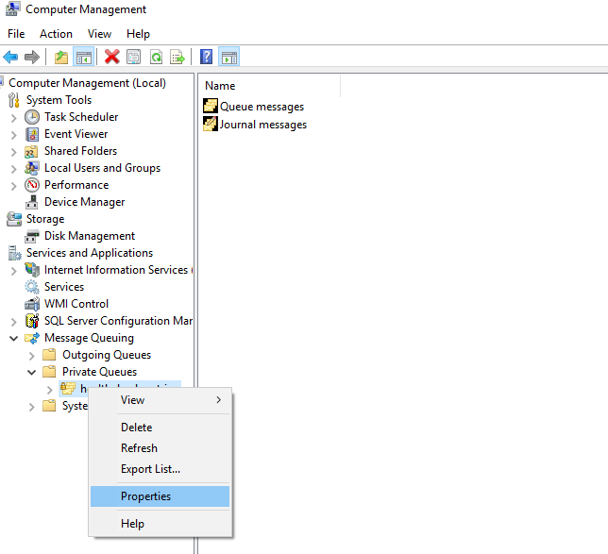

1. Click on Security and Add button.

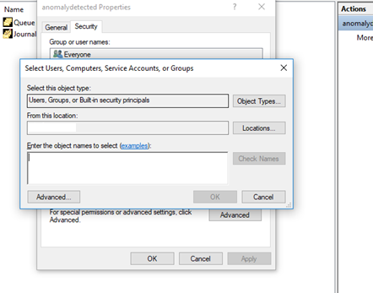

1. Add ‘Windows service account’ userid and click on OK as follows:

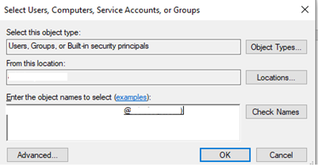

1. Select service account User from users and Groups section and Check below options from permissions section and click Ok
   * Send Message
   * Delete message
   * Delete

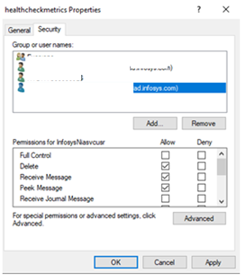

Repeat Steps 1-9 for creating the following queues:

* anomalydetected
* notifications
* superbot_poison
* environmentscanmetrics

# Process Loader Service Setup

## Prerequisites

* Script Control Center has been setup
* Admin access required to create service
* Windows Service account is required for service execution
* Ensure that the libraries have been extracted to folder “<Drive>:\Infosys\Superbot\1.0\processloader” as mentioned in section 2
* “Infosys.Lif.MSMQ.dll” needs to be available in C:\Infosys.IntegrationLib\References\ as mentioned in section 2

## Creating ProcessLoader Windows Service

1. Open command prompt in administrative mode and type in following command :

sc create Infosys.Superbot.Processes binPath= "<Drive>:\Infosys\Superbot\1.0\processloader\Infosys.Ainauto.Superbot.ProcessLoader.exe" start= demand

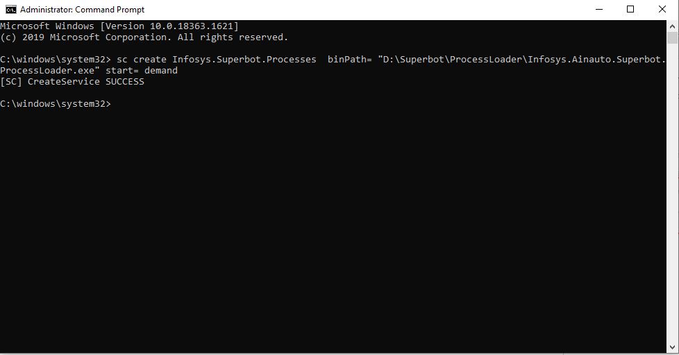

1. Open the services.msc by typing services.msc in the run .

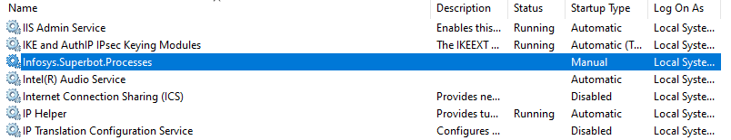

1. In the services list find the superbot process that has been created and right click to open the properties window.

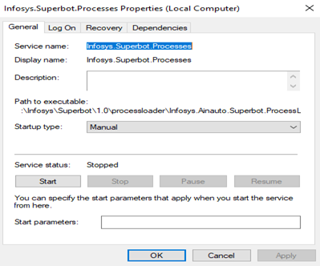

1. Click on Log On tab on the top and add windows service account to start the service

and click on Apply.

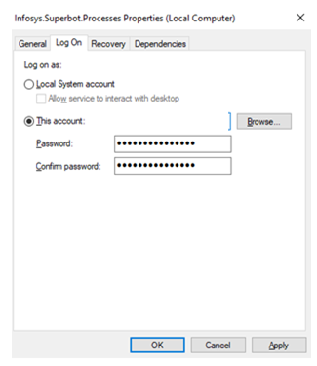

1. Right click on the Infosys.Superbot.Processes service to start the service .

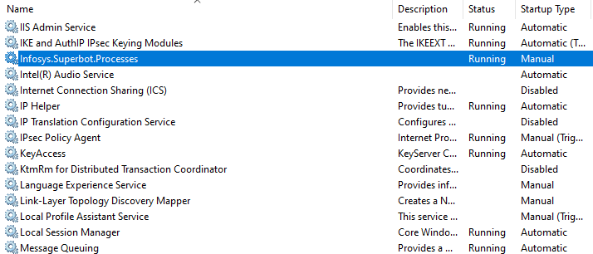

# Superbot Environment Scan Setup

## Prerequisites

* Admin access required to create task
* Service account is required for task execution
* Ensure that the libraries have been extracted to folder “<Drive>:\Infosys\Superbot\1.0\environmentscan” as mentioned in section 2
* “Infosys.Lif.MSMQ.dll” needs to be available in C:\Infosys.IntegrationLib\References\

## Setting Environment Scan Task

Thisallows Environment Scan Executable to be automatically executed whenever a certain set of conditions is met.

1. Open Task Scheduler from windows search tab .



1. Click on Create Basic Task tab on the left



1. Give the task name as **Infosys.SuperBot.EnvironmentScan** and click on next

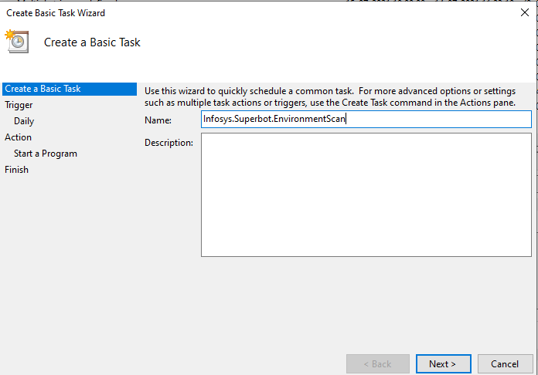

1. Set the task trigger according to your preference and click on next.



1. Select the start date and time for the task and click on next.

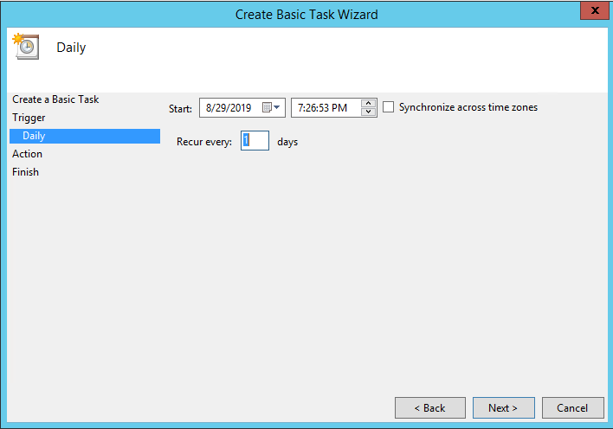

1. Select Start a program option in Action window and click on next.



1. Provide path for the **EnvironmentScan.ConsoleApp.exe** present in **<Drive>:\Infosys\Superbot\1.0\environmentscan** folder and provide arguments separated with spaces as shown in image-

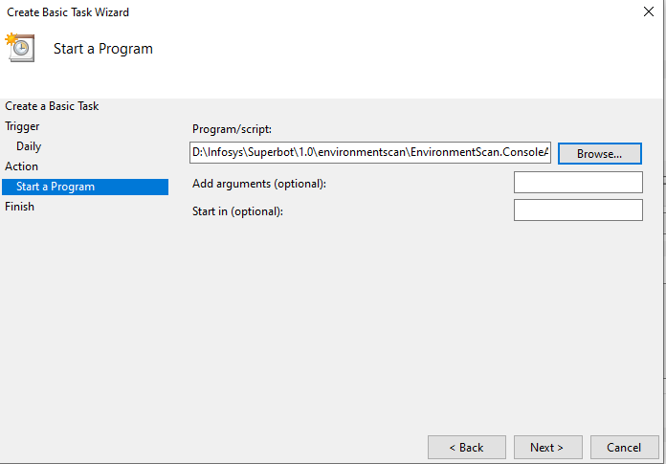

Click on next and click on finish .

1. The created task will be now shown in task scheduler library .

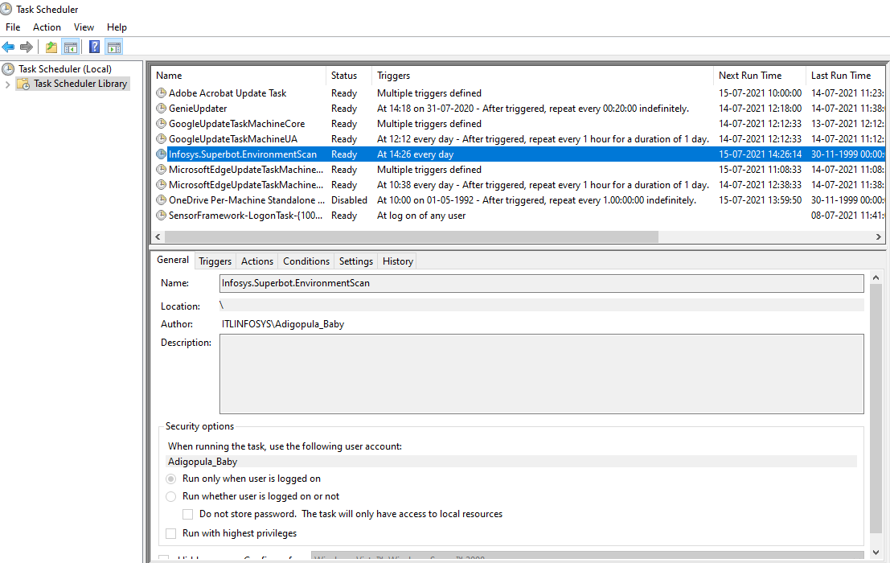

Double click on task and following window will open –

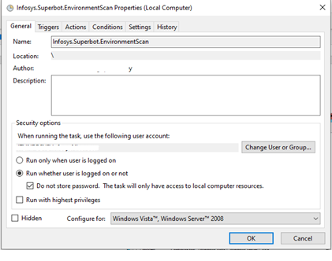

1. Click on Change User or Group in order to run the task with windows Service Account. Make sure to select Run whether user is logged on or not option below.
2. Click on Triggers option on top following window will appear –

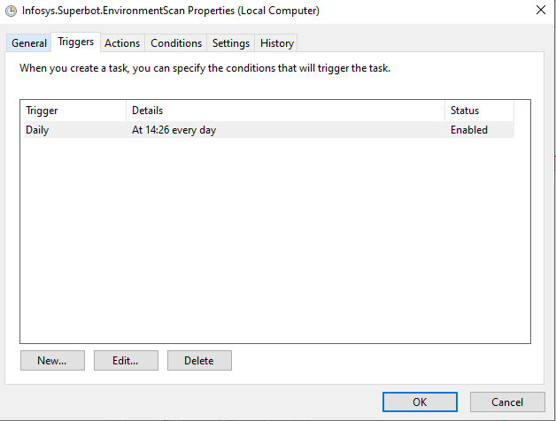

1. Click on Edit option in order to set the task run frequency schedule

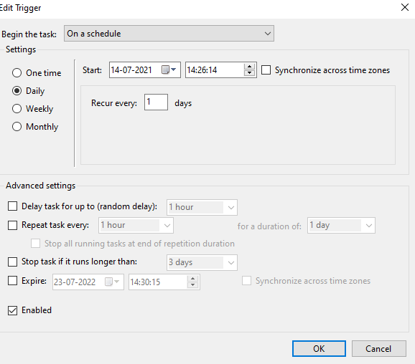

* In the Advanced settings section, you can provide the task run frequency according to Environment Scan ( How frequently you need to do ) requirement for the task to repeat after specified time For eg. For every day
* After setting click on ok.

1. In the Task Scheduler Library click right click on the created Infosys.SuperBot.EnvironmentScan task and select run. The task will start running in the background.

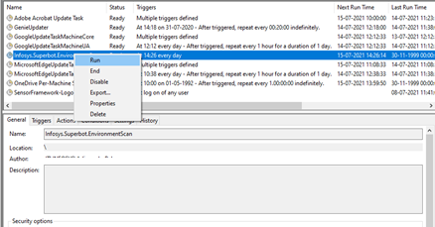

# Configuration Management View setup

## Prerequisites

* Windows Service account required for authentication and authorization
* Admin access requires for IIS
* Ensure that the libraries have been extracted to folder “<Drive>:\Infosys\Superbot\1.0\configurationmanagementview” as mentioned in section 2

## Configuration Steps

1. Follow steps present under section 5.2  from 1 to 7 (keep the site name as “configurationmanagementview” and provide the physical path as the location of “configurationmanagementview” folder present in the server)
2. After completing IIS setup try browsing below URL

<http://localhost/configurationmanagementview/home>.

# DashBoards

## Environment Operations Dashborad Setup

## Prerequisites

* Microsoft Power BI Desktop has been installed
* Ensure that the report file “EnvironmentOperationsDashboard.pbix” has been extracted to folder “<Drive>:\Infosys\Superbot\1.0\Dashboards\” as mentioned in section 2

## Setup

1. Open the report “EnvironmentOperationsDashboard.pbix” and report as shown below.

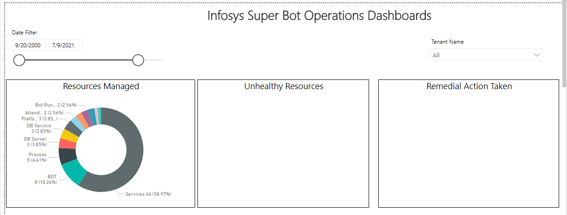

1. In case we want to change the db, Go to File and click options & setting and select Data source settings

* Before changing the data source, create local user by follow steps present under  Section 3.4 (keep the Login name as “superbotreportuser”)

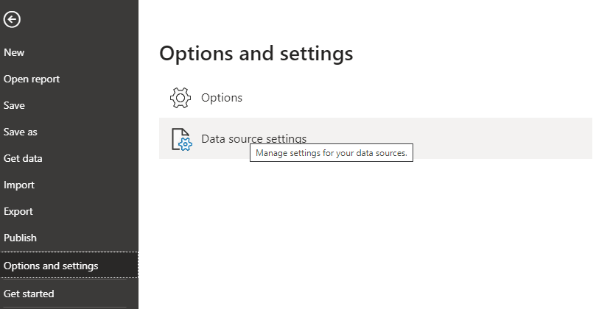

Click on “Change Source”

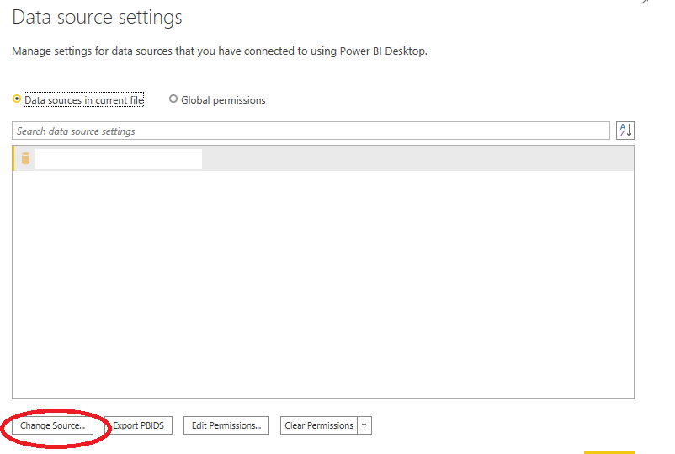

1. Provide “server”,“Database” ,created local userid and password values and click Ok

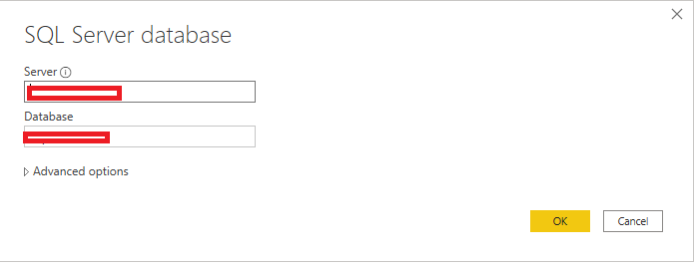

1. Report gets updated

# TroubleShooting

## SuperBot and ConfigurationManangement api

* + 1. Logs related to api’s are available in logs database.
    2. Below is the query to get the latest logs

*SELECT TOP 1000 [LogID]*

*, [EventID]*

*, [Priority]*

*, [Severity]*

*, [Title]*

*, [Timestamp]*

*, [MachineName]*

*, [AppDomainName]*

*, [ProcessID]*

*, [ProcessName]*

*, [ThreadName]*

*, [Win32ThreadId]*

*, [Message]*

*, [FormattedMessage]*

*FROM [IAPWEM_Logs]. [dbo]. [Log] order by LogID desc*

* + 1. Message and FormattedMessage give error details

## Task Scheduler failed to start

* 1. Task scheduler failed to start due to invalid windows service account

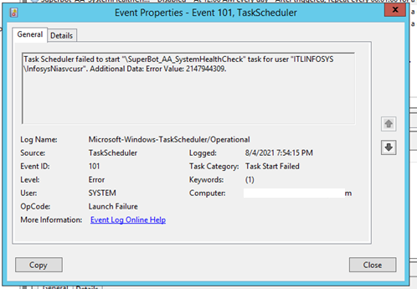

* 1. Update task scheduler user details with valid windows service account

## Cannot connect to SQL Server

“Cannot connect to the server” error occurred due firewall.

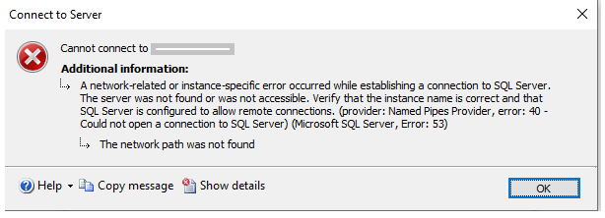

Add the sql server port “1433” to windows firewall as mentioned in Section

## Cannot run the Task

User cannot runt the scheduled task due to Log on as batch job rights

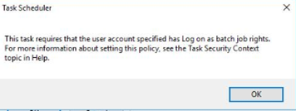

Add windows service account to “Logon as batch job policy” as mentioned in section

# FAQ

1. Which features of MSMQ to be selected?
2. Refer to the section
3. Which features of IIS to be selected?
4. Refer to the section
5. How to add SQL Server port “1433” to windows firewall?
6. Refer to the section
7. How to windows service account to “Add logon as batch job” policy?
8. Refer to the section