**Infosys RPA Control Center User Guide**

**Jul-2021**

COPYRIGHT NOTICE

© 2021 Infosys Limited, Bangalore, India. All Rights Reserved. Infosys believes the information in this document is accurate as of its publication date; such information is subject to change without notice. Infosys acknowledges the proprietary rights of other companies to the trademarks, product names and such other intellectual property rights mentioned in this document. Except as expressly permitted, neither this documentation nor any part of it may be reproduced, stored in a retrieval system, or transmitted in any form or by any means, electronic, mechanical, printing, photocopying, recording or otherwise, without the prior permission of Infosys Limited and/or any named intellectual property rights holders under this document.

Infosys Limited

Electronic City,

Hosur Road,

Bangalore 560 100

India.

Telephone: 91 80 2852 0261

Fax: 91 80 2852 0362

Website: http://www.infosys.com

**Table of Contents**

1. Introduction 4

2. Clusters 4

3. Portfolios 4

4. Component Health 6

5. Environment Scan 12

# Introduction

This document helps user to understand the RPA Control center Dashboard. The Infosys RPA Control center provides a cumulative view of the health of the various RPA/IT components. If health is identified as warning or critical, remediation actions can be taken by Infosys Super Bot.

# Clusters

* Cluster is nothing but a group of Portfolios, user can create “n” number of clusters. If user wants to create a new cluster, please refer “Create Portfolio” Section in SuperBot_Installation_Document.docs
* Open “http://localhost:8080/ops-portal/”
* Go the left side panel and click the “CLUSTER LIST”, it displays all clusters which are configured in the system and its health
* In this example, the user has configured the following Clusters
  + Finance – AA
    - It has 2 portfolios, and both are healthy
  + Logistics – UiPath
    - It has 2 portfolios, in that 1 portfolio is Critical

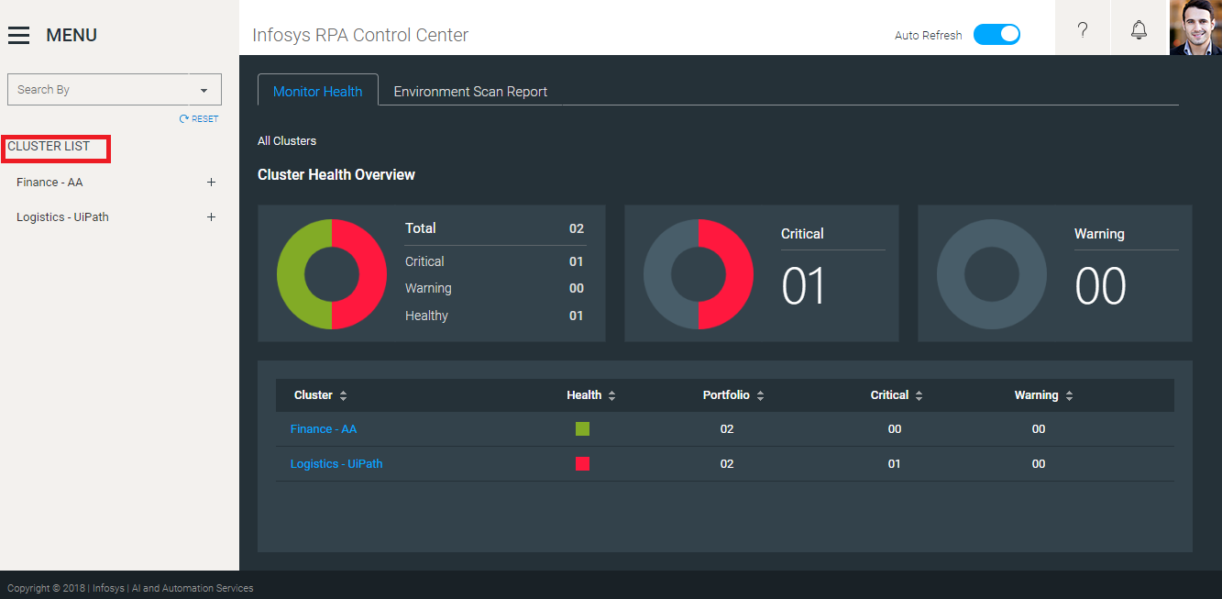

Figure

# Portfolios

* Portfolio is nothing but a group of RPA/IT components, user can create “n” number of Portfolio and Map with any RPA/IT components.
* If user wants to create a new Portfolio, please refer “Create Portfolio” Section in SuperBot_Installation_Document.docs
* If user wants to Map the RPA/IT components to Portfolio, please refer “Map Resource to Portfolio” section in Infosys Resource Configuration – RPA Platform Configuration User Guide
* If the user clicks on “**Finance-AA**” cluster, it displays all portfolios which are configured under this “**Finance-AA**” cluster and its health
* In this example, the user has configured the following Portfolios under “Finance – AA” cluster
  + Finance Infrastructure
    - It has 28 RPA/IT components, and all are healthy
  + Finance Business Process
    - It has 4 RPA/IT components, and all are healthy

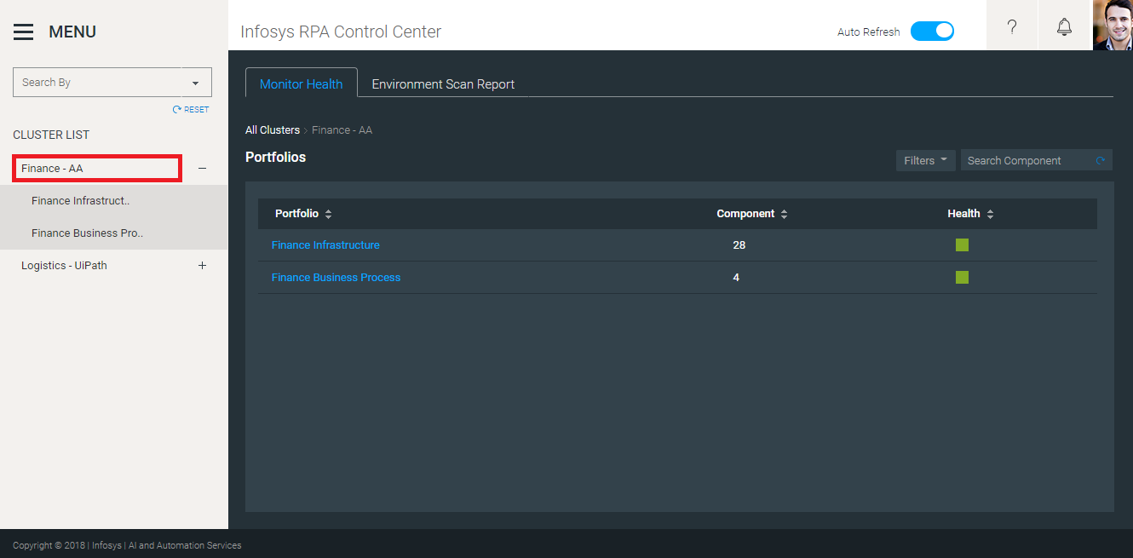

Figure

# Component Health

* If user clicks on portfolio it will display overall health of the components under that portfolio

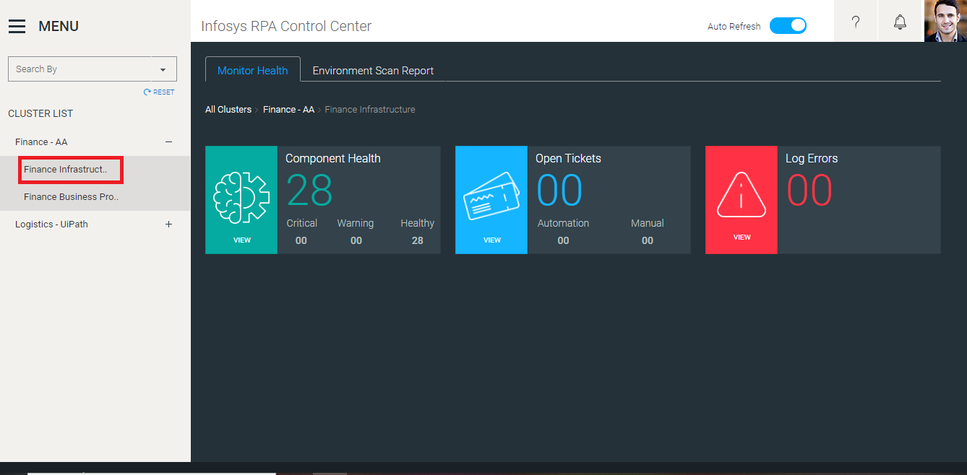

Figure

* Component Health has three cards

1. Component Health
2. Open Tickets – <<Not Implemented>>
3. Log Errors – <<Not Implemented>>

* Component Health card provides the following information
  + Total number of Components under the portfolio
  + Number of Critical Components under the portfolio.
  + Number of Warning Components under the portfolio
  + Number of Healthy Components under the portfolio
* In this example all the 28 components under Finance Infrastructure are healthy

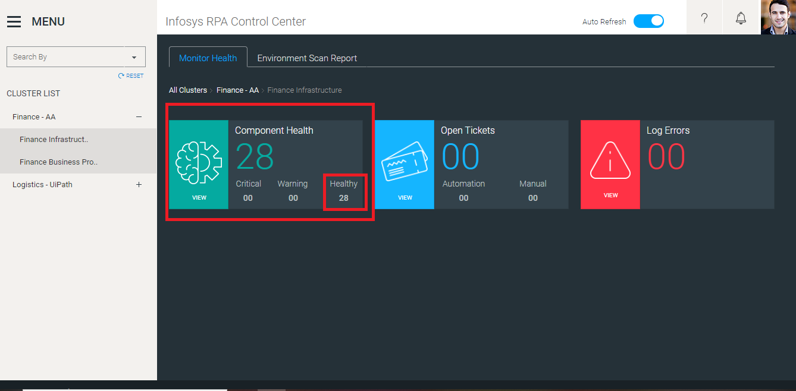

Figure

* If user clicks on Component Health card, then it displays all the components.

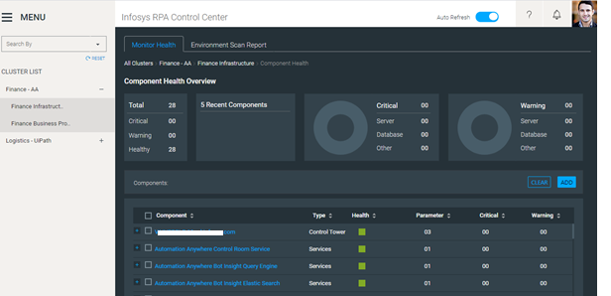

* This screen provides the health overview of all the components and it has the following cards
* Total: It provides total count of the components and how many of them in healthy, critical, and warning stage
* 5 Recent Components: It provides 5 Recent un-healthy component details
* Critical: Total Number of Critical components (like server, Database and Other)
* Warning: Total Number of Warning components (like server, Database and Other)
* These cards will act as filters, for example if user click on critical card it will show only critical components in the Component Section.
* Component Section will have information about each component. It will show Type of components, health, number of parameters, critical and warning count
* If user expands the component by clicking “plus” icon it will show all the monitoring parameters, Maximum Threshold value and Actual value of that component.

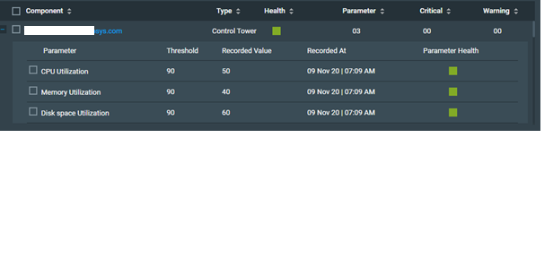

Figure

* User can use “Add” option to apply filter the components based on Health and Type.

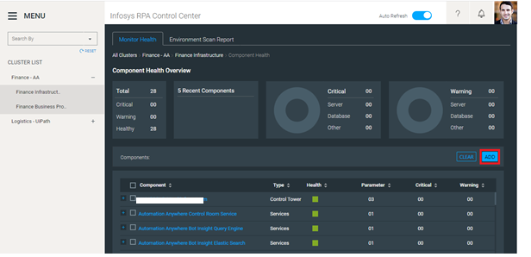

Figure

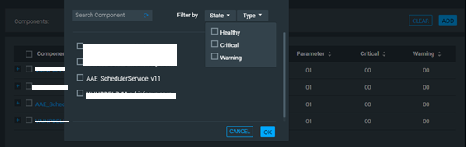

Figure

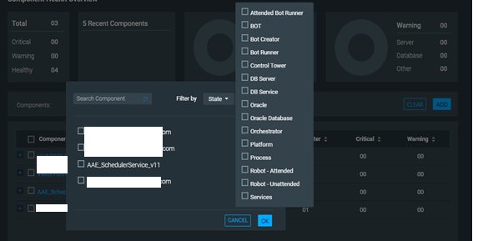

Figure

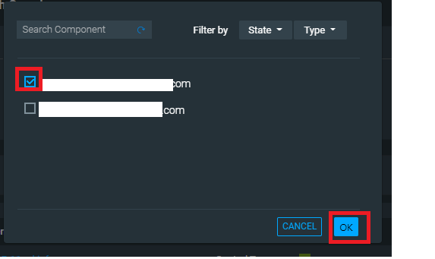

Figure

* Based on the filter, System will display only those components

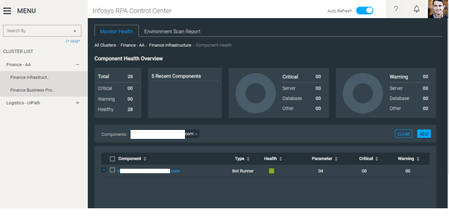

Figure

* If user clicks on “Clear” Button, all the filters will be removed, and displays all the Components.

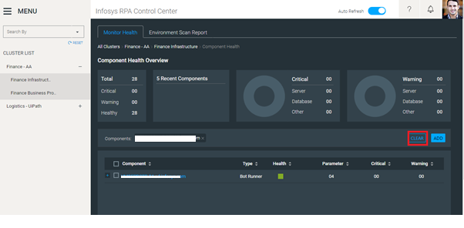

Figure

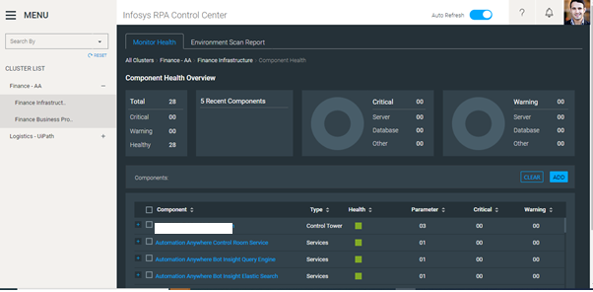

Figure

# Environment Scan

* Environment Scan Reports provides the following details of the RPA Components
  + Installed Software details
  + OS Details
  + Screen Resolution Details
* For example: User has given the following details and click submit. It displays any Software/OS/Screen Resolution installed/modified/Deleted during the period
  + Resource Type: Bot Runner
  + Resource Name: VM0001
  + Start Date: 14-Apr-2020
  + End Date: 16-Apr-2020

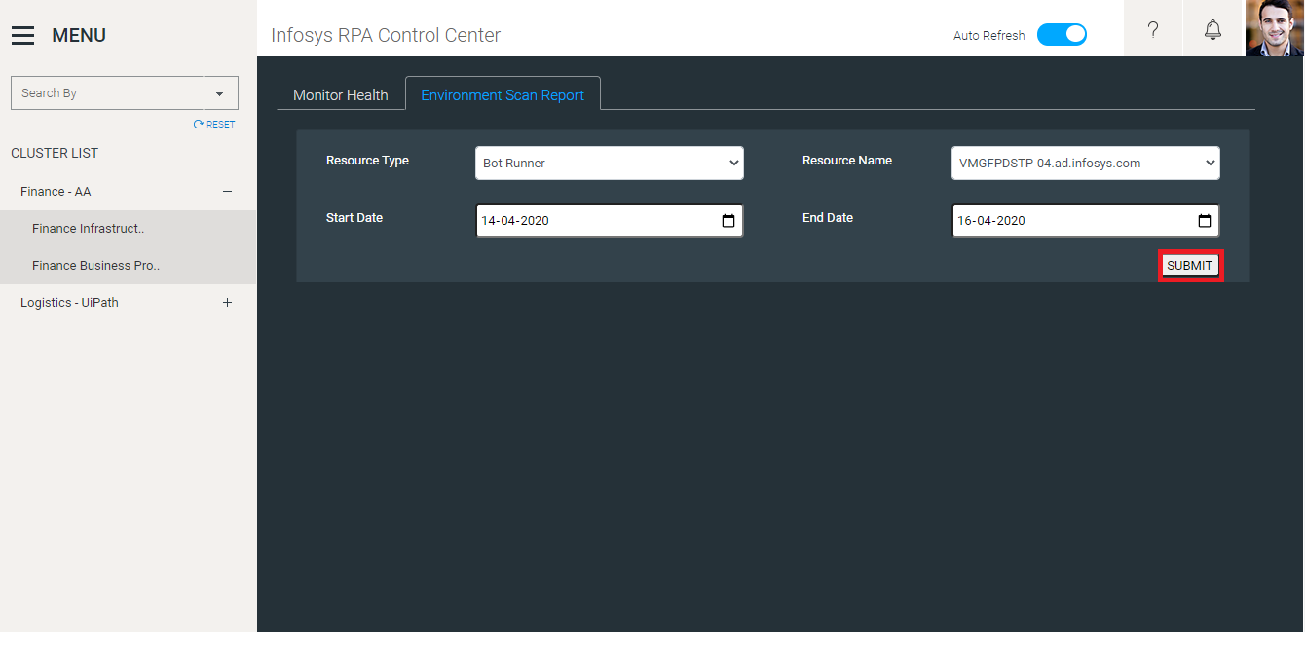

Figure

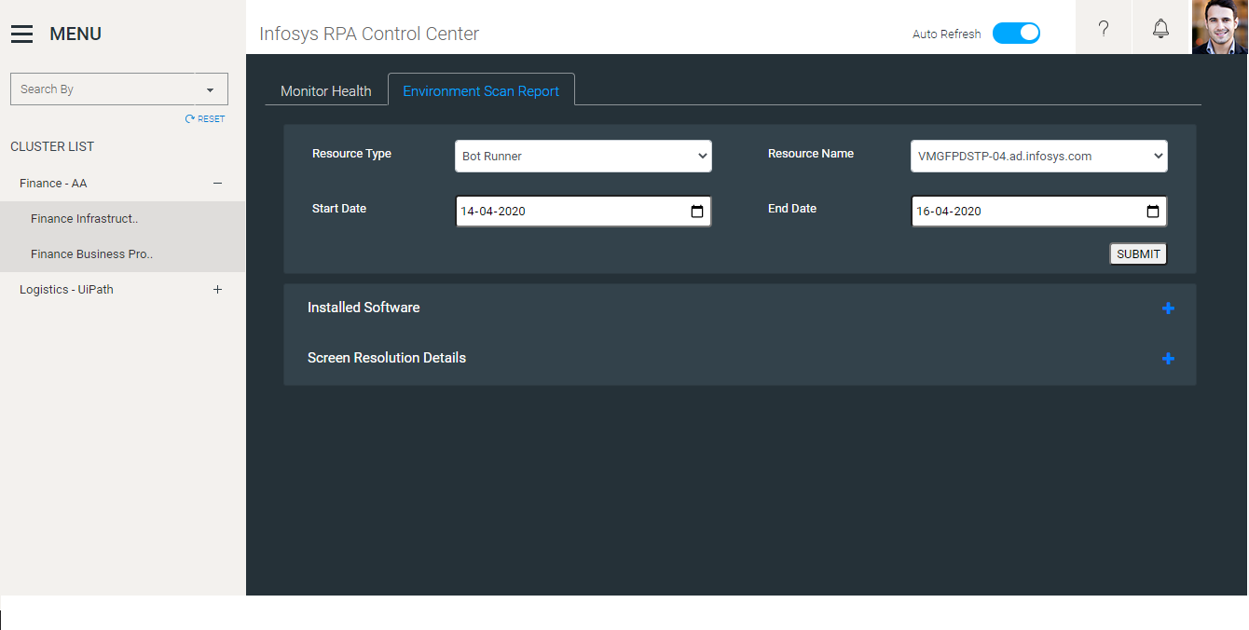

Figure

* If user can expand the details by clicking “plus” icon, it will display all the information

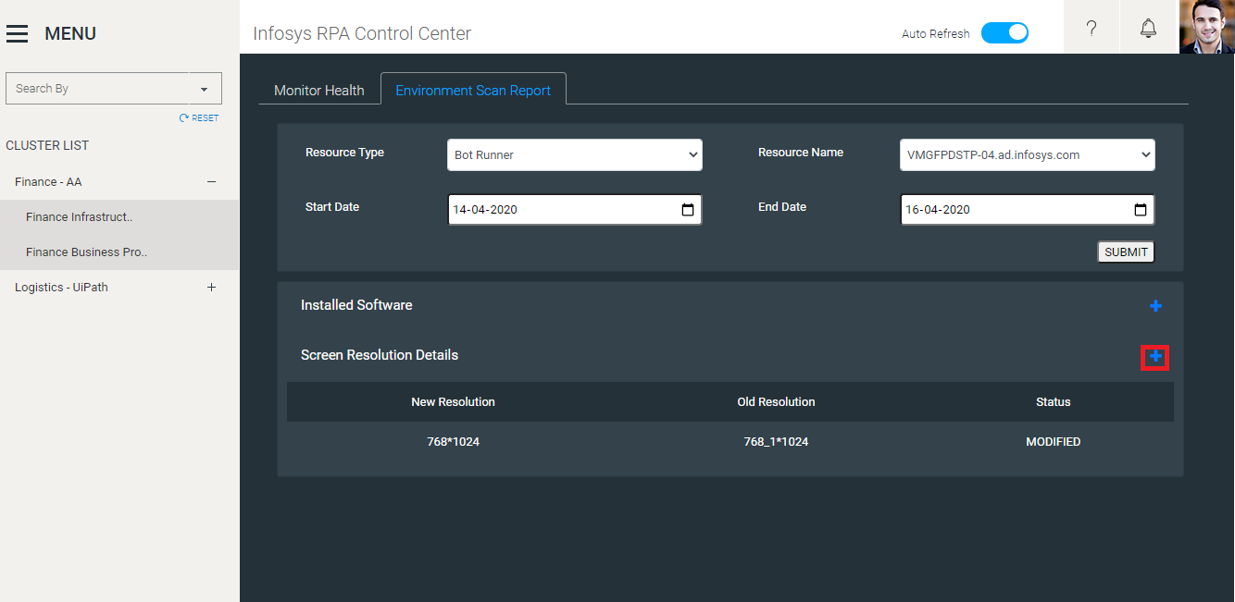

Figure