Home Page

https://hireprogrammeruk.testingweblink.com/



Rewrite the CTA button text for: Why Choose Us
Linked URL: https://hireprogrammeruk.testingweblink.com/about

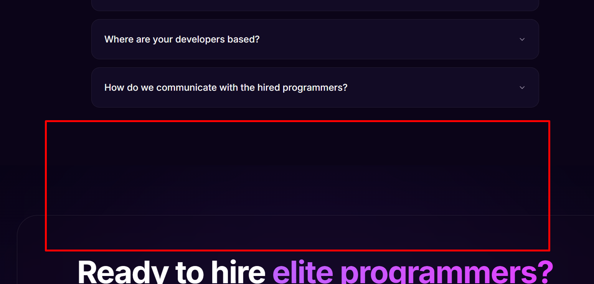

Please fix the spacing issue.

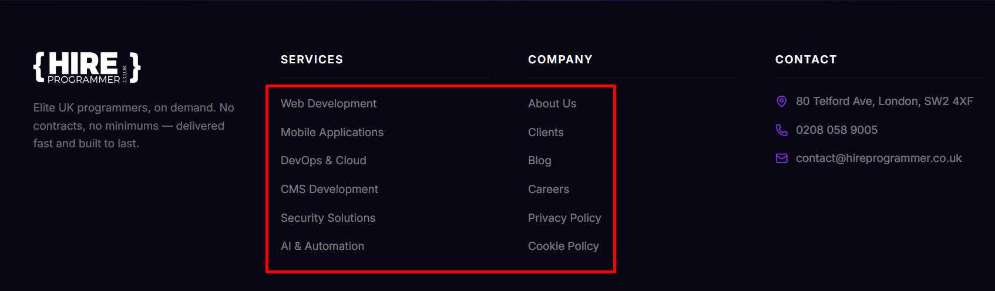

Ensure the Services and Company pages are redirected to the correct URLs.

Note: Please add all the services to the website footer.

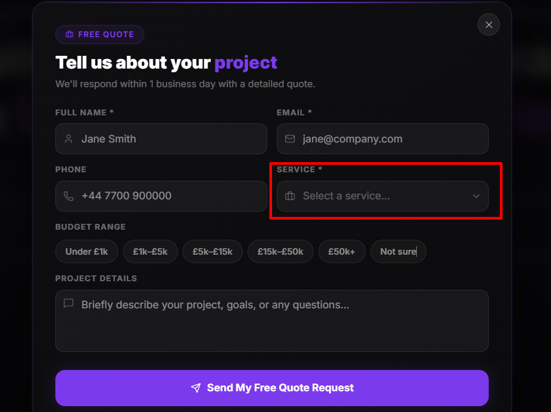

Please add all the services, as some are currently missing.

Contact Us Page

https://hireprogrammeruk.testingweblink.com/contact

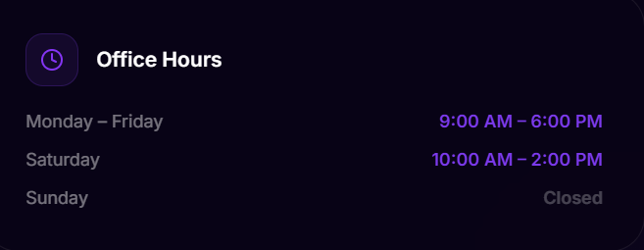

- Monday: 9:00 AM – 5:30 PM
- Tuesday: 9:00 AM – 5:30 PM
- Wednesday: 9:00 AM – 5:30 PM
- Thursday: 9:00 AM – 5:30 PM
- Friday: 9:00 AM – 5:30 PM
- Saturday: Closed
- Sunday: Closed

Please update these business hours.

About Us Page

https://hireprogrammeruk.testingweblink.com/about



Please add relevant images for the team members.

Clients Page

https://hireprogrammeruk.testingweblink.com/clients

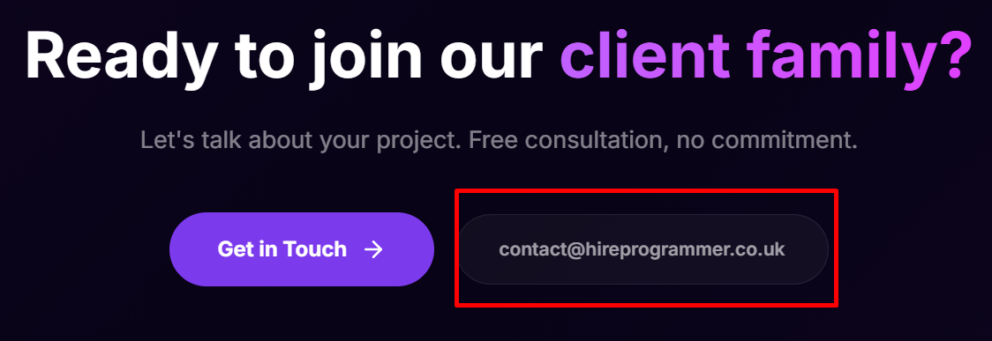

Since users can already contact us through the 'Get in Touch' button, the email address is not relevant in this section and can be removed.

Service Page

https://hireprogrammeruk.testingweblink.com/services

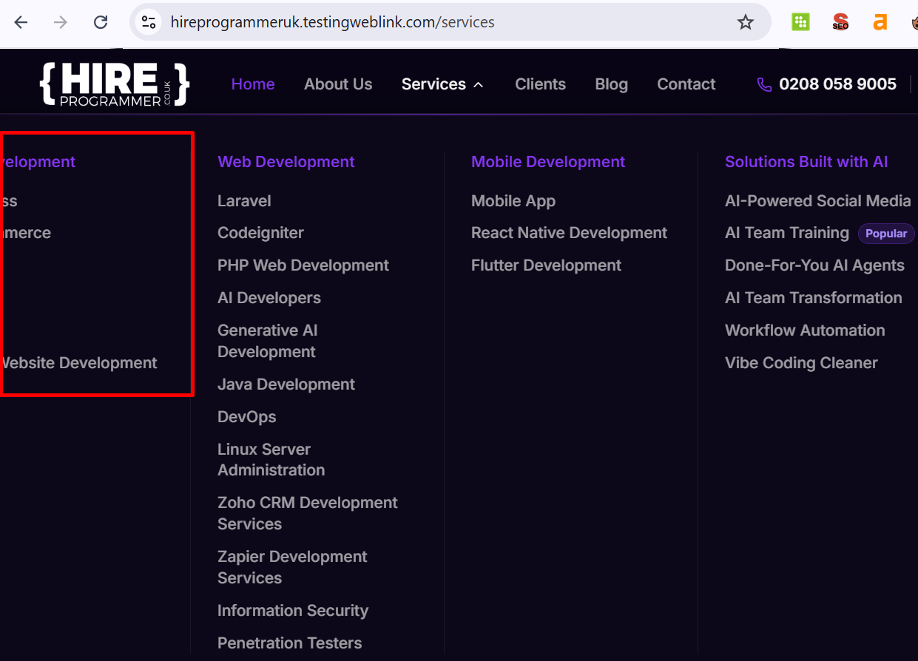

The text in the Services dropdown menu is being cut off on the left side. Please adjust the menu width, padding, or alignment to ensure all text is fully visible.



Since the 'Get in Touch' button is already available in this section, the phone number appears to be unnecessary and can be removed.

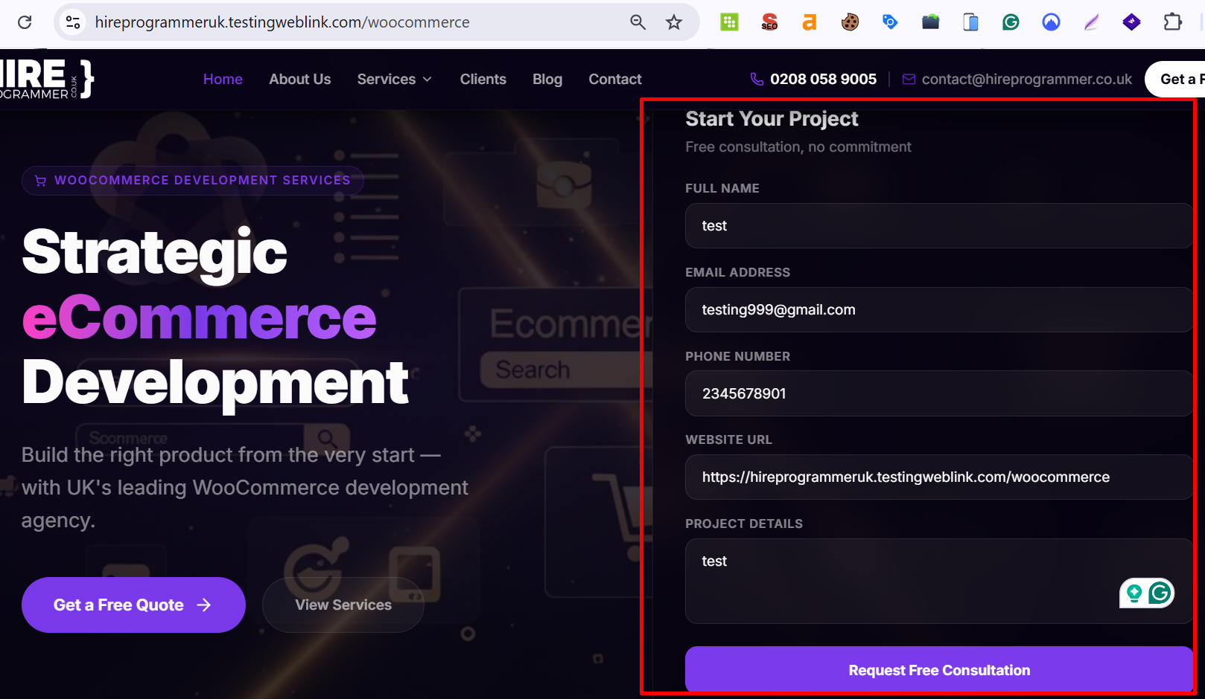

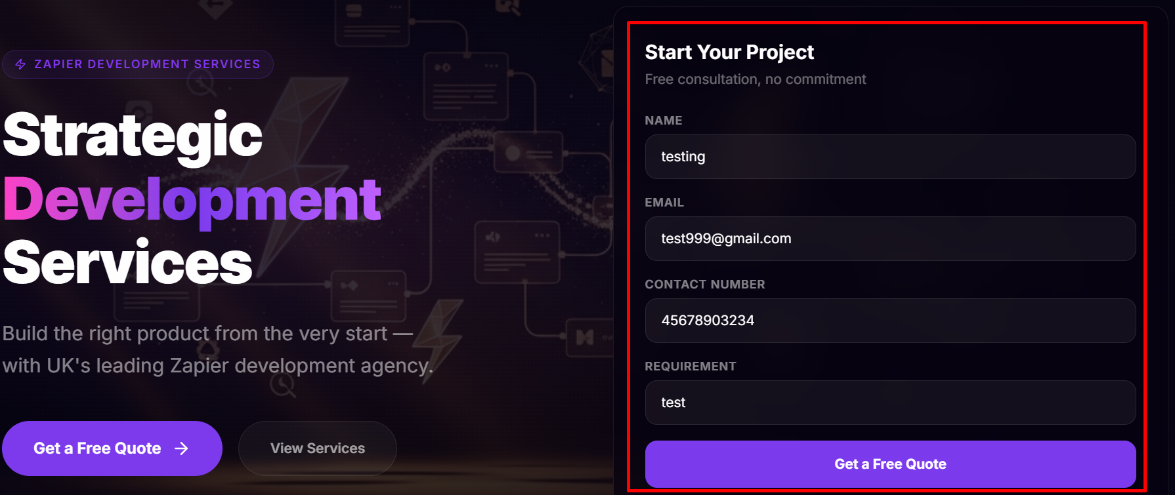

Please check the form submission functionality. The form is not submitting directly; instead, it triggers another CTA form popup. It should submit successfully without opening any additional forms.

Note: Please make sure all service pages have these issues resolved.



https://hireprogrammeruk.testingweblink.com/woocommerce

Note: Since the 'Get in Touch' button is already available in this section, the phone number appears to be unnecessary and can be removed from all service pages.

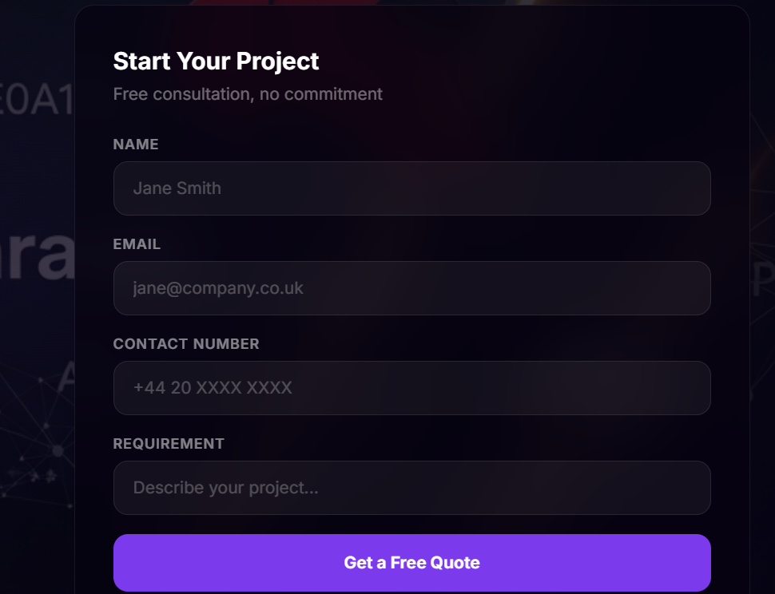

https://hireprogrammeruk.testingweblink.com/ai-team-training

https://hireprogrammeruk.testingweblink.com/ai-agents

https://hireprogrammeruk.testingweblink.com/ai-team-transformation

https://hireprogrammeruk.testingweblink.com/workflow-automation

https://hireprogrammeruk.testingweblink.com/vibe-coding-cleaner

Can we add a contact form similar to the one shown above on the following pages to improve lead generation and user engagement?



URL: https://hireprogrammeruk.testingweblink.com/ai-team-training

Please remove the 'Free Consultation' button, as it links to the same destination as the 'Get Your Team Started' button.



URL: https://hireprogrammeruk.testingweblink.com/ai-team-transformation
Please remove the 'Free Consultation' button, as it links to the same destination as the 'Get Your Team Started' button.

