# InfraGard Technology Tool Kit Disclaimer Notice:

# Created by Deborah Watson, Technology Tool Kit Program Development Manager, InfraGard - Houston Chapter; adapted from content created by Dave Armstrong, dave@bindshell.net

# IN NO EVENT SHALL INFRAGARD BE LIABLE TO ANY PARTY FOR DIRECT, INDIRECT, SPECIAL, INCIDENTAL, OR CONSEQUENTIAL DAMAGES, INCLUDING LOST PROFITS, ARISING OUT OF THE USE OF THIS SOFTWARE AND/OR DOCUMENTATION, EVEN IF INFRAGARD HAS BEEN ADVISED OF THE POSSIBILITY OF SUCH DAMAGE.

# INFRAGARD SPECIFICALLY DISCLAIMS ANY WARRANTIES, INCLUDING, BUT NOT LIMITED TO, THE IMPLIED WARRANTIES OF MERCHANTABILITY AND FITNESS FOR A PARTICULAR PURPOSE. THE SOFTWARE AND/OR ACCOMPANYING DOCUMENTATION, IF ANY, PROVIDED HEREUNDER IS PROVIDED "AS IS". INFRAGARD HAS NO OBLIGATION TO PROVIDE MAINTENANCE, SUPPORT, UPDATES, ENHANCEMENTS, OR MODIFICATIONS.

# Coder

A windows utility to encode and decode various encoding schemes. Currently supports Base64, Hex, HTTP URL Encoding and MD5.

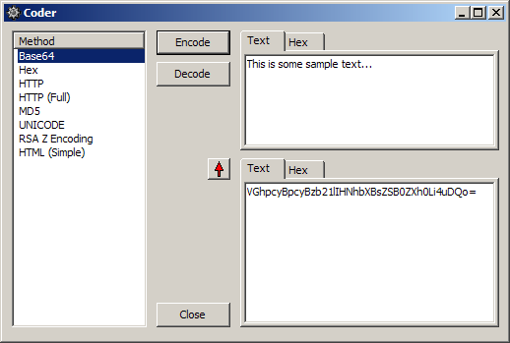

**Download**

A safe version of **Coder** can be obtained from the InfraGard site at [***insert link here*]**: [Coder-2-4-1.zip](http://bindshell.net/tools/coder/Coder-2-4-1.zip) (md5sum: 97aa747de06588d1d040fa478ace4b48)