# InfraGard Technology Tool Kit Disclaimer Notice:

# Created by Deborah Watson, Technology Tool Kit Program Development Manager, InfraGard - Houston Chapter; adapted from content created by Dave Armstrong, dave@bindshell.net

# IN NO EVENT SHALL INFRAGARD BE LIABLE TO ANY PARTY FOR DIRECT, INDIRECT, SPECIAL, INCIDENTAL, OR CONSEQUENTIAL DAMAGES, INCLUDING LOST PROFITS, ARISING OUT OF THE USE OF THIS SOFTWARE AND/OR DOCUMENTATION, EVEN IF INFRAGARD HAS BEEN ADVISED OF THE POSSIBILITY OF SUCH DAMAGE.

INFRAGARD SPECIFICALLY DISCLAIMS ANY WARRANTIES, INCLUDING, BUT NOT LIMITED TO, THE IMPLIED WARRANTIES OF MERCHANTABILITY AND FITNESS FOR A PARTICULAR PURPOSE. THE SOFTWARE AND/OR ACCOMPANYING DOCUMENTATION, IF ANY, PROVIDED HEREUNDER IS PROVIDED "AS IS". INFRAGARD HAS NO OBLIGATION TO PROVIDE MAINTENANCE, SUPPORT, UPDATES, ENHANCEMENTS, OR MODIFICATIONS

# SynScan

A fast half-open portscanner. This tool will send TCP packets with the SYN flag set at the destination address. SynScan will send traffic as fast as the host network interface can support.

Developer: John Anderson

Was originally based on SynScan version 1.6 by psychoid with the following changes:

* Fixes for several format string overflows and other bugs
* Split into multiple programs for sending and receiving of SYN packets
* Added a separate "sslog" tool which only logs open ports and doesn't perform further checks
* Support for identifying samba servers in synscand
* Support for querying the Server: header on HTTP servers
* Support for Open X11 server scanning
* Ported to Solaris and IRIX operating systems
* Adjusted scan timing to provide for much faster network scanning
* Added support for IPv6 (currently in beta)

**Screen Shots**

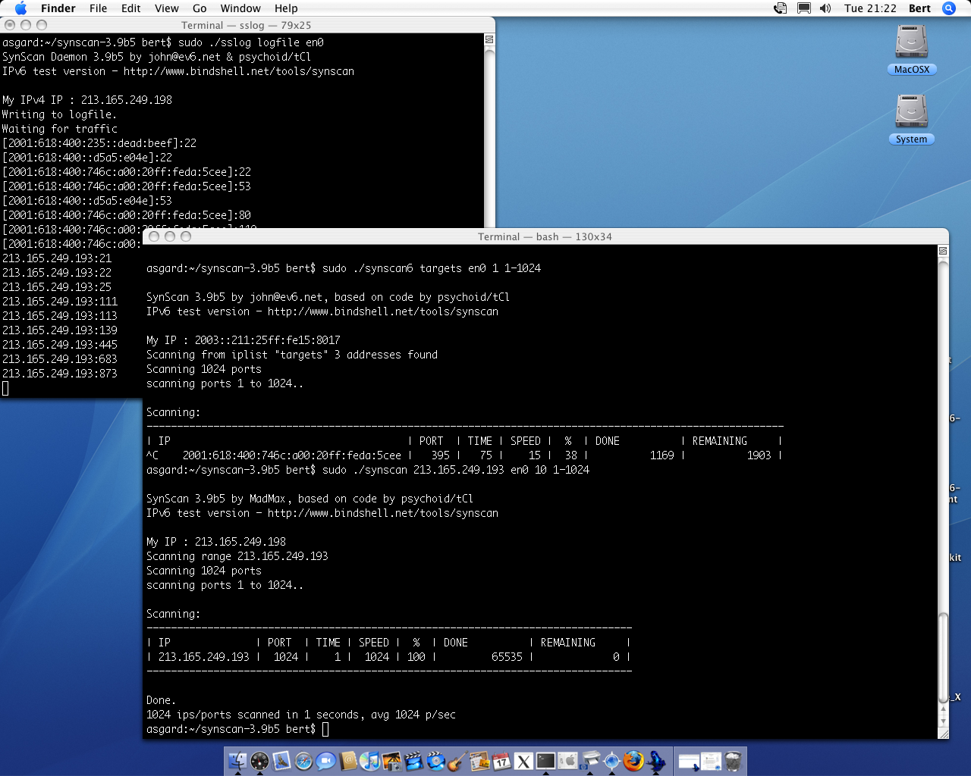

Download A safe version of RFIDTool can be obtained from the InfraGard site at: [insert links] [synscan-3.9b8.tar.gz](http://bindshell.net/tools/synscan/synscan-3.9b8.tar.gz) (md5sum: 319357bb2f4cbd50271a09d2339e5d3f)