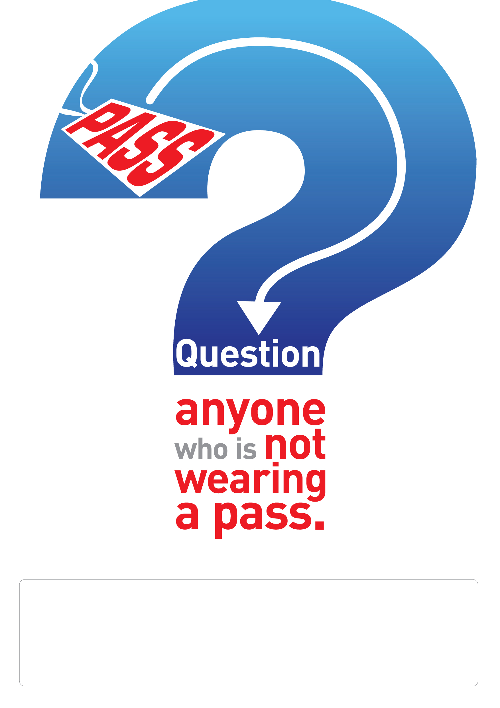
YOUR COMPANY INFORMATION HERE

