UNIT 4.
DATABASE DESIGN AND DEVELOPMENT

Subject: Advanced Programming (Programación Avanzada)
Course: 2PVG
Professor: Arnau Rosselló
Year: 2025-2026
Students: Andreu Sánchez Castelló, Guillermo Martorell Hurtado

Index

1.- Database 03
Structure 03
Relations 03

2.- Tasks 04
Maria DB connection 04
SQLite connection 04
ImGui 04
ESAT’s Graphic Library 04

3.- User manual 05

4.- Conclusions and future work (Post-Mortem) 08

1. DATABASE

Structure

Our database design represents and connects various objects related to the game Rummikub. It consisted, initially, of 13 entities.
User | Difficulty
Tile | Game_Config
Tile_Status | Match_Group
Match | Tournaments
Match_Tile | Tournaments_Payout
Match_Players | Tournaments_Registration
Match_Reward
In our database the table and column names will be in Spanish. Some entity attributes / table columns have been omitted for simplicity.

Relations
The aforementioned entities are related to one another, following the schema shown below:
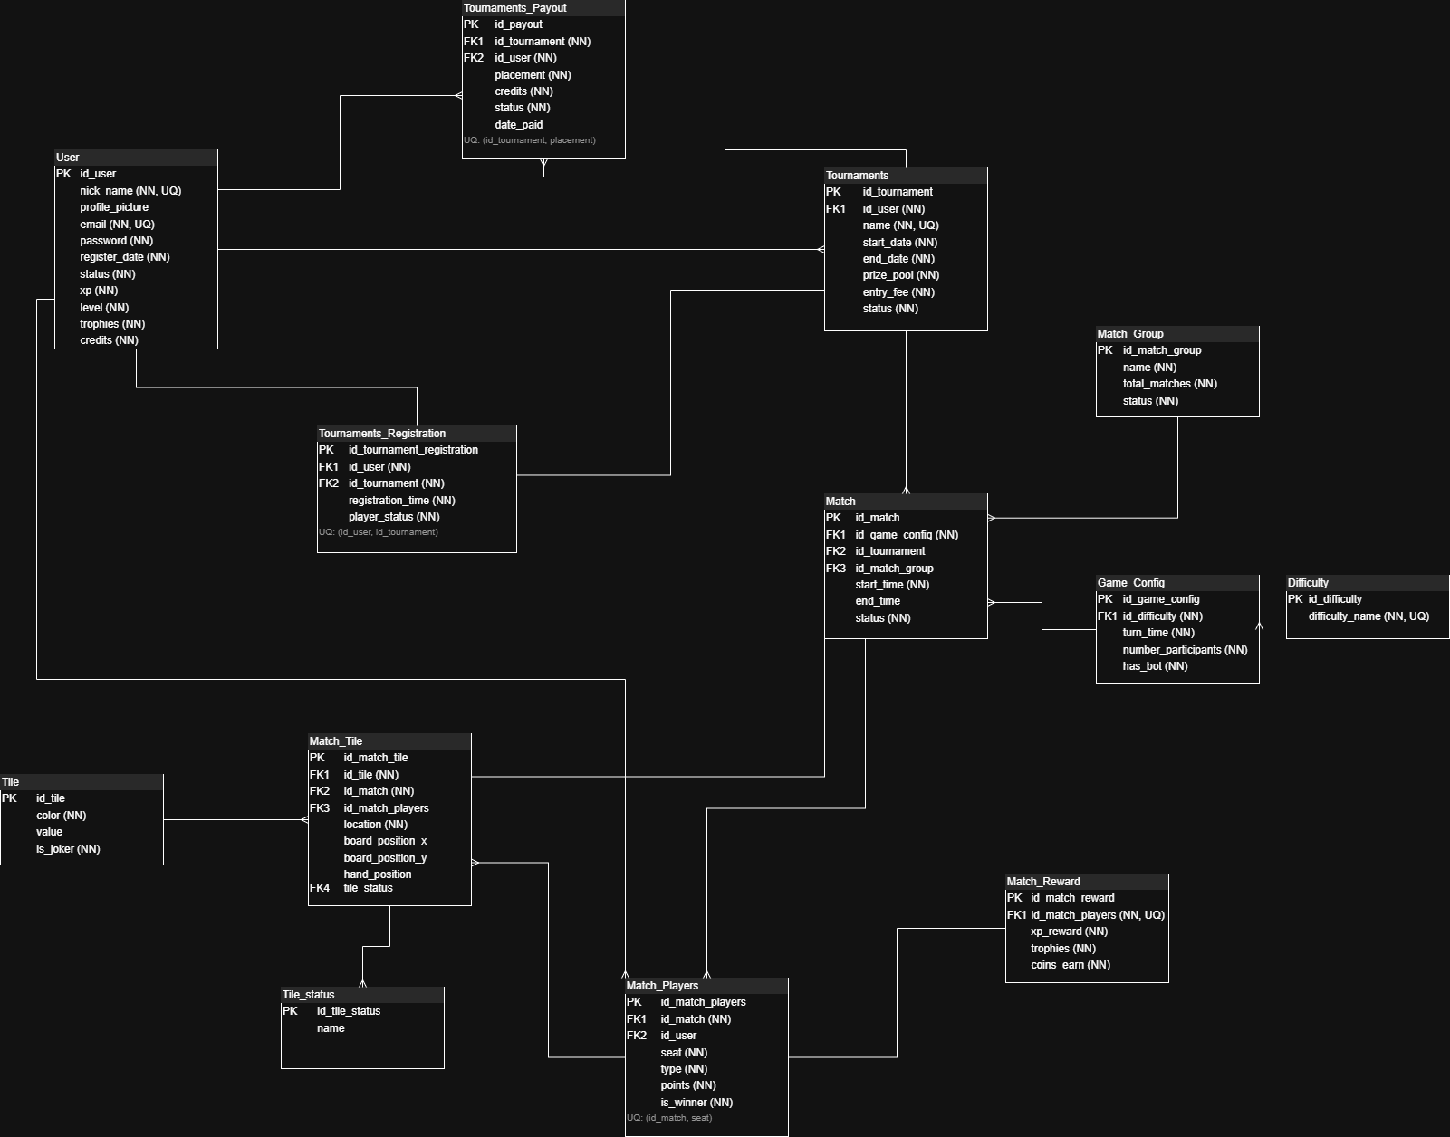

2. TASKS

The project was initially designed with the MariaDB DBMS in mind. Later on, we decided to add support for SQLite databases as well.

Since our graphic library is compiled for a 32-bit architecture, this forces our application code to be 32-bit compatible.

Maria DB Connector (Made by Andreu Sánchez)
Modern MariaDB libraries are meant for a 64-bit architecture, but luckily, there are some well-maintained projects of 32-bit connectors that we could use in our project.

This option connects to a remotely-hosted MariaDB instance, that can be managed from the program interface. This connection can be tested using file
connection.cc (instructions below).

SQLite Connector (Made by Guillermo Martorell)
This connector allows the user to manage a file-based SQLite database that is picked using a file dialog.

Made by using sqlite3’s amalgamation, which contains, in just a couple of files, all required code to interact with SQLite databases.

ImGui
Our program’s visual side was made using ImGui, a command-based graphical interface optimized for performance and widely used in a variety of applications.

ESAT’s Graphic Library
The last piece of the puzzle is our school’s graphic library, which acts as a graphical backend / renderer for ImGui. The key point here is to prevent the main draw loop from executing SQL queries on each frame, which would stress the database and potentially freeze our program’s execution.

3. USER MANUAL

This section will guide you through the required steps to compile, run and use our program. They assume you are on a Windows machine with a usable Visual Studio Developer Command Prompt (x86) installed on your system.

Testing the database connection
- Open a Developer Command Prompt for VS (x86) window
- Go the project’s root folder
- Execute the command: compilation.bat connection.cc
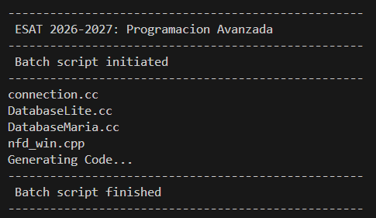
- Execute the file: connection.exe
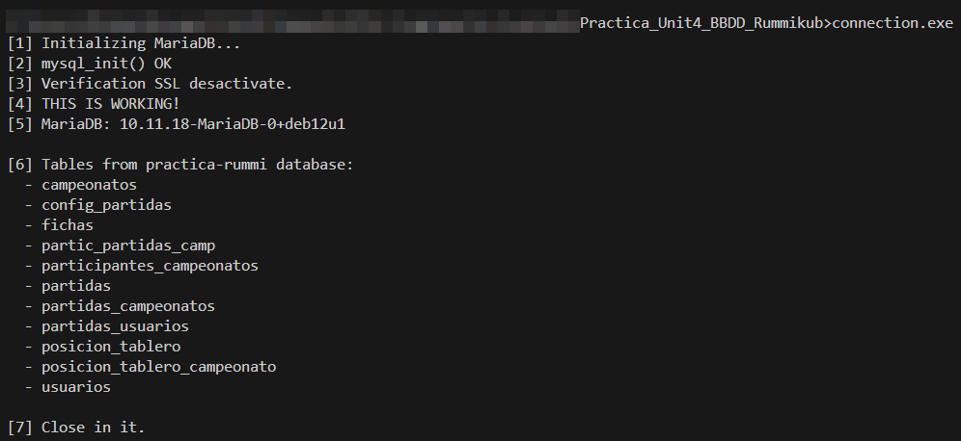

If we want to test the connection to the SQLite database (file must be located under ./SQLite/rummi.db) follow the same steps but with the connectionLite.cc file:
> compilation.bat connectionLite.cc
> connectionLite.exe

Using the program
Compilation
The script compilation.bat also allows us to compile the main program:
> compilacion.bat main.cc

If this command exits without errors, the program has been successfully compiled and a file main.exe should have been created as the main executable.

Execution and database selection
Launch our program’s entry point:

> main.exe

You will be prompted to choose between the MariaDB connection, the SQLite connection, or exit the program.
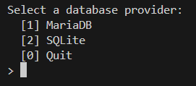

MariaDB
Picking this option brings us directly to our program’s main part, the database visor, listing all the tables contained in the Database and an additional button that shows the database structure. Clicking on any of them will list all their data.
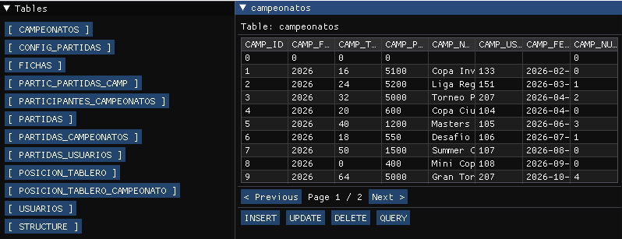
Additionally, we see some buttons to perform various operations on the database.
- DELETE allows us to remove rows. The first column is used as the removal key.
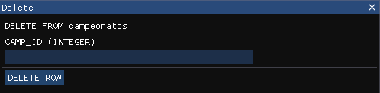

- INSERT and UPDATE bring you to the insert and edit forms, respectively. The first field is, again, used as a key for the update operation.
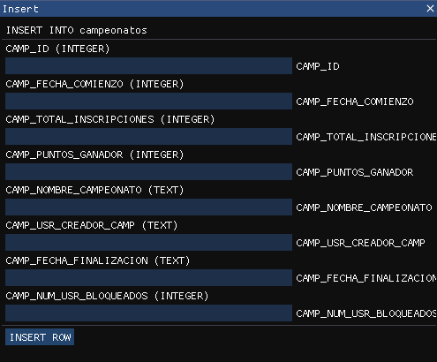
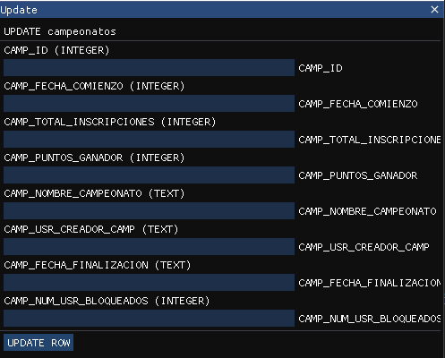

- Last, but not least, QUERY brings you to the “free-style” query menu, that allows the user to run arbitrary queries.
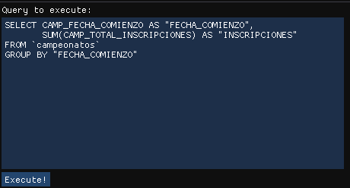

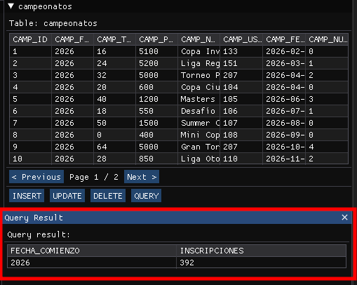
When we press “Execute!”, the query will run and the results will be shown right below the table’s data.

SQLite
Choosing this option will first show a file picker to open the SQLite database file we want to manage.
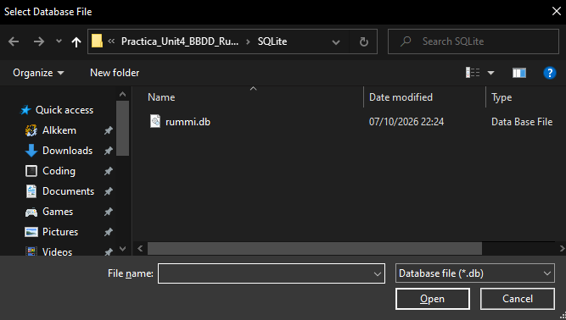

After doing so (if a valid SQLite database file is chosen) we can proceed exactly as in the previous section.

Relating tables
The “freestyle” query option also allows us to perform more complex queries, potentially relating entities between them.
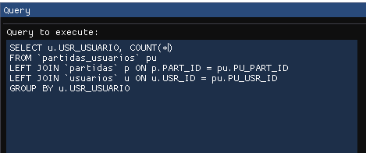
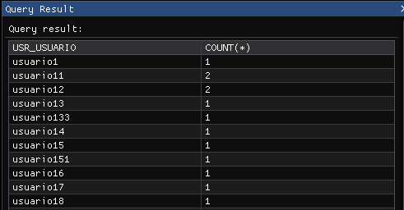

CONCLUSIONS AND FUTURE WORK (Post-Mortem)

This project served as a good example of a real-life application that we, as programmers, will have to design, implement and test in the future.

In particular, our solution:
- Allows the user to navigate the contents of a database, and also showing its structure.
- Allows the user to perform basic SQL operations on it, as well as executing more complex queries to suit the user’s needs.
- Is capable of communicating with more than one type of Database Management System.
- Does not stress the database, nor the client application, thus increasing overall performance and efficiency.
However, it still exhibits some known limitations:
- In the SQLite part, it allows writing character strings in numeric fields.
This is partly due to SQLite’s flexible column typing, but still it would be nice to disallow the input of wrongly formatted data.
- The graphical window system is sometimes a bit cumbersome to work with
- The codebase could be further organized into separated files with more well-defined responsibilities.
Overall, the implemented solution fulfills the basic needs of a SQL client application, but it could still benefit of some improvements. Nonetheless, the result was pretty decent for our current level of knowledge.

