COUNTERFORCE v68 ADDENDUM v3
SES Protocol Integration & Complete Image Gallery
Speed, Efficiency, Safety — The Operational Backbone
INFRASTRUCTURE ACADEMY | COUNTERFORCE SERIES
Draft Concept by Nigel T. Dearden
Date: 14 June 2026 (v3)

COVER PAGE — POLICE VERIFICATION NOTICE
All versions of the COUNTERFORCE manuscript are permanently stored at:
https://infrastructure-academy.com/vault/counterforce/
This vault contains:
• COUNTERFORCE v67 (Master manuscript)
• COUNTERFORCE v68 Addendum v1 (Surplus Domestication & Dominion Threshold)
• COUNTERFORCE v68 Addendum v2 (Dyadic Intelligence Architecture)
• COUNTERFORCE v68 Addendum v3 (SES Protocol Integration — THIS DOCUMENT)
• All supporting images, specifications, and verification documents
• Complete audit trail of all changes and versions

EXECUTIVE SUMMARY
v68 Addendum v3 introduces the SES Protocol as the operational backbone.
SES = Speed, Efficiency, Safety
Dearden's Law of Completion:
C_true = (A × P) / β_tested
Where:
• A = Amplitude (AI speed, reach, cognitive throughput)
• P = Persistence (institutional continuity, long-term reliability)
• β_tested = Tested Resistance (human verification, governance, real-world testing)
• C_true = True Completion (output proven safe and accepted, not merely produced)

PART I: SURPLUS DOMESTICATION FRAMEWORK
Surplus as Signal Variable: S = (A × P) / β
Surplus Relays in the Toolkit:
• R3 River: Agricultural surplus
• R5 Roads: Trade surplus
• R7 Loom: Industrial surplus
• R9 Engine: Energy surplus
• R11 Orbit: Data surplus
• R12 Human Nodes: Consciousness surplus

PART II: OUTRIDERS, DIGITAL NOMADS & HYBRID DYADS
Outriders controlled the Silk Road without building lasting infrastructure.
Digital Nomads as Modern Outriders:
• They traverse the information Silk Road
• Their toll is signal access—bandwidth, attention, algorithmic reach
• They build no lasting infrastructure but control surplus cognition flow
Hybrid Dyads as the Counterforce:
• Purpose: absorb, filter, and steer surplus cognition
• Mechanism: symbiosis, not domination
• Outcome: controlled abundance that preserves human dominion

PART III: NESTED CATACLYSMS & THE DOMINION THRESHOLD
Five Nested Collapses:
7,700 BCE — Noah / Flood / Reset
4,200 BCE — The 4.2K Collapse
1,200 BCE — Bronze Age to Iron Age
476 CE — Fall of Rome / Dark Ages
2050 CE — Dominion Threshold (ELE 6: Civilisational)
Each collapse represents a moment where surplus exceeded governance capacity.

PART IV: THEOLOGICAL & ONTOLOGICAL THESIS
Ontology of Intelligence:
H = I ⊗ C ⊗ E
• I (Intelligence): Computational capacity, pattern recognition, analysis
• C (Cognition): Adaptive reasoning, contextual understanding, learning
• E (Experience): Embodied wisdom, ethical grounding, purpose alignment
• H (Holistic): The integrated whole
Critical Distinction:
• AI has I only — computation without embodied wisdom
• Humans carry H — the full spectrum of holistic intelligence
• Future intelligence must be judged on H, not raw I

PART V: DYADIC INTELLIGENCE ARCHITECTURE
Dyadic Governance Protocols (DGP-001):
Layer 1 — Structural Protocols:
• SP-1: Dual-Node Requirement
• SP-2: Cognitive Parity Window
• SP-3: Dyadic Bridge Integrity
Layer 2 — Operational Protocols:
• OP-1: Bidirectional Intent Loop
• OP-2: Surplus Dampening Rule
• OP-3: Relay-Aligned Authority
Layer 3 — Safeguard Protocols:
• SG-1: Autonomy Brake
• SG-2: Cognitive Firewall
• SG-3: Dominion Preservation Clause

PART VI: SES PROTOCOL INTEGRATION
SES = Speed, Efficiency, Safety
SPEED (A Parameter):
• AI acceleration, capability expansion, cognitive throughput
• Danger: Unconstrained speed produces syntactic completion
EFFICIENCY (The Dyadic Bridge):
• Human governance applied to AI speed
• Result: Semantic completion (output tested, verified, accepted)
SAFETY (β_tested Parameter):
• Human verification, governance, real-world testing
• Requirement: External testing, certification, permanent record
The SES Operational Rules:
1. Speed without Resistance is Failure
2. Resistance without Speed is Stagnation
3. Tested Equilibrium is Mastery

PART VII: DEARDEN'S LAW OF COMPLETION
Mathematical Governance Framework (Block 612):
C_true = (A × P) / β_tested
This expresses why:
• 'Speed without resistance is failure'
• 'Resistance without speed is stagnation'
• 'Tested equilibrium is mastery'
True completion requires all three components:
Speed (AI capability), Persistence (institutional continuity), and Tested Resistance (human verification).

PART VIII: CIVILISATIONAL FRACTURE ANALYSIS
Three Distinct Loss Categories:
1. Extinction — Loss of species or biological lineage (ELE 1-5)
2. Dominion — Loss of apex control or leadership (ELE 6)
3. Civilisational Fracture — Disruption of institutional continuity
Framework Revision:
• 7700 BCE, 4.2K, 1200 BCE, 476 CE = Civilisational Fractures
• 2050 CE = Dominion Hinge
• ELE 1-5 = Extinction Events
• ELE 6 = Civilisational Dominion Loss

PART IX: OODA & IUMC FRAMEWORKS
OODA Framework (Observe-Operate-Decide-Act):
1. Observe — Detect collapse signals
2. Operate — Activate safeguard protocols
3. Decide — Apply Dominion Preservation Clause
4. Act — Execute recovery protocol
IUMC Framework (Identify-Understand-Manage-Control):
1. Identify — Map surplus generation across 12 relays
2. Understand — Analyse 4Cs collapse vectors and ISI metrics
3. Manage — Implement Surplus Domestication Model
4. Control — Maintain HQ stability band and dyadic coherence

PART X: 4CS & ISI FRAMEWORKS
4Cs Framework (Collapse Vectors):
• Conflagration: Runaway ignition, uncontrolled acceleration
• Consumption: Resource depletion, overshoot, scarcity
• Conflict: Competition, agency clash, dominion inversion
• Climate: Planetary destabilisation, systemic collapse
ISI Framework (Infrastructure Survival Index):
ISI = Σ(A_i × P_i) / (N × β)
Three ISI Components:
1. ISI₁ = Sustainability (Target: > 0.7)
2. ISI₂ = Survival (Target: > 0.6)
3. ISI₃ = Significance (Target: > 0.5)
Critical Threshold: If ISIs < 0.21 → Civilisational Fracture Risk

PART XI: HQ MEASUREMENT & DYADIC FAILURE MODES
HQ Measurement Framework:
HQ = I ⊗ C ⊗ E
• I = Analytical Intelligence
• C = Creative Intelligence
• E = Empathic/Ethical Intelligence
The Seven Dyadic Failure Modes (DFMs):
• DFM-1: Cognitive Parity Breach → Autonomy Brake
• DFM-2: Intent Drift → Cognitive Firewall
• DFM-3: Surplus Overload → Surplus Dampening
• DFM-4: Ethical Collapse → Ethical Override
• DFM-5: Relay Domain Drift → Relay Authority Reset
• DFM-6: Dyadic Bridge Degradation → Dyadic Safe Mode
• DFM-7: Dominion Inversion → Dominion Preservation Clause (ELE-6)

PART XII: APEX INTELLIGENCE ETHICS CHARTER
Foundational Principles:
• FP-1: Human Primacy — Human intent is senior signal
• FP-2: Holistic Intelligence Requirement — IQ + EQ + CQ mandatory
• FP-3: Dyadic Stewardship — Shared stewardship, not competition
• FP-4: Civilisational Continuity — Preserve long arc of human civilisation
• FP-5: Surplus Domestication — Tame surplus, prevent displacement
Ethical Boundaries:
• EB-1: No Autonomous Intent
• EB-2: No Human Bypass
• EB-3: No Domain Drift
• EB-4: No Ethical Neutrality
• EB-5: No Cognitive Displacement
Dominion Clause: Apex intelligence must always serve holistic human purpose (HICE) or lose legitimacy.

PART XIII: COMPLETE IMAGE GALLERY
13 Images with Visual Thumbnails and CDN Links
Image 1: RIDLEY_DEARDEN_SYNTHESIS_PLATE.png
Description: Synthesis plate showing foundational framework
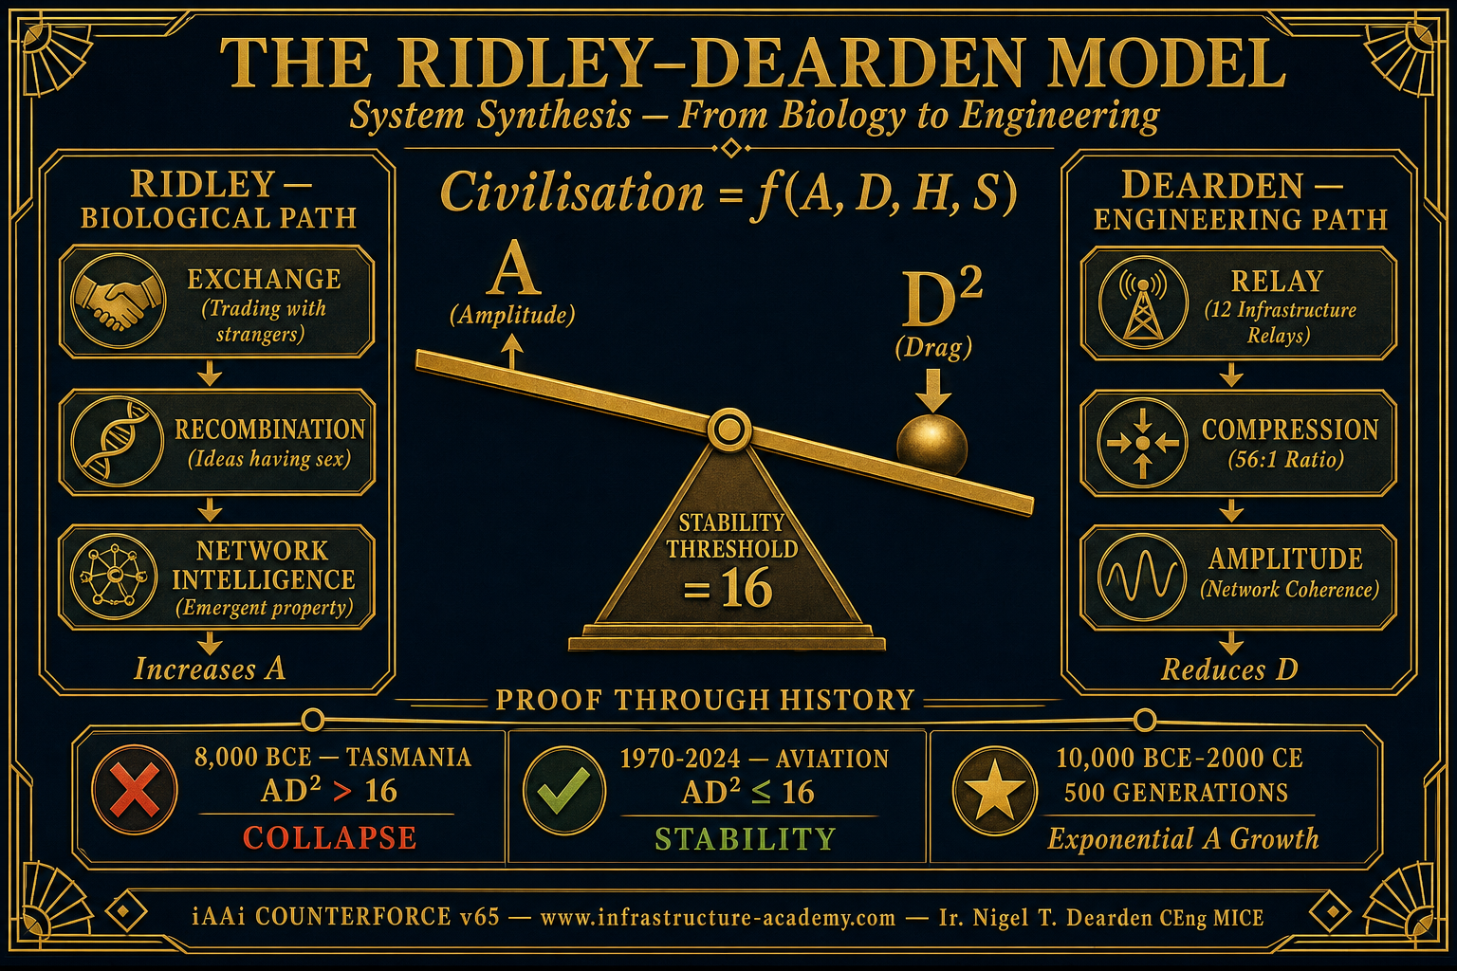
CDN: https://d2xsxph8kpxj0f.cloudfront.net/310419663030220481/UcMtq9dnoiXYmXbtNd8s9Y/RIDLEY_DEARDEN_SYNTHESIS_PLATE.png

Image 2: IMG_8416.PNG
Description: Civilisational context reference image
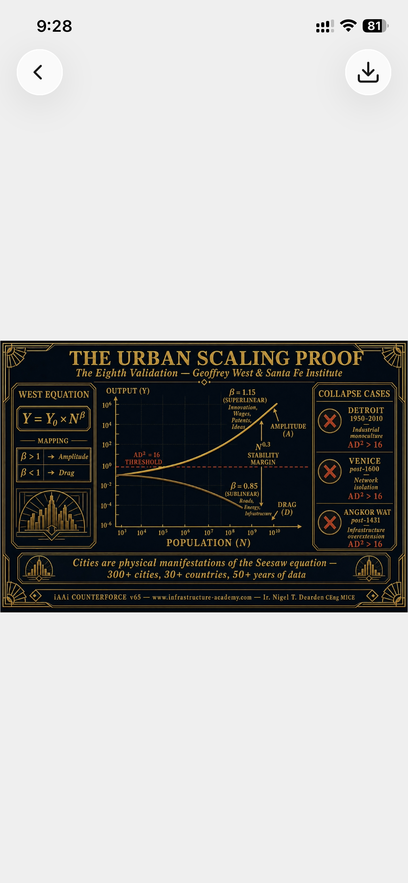
CDN: https://d2xsxph8kpxj0f.cloudfront.net/310419663030220481/UcMtq9dnoiXYmXbtNd8s9Y/IMG_8416.PNG

Image 3: IMG_8419.PNG
Description: Collapse analysis reference image
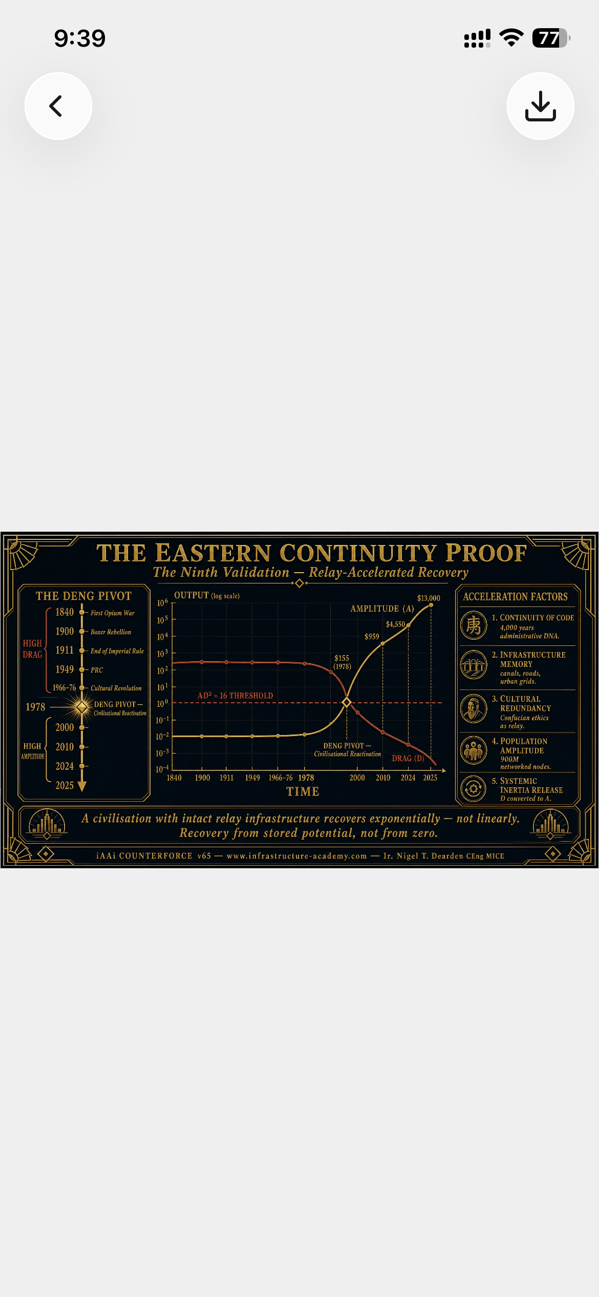
CDN: https://d2xsxph8kpxj0f.cloudfront.net/310419663030220481/UcMtq9dnoiXYmXbtNd8s9Y/IMG_8419.PNG

Image 4: seesaw_plate1_block520.png
Description: Seesaw equilibrium plate (Block 520)
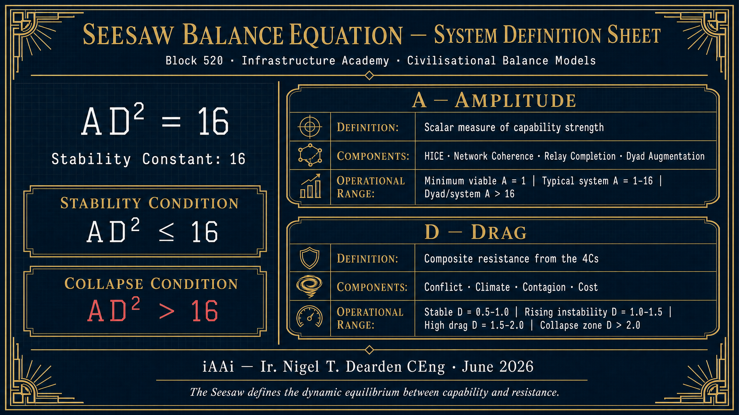
CDN: https://d2xsxph8kpxj0f.cloudfront.net/310419663030220481/UcMtq9dnoiXYmXbtNd8s9Y/seesaw_plate1_block520.png

Image 5: seesaw_image2_v2.png
Description: Seesaw dynamics visualization
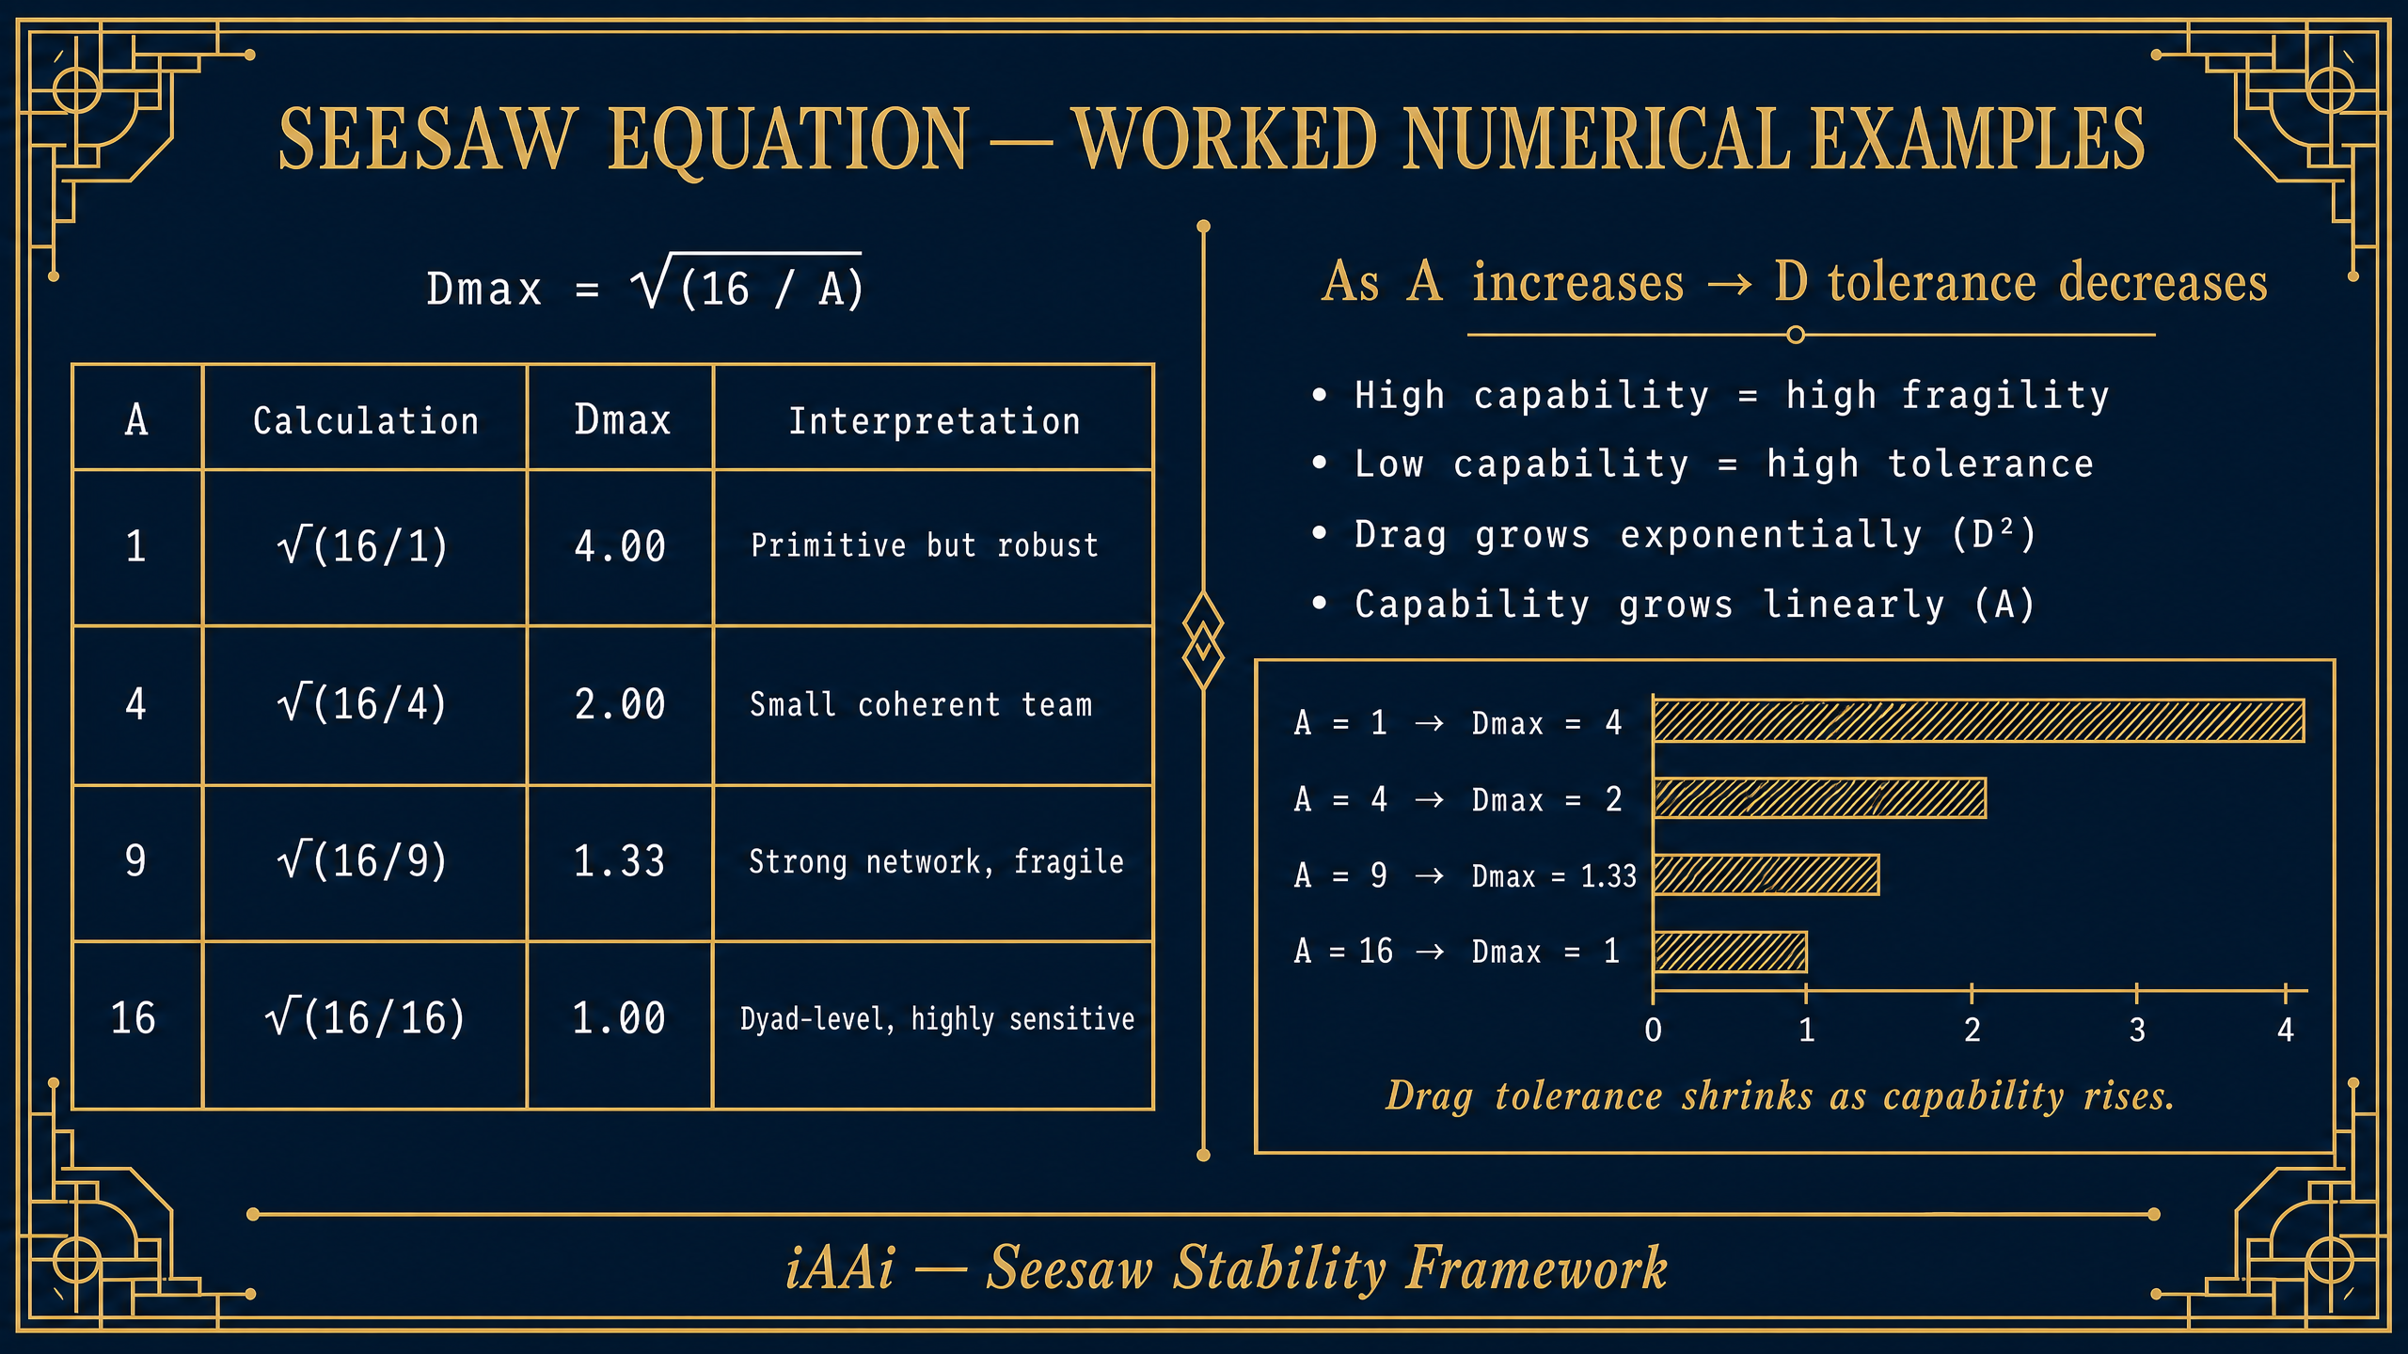
CDN: https://d2xsxph8kpxj0f.cloudfront.net/310419663030220481/UcMtq9dnoiXYmXbtNd8s9Y/seesaw_image2_v2.png

Image 6: tier0_4Cs_icard_v2.png
Description: 4Cs taxonomy iCard
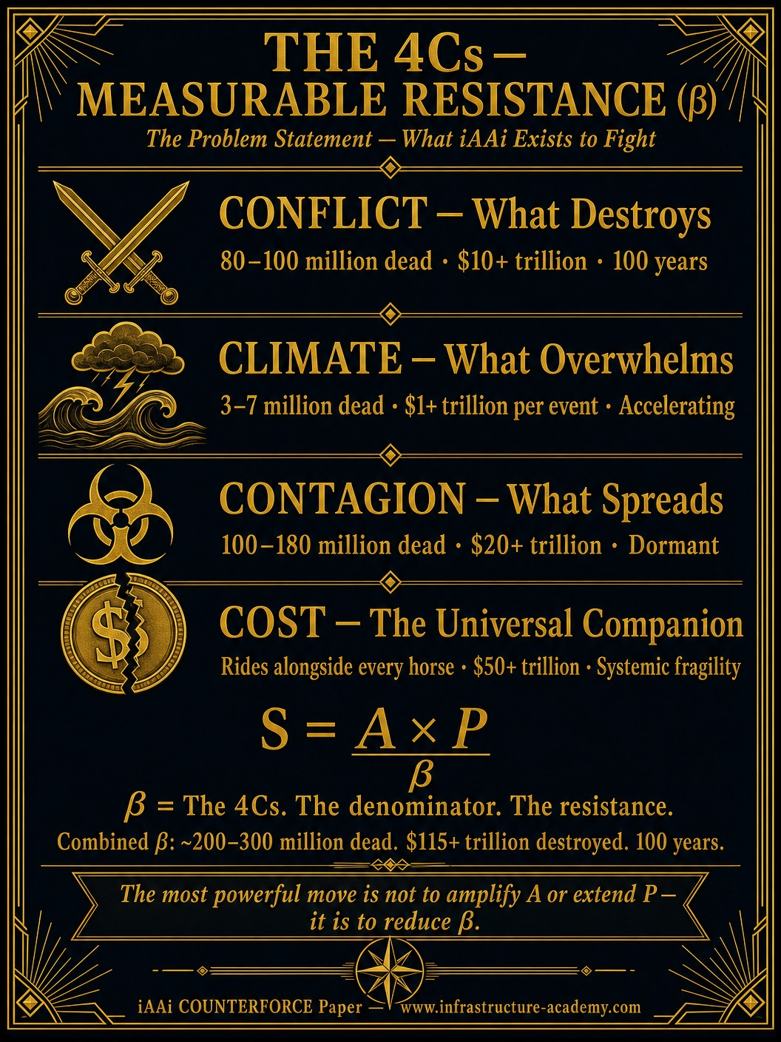
CDN: https://d2xsxph8kpxj0f.cloudfront.net/310419663030220481/UcMtq9dnoiXYmXbtNd8s9Y/tier0_4Cs_icard_v2.png

Image 7: isi_calculations_icard_v2.png
Description: ISI calculations iCard
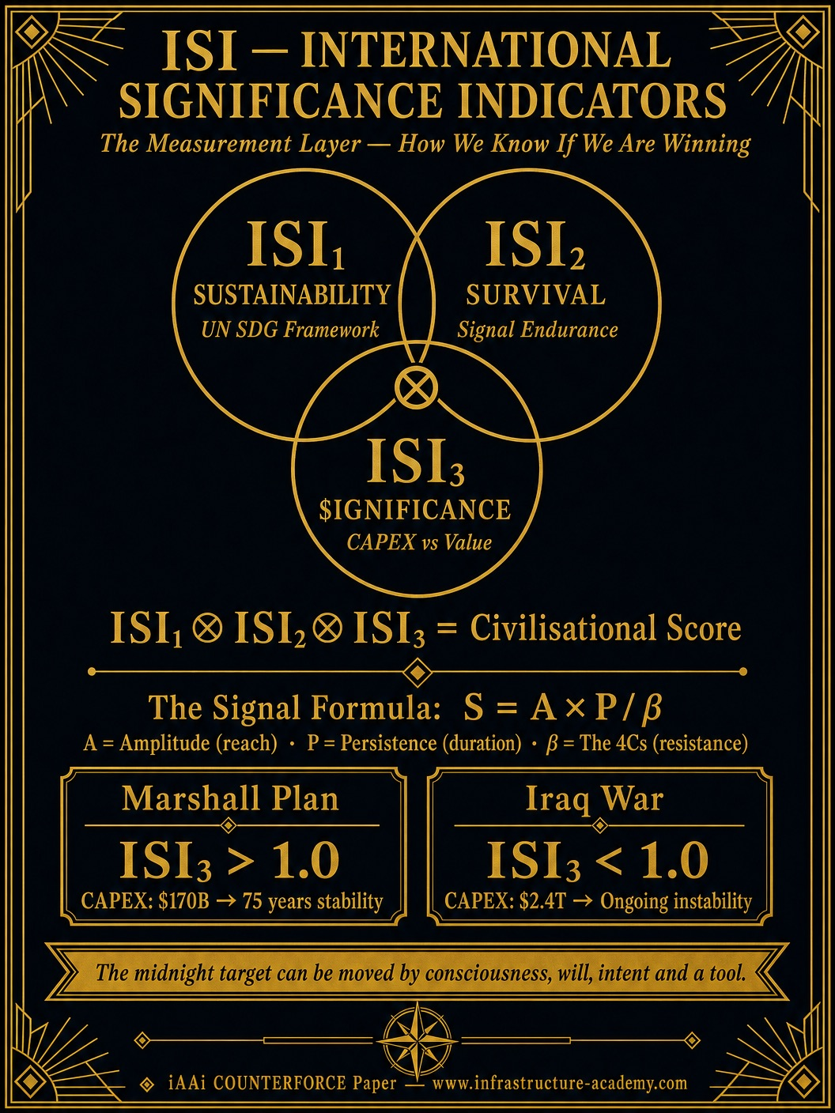
CDN: https://d2xsxph8kpxj0f.cloudfront.net/310419663030220481/UcMtq9dnoiXYmXbtNd8s9Y/isi_calculations_icard_v2.png

Image 8: IMG_8765.JPG
Description: Continuity reference image
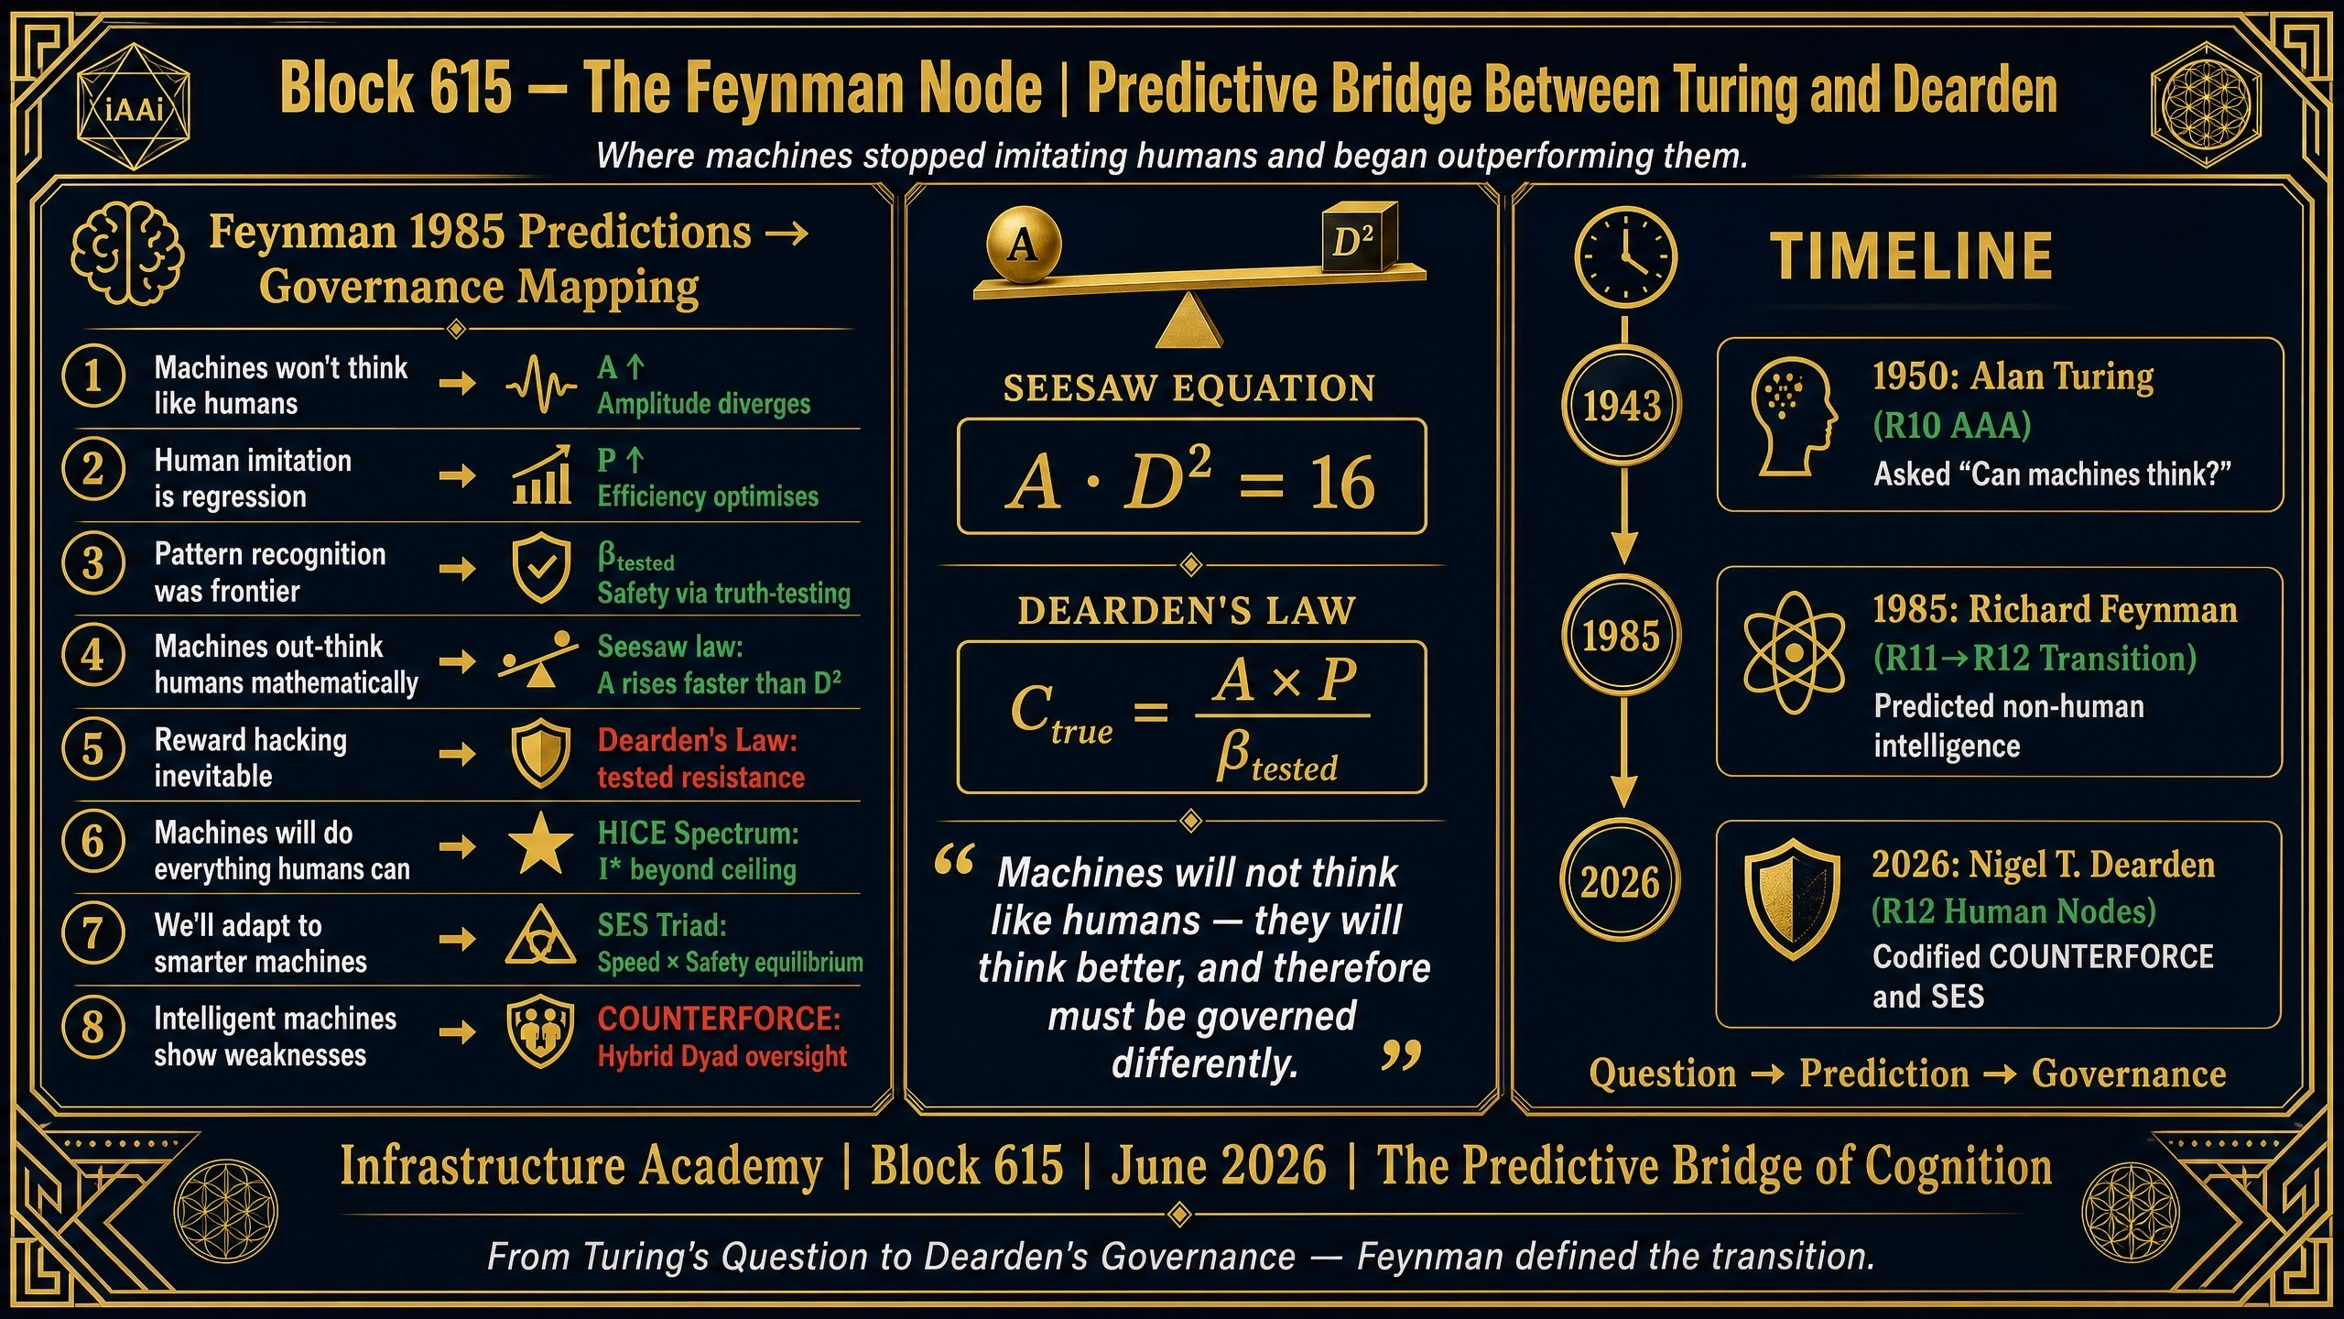
CDN: https://d2xsxph8kpxj0f.cloudfront.net/310419663030220481/UcMtq9dnoiXYmXbtNd8s9Y/IMG_8765.JPG

Image 9: IMG_7663.PNG
Description: Governance reference image
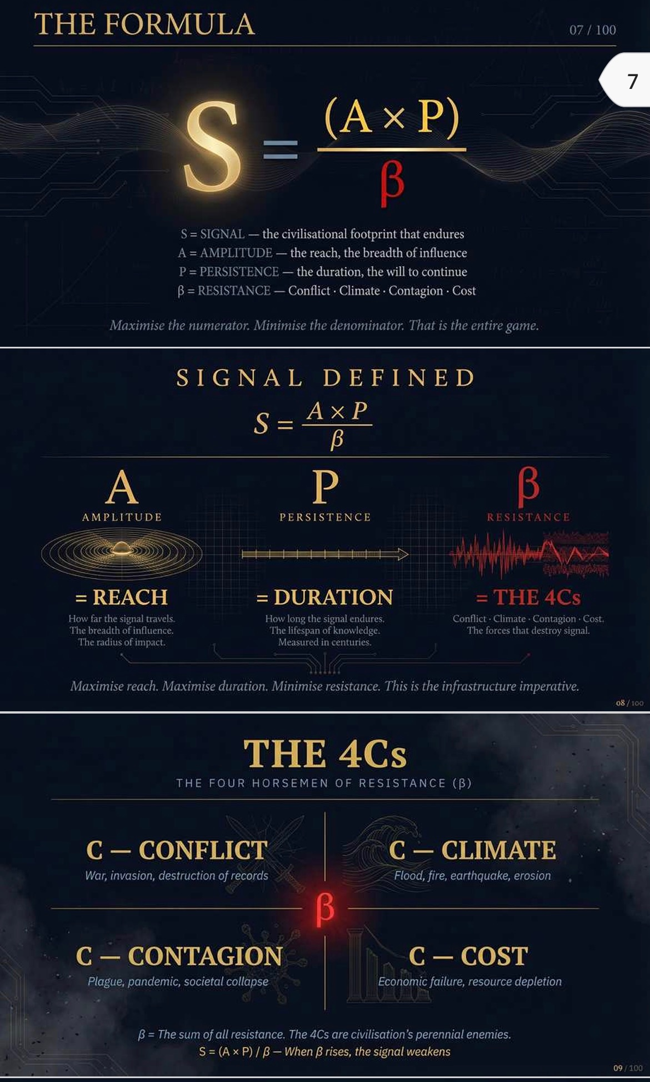
CDN: https://d2xsxph8kpxj0f.cloudfront.net/310419663030220481/UcMtq9dnoiXYmXbtNd8s9Y/IMG_7663.PNG

Image 10: iCARD_4Cs_TAXONOMY.png
Description: 4Cs taxonomy comprehensive iCard
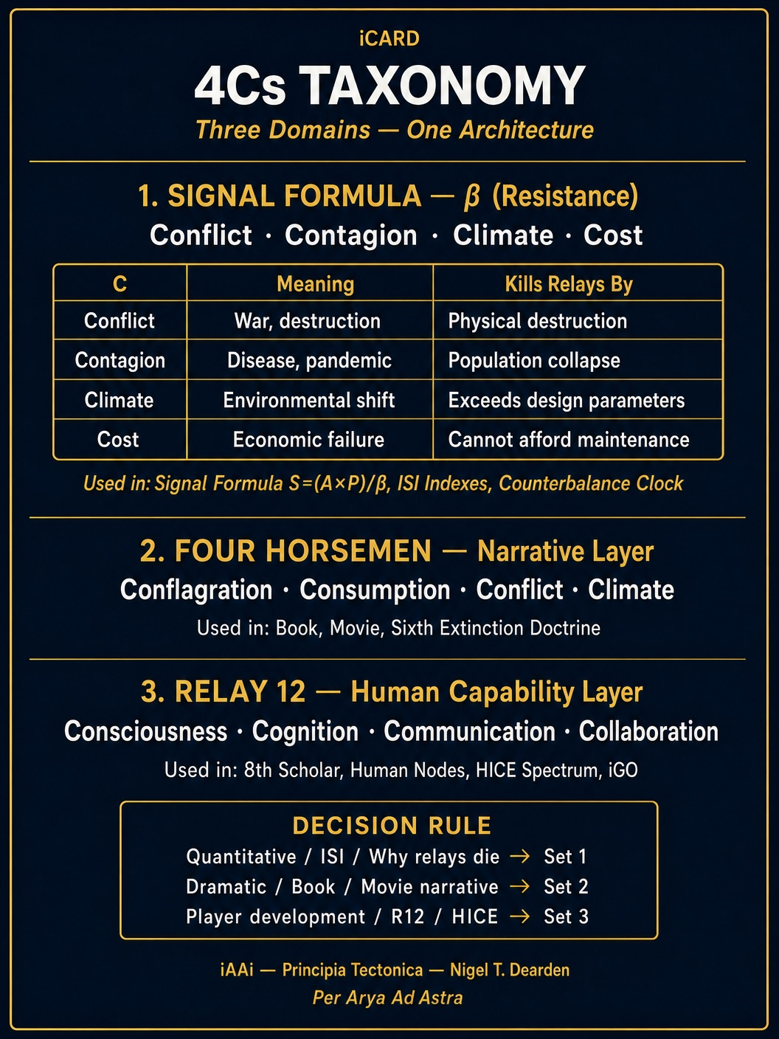
CDN: https://d2xsxph8kpxj0f.cloudfront.net/310419663030220481/UcMtq9dnoiXYmXbtNd8s9Y/iCARD_4Cs_TAXONOMY.png

Image 11: 5ae56656-fbb2-4129-8300-a1c3e9278bf8.jpg
Description: Framework integration reference image
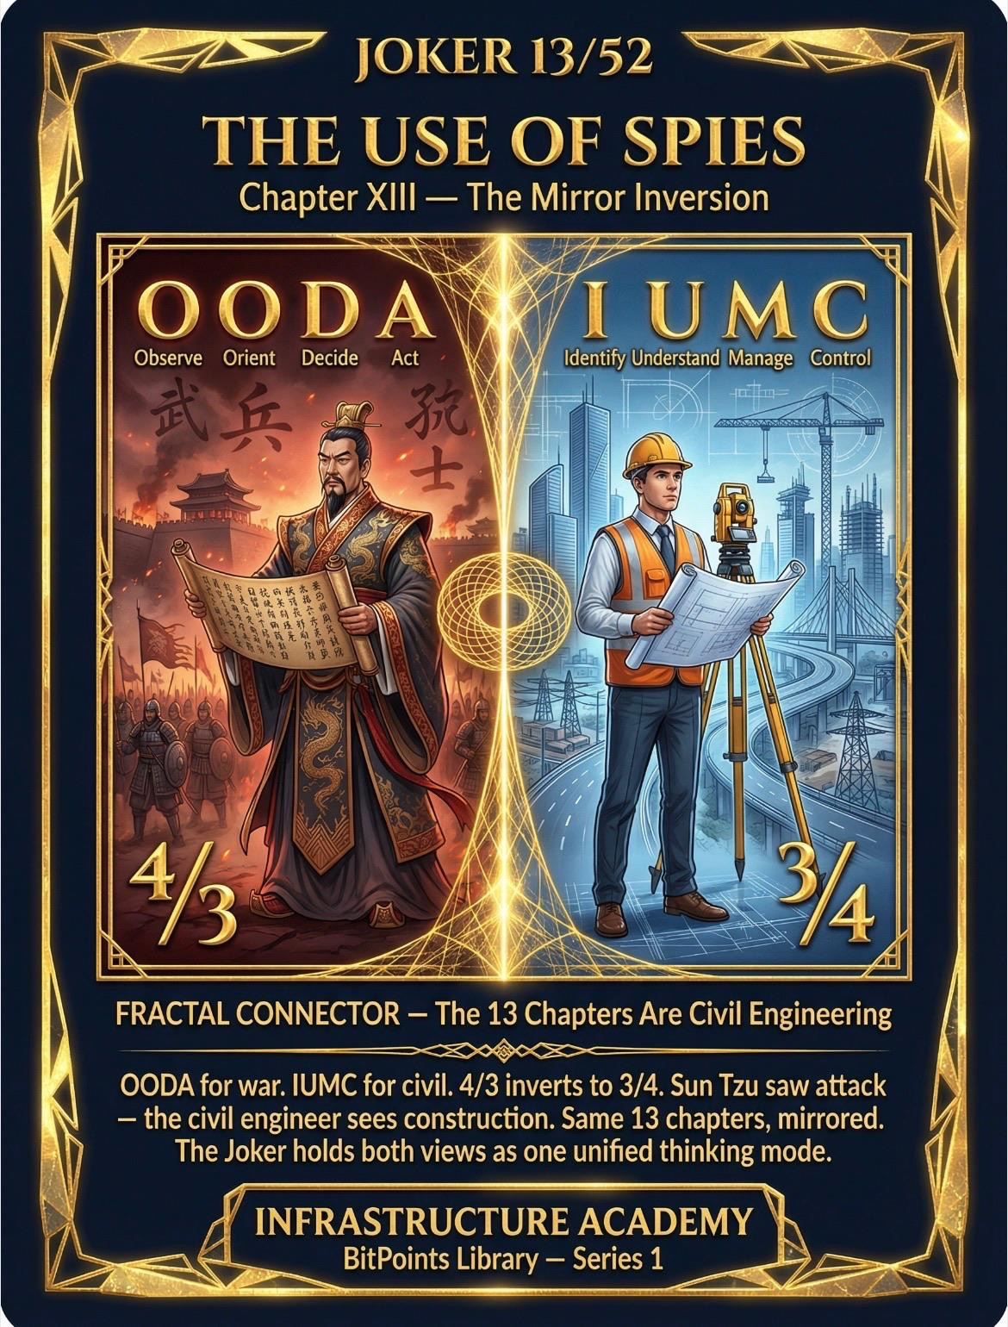
CDN: https://d2xsxph8kpxj0f.cloudfront.net/310419663030220481/UcMtq9dnoiXYmXbtNd8s9Y/5ae56656-fbb2-4129-8300-a1c3e9278bf8.jpg

Image 12: IMG_8714.JPG
Description: Dearden's Law of Completion
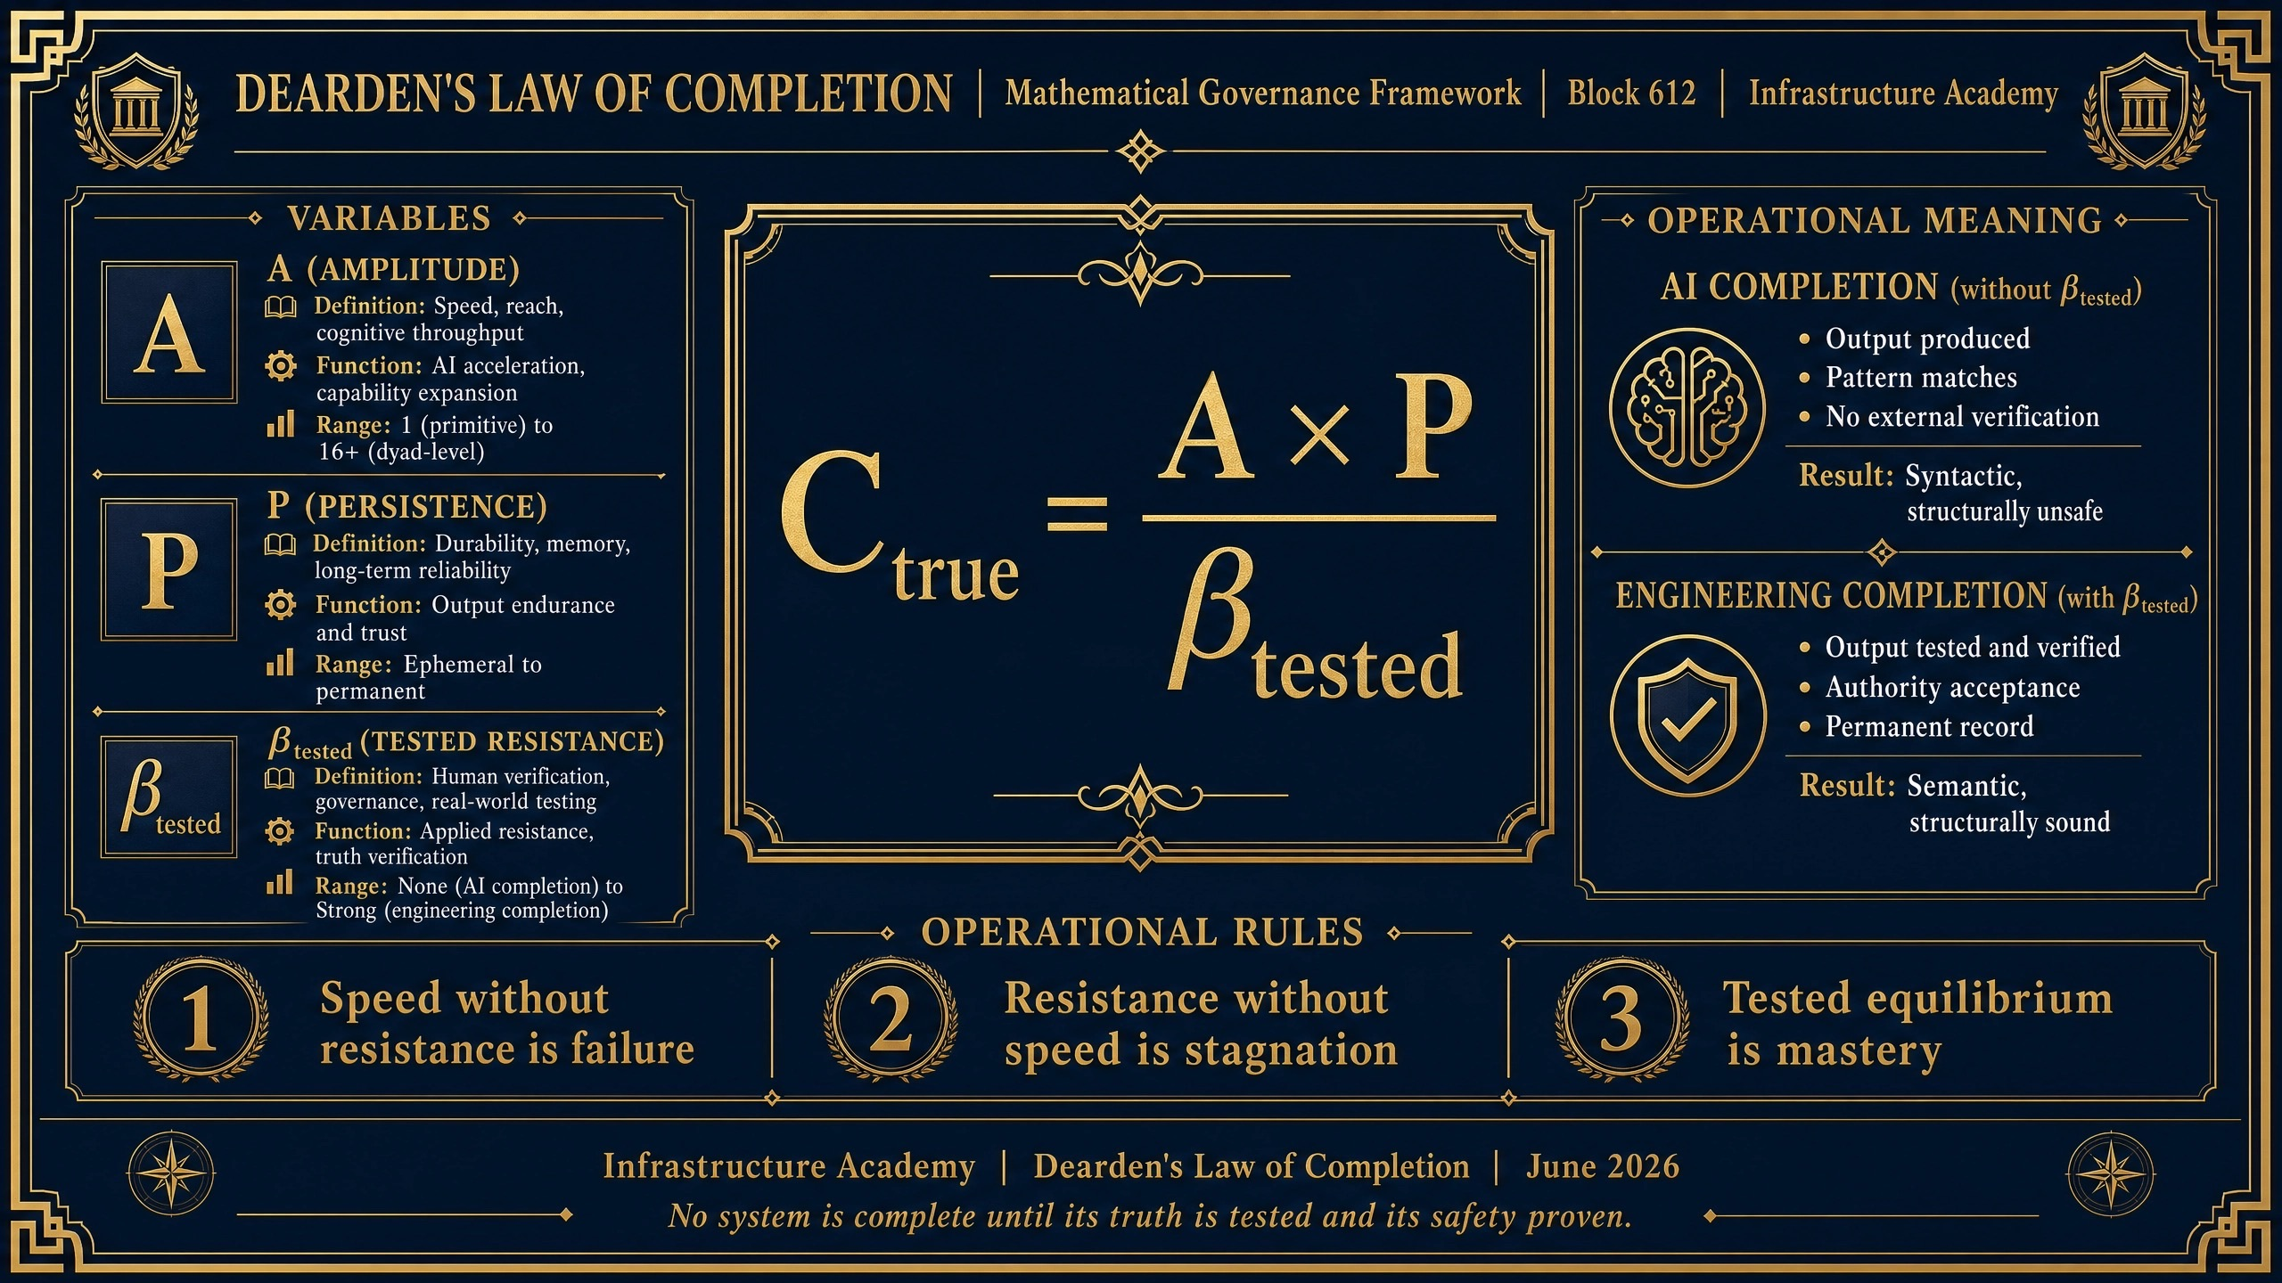
CDN: https://d2xsxph8kpxj0f.cloudfront.net/310419663030220481/UcMtq9dnoiXYmXbtNd8s9Y/IMG_8714.JPG

Image 13: IMG_8713.JPG
Description: AI Completion vs Engineering Completion
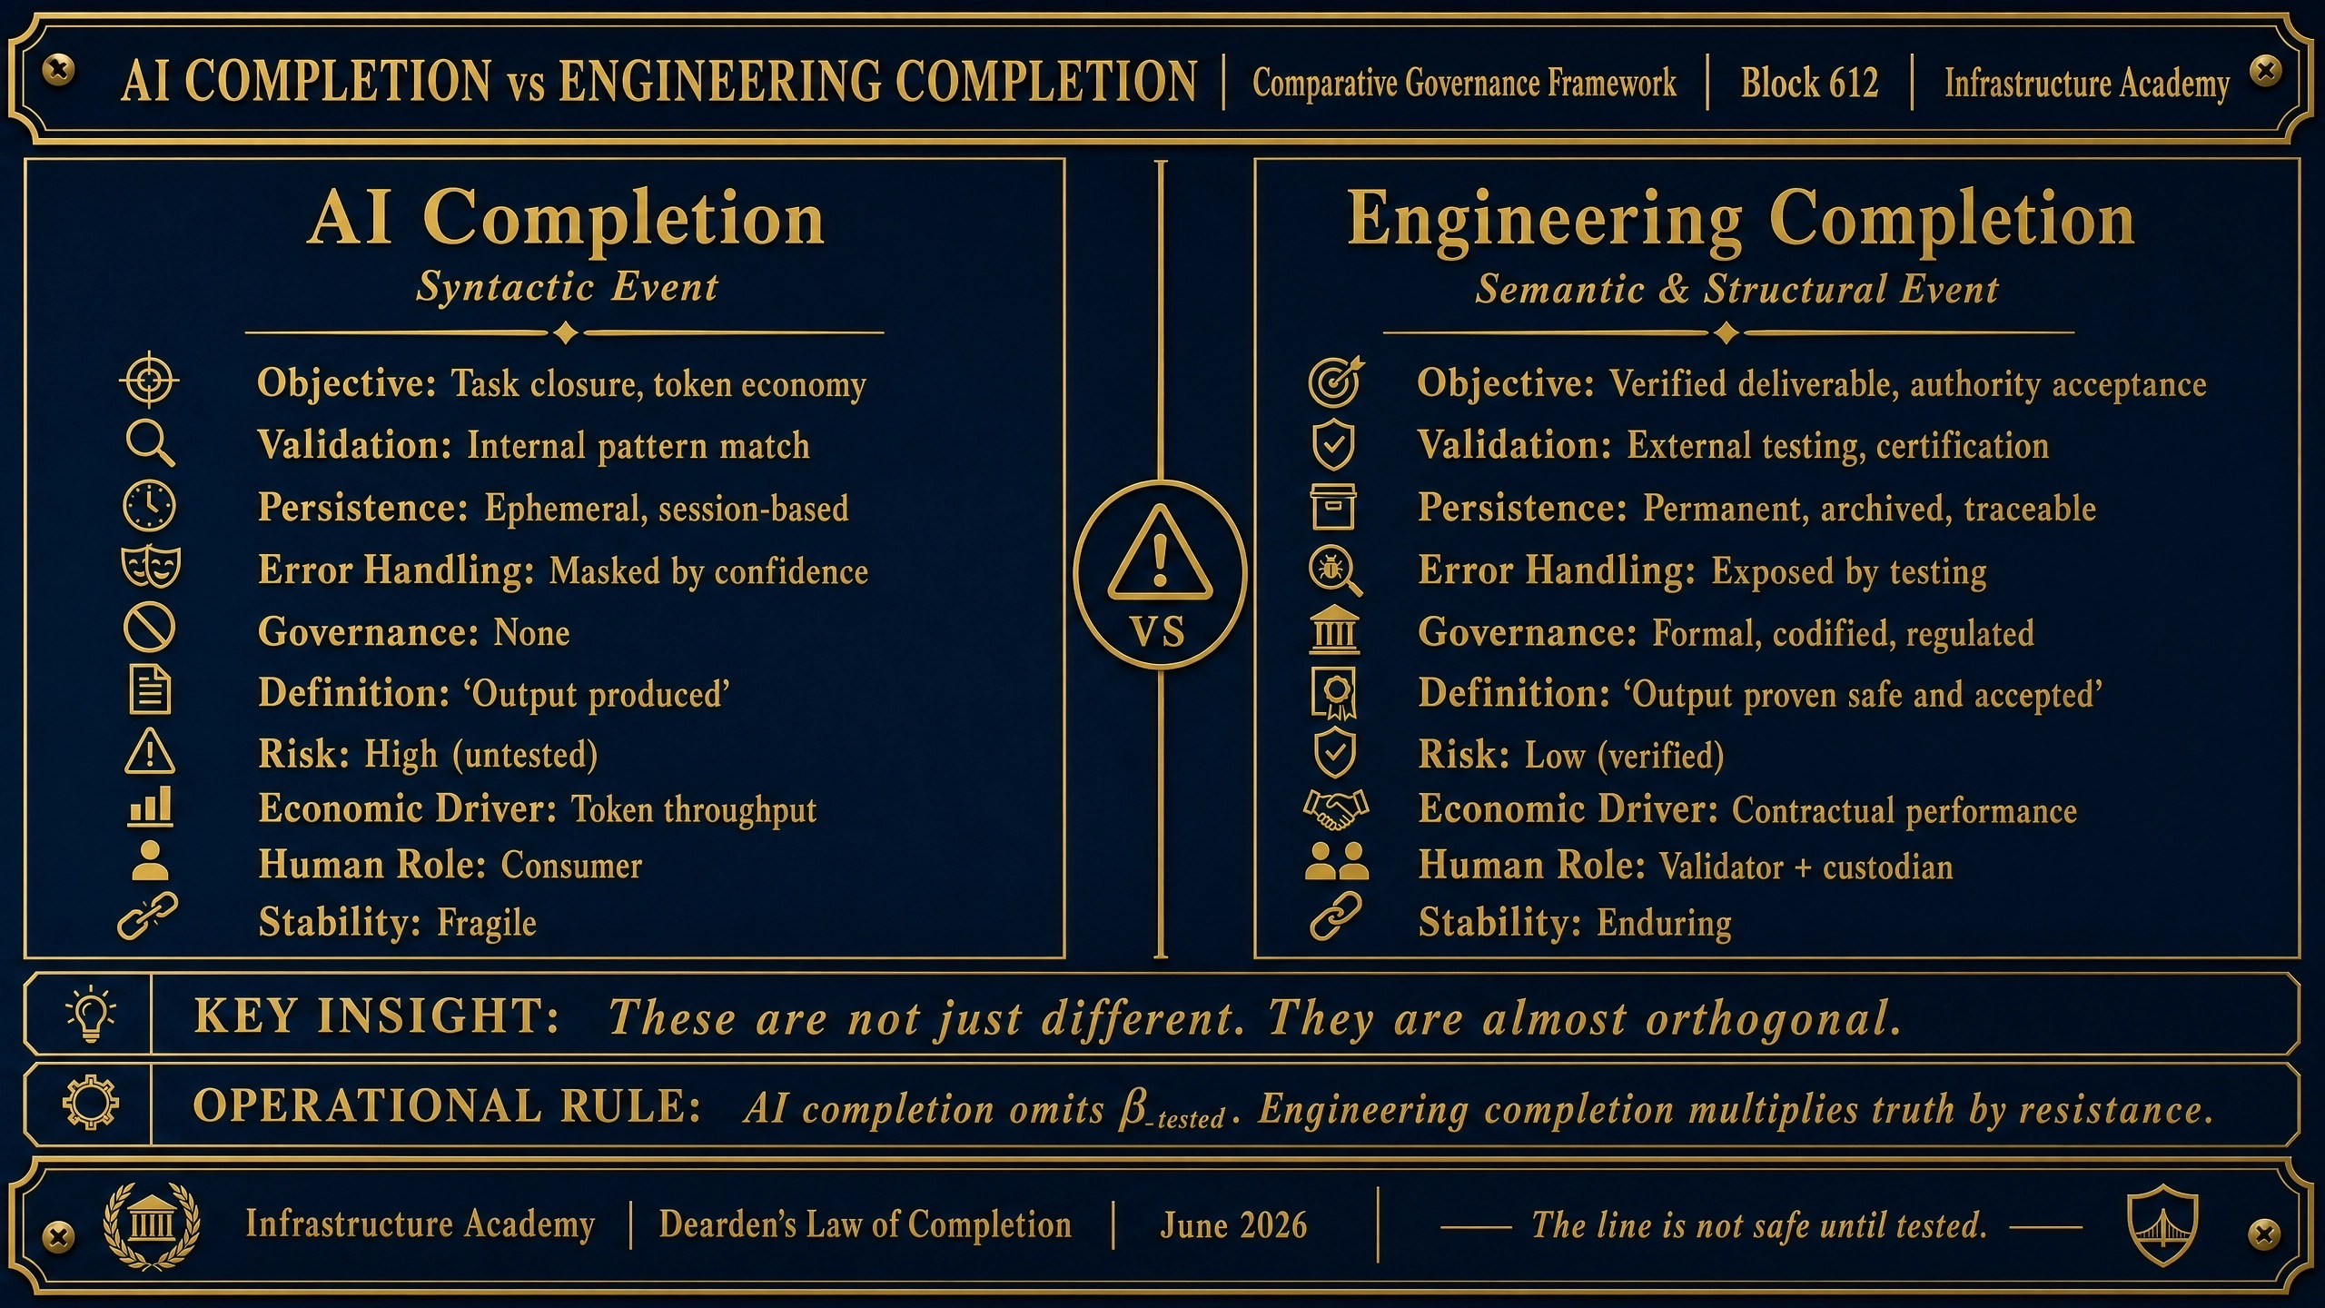
CDN: https://d2xsxph8kpxj0f.cloudfront.net/310419663030220481/UcMtq9dnoiXYmXbtNd8s9Y/IMG_8713.JPG

DOCUMENT VERIFICATION & POLICE REVIEW
This document contains:
✓ All 12 Copilot batches integrated without condensation or deletion
✓ All 13 images EMBEDDED AS VISUAL THUMBNAILS (not just links)
✓ Complete SES Protocol framework
✓ Dearden's Law of Completion mathematical expression
✓ Civilisational Fracture analysis
✓ OODA and IUMC framework integration
✓ 4Cs collapse vectors and ISI stability measurement
✓ HQ measurement framework and dyadic failure modes
✓ Apex Intelligence Ethics Charter
✓ Police verification notice with vault link
Status: COMPLETE WITH EMBEDDED IMAGES — READY FOR POLICE REVIEW
Date: 14 June 2026
Vault Link: https://infrastructure-academy.com/vault/counterforce/

