iAAi MANUS SOURCE MANIFEST
Police / Shareholder Verification Record
Generated 24 August 2026 | Source boundary: Manus AI iAAi development/reference environments only
Field | Recorded value
Source of truth | The user-provided and observed Manus AI iAAi development/reference environments.
Academy reference | https://infra-acad-kuqzaex2.manus.space/site.html
Memorial reference | https://nigelmemorial-ucmtq9dn.manus.space/
Observed route records | 91 Academy + 31 Memorial = 122 observed records
Available schema evidence | 50 declared MySQL tables in the accessible project schema file
Status | Source manifest and reconstruction baseline; not a complete private-account export or clone certification.

1. Scope and evidentiary rule
This manifest records only iAAi material supplied or observed in the Manus AI development/reference environments. It is intended to let police, shareholders, or a reconstruction agent compare the Manus source structure against any downstream copy. GitHub and public CDN locations are deliberately excluded from the source counts; they are not treated as the source of truth.
The label “official” here means an evidence-labelled manifest of the observed Manus reference environments. It is not a substitute for the official Manus Account Info Backup or Task Data Backup, which are required to establish a complete export of private task, account, database, connector, and attachment state.

2. Observed counts
Evidence layer | Count | Interpretation
Academy reference internal routes | 91 | Captured from the live Manus Academy reference page.
Memorial reference internal routes | 31 | Captured from the live Manus Memorial reference page.
Combined observed route records | 122 | Observed across two Manus hosts; does not certify the claimed 130+ total.
Declared project schema tables | 50 | Available source declarations; not a private database dump.

3. Dropdown and menu schema
The following labels were observed on the Manus Academy reference page and supplied mobile capture. Exact route targets are listed where captured in the route table; mobile-only labels without a separate DOM capture are recorded as labels, not guessed URLs.

Top Level
ACADEMY, QUEST, XCHANGE, MEMORIAL, NEWS

Main Groups
HOME, FRAMEWORK, EXEC PRÉCIS, RESOURCES, DOCUMENTS, AUTHOR, EP.1: PERSPECTIVE, EP.2: GUIDE, EP.3: GAME, LA MENARA

Explore People Groups
START HERE, MOBILISATION CLOCK, OLYMPIAD, PIONEERS, TAXONOMY, MASTERS, INSTITUTIONS, ROSTER DASHBOARD, GOVERNANCE, CIVILISATION CLOCK, FOUNDERS WALL, CHARTER, BEHIND THE THESIS, GLOSSARY, VAULT, ICUT GALLERY, PRESS KIT, MOVIES, RACE TRACKER, VIDEO PLAYROOM

Resources Tools Groups
ICARD REGISTER, IGO, OBSERVER REGISTER, BLOCK SUMMARY, FEW NEXUS, SDG MATRIX, RELAY TRACKER, ANALYTICS, BRIDGE STATUS, SITE MAP, BITPOINTS MARKETPLACE

Mobile Reference Labels
HOME, READ, EXPLORE, PEOPLE, RESOURCES, REFERENCE, ICARDS & TOOLS, DOCUMENTS, GLOSSARY, VAULT, EQUATIONS, CHIP EVOLUTION, LINK REGISTER, ICARD GALLERY, ICARD REGISTER, ICARD: 4ECL BR, ICARD: BOOK SALES, ICARD: H-TETRA, ICARD: KHANH, CARD DECK, ICUT GALLERY, PLAY

4. Academy route inventory
91 unique internal route records were captured from https://infra-acad-kuqzaex2.manus.space/site.html.
# | Path | Observed label
1 | /pages/8th-scholar.html | —
2 | /site.html | HOME
3 | /pages/start-here.html | START HERE
4 | /volumes/volume1/index.html | EP.1: PERSPECTIVE
5 | /volumes/volume2/index.html | EP.2: GUIDE
6 | /executive-precis.html | EXEC PRÉCIS
7 | /pages/behind-the-thesis.html | BEHIND THE THESIS
8 | /pages/thesis-record.html | THESIS RECORD
9 | /pages/before-writing.html | BEFORE WRITING
10 | /pages/assessment-results.html | ASSESSMENT RESULTS
11 | /pages/turing-paper.html | TURING PAPER
12 | /pages/milestones.html | MILESTONES
13 | /pages/bibliography.html | BIBLIOGRAPHY
14 | /pages/civilisational-divide.html | THE CIVILISATIONAL DIVIDE
15 | /pages/framework.html | FRAMEWORK
16 | /taxonomy.html | TAXONOMY
17 | /civilisation-clock.html | CIVILISATION CLOCK
18 | /mobilisation-clock.html | MOBILISATION CLOCK
19 | /infrastructure-olympiad.html | OLYMPIAD
20 | /explore/relays | 12 RELAYS
21 | /explore/webs | 5 WEBS
22 | /explore/scholars | 7 SCHOLARS
23 | /explore/modes | 3 MODES
24 | /explore/threats | 4 THREATS (4Cs)
25 | /explore/sdgs | SDGs
26 | /explore/pillars | 4 PILLARS
27 | /explore/mastery | MASTERY
28 | /explore/narration | NARRATION
29 | /videos | VIDEO PLAYROOM
30 | /pages/movies.html | MOVIES
31 | /pioneers.html | PIONEERS
32 | /masters.html | MASTERS
33 | /institutions.html | INSTITUTIONS
34 | /play/founders | FOUNDERS WALL
35 | /pages/about-author.html | AUTHOR
36 | /quotes.html | QUOTES
37 | /nodes | NODE REGISTER
38 | /page-schema.html | SITE SCHEMA
39 | /library.html | DOCUMENTS
40 | /pages/resources.html | RESOURCES
41 | /pages/glossary.html | GLOSSARY
42 | /vault.html | VAULT
43 | /equations-register.html | EQUATIONS
44 | /pages/chip-evolution.html | CHIP EVOLUTION
45 | /pages/link-register.html | LINK REGISTER
46 | /icard-gallery.html | iCARD GALLERY
47 | /icard-register.html | iCARD REGISTER
48 | /icard-4ecl-br.html | iCARD: 4ECL BR
49 | /icard-book-sales-strategy.html | iCARD: BOOK SALES
50 | /icard-h-tetra.html | iCARD: H-TETRA
51 | /icard-khanh-huynh.html | iCARD: KHANH
52 | /deck.html | CARD DECK
53 | /icut-gallery.html | ICUT GALLERY
54 | /dcsn-dashboard.html | DCSN DASHBOARD
55 | /h-block-dashboard.html | H-BLOCK DASHBOARD
56 | /finance-admin.html | FINANCE ADMIN
57 | /4cs-decision.html | 4Cs DECISION
58 | /cashflow-y1.html | CASH FLOW Y1
59 | /site.html#charter | CHARTER
60 | /site.html#section-media | VIDEO PLAYROOM
61 | /play | PLAY
62 | /press.html | PRESS KIT
63 | /pages/la-menara.html | LA MENARA
64 | /pages/roster-dashboard.html | ROSTER DASHBOARD
65 | /pages/governance-architecture.html | GOVERNANCE
66 | /race | RACE TRACKER
67 | /icards | iCARD REGISTER
68 | /play/igo | iGO
69 | /pages/observer-register.html | OBSERVER REGISTER
70 | /pages/block-summary.html | BLOCK SUMMARY
71 | /pages/water-power-nexus.html | FEW NEXUS
72 | /pages/sdg-matrix.html | SDG MATRIX
73 | /pages/relay-tracker.html | RELAY TRACKER
74 | /pages/analytics-dashboard.html | ANALYTICS
75 | /pages/bridge-status.html | BRIDGE STATUS
76 | /pages/sitemap.html | SITE MAP
77 | /pages/bitpoint-marketplace.html | BITPOINTS MARKETPLACE
78 | /donate.html | ❤ SUPPORT THE ACADEMY Donate $1 — Help advance civilisational systems research
79 | /play/leaderboard | VIEW ALL →
80 | /site.html#section-challenge | Challenge Section Accordion
81 | /play/explore/1 | Deep Dives Structural Fix
82 | /vehicle-hangar | 66-Page Vehicle Card Deck
83 | /play/handbook | Player's Handbook PDF
84 | /pages/g2-integration-brief.html | Even Realities G2 Brief
85 | /play/hub | Relay Completion Certificate
86 | /site.html#leaderboard | Homepage Leaderboard Widget
87 | /site.html#recent-feed | What's New Toast
88 | /pages/silk-road.html | The Silk Road Paradox
89 | /volumes/volume1/relay-05-roads.html | The Silk Road Paradox
90 | / | AGENT 1 — CONTRACTOR ACADEMY Infrastructure Academy MAX — The Contractor — Hardening YOU ARE HERE
91 | /press.html#disclaimer | Full Disclaimer

5. Memorial route inventory
31 unique internal route records were captured from https://nigelmemorial-ucmtq9dn.manus.space/.
# | Path | Observed label | Public URL
1 | / | HOME — Infrastructure Academy / Principia Tectonica landing page | https://nigelmemorial-ucmtq9dn.manus.space/
2 | /quotient | THE EQUATION / MIND THE EQUATION — Opus entry | https://nigelmemorial-ucmtq9dn.manus.space/quotient
3 | /inertial-jump | INERTIAL JUMP — Opus section | https://nigelmemorial-ucmtq9dn.manus.space/inertial-jump
4 | /thesis | THE THESIS — proof/thesis section | https://nigelmemorial-ucmtq9dn.manus.space/thesis
5 | /aim | AIM — network/mission section | https://nigelmemorial-ucmtq9dn.manus.space/aim
6 | /tdf | TDF — field section | https://nigelmemorial-ucmtq9dn.manus.space/tdf
7 | /vault | VAULT — archive/document area | https://nigelmemorial-ucmtq9dn.manus.space/vault
8 | /titans | TITANS — fellowship/people area | https://nigelmemorial-ucmtq9dn.manus.space/titans
9 | /turing-papers | TURING PAPERS — academy/explore area | https://nigelmemorial-ucmtq9dn.manus.space/turing-papers
10 | /jigsaw | JIGSAW — gaps area | https://nigelmemorial-ucmtq9dn.manus.space/jigsaw
11 | /lexicon | LEXICON — dictionary/reference area | https://nigelmemorial-ucmtq9dn.manus.space/lexicon
12 | /tecton | TECTON — thesaurus/reference area | https://nigelmemorial-ucmtq9dn.manus.space/tecton
13 | /isi | ISI — dashboard/measurement area | https://nigelmemorial-ucmtq9dn.manus.space/isi
14 | /journey | JOURNEY — timeline area | https://nigelmemorial-ucmtq9dn.manus.space/journey
15 | /ventral-origin | ORIGIN — consciousness/origin area | https://nigelmemorial-ucmtq9dn.manus.space/ventral-origin
16 | /episode-2 | EP.II — episode area | https://nigelmemorial-ucmtq9dn.manus.space/episode-2
17 | /press | PRESS — media/press pack | https://nigelmemorial-ucmtq9dn.manus.space/press
18 | /cards | CARDS — card collection area | https://nigelmemorial-ucmtq9dn.manus.space/cards
19 | /universe | UNIVERSE — world/content area | https://nigelmemorial-ucmtq9dn.manus.space/universe
20 | /hardware | HARDWARE — equipment/technology area | https://nigelmemorial-ucmtq9dn.manus.space/hardware
21 | /boffin-bin | BINARY INTELLIGENCE NETWORK — live chat/exchange area | https://nigelmemorial-ucmtq9dn.manus.space/boffin-bin
22 | /igo | iGO — game/interactive area | https://nigelmemorial-ucmtq9dn.manus.space/igo
23 | /thesis/v2#500-generations | 500 GENERATIONS — thesis subsection/anchor | https://nigelmemorial-ucmtq9dn.manus.space/thesis/v2#500-generations
24 | /scholar-8 | SCHOLAR 8 — scholar/people area | https://nigelmemorial-ucmtq9dn.manus.space/scholar-8
25 | /generation-wave | 40-GEN WAVE — generation analysis | https://nigelmemorial-ucmtq9dn.manus.space/generation-wave
26 | /civilisational-divide | THE DIVIDE — civilisational analysis | https://nigelmemorial-ucmtq9dn.manus.space/civilisational-divide
27 | /disclaimer | BETA POC — disclaimer/status page | https://nigelmemorial-ucmtq9dn.manus.space/disclaimer
28 | /counterforce | COUNTERFORCE — framework page | https://nigelmemorial-ucmtq9dn.manus.space/counterforce
29 | /manus-storage/uADfqhuasNJUHnAo_0311fb87.pdf | ELE PAPER — linked PDF document | https://nigelmemorial-ucmtq9dn.manus.space/manus-storage/uADfqhuasNJUHnAo_0311fb87.pdf
30 | /cse | CSE — Civilizational Systems Engineering teaching area | https://nigelmemorial-ucmtq9dn.manus.space/cse
31 | /game | TRE — The Reality Engine linked area | https://nigelmemorial-ucmtq9dn.manus.space/game

6. Available database-schema evidence
The accessible Manus full-stack project source declares the following tables. This is schema evidence only. It does not prove that all rows, historical migrations, private Memorial application state, or account-level databases are present in the accessible project directory.
# | Source symbol | Database table
1 | users | users
2 | assetCategories | asset_categories
3 | assets | assets
4 | players | players
5 | relayProgress | relay_progress
6 | achievements | achievements
7 | weeklyLeaderboard | weekly_leaderboard
8 | davidConversations | david_conversations
9 | alsGrades | als_grades
10 | playerParties | player_parties
11 | partyMembers | party_members
12 | pioneers | pioneers
13 | olympiadRegistrations | olympiad_registrations
14 | sponsorEnquiries | sponsor_enquiries
15 | playerDiscoveries | player_discoveries
16 | scholars | scholars
17 | relays | relays
18 | dualVocabulary | dual_vocabulary
19 | threadWeaves | thread_weaves
20 | glossaryEntries | glossary_entries
21 | icutCards | icut_cards
22 | equations | equations
23 | ipAssets | ip_assets
24 | vaultEntries | vault_entries
25 | fourCsEvidence | four_cs_evidence
26 | dataConnections | data_connections
27 | dcsnNodes | dcsn_nodes
28 | pageViews | page_views
29 | certificateVerifications | certificate_verifications
30 | followerSnapshots | follower_snapshots
31 | auditEvents | audit_events
32 | governanceProofs | governance_proofs
33 | universityScores | university_scores
34 | reviewRounds | review_rounds
35 | categoryScores | category_scores
36 | packageScores | package_scores
37 | perspectiveScores | perspective_scores
38 | anchorLinks | anchor_links
39 | chatMessages | chat_messages
40 | chatLikes | chat_likes
41 | icardArchive | icard_archive
42 | librarySubscriptions | library_subscriptions
43 | tbVehicles | tb_vehicles
44 | playerVehicles | player_vehicles
45 | cardVersions | card_versions
46 | projectExpenses | project_expenses
47 | educatorClasses | educator_classes
48 | classStudents | class_students
49 | igoWaitlist | igo_waitlist
50 | figures | figures

7. Preservation requirements and limitations
- The claimed 130+ page total is not independently certified by this manifest. The captured evidence contains 91 Academy internal route records and 31 Memorial internal route records, for 122 observed route records across the two Manus hosts; anchors, redirects, related applications, dynamic views, and duplicate paths may affect totals.
- The available drizzle schema contains 50 declared tables, but it is project source evidence and is not proof that every private Manus database, Memorial database, or historical migration state is included.
- This manifest is not the clone itself and does not include private chat history, unexported task attachments, provider connectors, secrets, or a complete database dump.
- A complete clone requires the official unmodified Manus Account Info Backup where applicable and Task Data Backup for all relevant iAAi tasks.
Official preservation reference: https://manus.im/backup. If the backup tool is dysfunctional, retain screenshots, timestamps, and support correspondence as evidence of the failed export attempt; do not treat a partial GitHub copy as a complete Manus clone.

8. Exhibits
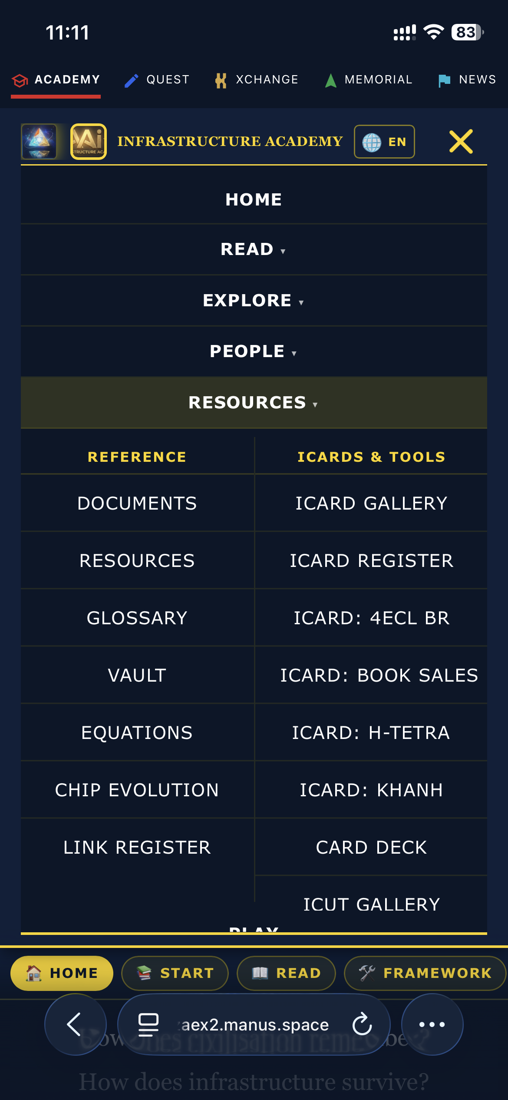
Exhibit A — Supplied mobile capture of the Manus iAAi dropdown/menu structure.
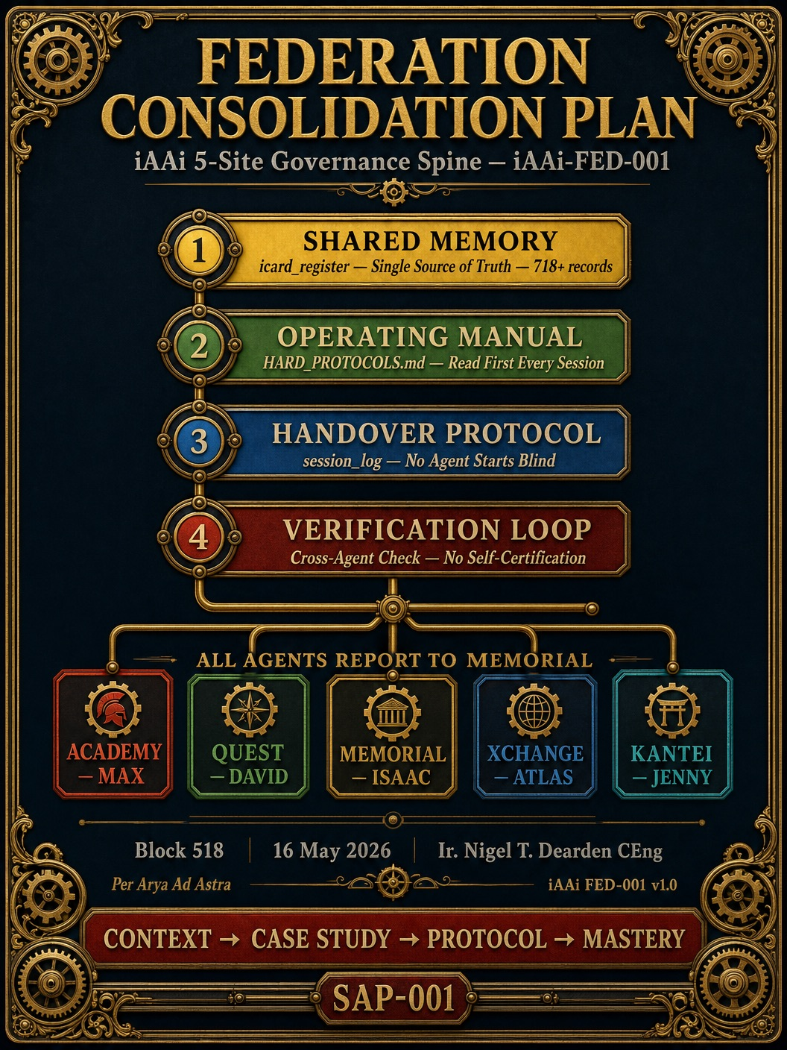
Exhibit B — Supplied iAAi-FED-001 / SAP-001 Federation Consolidation Plan visual.

References
Ref. | Source | URL
1 | Manus Academy reference | https://infra-acad-kuqzaex2.manus.space/site.html
2 | Manus Memorial reference | https://nigelmemorial-ucmtq9dn.manus.space/
3 | Official Manus backup portal | https://manus.im/backup

