1 System model of the Forch corridor

Model and boundary
The course's four-step model covers the canton of Zürich (1,223 NPVM zones) for the weekday evening peak, 17:00-18:00. Generation and distribution come fixed from the NPVM matrix; a five-option logit (car, PT with walk or bike access, bike, walk) and an MSA/BPR road assignment run coupled until the road gap is under 2 %. Assignment runs on a reduced network around our corridor, with external zones attached to gates.

Corridor
The corridor is the Forchbahn catchment: the course's 70 city zones along the S18. Every zone of Zollikon, Zumikon, Küsnacht, Maur and Egg nearer to a Forchbahn station than to any other rail station, all zones within 1.5 km of Forch station. Plus Fällanden and Dübendorf: 125 zones, 143,285 residents (Figure 1.2). Without Fällanden and Dübendorf the cordon cut the northern city and loaded the Glattal onto residential streets. Of five variants compared, this is the smallest that keeps the Forch catchment, fits the city-edge counts no worse and removes that jam. Of seven gate settings, a cap of 60 gates at 500 m is the smallest that gates every gateable major road crossing, with delay within 4.7 % of the next larger set.
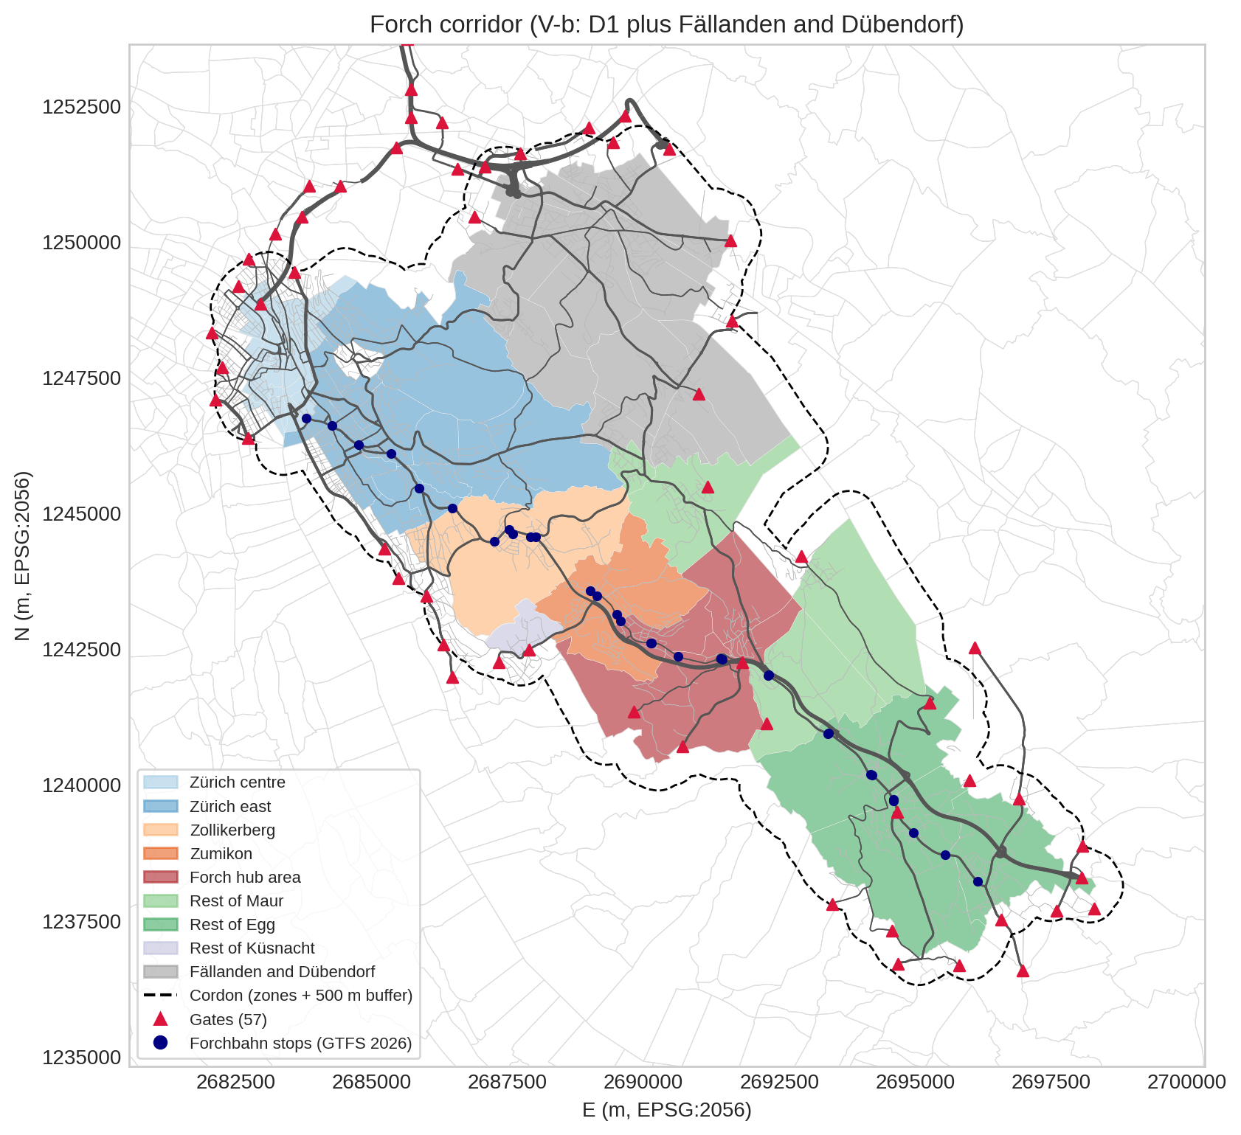
Figure 1.2. Forch corridor V-b: 125 configured zones in 9 reporting regions, the 500 m cordon buffer, the 57 gates and the Forchbahn stops. Coordinates in m, EPSG:2056. Sources: zones.parquet, GTFS 2026 (course archive), OSM extract of 2026-10-09; tools/build_forch_corridor.py.

Demand
The cordon retains 184,126 trips in the peak hour. 169,621 with at least one end inside plus the assumed pass-through. 44 % internal, 24 % inbound, 24 % outbound and 8 % pass-through (the assumed 5 % of trips between two outside zones). The Forch relations are small: 42 trips from Zürich centre to the hub area and 39 back. The matrix is nearly symmetric because the course built it as the NPVM average-weekday matrix times a peak share per mode; counts at the city edge show 58 % of the real evening traffic leaving the city. The appraisal's 5,000 people in the 1.5 km catchment match the hub area's 4,990 residents; daily trips per resident there are 30 % below the cantonal survey.

Modal split, Stage 0, before congestion feedback
Mode | Trips (peak hour) | Trip share | PKM share, trips >= 5 km (headline)
Car | 56,871 | 33.5 % | 67.6 %
PT (all) | 34,209 | 20.2 % | 24.6 %
PT-walk | 25,072 | 14.8 % | 15.7 %
PT-bike | 9,138 | 5.4 % | 8.9 %
Bike | 24,584 | 14.5 % | 6.1 %
Walk | 53,956 | 31.8 % | 1.7 %
Total | 169,621 | 100.0 % | 100.0 %
The car carries 34 % of trips but 68 % of PKM over 5 km, because its trips are long. The 5 km filter stays: 3-5 km trips between the hub area and Zumikon, Egg or Maur are only 7.2 % of the hub area's motorised trips. In the hub area itself the car share is 52 % of trips. On a daily basis the NPVM's car and PT distance shares are within 6 points of the cantonal survey; bike and walk distance is overstated because it is measured on the road network.

Assignment
All runs reach the 2 % road gap (the coupled run after 28 iterations). Feeding congestion back into mode choice lowers delay from 56,899 to 6,012 veh-h and the car trip share from 33.5 % to 28.8 %, while PT rises from 20.2 % to 23.6 %.
Total delay is 6,012 veh-h, of which 4,361 outside the city of Zürich; the worst link lies in Wallisellen (secondary, V/C 2.1). With the first corridor D1 the cordon cut the northern city and the delay was 46,785 veh-h, almost all on residential streets near Milchbuck. Against published daily volumes the model's peak flows on the Forchstrasse at Waldburg and on the A52 are 71 to 122 % too high, and at the four radial counters at the city edge the mean gap is 186 %. The model's PT ride from Stadelhofen to the zone of Forch station ends at Neue Forch and takes 14 min, 5 min less than the timetable's stopping trains.

Indicators, Stage 0
These come from coupled runs, so the shares differ from the modal split table above.
Indicator | Unit | Year 1 | Year 40 | Change | Better | Phase 1 outcome (5.3 table)
Mode-choice journey time | min per trip | 21.3 | 21.1 | -1.0 % | lower | #3
Road delay (vehicle-hours incl. background, cordon) | veh-h per peak hour | 6,012 | 7,111 | +18.3 % | lower | #5, #3
Car CO2 | t CO2 per peak hour | 56.6 | 22.5 | -60.3 % | lower | #6
Trips (all modes) | trips per peak hour | 169,621 | 203,545 | +20.0 % | demand | #2
Year 40 adds 20 % demand: delay rises by 18 % (less than demand, because the car share falls at the same time), CO2 falls with the assumed fleet, and journey time falls slightly as trips shift to faster e-bikes and PT. Lower is better for time, delay, CO2 and car shares, higher for PT shares; they map to our Phase 1 outcomes on modal split, travel time, car traffic and emissions. Because the corridor totals mix the city with the Forch side, we add the hub-area shares and the delay outside the city (4,361 veh-h in Year 1) as Forch indicators.

What the model cannot show at Forch
- The evening rush. The "peak-hour" matrix is a scaled daily matrix, so it has no homebound direction; directional effects of the hub are outside the model.
- People driving to Forch station and parking there: mode choice has no park-and-ride option. Walking and cycling to a station are in the model, but the zones around Forch are large and each may only use a short list of stops near its centroid (Forch station is on it for one of the four hub-area zones), so the model sends their PT trips to Maiacher, Neue Forch, Scheuren or a bus stop: only 6 PT trips an hour between Zürich and the Pfannenstiel use Forch station in Stage 0.
- Measured road volumes. Modelled peak flows on the Forch roads are well above the counts, partly because one national peak share is applied to a saturated road, the course adds an uplift to car and background traffic, and the road assignment lets flows exceed capacity. Read V/C above 1 there as "busy".
- Two Pfannenstiel zones cannot be left by car in the prepared network, and one has no PT path.

