IDP for DotNet Applications

INFOSYS LTD,
Bengaluru.

Document No. : | IDP_OSS/Doc :D09 | Version.Rev : | 1.00
Authorized by: |  | Date

COPYRIGHT NOTICE

© 2018 - 2019 Infosys Limited, Bengaluru, India. All Rights Reserved. Infosys believes the information in this document is accurate as of its publication date such information is subject to change without notice. Infosys acknowledges the proprietary rights of other companies to the trademarks, product names and such other intellectual property rights mentioned in this document. Except as expressly permitted, neither this documentation nor any part of it may be reproduced, stored in a retrieval system, or transmitted in any form or by any means, electronic, mechanical, printing, photocopying, recording or otherwise, without the prior permission of Infosys Limited and/or any named intellectual property rights holders under this document.

Infosys Limited
Electronics City,
Hosur Road,
Bengaluru 560 100
India.
Telephone: 91 80 2852 0261
Fax: 91 80 2852 0362
Website: http://www.infosys.com

REVISION LIST

Ver.  Rev | Date | Authors | Reviewed  By | Description
0.00a | 3-Sep-2018 | Priya Kotabagi | KrishnaKanth B.N
1.00

REQUIREMENTS

OVERVIEW
DevOps is the combination of practices, and tools that increases an organization's ability to deliver applications and services at high velocity.
Infosys DevOps Platform (IDP) is a centralized platform to promote DevOps (continuous integration, continuous deployment and continuous testing). This platform can be leveraged for various technologies (Java, .Net, etc.) to schedule automated builds along with validations such as code analysis, unit testing, code coverage analysis, open source compliance checks, obfuscation, Automated testing etc.
This document shows how operations for a DotNet project (Build, deploy, testing) can be automated using IDP and a dashboard to show the status of each step in a graphical representation.

functionality

Continuous integration
Goal of the CI is to provide rapid feedback so that a defects can be identified and corrected ASAP. IDP supports CI in java project by doing compile, Unit testing, code analysis and code coverage with the help of various tools following tools described in the Usage section.

Continuous deployment
CD aims to reduce the time elapsed between writing a line of code and making that code available to users in production. IDP supports Tomcat, WebSphere and IIS deployments and deploy to Docker containers.

continuous testing
Continuous Testing is the process of executing automated tests as part of the software delivery pipeline in order to obtain feedback on the business risks associated with a software release. IDP supports functional and non-functional tests (Performance, Security, Service, Functional etc.) with help of various tools described in Usage section.

dashboard
Dashboards often provide at-a-glance views of KPIs (key performance indicators) relevant to a particular objective or business process. IDP provides a unified dashboard built on open source Grafana for visibility across DevOps pipeline.

IMPLEMENTATIONS

Development Environment
Development Framework
Development Language | .Net
Application Server
Browsers Supported | Chrome, IE, Firefox
OS | Windows
Hardware | VConfig6 8vCPU 32GB RAM

USAGE

creating Pipeline for the applicationS using idp portal

login page
- Login to IDP using active directory credentials.

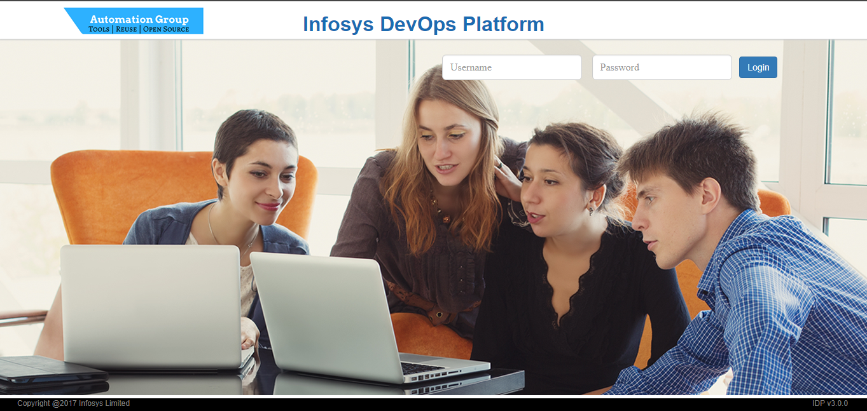

Fig 1: Login Page

- On successful login, you will be redirected to the history page which would show you a list of jobs that you had previously created.

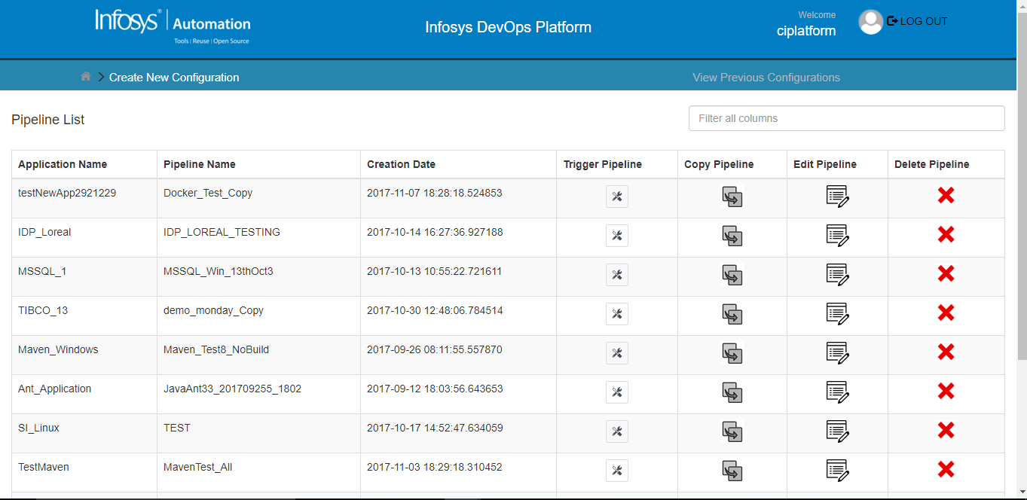

Figure 2: Previously created pipelines Page

BASIC INFO PAGE

PIPELINE Creation

Select the Application Name under which the “Pipeline” has to be created. Give a unique name for the “Pipeline”. Select the Build Server OS on which the “Pipeline” will be executed.

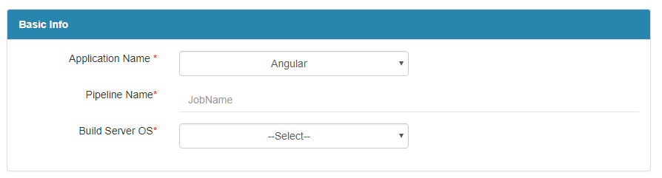

Figure 3: Basic Info Page-Pipeline Details

ADDITIONAL MAIL RECIPIENTS

This is an optional section where you can choose to send the notification emails to specific people. If All Application Users checkbox is selected, then mail is sent to all the users mentioned in that application. Click Continue Button to navigate to the next page or Click Reset Button to reset the contents of the current page.

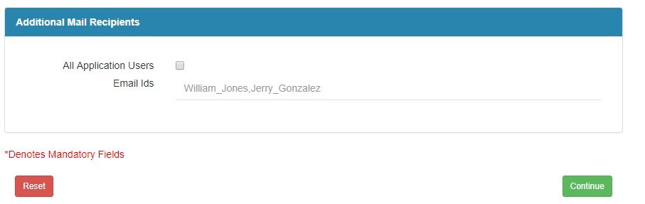

Figure 4: Basic Info- Additional Mail Recipients

code info pages
Technology and SCM Details

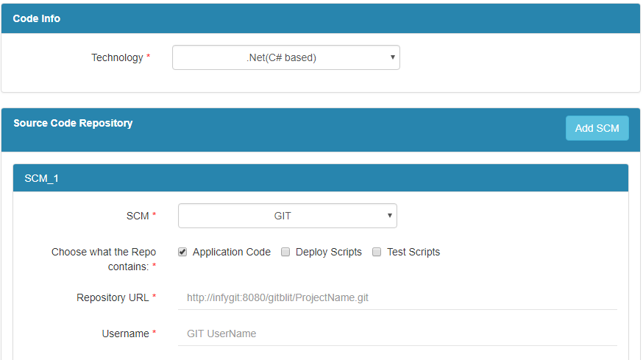

Figure 5: Code Page - Technology & SCM Details

Select the technology [.NET (C# based)]. Then configure the SCM tool used in the project. Select the SCM from where Source code has to be pulled out. There are four types of SCM’s in this platform – GIT, IBM RTC, MS TFS and SVN.

USING GIT
If GIT is chosen, then give the repository URL, Username and Password of the person who has right to check out the code from it along with default branch. If directories have to be included explicitly then check the checkbox and mention
directories. Select Repository Browser and its corresponding fields.

Using IBM Rational Team Concert
If IBM RTC is chosen, then give repository URL, RTC Workspace Name and Stream Name along with Username and Password.

Using Microsoft Team Foundation Server

If MS TFS is chosen, then give TFS Server URL, the path of the Project and User credentials.

Using SVN
If SVN is chosen, then give Repository URL, User credentials.

CUSTOM BUILD ACTIONS
This facilitates the custom build actions that needs to be performed before or after the build operations.

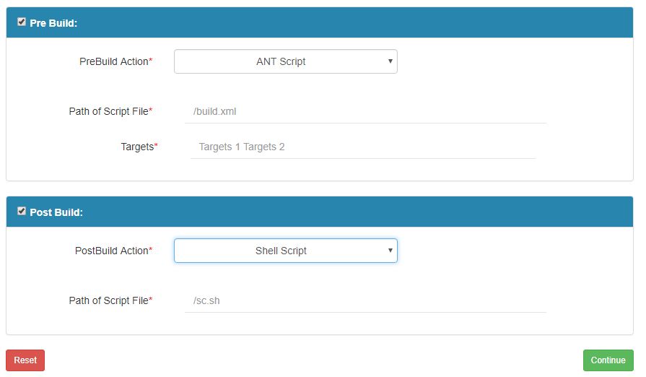

Figure 6: Code Page- Custom Build Actions

Pre Build Action
Any action that needs to be performed before a build action is configured here. Select the Pre Build action. This platform supports ANT Script, Shell Script and Batch Script. Enter the path of the Script file. If ANT script is selected enter the targets. (Ex: init, compile)

Post Build Action
Any action that needs to be performed after build action is configured here.
Select the Post Build action. This platform supports ANT Script, Shell Script and Batch Script. Enter the path of the Script file. If ANT script is selected enter the targets. (Ex: init, compile). Click on CONTINUE Button to navigate to the next page.

ADDITIONAL PIPELINE PARAMETERS

Pipelines can be defined with parameters as these parameters control what the pipeline does. The parameter type can be either string or password type. The password type is encrypted, then provide any name to Parameter and give the value also. Static can be selected if you do not want to change the parameter value at trigger time.

To change the parameter value at trigger time, then the static checkbox need not be checked and this parameter value can be provided in the input box of the trigger page.

bUILD INFO PAGE

This provides the list of operation that can be integrated to the build job, which can be scheduled along with the build operations.

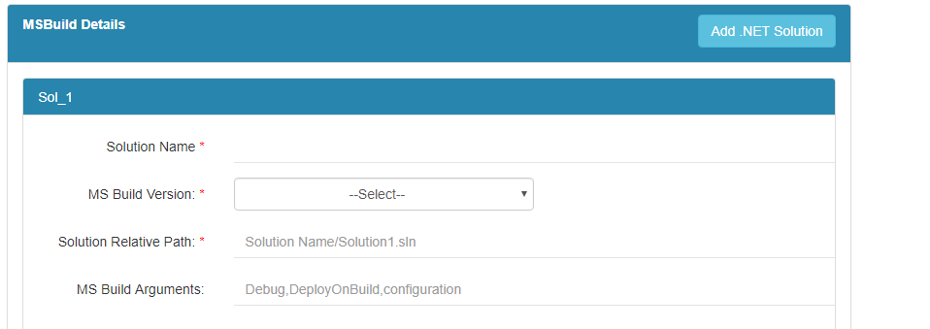
Figure 7: Build Page- .NET Solution

Provide the Solution Name of the solution file. The user can select either the default MS Build Version or any other version from the dropdown.
Provide the path of the solution file and give the MS Build Arguments as debug or Deploy On Build or Configuration according to the requirement.

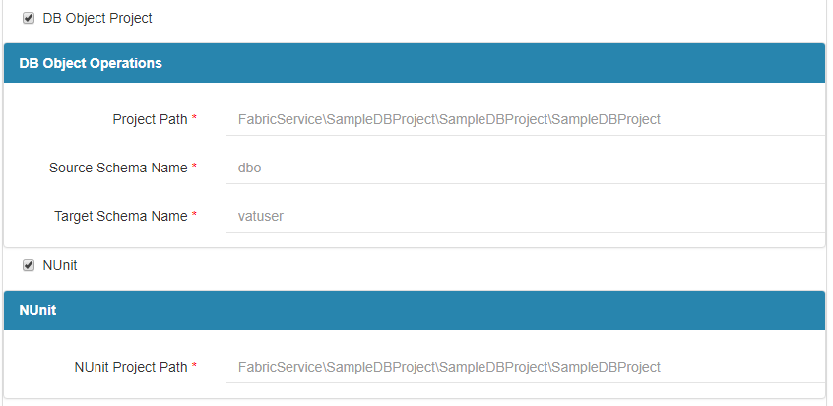
Figure 8: Build Page- DB Project Operations.

DB Object Project

Provide the project path to copy the schema from source to target by giving the Source Schema Name and Target schema name.

NUnit

NUnit, which is the open source unit testing framework for DotNet Applications can be selected in order to test by giving the path of NUnit project path relative to root folder.

Code Analysis

The selection of code analysis checkbox ensures tools are run for static code analysis. The user can choose either Sonar or Fxcop.

To perform code analysis using Sonar, user should have configured Sonar server and the URL of that server should be provided along with User credentails. Fxcop, the other code analysis tool which analyses the complied code rather than original source code can also be selected if the user wish to do code analysis using this tool.

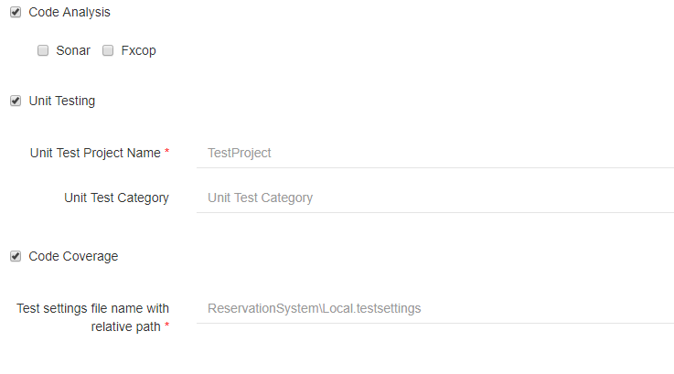
Figure 9: Build Page- Code Analysis

Unit Testing

The selection of Unit testing checkbox ensures the execution of test cases that are present in the project.

Code Coverage

Code Coverage option will be enabled once you select Unit Testing. Code coverage can be selected to get the code coverage of the code.

Post Build Module

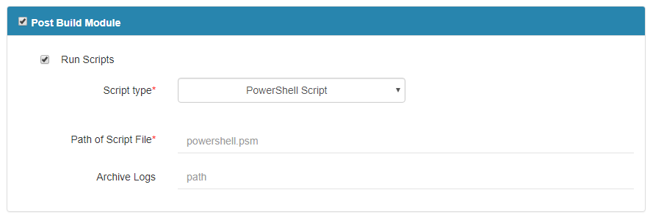

Figure 10: Build Page – Post Build Module

Any action that needs to be performed after a build action is configured here. Select the PostBuild action from the dropdown. It can be an ANT Script, a Batch file, a PowerShell Script or a Shell Script. Enter the path of the Script file. If ANT script is selected enter the targets. (Ex: deploy, test). Enter the path of archive logs.

Staging

If the user wants to overwrite the Artifact Repository Manager, then checkbox that option and then select Artifact Repository Manager (Nexus/JFrog Artifactory). This option can be chosen as the particular pipeline can have its own Artifact Repository Manager and need not depend on Application Level Artifact Repository Manager .NA can be selected in case you wish not to overwrite the Artifactory Repository Manager.

Dependent Pipeline

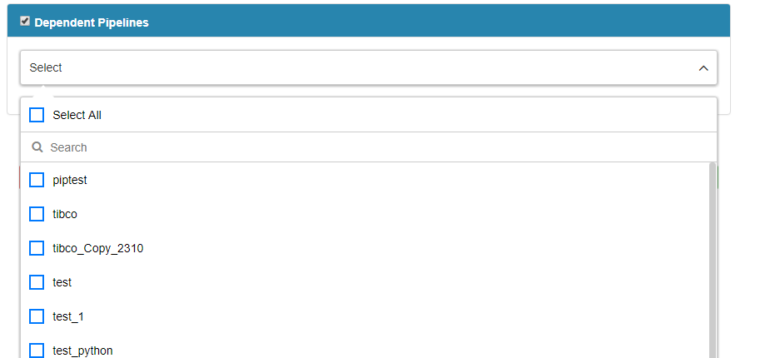

Figure 11: Build Page - Dependent Pipelines

Select the Pipelines in this Application which are dependent from the mutiselect dropdown.

dEPLOY INFO PAGE
Select the Deploy checkbox to select deployment of the packaged project into different application servers in different environments. Give the Step Name.
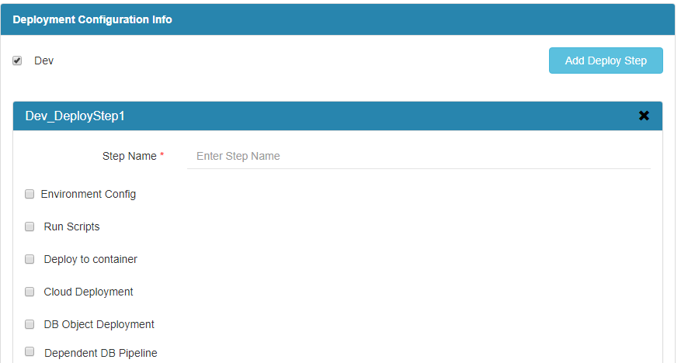
Figure 12: Deploy Page- Dev Environment

Environment Config

If there is a requirement to configure the environment before deploying the application on IIS server, then the environment config checkbox can be checked provided this environment has configured at application level.

Run Script

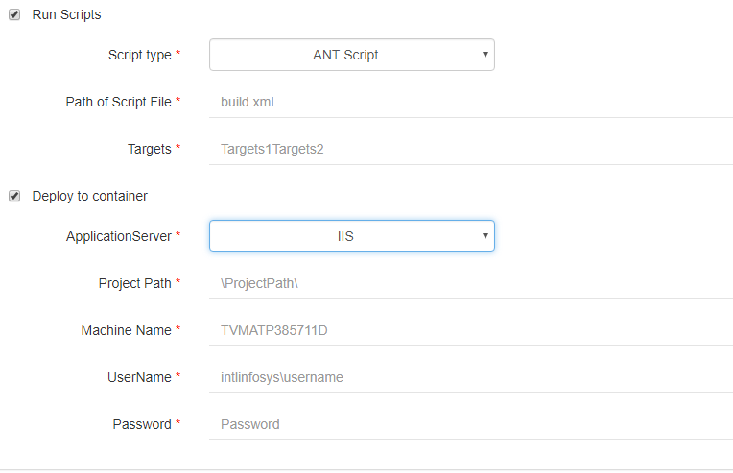
Figure 13: Deploy Page – Run Script

Different type of scripts are - ANT Script, a PowerShell Script, a Batch Script or a Shell Script. Provide the respective details.

Deploy to Container

For deploying the DotNet application, IIS server is used as the container. Provide the project path, IIS Machine name, IIS Username and Password respectively.

Cloud Deployment

If the user wants to deploy the application on cloud, then provide the JSON details for the same.

DB Object Deployment

In order to make any Database Changes, then DB server Name and DB Name can be provided.

Dependent DB Pipeline

If any DB deployment pipeline was created under the application, then select those DB Pipelines and give the DB Owners.

TEST INFO PAGE

Test Operations

Click on Add Test Step button at the top-right corner to provide the test details for a particular environment. Give the Step Name. Select either Run scripts or Test tool. Select Run Scripts if required. It provides an option of ANT Script, Shell Script, batch file, PowerShell and SSH.
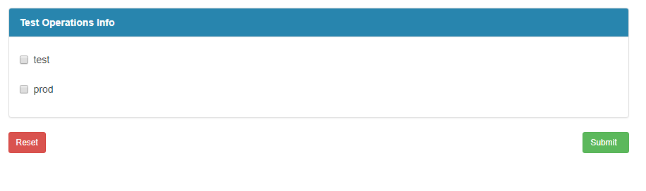
Figure 14: Test Page

ADD TEST STEPS

Select Test Tool

Provide the test category (Functional/Performance/Security/Service).

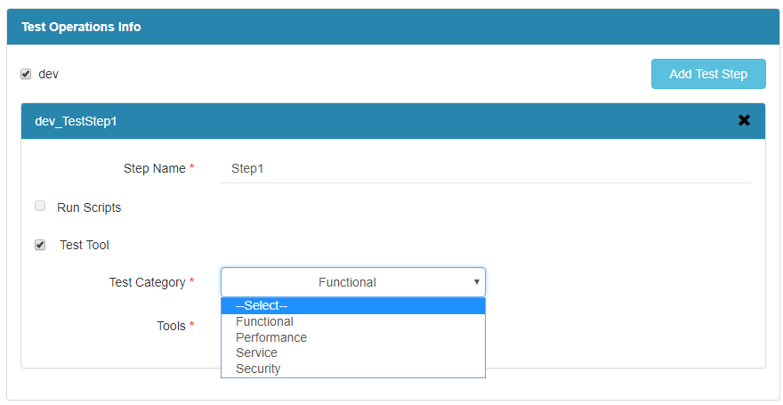

Figure 15: Test Page – Test Tool selected

FUNCTIONAL TESTS

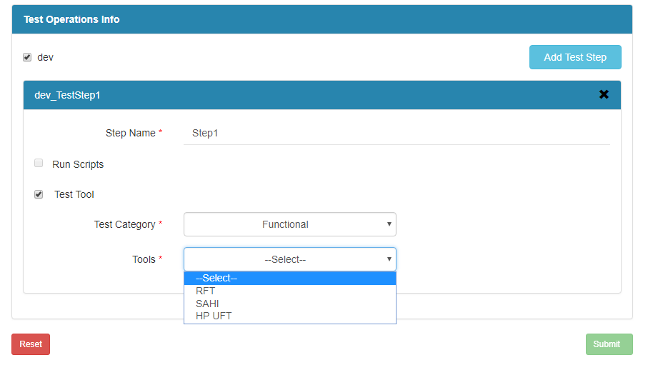

Figure 16: Test Page – Functional Category selected

For Functional Test Category there are three tools available – RFT, SAHI, HP UFT. On selecting the particular Tool provide the mentioned details.

PERFORMANCE TESTS

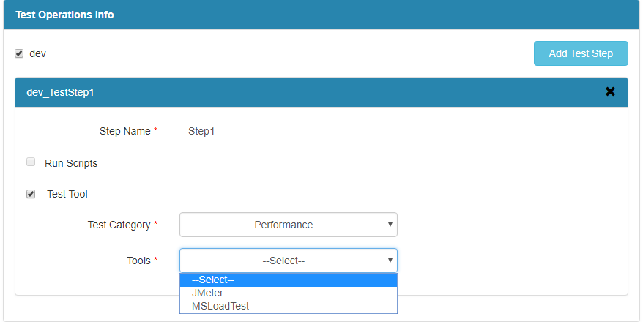
Fig 17: Test Page – Performance Test Category

Under Performance category, the two types of Tools supported are – Jmeter and MSLoadTest.

Using Jmeter

Provide the path of the test plan which has to be executed and the property file if required.

Using MSLoadTest

Provide the path of project containing the MS Load Test Suite with proper extension, MS Build arguments, MS Load Test name having .loadtest extension and Test category which has to be executed.

SERVICE TESTS

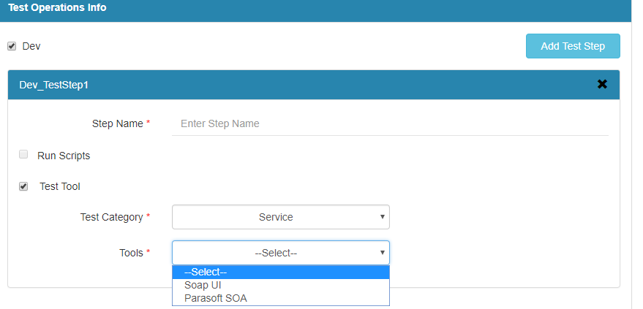

Fig 18: Test Page – Service Test Category

Under Service Category, Saop UI and Parasoft SOA Test Tools are supported.

SoAPUI
Provide the name of the project and location which contains Soap UI Test Suite, then give the name of the Test Suite which has to be executed.

PARASOFT SOA
Provide the name of the project containing Parasoft SOA Test, name of the Parasoft SOA Test project location which has to be executed, name of the Test Suite which has to be executed and name of the test configuration.

SECURITY TEST
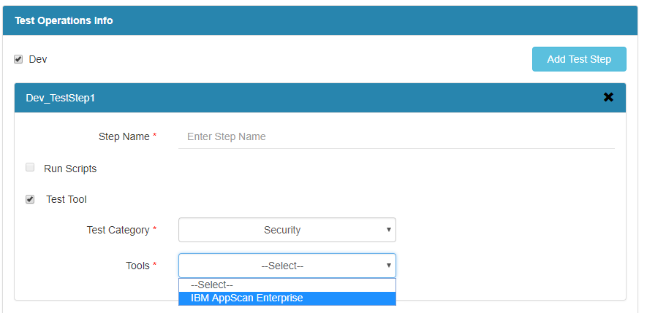

Fig 19: Test Page – Security Test Category

IBM APPSCAN ENTERPRISE
Provide the URL for the scan to test, user credentials and the “Pipeline” name which has to be executed.

SUBMITTING THE JOB
You can now click on Submit button to create a new build. It will give you the below screen once the configuration creation is successful.

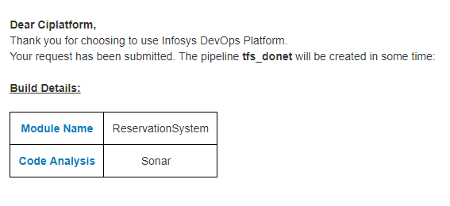
Figure 20 a: Success Page- Project Details

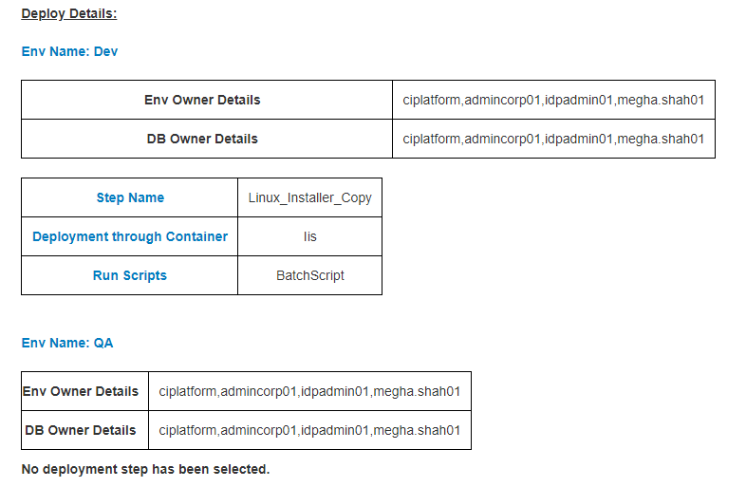

Figure 20 b : Success Page- Deploy Details

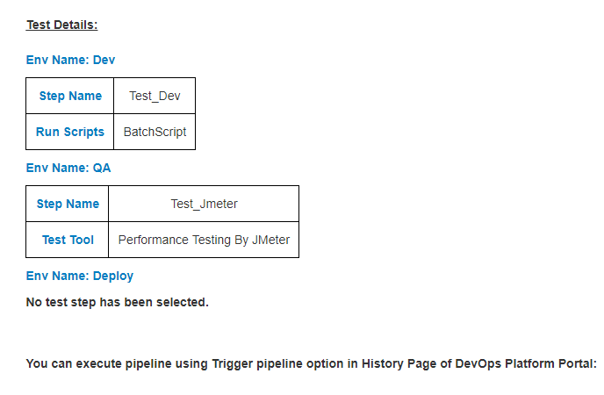
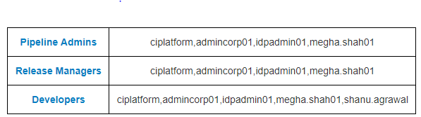
Figure 20 c : Success Page- Test Details

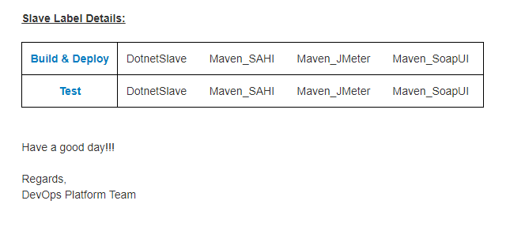
Figure 20 d: Success Page- Slave Details

