Curriculum Vitae - Yanua Ledesma

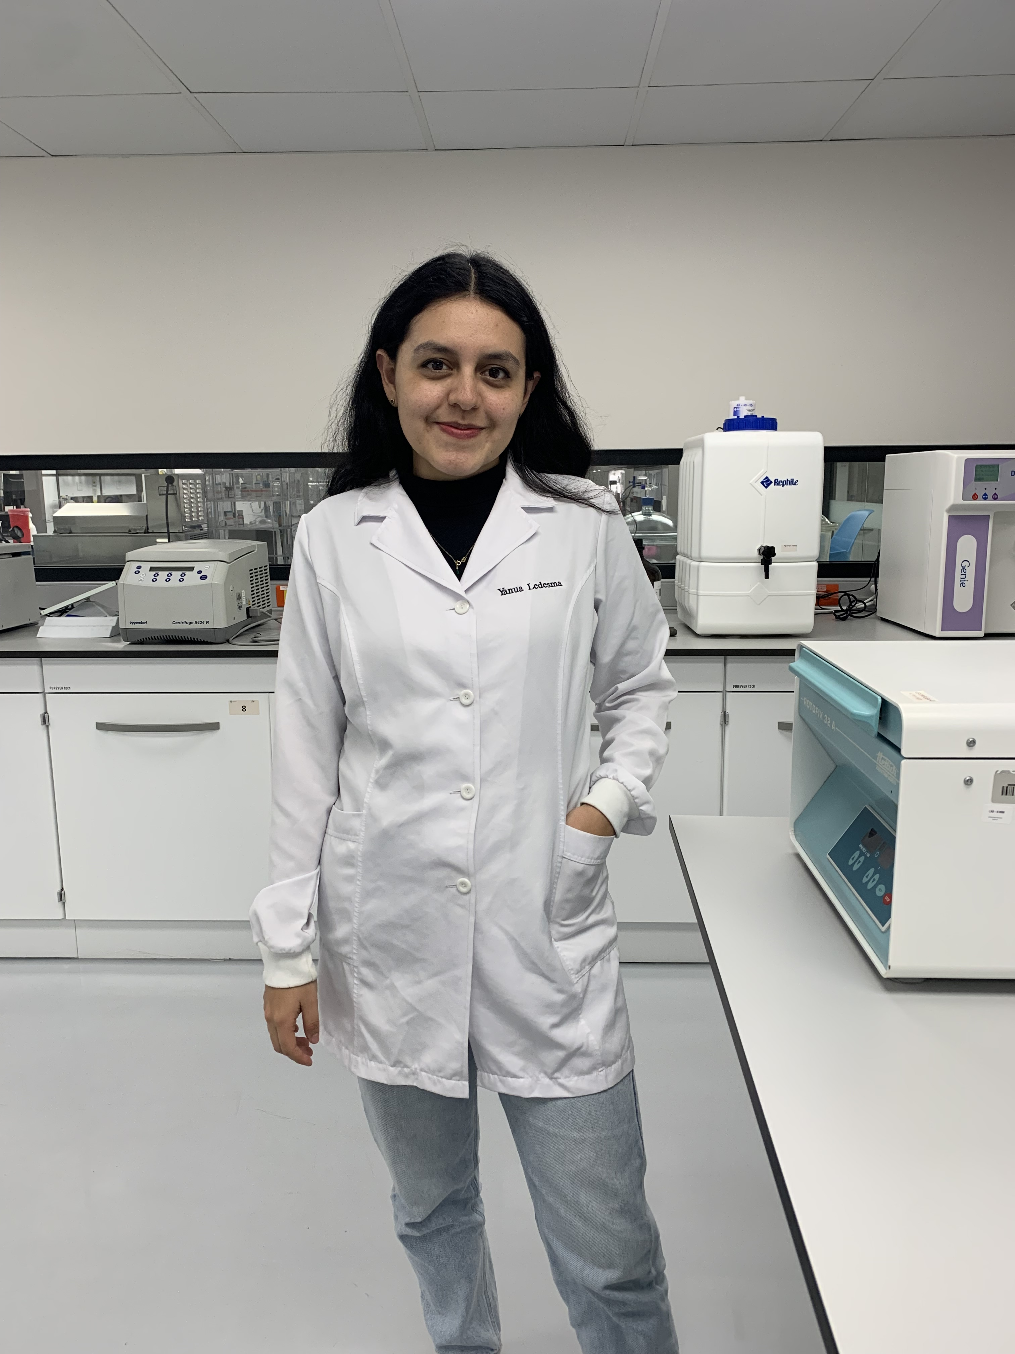
Contact Information
Name: Yanua Ledesma
Email: yanua_ledesma26@outlook.com
Cellular: 0983061620
Birth: 26/08/1998
LinkedIn: https://www.linkedin.com/in/yanua-ledesma
ORCID: https://orcid.org/0000-0003-4139-3018

Professional Profile
Biotechnology Engineer and PhD candidate in Veterinary Sciences with experience in the epidemiology of zoonotic diseases, molecular diagnostics, and project management. Author and co-author of indexed publications, with teaching experience at the university level and international collaboration in research on zoonotic diseases and non-tuberculous mycobacteria.

Education
- PhD in Veterinary Sciences – University of Buenos Aires (2024–present).
- Biotechnology Engineering – Universidad de las Américas, Ecuador (2017–2022). SENESCYT registration 1040-2022-2444386.

Research Lines
- Doctoral project UBA/UDLA: Paratuberculosis in sheep in Ecuador. Comprehensive study on diagnosis, epidemiology, and control strategies.
- Infectious diseases: microbiology, epidemiology, and molecular/serological diagnosis of Q fever, neosporosis, brucellosis, mycobacteriosis, protothecosis, and papillomavirusGenotyping the SLICK gene in two breeds of cattle (carora and limonero).
- Whole genome sequencing of new species of mycobacteria isolated from patients of Venezuela.

Professional and Teaching Experience
- Universidad de las Américas – Research Assistant (2020–2025). Sample processing, molecular diagnostics, epidemiological analysis, field coordination.
- Universidad de las Américas – Teaching Assistant, Cell and Molecular Biology II (March 2025–present). Responsible for practical classes.

Scientific Publications
- Bovine Papillomavirus Genotypic Diversity and a Putative Novel Viral Type in Ecuador. DOI: https://doi.org/10.3390/vetsci12070672
- Addressing the Concern of Orange-Yellow Fungus Growth on Palm Kernel Cake: Safeguarding Dairy Cattle Diets for Mycotoxin-Producing Fungi. DOI: https://doi.org/10.3390/microorganisms12050937
- A rapid and inexpensive 96-well DNA-extraction method from blood using silicon dioxide powder (glassmilk). DOI: https://doi.org/10.1093/biomethods/bpae079
- Shedding light on risk: Seroprevalence of Q fever among farm animals and workers in Ecuador. DOI: https://doi.org/10.1016/j.onehlt.2024.100939
- The Re-Identification of Previously Unidentifiable Clinical Non-Tuberculous Mycobacterial Isolates Shows Great Species Diversity and the Presence of Other Acid-Fast Genera. DOI: https://doi.org/10.3390/pathogens11101159
- High Prevalence of Prototheca bovis Infection in Dairy Cattle with Chronic Mastitis in Ecuador. DOI: https://doi.org/10.3390/vetsci9120659
- The Development of a Multiplex PCR Assay for Fast and Cost-Effective Identification of the Five Most Significant Pathogenic Prototheca Species. DOI: https://doi.org/10.3390/pathogens12081018

Scientific Publications in Progress
- A Fast and cheap DNA extraction method for plants: molecular identification of orchids from the Amazon. Principal researcher: Jacobus H. de Waard.
- First Report of Paratuberculosis in Sheep in Ecuador: A Case Study and Literature Review. Principal researcher: Jacobus H. de Waard. Submitted to BMC Veterinary Research (under review).
- On the footsteps of Calaway Dodson: Understanding Ecuadorian Telipogon. Principal researcher: Gabriel A. Iturralde.

Conferences and Presentations
- Participant at the International Engineering Conference FICA 2017: Sustainable Life and Industrial Revolution 4.0, October 30–31, 2017, Quito, Ecuador.
- Participant at the 1st International Biotechnology Congress, October 16–18, 2019, Quito, Ecuador.
- Participant at the Microbiology Week of Sociem Upao Piura and Scudep, August 24–30, 2020, virtual modality.
- Oral presenter at the XLIV National Biology Conference, December 1–3, 2020, Quito, Ecuador.
- Ledesma, Y. (2021). Participation in the Proceedings of the XLIV National Biology Conference. Pontificia Universidad Católica del Ecuador. ISBN: 978-9978-77-531-8.
- Participant at the VIII International Research Congress REDU, November 15–18, 2021, Ambato, Ecuador.
- Poster presentation at the 2nd International Biotechnology Congress, November 24–26, 2021, virtual modality.
- Poster presentations at the V C2B2 and XI SLAMTB, November 8–10, 2023, Bucaramanga, Colombia.
- Oral presentation of two research works at the V C2B2 and XI SLAMTB, November 10, 2023, Bucaramanga, Colombia.
- Oral presenter on advances in the diagnosis of paratuberculosis in sheep in Ecuador. Conecta Ciencia 2025, Universidad de las Américas.

Award
- Awarded for Best Research Work and Presentation at the 5th International Congress C2B2 and the 11th SLAMTB, Bucaramanga, Colombia.

Technical Skills
- Molecular and immunological techniques: PCR, nested-PCR, qPCR, and ELISA.
- DNA/RNA extraction: CTAB, phenol-chloroform, commercial kits, Glassmilk method.
- Epidemiology: statistical analysis, Rstudio, and QGIS.
- Fieldwork: sampling in sheep and goats.
- Bioinformatic tools: MEGA.

Languages
- Spanish – native
- English – B2 (certification issued by UDLA)

