1.Cover page(wel.html)

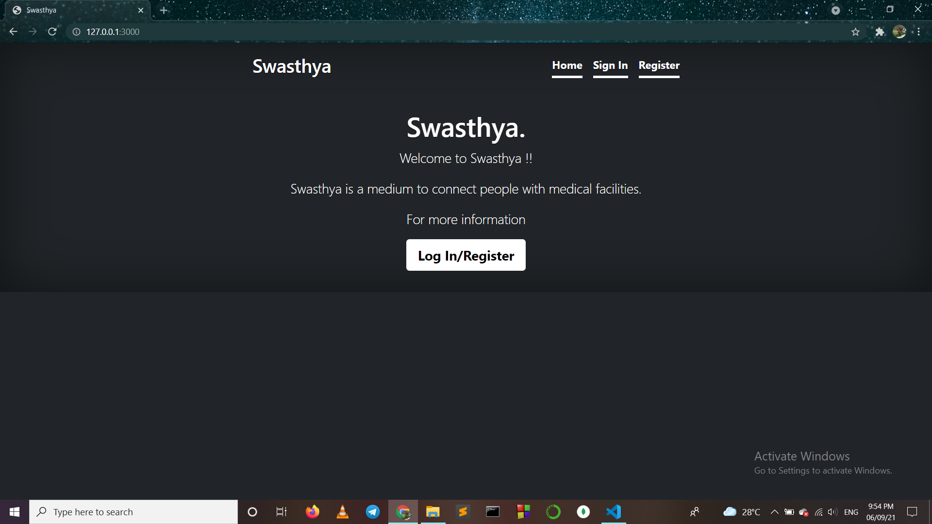

This page has 3 buttons : Home , Sign In , Register (Log In/Register is also Sign In page).

2. Sign In (signin.html) :

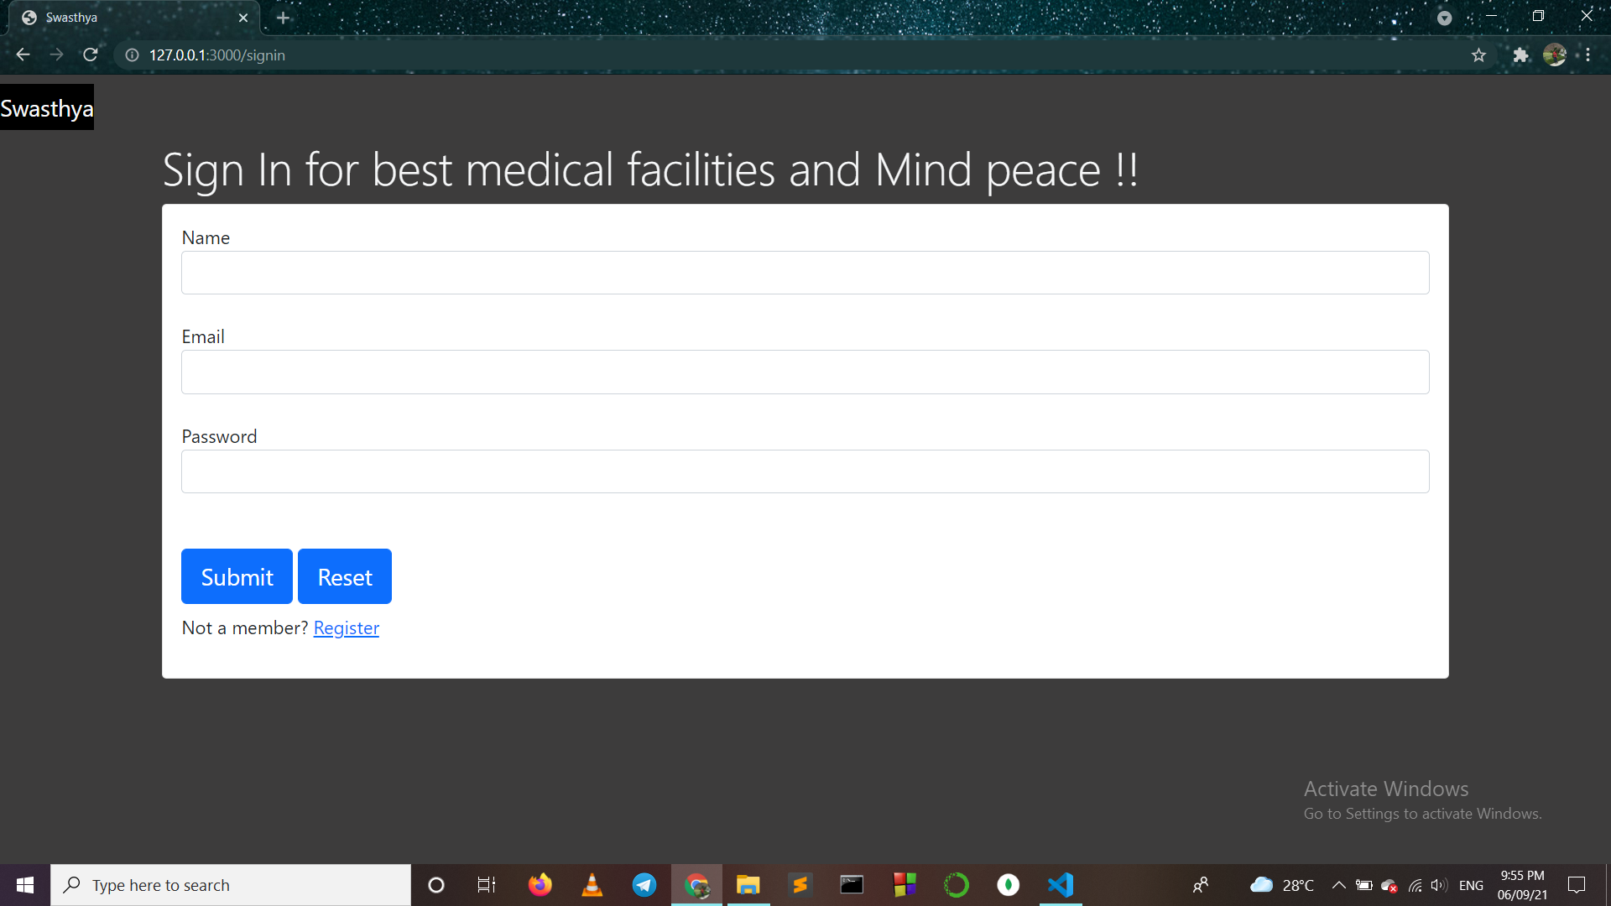

2. Register (register.html) :

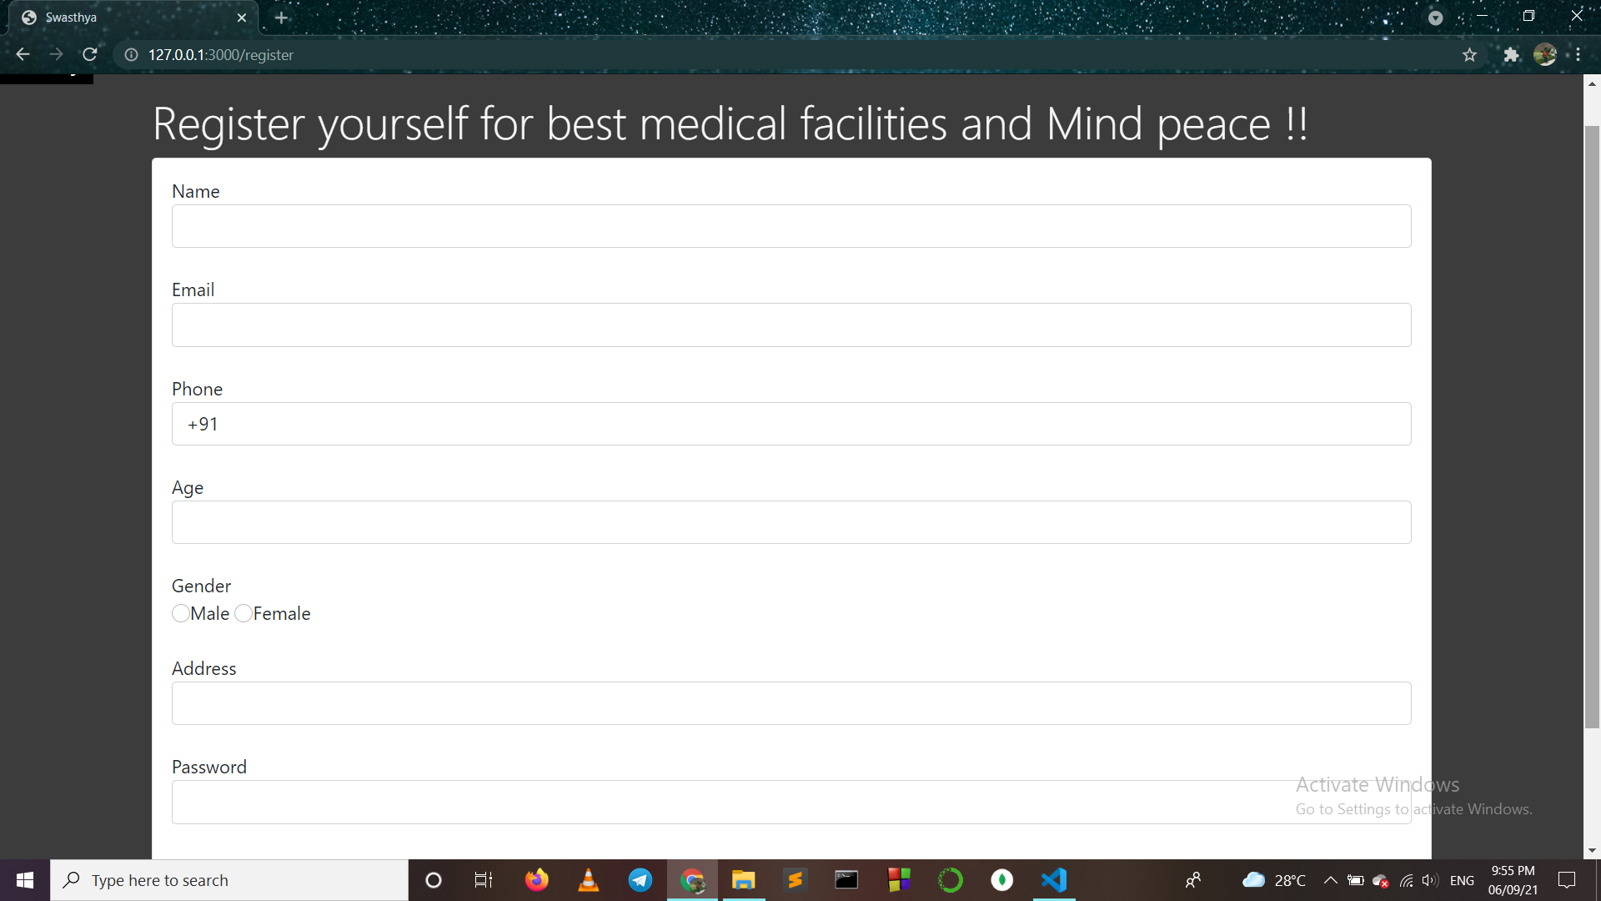

3. Home (index.html) :

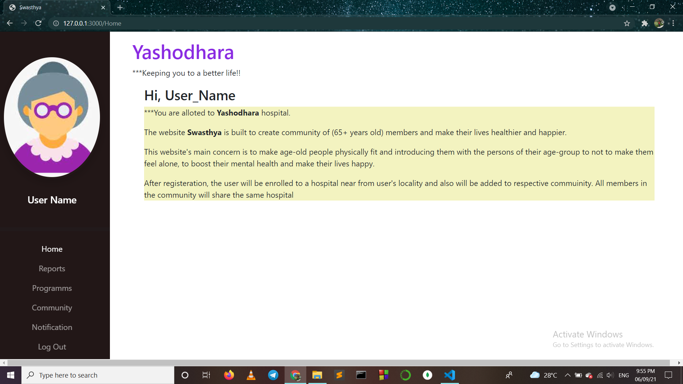

Home page contains 4 pages : Report, Programs, Community, Notification.

4. Report (report.html) :

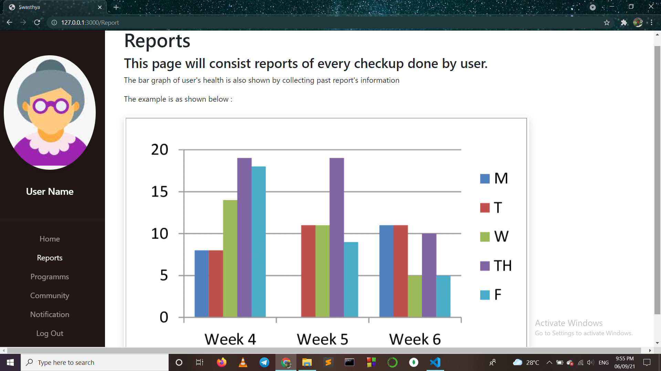

5. Programs (programm.html) :

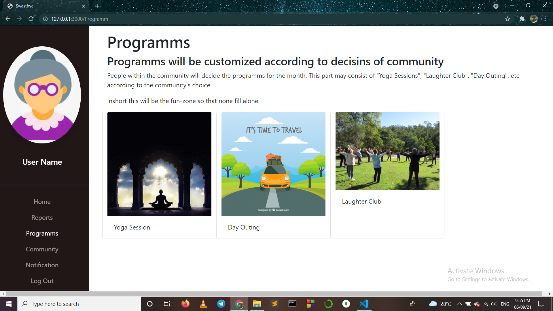

6. Community (community.html) :

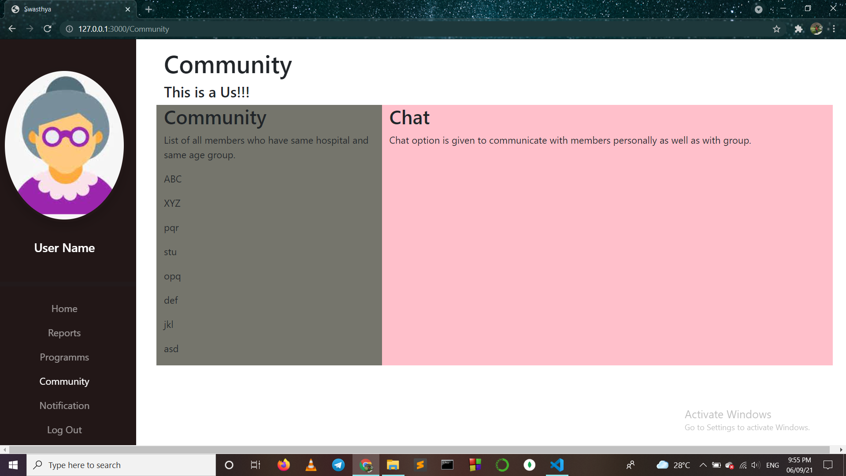

7. Notification (notification.html) :

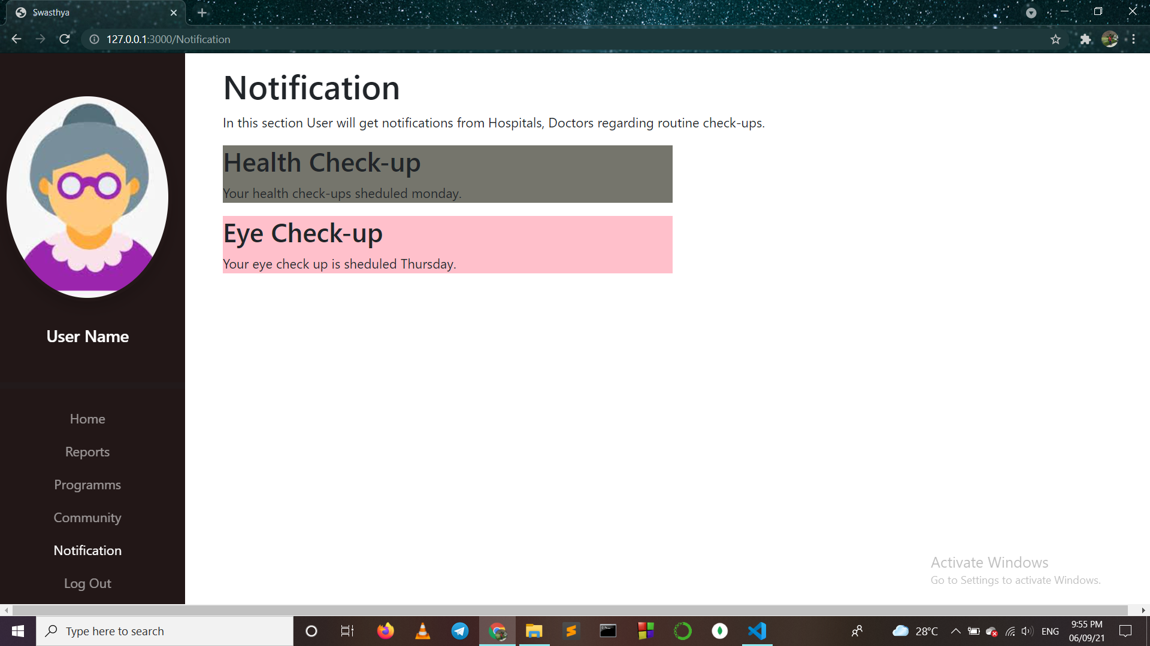

Log Out button will redirect to Cover page.

Sign In and Register web pages will be redirect to “Home” page after successful sign in and registration respectively.