Chapter 1 - The Weight of It
This was me.
Tired but wired. A terrible sleeper. No energy. A constantly busy mind. The nights I wanted sleep, it wouldn’t come. The moments I needed to be present, I could barely stay awake.
Despite being a glass-half-full kind of person, I was often depressed or moody. I learned to mask it. Lacking willpower and motivation, I pushed through on self-talk alone. Craving sugar and caffeine. Getting irritated by things that really shouldn’t have bothered me - I was good at filtering what came out… most of the time. It rarely boiled over into anger. It usually surfaced as short snappy comments, or more typically withdrawing myself before I said something I would regret.
Trying to cope was deeply exhausting.
Other times, when I wasn’t dealing with irritability, I just felt detached. Like I was on a different wavelength. I’d say or do something I thought might get a laugh, and it would land as weird, or just plain mean. Later I’d look back and wonder who that person was.
All the masking, the pushing through, the filtering, the disconnection - and all the while life never stopped. It was completely overwhelming. Keeping up felt like driving down the highway with the handbrake on.
The weight was killing me. Figuratively, in the day to day — but literally too. I knew it sat behind some of the most serious long-term diseases.
The nights were unpredictable. Some nights I would fall asleep as soon as my head hit the pillow. Others I would lie awake for hours. But every night I would wake several times. And getting back to sleep, when it came at all, took a long time. I tried compensating by spending nine or more hours in bed. But I was still only getting four or five hours of actual sleep. Broken and poor quality. Waking up only slightly less tired than when I got in.
You would think falling asleep the moment my head hit the pillow would be a good thing — it wasn’t. It meant I was running such a huge sleep deficit my body would just crash.
The days were their own kind of punishment. I spent most of them feeling like I could fall asleep at any moment. Particularly after meals, and in the dreaded afternoon dip — that stretch of mid-afternoon where the fatigue hit like a wall. I tried to nap whenever I could – weekends and commuting to work, mostly. These helped, but a semi-lucid 15 minute rest was usually all I could achieve. Sugar and caffeine filled the gap and got me through… until they didn’t.
Unless you’ve lived it, it’s hard to understand. I’d smile to myself when someone said, “God, I’m wrecked today — the fire alarm went off last night and it took me two hours to get back to sleep.” That was their worst night in memory. It was better than most of mine. Part of the problem was that I couldn’t even describe what was wrong. My thoughts were so scattered that “I can’t sleep” was about as far as I could get.
After years of trying and failing, I started to wonder whether the problem was just me.
I had recurring dreams, too. The setting was always different, but the theme never changed. Most dreams are unrealistic enough that when I woke, my rational mind took over and settled me — I knew none of it had been real. These weren’t like that. They were set in ordinary, everyday life, which made them hard to shake. Clubs that wouldn’t let me in. Friends making plans without me. Parties I wasn’t invited to. Jokes I wasn’t in on. The theme was always the same: you’re not good enough.
I so desperately wanted it to be one thing. A vitamin deficiency. A parasite. Some disease with a name and a cure — something I could point to and fix. A single villain to defeat. But there was never anything to find.
Maybe it was genetic. Maybe it was just how I was built. I had a busy mind. Things hit me harder. Perhaps I needed to stop fighting it and learn to live with it — accept it as my cross to bear, and put my energy into everything else that was good in life.
But there was a part of me that wouldn’t quite go there. I wish I could say it was some kind of Zen-like intuition. An admirable unwavering dedication. It wasn’t. It was more like a stubborn refusal to accept there was nothing I could do.
It was more like crawling through the desert. Exhausted and desperate, angry no one was coming to get me. Begrudgingly putting one heavy foot in front of the other, not knowing whether I’d make it out. But not able to give up entirely.
During the darkest stretches, thoughts would surface that frightened me. I knew I’d never act on them — but the fact they were showing up at all told me how badly this was affecting me.
There were times I would give up for a while. But I couldn’t quite accept that this was just going to be my life. That I’d feel this way for the rest of it.
So I kept going, because stopping felt worse. There was just too much I didn’t want to miss.
Because that’s what it had become — I was a spectator of my own life. Wanting to join in, but never quite having the energy to. Every birthday I felt another year had slipped past — another year wasted, in a life far less than it could be.
Often I would sit with my kids in the evening, reading to them before bed. It should have been a good part of the day. But I was always foggy, barely able to follow the words on the page. I would read aloud and not take them in. My children were right there, cuddling into me, and I was just trying to stay awake long enough to get to the end of the chapter.
That was it. That was the whole problem, the way it took over every important moment of my life.
I didn’t know if things could ever change.

Chapter 2 - The Turning Point
I started with my doctor. He gave me something to help me sleep, but made it clear he didn’t want to prescribe it again. What I really needed, he said, was to get to the root of it — and for that I’d have to see a psychologist, or someone like one. He didn’t think a sleep study was worth it either. It didn’t sound like apnea, and that’s mostly what it would be looking for.
He was right on every count. It was also where the trail went cold.
A GP is a generalist, and this wasn’t a generalist’s kind of problem. The tools he had were a prescription he’d rather not repeat and a referral onward — and that kind of help is hard to reach, with few practitioners and long waits.
I kept looking.
Books, podcasts, YouTube, forums. The occasional deep dive into whatever study had just made the rounds online. There was always something new — some YouTuber who had found ‘the thing’, the mechanism, the explanation that was going to finally make sense of it all.
I would get genuinely excited. This one feels different. This one might actually be it.
It never was.
Some of the problem was volume. The good books didn’t give you one thing to try, they gave you twenty. Sometimes more. Each with variations, caveats, individual differences to account for. For someone already exhausted and overwhelmed, the prospect of working through all of it was paralysing. So I’d pick one or two, and try for a couple of weeks. They wouldn’t work — or I couldn’t tell if they were working. So I’d stop them and move on to the next thing, wondering if I was ever going to find a fix.
The right information was there. I just didn’t have the framework to make sense of it.
The moment things started to click, I was driving.
That year, our whole family was into mountain biking — proper downhill, chairlift, helmet-and-pads stuff. The trails we loved were about six hours away, which meant long car trips, several times over. On one of those drives, kids occupied, kilometres rolling past, I was listening to audiobooks about sleep and the nervous system.
I’d been turning something over in my mind for a while. I’d had days on the mountain that were the most physically intense of my life — hours of full adrenaline, every sense switched on, pushing harder than I ever had in a gym. And yet I wasn’t sleeping better on those nights. In fact, I consistently slept worse. That just didn’t make sense.
But somewhere on that drive, it started to.
Cortisol, adrenaline, the nervous system, stress and how the body reacts to it — things I’d read about in isolation started connecting. I started to see a pattern.
I already knew that a stressful day at work led to a bad night’s sleep. But if daytime stress causes a nighttime problem, what about everything else that I did during the day?
Without realising it, I had been thinking about sleep entirely as a night-time problem — something with a magic switch - all I had to do was find it. But the night was never the problem. It was just where I noticed it.
I was beginning to see how much more the daytime mattered.
It reframed everything. Every tip I’d tried, every supplement, every bedtime routine — none of it was wrong exactly. Some of it was even well-supported by science.
Some people can try ‘one thing’ and swear by it. Most likely, they had a solid foundation. The tip worked because most of the system was already working. For me, the whole system was out of alignment - I spent all day doing the wrong things, so trying their ‘one thing’ was never going to work.
And if the day was where the problem existed, thats where the fix had to be.
That was when it became obvious. I needed to build a ‘good day’. The problem was, I didn’t know what a good day looked like. And I couldn’t find anything that showed me.
I didn’t need another book of tips or a rigid sleep protocol. I had a demanding job, a family, a commute, and the kind of tiredness that makes even simple things a chore. I needed something that held my hand, which worked within a modern busy schedule.
It had to be holistic. It had to be incremental - my willpower was running on empty. It had to be flexible enough that one bad week didn’t unravel the whole thing.
Since a program like this was nowhere I could find, I decided I had to build it.
The starting point was biology.
If I was going to build something that actually worked, I needed to understand the system I was trying to support. Not at a research level — I wasn’t looking to make new discoveries. Just to make sense of what had already been found and figure out what I could realistically do about it.
It began with re-reading and self-experimenting. Trying things, measuring the response, adjusting. It wasn’t a clean clinical trial. I couldn’t always tell what was working and what wasn’t. I paid close attention to how I felt during the day — energy levels, mood, the quality of my mornings. My WHOOP was tracking through all of it, too — though how that came about is a story for later. Because there were so many variables, it was never quite a process of: do this, get that.
The whole process took years. Years of not knowing what I was looking for, trying the wrong things, measuring (and guessing), discarding and starting again. I was building the program from scratch.
After all those years, I’d found what worked — and more importantly, what I could realistically sustain.
Fortunately, you don’t have to go through all of that. The program now exists.
And, here’s what I believe: if you follow the program as it’s laid out in this book, it will change your life — and far faster than the years it took me. I’ll give you a sense of what to expect, and roughly when, before you begin.
All the figuring out is done. You just have to put in the effort to follow along.
If you are still hoping for ‘one thing I can do for a good night’s sleep’, a program might sound like a lot. But compared to months, years or decades of searching without any permanent success, it’s nothing.
You won’t have to wait until the end to know it’s working. Somewhere partway through the program, you’ll see a noticeable improvement in your sleep, and you’ll feel something profound: an undeniable signal that breaks a story you’ve been telling yourself for a long time. The one that goes: I will never be a good sleeper.
Once that story breaks, the motivation to finish the program takes care of itself.
My version of that took longer — I was doing and testing the program at the same time. But it came. And eventually, the insomnia was gone.
And sleep was just the beginning.
Things I’d carried for years began to lift.
The anxiety went. Not dramatically, not overnight — but one day that background weight was lighter. The minor bouts of depression, gone. The irritability — this-shouldn’t-annoy-me-but-it-does — much less. My ability to handle stress improved - I hadn’t realised how much of my stress response was caused by exhaustion.
The recurring dreams stopped too. No therapy, no reliving childhood trauma, no working out what any of it meant — I just started sleeping properly, and one day I realised they were gone.
Energy started coming back. And then something I hadn’t felt in a very long time — excitement. Genuine anticipation about things I was going to do on the weekend. I hadn’t experienced that emotion in more than a decade.
But the one that meant the most was even simpler.
I started showing up. For my wife, for my kids, for the people around me. Not just physically present — actually there. The gap I’d been managing for years - between who I was and who I wanted to be - had closed. Those ordinary moments that should have made me happy finally did.
I still have bad weeks. I’m not a perfect sleeper. Some weeks the habits slip and I feel it. But I now understand why, and I know what to do about it.
I’ve gone from years of broken, poor-quality sleep to 7+ hours of good quality sleep most nights.
It has been absolutely life changing.
I’m not sharing this because my story is unique. The specifics are mine — the mountain biking, the trial and error, the shape of my sleep — but the pattern will be familiar. The searching, the failed fixes, the exhaustion that makes everyday things feel like way too much. If any of that resonated, you’re in the right place.
What I hope you take from this chapter isn’t the story. It’s the possibility.
Maybe you don’t have to accept: I’m just a bad sleeper. Maybe this isn’t the rest of your life.
The moment where you stop hoping it might be true and actually feel it — that’s closer than it probably feels right now.
And the biology is where it starts. I’m going to explain it in a way that you might not have seen before. The simplicity might make neuroscientists cringe, but we’re not neuroscientists. We just need to understand sleep well enough to get a meaningful improvement.
Take in as much as you can, it’s worth it.

PART 2 – The Science

Chapter 3 - The Uncomfortable Truth
Some people swear by hemp extracts for sleep. I started reading about CBN — a compound formed when THC breaks down, supposedly even more targeted for sleep than CBD.
The research was thin. The availability was patchy. But I’d already tried the common things. This felt like the next level. Maybe I’d finally found something that could fix me — it just hadn’t made it to the mainstream yet.
Because alongside the sparse science, forums posts were saying: of course you haven’t heard of it — drug companies can’t patent a plant. When you’re exhausted and desperate, the conspiracy starts to sound a lot like hope.
So I bought some with the quiet optimism of someone who had been disappointed before.
It definitely did something. Some nights, it helped. I fell asleep more easily. Woke up slightly less. Enough to keep me using it.
But other nights, felt like it did nothing at all. Same oil, same dose. Nothing.
That inconsistency was frustrating. Was it working? Was I imagining it? Should I take more? Try a different brand? Take it at a different time? What was different about the nights it did work?
Whatever it was doing, it wasn’t a reliable fix, it was a nudge. Only on some nights, for reasons I couldn’t identify or reproduce.
I’d been here before — many times. A new study, a new supplement, a new technique. Hopeful at first, then back exactly where I started.
The problem wasn’t the CBN. The problem was the question underneath.
What’s a quick fix for my sleep?
It was the wrong question. That’s not how sleep works. It isn’t found in a product you buy or a simple hack — it’s something your body does, once the conditions are right. And like recovering from an illness or an injury, it doesn’t happen overnight. For sleep as broken as mine, there’s no quick fix. And searching for one is exactly what that kept me stuck. That’s the uncomfortable truth.
Not something I wanted to hear. But once I faced it, the question changed — not “what’s the quick fix?” but “what does it actually take?”
The answer I kept coming back to: fixing sleep is less like flipping a switch and more like getting fit. There’s no shortcut. You build it, gradually, from a foundation — over weeks, not overnight.
It was like I’d been drinking, smoking, eating badly, barely moving — and wanted to find ‘one thing’ I could do to get fit. Then I’d try that ‘one thing’ for a week or two, not see any results, and think: it must not work for me.
What kept me searching long after I should have stopped were the stories — a friend of a friend, a stranger online — someone who’d made one simple change and got a huge win.
And as we saw in the last chapter, a single change can work — but only on a foundation that’s already there. If your system is mostly functional then one well-chosen adjustment might genuinely be enough. Fix the timing of your last coffee. Cool the bedroom down. Cut the screen off earlier.
However, if the system itself is broken — if you’ve been running on poor quality, fragmented sleep for years, if you’re tired but wired most nights, if you’ve tried a dozen things and none of them stuck - you need to fix the foundation.
We generally know how fitness works, but nobody taught us about sleep. From a young age the basic concepts get taught in school. Move your body. Eat reasonably well. Rest and recover. Do it consistently.
Most adults, even those not as fit as they could be, have a reasonable idea - ‘I know… I should probably do a bit more of this, and a bit less of that’.
Sleep is different. You arrive at adulthood with a sleep system you’ve never been shown how to maintain. No framework or fundamentals. Just a vague sense that eight hours is probably good and that you should probably go to bed at a reasonable time. And when the system starts to fail — the quality drops, when you constantly waking at 2 am — the only toolkit you’ve been given is: Try this tip. Try that supplement. Try sleeping pills.
I don’t think this is some great conspiracy. It’s simply that most people never have a problem. They don’t understand insomnia. Go to bed, turn out the light, close your eyes, go to sleep. What’s so hard? What’s there to teach?
Modern culture doesn’t help either. If anything, it pushes the other way. We’ve built an odd kind of pride around not sleeping — the early riser who powers through on five hours, the high performer who treats sleep as a weakness, the devoted worker who wears exhaustion like a badge of honour. As if rest were a character flaw and not a biological need.
For a long time, I was caught up with that way of thinking. My response to exhaustion was to be that high performer, push through it — sleep is optional.
However, the reality is, only a very small percent of the population can genuinely function that way. For most of us, biology just doesn’t work like that.
And the consequences of getting it wrong aren’t trivial. Poor sleep is linked to serious, long-term consequences — heart disease, diabetes, depression, cognitive decline. And driving tired can impair you as badly as driving drunk.
The stakes are high.
Which brings me back to the real question. If quick fixes don’t work on broken foundation — what is the foundation, and how do we fix it?
I had the pieces but I didn’t have the framework that tied them all together. Until…
I eventually came to learn that underneath it all, the whole process of sleep depends on hormones.
Hormones that need to rise and fall in a predictable rhythm throughout 24 hours. When those hormones are aligned – right amounts, at the right times - sleep happens naturally. When they’re not, no tip in the world will reliably fix it.
As I dug deeper, I discovered there are dozens of hormones involved in sleep. A long, complicated list. But I wasn’t looking for a complete biological picture. I was looking for leverage. I wanted to focus only on the ones that would move the needle — the hormones that did most of the work, and the ones I could actually do something about.
That’s when the pattern emerged. The list narrowed from dozens to just four.
Four hormones that sit at the top of the system. When aligned, they bring the rest into order. When they’re not — everything else is treating symptoms.
That’s the foundation. Four hormones.
What they do, how they work and what disrupts them, is where we start. And most of the habits that keep them aligned don’t require anything extraordinary. Just a commitment to some small adjustments, in an ordinary day.
The foundation is fixable. And that’s what the rest of this book is about.

Chapter 4 - Sleep Incorporated
I’d like you to think about the sleep system as a hierarchy, like a company. I’m going to call it Sleep Incorporated. You’re the CEO.
This company makes only one thing: a good night’s sleep. But you can’t place an order directly. That’s the uncomfortable truth from Chapter 3: sleep is something your body does, once the conditions are right. You can’t sit down at night and decide to produce it. It’s an output, and outputs arrive when everything upstream is working properly.
So your job isn’t to make sleep. As CEO you can’t reach in and operate the machinery yourself. What you can do — all you can do — is send the right signals across the day, so the company produces the result on its own.
There are only only three such signals, and you’ll spend the rest of this book learning how to use them. So, here they are. A signal to be active. A signal to be calm. And, a signal about timing. Hold those loosely in your mind while we consider the rest of Sleep Incorporated.
At the head of the company you have 4 key hormones. These are your executives.
They’re the four we landed on last chapter — not a complete biological picture, but something more useful: your 4 best leverage points. Your A-team.
Lets meet them.
Two strongly influence sleep. And two strongly influence awake.
The Sleep Executives:
Adenosine¹ — your sleep pressure executive. The force that builds from the moment you wake up, making you good and tired by bedtime.
Melatonin — your sleep timing executive. Watching the clock and signalling your body night has arrived and it’s time to sleep.
The Wake Executives:
Cortisol — your waking-energy executive. Gets you up in the morning, sharpens your focus, and keep you going through the day.
Dopamine — your motivation executive. Wired to keep you stimulated and searching.
Below the executives sit the managers — a dozen or so supporting hormones. They take their lead from the top and translate it into the more detailed operations of the body — mood, temperature, appetite, recovery. They matter, but for the most part they usually follow.
Below the managers are the workers - the neurotransmitters that carry the moment-to-moment instructions, firing and inhibiting, keeping the machinery moving. There are a lot of them. They are very busy. And they almost entirely depend on clear direction from above.
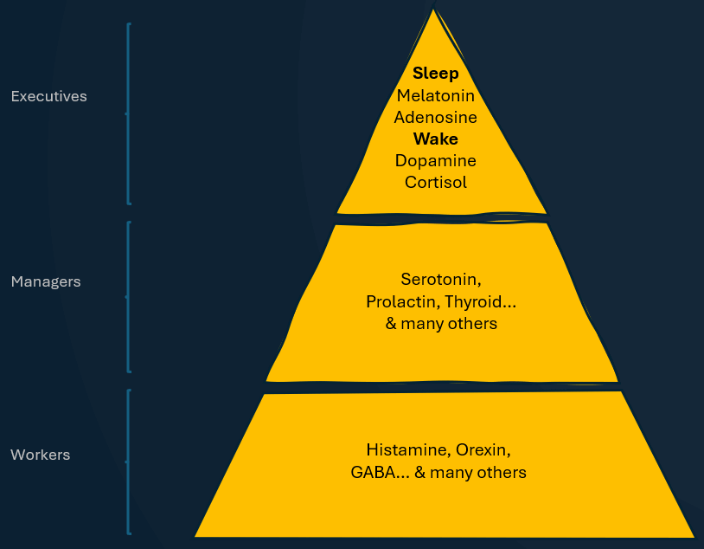
image-sleep-incorporated.gif
If the executives are aligned, the whole company functions properly. The managers know what to do. The workers carry it out. You sleep.[^2]
When the executives are not aligned — cortisol still high when it should be falling, dopamine fed all evening when it should be quieting — the managers get conflicting instructions which they pass straight to the workers. Some are ready for you to sleep, others are working hard to keep you awake. The result is chaos. You’re lying awake at midnight, mind still running, wondering why can’t drift off.
So if the executives were the thing to fix — I needed to understand exactly what fixing them looked like. How each one should move, hour by hour, across a full day. I started mapping it out. Then one morning, standing in the shower, I drew it on the foggy glass with my finger.
That’s when it clicked. Each one needed to rise and fall, in the right amounts, at the right time of day to arrive at the right point at bedtime. The concept was so simple. At night, the sleep hormones need to be high, and the wake hormones need to be low.
Here’s what that looks like. This graph shows a lot we haven’t talked about yet. For now its enough to know: hormones will rise and fall throughout the day. A good nights sleep depends on them landing in the right place at bedtime.
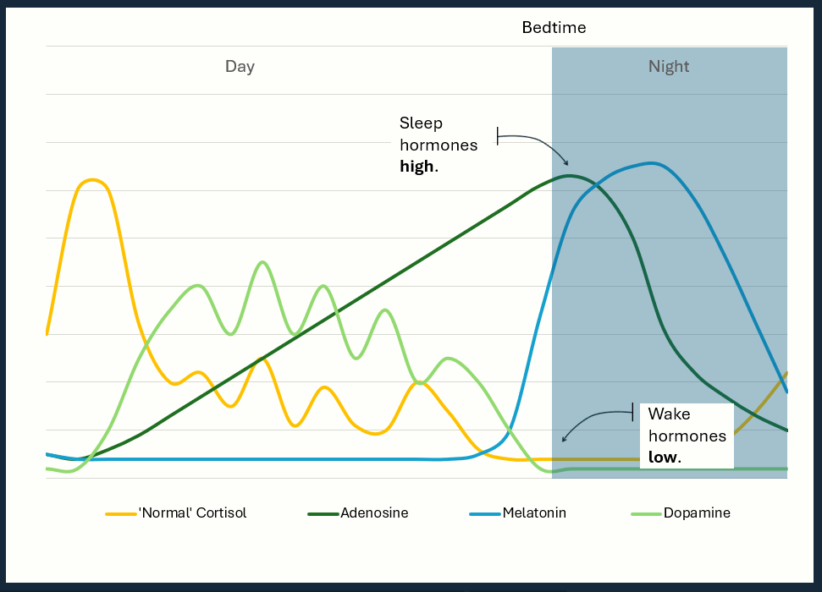
image-hormones-aligned.gif
Once I had that picture in my head, everything else really started to organise around it. That hunch from the drive — that the daytime mattered more than the night — finally had a structure behind it. The habits that would help me sleep weren’t bedtime habits at all. They were mostly daytime ones. Sleep was downstream of everything else.
I also started to see why all the quick fixes I’d been trying were so unreliable. A sleeping pill, for instance, is like an external consultant. Coming from the outside, bypassing the executives and the managers, and delivering a message straight to the workers. “Forget the the orders from the top… clock off and go to sleep.”
Sometimes it worked, sometimes it didn’t. But it never fixed the root problem — the executives were misaligned, and the system was still screaming top-down: wake up.
I’m not anti-sleeping pills. I’ve come to realise sometimes they’re the only thing that gives immediate relief, and used short-term they can help while you fix deeper alignment issues. If you’re already on them, I wouldn’t recommend stopping. Instead build the foundation first, then speak to your doctor.
The graph above - which I will take you through in detail in the next four chapters - shows each of the hormones moving as they should. When they arrive at the correct place at bedtime, that’s alignment.
When they don’t… that’s the misalignment I lived with for more than 20 years.
Middle of the night. Wide awake. Heart going. Thoughts running through tomorrow’s meeting, solving problems, anything — just running. Creating the kind of exhaustion where your tired to your bones but your mind refuses to shut down. I didn’t need a good night’s sleep - I needed a month of them!
This wasn’t some quirk of my personality or a sign that I was fundamentally broken.
Cortisol hadn’t come down. Dopamine had been topped up all evening — screens and notifications — a mind that never got a break. Melatonin was trying to rise, but it was fighting two executives still insisting on wakefulness. Adenosine was high. The tiredness was real. But nobody was listening.
Not broken, misaligned.
I was the CEO of Sleep Incorporated I just didn’t know it. I kept hiring consultants — one fix after another — never understanding why nothing stuck. The company kept underperforming and I kept looking for someone to step in and help.
The answer wasn’t a new consultant. It was learning how the business actually worked.
And that’s what I want to give you — an understanding of the four executives. The hierarchy that follows their lead. The system that wants to run well. And the three signals that drive it: activating through the day, calming through the evening, and the timing that switchs between the two.
What you don’t have yet is the detail — what each executive does, what disrupts them, and what you can do in your ordinary day to support them.
That’s what the next four chapters are about. Each one takes a single executive hormone and goes deeper.
By the time you’ve read all four, you’ll have something I didn’t have for more than 20 years - a map of your own system, and a clear sense of what you can do to start supporting it.

[^1] Technically, adenosine is a neurotransmitter rather than a hormone — but all four are doing the same kind of job: chemical messengers that tell your body what state to be in. For simplicity it will be labelled as a hormone throughout the book.
[^2] A note on exceptions. For some women, sleep deteriorates sharply in perimenopause or menopause as progesterone and oestrogen drop — a problem at the manager level that executive alignment alone can’t fully override. If menopause is the only thing that changed, HRT may be enough to restore the conditions that make sleep possible again. But if your sleep was already fragile, or menopause has knocked other things out of rhythm, you’ll likely need both — HRT and the work in this book. Rarer diseases can disrupt managers or workers directly. In all of these cases the framework still helps — but it’s a starting point, not the whole answer, and your doctor is the right person to take it further with.

Chapter 5 - Adenosine
Every book said the same thing: don’t drink coffee after a certain time.
At the time, I was ignoring it. My reasoning felt solid — some nights I fell asleep the moment my head hit the pillow. Coffee: not the problem.
It changed on a boat.
I was away with a group of friends — a dads’ trip, a few days out on the water. The boat ran a tab system: every coffee, every beer, marked down against your name to settle at the end. When the bill came I noticed my coffee column was almost as long as everyone else’s combined.
I did the maths - seven cups a day.
I knew I drank a lot of coffee. I didn’t know it was that much. Seeing it stacked up against everyone else was a huge wakeup call. I’d spent years telling myself coffee wasn’t the problem. But this just wasn’t right.
I really needed to know what all this caffeine was doing to my body.
That’s when I first came across adenosine.
From the moment you wake up, your brain starts producing adenosine - a natural byproduct of being awake. It accumulates through the day, building what is sometimes called sleep pressure: a slow, biological push toward sleep that gets stronger with every hour you’re awake.
By evening, if the system is working as it should, adenosine levels are high enough that the pressure is real and physical. Eyes heavy. Thinking slower. Bed starts calling your name. That’s the system doing what it’s designed to do.
What happens next is really important. During sleep the brain clears adenosine — fastest during deep (slow wave) sleep, which happens more in the first half of the night.
By morning, if that clearing has happened properly, that pressure has largely lifted. You wake up alert and ready, with the cycle reset and ready to start again.
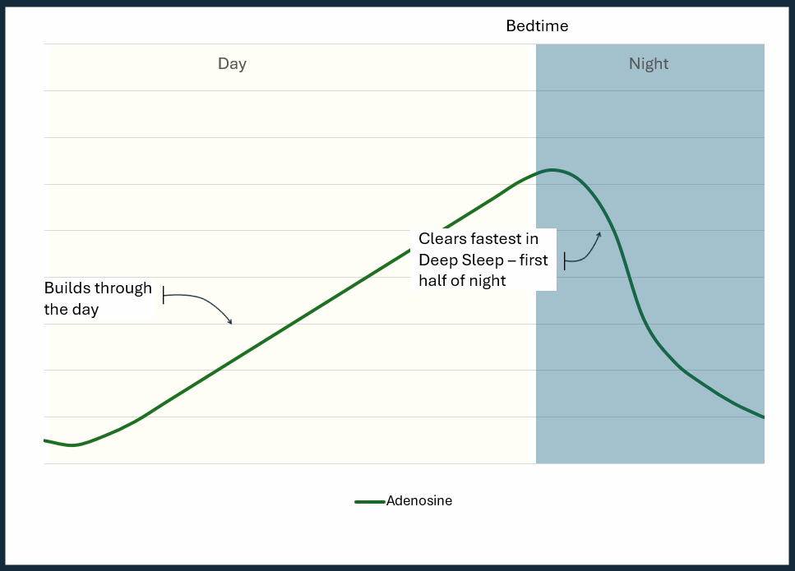
image-adenosine-normal.gif
The problem is almost never a shortage of adenosine. Your body generates it continuously, all day, regardless of how the previous night went. If you’ve been awake all day — even sedentary, unproductive, running on fumes — adenosine has been building since the moment you opened your eyes. But you already know this — it’s why you feel tired all the time.
The problem is usually one of two things — or both. Either something is overriding adenosine and you can’t get to sleep, or the pressure isn’t clearing properly overnight and you wake up tired.
Overriding adenosine is an alignment problem. Chapter 4 introduces the other executives — and when they’re not moving in the same direction, the signal gets drowned out. The pressure is real. Adenosine is still built up. Its just not winning the battle. You’re tired, but you lie awake anyway. More on that in Chapter 7.
Adenosine not clearing overnight usually comes down to one thing above all: not enough deep sleep. When deep sleep is fragmented or suppressed, adenosine clears more slowly, not leaving enough time for the brain to finish the overnight reset. You sleep, but don’t fully empty the tank.
Several things disrupt your deep sleep:
Caffeine was my main interference. It suppressed my deep sleep more than it stopped me falling asleep — which is why I could drop off instantly and still wake exhausted. That’s Chapter 14.
Stress holds the brain in a lighter, vigilant state — the opposite of what deep sleep needs. The night feels thin and restless. That’s Chapter 19.
Warmth works against you more than most realise: deep sleep needs your core temperature to drop, and a warm sleep environment makes that harder. That’s Chapter 13.
An irregular schedule cuts deep sleep timing. It’s front-loaded into the first part of the night — start late and you may not recover the full amount. That’s Chapters 17 and 18.
Screens don’t need to be blaring. The light, notifications, and habit of checking fragment the lighter stages and eat into slow-wave sleep. That’s Chapter 22.
Whatever your disruptor, the pattern is the same: it costs you the deep sleep that clears a lot of the tiredness — often without you noticing. What you feel as morning grogginess doesn’t always mean you’re not a morning person. It can mean clearing ran short.
For me, the loop looked like this: tired, reach for coffee, suppresses deep sleep, adenosine doesn’t clear, wake up tired, reach for coffee. Every part felt logical. Every part was making it worse.
The way out of the loop isn’t forcing it. It’s understanding what the thing you’re reaching for is actually doing.
Caffeine is the clearest example. Every cup is activating — a signal that lasts for hours. A cup late in the day reaches well into the evening, exactly when your body needs to be calming.
I did eventually reduce my caffeine. How that actually worked — what stuck when everything else hadn’t — is Chapter 14. But understanding why it mattered came first.
Did it fix my sleep? Not entirely. It wasn’t the only thing fragmenting my deep sleep — but it was the largest, and removing it was where the visible progress started.
Understanding more about adenosine and deep sleep changed the question I was asking, from: why can’t I sleep? to: what else am I doing that’s getting in the way? That was progress.
Adenosine is sleep pressure — the force that makes you want to sleep. What it doesn’t explain by itself is why, with all that pressure built up, you can still lie awake at midnight, wired and frustrated, wondering why your body won’t cooperate.
That’s not an adenosine problem. That’s a timing problem — and it takes more than one executive to solve it. Caffeine has a role to play there too — but that’s for Chapter 7. Melatonin is next.

Chapter 6 - Melatonin
It felt like I had a window.
Thirty, maybe forty minutes in the evening when sleep felt genuinely possible. Heavy eyelids. The couch getting comfortable.
Miss it, and the night was gone.
It didn’t matter how tired I was. If something disrupted that window, I’d lie in bed waiting for it to come back. It usually took hours. Sometimes I’d give up, go downstairs, and watch television until one or two in the morning — sometimes later — running out the clock until adenosine finally took me by force.
The frustration made it worse. Getting annoyed at being awake, then annoyed at being annoyed. Once I hit that loop, I was more awake than when I went to bed.
For years I had one explanation: I was just a bad sleeper. A bit weird - I have a sleep window. At some point I even bought melatonin supplements — the logic seemed sound: it signals sleep, it’s natural, more must be better. They didn’t do much. I filed it under things that don’t work for me and went back to running out the clock. I didn’t realise the whole thing had a perfectly understandable hormonal explanation.
Melatonin is not a sleeping pill your body makes. It’s a signal.
As the day fades and light drops, your brain begins releasing it. Slowly at first, then more steeply through the evening. It tells the system: night is coming, begin the sequence. Core body temperature drops slightly. Alertness falls. The machinery prepares.
But the signal doesn’t force sleep — it enables it. It moves you toward the conditions where sleep becomes possible.
Those conditions converge in a narrow window: melatonin rising steeply, adenosine high from a full day of wakefulness, cortisol low, core body temperature falling — and a separate circadian alertness mechanism, finally standing down.
When they align, you feel the strongest pull toward sleep. That’s what I was feeling as my thirty- or forty-minute sleep window. Melatonin continues to rise afterward, but more slowly. So does adenosine if you’re still awake. It peaks and holds high through the middle of the night — long after this window. But the other signals have shifted. The convergence has passed. The pull weakens with it. At this point, if the Wake Executives are still at their desks, you’ve missed the window. You’re exhausted but wide awake.
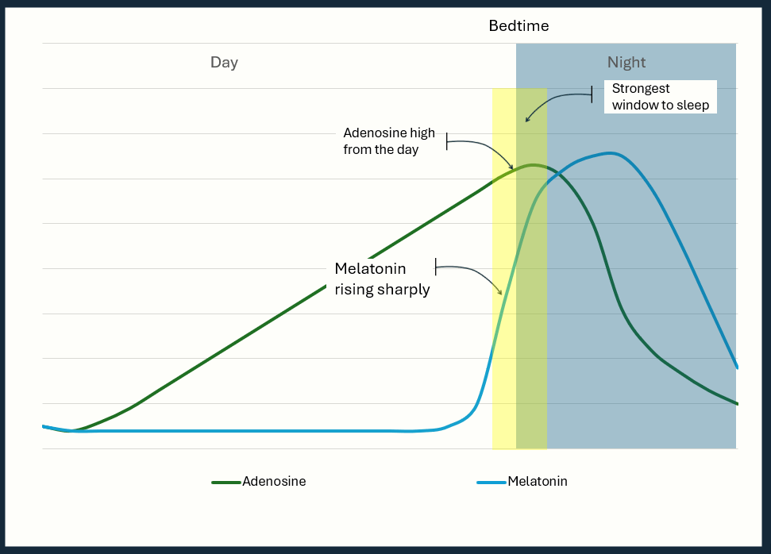
image-melatonin-normal.gif
For someone with a well-regulated sleep system, there’s flexibility across a longer stretch of the evening. The Wake Executives are calm and ready to hand over — the Sleep Executives don’t have to battle them out the door.
For a chronic poor sleeper, it’s different. The Wake Executives stay elevated, spike unexpectedly, refuse to go home. That flexibility disappears. Sleep becomes a contest. The pull to sleep is only strong enough to win at the steepest part of the rise, if at all.
For me, this explained a great deal. The frustration. The television until early hours of the morning. I’d been fighting a clock I didn’t know existed.
So why do poor sleepers miss the window? Three reasons.
Light. Melatonin production is tightly coupled to the absence of it. Bright light in the evening — particularly the short-wavelength light that screens produce — tells the brain it’s still daytime. The signal gets delayed, or somewhat suppressed.
Irregular schedule. Melatonin doesn’t operate on demand. It follows a rhythm — and that rhythm is set, gradually, by consistent behaviour. Go to bed and wake up at wildly different times each night and the system loses its reference point. The rise still happens, but it happens at the wrong time, or flattens, or arrives too late.
Stress and hyperarousal. Even when melatonin is present and rising on schedule, a nervous system running too hot can override it. The signal is there. But if the mind is still running — thoughts looping, stuck in go-mode — still activating when it should be calming — melatonin can’t win that contest. That’s cortisol’s problem.
The supplements I’d tried made sense to me back then — but they were answering the wrong question. The bad nights weren’t a melatonin deficiency — the signal was already there. The problem was everything fighting it. And extra melatonin won’t fix that.
Dim light in the evening, a consistent bedtime and morning light exposure — covered in the habit chapters — give the system what it needs to set the rhythm. Do those reliably and the timing takes care of itself. Calm the nervous system too, and you have a window that opens on schedule — with the right conditions for melatonin to win once it does.
But getting to sleep is only half of melatonin’s job.
The window is about falling asleep. Staying asleep is a different job. After the sharp rise, melatonin levels off — holding high through the middle of the night. Then production stops. At this point melatonin should be high enough, that even though it begins to drop, there’s enough to carry you through until morning. Still doing its job until the Wake Executives are ready to take over.
For a lot of poor sleepers, that peak sits lower than it should. The melatonin still comes, but weaker. So when production stops, there’s less melatonin to carry you through the exact hours when the night is most fragile, making your sleep easier to break. A noise, a full bladder, a stray spike of stress — things a stronger sleep signal would absorb — are now enough to surface you. You wake at two or three in the morning and can’t work out why.
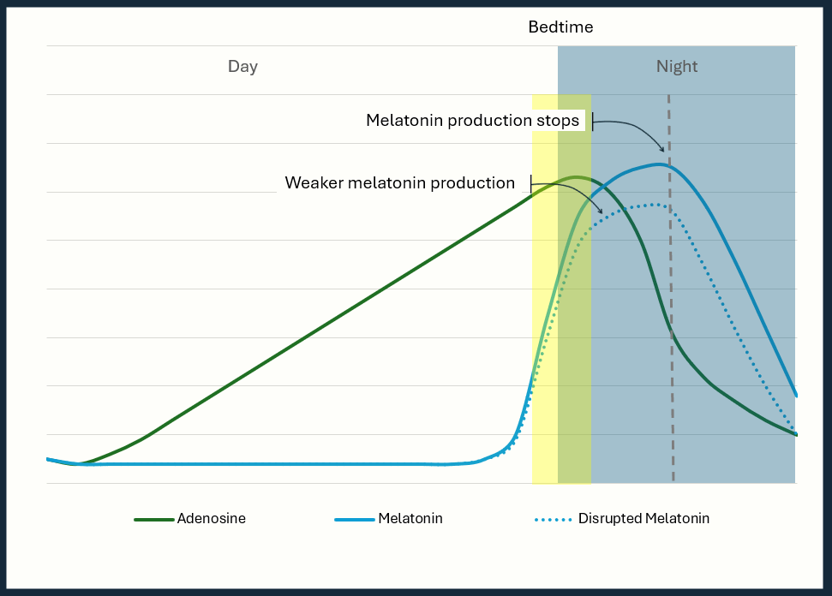
image-melatonin-weak-production.gif
You might be thinking: if the signal runs low through the night, why not top it up? Take some melatonin to hold the night, not just to open it.
You’re not the first. That’s the thinking behind slow-release melatonin — a version built to trickle out over hours instead of arriving in one early pulse, meant to hold a steadier level through the small hours.
But the evidence is thin — the best result is around thirteen extra minutes. If you’re only getting four hours a night, that isn’t the change you’re looking for. It isn’t the fix for a night that won’t hold.
Your instinct is probably the same when you miss the window — a small dose might recreate the signal. It’s not a bad instinct.
But it works against you. Melatonin is a timing signal — take it late and the body learns to expect sleep later. The morning routine later in the book is the better fix for pulling it back into line.
So melatonin can fall short in two directions. Arriving too late to open the window cleanly, or running too low to hold the night. Most people who sleep badly experience both. The good news is the same fix discussed above works for both — consistent timing and a steady rhythm, tends to produce a strong signal.
Taking melatonin can still be useful — just not in the scenarios above.
Jet lag, shift work, any time your sleep is on the wrong schedule — here, shifting the clock is exactly the point. When you cross time zones or a new roster puts you to bed at a different hour, the melatonin signal isn’t disrupted so much as stranded. Your body is still signalling night according to where — or when — it was set. A small dose — 0.5 to 1mg — taken 30 to 60 minutes before your new target bedtime helps nudge the clock toward where it needs to be. This is the one scenario where it’s doing exactly what it was designed to.
One cost worth knowing: dose. Most over-the-counter melatonin runs far higher than what the body naturally produces. Take too much, and residual melatonin can still be circulating by morning, producing grogginess. And because the body responds to the rise rather than the level, a high dose doesn’t increase the effect — it just extends it into the morning and gradually blunts your sensitivity to the natural signal. That’s why 0.5mg works. It’s enough to send the signal. More isn’t more.
Looking back, melatonin wasn’t my problem.
My body was making melatonin — strong enough that I could feel the window. But an irregular sleep schedule meant it rarely arrived on time. And through the night, it was probably running low.
The answer isn’t a bottle. A signal that arrives late and one that runs low are, underneath, the same problem — a rhythm that’s lost its footing. And you set a rhythm with timing and light, not with a higher dose. Understanding what melatonin actually does — and what it doesn’t — at least explained why some nights sleep came the moment my head hit the pillow, and others it didn’t come for hours.
Late and low might have been manageable on their own. But something was also fighting it — and a weak signal is easy to break when something’s pushing back. So who walks back into the building at three in the morning and turns the lights on?
That’s cortisol’s problem. And cortisol, as it turns out, has a great deal to answer for.

Chapter 7 - Cortisol
Most problems with sleep really come down to two things. Getting to sleep, and staying asleep. For a long time, I struggled with both.
If I had to pick the bigger of the two, mine was staying asleep. But I’m not sure that distinction matters much. If I missed my window — and by now you know how narrow that was — I was lying awake. If I managed to get to sleep, I’d typically wake somewhere between one and three in the morning. Either way, it ended up in the same place. Alert in a way that nobody wants at that hour. Mind running.
Sometimes it was reliving difficulties from the past. Sometimes catastrophising about things that could go wrong. But often it had a positive focus — ways to move forward in life. Getting fitter. House renovations. Things to do with the kids.
Because I wasn’t always awake with anxious thoughts, for years I assumed insomnia advice didn’t apply. I just had a busy mind.
Being awake with anxiety and being awake with ideas felt like different problems. Most of the sleep advice is aimed at the anxiety version. Mine didn’t fit. A busy mind full of half-formed plans didn’t have a solution. The feel-good ideas made it harder to name as a problem.
However, what I learned is anxious version or positive version, both involve cortisol.
Cortisol gets a bad reputation. The stress hormone — something to be managed, reduced, kept in check. That’s not quite right.
Cortisol is a Wake Executive — the one running the day shift. It’s the body’s alertness system, sharpening focus and preparing you for whatever the day requires. Before you open your eyes, it’s already rising, peaking in the first hour or so after waking, then beginning its long downward curve through the day, declining through the afternoon and into the evening until, by the time sleep approaches, it’s low enough for the Sleep Executives to take over. That’s the rhythm.
That curve is your baseline. Demand lifts you above it. A difficult meeting, a hard workout, a deadline, a disagreement — each one triggers a temporary spike, giving the system what it needs to respond. Then, when the demand passes, a well-regulated system brings it back down to the line. Spike and return. Spike and return.
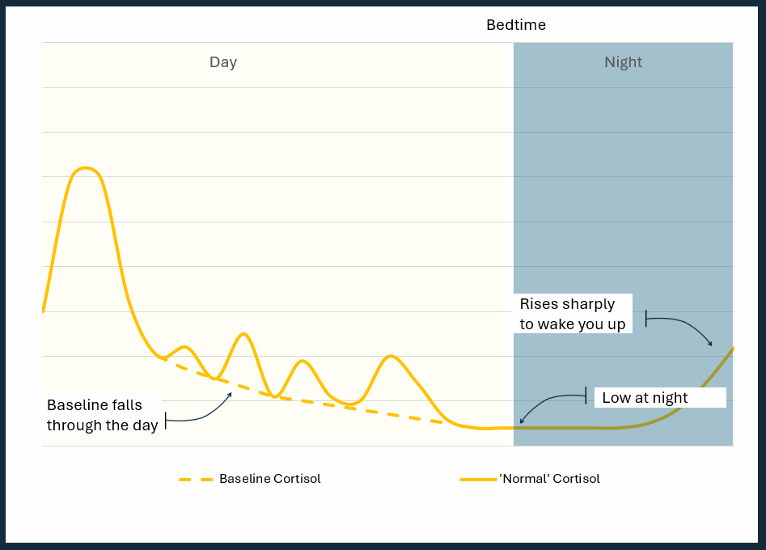
image-cortisol-normal.gif
That’s the system working. But what counts as demand is broader than it looks.
Cortisol has been popularised as the fight or flight hormone. Keeping you alert, ready to act on threat, whether you’re in real danger or not. But the popular version is too narrow.
Cortisol actually mobilises you for anything that feels like it needs immediate action.
It gives your body energy and gets your mind alert and focused. This makes sense in the popular definition — if you really were in danger, your mind races through every option for safety. It’s solving problems at hyper speed.
It also makes sense when you have a deadline. Or when you’re in go-mode, super productive, frantically ploughing through your day, crossing as much as possible off your list.
That’s the racing mind.
The nervous system doesn’t distinguish between a threat and productivity. Both can feel urgent. And if they feel urgent, they get cortisol.
That’s what was happening for me at 2am. Sometimes the thoughts were dark and anxious and they fit the popular definition. But often they weren’t — getting fitter, the next holiday, activities with the family. A better version of something. It felt purposeful and productive. Better than lying awake worrying. But cortisol was running either way — keeping the mind racing.
The problem wasn’t that cortisol was running. It was when.
Cortisol and melatonin should work in opposition — in the evening as cortisol falls, melatonin rises. When that handover happens cleanly, sleep follows.
This is activating and calming at their clearest. Cortisol is the activating chemistry — while it stays high, calming can’t take over for the night. Everything in the program is, one way or another, about getting cortisol to stand down on time.
This is the mind that won’t switch off at night. Not a flaw in you — cortisol, still high when it should be falling. Bring it down on time, and the mind comes down with it.
There’s a subtler version of this, too. The nervous system learns by repetition, and after enough nights lying awake and frustrated in the same bed, the bed itself becomes a trigger — cortisol rising the moment you get in, before a single thought arrives. (Retraining that is a job for later in the program.)
Either way, when the Cortisol executive refuses to pack up and go home, you lie in bed with your eyes open, exhausted and alert, wondering what’s wrong with you. And if you do get to sleep, it can still find you later — when melatonin eases back, whatever cortisol was still running fills the gap.
There’s a reason it tends to be that hour — melatonin’s retreat, as the last chapter described, creates an opening. For a good sleeper, cortisol stays low enough that it doesn’t matter. But when it’s riding higher than it should, that step back is all it needs.
Caffeine makes this even harder. Every cup taken too late is a mild cortisol stimulus — a small kick to a system that should be gradually falling toward evening. Caffeine keeps nudging it back up. By evening, instead of a cortisol level low enough for sleep to take over, the baseline is higher than it should be. Every misplaced cup is keeping it from standing down on time.
Here’s what I was doing in my worst period.
Lying awake at 2am, I would typically do one of three things — all of which felt entirely reasonable at the time. I’d get up, open the laptop, and start working. Get something done. Turn a bad night into a productive one. Or I’d put on the television — something binge-worthy that had me hooked. Or I’d reach for the phone - Youtube, social media, emails.
This is the pattern modern life has perfected. Not intentionally — the technology doesn’t set out to ruin sleep. It’s designed to capture attention. And attention costs cortisol.
Before the phone, if you arranged to meet someone and they were late, there was nothing to do but wait. Watch people walk past. Let your mind go where it wanted. The nervous system got downtime, and downtime was exactly what it needed.
That experience is almost gone. The phone fills every gap. Social media feeds are built to surface the most provocative content first — because provocation triggers a response, and a response means engagement. Outrage, excitement, genuine interest — it doesn’t matter. The nervous system treats them all the same. Every piece of stimulation is another small bump. Over time, those bumps accumulate. Baseline cortisol creeps up. The evening decline gets shallower. The Sleep Executives are trying to advance, but the Wake Executive - cortisol - never fully leaves the building.
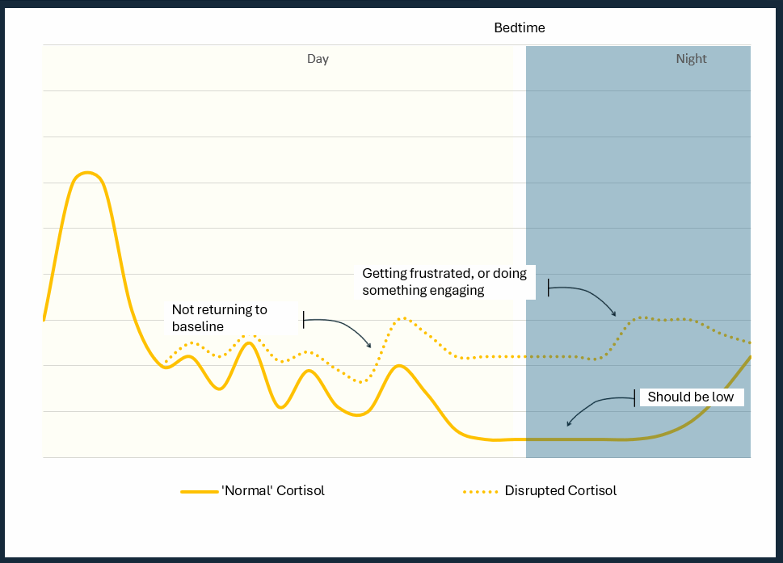
image-cortisol-not-baseline.gif
This makes returning to sleep harder. Which increases the frustration. Which spikes cortisol. Which makes sleep harder still. And unfortunately it gets worse.
Sleep deprivation is stress - the body responds just like a threat — by releasing cortisol. Which means a bad night sends cortisol into the next morning already running hot. The baseline higher, the drop shallower. The Sleep Executives facing steeper resistance the next night.
The habits I’d adopted to cope with the wakefulness were the same habits making the wakefulness worse. Getting up to work felt productive. It was the opposite. Binge watching television seemed to block the busy mind. The next day, coffee got me through. Every one of them a signal to the Wake Executive that the shift wasn’t over. Every coping mechanism I’d reached for was, in cortisol terms, an accelerant.
The first thing that actually changed wasn’t something I found in a research paper.
It was a podcast. One of dozens I was working through at the time, trying to piece together what I could do to fix my sleep. The guest said something simple — almost throwaway: don’t do things at night that you’d do during the day. It sends completely the wrong signal.
I didn’t fully understand it at the time, but it made sense. I stopped getting up to work. I stopped looking at my phone. I didn’t yet know why — I just knew, from that line, that I shouldn’t. We’ll come back to the television.
It wasn’t until years later, when I understood the biology, that the logic clicked into place. The system knows what to do. What’s complicated is protecting that rhythm in an environment designed, at every turn, to override it.
Every spike that didn’t return to baseline. Every evening habit that kept the Wake Executive at the desk. Every bad night that sent extra cortisol into the next morning, making the whole cycle harder to break.
The signal was never the problem. The rhythm was.
Cortisol at least announces itself. The next one doesn’t.

Chapter 8 - Dopamine
Of the four executives, dopamine was the one I understood least. And probably the one doing the quietest damage.
It didn’t announce itself. There was no 2am wake-up, no racing mind, no moment where something had obviously gone wrong. The dopamine problem looked completely normal. It looked like everyone else’s evening.
On nights when I went to bed before my wife, I’d reach for my phone while I waited. Just to fill the gap. She wasn’t there yet, and the phone was on the bedside table. The reach was automatic.
What happened next varied. Sometimes ten minutes. Sometimes longer than I’d like to admit. Either way, by the time I put the phone down, something had changed — I wasn’t more tired. The quiet that should have been pulling me toward sleep had been replaced by something alert and restless.
I noticed this pattern for a long time before I understood it. Even when I suspected the phone wasn’t helping, I didn’t know why.
That was dopamine’s signature. Quiet. Unremarkable. A system running the wrong way without ever announcing it.
Cortisol pushes you to survive. Dopamine pushes you to thrive.
Dopamine responds to opportunity. The brain releases it to say this is worth pursuing. When you’re working on something interesting and time flies, that’s dopamine. Without it time drags. This is fine during the day. But it requires regulation to bring it down in the evening.
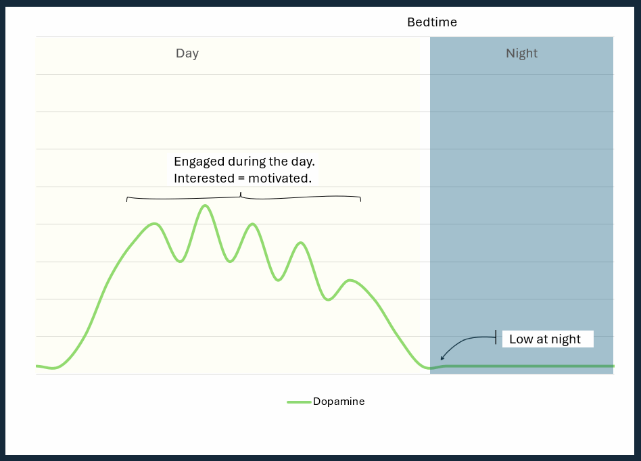
image-dopamine-normal.gif
Train it on fast, cheap signals — social media, notification pings, short-form video — and the quieter signals may start to lose out. Including the calm that should be settling you into sleep.
Here’s what I was actually doing on those nights with the phone.
The feed I’d built — or more accurately, the feed that had built itself around my behaviour — was heavy on outrage, gender wars, political corruption, woke versus traditional, instant karma clips. The kind of content that triggers a strong reaction — a jolt of stress, cortisol along with it — before you’ve had time to decide whether you want one.
I knew, on some level, that it wasn’t useful. Occasionally I’d catch myself and think: what are you doing? This is rubbish. So I built a habit. Whenever I noticed I’d pivot to something else — how-to videos, something educational, or product research on something I wanted to buy. I’m naturally curious, so that kind of content felt better. More productive. More like me.
What I didn’t understand was that I’d solved nothing.
Both types of content were doing the same thing to the same system. The outrage feed delivered fast, volatile spikes — the neurological equivalent of a shove, cortisol in the mix. The curiosity content delivered slower, warmer ones — more like a sustained hum, the same dopamine minus the cortisol. Different feeling. Same mechanism. I’d traded what I recognised as a problem for something that felt like a solution. The feeling had changed. The sleep hadn’t.
This is how dopamine works against you. The brain doesn’t care whether the spike comes from outrage or curiosity, from a conspiracy clip or a product review. What it responds to is novelty and unpredictability — the possibility that the next thing might be interesting. That’s what drives the doom scrolling.
When I tuned in to my body, it was most obvious with short-form videos. Interesting. Funny. Outrageous. Boring. Boring. Interesting. The brain stays alert, waiting for the next one.
Over time, the thinking goes, this may recalibrate the reward system: fast, frequent, unpredictable spikes become the baseline, and slower signals — including those coming from the Sleep Executives — start to register as dull by comparison.
That’s the sleep problem. Dopamine is best known as the reward chemical and that’s exactly the point: it keeps you stimulated and searching. A mind still searching is not a mind letting go for the night. The later you stay on the feed, the more it compounds — the Wake Executive dopamine, activated. Indifferent to the fact that sleep should be happening.
Which explains the mistake I was making.
When I switched to more ‘wholesome’ content, it felt better, but it wasn’t calming. Curiosity still activates you — this is interesting, I want to know more. Which is fine during the day, but not when you should be getting off to sleep.
The contrast that made this clear to me was the television. The right show — low-stakes, predictable, easy to follow — is genuinely passive. The brain isn’t anticipating what comes next. It’s just following along. That’s different to an emotional drama, thriller or suspense. And very different to a social feed. I’ll come back to what to watch and what to avoid in Chapters 15 and 17. The mechanism is what matters here.
Two things finally pushed me to change.
The first came from that podcast line — the one about not doing daytime things at night.
The second came when I wasn’t looking for it.
I was trying to understand why experts were so concerned about screens and gaming for children. The warnings were everywhere — but I wanted to understand the mechanism.
What I found was dopamine.
Gaming, it turns out, is almost perfectly engineered to deliver it. Constant rewards. Immediate feedback. Unpredictable outcomes. Every well-made game is designed to keep the dopamine signal running. The same logic applies to social media. Built entirely to hook you in and keep you there.
At first I thought - surely this didn’t apply to me - I wasn’t a child. I wasn’t gaming. I was an adult. I could watch product research and how-to videos. Surely that was different.
Maybe it is different. Maybe it doesn’t affect adults as much as children. I’m not sure.
What I do know is that the mechanism doesn’t change. Dopamine at night is working directly against the Sleep Executives. It doesn’t matter whether the spike comes from gaming, swiping through short-form video, or a deep-dive into espresso machines. The signal is the signal.
Looking back, that pre-bed scrolling was almost certainly pushing me past my sleep window some nights. Enough dopamine — and the cortisol that came with it — to carry me through to the point where the steep rise had passed. By the time I put the phone down, the window had closed.
I hadn’t been unlucky on those nights, I’d been scrolling through my own sleep window.
Understanding that took years. And here’s the thing about understanding — it’s necessary, but it isn’t sufficient. The biology made sense to me long before my behaviour caught up with it.

Chapter 9 - What Goes Wrong
You’ve now met all four executives. One at a time. Now lets put them all in the room together.
Back in Chapter 4 I showed you this and said to hold it loosely. By now it should make a lot more sense
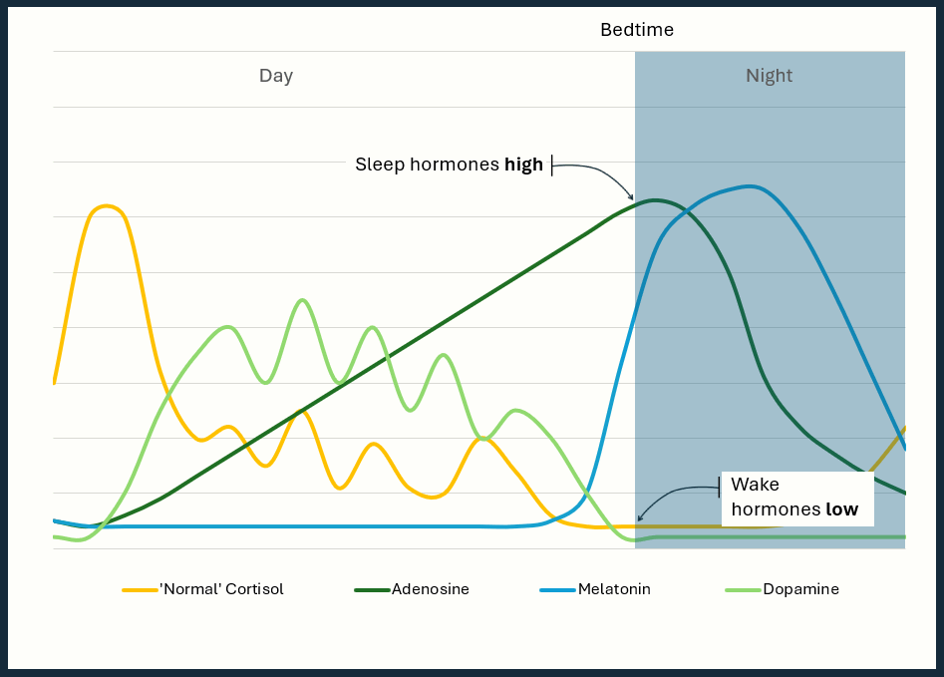
image-when-it-all-lines-up.gif
Through the day, the Wake Executives run the shift. Through the evening, they stand down. The Sleep Executives take over. At bedtime, sleep hormones high, wake hormones low.
If everything lands where it should, that’s alignment. You don’t feel any of it. You just sleep.

The bad night
The other version is misalignment. And it can go very wrong. Cortisol won’t fall. Still activated, deep into the night. Dopamine keeps spiking — every phone check another hit. Melatonin is rising, but it’s outnumbered: two Wake Executives that won’t go home, against a lower melatonin through the night. Adenosine just keeps building - maybe the others finally take notice. But it’s run out of time in the night to clear properly overnight.
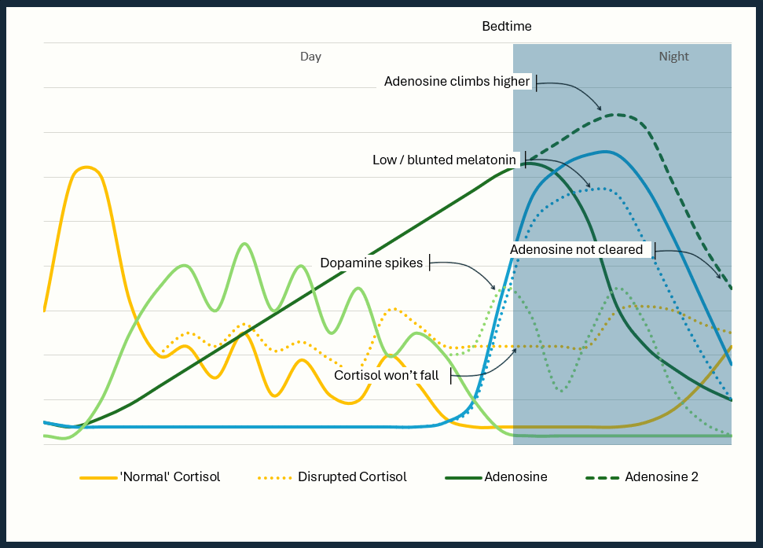
image-when-it-goes-wrong.gif
Looking at the graph, its overwhelming how complicated this is. And understanding the complication alone, was a light-bulb moment. I finally realised… that’s why there is no magic fix. How did I ever expect, with so much going wrong, that just before bed, I could take a pill or do one simple trick, and everything would fall back into line for a solid eight hour sleep?
Don’t worry if that’s a lot to take in at once. It will make more sense as we move through the most common symptoms of insomnia. ## Struggle getting to sleep
Cortisol
Through the day, your nervous system should keep returning you to baseline, so you arrive in the evening low and ready for sleep. Two things can stop that. Either you’re activated all day — hypervigilant, anxious, stuck in go-mode — and never brought back down. Or the bed itself has become a trigger: enough nights lying awake there, and your system starts switching on the moment you get in.
Either way, you take elevated cortisol into the night, fighting to keep you awake. Your mind won’t settle.
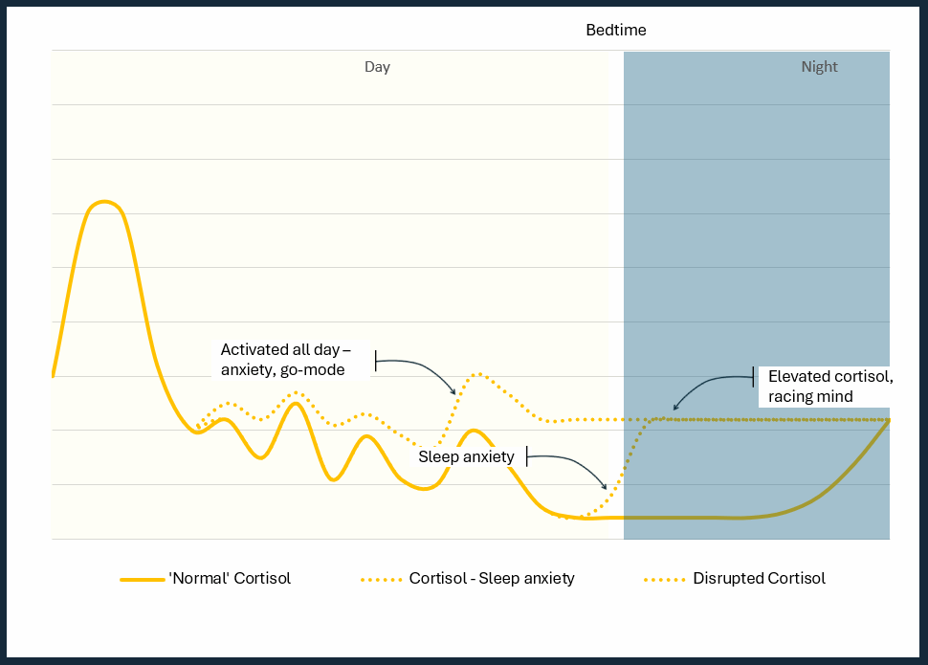
image-cortisol-struggling-to-sleep.gif
Dopamine
Cortisol alone is enough to fight melatonin and adenosine. But add a quick scroll, or an engaging show right before bed — then another when you wake in the night — and now both Wake Executives are keeping your eyes open. And it isn’t only the content you’d call a problem: even the “wholesome” stuff — how-to videos, a deep dive into something you’re curious about — runs the same system. Curiosity activates you just as readily as outrage.
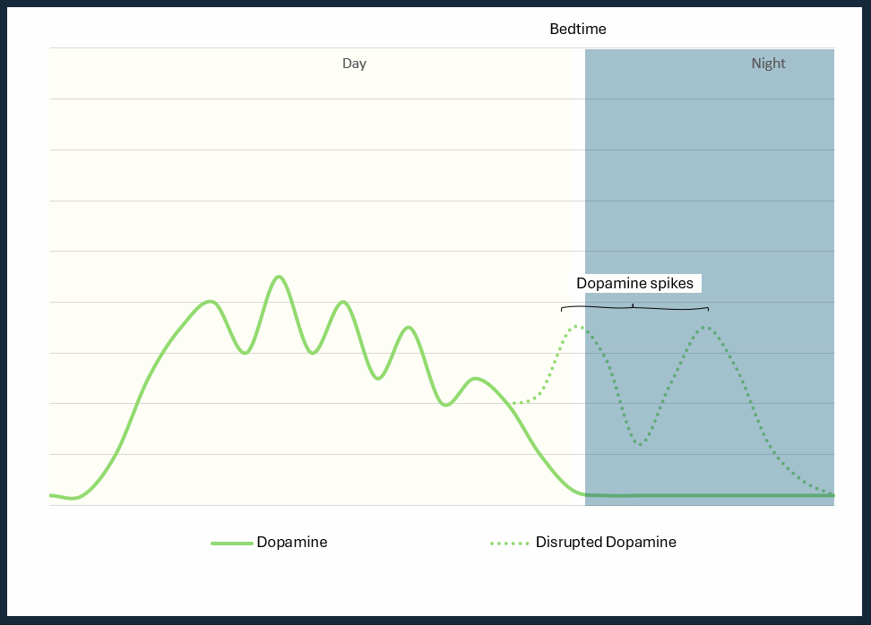
image-struggling-to-sleep-dopamine.gif
Adenosine
Since you still haven’t got to sleep, adenosine keeps building. If you do finally manage a few hours, it’s only because the pressure got so strong the other hormones had no choice but to listen and stand down for a while.
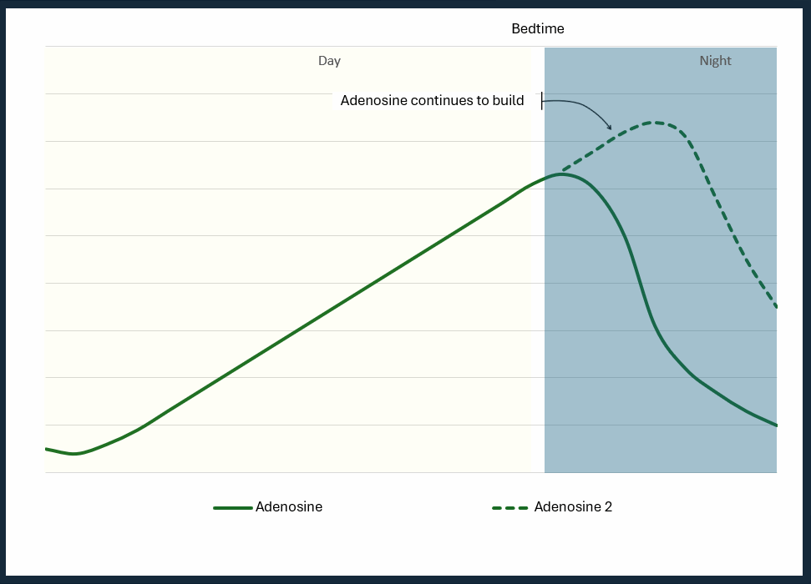
image-struggling-to-sleep-adenosine.gif

Sleep window
The narrow sleep window from Chapter 6 — melatonin rising fastest, not at its peak, adenosine high, the convergence — is roughly the stretch when the pull to sleep is strongest.
If cortisol is higher than it should be, but not high enough to override all that, this is the one moment sleep can still win.
Miss it — melatonin’s steep rise flattens, the convergence passes — and the pull weakens until cortisol is winning the fight again. You’re awake.
And the most common way to miss it is self-inflicted: a scroll or a screen at exactly the wrong moment, enough dopamine to carry you past the steep rise. You weren’t unlucky — you scrolled through your own window.
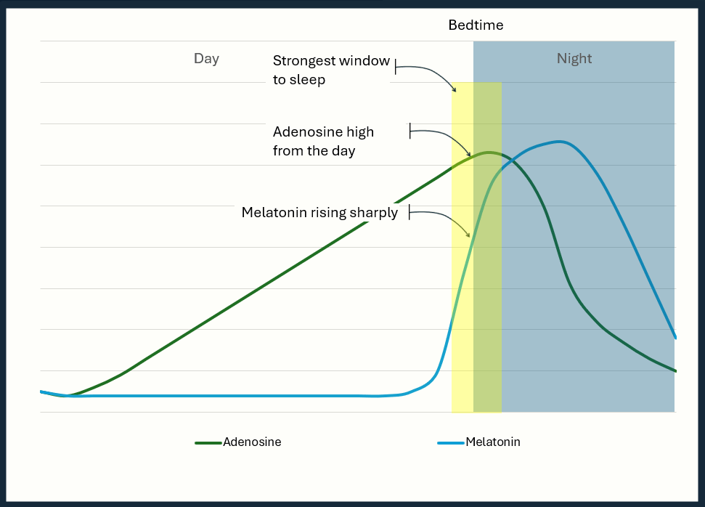
image-sleep-window.gif

Waking at 2am
If you do get to sleep in your window, the next most common complaint is waking in the small hours — somewhere around 2 to 3am, depending on when you went to bed.
Around then, your circadian system starts turning the night around, preparing you for morning.
Melatonin has peaked and its production tails off. For a good sleeper there’s still plenty in the tank to carry through to morning. For a poor sleeper — the weak overnight hold from Chapter 6 — there’s less to carry through, and even the step down itself, rather than the total amount, can be enough to weaken the signal.
Deep sleep, and the sleep pressure it discharges, is front-loaded into the first half of the night. So by the small hours much of that pressure has already been spent: adenosine is still working, but with less force than earlier, no longer backing melatonin up as strongly.
For a good sleeper, both Sleep Executives easing off at once is no problem — cortisol is low and only just beginning to climb. They sleep through, or surface briefly, a quick trip to the bathroom, and back down. But for a poor sleeper with cortisol already running high, that same moment is the opening: the Wake Executive is suddenly strong enough to overpower the fading Sleep Executives and flick you into full racing-mind mode. Sleep is usually done for the night.
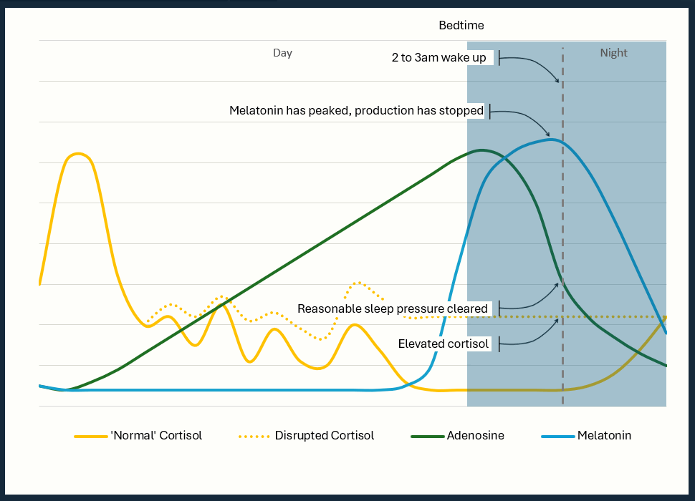
image-2-3-am-wake-up.gif

Wake up tired
Sometimes nothing dramatic happens. No fight to get down, no wake-up in the dark. You sleep — and still wake up flat. This is adenosine that never cleared. It empties fastest in deep sleep, and deep sleep is easily stolen — caffeine too late, a warm room, a restless or screen-lit night. The hours were there; the depth wasn’t. So you wake with yesterday’s pressure still on board. That isn’t “not a morning person.” The clearing just ran short.
The problem is that a few hours isn’t enough to clear it. You carry the leftover pressure — sleep debt — through the next day and into the following evening. Starting the next day already behind.
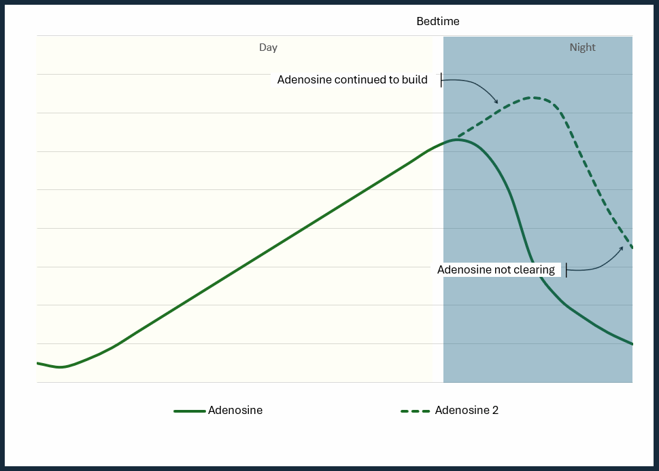
image-wake-up-tired-adenosine.gif

Same problem, every time
Different nights. One cause.
Not a flaw in you. Not a bad sleeper. Misaligned — four executives arriving at bedtime in the wrong places.
Which is the good news. Alignment is something you can change. And you mostly change it during the day, not at night.
That’s the program.

PART 3 – The Program

Chapter 10 - Taking Ownership
I was the problem, and I was the solution. I was the CEO of Sleep Incorporated, which meant it was mine to fix.
That felt heavy but understanding it was actually a relief. I’d spent years looking for something outside myself to fix it. A pill. A routine I’d read about somewhere. A YouTube expert with the one thing I was missing. None of it stuck, because none of it had addressed the whole company.
Once I stopped waiting to be rescued and started running the company myself, I got to work on a training program.
For most of my life I’d been stuck on the activated setting — wound up, switched on, a system that never clocked off. What was missing was the other one: a calming system strong enough to take over at night.
You met those two settings back in Chapter 4: they’re built to take turns, and bad sleep is almost always a fault in the handover — a calming system too weak to take over, or the two swapping on the wrong schedule.
So the habits do three jobs, the three signals from Chapter 4 turned into daily action. Train the body clock. Build the calming system. Stop activation at the wrong times. Every habit in the chapters ahead is one of those three. Know each habit’s job and you’ll see how it works toward a good night’s sleep.
The program runs in order — twelve habits, each building on the last. Ready for you to work through at your own pace.
Each habit is based on solid, well-established sleep research — the same science we walked through in the last four chapters.
What I’ve done is curate. Determined the sequence. Determined how much to do and when. Worked out what can flex and still give results. And most importantly built it to fit into a modern lifestyle - full-time job, family, exercise, and the general busyness of a life.
I could easily give you twice as many habits, and they’d all have research behind them. But that’s not a program. That’s a list. And a list is easy to close and never look at again.
Massage, for example, didn’t make the cut. The research is solid. But the cost and time away from the kids’ dinner and bed routine, just wasn’t realistic for me.
The question for each habit was the same: what does science say is ideal, what’s realistically achievable most of the time, and do I still get results if I aim for that?
I very deliberately sacrificed science-optimal for life-optimal. Because a habit you sustain beats a perfect protocol you abandon in a couple of weeks. The habits in this program are the ones that survived that test.
Your schedule and family life won’t be exactly the same as mine. But I hope to share what I did, give you an understanding why, and encourage you to be imperfect and adjust to suit your circumstances.
Some of these habits you might already be doing. If so, great — cross them off and take the win. For the rest, go slowly. Introduce one or two habits at a time. If they feel easy, add a couple more. If not, pause and work on these until they do. Slow changes that stick beat fast ones that don’t.
A fair question before you start is: how long? The honest answer is it depends on where you’re starting and how quickly you move. The program runs in phases. Move at roughly a phase a week and you could be through them in six weeks; if you already have some of these habits in place, then maybe faster. Go slower and that’s fine too — this isn’t a race.
But the moment worth waiting for isn’t the end. It’s the first time the change becomes undeniable — not “I think I feel better”, but “something has definitely shifted”. For me, that arrived a week or two after the habits in phase 4 had bedded in — the first nights my calming system did the work on its own, without me forcing it. That’s what breaks the old story: I’ll never be a good sleeper. Once it comes, your motivation to finish the remaining habits takes care of itself.
One last thing before Phase 1 begins.
I strongly recommend recording whatever you’re working on, with regular self-check-ins. The easiest way is the app at www.sleepbuilders.com.au. It’s free, so I’d really encourage you to use it. It’ll help you navigate the program, track where you’re at, and prompt those check-ins. If you’re like me, I didn’t always do everything, every day. I needed reminding and reinforcement.
If an app isn’t for you, paper works just as well. A simple list, phases marked off, habits ticked as they land. A few notes-to-self about progress. What matters isn’t how — it’s that you do it. Writing things down is a simple and powerful way to help with commitment.
Either way - app or paper - here’s the thing I’d encourage most of all. People are far more likely to see the program to the end if they are doing it with other people — working the same habits, answering questions and helping each other through challenges. It really is worth joining the community — it’s called Sleep Builders, and you’ll find it at the same url, www.sleepbuilders.com.au.
That’s it. You now know everything you need to know before we begin. There’s nothing left to do but turn to Chapter 11, and let’s get to work.

Phase 1 – get set up

Chapter 11 - Your Feedback Loop
A friend called me out of the blue one afternoon. A keen runner who tracks everything — “Do you still struggle with sleep? Interested in trying a tracker? I’ll post it to you.”
I’d thought about trackers before and talked myself out of it. I already knew I was tired. I didn’t need a device to tell me that. And the family budget had enough going on without adding another gadget to the pile. What was the point?
But since there was no cost, I thought why not give it a try.
On reflection, if I trace the chain of events that led to this book — the research, the habits, the program, the results — that phone call is where it all began. One small act of thoughtfulness from a friend.
What I didn’t know at that time was how useful a tracker could be. I assumed it would just give me a few good-to-know numbers which showed how badly I slept. And that wouldn’t change anything.
When the data started coming in, the first thing I noticed surprised me. Some nights I was getting more than five hours — fragmented, interrupted, but more than five hours nonetheless. But even on these ‘good’ nights, the tracker told me deep sleep was very low.
That sent me down a path I hadn’t anticipated. All of a sudden, I had new questions to ask. Tiredness just tells you something is wrong. The data was giving me something specific to look at. And something to act on: change one thing, then watch the next few nights to see if it moved.
That’s what a sleep tracker is: a feedback loop. Clearly, its not going to fix your sleep. But over time it shows you whether the habits you’re building are moving you in the right direction.
For some people having a tracker can make them obsessed and more anxious. Sometimes unnecessarily so, because the trackers aren’t perfectly accurate night to night — a single bad reading may mean less than it seems.
If this is you, try to reframe you’re thinking - don’t look every morning for a pass or a fail from last nights sleep. Instead, take each day as an interesting data point. Add it to your cumulative learnings and look at trends over time.
This matters most at the beginning of the program, before you’ve changed anything. The tracker gives you a baseline — a picture of where you’re starting from. As the habits build, it becomes the mechanism that tells you what’s working. Without it, you’re making changes in the dark… pun intended.
When I first opened the app, I tried to understand everything at once. There were dozens of metrics — heart rate variability, respiratory rate, sleep stages, efficiency scores, strain, recovery — and I had no idea which ones mattered or in what order. It was overwhelming.
So here is what I’d tell someone starting out: ignore most of it, at least for now. There’s a natural order to this, and it starts simple. The first things to look at are the basics:
How many hours are you actually sleeping?
Are you going to bed and waking up at roughly the same time each day?
What is your sleep efficiency? (time in bed asleep vs awake - good target is above 85%)
These three measures — duration, consistency, efficiency — are a great place to begin when you’re first starting out. When you’re well short of what you need, almost any habit lifts total duration first — so it’s the number that moves soonest, and the right one to watch at the start.
Once those are in a reasonable range, you can start paying attention to quality, which matters just as much. It simply comes second. This is where sleep stages become useful — not as precise measurements, but as trends. The habits ahead are what move it; for now just focus on getting more hours.
Deep sleep is where the body does its physical repair work. REM sleep is central to memory consolidation and emotional processing. Together they’re called restorative sleep; the rest of the night is lighter sleep.
The exact numbers will vary night to night and the trackers aren’t perfectly accurate on staging — more on that in a moment — but watching whether your deep sleep is trending up or down over weeks tells you something tiredness alone doesn’t.
This is also where your habit changes show up once the hours are steady. Adjusting when you have your last coffee, your last drink, how close to bed you exercise — these register in your quality metrics even if you don’t always feel the difference.
The third layer — heart rate, heart rate variability, recovery scores — is for later. Heart rate variability (hrv) in particular is worth understanding: it reflects how well your nervous system is balancing its two modes – activated and calm (the names in this book, not the scientific names). A higher variability generally means better recovery and a more resilient system. But this is a refinement metric, not a starting point.
What trackers actually get right
Here’s the thing about sleep tracker accuracy: the studies are all over the place. Some suggest the devices are unreliable. Others suggest they’re close enough to be genuinely useful. Reading the research without context, you could talk yourself out of tracking altogether.
The evidence actually points to something more nuanced than either camp admits. There are two distinct things trackers measure, and they’re not equally accurate. I’m generalising here to keep things simple.
The first is total sleep time. They typically get this right — with one exception. If you spend a lot of time lying very still while awake, some devices will count it as sleep. My WHOOP has occasionally logged me watching television on the couch as light sleep. The fix is straightforward: adjust your recorded bedtime to reflect when you actually got into bed. Once you do that, total sleep time is reliable.
The second is sleep stage classification — how much of your night was light, deep, or REM. Here the trackers are less precise. The validation studies I’ve seen put the nightly error around twenty to thirty minutes, narrowing to roughly ten once you average across a week. Which means the nightly number is noisy, and the weekly trend is more important.
From my own experience, they’re accurate enough to tell you whether a habit is working.
One other thing worth knowing: as of writing, the Oura Ring has the most published research behind it. That might mean it’s the most accurate tracker on the market. Or it might simply mean it’s the one that’s invested most heavily in publishing its findings. Either way, if you want the most evidence-backed option, it’s a reasonable place to start.
What I use
I use the WHOOP. Partly because it has a strong research reputation. But honestly, mostly because it’s less bulky than the Apple Watch to wear to bed. That’s the kind of consideration that doesn’t make it into the product reviews but ends up mattering every single night.
At some point I’ll test it side by side with the Oura Ring. When I do, I’ll update the app.
What I can tell you is what it did for me in the early months of the program. I was experimenting with supplements — trying different combinations, different timings, on for a couple of nights, off for a couple of nights. It wasn’t perfect science. Things don’t always work in isolation, and there were other variables I couldn’t fully control. But when I could see some kind of on/off correlation showing up in my total sleep time, that was good enough to count as a step forward. The tracker made that visible.
Even though it was the deep sleep number that first got me excited about tracking, once I got going, I paired back and I focused almost entirely on quantity. Total hours felt most urgent, so that’s what I watched.
When you’re getting much less sleep than you need, all habits are going to help with total duration. Quality matters just as much (ie. deep and REM) but the comes later. Trying to optimise everything at once is too overwhelming. Start simple – just focus on total hours of sleep.
So here is what I’d suggest before you move on.
If you don’t have a tracker, decide which one you’re going to get. WHOOP, Oura, Apple Watch — any of them will do what you need. Pick one and order it.
If you already have one, open the app tonight. Ask the AI:
In the last 30 days, excluding outliers, what is my average total number of hours sleep per night?
Excluding outliers, what is the average of the bottom 20%?
Excluding outliers, what is the average of the top 20%?
This is your baseline. It tells you on average you sleep X hours per night. On bad nights its around Y and good nights around Z.
In the coming weeks or months, these will be a good reference to look back on.

Chapter 12 - Supplements
For a long time, supplements were my hope for a silver bullet. I’d find something that promised deep, restorative sleep, read enough five-star reviews to convince myself this was the one, order it, and wait. It usually turned out just like my experience with CBN – never seemed consistent. Typically, I’d move on within a couple of weeks and start the search again.
Once I started tracking sleep, eventually I found a few that did work. They still didn’t give me ‘the best sleep ever’ that many claim. But tracking showed meaningful increases in deep sleep and total sleep.
Not all supplements are the same
Before I get to the specific supplements, there is one thing worth knowing — most supplements share a generic ingredient name. For example Magnesium. But often within those generic names, the form or extract makes a significant difference to how well the body absorbs it and what it actually does.
I spent money on the wrong forms before I understood this. The generic magnesium I started with did very little. When I switched to the specific form I mention below, the difference was noticeable.
What I take and why You met cortisol back in Chapter 7 — the hormone meant to fall away through the evening but, for most of us, refuses to. Once I understood that, my search narrowed to one question: which supplements target cortisol? That left only a handful to test, and after some trial and error, I landed on these three.
The first is Phosphatidylserine, sometimes marketed as PS. It’s a type of lipid that exists naturally in the brain and appears to blunt the evening cortisol response. The form to look for is soy- or sunflower-derived. The typical dosage is around 400 milligrams, taken 30 – 60 minutes before bed.
The second is Ashwagandha. This one has been around for centuries and has some solid modern research. The extract with the most evidence behind it is called KSM-66 — that’s a specific form of ashwagandha root extract, standardised to contain a minimum concentration. If the label just says “ashwagandha” without specifying KSM-66, it won’t be the most effective form. The dosage range is 300 – 600 milligrams. The science says take in the late afternoon or evening. Its primary effect for sleep is reducing the stress response — making the evenings a little calmer.
The third is Magnesium. This is the most well-known of the three. For sleep, the form worth looking for is Magnesium L-threonate, often recommended on the basis that it crosses into the brain more readily. Magnesium citrate and glycinate are reasonable alternatives if L-threonate isn’t available. Dosing depends on the form. For L-threonate, the studied serving is about 2 grams of the compound — which delivers only around 144 milligrams of elemental magnesium — and studies often split it across the day rather than taking it all at night. For citrate or glycinate, aim for roughly 150 – 300 milligrams of elemental magnesium in the evening.
There are other effective supplements out there. But as I cycled through them, some gave me side effects. Typically disturbing dreams or digestive issues.
For quick reference:
Supplement | Form to look for | Dosage
Phosphatidylserine (PS) | Soy- or sunflower-derived | ~400 mg
Ashwagandha | KSM-66 extract | 300–600 mg
Magnesium | L-threonate (citrate or glycinate as alternatives) | L-threonate ~2 g (≈144 mg elemental); citrate/glycinate 150–300 mg elemental
What the data actually showed
Here is where the tracker earned its place.
I used the same on/off approach I described in the last chapter — cycling each supplement, watching the tracker, looking for improvements.
Some of what I found surprised me. Certain supplements improved my deep sleep measurably — I could see it in the staging data, trending upward over the weeks I was taking them. Others I tried along the way brought side effects I hadn’t anticipated. Vivid, unsettling dreams on some nights. Occasional heart rate spikes that showed up in the overnight data and disappeared when I stopped taking them. Nothing dangerous — but enough to make me drop and keep looking. The three I’ve landed on didn’t give me those problems. They just quietly did what I needed them to do.
This is why the tracker matters for this part of the program specifically. Supplements affect people differently. The dosage ranges I’ve given are starting points, not prescriptions. What the data showed me was my own response — and without the tracker, I’d have had no way to know whether what I was feeling was real or imagined.
Why I stopped looking for more
My goal was always to keep things as simple as possible — the minimum number of supplements for the maximum benefit. Cortisol is often the biggest sleep problem, and all three target it from a different angle. So I stopped. Not because nothing else out there works, but because more would only make the routine harder to keep.
When I take them
I don’t follow that exactly.
I take all three after dinner every night. A routine that I’ll actually follow beats a routine that’s theoretically optimal. An overwhelmed, sleep-deprived brain does not need another thing to remember at different times of the evening.
I have my little routine – finish dinner, take my plate, get my supplements. Done.
When you get start, don’t take all three at once. If one doesn’t agree with you — an unsettled stomach, disrupted dreams, anything that feels off — it’s easier to identify which one.
Layer them in instead. Start with one supplement for two days. Then add the second for the next two days. Then add the third. By the end of the week you’ll be taking all three after dinner.
Better sleep may not immediately show on your sleep tracker this early in your journey. That’s ok. We’re just getting started. Supplements are a support, not the main event. As the other habits in this book fall into place, they give the supplements more room to do their work. Keep them in the routine and let progress build.
If something doesn’t feel right at any point — stop that supplement, let things settle, and reintroduce it at a lower dose or try a different form.
Three supplements. Consistent timing. Trackable results. That’s the whole strategy.

Chapter 13 - Your Sleep Environment
If you’ve spent any time reading about sleep online, you’ll have come across bedroom environment. It’s one of the most reliably hyped topics in sleep hygiene — blackout blinds, white noise machines, cooling mattress pads, temperature-controlled everything. The promise that optimising your bedroom will transform your sleep.
I want to offer a more honest version of that argument.
I didn’t approach my bedroom environment the way the internet suggested - a ‘sleep sanctuary’ complete with incense, candles and sounds of the rainforest. I just looked at the obvious things that were most likely disturbing my sleep and made some adjustments. Simply because it made sense to remove friction, the effort was minimal, and once done, I didn’t have to think about it again.
That’s the only argument I’m making in this chapter. Your bedroom environment won’t fix your sleep by itself. But it definitely contributes. So go ahead and remove the things that are working against you.
Light is the easiest thing to fix
The science on light and sleep is straightforward. When light enters the bedroom during the night, your body reads it as a signal — almost morning, time to start waking up. It doesn’t take much. Even low-level light can put your system into a state of mild alertness that runs quietly in the background all night, reducing the quality of sleep without you ever fully waking. You don’t need to read deeply into the research to act on this one. Less light is better. It’s worth stopping what you can.
In our previous house we had blackout blinds. They worked reasonably well — but they sat slightly off the wall, with gaps around the edges, and on bright mornings or in rooms facing streetlights, those gaps let in more light than you’d expect. Good, but not great.
In our current house I had recessed blackout shutters installed directly into the window frame. About as close to zero outside light as you can get. Whatever your solution might be, the target is a faint silhouette of your hand when you hold it up.
Achieving that target means no small light sources either — clocks, chargers, standby LEDs, anything with a glow. A small piece of tape directly over the led is all you need. It’s not glamorous but it works perfectly.
Temperature is about control, not perfection
Temperature is wired into the biology of sleep itself — your body has to cool down to fall asleep and to stay there — and the core science behind it is well established.
Most popular sources quote an optimal range of somewhere between 16 and 20 degrees Celsius (roughly 60 to 68 degrees Fahrenheit), with around 18 degrees — about 65 Fahrenheit — most often singled out as the target. I think that advice could be better, for two reasons.
First, it says nothing about what you’re wearing or sleeping under. That’s why the range is so wide — it really depends on your clothes and your bedding. But a number on the thermostat can’t tell you whether your duvet is too thick, or whether tonight calls for long pyjamas or just a singlet and shorts. And those choices change everything.
Second, and more important: if you don’t have air conditioning — and I didn’t — hitting that 18-degree target is often simply impossible. Telling someone to set a room they can’t control to a precise temperature isn’t helpful advice. It’s one more obstacle stacked against them.
So here’s the version that actually helped me — the bit beyond the headlines.
The room itself is only one factor — and not the one to fixate on. What matters is that the whole setup — room temperature, what you’re wearing, your bed coverings — lets your body drop and maintain a comfortable skin temperature throughout the night.
The temperature that actually counts isn’t the air in the room. It’s the warm pocket trapped between your skin and your covers — your bed climate.
Before you fall asleep, your core body temperature begins to drop by around half a degree to a degree Celsius (about one to two degrees Fahrenheit). It’s part of how sleep is initiated. Remember the convergence of signals in that narrow window — the one that creates the strongest pull toward sleep? A falling core temperature is one of them. Your body needs to shed heat outward through your hands and feet, and conditions that are too warm prevent that from happening efficiently, making it harder to fall asleep.
And the job isn’t done once you’re out. Your body has to hold that lower temperature all night. Too warm and it struggles, fragmenting sleep and pushing you toward awakenings. Especially during REM sleep, when your body largely stops regulating its own temperature and is left at the mercy of the room. It’s why a hot, stuffy night sometimes comes with vivid, restless dreams.
So how warm is too warm? It depends almost entirely on your covers. The clearest illustration comes from studies of people sleeping near-naked — just shorts, no covers at all. For them, the ideal room temperature turned out to be around 29 degrees Celsius. Strip away the bedding and the room can be far warmer than the headline numbers suggest.
Which leads to a conclusion that sounds wrong but isn’t: a “perfect” 18-degree bedroom can give you worse sleep than a warm 29-degree one — if at 18 degrees you’re buried under a duvet that’s too thick. The room was never really the problem. The bed climate was.
So the practical target is simple: get your bedroom to roughly 29 degrees or below — which most rooms manage most of the year. From there, you tune the bed climate with the two things you can actually control: your bedding and what you wear.
If you’re lucky enough to have air conditioning in the bedroom, this might be easier to manage. Same bedding each night, same thermostat temperature.
If you don’t have air conditioning, and I didn’t, the good news is: I fixed my insomnia without it.
Where I landed was several thin layers of cotton blankets rather than a single heavy duvet. In practice it means I can adjust easily depending on the room temperature each night. Push a layer off, pull one back on — until the temperature feels right.
On the hot nights, when there are no more layers to take off, I use a large fan positioned to push cool air from another room toward the bedroom. Not perfect, but enough of a difference that my body temperature can do what it needs to.
Noise is more individual
Of these environmental factors, noise depends most on your personal circumstances. What matters is whether sound is interrupting your sleep. Sudden sounds in particular can either pull you out of sleep entirely, or pull you out of deep sleep without fully waking you, reducing your sleep quality.
The first thing worth doing is identifying anything actually disturbing you. For some people it’s traffic. For others it’s a partner snoring, a neighbour’s air conditioner, people up later than you slamming doors. Ideally you want to eliminate the source. If you can’t, earplugs are the go-to.
In our case, it was the dog. We had a neighbour who often came home are 10.30pm. Just at the time the house was quiet, and I was drifting off to sleep – barking rang through the house. Boom - wide awake. Remember what I mentioned earlier about missing my sleep window?
I researched barking collars and landed on a citronella collar — a small spray when the dog barks, interrupting the behaviour without harming the dog. It worked. The barking dropped off, my sleep stopped being interrupted. Well worth the cost… except when we forget to put it on.
I’m not suggesting everyone needs a citronella collar. You might not even have a dog. The point is more general: whatever is disturbing your sleep, find a way to deal with it. Put things over your windows to block outside noise. Teach your teenagers how to close doors quietly. Sleep is hard enough already. Don’t put up with fixable things that can make it easier.
And finally — the TV
A television in the bedroom works against you in two ways.
Firstly, it introduces stimulation — news, drama, interesting series, content designed to hold your attention at the moment your nervous system should be winding down.
Secondly, your brain learns by association. TV teaches it that the bed is also for being awake and entertained, not just sleeping. Note that the light output isn’t really the main concern here — it’s the stimulation and the association that are doing the damage.
If you’ve got a TV in the bedroom, take it out. The bed is for sleep; remove anything that tells your brain otherwise. There’s a fuller version of this in Chapter 16, where it matters most — but for this chapter, the simple version is enough.

Phase 2 – Remove Disruption

Chapter 14 - Habit 1: Caffeine
I was not a low-intake, well-timed coffee drinker. I was seven cups a day, last one at a bit after 3pm, and completely convinced it wasn’t affecting my sleep.
Phase 1 was about getting set up — a tracker running, a supplement routine bedded in, a bedroom that works for sleep rather than against it. None of that required you to give anything up. Phase 2 does. And caffeine is first, not because it’s the easiest, but because for a significant number of people it is the single habit most likely to be disrupting their sleep. It’s also the clearest activating input there is — which makes cutting it back, or simply moving it earlier, your first real move toward calm.
Throughout this chapter, treat energy drinks the same as coffee — the same caffeine, the same half-life, the same rules apply.
If coffee is not really your thing – either you don’t drink it, or one cup in the morning and you’re done — this chapter is still worth reading. The second half talks about how to actually change a habit. The mechanics — what worked when everything else didn’t, and why. And if you’re anything like I was, you’ll assume cutting back has to be miserable. It doesn’t.
For me, coffee – and lots of it – was the best way I knew how to cope with the fatigue. And for a very long time I thought that was totally fine. I usually fell asleep the moment my head hit the pillow. Most nights, in record time. Whatever the books said about caffeine clearly didn’t apply to someone whose body shut down as fast as mine did. The evidence was right there. Head down, out in minutes. Coffee — not the problem.
What I wasn’t connecting was everything that came after. The wake-ups. Two hours in, sometimes three, wide awake. Lying there for an hour, two hours, occasionally the rest of the night.
And when I wasn’t out like a light, I looked for different explanations — stress, a busy mind, something that had happened that day. It never occurred to me that the thing connecting all of them was sitting in a mug on my desk in the middle of the afternoon.
What caffeine is actually doing
The largest effect of caffeine isn’t actually to give you energy. It blocks the receptors in your brain that read adenosine — the chemical that builds through the day and pushes you toward sleep. The adenosine is still accumulating; your brain just can’t feel it. You’re tired, but the warning light is switched off.
When the caffeine wears off and the adenosine that’s been building behind it floods back, that is the afternoon slump. It exists for everyone, but caffeine makes it significantly worse — turning a manageable dip into a wall. Which sends most people reaching for another coffee.
This was the loop. Tired in the afternoon — another coffee. Wired at night — couldn’t understand why. Groggy in the morning — straight to the machine.
Caffeine also stays in the system much longer than I realised. I read that it had a roughly five-hour half-life. I thought that meant it was gone in ten hours. Last coffee at 10am, clear by 8pm.
That’s not how it works. Every five hours or so, the amount in your system halves. Two double-shot espressos before 10am sounds reasonable. Halve that: it’s the equivalent of a large coffee at 3pm. Halve it again: a single shot espresso at 8pm — still circulating well into the evening, still blocking the signal your brain needs to sleep.
I’m still too scared to do the maths on my seven-cup days.
There’s also the morning. In the first sixty to ninety minutes after waking, two things are completing: cortisol is finishing the surges that wakes you and adenosine finishes its overnight clearance. Drinking coffee in this window competes with both. Over time, it appears to train the body to rely on the cup rather than its own waking response. Both point to the same recommendation: delay the first coffee by sixty to ninety minutes. Let the body do its own work first.
This is the one I’m still working on. I spent years reaching for the cup the second I woke, and a habit that old doesn’t let go quickly. Everything I’ve read backs it, and that’s part of what keeps me at it. I can’t point to a sign on my tracker yet — it’s still early. Twenty years of interfering with that process takes time to surface. But I feel enough to keep pushing the first cup back. Some changes announce themselves. This one’s a slow burn.
Five minutes earlier
Once I understood what caffeine was actually doing, I knew something had to change. The maths was not in my favour.
The obvious move was to quit. And I tried. Every time I discovered something I thought would help my sleep I’d draw a line and commit to it. Cold turkey. I did it with real conviction, more than once. But it never lasted. A few good weeks, and then life got busy, and I was back to my old habits before I knew it.
It wasn’t a willpower problem — or at least, not in the way I’d always assumed. Sleep deprivation measurably reduces your capacity for self-control. That’s not a character flaw. That’s biology. The problem was that cold turkey required willpower from a body too depleted to generate it. I was asking the least-resourced version of myself to make the hardest possible choices. It was never going to work.
So I tried something different.
Instead of cutting coffee out, I moved my last coffee of the day five to ten minutes earlier. That was it. And once that felt normal, I moved it another five to ten minutes earlier. Then every few days I stopped to give myself credit – wow, I was now 30 minutes earlier than when I started.
It took weeks. And if work got hard, or life got busy, I would pause. Holding where I was. I’d got there slowly, so the new time wasn’t hard to hold. When things calmed down, I’d continue.
As my late-afternoon coffee got closer to my mid-afternoon coffee, I no longer felt like I needed it. Dropping it entirely pushed my last coffee of the day forward by close to an hour in one step. It was a little harder – but not for long. I paused until it got easy.
This was a huge win for motivation. The cup that had felt non-negotiable for a decade — I simply stopped wanting it. No hard work resisting cravings. Instead cravings just gone.
The same pattern repeated as I moved everything earlier.
The psychological link between waking up and walking straight to the machine was the last thing to go, and the hardest — harder than any of the afternoon coffees. But the method was the same.
At the time of writing I’m at two cups, both before ten in the morning. I got there slowly, unglamorously, and without a single moment that felt like a breakthrough. Which is, I’ve come to think, exactly what sustainable change looks like. Cold turkey only ever gave me two good weeks and a story about trying. The slow version is the only thing that stuck.
Cutting back on caffeine was the first change I made that moved the needle — noticeably. I just wish I’d been using a sleep tracker from the start. I would have loved some before and after data on that.
That’s why tracking begins on day one in this program. You’ll have the data I didn’t.
Caffeine was never the whole problem. Cutting back removed one real obstacle, not all of them. The rest — the cortisol, the timing, the habits I hadn’t touched yet — were working against me. Some nights I slept better. Others, worse. Still not where I needed to be.
If caffeine is a problem for you, the move is simple. Pick the last coffee you drink each day. And tomorrow, drink it five to ten minutes earlier than you did today.
That’s it. Not a new routine, not a different version of yourself, not cold turkey. One cup, moved slightly. When it feels normal, move again.
When it feels hard, hold the line where it is. Don’t move again until it’s easy.
If you’re not ready to touch the morning coffee yet, don’t. Start with the last one. The morning will come.
If caffeine isn’t a problem for you — strike it off the list. Enjoy the easy win.
Either way, the same slow method applies to everything that comes next.

Chapter 15 - Habit 2: Alcohol
Caffeine was my first crutch. Alcohol was my second.
They’re related in a way that took me a long time to see. Both felt like they were helping — one to get through the day, one to wind down at the end of it. But both were making the underlying problem worse. And both required a compromise rather than a clean solution, because neither was something I was willing to give up entirely.
If you don’t drink, this chapter asks nothing of you. It’s still worth reading, to understand why that choice is quietly helping your sleep. Either way, you can cross it off as one thing you’re already getting right.
For everyone else — and I’m very much in this group — the science here is uncomfortable. For your overall health, the latest position is blunt: no amount of alcohol is good for you, and the recommended level is now zero. For sleep, the direction is no different.
And once I learned that, I had a real problem. One of my hobbies is brewing beer.
Fortunately, there’s a more realistic position — one that accepts alcohol is deeply entwined in how we live, and offers next best advice: drink as infrequently as possible, as little as possible, as far from bedtime as you can manage.
This I could work with.
What I’d been telling myself, up to that point, was: alcohol helps me sleep. It calms my nerves. Takes the edge off. Slows my mind. Helps me fall asleep faster. The evidence seemed obvious — a drink or two in the evening, and I felt more sleepy. Things that usually bothered me didn’t matter as much. All positives. Up until I fell asleep, that is.
What alcohol actually does
It does help you fall asleep faster. That much is true. The problem is what it does to the rest of the night.
Alcohol sedates rather than induces natural sleep.
The two stages you met in Chapter 11 — deep sleep for physical repair, REM for memory and emotional processing — are your restorative sleep.
In the first part of the night, alcohol does something sneaky. It doesn’t rob you of deep sleep — if anything you get more of it, pulled early, which is part of why the sleep feels so convincing. What it suppresses is REM, the dreaming sleep that handles memory and emotion. And it doesn’t cost you evenly: even a drink or two measurably eats into that restorative sleep, and the more you drink, the more it takes.
So you wake having ticked the deep-sleep box but missing the things that actually leave you feeling rested: unbroken sleep, a full share of REM, and a body that properly powered down overnight. That’s a big part of the tiredness behind a hangover — not sleep you never got, but recovery the night never finished. Alcohol didn’t create that tiredness; it just stopped the night from clearing it.
There’s a problem in the second part of the night too. After a heavier night of drinking, I would often crash out for the first three or four hours. Then wide awake. Three or four in the morning, heart going, no prospect of getting back to sleep.
This is metabolic rebound: heart rate up, blood pressure up, the body shifting from suppressed to activated at the point in the night when it should be doing it’s recovery work. For a good sleeper the rebound might mean a patch of light sleep before drifting off again. For someone already not sleeping well, it can mean that night’s sleep is over.
If you do sleep through the metabolic rebound, you hit REM rebound. The REM suppressed earlier springs back — often as more intense, vivid, sometimes disturbing dreams in the early hours. If you’ve ever woken from an unusually vivid dream after a night of drinking, that’s what you were experiencing.
How much all this costs you depends on your reserve. With no sleep debt, one disrupted night may not matter much. Running on empty, it’s a substantial blow. It’s why some people wake up fine after a few drinks while others — and I’m reliably in this camp — wake up feeling terrible.
What I actually do
Until I understood what alcohol was doing to my sleep, most weeks I would drink at least one beer every night to unwind from the day, and two or three on weekend nights. I knew it wasn’t recommended for peak athletes. But I didn’t think it was a problem for the average person wanting a decent night’s sleep.
The first thing that had to change was the frequency.
A dry working week was the decision I landed on. Nothing on weeknights. This was hard at first. It was so engrained in my daily routine. So I applied the same approach as caffeine. I stopped one night a week to begin with. Then expanded on that. Until Sunday to Monday were clear.
That left the weekends. Ideally, I would have stopped them too. But beer is part of my social life, and a hobby — you can’t ask a baker not to taste his pastries. I wasn’t prepared to give it up entirely. So here I landed on one to two drinks, finishing at dinner time. That typically means at least 3 hours before bed. And having it with food slows absorption and softens the peak.
It’s not the optimal position. The science is clear on that. But it’s an honest one — a compromise made with full awareness of the cost, not in ignorance of it.
Here’s what to take from this chapter.
If you’re drinking most evenings — even one drink — start with frequency. A dry working week is the simplest, highest-impact change — it takes the decision off the table on the nights you most need to sleep well.
If you’re already drinking infrequently, just shrink the impact: earlier, with food, as little as the occasion allows — ideally two drinks max, finished with dinner.
And if you’re not ready to change anything yet — if the evening drink feels genuinely non-negotiable right now — I really recommend: do something, not nothing. Find the smallest possible move. One fewer drink. One night a week without.
A small shift you hold onto is worth more than a big commitment you drop. The direction matters more than the distance.

Chapter 16 - Habit 3: Can’t sleep routine
There’s a question that most people with sleep problems ask first, before they think about hormones or habits or any of it — what do I do when I can’t sleep?
Tonight, when I’m lying in the dark, mind already running, the clock ticking toward an hour that means tomorrow is going to be very difficult. What do I actually do with that?
When you notice your mind racing, or frustration starting to rise, and you just know that staying in bed won’t work anytime soon — get up.
Move to a dimly lit space. Nothing that tells the brain the day has restarted. And do something mildly amusing and undemanding. Low thinking TV, listen to music or bedtime stories, anything that is — and this is the key — only just engaging enough to distract you from your thoughts. But not engaging enough to activate you.
The goal is to get out of your own head, but not to call the Wake Executives — dopamine and cortisol — back in to the office. Nothing so interesting that you can’t stop watching, or reading. No dramas that have you contemplating life, no reality TV that gets you annoyed by certain characters. Definitely no suspense or thrillers. Not even interesting documentaries.
Wait until your eyes are feeling really heavy — however long that might be — then return to bed. Or just sleep on the couch. For me, once all the other habits kicked in, I rarely needed to get out of bed in the middle of the night, so any association formed with the couch wasn’t a problem. Returning to bed is better, but sleeping is what matters most. If you wake again, repeat — it works the same way at 11pm as it does at 4am.
There’s a fear worth discussing: if I get up, I’ll lose even more sleep. In my experience, it rarely plays out that way — the frustration loop steals more hours of sleep than getting up ever does. If the dim room and low engagement do their job — which, more often than not, they do — sleep comes back sooner than it would have lying in bed frustrated. If not, you’ve spent those hours resting instead of fighting. Lying in bed struggling offers neither.
For a long time, my answer was the opposite: stay in bed. Keep the lights off. Don’t get up — that will only wake you further. Just lie there, stay still, and eventually sleep will come back. It seemed like the only logical position. Getting up felt like admitting defeat, like telling the body it was acceptable to be awake at 2am. So I stayed, lay there in the dark and waited. Dead tired. Wide awake.
The problem was that waiting wasn’t resting. It was thinking.
Why staying in bed makes it worse
Two things happen when you lie awake in bed frustrated, and both of them work against you.
The first is hormonal. By now you know cortisol doesn’t care what the stressor is — and lying awake annoyed at not sleeping is a stressor like any other. The more frustrated you get, the more cortisol rises, the more alert you stay, the less possible sleep becomes. The thinking doesn’t stop; at 2am it finds the thing you’re most worried about, which feeds the frustration, and round it goes. A downward loop.
The second is about association. The brain learns by repetition. It builds connections between environments and expected states — between contexts and what the body should be doing in them. We discussed this briefly in the Chapter 7 - Cortisol. Your bedroom, ideally, is a place the brain associates strongly with sleep: you get in, the lights go off, the system begins to wind down.
Every minute spent lying awake and anxious in bed adds a data point to a different association. Bed-equals-racing-mind, instead of bed-equals-sleep. Do that enough nights in a row and the bed itself becomes a cue for wakefulness — the brain activates the moment you get into it, because that’s the pattern. This is why some people with chronic insomnia find they can fall asleep easily on the couch but the moment they move to bed their mind switches on.
Every activity in bed — phone, TV, worrying — teaches the brain that bed is a place where those things happen. Sleep is the thing that gets crowded out.
The goal, then, is not to force sleep back. It’s to protect what the bed means — and that means getting out of it when sleep isn’t happening.
Getting up does something lying there can’t: it removes the pressure to sleep. In bed, not sleeping, you are — consciously or not — struggling.
Two established therapies land on the same instruction. CBT-i — cognitive behavioural therapy for insomnia — makes “don’t lie in bed awake; get up” a central recommendation. ACT-i, its acceptance-based cousin, adds the why: acceptance of wakefulness, because the struggle generates more arousal than the wakefulness itself. (I only worked out the match after learning it the hard way.)
The routine is a practical version of that idea. When I can’t sleep, I do this. A protocol instead of a struggle. In the language of the program, you’re refusing to feed the activating side — no frustration, no dopamine — so the calming side can come back on its own.
Getting the engagement level right
Before I understood any of that, my first instinct was simple: get up and do something enjoyable. So I got up and swapped one mistake for another. I turned on the television.
My default was something to binge watch. Something that sounded interesting. Problem was, this held my attention for hours. I would binge episode after episode, interested enough to keep watching. Feeling drowsy but not feeling able to sleep. On the good nights sleep would eventually take hold and I’d get a couple of hours before it was time to get up. On the worst nights, I went all the way through to morning.
It wasn’t until I understood what dopamine does to the system that I worked out where I’d gone wrong. Interesting content triggers dopamine — the opposite of the state you need for sleep. And anything gripping enough drives cortisol too: suspense, a cliffhanger, an irritating character. So it wasn’t the swap it felt like. I’d called dopamine in without sending cortisol home — both Wake Executives, back at their desks. Engagement feels better than frustration. But neither gets you back to sleep.
In practice, that meant shows that were mildly amusing — nothing with suspense, nothing with a plot I needed to concentrate on. I started by experimenting with things like Seinfeld, Scrubs, Big Bang Theory, Brooklyn 99. These worked well. Then I found cartoons, which gave one more level of disconnection — The Simpsons, Family Guy, Archer, South Park. The first lot I would probably watch during the day, but cartoons I wouldn’t. Which was precisely the point. If I really liked them, they would have kept me up.
The principle isn’t really about television or those particular shows. It’s about finding something with just enough stimulation to pull you out of your own head — but not so much that it spikes dopamine or cortisol. Think of a children’s book I struggled to stay awake for — different medium, same principle.
For others it might be reading, music, bedtime stories, gentle stretching — the medium doesn’t matter. (Television worked for me - see footnote about blue light and screens).
In the early days of building this habit, I would watch for hours — four, sometimes five episodes before I felt drowsy enough to go back to bed. As the other habits in the program strengthened, that number came down on its own.
I still use it — though these days I rarely need it. And when I do, I rarely make it through a single episode.
The routine works on two timescales: tonight it breaks the spiral, and over weeks it rewrites the association — bed equals sleep, in the language the brain actually speaks. The first few nights may feel worse, not better; the new pattern hasn’t had enough repetitions yet. That’s expected.
So the next time you’re lying awake at 2am, you’ll have something to do — and even when it doesn’t get you straight back to sleep, it’s moving you in the right direction, one night at a time.
Phase 3 begins in the morning.
Footnote: On blue light: the unwanted effects depend entirely on the intensity reaching your eyes, and people differ enormously in how sensitive they are. Most people start to show melatonin suppression somewhere around 25 lux; the most sensitive react to as little as 6–10 lux. A standard TV at three metres registers only around 5 lux by the time the light reaches your eye — so even the most sensitive person is unlikely to be affected by it. A phone or tablet held 30cm from your face is a different story, at 25–50 lux. Even then — and this is the part the blue-light panic skips over — the practical effect is small: in controlled studies, screen light delays sleep onset by only around ten minutes, and what’s on the screen matters at least as much as the light. When a national expert panel reviewed the evidence, they agreed that pre-bed content disrupts sleep — but couldn’t agree that pre-bed light does.

Phase 3 – Train your body clock

Chapter 17 - Habit 4: Your Morning Routine
For a long time, my solution to a bad night was to sleep-in as long as possible.
It seemed obvious. I’d been awake for hours in the middle of the night — lying there, finally drifting back off sometime between 4 and 5am, alarm going off at 6. My job had flexibility on start time so I used it. I’d roll in late, make up the hours, it wasn’t a problem. I thought I was being smart. Banking every hour of sleep I could get.
I was completely unaware of the chaos I was causing for my Sleep and Wake Executives — adenosine and melatonin, cortisol and dopamine, the four we met earlier. The problem is what happens to your body clock when the start of your day keeps moving around.
Your body is not keeping score of hours the way you might think it is. It is not a bank where you deposit what you missed and withdraw it later. It is a timing system. And the single most important input into that system is the time you wake up and get light into your eyes.
When that time shifts, even by an hour or two, everything shifts with it. The cortisol awakening response, your body’s natural alerting mechanism, fires later. The countdown to evening melatonin release starts later. By the time you want to sleep that night, your Sleep Executives haven’t had enough time to build to the level they need. The window hasn’t arrived yet. You’re lying there, tired but wired, frustrated that you are losing all the extra sleep you gained that morning.
The morning signal is the most powerful cue your body has to set its internal clock.
Light entering your eyes in the first thirty to sixty minutes after waking tells your brain: it’s daytime. The Wake Executives fire. The sleep countdown begins. Done consistently, your body knows what to expect. The melatonin that helps you sleep that night will be ready when you need it, because your system has been tracking the hours since morning light arrived.
Without that signal — or with it arriving at a different time each day — the countdown starts from wherever your body happened to surface. And a system that can’t predict when the day begins struggles to predict when sleep should begin.
The habit itself is simple. Get outside within thirty minutes of waking. Natural light, even on an overcast day, is dramatically brighter than indoor lighting — bright enough to trigger the response that indoor lamps, phone screens, and ceiling lights cannot replicate. Five to fifteen minutes in direct sunlight is usually enough. On an overcast day, aim for twenty minutes. The sky, even grey, delivers far more light than the inside of a house.
Light alone will do the job. But movement alongside it helps too — exercise is its own gentle cue to the body clock. A morning walk gives you both at once. That’s the habit worth building. It doesn’t need to be long. It just needs to happen.
The walk was typical of how insomnia played out for me. A daily habit I wanted to build — and, at the same time, one that fatigue had me really not wanting to do at all. That constant tension extended to so many activities in my life, and it was a punishment in itself. For quite a while I had to force myself out the door.
It helped that my wife and our dog were already in the routine. But I joined them quiet, a bit grumpy, reluctant to be there, and not the most pleasant version of myself. I did the best I could to mask it. Some days I managed better than others.
As the sleep improved, the walks changed. Slowly, reluctant became less reluctant. Less reluctant became keen. Keen became — I don’t want to miss it. I started talking more. Noticing the light, the air, whatever was happening around me. At some point, the walk stopped being a thing I was forcing and started being a thing I wanted.
Along the way, I made one simple addition. I stopped looking at the ground. Head up, shoulders back, eyes up and out — toward the horizon, the mountains, the trees, the clouds, rather than my feet or my phone. Taking in whatever nature was in front of me. It cost no extra time and almost no effort — I was already out there. And walking like that, I felt calmer, more confident, and more in control. For something that costs nothing, the return was surprisingly large.
I’m not sure the sleep caused the walks to improve, or the walks helped the sleep improve, or both. But the grumpy, quiet version of me mostly disappeared.
The movement doesn’t have to be a walk — a run, a cycle, anything that gets you outside works just as well. If movement genuinely isn’t possible, getting outside for fifteen minutes still delivers most of the signal. Sit and read, stand in the garden, whatever works. And if your schedule or situation keeps you inside entirely, a bright light therapy lamp at breakfast can be a workable substitute.
But what if you had a really late night and you are desperate for more sleep?
This is the rule I find hardest to follow. But the answer is always the same: wake time does not move. Get up. Even if only for a couple of hours. Let the Wake Executives turn up to work at the time they expect. Give the system its signal. Then, if you are absolutely desperate, the shortest nap you can manage. Twenty minutes at most. Not before mid-morning and not in the late afternoon. Just enough to take the edge off without pushing the evening window. Better still, turn to the napping chapter when you get there. There is another way to do it that doesn’t cost you the following night.
What you are trying to avoid is the full sleep-in. Rolling over and going back to sleep for a couple of hours sends an inconsistent signal to the executives. I’ve broken this rule — lain in on a Sunday after a rough Saturday, told myself it didn’t matter, and spent the following week paying for it. I know what it costs. It’s better to tough it out to ensure a quality sleep that evening, because the morning routine is not really about the morning.
It is about the following evening.
The signal you send at six or seven in the morning — consistent, bright light and at the same time each day — sets the timer for when the Sleep Executives need to be ready to take over. Everything that follows — the cortisol clearing, the adenosine building, the melatonin rising — runs from that fixed starting point.
You are not building a morning habit. You are setting a clock. This is the one time you want the activating side switched on hard — on purpose, early. The same light that wakes you decides when calm takes over that night.
When the clock is set well, the rhythm holds. When the rhythm holds, sleep becomes something that arrives rather than something you chase.
The habit is this: wake at a consistent time, get outside within thirty minutes, walk if you can, look up when you do.
That is all it needs to be for now.
Then turn to Chapter 17, where we build the other end of the day.

Chapter 18 - Habit 5: Your Evening Routine
The evening doesn’t need to be elaborate. A couple of the right things, done consistently — a clear signal that the Wake Executives are ready to hand over to the Sleep Executives. That’s all the system needs.
What’s already happening by the time dinner is done: cortisol — your primary Wake Executive — is naturally declining. Melatonin is beginning to rise. The sleep window is approaching on its own.
What the evening requires, then, is that you stop interfering with it.
Bright overhead light tells the Sleep Executives you’re not ready for them yet. So does stimulating content, and so does any conversation that goes somewhere emotionally activating. Each of those inputs is a signal that the day isn’t over yet — so the window slides later, and you arrive at bed exhausted but wide awake.
My evenings have a shape that isn’t exactly negotiable. Dinner, homework, then getting three kids to bed. By the time the last one is down, the gap between that moment and my own reasonable bedtime is not particularly long. Whatever the evening habit was going to look like, it had to fit inside that window — not replace what came before it.
This is probably closer to most people’s reality than the the sleep-sanctuary evening the internet sells you. The question isn’t how to design the perfect evening from scratch. It’s what to do with the time that’s left once the day has happened.
For most people, that gap exists. It might be 30 minutes. It might be an hour. It doesn’t need to be more than that.
By the time the kids are down, the lights are already down. Homework and reading happens at desk lamps — lower, directional light that isn’t flooding the room. It’s not a deliberate sleep strategy at that point, it’s just practical. But it means the handover to the Sleep Executives has already quietly begun before the evening is technically over.
From there, no phones — nothing in my hand, nothing I can scroll. I watch TV for at least 30 minutes — something undemanding, nothing that’s going to spike the Wake Executives. A sitcom, a mild comedy. It’s the same low-engagement watching as the can’t-sleep routine — but you can afford to dial it up slightly more than you would at 2am.
When the TV goes off, the evening is over. Teeth, PJs, bed. No social media. No checking messages. No conversation that might go too deep. Nothing that will spikes dopamine or cortisol. Anything like that can wait until morning.
The bed is for sleep. Whatever didn’t get resolved before I got into it doesn’t get resolved in it. If I really need a conversation – this is real life – do it sitting up. Lying down means sleep. The only exception is intimacy.
In practice, the day ends in the same place every time, so the body can begin to recognise it as a signal for sleep.
The last part of this habit is the actual time itself.
Start by working backwards from your wake-up time. Allow eight hours. That gives you roughly thirty minutes to fall asleep and seven and a half hours of actual sleep — a solid baseline. Of course, you may not be getting that at the beginning, but that is what you are working toward. That’s your bedtime and it should be consistent, within reason.
The science says keep your bedtime within 30 minutes of the same time, each night. There is reasonable evidence behind this — even modest deviations later than your usual bedtime show measurable effects on heart rate and recovery the following day, and the effect compounds the further you stretch it.
In practice, this is a judgement call. If you genuinely aren’t sleepy when your set bedtime arrives, going to bed anyway tends to mean lying there frustrated — which is the opposite of what we are trying to achieve. Stay up a little longer — keep the evening quiet, nothing activating — and let sleep find you.
Going to bed earlier is a little more flexible. Earlier than your set time, providing you’re feeling sleepy, is generally fine. In fact, as my sleep improved, I found that bed-a-bit-earlier was the only sustainable way to catch up on a poor night without resorting to napping. Varying your bedtime carries a cost, but going earlier its less of a problem.
So: aim for consistency, allow for tiredness in either direction, and treat the thirty-minute window as your target-most-nights rather than a hard rule.
The one thing that doesn’t flex is the morning. The wake-up time is the anchor. The bedtime can move a little in either direction. The morning cannot. Protect it, and the occasional late night stays recoverable instead of becoming drift.
That’s the evening. Lights down soon after dinner. Something undemanding for an hour. A clean line to bed. Bed is for sleep only. And aim for a consistent bedtime, occasionally earlier or later depending on sleepiness.
Phase 3 is now in place. You have a morning anchor and an evening one. The day has a shape your body can recognise, and the system has the inputs it needs to do its job.
What sits between those two anchors is the nervous system that keeps everything regulated. That’s what we work on next.

Phase 4 – train your nervous system
The focus of this phase is to train your nervous system — building the calm and tempering the activation. Three habits, different in form, all working the same underlying system.

Chapter 19 - Habit 6: Meditation
You may have noticed that we are eighteen chapters in before I have asked you to meditate.
That was deliberate.
Meditation is probably the single most eye-roll-inducing recommendation in sleep advice. I know that. I felt it myself. And I know that if I had opened this book with it, a number of you would have closed the book. So I didn’t. I wanted you to have the supplements in place, the environment sorted, the caffeine and alcohol addressed, the rhythm established. I wanted you to have momentum, and results, and enough trust in the program that when I finally asked you to do the thing that looks the most like wellness cliché — you might actually try it.
When I was lying awake at two in the morning, mind going at full speed, frustrated and exhausted in equal measure, the last thing I wanted to hear was: you just need to calm down and breathe. It felt dismissive. It felt too simple. And it felt completely disconnected from what I was actually experiencing.
Because when people told me that breathing exercises had helped their racing mind, I assumed their racing mind was like a car doing ten over on a quiet country road. One tap on the brakes and it’s fixed.
Mine felt like a monster truck tearing through a city street, demolishing everything in its path.
A gentle breath was not going to fix that. And back then, I was right — it wouldn’t have. But I was wrong about why.
I had been thinking about meditation as a calming tool. Something you reach for in the moment, like paracetamol for a headache. Racing mind arrives — apply breathing — racing mind subsides.
That’s not what it is.
There’s a more careful version of the same idea, and it’s one of the most common explanations you’ll hear: that you calm down by signalling to your body that it’s not under threat. Reassure the system, and it stands down. For some people, on some nights, I’m sure that’s exactly right. It just never covered all of mine.
Plenty of nights I wasn’t registering a threat. I was wide awake and busy — planning, solving, improving something. You’ll remember from Chapter 7 that the nervous system doesn’t separate threat from productivity; both feel urgent, and both get cortisol. Telling myself I was safe did nothing for those nights, because there was no threat to talk myself out of.
What both kinds of night shared wasn’t a threat. It was a calming system too weak to bring me down — not broken, just undertrained. So a racing mind isn’t something to soothe in the moment, and it isn’t a threat to reason your way out of — it’s a strength problem. The thing that needed fixing was never the content of the thoughts. It was the capacity to come down from them. And you can’t build that capacity in the moment. A few quick push-ups right before you lift something heavy won’t get it off the ground.
But do those push-ups every day? That’s different. That’s strength training.
Breathing — done consistently, even if done badly — is nervous system strength training.
At first, I was terrible at it. My mind wandered constantly. I’d lose focus after 30 seconds and spend the rest of the session aware that I was failing to meditate rather than actually meditating. Some sessions I gave up halfway through.
I kept going anyway. And slowly, something shifted.
One night, at the typical wake up time, I did a meditation… and it helped. Just a little. Typically, a night-time wake-up meant at least an hour or two awake. But this time it calmed me. My mind still wandered, but I was able to return it more easily. I didn’t quite get back to sleep. But I was lying there a lot calmer than I ever had before. And that was enough for me to feel like it was a turning point. I had proof the system was responding. And this was just a couple of weeks in.
If you asked me to rank all the things I did to fix my sleep — the supplements, the environment, the caffeine reduction, the morning routine, the evening routine, all of it — I would have to think carefully about most of the list. Not about this. Meditation would take first place instantly.
It was also the hardest habit to build, and the results took a couple of weeks before I noticed much. But the changes that followed — the middle-of-the-night recoveries, the stress that stopped running for hours, the nervous system that gradually learned to stand down — are why.
Here is what actually happens when you meditate.
Your nervous system runs in two broad modes. You already know them — we’ve been calling them the activating and calming systems since the start. Here’s the biology underneath them.
The first — a sympathetic dominant state, your activating system. It’s often called fight or flight. High alert, cortisol elevated, the body primed and ready. This is go-mode. Work stress, life pressure, keeping you safe, getting you through a busy day.
The second — a parasympathetic dominant state, your calming system. It’s often referred to as rest and digest. Cortisol dropping, the body doing the maintenance work. Shifting you out of go-mode. It might be doing nothing, or it might be doing things just not at 100 miles an hour. This is the relaxed state. If you can remember what that feels like.
Most people with persistent sleep problems spend too much time in the activated state — stuck in go-mode, always on alert. The calming system rarely gets a turn, so it weakens from lack of use until it can’t bring them back. The two are supposed to take turns — one speaks, the other listens, then they swap. Instead, the activating system has grown so loud it never stops talking. And the calming system has forgotten how to speak up for itself.
Meditation, done consistently, builds that muscle. By gradually strengthening the calming system, you are teaching it to hold its ground — and the activating system to back off. Once that balance begins to return, you will have it when you need it — and reaching for it in the middle of the night will start to work.
This might sound a bit abstract, but the calming system has an anatomy. A physical pathway it actually runs through.
Its primary channel is the vagus nerve. A long nerve that runs from your brainstem down through your throat, your heart, your lungs, your gut. When you slow your breathing down, when you extend the exhale, when you bring your attention to the sensations in your body rather than the thoughts in your head — you are directly stimulating that nerve. It’s not a metaphor. The slow exhale mechanically activates the vagus nerve through the diaphragm and the lungs.
But the vagus runs both ways — it doesn’t only carry calming signals down to the body, it carries information up from it — so simply attending to those sensations works the nerve from the other side.
Of all the organs the vagus nerve connects to, the lungs are unique — the only organ you can take off autopilot. When the body is genuinely calm, breath slows on its own. Reverse engineer that: slow the breath deliberately, and the rest of the system responds, the vagus nerve sending a safety signal to the activating system.
This connects back to Chapter 7 — and to cortisol. Cortisol won’t stop just because you ask it to; there’s no direct switch. But the vagus nerve is a back channel to the system that governs it. A trained, well-exercised one helps turn down the cortisol response. When that happens at night — as the result of consistent daily training — the mind slows down because the Wake Executive — cortisol — has finally left the building.
Which means the breathing isn’t asking your mind to be quiet. It’s changing the chemistry that makes quiet possible.
So how much of it do you need?
From my own experience: 5 minutes is too short. The session ends before the system has had time to shift. 10–15 minutes is the sweet spot — long enough to feel something, short enough to repeat often. Beyond that, the returns diminish and the barrier to do it goes up.
For meditation, consistency beats duration.
The person who meditates for 10 minutes every day will build a stronger calming system than the person who does 30 minutes once every few days. It’s the daily rep that builds the strength, not the occasional long session.
Don’t aim for perfect sessions. Aim for sessions. The next question is which kind.
There are many types of meditation. I tried several. What I’m going to describe is the one I found most effective and easiest to stick with — and I recommend it for one reason: the direction the signal travels.
When the activating system is running the show, signals are flowing one way: brain to body, keeping everything on alert.¹ To shift out of that state, you need to reverse the direction. Body to brain. Feeding the brain information from the body — sensation, breath, physical presence — rather than letting the brain continue to drive. This is what pulls the calming system back online.
This matters for choosing a method. Meditation that keeps you in your head — visualisation, affirmations, thinking your way to calm — keeps the signal flowing brain to body. Both have value. But body-based meditation runs the other way, body to brain.
Which is why the body scan is where I start.
The idea is simple. Move your attention slowly through your body, one area at a time. As you inhale, imagine that area filling — not dramatically, just a quiet awareness of it. As you exhale, feel it soften. In the pause after the exhale, notice whatever is there — tension, warmth, a feeling you can’t describe. Doesn’t matter, just feel it. Stick with this body part until it feels heavier than when you began. Then move to the next area.
You are not trying to relax each part of the body by force. You are attending to it. The attention itself is the signal — and which direction it travels is the whole point. Telling yourself I am here, I am safe, the threat has passed is brain to body: a message in words, pushed down from the top. The body scan has no words at all — you feel what is there, acknowledge it, let it be, and the sensation itself carries the message up.
This approach is similar to Yoga Nidra, if you have come across that. But it doesn’t really need a name or a tradition behind it. Move through the body. Breathe and feel — that’s it.
For the breathing itself, keep it simple. There is a lot of discussion around specific breathing patterns — counted ratios, complex sequences, techniques with names. I tried several and found most of them too rigid. And they put my attention on getting the pattern right rather than on the body, which is where the attention should be.
So this pattern is intentionally simple: inhale slowly through the nose, exhale slowly through the nose, add a gentle pause before you start again.
Nasal breathing naturally slows the breath down — it’s much harder to over-breathe through your nose than through your mouth. The pace regulates itself.
When you inhale, your heart rate speeds up. When you exhale and pause, it slows down. With the exhale and pause longer than your inhale, there’s more time slowing down than speeding up. That’s exactly what we are trying to do.
A rough guide: 5 seconds in, 5 seconds out, 5-second pause. But don’t force it — especially the pause. If it feels strained, you have gone too far. Find the slowest rhythm that feels natural and stay there.
The environment matters too — specifically, what you listen to. I strongly recommend background audio. Ideally with noise cancelling earbuds or headphones if possible. If not possible, a phone playing quietly near your head will work.
The first reason is the more obvious: it helps to block out background noise. A barking dog, a car outside, people talking — can pull you out of a session. Consistent background audio reduces that variable.
The second is conditioning. Use the same audio every time — something you’d never normally listen to, so you don’t carry any other association into the session. Personally, I search for ‘528 Hz’. Some claim the frequency itself aids sleep, but the more important point is this: I’ve made it my meditation music. Over time my brain has come to recognise it as a signal for calm, even before the session has properly begun.
On position — what matters most is that your position is different enough from your normal waking state that your brain registers a shift. For me: flat on my back, no pillow, one hand on my chest, one on my stomach, earbuds in. That’s it. No special posture, no particular setting. The same position every time. Which is part of the point.
As for when — I use three triggers. Getting into bed at night. Waking in the morning, before I get up. And if I wake during the night and can’t get back to sleep. The same triggers every time, the same simple lying position — that’s what makes it stick.
Once a day is the minimum — less than that, you probably won’t see any results. Twice a day will meaningfully speed up the progress. Three times is a bonus.
The morning session is training. You are not trying to feel calm — you are doing the work.
The evening and middle-of-the-night sessions are different. You want the calm, you are reaching for it. But if it doesn’t arrive — if sleep doesn’t follow — that is still a training session.
If you’re working through the middle-of-the-night routine from Chapter 15, meditation now belongs at the front of it. Before you get up — before anything else — try the body scan meditation first. If it works, you’ve stayed in bed and avoided the disruption altogether. If it doesn’t, nothing is lost. Get up and follow the rest of the Chapter 15 routine from there. Meditation doesn’t replace it. It sits in front of it as a first attempt at getting back to sleep.
That is the thing I most want you to take from this chapter. You are not trying to win at meditation. There is no correct experience. You are training a system you cannot see directly — and the evidence won’t show up in the sessions themselves.
It will show up at two in the morning. You’ll reach for it, and it will work. A few weeks in, you’ll get back to sleep without needing it at all. Keep going — morning and night — and it starts doing its work during the day too. You’ll arrive at bedtime with the Wake Executive — cortisol — already clocked off, and the nights start taking care of themselves.
Meditation didn’t fix my insomnia on its own. But it definitely moved the needle. The greatest benefit wasn’t calming me down in the moment. The greatest benefit came from making the calming system strong enough to do its job.
That’s the muscle. Keep building it.
¹ If you are a neuroscientist, you will know this is not exactly true — the relationship is bidirectional. I am using creative licence here to help conceptualise why regulating exercises work, not to give a precise account of neural signal architecture.

Chapter 20 - Habit 7: Napping
Napping is one of those habits that feels completely logical when you’re exhausted.
I used to love napping. I was sleep-deprived, always struggling to fall asleep and stay asleep, waking at two or three in the morning and lying there for hours. No matter which way you looked at it, I wasn’t getting enough rest. So my thinking was simple: get as much as I can, whenever and however I can. If my body was desperate for sleep, the answer was more sleep. More of it, any time it was available.
It made perfect sense. But it was also making things worse.
The irony was that napping wasn’t even reliable. Sometimes I’d lie down in the afternoon, genuinely exhausted, and sleep just wouldn’t come. Tired but wired — the same state that was keeping me awake at night was following me into the day. So I’d get up feeling worse than before. Frustrated, unrested, and no closer to catching up.
What I didn’t understand was that the naps I did manage were part of the problem. Especially when they ran long or landed too close to bedtime — I was spending down the very resource that was supposed to help me sleep that night. The short-term relief felt like progress. It wasn’t. I was borrowing against a debt I was already struggling to pay back.
The standard advice on napping is reasonable. Keep it short — twenty minutes at most. Don’t nap within seven to eight hours of your bedtime. And if you genuinely need one for safety — if you’re about to get behind the wheel and you’re not sure you should — then nap. That’s not a habit question, that’s a judgement call, and safety wins.
The reason for the rules comes down to adenosine — the sleep pressure that’s been building since you woke up. Napping clears some of that out. A short nap at the right time eases the worst of it without doing much damage. A long nap, or one too close to bedtime, and you arrive at your sleep window with the pressure already partially reduced. The Sleep Executives don’t have enough to work with. The timing shifts. And that night you’re wide awake when you shouldn’t be.
Naps are a tool, not a habit. Something to reach for when you need to get through the next few hours. Not a way to recover what last night didn’t give you.
The problem was that understanding this didn’t make the exhaustion go away.
There were times when I needed to drive — weekend sport, holiday road-trips — and I was genuinely worried about it. I knew driving like this was dangerous. So I’d lie down beforehand and try to nap. Sometimes it worked, and it was just enough to feel safe. Other times, nothing. On to the next trick. Coffee and something sweet.
The obvious solutions weren’t working, and I knew they were costing me. That’s when it occurred to me that I was already doing something in the evenings that was helping — not because I was trying to sleep, but because I’d stopped trying.
I’d been meditating for a few weeks by this point. I was consistent enough that I knew what the body scan felt like and what it was doing.
So instead of lying down and trying to fall asleep, I lay down and meditated. Fifteen minutes. Alarm set.
That was the whole change.
It worked for two reasons. The first was that I was getting something real out of it regardless of whether sleep came. Another session of nervous system training. The same work I was doing at night, now running during the day as well. The calming system getting stronger. And later in the afternoon, if the fatigue built again, I could run another. Unlike a nap, it costs nothing.
The second was that the pressure lifted. I wasn’t lying there trying to do something my body was refusing to do. I wasn’t failing at napping. I was meditating, and I was doing it fine. Whether I drifted off or not was almost beside the point — the rest was already happening.
The intention is simple. Lie down wherever you are — couch, bed, floor — and do the body scan for about fifteen minutes, with the alarm set to twenty as a safety net. If you can’t lie down, sit somewhere quiet. Don’t expect a transformation. What you’re after is a tiny bump in alertness — enough to get you through the next couple of hours.
If you drift off and sleep, the alarm catches you at twenty minutes, before you overshoot. A nap that short won’t hurt your sleep that night.
If you don’t sleep — even better. You’ve finished the meditation, you get up quieter than when you lay down, and you’ve added another calming system session to the day. Nothing borrowed. Nothing owed.

Chapter 21 - Habit 8: Exercise
Exercise is one of the most consistently recommended sleep interventions there is. It is also one of the most misunderstood.
The mountain biking days from Chapter 2 were the clearest example. Full adrenaline from first run to last — and at the end of every one, someone would say it: “We’re going to sleep well tonight.” I’d smile and say nothing. Because I knew I wouldn’t. Sleeping worse, not better, dragging myself through the week that followed. I thought it was the price of doing something I loved. It wasn’t. It was a mechanism I didn’t yet understand.
Exercise spikes cortisol. That’s not a flaw in the system — that’s the point. Cortisol is what drives the effort. It sharpens focus, mobilises energy, keeps you moving when the body wants to stop. On a full day of downhill riding, I was running on it from the first run to the last. Cortisol, the Wake Executive, working flat out, doing exactly what he was designed to do.
The problem isn’t the spike. The problem is what happens after.
In a well-rested body with a trained calming system, cortisol clears within a few hours of the effort ending. The system shifts. The Wake Executive clocks off. The Sleep Executives take over. That’s the recovery the other dads were experiencing when they talked about sleeping well that night.
My calming system wasn’t strong enough to do that. I was carrying the cortisol from a full day of maximum effort straight through the evening and into the night. The Wake Executive wasn’t clocking off — he was burning the candle at both ends. And alongside the cortisol, my core body temperature was staying elevated far longer than it should. Intense exercise raises body temperature significantly, and it can take anywhere from thirty minutes to two hours to return to baseline — exactly the window when the body needs to be cooling down to initiate sleep. I was arriving at my sleep window still running hot in every sense.
Three or four days of that, and the cumulative effect was written all over the following week.
Most people don’t have days like that. But the principle applies well beyond mountain biking.
The fitness industry has spent years building a culture around intensity. Bootcamp classes, HIIT sessions, no-pain-no-gain messaging, social media feeds full of people pushing harder and going longer. For generally healthy, well-rested people, a lot of that is fine. The body can handle it. The calming system is strong enough to bring cortisol back down and reset before the sleep window opens.
For someone who is already sleep-deprived, it’s a different story. The calming system is already compromised. Recovery is already slow. And the people most likely to be chasing intense exercise as a sleep solution are often the ones least equipped to recover from it — particularly when that exercise is happening in the evening, which for many people is the only window they have.
The irony is almost perfect. You’re exhausted, you’ve read that exercise improves sleep, you drag yourself to a seven pm bootcamp class, and you go hard because that’s what the culture demands. Cortisol spikes. Body temperature rises. You get home at nine, shower, try to wind down, and wonder why you’re lying awake at eleven with your heart still racing. The advice was right. The execution was working against you.
What went wrong was the intensity and the timing — and nobody told you that those two things matter as much as they do.
Understanding that was the turning point. But understanding it intellectually and knowing what to actually do with it are different things. This is where my WHOOP changed how I thought about exercise entirely.
WHOOP tracks both strain and recovery. Strain is a measure of cardiovascular load across the day — every activity contributing to a cumulative score. Recovery is calculated each morning based on how well you slept, your resting heart rate, heart rate variability, and a few other markers. The two talk to each other. Your daily strain target is set in response to your recovery score. High recovery, higher target. Low recovery, lower target.
I expected to have to work hard to hit my targets. I didn’t.
My recovery scores were low enough — my baseline depleted enough from months of poor sleep — that moderate exercise was registering as significant strain. A brisk walk. A casual bike ride. A swim at a pace I could hold a conversation through. These were moving the needle in ways I hadn’t expected. I didn’t need to destroy myself to hit the number. I just needed to move.
It varies day to day, but often the morning walk plus a short, light gym session or a yoga class would hit my daily target. Just a modest raise in heart rate for roughly an hour in total.
That surprised me — I’m far from a fitness model, but at fifty I like to think I’m on the fitter side of average. In my depleted state, that was all it took. If that was enough for me, it’s likely enough for a lot of people.
Below shows sleep stress from my WHOOP tracker. Left shows how a high intensity day impacted my night. Right shows one of my most perfectly regulated nights.
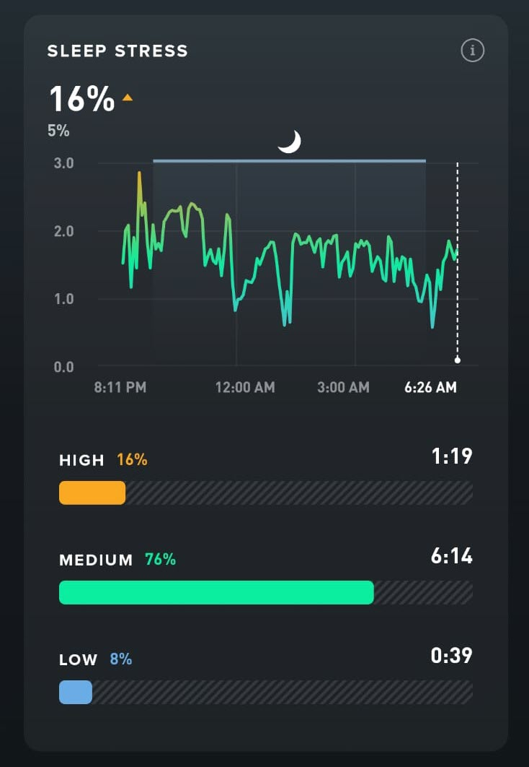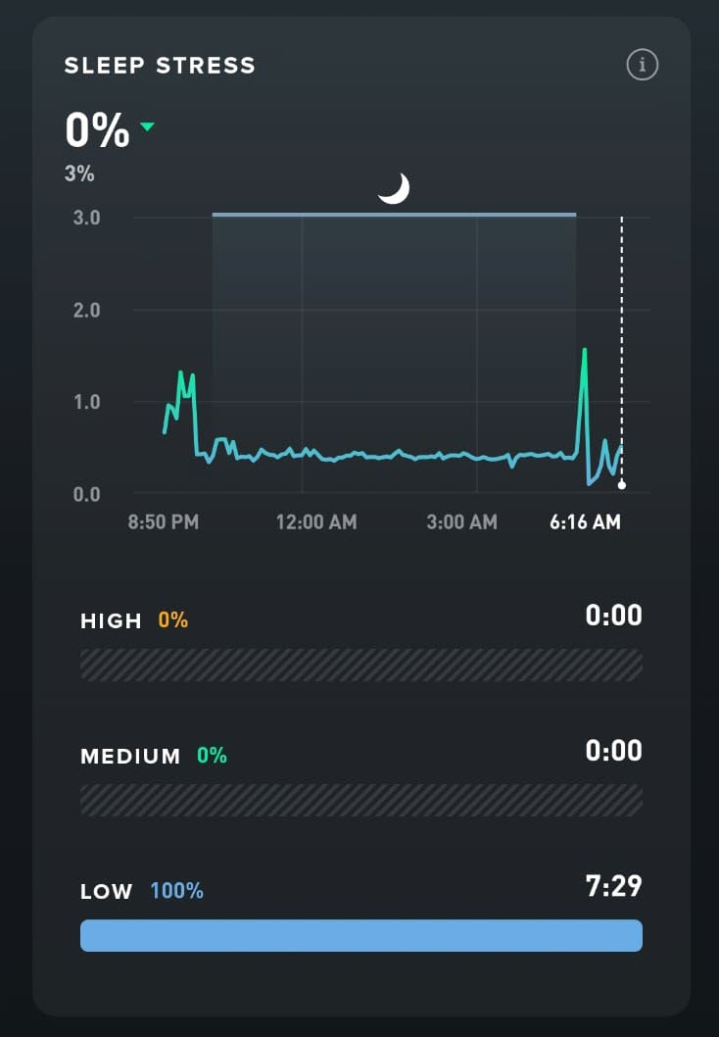
A great unexpected side-effect was how this changed my relationship with exercise motivation. The internal argument I’d been having for years — just do it, you know it’s good for you, stop making excuses — got quieter. It’s easier to talk yourself into a moderate session than a brutal one. The barrier to getting there drops. The session itself is more enjoyable. And the sleep that follows is better, which means the next day’s recovery score is higher, which means you can do a little more. Eventually, you want to do more. The feedback loop runs in the right direction for once.
So what does this look like in practice?
The morning walk is already your baseline — it’s been there since Chapter 17. But if you want to build on that, if you want intensity, the morning is the best time.
Make the walk a run. Take the bike out. Hit the gym before work. Whatever form intensity takes for you, front-load it. But front-loading doesn’t mean transplanting the bootcamp to seven in the morning. For someone already sleep-deprived, all-out effort is likely still too much whatever the hour. Think one level below your maximum — a run rather than sprint intervals, a gym session you push through but could repeat tomorrow.
The WHOOP logic applies: let your recovery score set the ceiling, not the class. Morning exercise works with your cortisol curve rather than against it — the cortisol awakening response is already rising when you wake up, and exercise channels that into effort rather than creating a fresh spike later in the day that has to clear before you can sleep. Studies also link regular exercise to lower cortisol levels and better sleep quality over time.
Once the afternoon arrives, the calculus changes. The research recommends finishing vigorous exercise at least four hours before sleep onset — but most of those studies were done on healthy adults without sleep disorders. People whose calming systems were already working. If you’re reading this book, you’re probably not that person.
My own experience, and it’s self-experimentation rather than science, points to at least six hours as the safer margin. For most people, that means finishing before 4pm (assuming a 10pm bedtime). This is a good rule of thumb, but earlier in the day is still better, especially when your recovery baseline is already low.
Anything after 4pm should be low-intensity. A walk. A gentle swim. Stretching. Movement that asks something of the body without demanding a stress response in return.
On low intensity, yoga deserves a closer look — because it actively trains the nervous system while you move. It falls under what’s sometimes called somatic exercise — movement practised with deliberate awareness of the body and breath. Paying attention to the physical experience of moving. How the breath changes. Where tension lives. What releases when you stop pushing.
That’s the same principle as the body scan. The same attention, just moving rather than still. Where meditation trains the calming system at rest, somatic movement trains it in motion. More signals for the same bottom-up channel — more ways to stimulate the vagus nerve and build your calming system.
Once I understood that, something I’d half-noticed since I first tried yoga made sense — the nights I did it, I generally slept better.
Tai chi works on the same principle. So does qigong. The specific practice matters less than the quality of attention — slow movement, breath connection, awareness of what the body is doing rather than just asking it to perform.
I replaced two intense evening sessions a week with two yoga sessions. The difference was meaningful – as if I could literally feel the calming system getting a workout it hadn’t been getting before.
I recommend starting with one session a week any time that works. Build to two. That’s enough to feel the difference.
Sometimes an intense evening session can’t be avoided. Evening team training. A late class you committed to. Life doesn’t always arrange itself around the ideal exercise window, and the answer isn’t to stop moving — it’s to manage the aftermath as deliberately as you can.
After those mountain-biking days my protocol was: a plunge in a cold stream if one was nearby, a cool shower if not — anything to bring the body temperature down — then a long stretch in front of something easy on TV, then the full body scan before bed. The goal across all of it was the same — give cortisol every chance to clear, give body temperature every chance to drop. Build whatever version of the comedown you can.
The rule is simple: intensity as early as you can manage, nothing vigorous after 4pm. One or two yoga sessions a week. If an intense evening session is unavoidable, take the comedown seriously.
If you have a tracker like WHOOP, let the daily strain recommendation do the thinking for you. It knows how well your body recovered last night.

Phase 5 – optimise your inputs (remove remaining disruptors)
Phase 2 cleared the biggest disruptors. Phase 5 clears the rest.
These habits are subtler — each generating its own quiet cortisol signal, interfering with the body’s ability to cool and settle, or feeding the Wake Executives in ways that compound through the night. They come last not because they matter less, but because once you’ve made progress on your sleep and restored a little willpower, they’re easier — and the effect, though quieter, is one you’ll notice.

Chapter 22 - Habit 9: Social Media
Social media is the first habit in Phase 5 — and probably the one you’ve heard the most about already.
Food, hydration, sugar — this phase is about what you put into your body. Social media is about what you put into your mind.
I knew it wasn’t good for my brain. Everyone says so. For a long time I thought the problem was blue light, and I assumed the filter on my phone was solving it. It was only when I started reading past the headlines and into the studies themselves that I found there was more to it than that.
“Blue light is the villain” was the early headline — and it wasn’t quite right. The light is real: it can suppress melatonin and nudge the body clock later. But it’s not the whole story. More recent studies show that what’s on the screen plays the bigger role: stimulating or emotionally engaging content delays sleep onset more than light exposure alone. So you can’t blue-light-filter your way out of it.
The catch is, it never feels like a problem. You pick up the phone and within thirty seconds you’re laughing, or outraged, or genuinely interested in something. You feel alert. Engaged. Usually better than you did before you picked it up. That’s the whole point. The problem isn’t that it feels good. The problem is when, how much, and what it’s doing to the two Wake Executives running in the background while you scroll.
When I actually looked at what I was watching, the picture got uncomfortable.
My feed was the same outrage machine from Chapter 8 — politics, this-side-versus-that-side commentary, the watch-this-guy-get-what-he-deserves clips. On some level I knew it was cheap trash — I’m smarter than that — but I kept getting dragged in.
A spare two minutes in the kitchen, a wait at the school pickup line, the gap between dinner and bed, the moment I’d put the kids down — phone out, thumb moving. I wasn’t watching it because I was bored. Some part of my system just wanted the next hit, and the next, and the next.
What I didn’t understand at the time was what it was doing to my body.
This is the dopamine-and-cortisol trap from Chapter 8, in its purest form: every piece of content lands a small hit — curiosity from the things that interest you, cortisol from the things that provoke you — and most feed content delivers both at once. Late-night, that’s activating — both Wake Executives running on full, priming you for novelty and threat exactly when you need to be winding down.
The algorithm learns what you engage with — what you click, what you watch to the end, what you react to. It has no opinion about your sleep or your mental health. It just serves you more of what you’ve already responded to. And we respond most reliably to content that makes us feel something – outrage, shock, indignation. Its human nature. The platform didn’t create it. It just found it and tapped in.
The sleep window doesn’t wait. The longer you stay in the feed, the more of it you spend in the wrong state. You scroll straight past it — the way Chapter 8 warned. You’re tired but wired. By the time you put the phone down, the conditions that were lining up to carry you into sleep have already shifted.
The worst version of this is the middle of the night. Waking briefly is normal — almost everyone does it. But the phone is right there, and you tell yourself you’ll just check the time. Within seconds you’ve opened something. Within a minute you’re activated. What should have been a moment’s stir back into sleep becomes a long stretch of full wakefulness, or worse, sleep is done for tonight.
That one behaviour — picking up the phone in the middle of the night — is one of the most disruptive things a poor sleeper can do.
The first step is non-negotiable. If you wake in the middle of the night, do not check your phone. Leave it face down. That single behaviour change — before anything else — is the highest-leverage move in this chapter. Even a glance at a notification is enough. If sleep doesn’t come back, the can’t-sleep routine from Chapter 16 is what takes over — the phone is never part of it. Everything else can be worked on gradually. This one can’t wait.
Steps two and three are daytime habits. The good news is that the feed you have is largely a reflection of what your nervous system has been responding to — which means it can change.
The second step is awareness before reduction. Before you try to use your phone less, change what you’re using it for. Start noticing which content activates you, winds you up, leaves you agitated, and stop clicking on it. The reason isn’t discipline — it’s that you now know what it’s doing to your cortisol while you watch it. Once you know that, the decision to scroll past it gets a little easier.
Then start clicking toward things that genuinely interest you instead. Content that engages you without working you up. The difference matters more than the amount of time you spend on the phone. And the encouraging part is that the feed responds quickly. You’re not fighting the platform — you’re redirecting it. Once the feed changes, the pull toward spiking content weakens on its own.
The third step is reduction. Do it less, but give yourself some time. Content is a higher priority than the amount. So start with step two today. Let step three wait until the new feed has settled which should reduce the pull at least a little. Then cut the time down too. Your evenings are already handled: after Chapter 18, the phone is away once the wind-down begins. So this step is about the daytime scrolling — the spare minutes, the queues, the gaps between things. Hold strong and keep resisting the urge to click the old content. The moment you start engaging with it again, the feed notices.
For me the shift looked like this.
I stopped clicking on politics. Stopped engaging with the debate videos, the outrage compilations – all of it. When it came up — and it still came up, because the algorithm doesn’t change overnight — I scrolled past without stopping. Just with the knowledge of what clicking it was actually costing me.
And I started clicking on things I genuinely loved. Mountain biking. Surfing. Brewing beer. The algorithm rarely served me these things — but the more deliberately I clicked toward them, the more they came.
I stayed away from near-miss and crash compilations in mountain biking – the content matters, not just the topic. I was after things that calmed me, not wound me up.
Within a few days the feed started to change. Within a week it looked genuinely different. The outrage content got crowed out. The stuff I knew was better for me came forward. I hadn’t deleted anything. I’d just changed what I was telling the algorithm I wanted.
So tonight: leave the phone face down. Tomorrow: start noticing what you’re clicking on and why. The awareness comes first. Everything else follows from it.

Phase 6 – optimise your inputs

Chapter 23 - Habit 10: Hydration & waking up to pee
Hydration is the first chapter in Phase 6 — and probably the one that feels least like a sleep habit.
I knew I should be drinking a couple of litres a day, but I didn’t really know why. And when life got busy — three kids, full days, a brain already running on fumes — it just didn’t register on the priority list. I’d remember at three in the afternoon that I’d barely had anything and try to catch up. It still doesn’t feel dramatically different during the day when I get it right. But it shows up on the tracker. A few more minutes of deep sleep. Slightly higher recovery scores. Small numbers. But they kept showing up.
The pattern was working against me in ways I hadn’t connected to sleep at all.
Even mild dehydration — the kind you don’t consciously notice — is enough for the body to register as a low-level stress state. Cortisol rises in response. Not dramatically, not in a way that feels like anything in particular, but enough to raise the baseline at a time when it should be falling. The Wake Executive gets a little more motivation to work harder than he needs to today.
The sleep system doesn’t fail in one go — it gets quietly undermined by small things stacking on top of each other. Dehydration is one of the smaller things and one of the easiest to fix.
Hydration, in this sense, is not about optimising. It’s about removing an unnecessary stress signal.
It works in another direction too. Dehydration also makes it harder for the body to cool down — and cooling down is part of what triggers sleep onset. When you’re mildly dehydrated, that process slows. Sleep still comes — just slightly harder to reach when you want it.
There’s a third piece, specific to the middle-of-the-night bathroom trips. It’s not always about how much you drank. When cortisol is elevated and sleep is light, the bladder signal that most people sleep through becomes loud enough to wake you. The body is designed to hold more at night — but that system relies on cortisol being low and sleep being deep. Lose either one, and a signal that was always there breaks through.
The amount still matters — which is why you taper in the evening. But if you’re doing that and still waking up, the problem might not be your bladder. It might be your sleep depth.
As my sleep improved, I noticed the night-time bathroom trips becoming less frequent. I’m down to once a night now. It doesn’t bother me anymore. It’s a quick trip in the dark, back to bed, and straight back to sleep. Just like a normal person. Another indication that something significant had changed.
The rules that got me there don’t require much.
Drink most of your fluids through the morning and early afternoon. Don’t rely entirely on thirst as your guide. Its slightly delayed, so by the time you feel it, you’re already behind. I made it as easy as possible for myself. I bought a two-litre bottle, filled it every morning, and made sure I’d got through it before the evening. No tracking, no measuring — just one visible target that reset each day. For most adults, around two litres is usually a reasonable daily amount — a little more if you’re active or it’s hot — but the bottle gave me the number without having to think about it.
Start tapering in the early evening. Small sips after dinner are fine. Large volumes are what cause the problem. If you want a rough signal for whether you’re getting it right, urine colour is the simplest one. Pale straw means the body has what it needs. Dark yellow means you’re behind. Clear means you’ve overdone it.
The one thing the system can’t absorb is a late catch-up. As a rule, you don’t want to be taking in large amounts in the last three hours or so before bed — roughly from dinner onward. If you’ve drunk barely anything by mid-afternoon and then try to hit your target in the hours before bed, you’ve solved one problem by creating another: a large volume close to bedtime is a reliable way to wake up several times in the night.
If you do get to late afternoon well behind, the honest answer is there’s no clean fix — distributing through the day was the move, and you’ve missed it. But the least-bad version isn’t to slam two or three litres at dinner. Bring your intake up before 5pm (or five hours before bed), then taper off toward 7pm (or 3 hours before bed), in smaller amounts. And if it’s already late evening, don’t try to catch up at all — small sips if you’re thirsty, otherwise accept the shortfall and reset in the morning. A slight deficit tonight costs less than a disrupted night trying to correct it.
That’s all there is to it. Hydration quietly helps cortisol stay a little lower, and the body cool down more easily. The system gets a clear run at night without something working against it. It’s not dramatic, and it won’t fix poor sleep on its own. But it removes a source of friction that most people don’t even know is there — and removing friction is the whole point of Phase 6.
Fill the bottle in the morning. Start tomorrow.
No hacks. No complexity. Just giving your body what it already expects.

Chapter 24 - Habit 11: Food Timing
Evenings are when life happens. Sometimes a race to get dinner on time, kids through homework and bed, and a few chores. You finally get some time to relax. A snack creeps in. For a long time I didn’t think any of it was relevant to what happened an hour later when I closed my eyes. If anything, I thought the opposite.
You know that warm, heavy feeling that sometimes follows a big meal — what some people call a food coma? I loved that feeling. It felt like the body making a case for sleep. I thought I could use it.
It’s a bit like alcohol though – while it might help us get to sleep, the quality suffers.
And here’s why.
You already know the conditions sleep requires — temperature dropping, the calming system taking its turn, the activating system standing down.
When you eat, your body shifts into an active state — exactly what it needs to do to digest the meal. Metabolism rises, core temperature follows, insulin is released, and your gut gets to work.
The problem is simply one of timing. It’s the same conditions that prevent sleep from starting properly, arriving at the worst possible hour. You’re asking the body to cool down while it’s generating heat — the activating system running when it should be standing down.
You’ll often still drop off if the food-coma feeling is strong. But the sleep you get is lower quality and more fragmented. You might not feel the difference during the night, but you’re paying a cost that shows up in how you feel the next day. The body is still processing when it should be restoring – and restoration is the whole point.
The research is consistent on this: the closer to bed you eat, the worse the night. I use 3 hours as the target. It’s both a well-supported minimum and realistic to maintain.
In practice, three hours is reasonably straight forward. I aim to finish dinner by 7pm, for a 10pm bedtime. Sometimes dinner runs late and I eat late — I accept that. But I do what I can to keep those exceptions occasional.
The other situation is hunger. If it feels like it’s been a long gap since dinner and you’re genuinely hungry at bedtime, going to bed on an empty stomach isn’t the answer. Hunger is its own cortisol trigger. Cortisol at bedtime is exactly what the rest of this program has been working to avoid. A small snack is better than lying awake — but if it becomes a regular habit, use the incremental approach to gradually move the snack earlier until the gap closes on its own.
If you do snack, composition matters less than people think. Protein may help steady blood sugar overnight; carbohydrates help tryptophan reach the brain to support melatonin. Both have a case.
I’ll eat either. If you want a recommendation, protein wins — the safer choice if you have an underlying glucose regulation problem.
What matters more than what you eat is the size: just enough to take the edge off and get you to sleep. Not a meal, only a small bridge. Neither too full nor too hungry. That’s the whole brief.
It fits where you’d expect. Light sets the clock. Sleep timing reinforces it. Food timing keeps everything aligned.
Your starting point is simple: finish your last substantial meal three hours before bed, most nights. Snack only if you need to. Keep it small.
The next chapter looks at sugar — specifically what happens when blood sugar spikes and crashes in the hours before bed, and why that cortisol rebound is waking more people up at two or three in the morning than they realise.

Chapter 25 - Habit 12: Sugar & Food Sensitivities
I knew sugar wasn’t good for me. I’d known that for years. It didn’t stop me.
There was a slump that came every couple of hours — mid-morning, after lunch, mid-afternoon, the commute home, after dinner. Each one needed managing.
Sugar was how I managed it. A biscuit with a coffee. Something sweet after lunch. A handful of whatever was in the cupboard when the three o’clock wall arrived. I wasn’t eating it for pleasure, particularly. I was eating it to get through the next couple of hours so I could get through the next thing. How else was I supposed to have the energy to do everything that needed doing? Coffee and sugar was the answer.
I tried to quit several times. It never stuck. So I attacked it the way I’d attacked caffeine — reduce, not quit, and do it incrementally. Two sugars in my coffee, then one and a half, then one, then half, then none. Pausing at each stage long enough for the new level to feel normal before dropping again. This worked to change my taste a little. But the craving for the energy it gave me didn’t go away. I was still hitting the wall every couple of hours. I’d just stopped reaching for the same thing to get over it.
What did most of the heavy lifting, in the end, wasn’t focusing on sugar directly. It was focusing on everything else.
By then I understood what I’d been up against. We already saw, with caffeine, that sleep deprivation measurably reduces your capacity for self-control — willpower runs on a battery that poor sleep never fully recharges.
But it gets worse. Lack of sleep also pulls two of the appetite managers out of line. It raises ghrelin, which translates to “I’m hungry”, and lowers leptin, which translates to “I’m not full yet”.
And ghrelin doesn’t only make you hungry — it acts on the brain’s reward system, tilting what you crave specifically toward sweet, fatty food. So I wasn’t fighting a vague urge to eat. I was being pushed straight toward a sugary snack, while the willpower to stop was on zero battery. Cravings turned up, willpower turned down, and both pointed at sugar. No wonder quitting never stuck.
And that was the part no one had ever told me. Every other time I’d tried to quit, I’d been doing it the hardest way possible — willpower on empty, the appetite managers pulling hard in the opposite direction. For a long time I believed I just needed to be tougher — that I had to want it more. I suspect that idea came from a lifetime of advice written by people who’d never had a sleep problem. I now believe that if you want stronger willpower, sleep comes first.
So when the rest of the program started improving my sleep, it undid the double bind I’d been fighting — cravings high, willpower low. It felt like an unfair advantage I’d never had going into any of those earlier attempts. The slumps flattened out and those managers settled back into line — leptin and ghrelin saying the right things at the right times again. The cravings lost enough of their grip to become resistible. I didn’t engineer that part directly — everything else clicking into place took the pressure off. A conscious effort did the rest.
That’s why sugar comes this late in the program. Caffeine and sugar both put pressure on the same systems — tackling them simultaneously is too much change at once. Build the other habits first, let sleep improve, then use this chapter to address what’s left.
Those slumps and crashes have a mechanism that explains what’s actually happening when you eat sugar and feel that brief lift.
Blood glucose rises quickly — especially with refined sugar or simple carbohydrates. The body responds by releasing insulin to bring it back down. If the sugar load is large, or if this is happening repeatedly across the day, the correction overshoots. Glucose drops below where it started. The brain, which runs almost exclusively on glucose, registers this as an emergency. And the body’s response to emergencies is cortisol.
Cortisol mobilises stored energy and raises blood glucose back to safe levels. The problem is that cortisol is also a Wake Executive — it’s the signal that says stay alert, stay ready, don’t rest. Every sugar crash is quietly asking your body to produce more of it. Do this often enough, across enough years, and the Wake Executive can become overworked and reactive. Firing when it shouldn’t. Flat when you need it. And not clocking off when he’s supposed to.
It’s a terrible irony. The symptoms of that dysregulation — the fatigue, the difficulty concentrating, the low mood between meals — are exactly the feelings that send you back to sugar for another hit. The loop feeds itself. You’re not weak-willed. You’re caught in a hormonal cycle that sugar both causes and temporarily relieves.
This matters most in the evening.
Cortisol follows a daily curve — highest in the morning, lowest by the time the Sleep Executives take over at night. A significant sugar hit late in the evening — a dessert, something sweet out of habit — disrupts that handover directly. The spike arrives, the crash follows, cortisol fires again to correct it — and suddenly the Wake Executive is back at work at exactly the moment he was supposed to clock off.
The result isn’t always that you can’t fall asleep. Sometimes you can. But the sleep you get is shallower, more fragmented, easier to break.
And for a lot of people, there’s a specific hour — somewhere between two and three in the morning — where you wake up alert, anxious, or hot, for no obvious reason. The cortisol chapter explained why it tends to be then: as melatonin eases in the small hours, any cortisol riding higher than it should jumps in to fill the gap. A late sugar hit is one more thing that can light that fuse — a blood sugar dip provoking a cortisol surge of its own, pulling you out of deep sleep at the worst possible time. It’s easy to assume you woke to use the bathroom — but often the cortisol surge comes first, and the bathroom is simply what you notice once you’re awake.
Knowing that changes what you do about it.
In practice, my approach to sugar looks a lot like my approach to alcohol.
I don’t eat sugar after dinner — or if I do, it’s as little as possible and as low-sugar as I can make it. A small scoop of ice cream. A low-sugar hot cocoa. Something that satisfies without loading the system. During the day, I still enjoy the occasional sweet treat. Rarely soft drink - zero sugar if I do. And only some days, not at every slump every couple of hours the way it used to be.
The method is the same as everywhere else: don’t try to quit, just reduce. Adjust until that feels normal, then reduce again. The taste follows the behaviour if you give it enough time.
There’s one more layer worth knowing about — particularly if you’ve done the work and still feel like something’s off.
Some people have food sensitivities that are quietly generating what may be a low-grade immune response in the background — not an allergy, nothing immediate or dramatic, but a slow, delayed reaction that keeps the body mildly stressed. The kind of thing that’s easy to misread as something else.
The symptoms are often subtle and disconnected from eating: disrupted sleep, persistent fatigue, brain fog, bloating, unexplained skin reactions, or a stuffy nose that never quite goes away. That last one is worth noting specifically — nasal congestion at night disrupts breathing, fragments sleep, and can be caused by food sensitivities in people who’d never think to make the connection.
The most commonly reactive foods are gluten, dairy, eggs, and soy. If any of those feature heavily in your diet and you recognise the symptoms above, an elimination approach is the most reliable place to start — remove the suspected food for a few weeks, reintroduce it, and watch what happens. Blood tests that assess immune reactivity to a broad range of foods are also available, returning results in a simple traffic-light format.
While I found these tests extremely helpful — they helped uncover the cause of persistent mild congestion - it’s important to note the science is contested. Many clinicians consider them unreliable, and the results should be treated as a prompt for further investigation, not a diagnosis.
If something is still disrupting your sleep, sensitivities are worth investigating. For some people, it’s the final piece.
Your starting point for this chapter: draw the after-dinner line on sugar and hold it. If you suspect a sensitivity, start with the most likely culprit and give elimination a few weeks. Use your tracker to watch what happens.
The sugar piece is a good illustration of how the whole program works. It wasn’t one thing fixing the other. Better sleep made cutting down manageable — and cutting down made the sleep better still. One thing led to another, the way it does when the system is working as it should. An upward spiral. Each part making the next part easier.
And that’s it.
That’s the last habit. Twenty-four chapters, twelve habits. The program is built.

PART 4 – Over to you

Chapter 26 - What Happens Next
Most people start in the same place. Sleep is a night-time problem, fixed at night, by trying harder at night. Better willpower. Earlier bedtime. The right supplement. Something that works on the night itself, because that’s where the problem seems to live.
That’s where I started.
The program starts from a different idea. You are not trying to fix sleep directly. You are creating the conditions that allow it to happen. Nobody tries to get fit on the night of a race. You build the fitness first, and the performance follows. Sleep works the same way. That shift — from chasing the outcome to supporting the system that produces it — is the whole thing.
The habits were actually doing three things: training your body clock, building your calming system, and removing what kept you activated at night — so sleep could come when it should. Each one seemed almost too small to matter — light exposure in the morning, a three-hour gap before dinner, a consistent wake time. None of it felt like fixing sleep. That was the point.
The progress is gradual — but the moment you recognise it doesn’t have to be.
There’s no single morning where the problem is suddenly “fixed.” What happens instead is quieter — and it adds up. Falling asleep becomes slightly less effortful. You notice you’ve stopped watching the clock. A run of good nights starts to feel normal rather than lucky. And then, at some point, it becomes undeniable — the change you’d been waiting for is unmistakably real. The bad nights still come — they always will — but they stop defining you as a bad sleeper. Sleep stops being something you think about with anxiety.
You’ve come a long way to get here. You’ve read the book. You know more now than when you started. But knowledge doesn’t fix sleep. Action does. And the gap between the two is where almost everyone gets stuck.
It doesn’t matter whether it feels manageable or overwhelming right now. You don’t need to do everything. You need to do something. Then the next thing. Then the thing after that.
Everything you need is already in your hands. That said, if you’d like extra help, there’s a free app to track your progress, and the Sleep Builders community to ask questions and share progress. You’ll find both at www.sleepbuilders.com.au. You don’t need it. But it’s there.
Either way, start with the foundational stuff. Order a couple of things online. Set up your environment. Then pick the first habit that feels achievable. Build it until it’s automatic. Then pick the next one. You already know what to do — you’ve just read it. The only thing left is to begin.
If you stay with it, something will shift. The nights will become more reliable. The mornings will feel different. Sleep will stop being something you lie awake hoping for and start being something you can count on. Not every night. But most nights. In a real life, with family and a full schedule and everything else that doesn’t stop just because you’re trying to sleep better.
Most nights is enough.
When my wife read the first draft chapters of this book, she came downstairs a little teary. She gave me a hug and said: it really is a lot you’ve been through. It’s amazing you’re still here. I told her I had a big rock to lean on — it was amazing she’d stuck with me through it all. She said: I knew you were still in there.
That was the greatest success of all. Not sleep scores. Not optimising protocols. Having someone you care about deeply notice the change in you. Becoming present for the people who have been waiting for you to return.
I wish you every success with it. This approach made a change in my life I didn’t believe was possible. That’s the reason I wrote it — the hope that it might do the same for someone else.
From here, the book has done what it can. You’re the CEO of Sleep Incorporated. You understand how the company runs now. You know how to align the four executives, who will turn the company around.
The mind that wouldn’t switch off finally can.
Now go get some sleep.

