# Lab: Spring Boot and Spring Data

# West Compass Dealer Shop

West Compass Dealer Shop is an application in which you register cars, with several properties.

You will have to create a simple application which has several pages and some object entities.

## Data

This is the data layer of the application. There are some data object for you to implement.

### Brand

Create a Brand class, which holds the following properties:

* id – a **uuid or number**.
* name – a **name of brand**.
* **created** – a **date and time**.
* modified – a **date and time**.

### Model

Create a Model class, which holds the following properties:

* id – **uuid or number**.
* name – a **model name**.
* imageUrl – the **url of image**.
* startYear – a **number**.
* endYear – a **number**.
* **created** – a **date and time**.
* modified – a **date and time**.
* brand – a **model** **brand**.

### Offer

Create a Model class, which holds the following properties:

* id – **uuid or number**.
* description – some **text**.
* engine – **enumerated** value.
* imageUrl – the **url of image**.
* mileage – a **number**.
* price – the **price of the offer**.
* transmission – **enumerated** value.
* year – the **year** of offered car.
* **created** – a **date and time**.
* modified – a **date and time**.
* model – the **model of a car**.
* seller – a **user that sells the car.**

### User

Create a User class, which holds the following properties:

* id – **uuid or number**.
* **username** – username of the **user**.
* **firstName** – first name of the **user**.
* **lastName** – last name of the **user**.
* active – **true OR false**.
* role – **user's role**.
* imageUrl – a url of user's picture.
* **created** – a **date and time**.
* modified – a **date and time**.

### UserRole

Create a UserRole class, which holds the following properties:

* id – **uuid or number**.
* **role** – **enumerated** value.

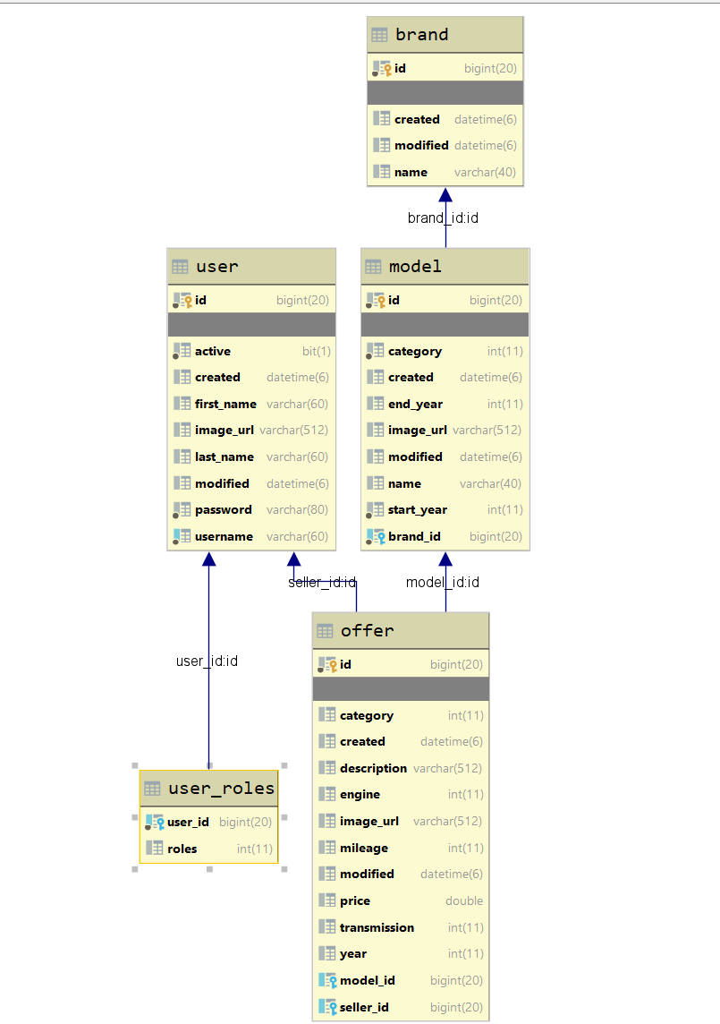This is an example of ER Diagram

## Populate DB

* For this moment, populate your DB manually. Our app should be extended in the next lecture and have this functionality.

## Home/index - route ("/")

It should support only a **GET** request.

It should return the following HTML page, upon a **GET** request.



## All Cars - route ("/cars/all").

It should support only a **GET** request.

It should return the following HTML page, upon a **GET** request.

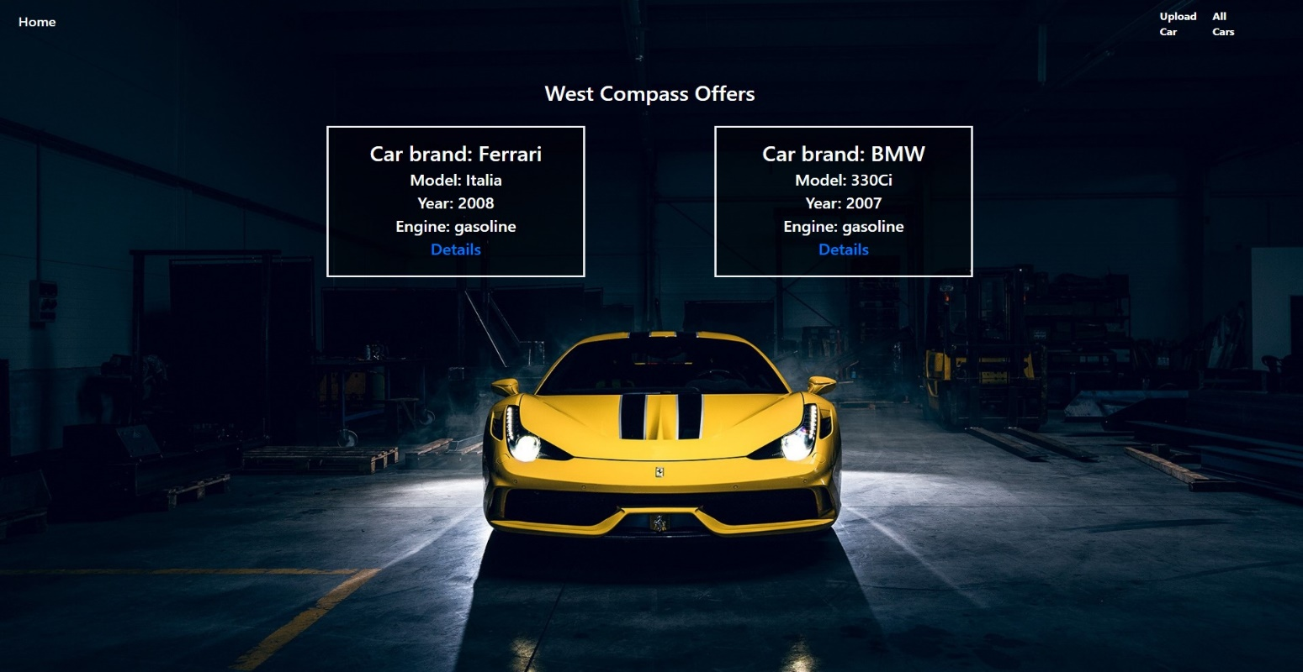

**Hint section:**

* Because you will learn Thymeleaf next week, we'll give you a little hint on how to implement this functionality
* This is an example code of how to visualize all offers in the **all.html** page using **th:each**:

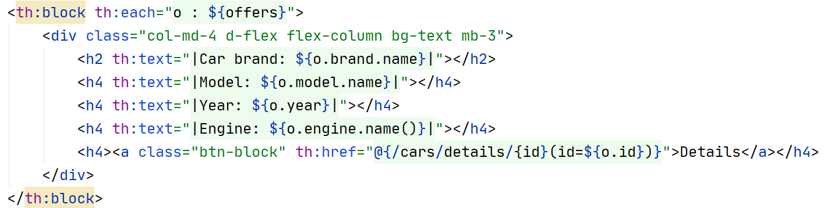

* This is a link to the documentation
  + <https://www.thymeleaf.org/doc/tutorials/2.1/usingthymeleaf.html#using-theach>