Software Design Specification for Real Audio 8 Decoder on T4G-MeP

Document Id: SoC_T4GRealAudioMeP_SDS

Last Revision and Date: 1.0: 16-03-2005

SoCrates Software India Pvt. Ltd.

Bangalore

Revision History
Version | Date | Description of change(s) | Author(s) | Approved By
0.01 | 24 – Sept-2004 | Initial version | Tejas M | Not approved
1.0 | 16-Mar-2005 | Approved | Sudeendra | Dr. Debasmita Shaw

TABLE OF CONTENTS
1 Introduction 5
2 Definitions and Acronyms 5
3 References 5
4 Assumptions, Dependencies and Constraints 6
4.1 Assumptions 6
4.2 Dependencies 6
4.3 Constraints 6
5 Scope 6
6 Risk 6
7 Design Methodology 6
8 System Architecture 7
8.1 Conventions and Standards followed 7
8.2 System Overview 7
8.3 System Environment 8
8.4 Development Environment 8
8.5 Design Strategies 9
8.6 Tools used for design 10
8.7 Design Environment 10
9 Process Design 11
9.1 Process Organization 11
9.2 RA 8 Decoder Library. 12
9.3 RA8 Decoder Firmware 14
9.4 PCM Samples Rendering to DAC 14
10 Logical Data Design 16
10.1 Overview 16
10.2 Conventions and Standards followed 16
10.3 Data Model Diagram 16
11 Interface Design 17
11.1 Real Audio 8 Decoder Library 17
11.1.1 Gecko2InitDecoder 17
11.1.1.1 Description 17
11.1.1.2 Function 17
11.1.1.3 External Interface 17
11.1.2 Gecko2Decode 17
11.1.2.1 Description: 17
11.1.2.2 Function 17
11.1.2.3 External Interface 18
11.1.3 Gecko2FreeDecoder 18
11.1.3.1 Description 18
11.1.3.2 Function 18
11.1.3.3 External Interface 18
12 Real Audio 8 Decoder Optimization Techniques on MeP 19
13 APPENDIX A 24
14 APPENDIX B 28

Introduction
This document specifies the software design specification for Real Audio 8 Decoder and its command and control firmware on T4G – GMM module. TC35285XBG (T4G) is a multimedia engine for various kinds of mobile phones and personal digital equipments.

Definitions and Acronyms
Acronyms | Definition
AMR | Adaptive Multi-rate
3GPP | Third Generation Partnership Project
T4G | TC35285XBG Multimedia engine
MCF | M Core format
GMM | Graphics and media module
BB | Base band
ME | Media engine
MCPS | Millions of Cycles Per Second
MeP | Media Embedded Processor
MPI | Media Processor Integrator
API | Application Program Interface
FIFO | First in first out
DRAMC | Data Read Access Memory Controller
DAC | Digital to Analog Converter

References
[1] RA8 Decoder External Specification
Document Name: RA8DecoderExternalSpecificationv20.doc
[2] T4G – GMM Bus Bridge specification revision 2.0
[3] T4G Top level functional specification revision 0.1.a
[4] Software Requirement Specification of Real Audio 8 Decoder
Document Name: SoC_RA8_SRS_1.0.doc

Assumptions, Dependencies and Constraints

Assumptions
The tools and software provided by other parties are assumed to be bug free.

Dependencies
- Any change in GMM bus bridge specification or T4G top level functional specification may result in change in the design of the Real Audio 8 decoder.

Constraints
- Integration of Host (BB-CPU) and T4G will be simulated with a test MFC program running on the PC.

Scope
TC35285XBG (T4G) is a multimedia engine for various kinds of mobile phones and personal digital equipments. T4G has various engines like video codec engine, JPEG codec engine, graphics and media module engine (GMM), LCD controller etc. Scope of the project involves development of Real Audio 8 decoder firmware on GMM module which has MeP RISC engine and the command interface with the BB-CPU host through the communication registers in GMM Bus Bridge. The command interface with the BB-LSI is designed based on the communication protocol as mentioned in the reference [1].

Risk
No risk is foreseen provided the system has predictive behavior and the communication are as per the protocol designed in reference [1]. Since the integration with BB-LSI is possible in the customer location only, only simulation is possible by developing and testing with host test Application.

Design Methodology
RA8 Firmware and library design is based on Functional description of the modules in reference [1] and [4].

System Architecture

Conventions and Standards followed
AMR encoder implementation is based on the following Real network standards.
- Real Audio 8 External specifications, Audio – video Technological Codec group, Real networks, October 31st, 2003. Version 1.0
- Real Audio 8 Codec summary, Audio – video Technological Codec group, Real networks, October 31st, 2003. Version 1.4
- Real Audio 8 fixed point decoder performance, Audio – video Technological Codec group, Real networks, October 31st, 2003. Version 1.4.

System Overview
The T4G system which uses MeP for Real Audio 8 decoding with the host base band chip controlling the Real Audio 8 decoder is shown below. In T4G, one among the module is named GMM, which has its main core a MeP RISC engine. The functionality of GMM module is graphics as well as media processing. Real Audio 8 decoder firmware will be developed on MeP processor and the commands for the same will be received from the host machine. The command interface is through common shared eDRAM memory where in the host can write commands and MeP acts according to the commands received coupled with responses and notifications.
As shown in Figure 1 the user can select any of the required files to be decoded and played. Depending on the user inputs, the parameter for that particular file will be selected and stored in the shared eDRAM memory. The eDRAM is accessed through BB – CPU bus interface and setting proper register of DRAMC. The user inputs will control the Host processing and in turn will control the MeP Real Audio 8 decoder firmware.
For the user selected input Real Audio 8 encoded file, DAC initialization and Real Audio 8 decoder initialization happens. After these initializations, host programs starts filling the real audio 8 encoded data read from the file into the input buffer allocated in the eDRAM. The Real Audio 8 decoder, starts decoding frame-wise and dumps the PCMs samples into the outbuffer, also allocated in the eDRAM. The MeP firmware interrupts DAC for fetching the PCM samples and playing out the same through speakers as shown in the figure 1 below.
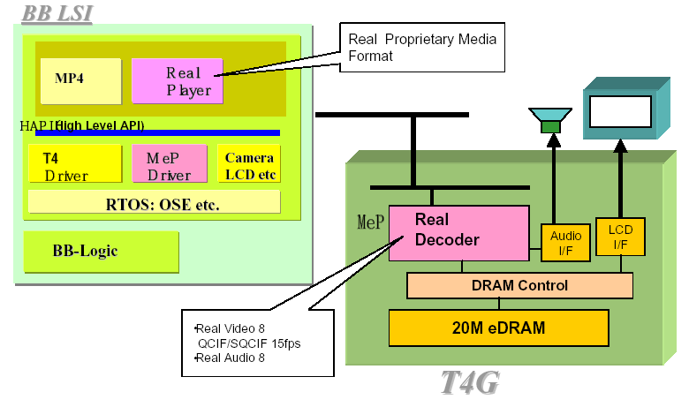

System Environment
Development of RA8 firmware will be carried out on T4G PCI board provided by Toshiba Corporation. Please refer development environment section 8.4 below for more details.

Development Environment
Development of RA8 firmware will be on T4G PCI board. The schematic of entire development environment along with the T4G PCI is shown in Fig 2. The board will be connected in one among the PCI slots of the PC. Code is first compiled using the MeP MPI tool on Linux Red Hat 7.2 OS to generate the executable .abs file. The Executable (.abs file) can be debugged by downloading it on T4G-MeP using Sophia JTAG Emulator. The entire system which comprises of the host BB-LSI chip driving the T4G chip will be simulated by sending the necessary control commands by virtue of a host program running in PC.
Hardware requirements:
T4G PCI board from Toshiba Corporation.
Sophia UniSTACII In-Circuit Emulator.
Windows 2000 PC.
Software requirements:
T4G WDM driver version T4GPCI_v5120
Watch point debugger version 4.1.1.
Host software application (Microsoft Visual Studio 6.0).
Red-hat Linux 7.3 operating system for MeP simulator.
MPI 2.0, release 2.8.4 tool chain for MeP C3 architecture.

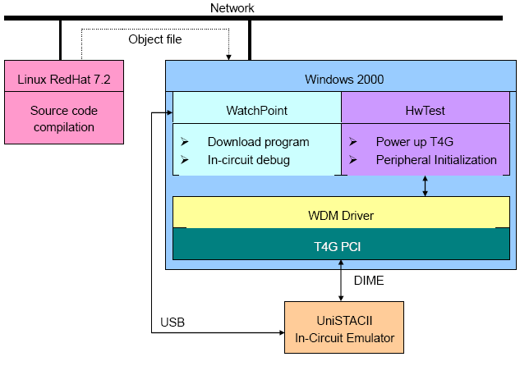
Figure 1 : Development Environment.

Design Strategies
Design strategy is as follows :
  - Port the Real Audio 8 Decoder on to MeP platform.
  - Remove all dynamic memory allocations.
  - Do C level Optimizations
  - Analyze the complete Data Flow of the Real Audio 8 Decoder and reduce eDRAM access cycles using DMA where ever possible
  - IO Buffer Design.
  - Real Audio 8 Firmware and Library Development
  - Host program development to accept any Real Audio 8 encoded file and call the Real Audio 8 decoder, present at the MeP platform.

Tools used for design
None

Design Environment
NA

Process Design

Process Organization
HOST

T4G

GMM

Input Buffer

And

Output Buffer
RA8 Firmware
RA8 MeP Decoder Library
Input RA8 encoded File

DAC

Host
Command and Control Interface

Host User Console
SPEAKER
OUTPUT

Figure 2 : Process Block Diagram

This section briefly explains the interaction between the various modules in the system. Figure 3 shows the basic modules used in the system. The basic modules are:
- RA8 Decoder Library.
- RA8 Decoder Firmware.
- Data Rendering to the DAC.
Initially the RA 8 encoded data is given to the Host. The Host user console controls the Host command control interface which in turn controls the RA 8 decoder firmware. Based on the command from the host, the data is fetched and processed accordingly. The RA 8 MeP library decodes the data given by the Host and writes the processed data into the output buffer. The RA 8 decoder firmware generates an interrupt to the DAC conveying that the output buffer has written data and is ready to be rendered. The DAC acknowledges the interrupt and plays out the PCM samples at the set sampling rate, until the DAC is reset again.

RA 8 Decoder Library.
The RA 8 Decoder Library basically performs the decoding operation of the input data filled in by the Host program.
Decouple Coefficients
(if joint stereo)
Decode Side Info
(gain, coupling, power envelope, category index)

Categorize and Expand
(calculate quantizers)
Decode Huffman Vectors
Dequantize

RA 8 Encoded Data

1

1

IMLTNoWindow

Apply synthesis window
to first half
of current IMLT
Apply synthesis window
to second half
of current IMLT

Apply Gain
Window
(if attacks)
Apply Gain
Window
(if attacks)

Z^{-nmlt}
(save overlap)

Round to 16-bit PCM
(with clipping)

Figure 3 : Real Audio 8 Decoder Library Flow Diagram

RA8 Decoder Firmware
RA8 decoder is initialized by running the host code and downloading MeP Decoder library. The Host program takes care of input data reading from the file and writing into the input buffer present in the eDRAM. The RA8 decoder will take the data from the input buffer and will decode it. After completing one frame decoding, it will write into the output buffer which will fetched by the DAC and played at the sampling rate. There are 2 separate output buffer which work in a ping – pong way. At any point of one will be given to decoder for writing the decoding data and the other will be given to DAC for playing the PCM samples.

PCM Samples Rendering to DAC
The Output buffer for the Real Audio 8 decoder will be allocated in EDRAM. There are two output buffers which function in a PING – PONG way. That is at any point of time one buffer will be given to decoder and the other will be given to DAC. The DAC will take the PCM samples from the selected buffer and play it at the rate of sampling frequency.

Is the Input buffer empty ?
start
Read data from input RA file and fill the Input buffer - EDRAM
Flag ?
Select Output Buffer - 1
Select Output Buffer - 2

Real Audio Decoder
Is Decode Over
Render to DAC
End
NO
YES
SET
RESET
NO
YES
Figure 5 : Real Audio 8 Firmware Flow Diagram

Logical Data Design

Overview
The encoded audio data is filled into input buffer located EDRAM. The host program implements circular buffer mechanism for filling the audio data into input buffer. The host program updates a input buffer write pointer as and when it fills on frame data. At the Mep side, the firmware verifies the input buffer depending on the input buffer write pointer. The decoding is started only when, there is at least one encoded audio frame in the input buffer and an empty output buffer. The DAC fetches the decoded audio samples and empties the output buffer.

Conventions and Standards followed
NA

Data Model Diagram

eDRAM

Input File

Input Buffer

Output
Buffer

RA8 Decoder Library
Figure 6: Data Flow Diagram.
DAC

Interface Design

Real Audio 8 Decoder Library

Gecko2InitDecoder

Description
This function is used to initialize all the parameters required for the Real Audio 8 decoding for a specific Real Audio 8 encoded file.

Function
U32 Gecko2InitDecoder(Gecko2Info * pGecko2Dec, U32 *pCodingDelay)
The main function of this module is to initialize all the file specific parameters, set from the host side.

External Interface
Variables and Constants: None.
Input / Output:
TYPE | NAME | IN/OUT | DESCRIPTION
Gecko2Info * | pGecko2Dec | In | This is a pointer to Gecko2Decode structure.
U32 | pCodingDelay | In | This will set the redering delay for output frames.
Return Value: Zero on Success, or an -1 value if any error occurs.
Pseudo-code / Algorithm:
1. Initialize all the variables, structures etc to their default initial values.
2. Generates the VLC tables.

Gecko2Decode

Description:
This function is called to Decode one Audio frame.

Function
U32 Gecko2Decode(Gecko2Info *gi, int lostflag)
The main function of this module is to decode one frame of compressed audio data.

External Interface
Variables and Constants: None
Input / Output:
TYPE | NAME | IN/OUT | DESCRIPTION
struct Gecko2Info * | pGecko2InfoDec | In | This is a pointer to Gecko2Decode structure.
U32 | lostflag | In | This flag, tells if there was any loss in the frames during streaming.
Return Value: Zero on Success or an error value if any error occurs.
Pseudo-code / Algorithm:
- Decode the input encoded data.

Gecko2FreeDecoder

Description
This function resets all the variables back to zero. Also deletes all structures etc created.

Function
Gecko2FreeDecoder(Gecko2Info *gi);
The function of this module is to reinitialize the state variables; de allocates the buffer and clears the structure.

External Interface
Variables and Constants: None.
Input / Output:
TYPE | NAME | IN/ OUT | DESCRIPTION
struct Gecko2Info * | pGecko2InfoDec | In | This is a pointer to Gecko2Decode structure.
Return Value: Zero on Success, or an error value if any error occurs.
Pseudo-code / Algorithm:
1. Reinitialize all the state variables to zero.
2. Reinitialize all the state buffers to zero.

Real Audio 8 Decoder Optimization Techniques on MeP
To meet the desired MIPS for Real Audio 8 decoder, on MeP platform certain optimizations are to be done. Here, optimization is achieved by restructuring the Data memory of the Real Audio 8 decoder. Accessing the external eDRAM takes more cycles than accessing internal DRAM. So, the intention is to keep the data under processing, in internal DRAM.

Memory accessible to MeP in this system is

- 24 Kilo Bytes of internal DRAM.
- 2.5 Mega Bytes of external eDRAM.

Data memory required for Real Audio 8 Decoder is roughly around 50K. Out of which, 30K is for tables. And 20K is for audio buffers, which is required during decoding of one audio frame.

Overlays in Real Audio 8 Decoder:

In Overlay technique, the internal DRAM address to which the particular section of eDRAM is to be transferred is mentioned in the linker file. The actual transfer of the data is done just before the time of processing by DMA Controller.

For the Real Audio 8 decoder, depending on the decoder flow and internal DRAM availability, overlays can be performed for following.

- Tables used during Huffman Decoding module.
- Tables used during Premultipy function of IMLT module.
- Tables used during Postmultipy function of IMLT module.
- Tables used during Synthesis Window module.
- Other miscellaneous tables used across the decoder.

Apart from audio tables, the buffers which are used during decoding of one frame is also kept in internal DRAM. Some buffers which need to be used across the frames, will be again stored back to eDRAM after processing.

Memory Map for Real Audio 8 Decoder:

The figure [ ] gives the part of eDRAM memory utilized by Real Audio 8 Decoder. Using overlay technique, tables are transferred to the internal DRAM, at the time of processing.

EDRAM AREA USED BY REAL AUDIO 8 DECODER

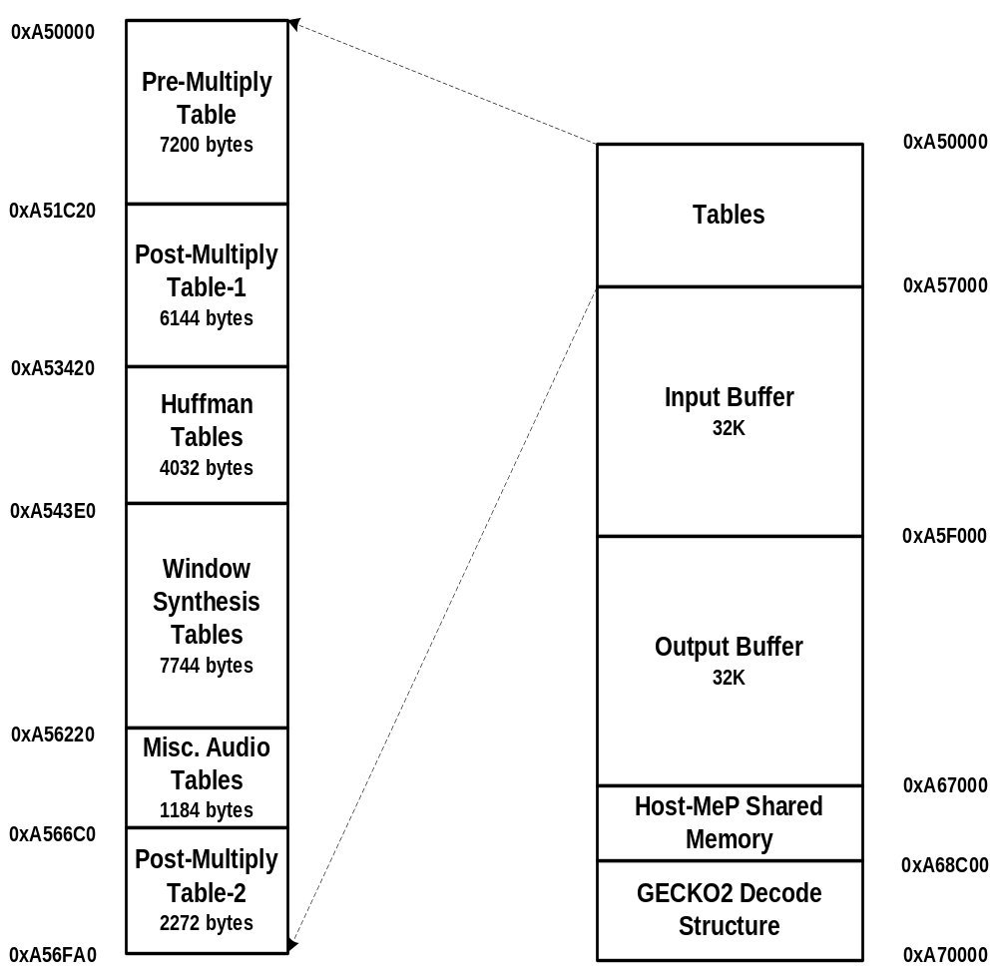
Out of 2.5 Mega Bytes of memory in EDRAM, real audio 8 decoder uses 128 Kilo bytes of memory. Different modules which utilize this memory can be classified as follows:

- Tables used in decoding of single audio frame.
  - These tables are required for decoding of single audio frame. It’s overlayed to internal DRAM during the processing time.
- Input and Output buffers used for the audio decoder.
  - Input buffer gets filled by the Host program. The decoded frames will be put to output buffer. DAC fetches the PCM samples from this output buffer and play the samples at sampling rate.
- Host and MeP shared memory.
  - This shared memory is used to set file specific parameters at the host side and the decoder and DAC firmware uses the set parameters at the MeP side.
- Gecko2Decode Structure
  - This is the main decoder structure, which is used across the decoding of audio frame.

Figures [a] to [c] depict the internal DRAM memory map for at 3 different stages of the decoder.

[a] Memory Map of Internal DRAM before the IMLT module :

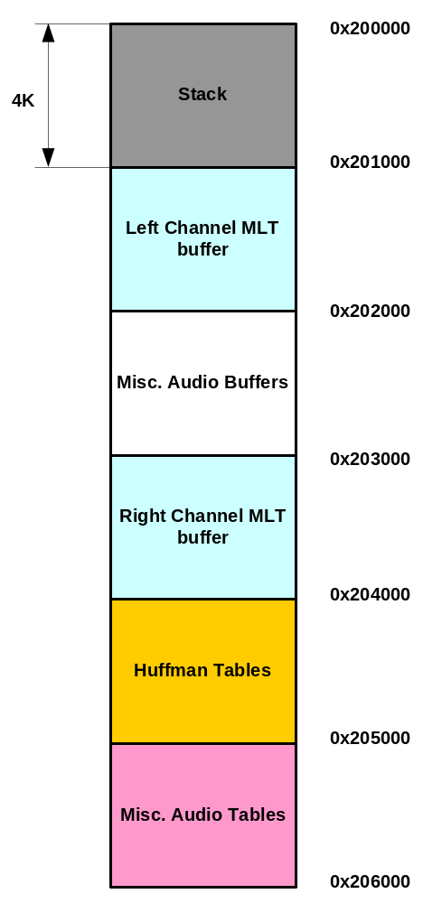

[b] Memory Map of Internal DRAM during the IMLT module:

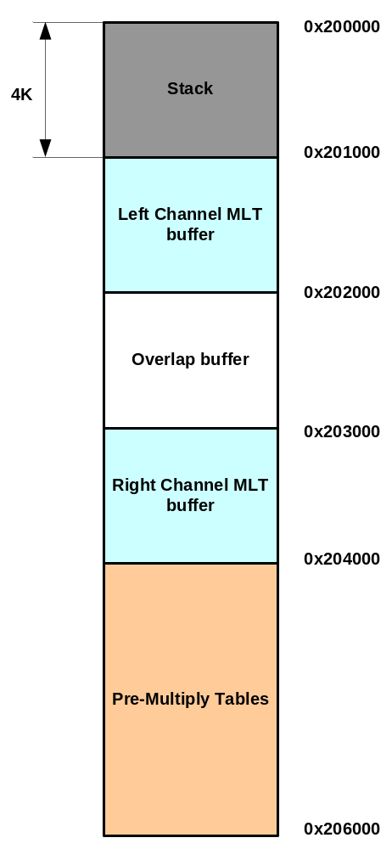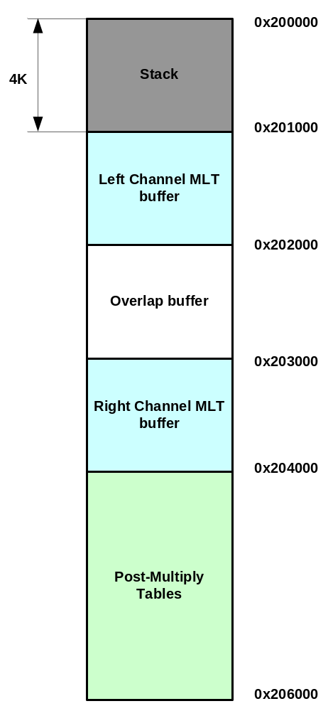

During PreMultiply function During PostMultiply function

[c] Memory Map of Internal DRAM after the IMLT module:

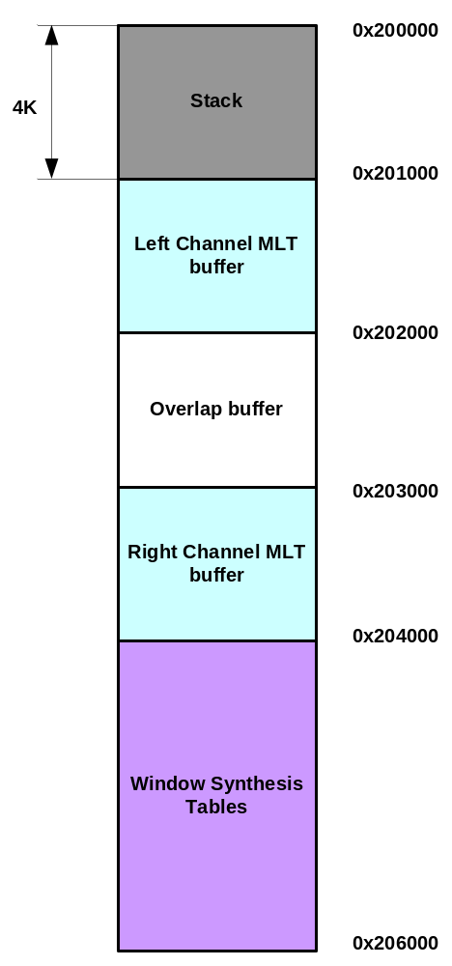

APPENDIX A

A. DIRECT MEMORY ACCESS

DMA Controller can transfer data from local/global bus to local/global bus, in parallel with the operation of MeP Core.
Features of DMAC
(1) Number of Channels
The number of DMAC channels can be selected from 1 to 6 at configuration time.
Note: The MPI configuration can also specify that the DMAC not be included. We are using 2 channels of 6 channels. They are channel 0 and channel 1.
Channel 0 : burst length is 32 bytes. We are enabling the chaining mode when ever is required in this channel.
Channel 1 : burst length is 16 bytes.

(2) DMA Transfer Directions
The DMAC provides for a data transfer capability between the local bus and the global bus, from the local bus to the local bus, and from the global bus to the global bus:
􀁺 From the local bus (MeP core or an expansion unit) to the global bus
􀁺 From the global bus to the local bus
􀁺 From the local bus to the local bus (MeP core or an expansion unit)
􀁺 From the global bus to the global bus
Note: The DMAC supports data transfers between local memories located within the MeP core and between the same expansion unit.

(3) Data Bus Widths
The MPI configuration can specify the global bus data width and the local bus width, as shown below.
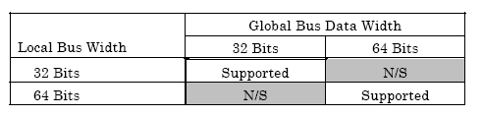

(4) DMA Burst Size
The DMAC uses burst transactions. The burst size is programmable channel by channel, as shown below.
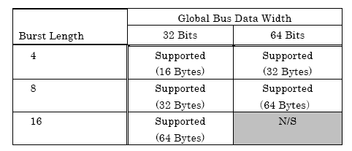
We are using only burst length 4 and 8. EDRAM address should be aligned accordingly depending on the burst length.

(5) Transfer Modes
The DMAC provides support for data transfers of a contiguous address region and a fixed address. This does not Support of the bitBLT transfer operation.
􀁺 From a contiguous region to a contiguous region
􀁺 From a fixed address to a contiguous region
􀁺 From a contiguous region to a fixed address

(6) Descriptor Chaining
The DMAC supports chaining data transfers. A chain descriptor contains the necessary information to complete one DMA transaction such as a transfer command, a source address, a destination address and the number of bytes to transfer. Chain descriptors can be linked together so that multiple DMA transactions can continue uninterrupted. A chain descriptor table is built in local memory located within the MeP core.

(7) External Request Generation
The expansion unit can use a request input signal to request one DMA burst transaction.

(8) DMA Termination with the CAR.ACT Bit
The ongoing DMA transfer can be terminated by clearing the ACT bit in the CAR register.

(9) DMA Termination Interrupts
The DMAC can generate an interrupt request to the Interrupt Controller (INTC) upon termination. The DMAC can terminate by normal completion or as the result of a bus error on the global bus. Each DMAC channel has an independent normal completion interrupt signal, which can be enabled and disabled under software control.

B. Registers Descriptions of DMA Controller
The registers of the DMAC are mapped to the control bus register space of the Processor Core.

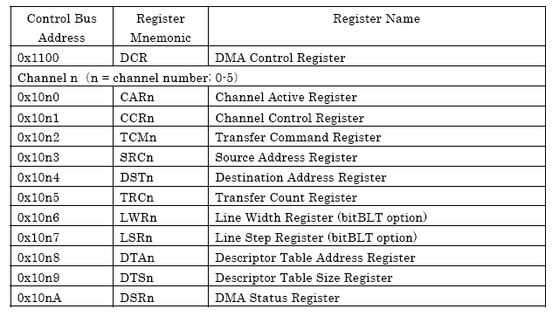

- DMA Initializations Routine:
This routine is called once, at the starting of the decoding process. Initializations are done using Channel Control Rregister of DMA controller. Here we are choosing the burst length, chaining mode support. We can enable the normal interrupt enable request and hardware transfer request interrupt.
ccr = (htrq << 12) | (bl << 8) | (dcm << 4) | nie
htrq : hardware transfer request
bl : burst length
dcm : descriptor chaining mode
nie: normal interrupt enable

- DMA Transfer routine:
DMA transfer could be made either foreground or background. In foreground dma transfer, we are waiting for the data transfer to get complete by polling on a status register (DSR – DMA Status Register). In background dma transfer , we will initialize the data transfer and wont wait for data transfer to get complete. In both type of transfer , source address , destination address and transfer size need to be known.

C. Constraints of DMA Controller
- Alignment of EDRAM Address: Alignment of EDRAM address depends on the burst length chosen. For the burst length 4, burst size is 16 bytes and EDRAM address should be 16 byte aligned. For the burst length 8, burst size is 32 bytes and EDRAM address should be 32 byte aligned. So according to the burst length chosen, we are aligning the EDRAM address to either 16 bytes or 32 bytes.

- Rectangular Data Transfer Using DMA Controller:
Since the DMA Controller is not supporting the Rectangular data transfer operations, we are simulating the rectangular operations using chaining modes. Here we are transferring line by line , linked by the chain. We are creating the chain descriptor table during run time, and then activating the DMA transfer process with chaining mode.
For these operations we are using channel 0, with 32 bytes of burst size. Here we need to take care of EDRAM address alignment to 32 byte location.

D. Types Of DMA Transfer
In the real audio 8 decoding process, the data required at that particular time is brought to the DMEM from EDRAM using dma calls. Decoder access the internal RAM for the data rather than EDRAM and thus decoding process takes less MIPS.
In all the dma transfer cases, EDRAM address should be aligned depending on burst length.

- Direct DMA transfer
Data to be brought in ( let that be either tables or structures ) , is redirected to the known EDRAM address using “ #pragma section” . DMA call is used to transfer from that EDRAM address to predefined DMEM address. Later for all operations on that data, internal DMEM is accessed.

- DMA Overlaying
Overlaying is similar to indirect access of EDRAM. Tables and structures are overlayed to DMEM. In case of overlaying, first we are redirecting the tables or structures to known address in EDRAM. Then those data is brought inside to DMEM using dma call. Here the tables or structures are accessed using the same name as it is defined.

APPENDIX B
Error Handling

Whenever the Real Audio Decoder encounters an error it either conceals it in case of a non fatal error or reports the error to the user if it is a fatal error. The non fatal error is concealed by the decoder itself and continues with decoding. But, in case of fatal errors it returns the error to the user and stops decoding the audio stream further.

Errors in Real Audio 8 decoding

Err No | Error Constant | Description | Error Type
0 | RA8_SUCCESS | Audio frame decoded successfully. | Not an error
1 | RA8_FATAL_ERR_DEC_PTR_NULL | Decoder structure pointer is null. | Fatal
2 | RA8_FATAL_ERR_INPUT_BUF_NULL | Input buffer pointer is null. | Fatal
3 | RA8_FATAL_ERR_OUTPUT_BUF_NULL | Output buffer pointer is null. | Fatal
4 | RA8_FATAL_ERR_INVALID_SAMPLES_PER_FRAME | Invalid number of Samples for frame decoding (Samples per frame must be 256, 512 or 1024). | Fatal
5 | RA8_FATAL_ERR_INVALID_CHANNELS | Invalid number of channels (channels other than 1 and 2 are unsupported). | Fatal
6 | RA8_FATAL_ERR_INVALID_FREQREGIONS | Invalid number of frequency regions for decoding (Frequency regions must be between 7 and 51). | Fatal
7 | RA8_FATAL_ERR_INVALID_SAMPRATE | Invalid Sampling frequency (Sampling frequency must be 8000, 11025, 22050 or 41000). | Fatal
8 | RA8_FATAL_ERR_INVALID_CPLQBITS | Invalid coupling Q bits(The value of coupling Q bits must be zero or between 2 and 6) | Fatal
9 | RA8_FATAL_ERR_INVALID_CPLSTART | Invalid start of coupling frequency region (coupling start region must be between 0 and number of frequency regions coded(nRegions)) | Fatal
10 | RA8_FATAL_ERR_INVALID_BITS_PER_FRAME | Invalid bits per frame (value of bits per frame must be between 192 and 2240). | Fatal
11 | RA8_ERR_IN_SIDEINFO | Error in side information decoding for the frame. | Recoverable error. (Non-Fatal)
12 | RA8_ERR_ATTACKS_EXCEED_IN_GAINCONTROL | Number of attacks in gain control exceeds maximum value (max value is 8). | Recoverable error.(Non-Fatal)
13 | RA8_ERR_IN_DECODING_POWER_ENVELOPE | Error during reconstruction of power envelope for the frame. | Recoverable error.(Non-Fatal)
14 | RA8_ERR_DECODING_HUFFMAN_VECTORS | Error in decoding Huffman vectors for the frame. | Recoverable error.(Non-Fatal)
15 | RA8_ERR_DECODING_SYNTHESIS_WINDOW | Error in applying Synthesis window for the frame. | Recoverable error. (Non-Fatal)

