DIAGRAMMI DI BODE

Processo

num/den =

10 s + 10
----------------------------
0.0625 s^4 + 0.25 s^3 + s^2

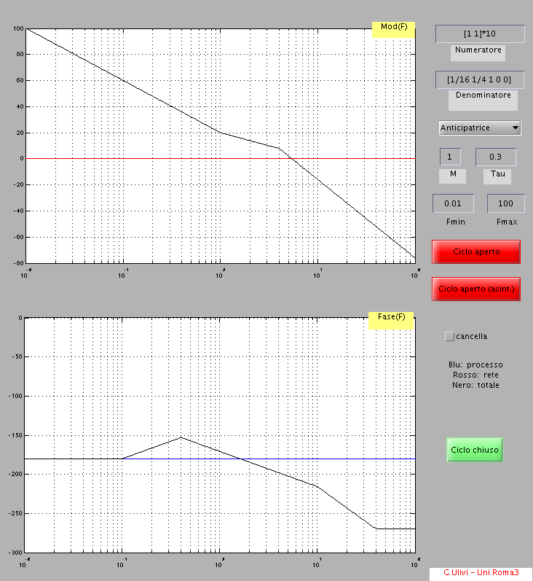

Processo

num/den =

0.25 s^2 + 0.5 s + 1
-----------------------
0.25 s^3 + 2.25 s^2 + s

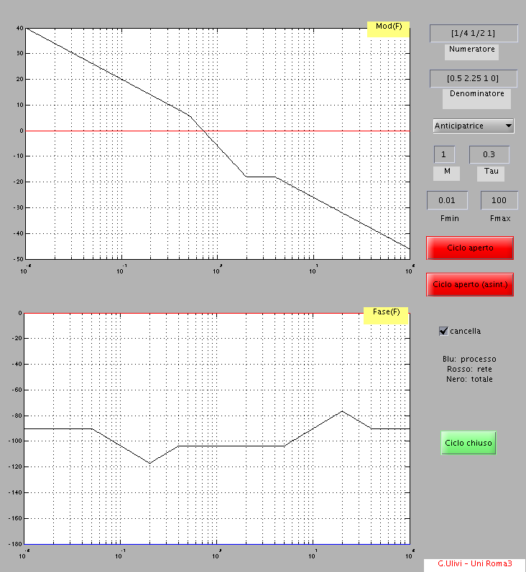

-2
----------------------
0.1 s^3 + 0.7 s^2 + s

