  We think for you!
  Don’t wait another day, from home you can get fit without going to any gym by being advised by our experts.
  
  
  We're waiting for you!
  DietPlus+
  Carrer del Rei en Jaume I,
  2, 46470
  Catarroja, Valencia(Spain)
  
  DietPlus+
  “When the harder the victory, the greater the happiness of winning”
Diet Plus+ is a web application created
Objectives
What can we offer you?
by five students from Florida in order to
provide diets and exercises for those who
Obviously, we offer you a place where you can consult any kind of diet or exercise.

  - First of all, you must register. In this way, you can save the diets and exercises you like in your profile and see them as many times as you like.

  - On the other hand, you can calculate your BMI and your ideal weight.

  - Finally, you can be informed about the news we’ve uploaded from any event, and we’re sure you’ll be very interested in it



We want to guarantee a right planning of our diets and exercises, for this reason, we provide a section in the profile called
library, so that you can add the diets and
exercises that best fit your preferences

love sport and healthy life.

Who are the people we want to help?

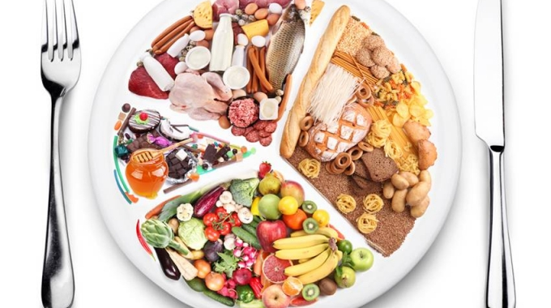
People interested in taking care of their health and keep their body fit, that’s why we provide every kind of diets and exercises on our website, which is divided into sections depending on the kind of diet that you want to start and what part of the body you want to strengthen.



This application has been created and run by the same people who are experts and support the content of this website. They will answer the messages received by users of they have got any doubts.

