Microeconomic Theory (Labor Markdowns)
So far, we have seen in class that the relationships between firms and workers are mediated by the impersonal market forces of supply and demand.
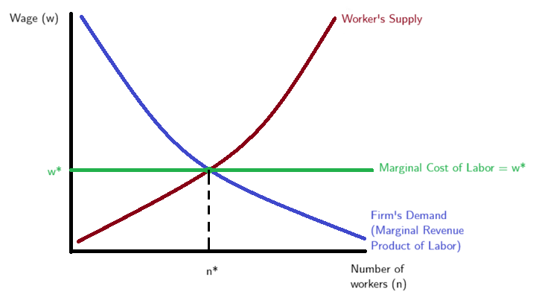
Under perfectly competitive markets workers are paid their contribution to firms’ revenues, also called the marginal revenue product of labor. Workers are perfectly and instantly mobile across jobs, jobs are all similar, and there is perfect information about where jobs are available and how much they pay. The highest possible level of production is obtained, given firms’ productivity distribution. These characteristics imply that firms and workers act as wage takers, identical workers have the same wage everywhere (law of one price).
As shown in the figure below, the firms take the wage w* as given and will hire n* workers that maximize profits (or minimize costs) which happens when the marginal cost of labor equals the given wage.
As in the words of the late Milton Friedman: “The employee is protected from being coerced by his employer by the existence of other employers for whom he can work.”
In the hypothetical case of a company reducing wages by 10 percent, the competitive model predicts that all workers eventually will quit and go to competitors. Firms have no scope for wage setting, and the market determines a worker’s value at every firm.

At the opposite end of the spectrum from a competitive market is a monopsony, where only one employer controls the hiring in a labor market. In this situation, the employer can’t just hire more workers at the same wage, it must raise wages to attract additional people, because workers are only willing to work more if the pay goes up. But if the firm pays everyone the same wage, then hiring one more worker at a higher wage means it has to increase pay for all workers, which makes expanding the workforce more expensive. That discourages the firm from hiring as many people as it otherwise would and creates a gap—called a markdown—between how much value workers create and how much they are paid. As a result, wages, employment, and total output end up lower than in a market with lots of competing employers. In this way, monopsony makes the economy less productive.
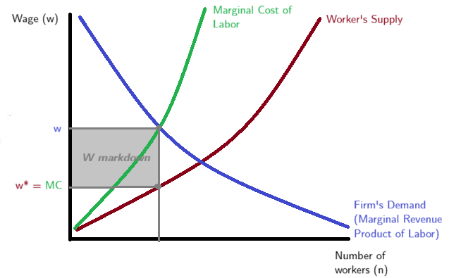

Research Question
Do women-led firms have lower markdowns?
$$Wage Markdown= β_{o}+β_{1}Female Ownership + γControls + e$$
Wage markdown is calculated as the ratio of the labor elasticity of the production function to the share of revenues paid as wages. The portion of wages workers receive for each dollar of value they create in their work.
Female Ownership is the share of female owners in the firm.
Controls considered: industry fixed effects and time fixed effects, capital intensity, productivity, industry HHI (concentration).
Expected Result and Transmission Channel
Firm management can significantly affect labor market competition through strategic decisions, such as consolidations, mergers, and wage-setting practices. (Bertrand and Mullainathan, 1999)
Bloom and Van Reenen (2007) is one of the first contributions emphasising differences in management practices.
Increased labor market concentration, often driven by management, reduces competition, leading to lower wages and diminished worker bargaining power
Conversely, management can influence market competition by affecting workers' outside options (Hall and Krueger 2010) (Schubert, Stansbury, and Taska 2022)
This effect is not homogeneous by gender. Labor market power significantly affects more women workers (Sharma, 2023) (Hirsh et al, 2010).
Female executives do make a difference in gender specific wage distributions as female executives are better at interpreting signals of productivity from female workers (Flabbi et, al.,2019).
Stelzner et al 2021 finds that because of gender- and race-specific historical and social outcomes, like the relatively lower household wealth of Black and Latino families and the increased household responsibilities of women, women and minority workers are more exploitable; employers can push their wage farther below the value of their marginal product.
Then if female executives reduce the gender gaps, this would be reflected on a lower overall markdown, specially driven by a lower markdown on female employees.
I would expect that the effect of Female Ownership on markdown is negative.
Data
Difficult option but higher level of disaggregation and richer set of variables
Colombia Manufacturing Survey
Level: Firm – year
Availability: 1995 - 2024
This is rich data set at the firm level with the number owners, white-collar employees, production employees by gender and type of contract. It also includes a wide rich set of variables for the firm to untangle the production function (capital, materials, payroll, costs, etc.) which will help with the markdown estimations.
Additional option (easier): CompeteLAC
Level: Industry-year
Availability: 1995 – 2021
This dataset was constructed by the Inter-American Development Bank Research Department and has the markdowns already calculated at the industry level (20 manufacturing industries), it includes other key variables such as industry performance, concentration, market power, capital, gross-output, labor, value added, wage bill, among others.
For this option I will add the share of female owners directly from the reports of the Colombia Manufacturing Survey that already are aggregated at the industry-year level.
Literature Review
Amodio and Roux (2024) find that in Colombia firm-level labor supply elasticity of around 2.5, implying that workers produce about 40% more than their wage level.
Using data from the U.S. 2007 to 2016 Tunyi et al, 2023 find that firm-level employment increases while the likelihood of downsizing decreases with BOD female representation, and overall employee productivity improves with female representation.
For Latin America (Flabbi et al 2017) find that measures of female leadership at the firm are correlated with company performance.
Moreover, firms owned by women were less likely than those owned by men to downsize their workforces during the Great Recession (Matsa and Miller, 2014).
Firms with female directors are less likely to make acquisitions leading to a lower market concentration (Levi et al, 2014)
Sanchez et al (2021) found for Chile that men would earn approximately 22% more than women as a result of the difference in labor supply elasticities by gender.
Female board representation matters for industries where male CEO overconfidence is more prevalent. Firms that do not have (sufficient) female board representation suffer a greater drop in performance as a result of the crisis than those that have female board representation. (Chen et al, 2019)
Quotas in Italy showed that female presence on the boards of directors of SOEs increased, while that of former politicians decreased. New directors replaced older and less talented men, thereby rejuvenating the boards and improving their quality. (Baltrunaite et al, 2023)
In the U.S. the percentage of female directors increases renewable energy consumption (Atif, et al 2021)
Labor market power can arise for several reasons, including a limited number of employers (Manning (2021)), varying job amenities (Card (2022)), or information frictions (Azar and Marinescu (2024))
If job search and matching are costly, however, competition remains limited even when many employers are present (Manning 2003; Mortensen 2010; Moscarini and Postel-Vinay 2010).
Collective bargaining can shield broader groups of workers from monopsony power by setting higher wage floors, standardizing pay, and reducing wage inequality (Farber et al. 2021).
The literature documents a negative relationship between HHI and wages. Azar, Marinescu, and Steinbaum (2017) and Azar et al. (2019) estimate that the elasticity of real wages with respect to HHI is around –0.1, implying that moving from the 25th to the 75th percentile of concentration reduces posted wages by 17 percent. Similar findings emerge from Benmelech, Bergman, and Kim (2018) and Rinz (2020), who use different data sources but reach conclusions consistent with these findings.
On average, workers in Latin America and the Caribbean take home in the form of wages 50 percent of what they contribute to their employers. In contrast, they take home 65 percent and 81 percent, respectively, in the United States and other advanced economies. In Colombia this value is 59. (IDB Competition Report)
Correlation Graph
Industry-Year level Correlation between the average markdown by industry (Firm-weighted) and the share of female owners by industry.
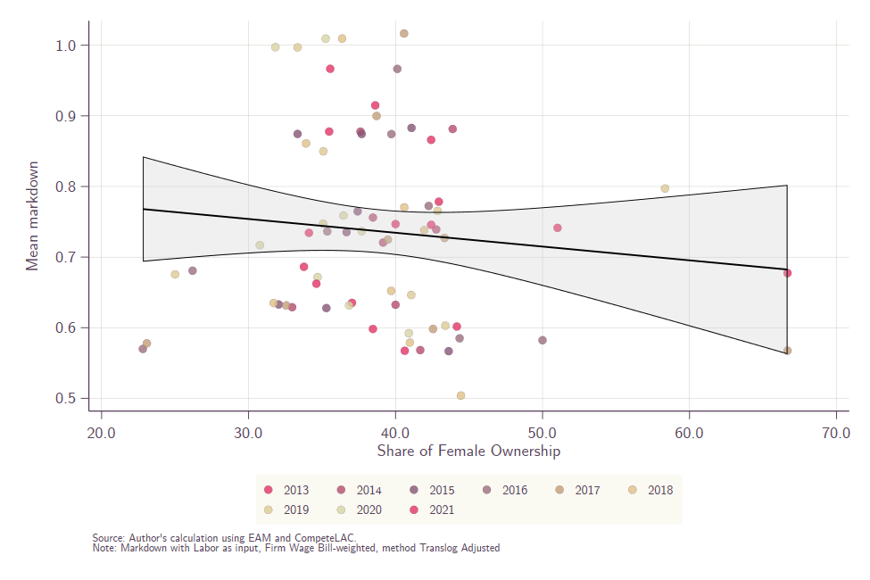
The graph shows a negative relationship which coincides with the first hypothesis, in which boards where the share of female owners is larger leads to a lower markdown, this can be driven by the management behavior of higher redistribution of wages according to the workers productivity and according to the literature, a lower gender wage gap (reducing the overall markdowns).
A concluding page that where you identify questions that will help you with your research
There are several weakness in the idea proposed, the main one is that ideally we would calculate the labor elasticity by gender to construct markdowns for men and women workers which would show if it is the case that female leaders push women markdowns down which would explain the lower markdowns or if this effect is not discriminative, however, the current data does not divide the wage bill by gender so we could not evaluate this hypothesis.
Moreover, this effect could be driven by productivity differences or it can be the case than If I go to firm data the effect could not hold when controlling for firm’s characteristics.
There is a channel that I found in the literature that could be related to a positive effect. In Colombia firms that support women’s presence in corporate governance positions are positively associated with firm performance (Moreno Gomez and Calleja Blanco, 2017). Large, more productive firms pay higher wages, yet relative to workers’ contributions to the value of the firm, the ratio is larger. This also related to the findings by Arbealez and Solarte (2020) in which women in Colombia have to overperform compared to men to obtained the same executive positions.

