Microeconomic Theory (Labor Markdowns)
So far, we have seen in class that the relationships between firms and workers are mediated by the impersonal market forces of supply and demand.
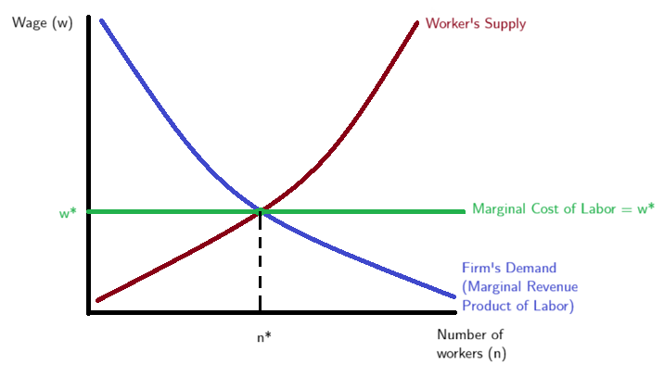
Under perfectly competitive markets workers are paid their contribution to firms’ revenues, also called the marginal revenue product of labor. Workers are perfectly and instantly mobile across jobs, jobs are all similar, and there is perfect information about where jobs are available and how much they pay. The highest possible level of production is obtained, given firms’ productivity distribution. These characteristics imply that firms and workers act as wage takers, identical workers have the same wage everywhere (law of one price).
As shown in the figure below, the firms take the wage w* as given and will hire n* workers that maximize profits (or minimize costs) which happens when the marginal cost of labor equals the given wage.
As in the words of the late Milton Friedman: “The employee is protected from being coerced by his employer by the existence of other employers for whom he can work.”
In the hypothetical case of a company reducing wages by 10 percent, the competitive model predicts that all workers eventually will quit and go to competitors. Firms have no scope for wage setting, and the market determines a worker’s value at every firm.

At the opposite end of the spectrum from a competitive market is a monopsony, where only one employer controls the hiring in a labor market. In this situation, the employer can’t just hire more workers at the same wage, it must raise wages to attract additional people, because workers are only willing to work more if the pay goes up. But if the firm pays everyone the same wage, then hiring one more worker at a higher wage means it has to increase pay for all workers, which makes expanding the workforce more expensive. That discourages the firm from hiring as many people as it otherwise would and creates a gap—called a markdown—between how much value workers create and how much they are paid. As a result, wages, employment, and total output end up lower than in a market with lots of competing employers. In this way, monopsony makes the economy less productive.
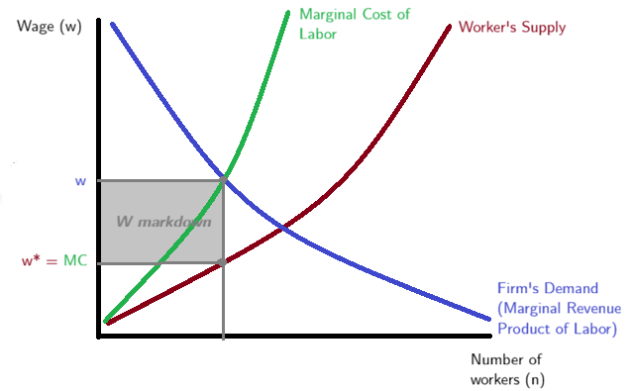
Research Question
Are women-led firms less likely to underpay workers because they dominate local labor markets?
$$Wage Markdown= β_{o}+β_{1}Female Ownership + γControls + e$$
Wage markdown is calculated as the ratio of the labor elasticity of the production function to the share of revenues paid as wages. The portion of wages workers receive for each dollar of value they create in their work.
Female Ownership is the share of female owners in the firm.
Controls considered: industry fixed effects and time fixed effects, region fixed effects, capital intensity, productivity, industry HHI (concentration).
Data
Difficult option but higher level of disaggregation and richer set of variables
Colombia Manufacturing Survey
Level: Firm – year
Availability: 1995 - 2024
This is rich data set at the firm level with the number owners, white-collar employees, production employees by gender and type of contract. It also includes a wide rich set of variables for the firm to untangle the production function (capital, materials, payroll, costs, etc.) which will help with the markdown estimations.
Additional option (easier): CompeteLAC
Level: Industry-year
Availability: 1995 – 2021
This dataset was constructed by the Inter-American Development Bank Research Department and has the markdowns already calculated at the industry level (20 manufacturing industries), it includes other key variables such as industry performance, concentration, market power, capital, gross-output, labor, value added, wage bill, among others.
For this option I will add the share of female owners directly from the reports of the Colombia Manufacturing Survey that already are aggregated at the industry-year level.
Literature Review
Despite the large number of employers overall, competition is often limited within local labor markets, where a few dominant firms account for a disproportionate share of employment. Combined with low worker mobility and limited bargaining options, this concentration enables employers to pay wages below workers’ actual contribution to production.
Previous research has identified employer concentration as the key contributor. In concentrated labor markets workers have fewer employment options, which increases the relative bargaining power of employers. Antitrust Remedies for Labor Market Power and World Bank Document and Anticompetitive Mergers in Labor Markets and World Bank Document

Firm management can significantly affect labor market competition through strategic decisions, such as consolidations, mergers, and wage-setting practices.
Increased labor market concentration, often driven by management, reduces competition, leading to lower wages and diminished worker bargaining power.
Conversely, management can influence market competition by affecting workers' outside options.

Correlation Graph
Microeconomic Theory
A concluding page that where you identify questions that will help you with your research

