**Coherent**

**User Manual**

1. Installation.

No installation is required. The software consists of a single executable file Coherent.exe, which can be launched from any folder in Windows OS. The same folder should contain additional file with ports configuration, ports.ini.

1. Working with the software.

2.1. Once the software is launched, it tries to connect to 5 hardware devices: two step motors for target movement, valves controller, vacuum gauge, and turbomolecular pump. If everything is fine, the corresponding message is displayed and the software is ready for work:

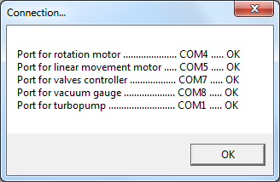

Alternatively, an error message is displayed:

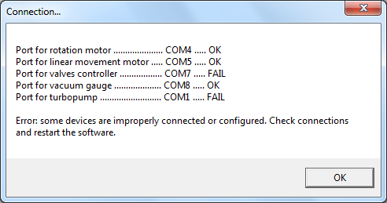

In that case, please check the connection cables and port numbers and then restart the software.

Warning: do not use COM ports with indices > 9!!!

To check the port numbers, please refer to Device Manager Windows utility. Navigate to Ports (COM & LPT) section. There you must see at least 5 different devices with the same port numbers as indicated in the Connection… dialog. To determine the type of the device connected to the specific port, you can disconnect and reconnect devices one by one. If you need to change the number of the specific port, please right-click the COM port and select Properties; click the Port Settings tab and click Advanced; change the COM port number to an available COM port number or rewrite some busy but disconnected one; you will probably need to restart your computer.

2.2. The main workframe is displayed after the connection:

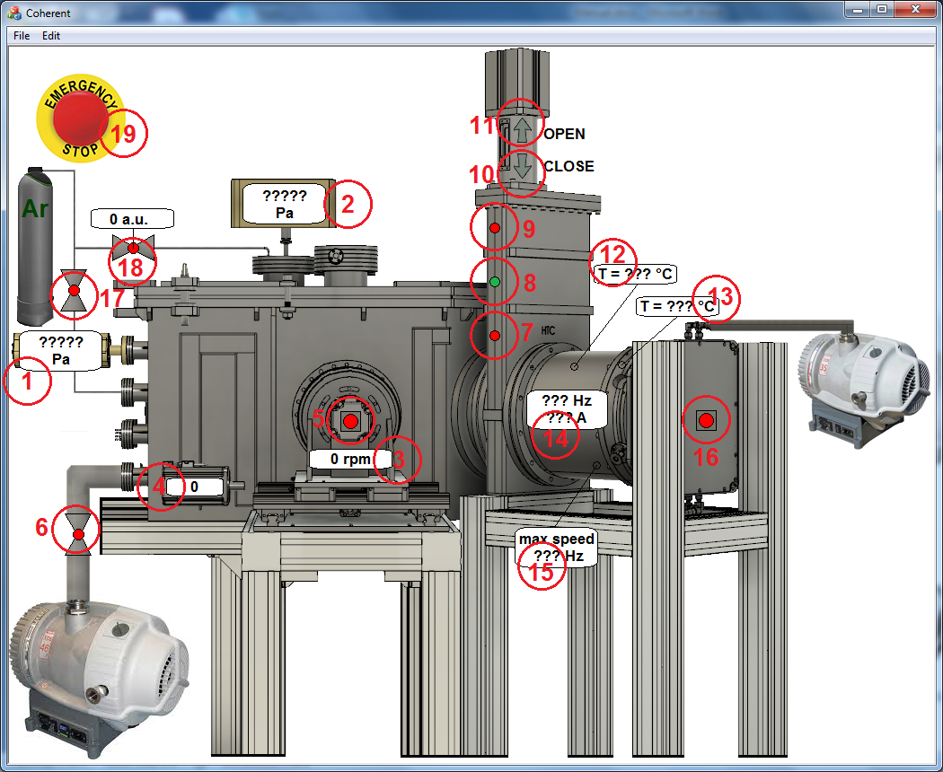

It consists of the following control elements:

1. Indicator showing the gas pressure inside the chamber.
2. Indicator showing the gas pressure inside the gas supply line.
3. Indicator showing the chosen rotation speed of the target.
4. Indicator showing the current position of the step motor controlling linear movement of the target.
5. Button used to start/stop rotation and linear movement of the target.
6. Button used to open/close the valve of bypass line.
7. Indicator showing that the valve between the turbomolecular pump and chamber is fully closed.
8. Indicator showing that the valve between the turbomolecular pump and chamber is in intermediate position.
9. Indicator showing that the valve between the turbopump and chamber is fully opened.
10. Button used to close the valve between the turbopump and chamber.
11. Button used to open the valve between the turbopump and chamber.

The valve will be opening/closing only when the left mouse button is hold and the cursor is above the arrows (10) – (11). Once the left mouse button is up or the cursor leaves the arrows area, the movement of the valve stops allowing achieving intermediate positions. To fully open or close the valve, a very short click on the button (10) or (11) is required.

12) Indicator showing the temperature of the turbomolecular pump motor.

13) Indicator showing the temperature of the turbomolecular pump control unit.

14) Indicator showing the current status of the turbomolecular pump. The rotation speed and motor current are shown.

15) Indicator, showing the set rotation speed of the turbomolecular pump. The value can be changed from Edit -> Set Turbopump Speed... menu item. The speed should be in the range of [225 … 450] Hz.

Waring: there is an endurance limit, the speed must not be changed more than approximately 87600 times.

16) Button used to start/stop the turbomolecular pump.

17) Button used to open/close the valve to vent the chamber.

18) Button used to set the argon flow into the chamber via the gas supply line. The flow is set and displayed in arbitrary units in the range of 0 … 2000 a.u.

The flow is regulated by the voltage applied to the mass flow controller (MFC): 2000 a.u. = 15 V. The relationship between a.u. and real flow (in sccm) is not linear. Small voltages can not open the MFC and no gas is flowing. Voltages above ~12 V fully open the MFC and maximum flow is supplied. Intermediate posituions supply intermediate flows. If you need to convert a.u. to sccm do the following procedure. 1) Pump the chamber down to the pressure p1. 2) Close all pumping lines. 3) Set some gas flow Q. 4) Waint for some time Δt. 5) Determine the pressure inside the chamber p2. 6) Calculate the flow: , where p0 = 1 atm = 105 Pa and v0 = 180 liters (chamber volume).

19) Emergency stop button: stops both motors and closes the valve between the turbopump and chamber.

1. Calibrating of the motors for target movement.

Target rotation and linear movement are applied to ensure the uniform sputtering of the material. The movement parameters are set using Edit -> Drive Parameters… menu item:

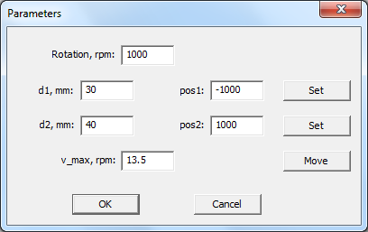

“Rotation” defines the rotation speed of the target. It should be on the order of 1000 rpm to ensure that the laser pulses do not overlap on the target. It is kept constant.

“v_max” defines the rotation speed of the motor controlling linear movement of the target when its position is equal to “pos1”. Note: if d1<d2 “v_max” is the maximum speed; if d1<d2, “v_max” is the minimum speed. The sign determines the direction of the movement.

When “Move” button is pressed, the target is moved linearly using “v_max” value. Its position indicated by (2) is changed. To stop the movement, press the button again.

For calibration, do the following steps:

* Move the target to the first end position using “Move button”.
* Manually enter the drive position into the field “pos1” or use the top button “Set”.
* In this end position, measure the distance between the laser spot and target center. Enter this value into the “d1” field.
* Change the sign of “v_max” and move the target to the second end position.
* Enter the drive position into the field “pos2” or use the second button “Set”.
* In this end position, measure the distance between the laser spot and target center. Enter this value into the “d2” field.
* Press “OK” button.

The rotation speed (v) of the motor controlling linear movement of the target will be determined at each moment of time based on the current position (pos) according to the equation:

$$v=\frac{v_{max}*d1}{d1+\frac{\left(d2-d1\right)*(pos-pos1)}{pos2-pos1}}$$

1. Turbomolecular pump protection.

If the pressure inside the chamber is higher than the critical value p_crit and turbomolecular pump is running, the valve between the pump and chamber is automatically closed. The value of p_crit can be ajusted from Edit -> Set Critical Pressure… menu item.