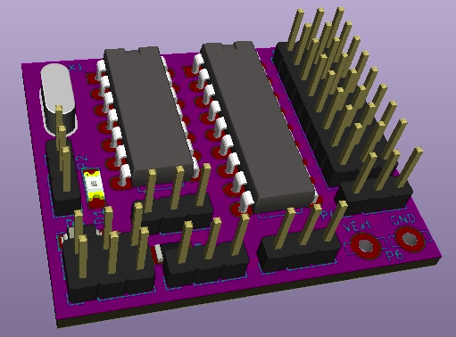
MS8-Xany

More than a simple 8-output MultiSwitch decoder for OpenAVRc

MS8-Xany MultiSwitch user manual
Copyright OpenAVRc 2018

Table of Content
1 THIS DOCUMENT 3
1.1 Versions 3
1.2 Copyright 3
1.3 Disclaimer 3
1.4 Contents 3
2 PRESENTATION OF MS8-XANY 4
2.1 Overview 4
2.2 MS8-Xany decoder specifications 4
3 MS8-XANY SCHEMATIC DIAGRAM 6
4 Making the MS8-XANY DECODER 7
4.1 Printed circuit board 7
4.2 Uploading firmware and configuring fuses 7
4.2.1 Uploading Firmware in ATtiny84 7
4.2.2 Configuring the fuses on ATtiny84 7
4.2.3 Very important note about the value of the fuses 7
5 Usage 8
5.1 Connecting to a receiver 8
5.2 Standard Mode : MultiSwitch / Digital switch 8
5.2.1 Wiring the loads on the outputs 8
5.2.2 Selecting the supply voltage for the S1 to S8 outputs 9
5.2.3 Free wheeling diodes 9
5.2.4 Direct relay control with integrated diodes in the ULN2803 9
5.2.5 Controlling opto-isolated relays 10
5.2.6 Recommended connections for 5V opto-isolated relays 11
5.3 X-Any configuration at the OpenAVRc transmitter side 11
5.4 Advanced Mode / Servo Control 12
5.4.1 Using the serial port on MS8-Xany 12
5.4.2 MS8-Xany command messages 13
5.4.3 Real configuration example 14

THIS DOCUMENT

Versions
Version | Date | Reason for update
0.1 | 20/12/2018 | Creation

Copyright
This document is Copyright © 2018 OpenAVRc.

Disclaimer
The OpenAVRc team is not responsible for any damage that may result from the misuse or possible malfunction of the OpenAVRc transmitter, the MS8-Xany decoder module and/or associated software.
It is therefore up to the end user to estimate, assume the risks and comply with the legislation in force depending on the country of use.

Contents
This document describes the making of the MS8-Xany decoder module as well as the settings for its use with the OpenAVRc transmitter.
MS8-Xany is a MultiSwitch decoder module with 8 digital outputs.
In addition to the classic MultiSwitch function, MS8-Xany can be set up so that its outputs drive standard servos with digital commands (0/1).
Finally, MS8-Xany can provide an auxiliary proportional channel for driving a standard proportional servo.

PRESENTATION OF MS8-XANY

Overview


X-Any option :
8 Contacts
(switches)
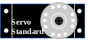
MS8-Xany
RX
TX


MS8-Xany decoder specifications
Specification | Value / Feature | Notes
Power supply | +3.3V to +6.6V | Set the "receiver voltage" jumper to "=" or "↓" according to the value of the voltage supplied by the receiver
X-Any Protocol | -Universal digital protocol used by OpenAVRc for remote accessories  - Integrity check with 8-bit checksum  - Works with all protocols, including 2.4GHz:  - PPM Protocol  - SPIRfMod Protocols  - MultiMod Protocols | Unlike many MultiSwitches, MS8-Xany also works with 2.4GHz HF modules
8 Digital Outputs | - Commanded in Digital mode by transistor output | Outputs configured in "Digital" mode (MultiSwitch)
Output voltage | - Internal: receiver voltage  - External: external voltage 5 to 24V | Selectable by jumper (common to 8 outputs)
Free wheeling diodes | Free wheeling diodes between the 8 outputs and + output power | Selectable by jumper (common to 8 outputs)
8 servo outputs | - Digitally driven  - End positions can be configured  - Duration of movement between end positions is configurable | - Outputs configured in "Servo" mode  - Reversal of servo travel possible by changing extreme values  - Ability to use receiver voltage  - Possibility to use an external voltage (compatible with servos)
1 proportional servo output | Proportional control of a servo from 988μs to 2008μs (0 to 255 steps of 4μs) | Presence of servo control is dynamically detected by MS8-Xany: nothing to configure except at the OpenAVRc transmitter side
Red LED lights when signal is lost | After 1.5 seconds without correct signal | Not managed if proportional servo used (shared connection)
Failsafe | - All outputs go to 0 in case of RC signal loss  - The proportional servo retains its current position | Synchronized with red LED turning on
TTL serial port | USB cable connector / FTDI TTL | For advanced configuration using a "Serial Terminal" application

Page left intentionnally blank

MS8-XANY SCHEMATIC DIAGRAM

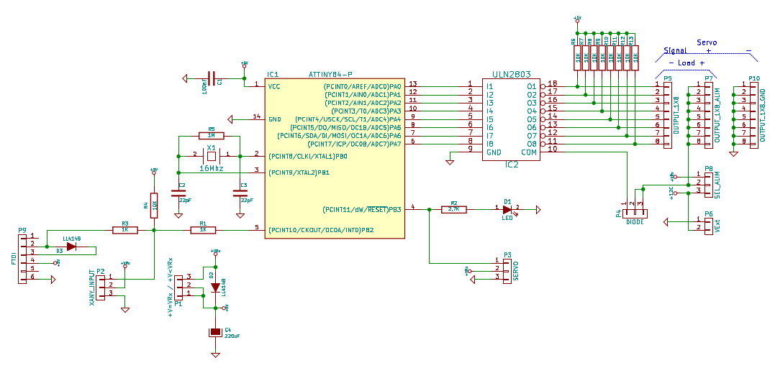
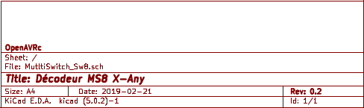

Making the MS8-XANY DECODER

Printed circuit board
TO DO

Uploading firmware and configuring fuses
The programming of the microcontroller ATtiny84 is done in 2 phases (in this order):
- Upload firmware
- Configure fuses

Uploading Firmware in ATtiny84
Using an AVR microcontroller ICSP programmer, upload the MS8_Xany_Vx_y.hex file to the ATtiny84.

Configuring the fuses on ATtiny84
The fuses are contained in special ATtiny84 registers that allow you to define certain parameters, such as the type of oscillator used, the role of certain pins and many other things.
On the ATtiny84, there are 3 "fuse" registers.
These "fuse" registers are also set using an ICSP programmer.
The values to be set into the 3 "fuse" registers of ATtiny84 are as follows:
- EXT_FUSE : 0xff
- HIGH_FUSE : 0xdf
- LOW_FUSE : 0xfe
With HIGH_FUSE at 0xdf, the Reset pin of the ATtiny84 remains configured as Reset function. If necessary, it is possible to reprogram the ATtiny84 with an ICSP programmer. In this case, the proportional servo function (S0 output) and the "Signal Lost" LED are not managed.

Very important note about the value of the fuses
Still using an ISCP programmer, it is possible to configure HIGH_FUSE to 0x5f, in which case the reset pin of the ATtiny84 is configured as an input / output pin, the proportional servo function (S0 output) and the "Signal Lost" LED will then be managed.
In this case, it is no longer possible to reprogram the ATtiny84 directly with an ICSP programmer since the Reset function of the ATtiny84 is needed.
To program back the reset pin of the ATtiny84 so that it has Reset function, it is necessary to apply a calibrated 12V signal to the reset pin. It is then necessary to use a small box of "Fuse Resetter" type.
After doing this, the ATtiny84 becomes programmable again using an ICSP programmer.

Usage

Connecting to a receiver
Before connecting MS8-Xany to the receiver, it is imperative to measure the voltage supplied by the receiver.
If the available voltage between the - and + pins of the 3-pin connector of the channel used is:
1. Lower than 5.7V, set the jumper "receiver voltage" to "="
2. Higher than 5.7V, set the jumper "receiver voltage" to "↓"

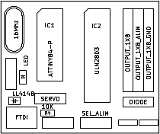

RC Input (Receiver ouput)
S
+
-
Position « = »
Position « ↓ »

Standard Mode : MultiSwitch / Digital switch
After uploading the firmware, MultiSwitch is the default mode: the digital switching mode of the 8 S1 to S8 outputs. So there is nothing else to configure to operate in MultiSwitch mode.

Wiring the loads on the outputs
The MS8-Xany is then used as a standard MultiSwitch module:
- The "loads" (like: a lamp) are connected to the S1 to S8 outputs between the pins "S" and "+", the 8 row points of "-" at the edge of the board is not used in this case.
S + -
S1
S2
S3
S4
S5
S6
S7
S8
Lamp

RC Input (Receiver ouput)
S
+
-

Selecting the supply voltage for the S1 to S8 outputs
RC Input (Receiver ouput)
S
+
-

S + -
+ -
5V < VExt < 24V
Position « VRx »
Position « VExt »
S1
S2
S3
S4
S5
S6
S7
S8
+VRx

It is possible to supply the S1 to S8 outputs (supply to +) from:
- +VRx voltage supplied by the receiver (Beware of the current consumption on the outputs!)
→ Power selection jumper on "VRx"
2. An external VExt voltage (5V to 24V) applied to the 2-pin connector at the bottom right
of the board
→ Power selection jumper on "VExt"

Free wheeling diodes
If the "loads" connected to the outputs are inductive (eg relays), the internal free wheeling diodes shall be connected, otherwise there is a risk to destroy the ULN2803.
S + -
Diode connected position
Diode disconnected position
S1
S2
S3
S4
S5
S6
S7
S8

S
+
-
RC Input (Receiver ouput)

Direct relay control with integrated diodes in the ULN2803
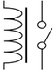
S1
S2
S3
S4
S5
S6
S7
S8

Relay
S
+
-
RC Input (Receiver ouput)

Controlling opto-isolated relays
There are very cheap "relay modules" often called "Arduino Relay Module". These modules include an opto-coupler allowing a total isolation between the control voltage and the supply voltage of the coils of the relays.
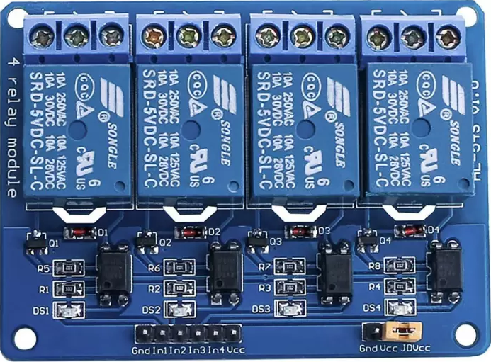

Yellow Jumper

The equivalent circuit diagram of one relay channel is given below:
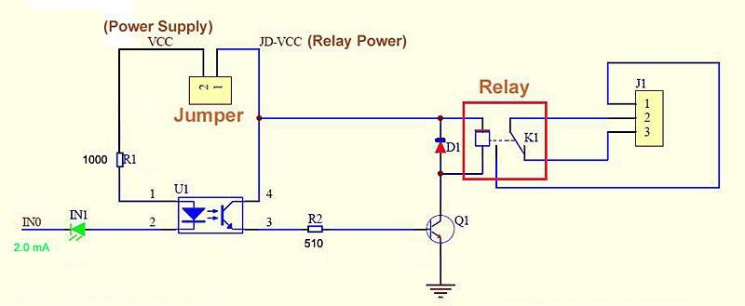

- VCC is the opto-coupler control voltage: accessible on the connector on the edge of the board
- JD-VCC is the control voltage of the relay coils: accessible on one of the jumper connector pins

Important Note:
To achieve full isolation between VCC and JD-VCC, the yellow jumper shall be removed.

Recommended connections for 5V opto-isolated relays

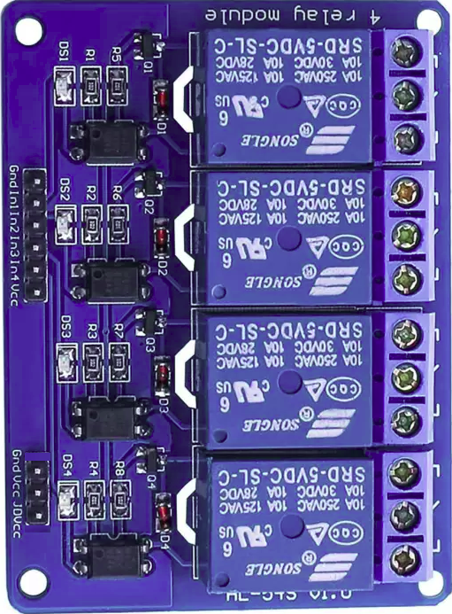
VCC
(only one needed)
In1
S1
S2
S3
S4
S5
S6
S7
S8
Separate power supply for relay coils:
+ 4.8V to + 7.2V
_
+
+ -
Position « VRx »
GND
JD-VCC
*

S
+
-
RC Input
(Receiver output)

- The optocouplers are powered by the receiver voltage (total consumption: around 10 mA)
- VCC of the relay board is connected to one of the OUTPUT_1X8 supply pins
- In1 of the relay board is connected to the S1 output
- In2 of the relay board is connected to the S2 output, etc.
- Relay coils are powered by a separate power supply (+ 4.8V to + 7.2V)
→ Since the power supplies are completely isolated, the receiver voltage will not be disturbed during relay switching: no risk of losing RC control.
* : On some "relay module" models, there is no GND pin near the JD-VCC. In this case, use the GND pin close to the In1 pin on the other connector.

X-Any configuration at the OpenAVRc transmitter side
Refer to the OpenAVRc manual to configure the X-Any instance with the following parameters:
- The channel number shall correspond to the channel number on which the MS8-Xany decoder will be connected to the receiver
- The number of repetitions will be first set to 3 (as soon as it will work, it will be possible to reduce this value to reach the maximum reactivity allowed by your HF set).
- Configure "Sw." with Sw.8: this will transmit the state of the 8 contacts
- If the proportional servo will be used on MS8-Xany, tick "Pot". This will add the transmission of the value of the potentiometer.

Advanced Mode / Servo Control
The MS8-Xany decoder has an access for advanced configurations: a TTL serial port.
To use it, it is necessary to disconnect the RC input of MS8-Xany to not disturb the operation of serial access.
It is this serial access that will allow the use of servos connected to the S1 to S8 outputs.
In this case, the "+" output voltage must be compatible with the servos!

Using the serial port on MS8-Xany
To access the serial port of MS8-Xany, you need a USB / TTL serial cable eg "FTDI" type.

The necessary pins on the USB cable / TTL series are:
- GND,
- +5V
- TX
- RX

The USB / TTL serial cable must be able to provide + 5V supply to MS8-Xany because during advanced configuration, MS8-Xany shall be disconnected from the receiver (shared pin).
1. Connect USB side of the USB / TTL serial cable to an USB port on a PC
2. On the PC, open a Serial Terminal, for example, PuTTY, TeraTerm, HyperTerminal, GtkTerm, or CoolTerm with the following parameters: 19200 baud, 8 data bits, 1 stop bit, no parity.
Depending on the Serial Terminal, it may be necessary to enable automatic line feeds on receipt of CR / LF to have a good display.
3. Connect the TTL side of the USB / TTL serial cable to the MS8-Xany 6-pin connector, this will power MS8-Xany (check that there are not too large consumers connected to the outputs, since it is the USB on the PC which provides the power supply + 5V)
4. Within 3 seconds after connecting to MS8-Xany, press the "Enter" key on your keyboard, the message "MS8 VX.Y" should appear on the Serial Terminal as shown below. If this is not the case, disconnect the USB / TTL serial cable from the 6-pin connector of MS8-Xany and repeat step 3 above.
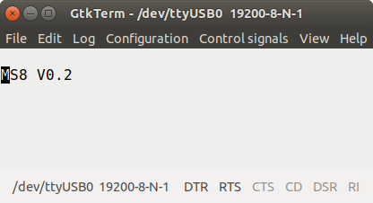

Example of connection with GtkTerm Terminal on Linux

MS8-Xany command messages
The list of messages supported by MS8-Xany is given in the following table:
←Command/→Response | Action | Notes
←Enter  →MS8 Vx.y | If sent within the 3 seconds after power on, the decoder enters Terminal mode | If failed and 3 seconds elapsed, unplug and reconnect the 6-pin USB / TTL serial cable connector
←S0?  →S0=Pos:4usStepOffset | Returns the current position in μs and the 4usStepOffset command which is the number of steps of 4μs (value between 0 and 255) to be added to 988 to have the pulse width in μs for the proportional servo | Pulse width (us) =  988 + ( 4usStepOffset x 4)
←S0=Pos  →S0 | Sets the position in μs for proportional servo | Returns ERR, if value not between 988 and 2008
←Sx?  →Sx=D:C  or  →Sx=S;Pos0;Pos1;Dur:C | If x is between 1 and 8, returns the configuration of the output No. x and the state "C" of the associated current Command (0 or 1)  - If the output is configured as MultiSwitch Digital output, the answer is: Sx = D: C  D = Digital (Digital)  - If the output is configured as a Servo output, the response is: Sx = S;Pos0;Pos1;Dur:C with Pos0 = the position in μs for the state 0, Pos1 = the position in μs for the state 1, and Dur = the duration (in ms) of the movement of the servo between Pos0 and Pos1 | Returns ERR, if  - Value x not between 0 and 8  - Pos0 or Pos1 < 600  - Pos0 or Pos1 > 2400  Sample answers:  S1=1000;2000;5000:0  S2=2300; 600; 8500: 1
←Sx=D  →Sx | Sets the output x to be Digital
←Sx=S;Pos0;Pos1;Dur  →Sx | Sets the output x as servo with Pos0 μs for 0, Pos1 μs for 1, and Dur ms | The real value in ms is internally recalculated by MS8-Xany taking into account the different resolutions / limitations and may be different when displayed.
←Sx=C  →Sx | If x is between 1 and 8, "C" defines the State (0 or 1) for the output x, whether the type is either Digital or Servo | Very handy for testing using the serial access without RC.
←Q | Exit Terminal Mode: MS8-Xany can be connected to receiver | Do not forget to disconnect the USB / TTL cable!

Real configuration example
In the example below:
• The pulse width for the servo connected to the proportional S0 output is:
[988 + (242 x 4)] = 1956 μs
→ the command (= the number of 4 μs steps to add to 988 μs) would be 242 for the pulse width of 1956 μs
• The outputs S1, S2, S3 and S8 are Servo type, their commands are respectively 0, 0, 1 and 1
• The outputs S4, S5, S6 and S7 are Digital type (MultiSwitch) type, their states are respectively 0, 1, 0 and 1
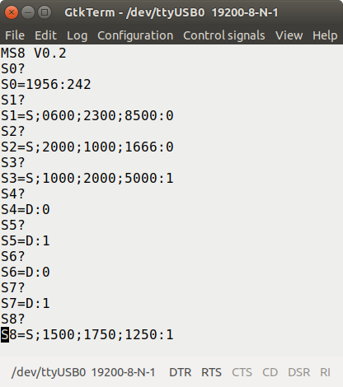

- Counterclockwise servo movement
If the contact N°1 at transmitter side is closed (Command=1), the pulse of the servo connected to the output N°1 goes from 600 µs to 2300 µs (→ a movement of around 180°) in 8,5 seconds, and goes from 2300 µs to 600 µs (→ a movement of around 180°) in 8,5 seconds if the contact N°1 at transmitter side is opened (Command=0).
S1
S2
S3
S4
S5
S6
S7
S8
Command=1
Position=2300µs
Command=0
Position=600µs
Duration of
Movement=1,67 s
S2
Position « VRx »

RC Input
(Receiver output)
- Clockwise servo movement
S1
S
+
-
With MS8-Xany, it’s possible to obtain a movement in the opposite direction : just swap the extreme positions (Pos0 and Pos1).
If the contact N°2 at transmitter side is closed (Command=1), the pulse of the servo connected to the output N°2 goes from 2000 µs to 1000 µs (→ a movement of around 100°) in 1,67 seconds, and goes from 1000 µs to 2000 µs (→ a movement of around 100°) in 1,67 seconds if the contact N°2 at transmitter side is opened (Command=0).
S2
S1
S2
S3
S4
S5
S6
S7
S8
Command=1
Position=2000µs
Command=0
Position=1000µs
Duration of
Movement=1,67 s
S2
Position « VRx »
RC Input
(Receiver output)
S
+
-

